


Name: Keti Hazbiu
Email: hazbke01@thu.de
Title: Kaya Robot Setup in Isaac Sim 5.1.0

1. Introduction
This document explains the main ROS 2 parameter files used for kaya mobile robot navigation. The goal is to understand what each important component does, why it is needed, and how the nodes are connected in RQt Graph.

1. Overview
The navigation system can be understood as several connected blocks. Each block solves one part of the robot navigation problem.
- AMCL estimates where the robot is inside the known map.
- The EKF filter combines odometry and IMU data to estimate local robot motion.
- The global costmap represents the known map for long-range planning.
- The local costmap represents nearby obstacles around the robot.
- The planner creates a path from the current robot pose to the goal.
- The controller follows the path by creating velocity commands.
- The velocity smoother reduces sudden command changes.
- The collision monitor adds a final safety check before the robot moves.
In simple words, the robot first needs to know where it is, then where obstacles are, then where it should go, and finally how it should move safely.

3. Fundamentals
Before reading the parameter files, you should understand a few basic ROS 2 terms.
- A node is a running ROS 2 program, such as /amcl, /ekf_filter_node, or /controller_server.
- A topic is a communication channel between nodes.
- A publisher is a node that sends data to a topic.
- A subscriber is a node that receives data from a topic.
- Parameter is a setting that changes how a node behaves without changing source code.
- Frame is a coordinate system such as map, odom, or base_link.
- Transform is the position and orientation relationship between two frames.
- AMCL is the localization method that estimates the robot pose inside a map.
- EKF is the Extended Kalman Filter that fuses odometry and IMU data.
- Costmap is a grid representation of free space, obstacles, and dangerous areas.
- Planner is the component that creates a path to the goal.
- Controller is the component that follows the path by sending velocity commands.
- Rqt Graph is a visual tool that shows how ROS 2 nodes and topics are connected.

4. Parameter Files Used
Two parameter files are used in this setup.
- kaya_nav2_params.yaml: configures Nav2 navigation, localization, planning, control, costmaps, behavior servers, velocity smoothing, and collision monitoring.
- ekf.yaml: configures sensor fusion between robot odometry and IMU data using an Extended Kalman Filter.

5. EKF Parameters
The EKF node combines odometry and IMU data to estimate the robot’s local movement.
- use_sim_time: true is used because the setup runs in Isaac Sim and all nodes should follow the simulation clock.
- frequency: 50.0 means the EKF updates 50 times per second, which gives Nav2 a smooth pose estimate.
- sensor_timeout: 0.1 means sensor data older than 0.1 seconds is treated as outdated.
- two_d_mode: true is used because Kaya moves on a flat plane, so z, roll, and pitch are not important.
- publish_tf: true allows the EKF to publish the odom -> base_link transform.
- odom0: /kaya/odom is the odometry input, and /imu is the IMU input. Odometry is mainly used for x, y, yaw, forward velocity, and yaw velocity. The IMU is mainly used for yaw and yaw velocity.

6. Comparison
As mentioned below, in this project, the kaya_nav2_params.yaml file was used to define the main navigation behavior of the Kaya robot.
This file was built based on an existing robot navigation parameter file from the Carter robot project. In the following section, a detailed comparison between both files is provided. Each changed or newly introduced parameter is explained together with the reason why it was modified or added.

6.1. AMCL
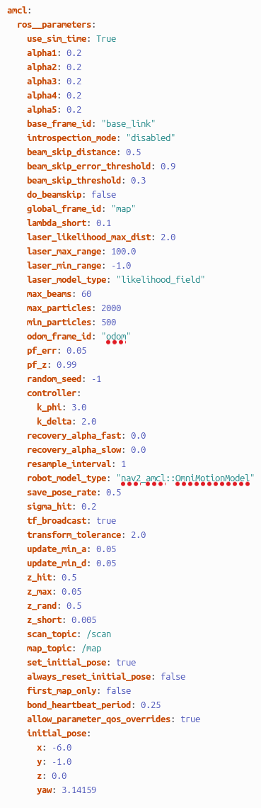
Carter_Navigation_Parameter Kaya_Navigation_Parameter
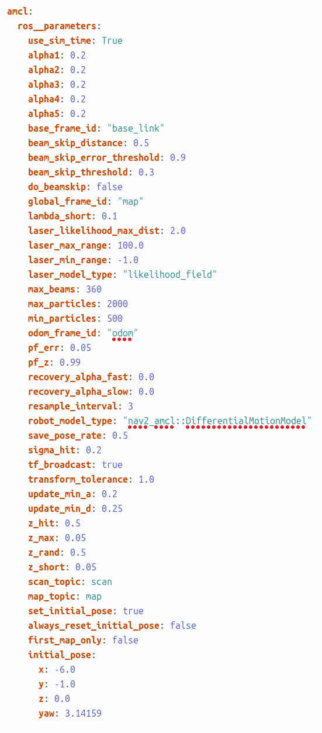

Comparison: AMCL Block

Carter_Navigation | Kaya_Navigation | Explanation
robot_model_type: "nav2_amcl::DifferentialMotionModel" | robot_model_type: "nav2_amcl::OmniMotionModel" | Changed because Kaya is an omnidirectional robot, while Carter uses a differential-drive motion model.
max_beams: 360 | max_beams: 60 | Reduced the number of laser beams used by AMCL to make localization lighter and reduce computation.
transform_tolerance: 1.0 | transform_tolerance: 2.0 | Increased tolerance to make TF transformation handling more stable in simulation.
update_min_a: 0.2 | update_min_a: 0.05 | AMCL updates after smaller rotation changes, which makes localization more responsive.
update_min_d: 0.25 | update_min_d: 0.05 | Reduced the influence of unexpected short laser readings.
z_short: 0.05 | z_short: 0.005 | Changed to match the scan topic used in the Kaya ROS 2 setup.
map_topic: map | map_topic: /map | Changed to match the map topic used in the Kaya ROS 2 setup.
Not present | controller:  k_phi: 3.0  k_delta: 2.0 | Added controller-related parameters for Kaya-specific navigation behavior.
Not present | bond_heartbeat_period: 0.25 | Added for lifecycle node heartbeat monitoring.
Not present | allow_parameter_qos_overrides: true | Added to allow QoS parameter overrides for ROS 2 communication compatibility.

6.2. Behavior Tree Navigator
Carter_Navigation_Parameter Kaya_Navigation_Parameter
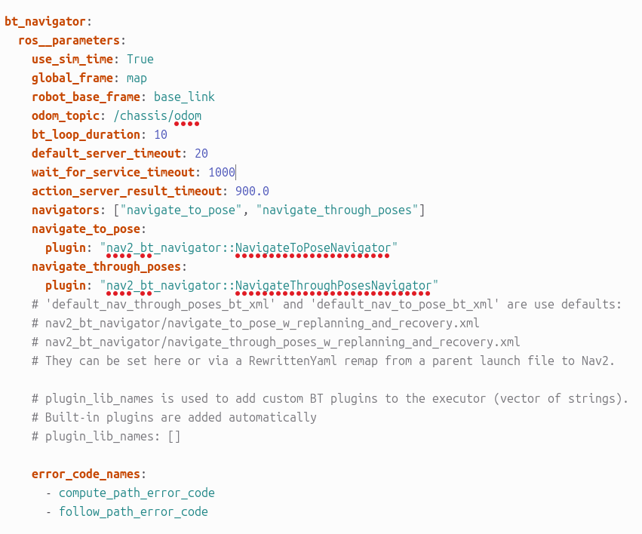
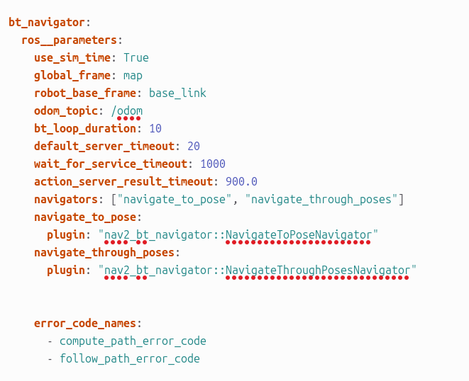

Comparison: Behavior Tree Navigator Block

odom_topic: /chassis/odom | odom_topic: /odom | Changed to match the odometry topic used by the Kaya robot setup. Carter uses /chassis/odom, while Kaya publishes odometry on /odom.
global_frame: map | global_frame: map | No change. Both robots use the map frame as the global reference frame for navigation.
robot_base_frame: base_link | robot_base_frame: base_link | No change. Both configurations use base_link as the main robot base frame.
bt_loop_duration: 10 | bt_loop_duration: 10 | No change. The Behavior Tree loop rate remains the same for both robots.
default_server_timeout: 20 | default_server_timeout: 20 | No change. The timeout for waiting on navigation servers remains the same.
wait_for_service_timeout: 1000 | wait_for_service_timeout: 1000 | No change. The waiting time for required services remains unchanged.
action_server_result_timeout: 900.0 | action_server_result_timeout: 900.0 | No change. The result timeout for the action server remains the same.
navigators: ["navigate_to_pose", "navigate_through_poses"] | navigators: ["navigate_to_pose", "navigate_through_poses"] | No change. Both configurations support navigation to a single pose and navigation through multiple poses.
navigate_to_pose:plugin: "nav2_bt_navigator::NavigateToPoseNavigator" | navigate_to_pose:plugin: "nav2_bt_navigator::NavigateToPoseNavigator" | No change. Both robots use the same plugin for navigating to one goal pose.
navigate_through_poses:plugin: "nav2_bt_navigator::NavigateThroughPosesNavigator" | navigate_through_poses:plugin: "nav2_bt_navigator::NavigateThroughPosesNavigator" | No change. Both robots use the same plugin for navigating through multiple goal poses.
error_code_names:- compute_path_error_code- follow_path_error_code | error_code_names:- compute_path_error_code- follow_path_error_code | No change. Both configurations use the same error code names for planning and path-following errors.
Commented default BT XML information is present in the Carter file. | Commented default BT XML information is removed in the Kaya file. | This does not change the behavior because comments are ignored by ROS 2. It only makes the Kaya file cleaner and shorter.

6.3. Local Cost Map Parameters
Carter_Navigation_Parameter Kaya_Navigation_Parameter
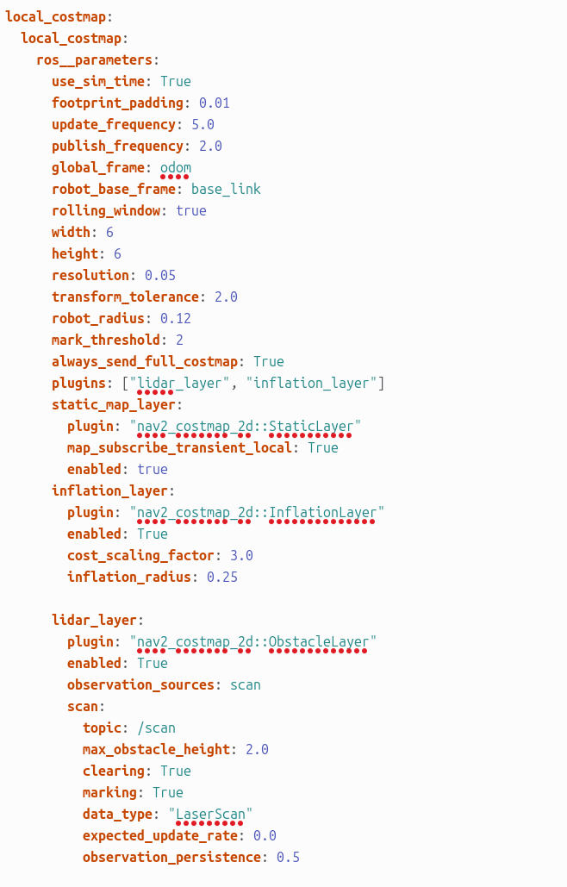
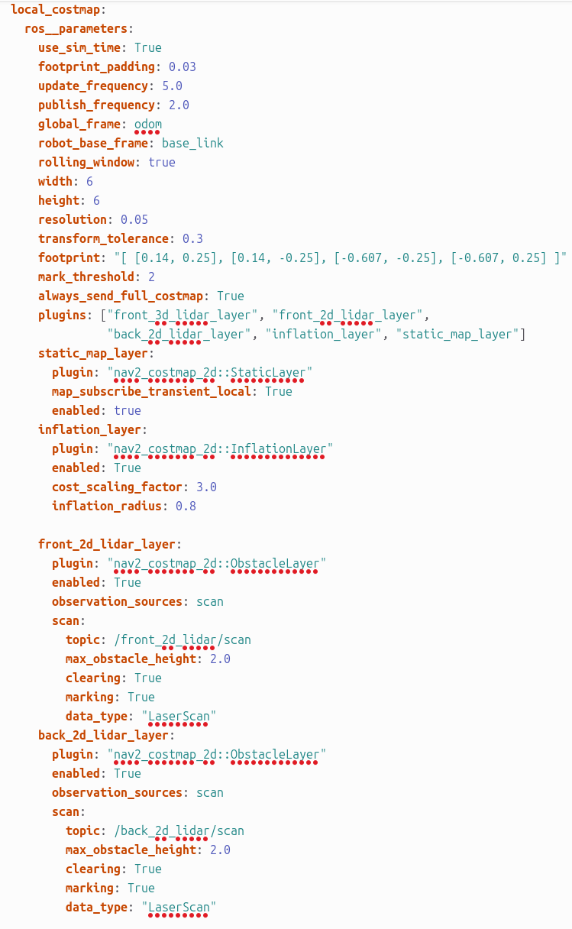

Comparison: Local Cost map Block
Carter_Navigation | Kaya_Navigation | Explanation
footprint_padding: 0.03 | footprint_padding: 0.01 | Reduced because Kaya uses a smaller safety padding around the robot footprint.
transform_tolerance: 0.3 | transform_tolerance: 2.0 | Increased to make TF transformation. handling more stable in simulation
footprint: "[[0.14, 0.25], [0.14, -0.25], [-0.607, -0.25], [-0.607, 0.25]]" | robot_radius: 0.12 | Carter uses a detailed rectangular footprint, while Kaya uses a simpler circular robot radius. This is easier and suitable for Kaya’s compact robot model.
plugins: ["front_3d_lidar_layer", "front_2d_lidar_layer", "back_2d_lidar_layer", "inflation_layer", "static_map_layer"] | plugins: ["lidar_layer", "inflation_layer"] | Kaya uses a simpler costmap setup with one lidar layer and one inflation layer instead of multiple front/back lidar layers.
inflation_radius: 0.8 | inflation_radius: 0.25 | Reduced because Kaya needs a smaller obstacle inflation area around obstacles.
front_2d_lidar_layer: | lidar_layer: | Kaya combines the lidar obstacle handling into one general lidar layer instead of using separate front and back lidar layers.
topic: /front_2d_lidar/scan | topic: /scan | Changed to match the laser scan topic used by Kaya.
back_2d_lidar_layer: | Not present | Removed because Kaya does not use a separate back 2D lidar layer in this setup.
topic: /back_2d_lidar/scan | Not present | Removed because Kaya only uses the /scan topic for lidar data.
front_3d_lidar_layer: | Not present | Removed because Kaya does not use a separate front 3D lidar layer in this configuration.
static_map_layer included in plugin list | static_map_layer not included in plugin list | Removed from the active plugin list because Kaya’s local costmap mainly depends on live lidar data and inflation.
expected_update_rate not present | expected_update_rate: 0.0 | Added to define the expected sensor update behavior for the Kaya lidar layer.
observation_persistence not present | observation_persistence: 0.5 | Added so lidar observations can stay active briefly in the costmap, helping obstacle handling remain stable.

6.4. Global Cost Map Parameters

6.5. Velocity Smoother and Collision Monitor

13. Other Important Nav2 Parameters
The map server loads the map using yaml_filename: KayaMap.yaml.
The behavior server uses the plugins spin, backup, drive_on_heading, and wait for recovery behavior.
The smoother server uses nav2_smoother::SavitzkyGolaySmoother with window_size: 7 and poly_order: 3 to smooth the planned path.
The waypoint follower runs with loop_rate: 20 and uses wait_at_waypoint to pause at waypoints.

— END OF DOCUMENT —

