


Name: Keti Hazbiu
Email: hazbke01@thu.de
Title: Kaya Robot Setup in Isaac Sim 5.1.0

Overview
This document describes the complete setup procedure for deploying the Kaya omnidirectional robot inside NVIDIA Isaac Sim 5.1.0. I also includes configuring a 2D LiDAR and IMU sensor, enabling the ROS2 bridge and wiring all required action graphs for clock, odometry, sensor publishing and holonomic drive control.

1. Prerequisites
Check the following before creating the robot setup.
Requirement | Why it is needed | Check
Ubuntu 24.04.1 | - | -
Isaac Sim 5.1.0 | Provides the simulator, robot assets, sensors, and Action Graph system. | Isaac Sim opens without errors.
ROS 2 installation | Receives topics from Isaac Sim and allows RViz/Nav2 testing. | Run ros2 topic list in a sourced ROS 2 terminal.
ROS 2 Bridge extension | Transfers simulated data from Isaac Sim to ROS 2. | Enable it in Window -> Extensions.

2. ROS2 Bridge Extension
The ROS2 bridge extension connects Isaac Sim topics to a running ROS2 middleware instance. Enable it before constructing any Action Graphs. In order to enable the extension follow the below listed steps:

- Open Window > Extensions.
- Search for: ROS2 Bridge.
- Toggle the extension to Enabled.
- Confirm that the ROS2 bridge status indicator is green in the toolbar.
- It is advised to restart Isaac Sim after enabling the extension.

3. Environment Setup
The Simple Room asset provides a bounded indoor environment. This gives the robot walls and obstacles that can be detected by the LiDAR.

Procedure:
- Launch Isaac Sim 5.1.0.
- Create a new empty stage: File > New Stage.
- In the top menu, navigate to: Create > Environments > Simple Room.
- Confirm that the Simple Room asset is appended to the active stage.

4. Kaya Robot USD Assets
Kaya is a compact, three-wheeled holonomic mobile robot designed for indoor navigation research. Its USD asset is shipped as part of the Isaac Sim robot asset library. Next, load the Kaya robot into the room. The robot must appear in the Stage tree because all sensor and Action Graph paths will refer to this prim.
Loading Procedure:
- Open the Asset Browser panel: Window > Robots > Asset Browser.
- Navigate to: Robots > Kaya.
- Select the kaya.usd asset file.
- Click Load as Reference.
- Verify in the Stage panel that the robot is registered at the path /World/kaya.

Checkpoint: Click /World/kaya in the Stage panel. You should see the robot selected in the viewport. If the robot path is not /World/kaya, note the exact path and use that same path in all later Action Graph settings.

5. How to add and configure the 2D LiDAR?
The used Lidar is a Slamtec RPLIDAR S2E. It is instantiated as an RTX LiDAR sensor and mounted on the robot base link. It provides distance measurements around the robot.

- Navigate to: Create > Sensors > RTX Lidar > Slamtec > RPLIDAR S2E.
- In the Stage panel, parent the sensor under /World/kaya/base_link.
- Rename the prim to lidar_layer.
- Set the local transform of lidar_layer as follows:
Translate X : 0.0
Translate Y : 0.0
Translate Z : 0.2
- Verify that the final LiDAR prim path is similar to /World/Kaya/base_link/lidar_layer/RPLidar_S2E.
Importante: The LiDAR must be attached under base_link. If it is accidentally placed directly under /World, it may stay fixed in the environment instead of moving with the robot.

6. How to add and configure the IMU Sensor?
The IMU sensor is needed in Isaac Sim to publish realistic inertial data such as acceleration and angular velocity, which helps ROS 2 estimate how the robot is moving. It is useful for navigation, localization and sensor fusion because odometry alone can drift or become less reliable.

- Create an Xform prim under /World/Kaya/base_link and rename it to imu_layer.
- Navigate to: Create > Sensors > IMU Sensor.
- Parent the new Imu_Sensor under imu_sensor.
- Set the local transform of imu_sensor as follows:
Translate X : 0.0
Translate Y : 0.0
Translate Z : 0.25

7.Action Graphs
Isaac Sim Action Graphs implement the ROS2 publishing pipeline through visual node programming. They define how Isaac Sim reads simulation data and publishes it to ROS 2. Each graph should be connected to a playback tick so that it runs continuously while the simulation is playing. In our case four graphs are required.

7.1 Main Action Graph
The main graph manages holonomic drive control and clock publication.

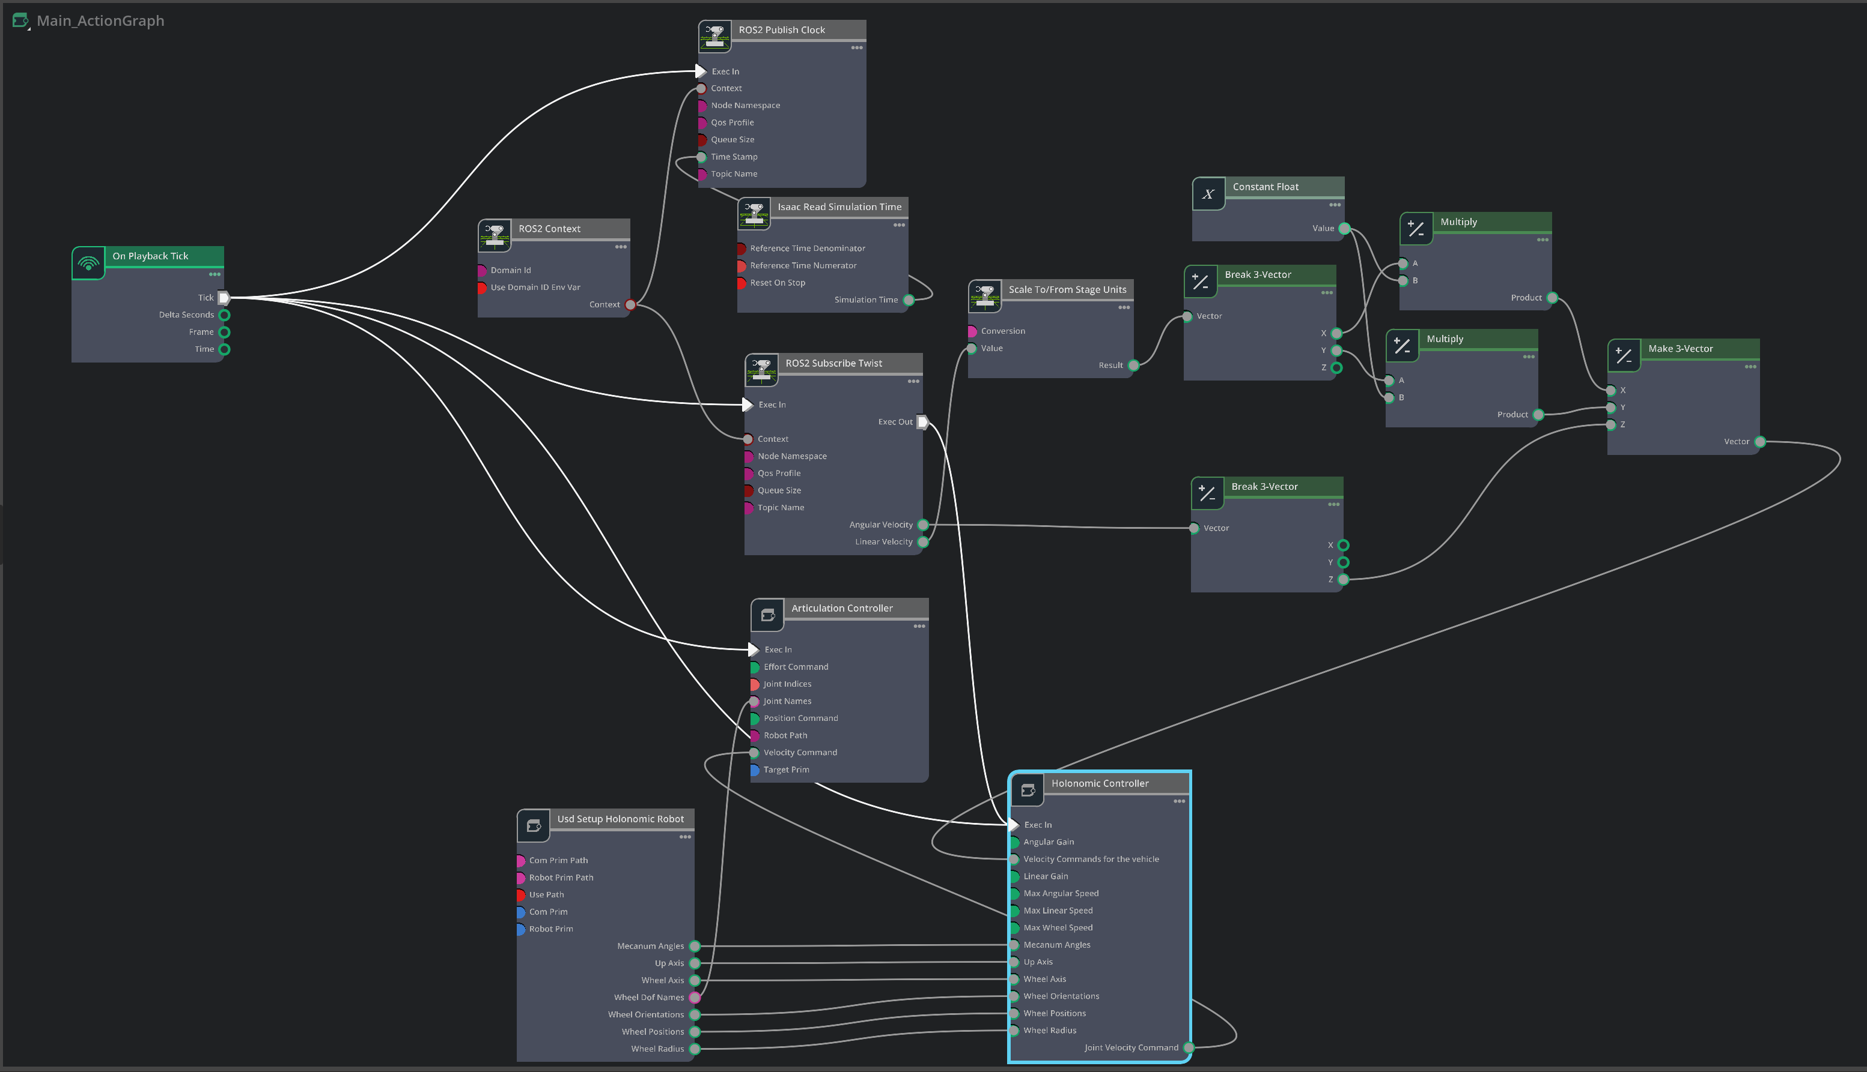

Node Configuration:

Node | Parameter | Value | Explanation
ROS2 Subscription Twist | topicName | /cmd_vel | Receives movement commands from /cmd_vel.
ROS2 Publish Clock | topicName | /clock | Publishes simulation time to ROS 2.
Articulation Controller | targetPrim | /World/kaya | Applies motion commands to the Kaya robot.
Usd Setup Holonomic Robot | comPrim | /World/kaya | Sets the robot center reference.
Usd Setup Holonomic Robot | robotPrim | /World/kaya/base_link | Sets the robot base frame.
Usd Setup Holonomic Robot | robotPrimPath | /World/kaya/ | Sets the complete robot path in the scene.
Constant Float | value | -1 | Inverts the control direction so the robot moves in the expected direction.

Verification:
To check whether data is being received on the topic, start the simulation and run the command below:
run ros2 topic echo /clock --once
run ros2 topic echo /cmd_vel --once
If the setup is correct, one clock and one cmd_vel message should be displayed in the terminal.

7.2 Lidar Action Graph
This graph takes the simulated LiDAR data from Isaac Sim and publishes it to ROS 2 on /scan. ROS 2 tools like RViz and Nav2 can then use this scan data.
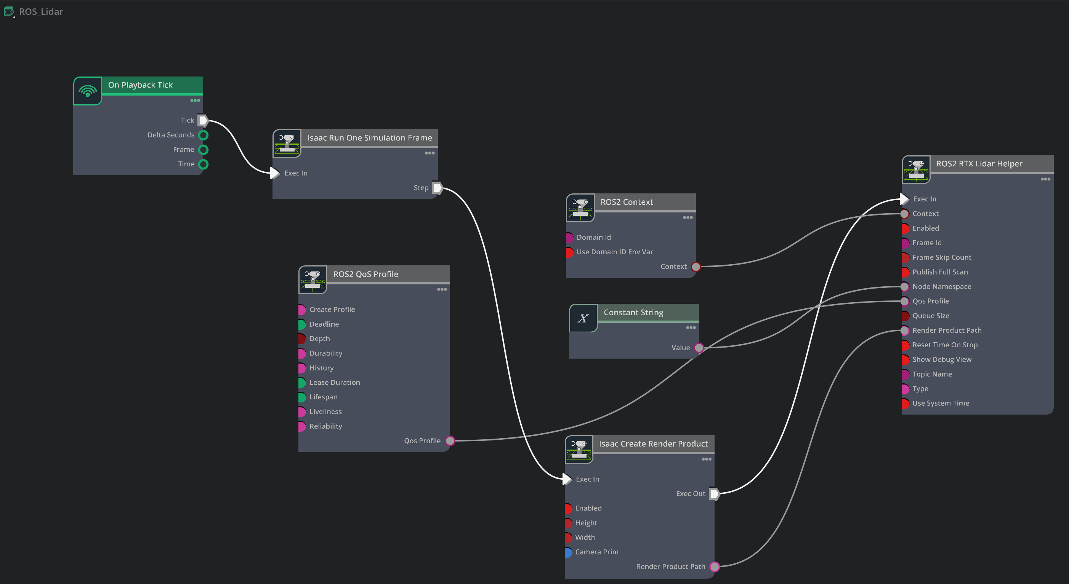

Node Configuration:

Node | Parameter | Value | Explanation
Isaac Create Render Product | cameraPrim | /World/kaya/base_link/lidar_layer/RPLidar_S2E | Creates the LiDAR render output for ROS 2.
ROS2 RTX Lidar Helper | frameId | RPLidar_S2E | Sets the LiDAR frame name in ROS 2.
ROS2 RTX Lidar Helper | topicName | /scan | Publishes LiDAR data on /scan.
ROS2 RTX Lidar Helper | type | laser_scan | Sends the data as a 2D laser scan message.

Verfication:
To check whether data is being received on the topic, start the simulation and run the command below:
run ros2 topic echo /scan --once
If the setup is correct, one clock and one cmd_vel message should be displayed in the terminal.

7.3 IMU Action Graph
The IMU graph reads the simulated IMU sensor and publishes it as a ROS 2 IMU message. This is different from the LiDAR graph because the IMU topic should contain inertial data, not laser scan data.

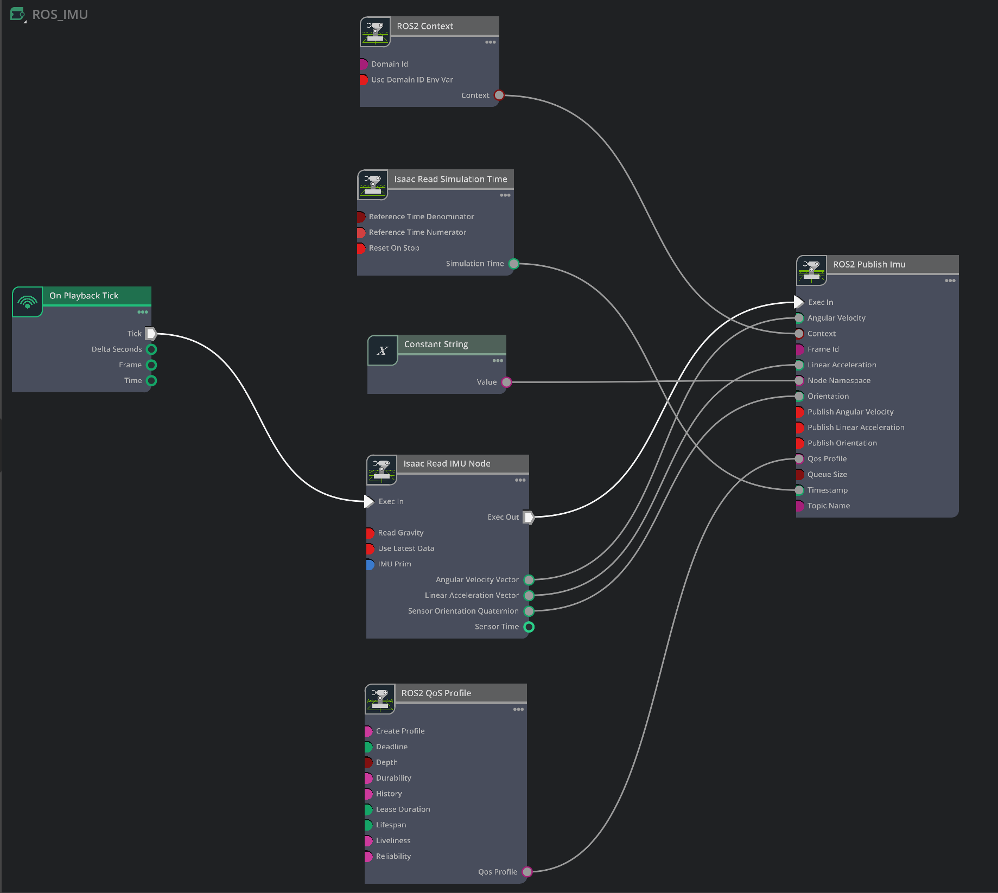

Node Configuration:

Node | Parameter | Value | Explanation
Isaac Read IMU Node | IMU Prim | /World/kaya/base_link/imu_sensor/Imu_Sensor | Reads data from the IMU sensor.
ROS2 Publish Imu | frameId | imu_layer | Sets the IMU frame name in ROS 2.
ROS2 Publish Imu | topicName | /imu | Publishes IMU data on /imu.

Verfication:
To check whether data is being received on the topic, start the simulation and run the command below:
run ros2 topic echo /imu --once
If the setup is correct, one clock and one cmd_vel message should be displayed in the terminal.
7.3 Odometry Action Graph
This graph publishes the robot odometry and TF frames. It connects odom, base_link, LiDAR, IMU, and wheel frames so ROS 2 tools can understand where each part of the robot is located.
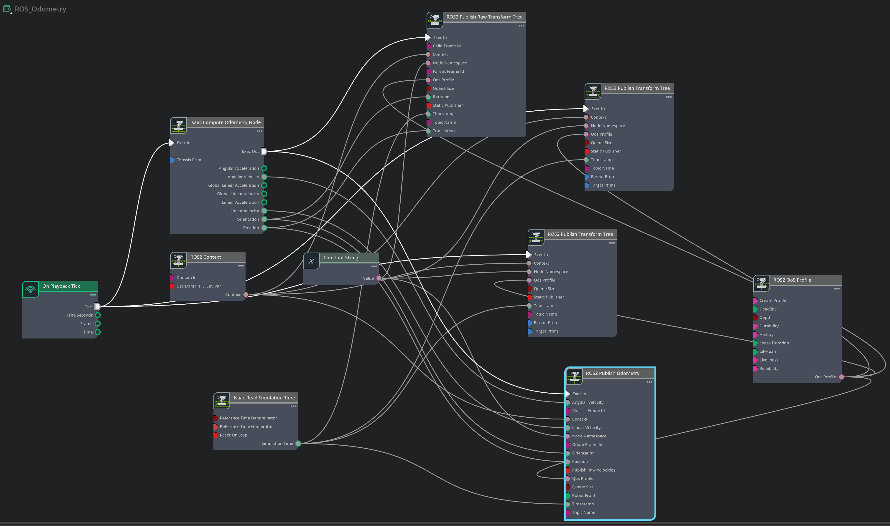

Node Configuration:

Node | Parameter | Value | Explanation
Isaac Compute Odometry Node | chassisPrim | /World/kaya/base_link | Computes robot movement from the base frame.
ROS2 Publish Odometry | chassisPrim | base_link | Sets base_link as the moving robot body.
ROS2 Publish Odometry | odomFrameId | odom | Sets odom as the odometry reference frame.
ROS2 Publish Odometry | topicName | /kaya/odom | Publishes odometry data on /kaya/odom.
ROS2 Publish Raw Transform Tree | childFrameId | base_link | Sets base_link as the child frame.
ROS2 Publish Raw Transform Tree | parentFrameId | odom | Sets odom as the parent frame.
ROS2 Publish Raw Transform Tree | topicName | /tf | Publishes the transform on /tf.
ROS2 Publish Transform Tree | parentPrim | /World/kaya/base_link | Uses base_link as the parent prim.
ROS2 Publish Transform Tree | targetPrims | /World/kaya/base_link/lidar_layer/RPLidar_S2E, /World/kaya/base_link/imu_layer/Imu_Sensor | Publishes TFs for LiDAR and IMU frames.
ROS2 Publish Transform Tree | topicName | /tf | Publishes sensor transforms on /tf.
ROS2 Publish Transform Tree 2 | parentPrim | /World/kaya/base_link | Uses base_link as the parent prim.
ROS2 Publish Transform Tree 2 | targetPrims | /World/kaya/axle_0, /World/kaya/axle_2, /World/kaya/axle_3 | Publishes TFs for the wheel frames.
ROS2 Publish Transform Tree 2 | topicName | /tf | Publishes wheel transforms on /tf.

TF idea: The odom -> base_link transform tells ROS 2 where the robot base is moving. The base_link -> sensor transforms tell ROS 2 where the LiDAR and IMU are mounted on the robot.

Verfication:
To check whether data is being received on the topic, start the simulation and run the command below:
run ros2 topic echo /odom --once
If the setup is correct, one clock and one cmd_vel message should be displayed in the terminal.

8. Wheel Positioning
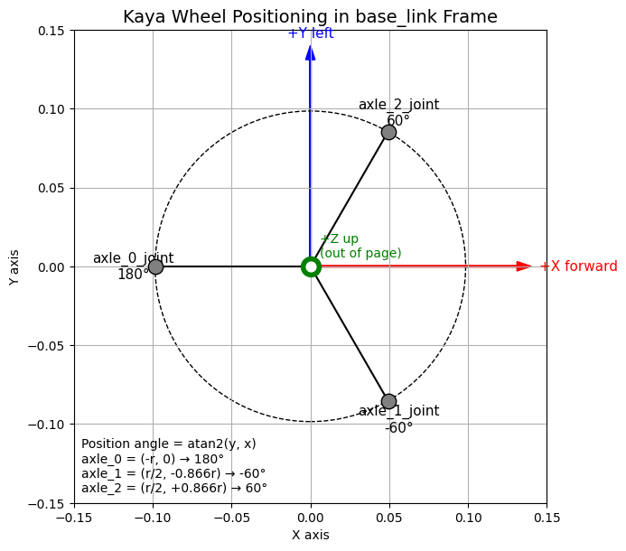
Configure the wheel positions according to the figure above. The Z rotation defines the angular position of each wheel joint around the robot base.
- Set the Local Rotation 0 → Z of World/kaya/base_link/axle_0_joint to 180.
- Set the Local Rotation 0→ Z of World/kaya/base_link/axle_1_joint to -60.
- Set the Local Rotation 0→ Z of World/kaya/base_link/axle_2_joint to 60.

9. Transformation Tree
After creating the Odometry Action Graph, you should be able to generate the TF tree. Make sure the simulation is running. Then open a terminal and run the command below:

ros2 run tf2_tools view_frames

After running the command, the generated TF tree will be saved in the same directory where the command was executed. The image below shows the generated TF tree for the Kaya robot.

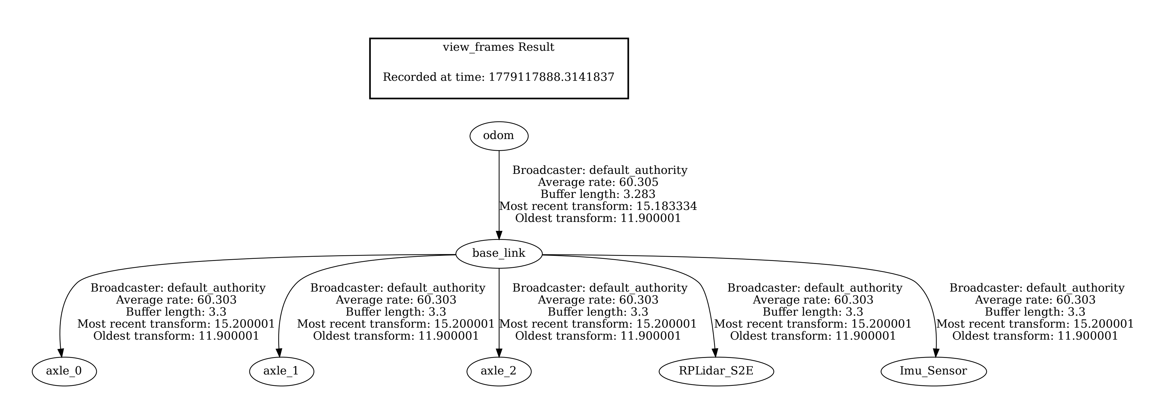

Note: The map → odom transform will be created later when Nav2 is added.

10. How to control the robot using teleop?
In order to be able to control the robot using keyboard you have to run in terminal the command listed below.

ros2 run teleop_twist_keyboard teleop_twist_keyboard

— END OF DOCUMENT —

