


Name: Keti Hazbiu
Email: hazbke01@thu.de
Title: ROS 2 Nav2 Configuration and RQt Graph Analysis for the Kaya Robot

1. Introduction
This document explains the main ROS 2 parameter files used for Kaya mobile robot navigation in Isaac Sim. The goal is to understand what each important navigation component does, why it is needed, and how the parameter values affect the robot’s behavior.
In addition to the parameter explanation, this document also includes RQt Graph visualizations. These graphs are used to show how the main ROS 2 nodes and topics are connected during navigation. This helps to understand the complete communication flow between localization, costmaps, planning, control, sensor input, and movement commands.

1. Overview
The navigation system can be understood as several connected blocks. Each block solves one part of the robot navigation problem.
- AMCL estimates where the robot is inside the known map.
- The EKF filter combines odometry and IMU data to estimate local robot motion.
- The global costmap represents the known map for long-range planning.
- The local costmap represents nearby obstacles around the robot.
- The planner creates a path from the current robot pose to the goal.
- The controller follows the path by creating velocity commands.
- The velocity smoother reduces sudden command changes.
- The collision monitor adds a final safety check before the robot moves.
In simple words, the robot first needs to know where it is, then where obstacles are, then where it should go, and finally how it should move safely.

3. Fundamentals
Before reading the parameter files, you should understand a few basic ROS 2 terms.
- A node is a running ROS 2 program, such as /amcl, /ekf_filter_node, or /controller_server.
- A topic is a communication channel between nodes.
- A publisher is a node that sends data to a topic.
- A subscriber is a node that receives data from a topic.
- Parameter is a setting that changes how a node behaves without changing source code.
- Frame is a coordinate system such as map, odom, or base_link.
- Transform is the position and orientation relationship between two frames.
- AMCL is the localization method that estimates the robot pose inside a map.
- EKF is the Extended Kalman Filter that fuses odometry and IMU data.
- Costmap is a grid representation of free space, obstacles, and dangerous areas.
- Planner is the component that creates a path to the goal.
- Controller is the component that follows the path by sending velocity commands.
- Rqt Graph is a visual tool that shows how ROS 2 nodes and topics are connected.

4. Parameter Files Used
Two parameter files are used in this setup.
- kaya_nav2_params.yaml: configures Nav2 navigation, localization, planning, control, costmaps, behavior servers, velocity smoothing, and collision monitoring.
- ekf.yaml: configures sensor fusion between robot odometry and IMU data using an Extended Kalman Filter

6. Main Parameter File Comparison (kaya_nav2_params.yaml)
As mentioned below, in this project, the kaya_nav2_params.yaml file was used to define the main navigation behavior of the Kaya robot.
This file was built based on an existing robot navigation parameter file from the Carter robot project. In the following section, a detailed comparison between both files is provided. Each changed or newly introduced parameter is explained together with the reason why it was modified or added.

6.1. AMCL
Carter_Navigation_Parameter Kaya_Navigation_Parameter
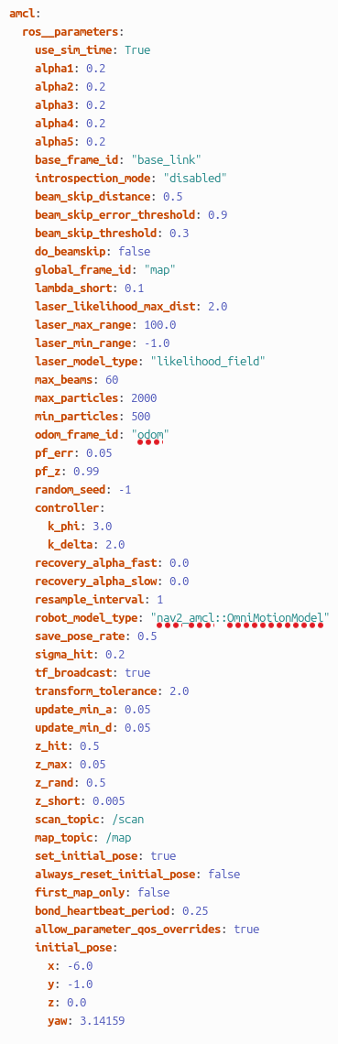
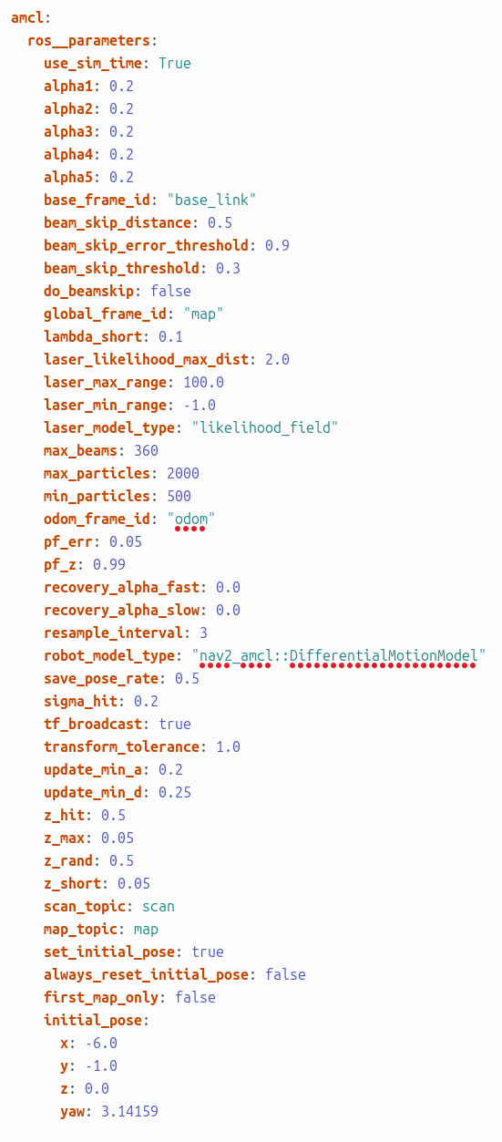

Comparison: AMCL Block

Carter_Navigation | Kaya_Navigation | Explanation
robot_model_type: "nav2_amcl::DifferentialMotionModel" | robot_model_type: "nav2_amcl::OmniMotionModel" | Changed because Kaya is an omnidirectional robot, while Carter uses a differential-drive motion model.
max_beams: 360 | max_beams: 60 | Reduced the number of laser beams used by AMCL to make localization lighter and reduce computation.
transform_tolerance: 1.0 | transform_tolerance: 2.0 | Increased tolerance to make TF transformation handling more stable in simulation.
update_min_a: 0.2 | update_min_a: 0.05 | AMCL updates after smaller rotation changes, which makes localization more responsive.
update_min_d: 0.25 | update_min_d: 0.05 | Reduced the influence of unexpected short laser readings.
z_short: 0.05 | z_short: 0.005 | Changed to match the scan topic used in the Kaya ROS 2 setup.
map_topic: map | map_topic: /map | Changed to match the map topic used in the Kaya ROS 2 setup.
Not present | controller:  k_phi: 3.0  k_delta: 2.0 | Added controller-related parameters for Kaya-specific navigation behavior.
Not present | bond_heartbeat_period: 0.25 | Added for lifecycle node heartbeat monitoring.
Not present | allow_parameter_qos_overrides: true | Added to allow QoS parameter overrides for ROS 2 communication compatibility.

6.2. Behavior Tree Navigator
Carter_Navigation_Parameter Kaya_Navigation_Parameter
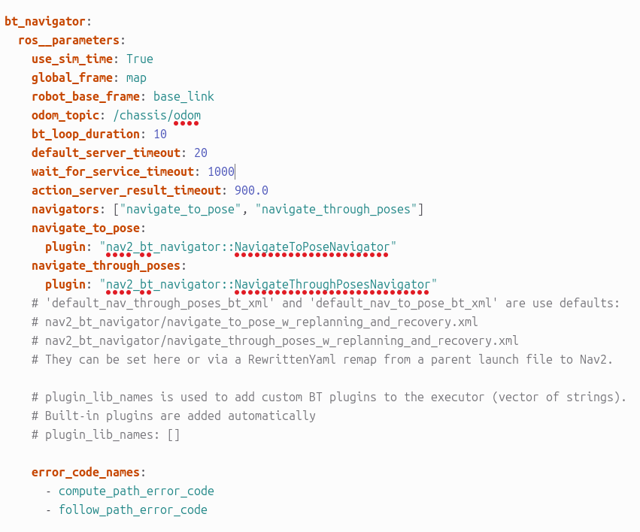
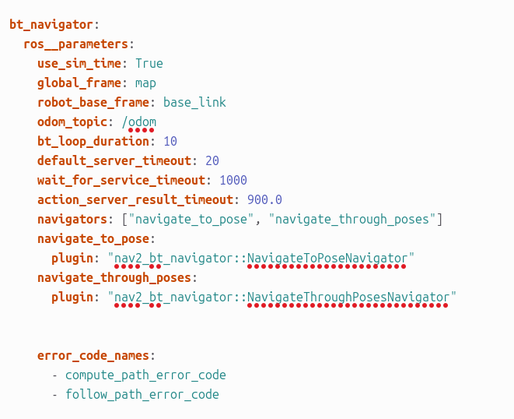

Comparison: Behavior Tree Navigator Block

odom_topic: /chassis/odom | odom_topic: /odom | Changed to match the odometry topic used by the Kaya robot setup. Carter uses /chassis/odom, while Kaya publishes odometry on /odom.
global_frame: map | global_frame: map | No change. Both robots use the map frame as the global reference frame for navigation.
robot_base_frame: base_link | robot_base_frame: base_link | No change. Both configurations use base_link as the main robot base frame.
bt_loop_duration: 10 | bt_loop_duration: 10 | No change. The Behavior Tree loop rate remains the same for both robots.
default_server_timeout: 20 | default_server_timeout: 20 | No change. The timeout for waiting on navigation servers remains the same.
wait_for_service_timeout: 1000 | wait_for_service_timeout: 1000 | No change. The waiting time for required services remains unchanged.
action_server_result_timeout: 900.0 | action_server_result_timeout: 900.0 | No change. The result timeout for the action server remains the same.
navigators: ["navigate_to_pose", "navigate_through_poses"] | navigators: ["navigate_to_pose", "navigate_through_poses"] | No change. Both configurations support navigation to a single pose and navigation through multiple poses.
navigate_to_pose:plugin: "nav2_bt_navigator::NavigateToPoseNavigator" | navigate_to_pose:plugin: "nav2_bt_navigator::NavigateToPoseNavigator" | No change. Both robots use the same plugin for navigating to one goal pose.
navigate_through_poses:plugin: "nav2_bt_navigator::NavigateThroughPosesNavigator" | navigate_through_poses:plugin: "nav2_bt_navigator::NavigateThroughPosesNavigator" | No change. Both robots use the same plugin for navigating through multiple goal poses.
error_code_names:- compute_path_error_code- follow_path_error_code | error_code_names:- compute_path_error_code- follow_path_error_code | No change. Both configurations use the same error code names for planning and path-following errors.
Commented default BT XML information is present in the Carter file. | Commented default BT XML information is removed in the Kaya file. | This does not change the behavior because comments are ignored by ROS 2. It only makes the Kaya file cleaner and shorter.

6.3. Local Cost Map Parameters
Carter_Navigation_Parameter Kaya_Navigation_Parameter
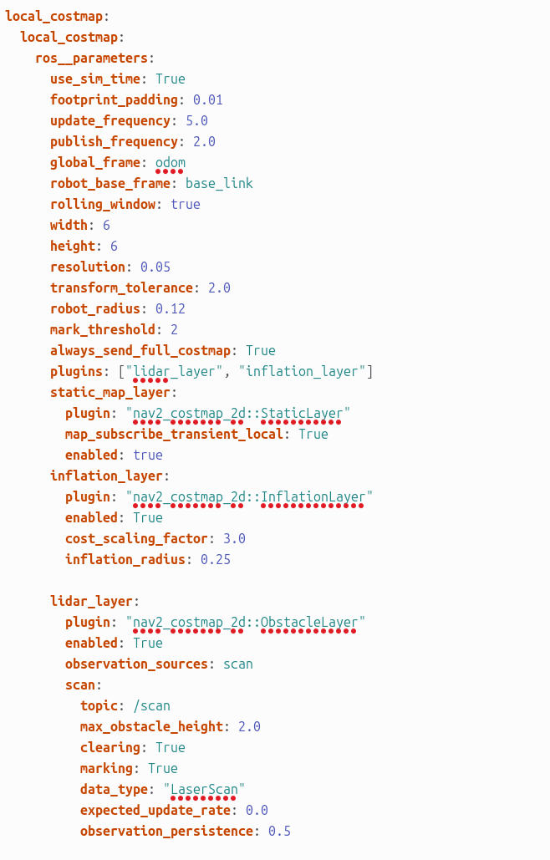
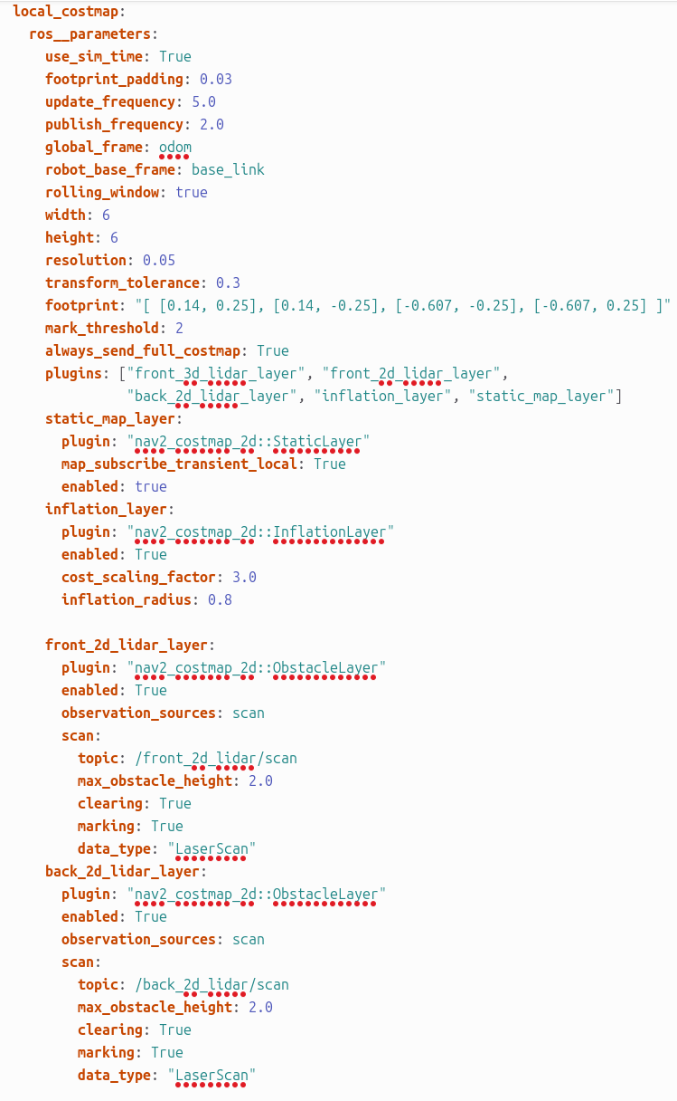

Comparison: Local Cost map Block

Carter_Navigation | Kaya_Navigation | Explanation
footprint_padding: 0.03 | footprint_padding: 0.01 | Reduced because Kaya uses a smaller safety padding around the robot footprint.
transform_tolerance: 0.3 | transform_tolerance: 2.0 | Increased to make TF transformation. handling more stable in simulation
footprint: "[[0.14, 0.25], [0.14, -0.25], [-0.607, -0.25], [-0.607, 0.25]]" | robot_radius: 0.12 | Carter uses a detailed rectangular footprint, while Kaya uses a simpler circular robot radius. This is easier and suitable for Kaya’s compact robot model.
plugins: ["front_3d_lidar_layer", "front_2d_lidar_layer", "back_2d_lidar_layer", "inflation_layer", "static_map_layer"] | plugins: ["lidar_layer", "inflation_layer"] | Kaya uses a simpler costmap setup with one lidar layer and one inflation layer instead of multiple front/back lidar layers.
inflation_radius: 0.8 | inflation_radius: 0.25 | Reduced because Kaya needs a smaller obstacle inflation area around obstacles.
front_2d_lidar_layer: | lidar_layer: | Kaya combines the lidar obstacle handling into one general lidar layer instead of using separate front and back lidar layers.
topic: /front_2d_lidar/scan | topic: /scan | Changed to match the laser scan topic used by Kaya.
back_2d_lidar_layer: | Not present | Removed because Kaya does not use a separate back 2D lidar layer in this setup.
topic: /back_2d_lidar/scan | Not present | Removed because Kaya only uses the /scan topic for lidar data.
front_3d_lidar_layer: | Not present | Removed because Kaya does not use a separate front 3D lidar layer in this configuration.
static_map_layer included in plugin list | static_map_layer not included in plugin list | Removed from the active plugin list because Kaya’s local costmap mainly depends on live lidar data and inflation.
expected_update_rate not present | expected_update_rate: 0.0 | Added to define the expected sensor update behavior for the Kaya lidar layer.
observation_persistence not present | observation_persistence: 0.5 | Added so lidar observations can stay active briefly in the costmap, helping obstacle handling remain stable.

6.4. Global Cost Map Parameters

Carter_Navigation_Parameter Kaya_Navigation_Parameter

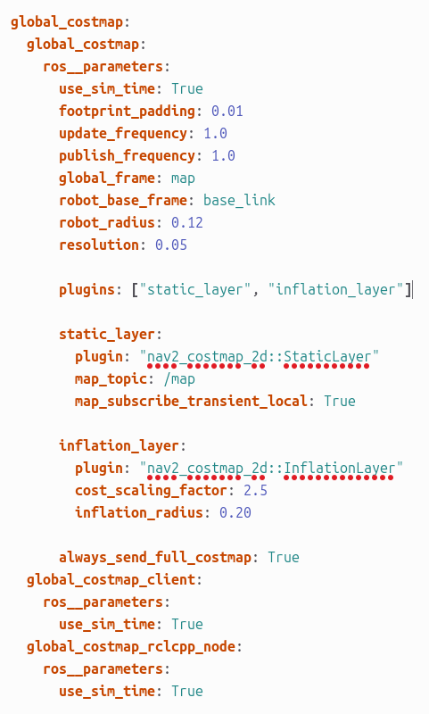
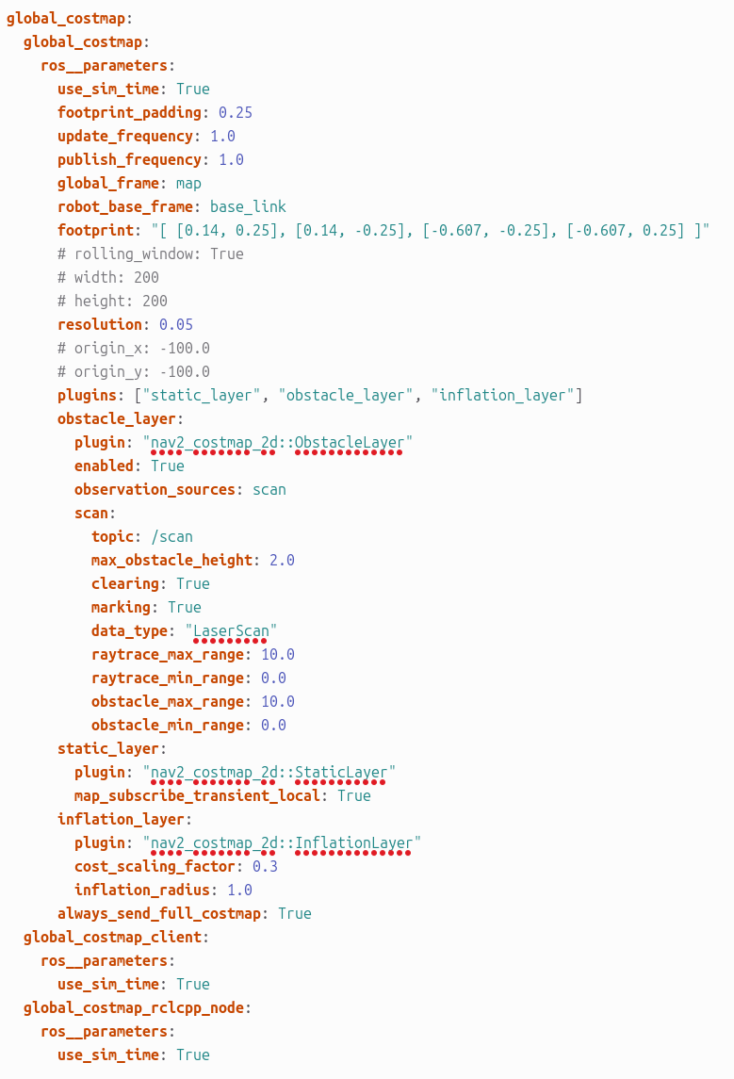

Comparison: Local Cost map Block

Carter_Navigation | Kaya_Navigation | Explanation
footprint_padding: 0.25 | footprint_padding: 0.01 | Reduced because Kaya uses a smaller safety padding around the robot model.
footprint: "[[0.14, 0.25], [0.14, -0.25], [-0.607, -0.25], [-0.607, 0.25]]" | robot_radius: 0.12 | Carter uses a detailed rectangular footprint, while Kaya uses a simpler circular radius model. This fits the smaller Kaya robot setup.
plugins: ["static_layer", "obstacle_layer", "inflation_layer"] | plugins: ["static_layer", "inflation_layer"] | The obstacle layer was removed in Kaya’s global costmap. Kaya mainly uses the static map and inflation layer for global planning.
obstacle_layer: | Not present | Removed because Kaya does not use a separate obstacle layer in the global costmap configuration.
topic: /scan inside obstacle_layer | Not present | Removed because the global costmap in Kaya does not directly use laser scan obstacle data.
raytrace_max_range: 10.0 | Not present | Removed together with the obstacle layer because raytracing is only needed when using scan-based obstacle clearing.
raytrace_min_range: 0.0 | Not present | Removed because Kaya’s global costmap does not use obstacle raytracing.
obstacle_max_range: 10.0 | Not present | Removed because scan-based obstacle detection is not configured in Kaya’s global costmap.
obstacle_min_range: 0.0 | Not present | Removed because the obstacle layer is not used in Kaya’s global costmap.
cost_scaling_factor: 0.3 | cost_scaling_factor: 2.5 | Increased so the obstacle cost decreases more sharply around inflated obstacles.
inflation_radius: 1.0 | inflation_radius: 0.20 | Reduced because Kaya needs a smaller safety inflation area around obstacles compared to Carter.
always_send_full_costmap: True | always_send_full_costmap: True | No change. Both configurations send the full costmap data.
global_costmap_client:ros__parameters:use_sim_time: True | global_costmap_client:ros__parameters:use_sim_time: True | No change. Both use simulation time for the global costmap client.
global_costmap_rclcpp_node:ros__parameters:use_sim_time: True | global_costmap_rclcpp_node:ros__parameters:use_sim_time: True | No change. Both use simulation time for the global costmap ROS 2 node.

7. ekf.yaml
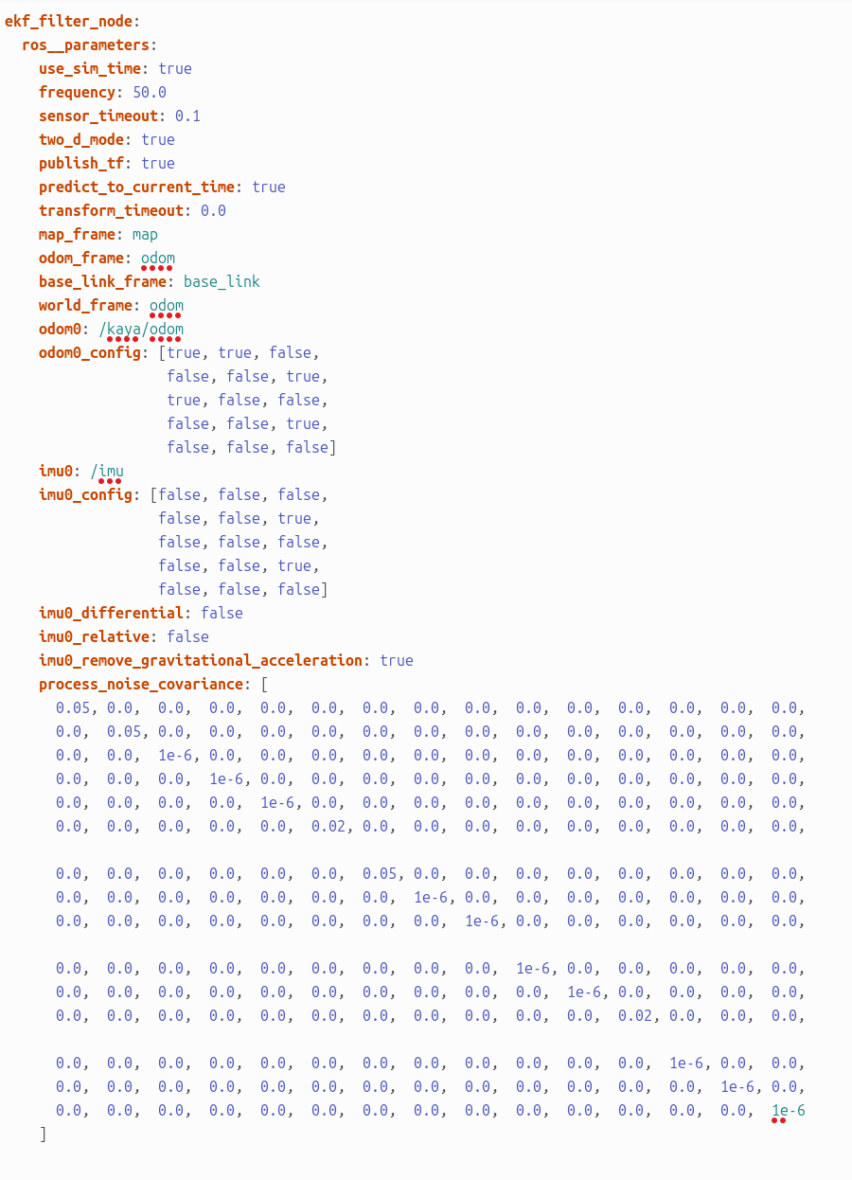

The ekf.yaml file configures the Extended Kalman Filter node for the robot. Its main purpose is to combine sensor data, mainly odometry and IMU data, into a smoother and more reliable estimate of the robot’s position, orientation, and movement. Instead of trusting only one sensor, the EKF filter fuses multiple inputs and publishes a filtered transform between frames such as odom and base_link. This helps the navigation system get a more stable robot pose, which is important for localization, path planning, and smooth movement in simulation.

Code / Parameter | Explanation
ekf_filter_node: | Defines the EKF filter node. This is the main node responsible for sensor fusion.
ros__parameters: | Contains all ROS 2 parameters used by the EKF node.
use_sim_time: true | Makes the EKF use simulation time instead of real system time. This is needed when running the robot in a simulator.
frequency: 50.0 | The EKF publishes the filtered state 50 times per second. A higher frequency gives smoother and more frequent pose updates.
sensor_timeout: 0.1 | If sensor data is not received within 0.1 seconds, the filter treats the sensor as temporarily unavailable.
two_d_mode: true | Forces the filter to work in 2D mode. This is suitable for ground robots because the robot mainly moves on a flat surface.
publish_tf: true | Allows the EKF node to publish the transform between frames, for example from odom to base_link.
predict_to_current_time: true | The filter predicts the robot state up to the current time. This helps reduce delay in the estimated pose.
transform_timeout: 0.0 | The node does not wait extra time for transforms. It uses the available transform data immediately.
map_frame: map | Defines the global map frame. This is usually used as the fixed world reference frame.
odom_frame: odom | Defines the odometry frame. This frame represents the robot’s local movement estimate.
base_link_frame: base_link | Defines the main body frame of the robot. It represents the robot base.
world_frame: odom | Sets odom as the world frame for this EKF. This means the EKF mainly publishes local odometry-based movement, not global map correction.
odom0: /kaya/odom | Defines the odometry input topic used by the EKF. In this setup, odometry data comes from /kaya/odom.
odom0_config: [true, true, false, false, false, true, true, false, false, false, false, true, false, false, false] | Selects which parts of the odometry message are used. Here, the filter uses x position, y position, yaw orientation, x velocity, and yaw velocity.
imu0: /imu | Defines the IMU input topic used by the EKF. The IMU provides orientation and angular movement information.
imu0_config: [false, false, false, false, false, true, false, false, false, false, false, true, false, false, false] | Selects which parts of the IMU message are used. Here, the filter mainly uses yaw orientation and yaw angular velocity.
imu0_differential: false | The IMU data is used as absolute measurement data, not as a difference between measurements.
imu0_relative: false | The IMU measurement is not treated as relative to the first received measurement.
imu0_remove_gravitational_acceleration: true | Removes gravity from the IMU acceleration data. This helps prevent gravity from being interpreted as robot movement.
process_noise_covariance: | Defines how much uncertainty the EKF assumes in the robot motion model. Lower values mean the filter trusts the prediction more, while higher values mean it expects more movement noise.

8. RQT Graph
In this project, RQt Graph was heavily used to understand how the ROS 2 navigation system is connected. It provides a visual representation of the active nodes, topics, publishers, and subscribers. This made it easier to verify whether the required navigation nodes were running correctly and whether the important topics were being published and subscribed to properly.

8.1 RQT Graph Visualization
In this section, RQt Graph is used to visualize how some of the most important ROS 2 nodes and topics are connected during navigation. The goal is not to explain every internal ROS 2 topic, but to focus on the main connections that are important for understanding the Kaya navigation system.
RQt Graph helps to show which nodes publish data, which nodes subscribe to data, and how information flows between localization, costmaps, planning, control, and movement commands.

AMCL

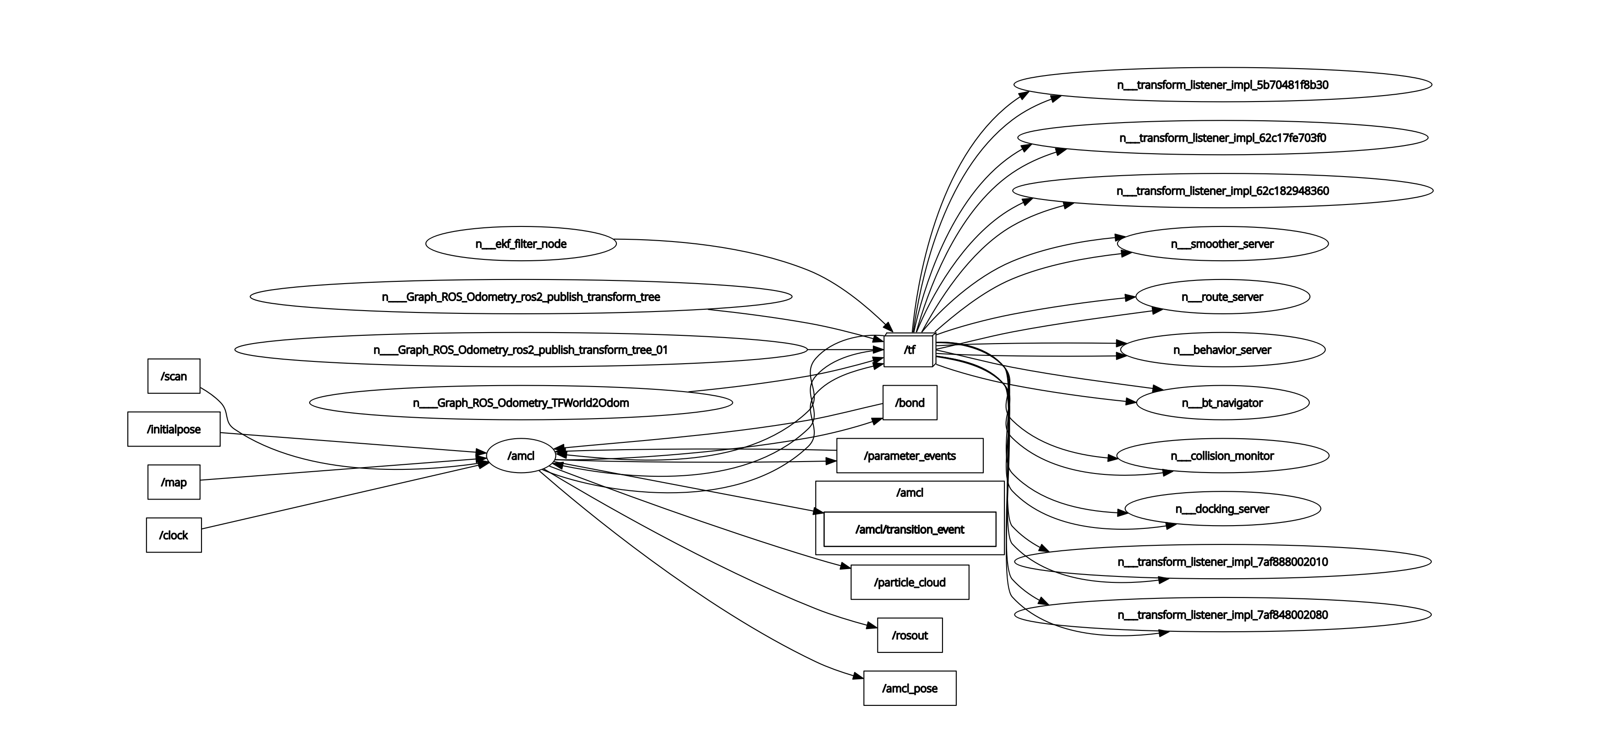
This RQt Graph focuses on the /amcl node, which is responsible for estimating the robot’s position inside the map. AMCL uses sensor and map information to calculate where the robot is most likely located.
- In the graph, the /amcl node receives input from important topics such as /scan, /map, and /initialpose.
- The /scan topic provides laser scan data from the robot. AMCL uses this scan data to compare the robot’s surroundings with the known map.
- The /map topic provides the environment map. This map is needed so AMCL can match the laser scan readings with the known structure of the environment.
- The /initialpose topic is used to give AMCL the robot’s starting position. This helps AMCL begin localization from an estimated pose.
- After processing this information, AMCL publishes localization-related outputs such as /amcl_pose and /particle_cloud.
- The /amcl_pose topic represents the estimated position and orientation of the robot in the map.
- The /particle_cloud topic shows the particle filter distribution used by AMCL. These particles represent possible robot positions, and over time they converge around the most likely robot pose.
- The graph also shows connections to /tf, which is used to publish and receive coordinate transforms between frames such as map, odom, and base_link. These transforms are necessary because the navigation system needs to understand the relationship between the map, odometry, and the robot body.

Local_CostMap
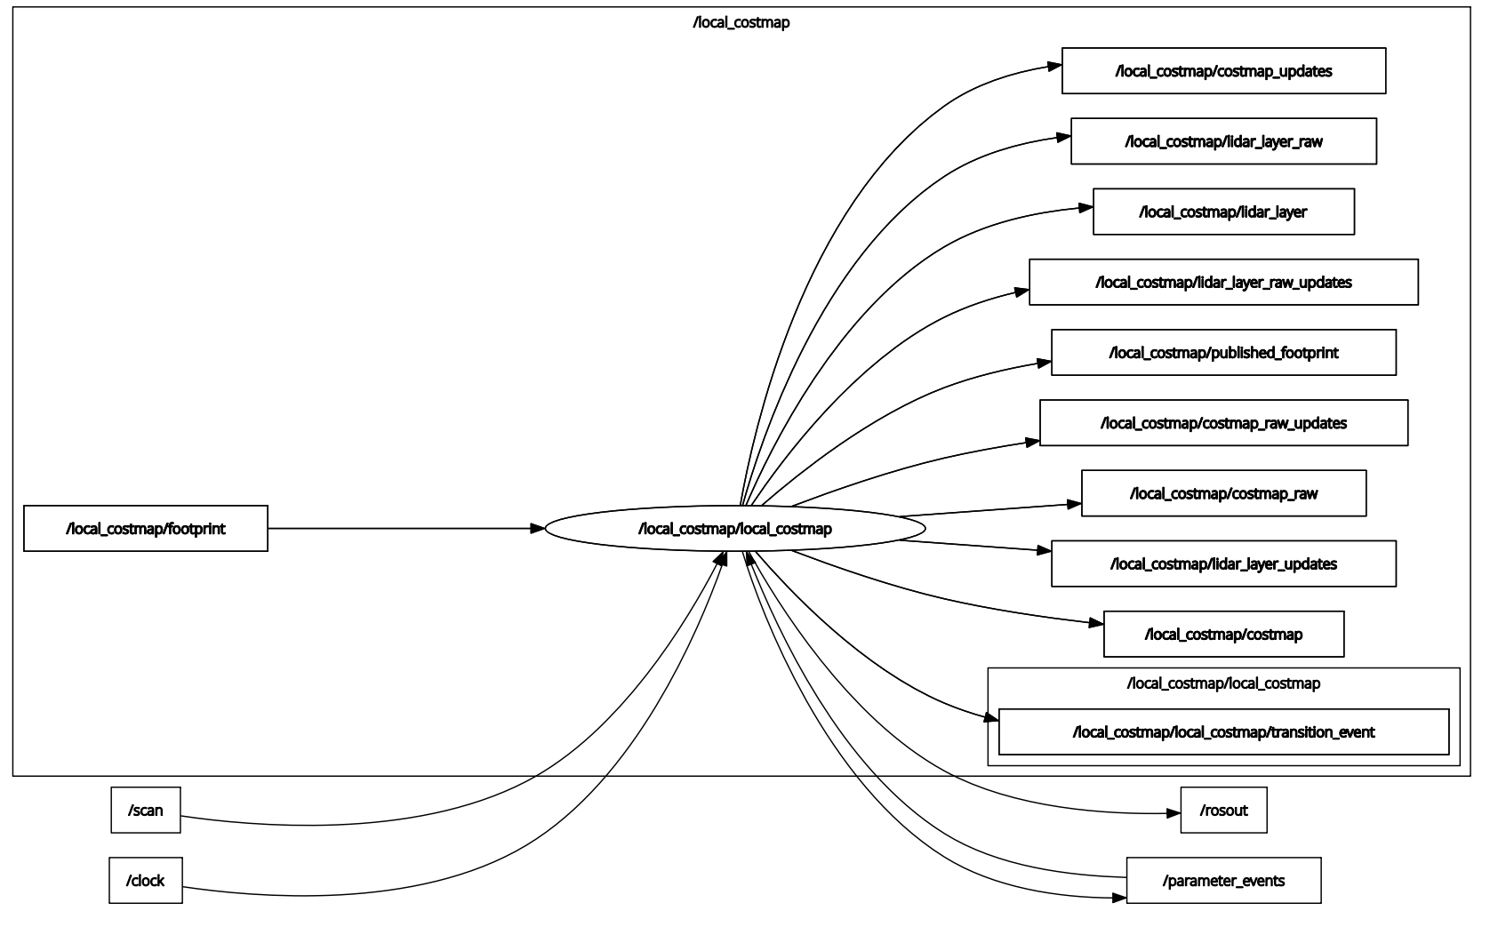
This RQt Graph shows the communication of the /local_costmap/local_costmap node. The local costmap is responsible for building a short-range obstacle map around the robot. It is mainly used by the controller to avoid nearby obstacles while the robot is moving.
- The /local_costmap/local_costmap node receives sensor input from the /scan topic. This laser scan data is used to detect nearby obstacles around the robot. It also receives footprint information from /local_costmap/footprint, which describes the robot’s occupied area. This helps the costmap understand how much space the robot needs while moving.
- The graph shows that the local costmap publishes several output topics, such as /local_costmap/costmap, /local_costmap/costmap_updates, /local_costmap/lidar_layer, and /local_costmap/published_footprint. These topics represent the current local obstacle map, updates to the map, processed lidar information, and the robot footprint.
- The /local_costmap/lidar_layer and related update topics show that the laser scan data is processed as an obstacle layer. This means obstacles detected from /scan are added to the local costmap. The controller can then use this information to avoid collisions while following the planned path.
- The graph also shows /parameter_events and /rosout. These are common ROS 2 system topics. /parameter_events is used when node parameters change, and /rosout is used for logging output. They are not the main focus of the navigation behavior.

Global_CostMap
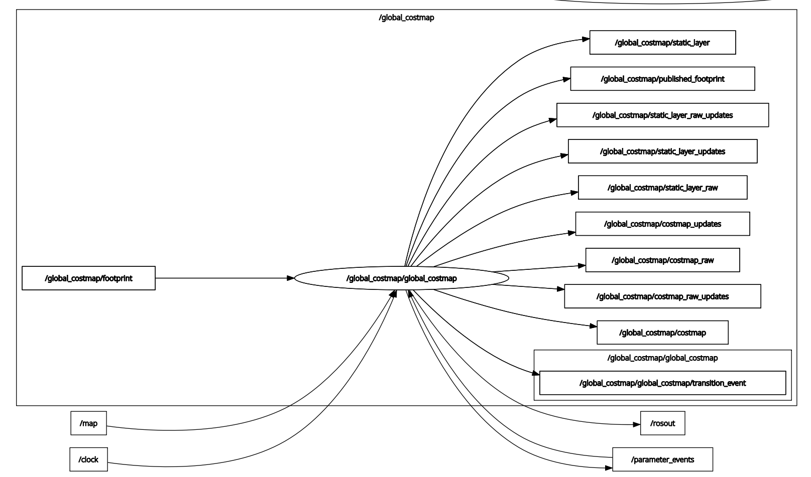
This RQt Graph shows the communication of the /global_costmap/global_costmap node. The global costmap is responsible for creating a map-based cost representation of the whole environment. It is mainly used by the planner to calculate a safe path from the robot’s current position to the target goal.
- The /global_costmap/global_costmap node receives information from the /map topic. The /map topic provides the static environment map, which contains the known structure of the environment, such as walls and fixed obstacles. This allows the global costmap to understand which areas are free and which areas should be avoided.
- The graph also shows the /global_costmap/footprint topic. This represents the space occupied by the robot. The global costmap uses this information to check whether the robot can safely pass through certain areas.
- The node publishes several costmap-related topics, such as /global_costmap/costmap, /global_costmap/costmap_updates, /global_costmap/static_layer, and /global_costmap/published_footprint. These topics provide the processed global costmap information to the rest of the navigation system.
- The /global_costmap/static_layer shows that the global costmap is mainly built from the static map. This is different from the local costmap, which focuses more on nearby sensor data. The global costmap gives the planner a larger view of the environment so it can create a path to the goal.
- The graph also contains /rosout and /parameter_events. These are common ROS 2 system topics. /rosout is used for logging, and /parameter_events is used when parameters change. They are not the main focus of the navigation behavior

— END OF DOCUMENT —

