CCS Website
Prototype

SUBMITTED BY:
Balane, Merchell
Calixtro, Jhon Michael
Junio, Meynard Brian Y.
Mariano, Jhusnine B.
Peña, Aldrin Jose V.
Torres, Lawrence

- INTRODUCTION

Project Overview
This project involves the design and development of a website prototype that promotes the College of Computer Studies (CCS) program. The prototype presents program offerings, key features, student opportunities, and essential information aimed at incoming students and other interested audiences.
Relevance to HCI
The project integrates Human-Computer Interaction (HCI) principles to ensure the website is usable, accessible, and intuitively structured. Concepts such as visual hierarchy, user-centered design, clarity, and efficient navigation were applied to create a seamless user experience.
Design Approach
The design process followed a user-centered and iterative methodology. Initial ideas were translated into wireframes, refined into high-fidelity screens, and evaluated through feedback cycles. Each revision incorporated HCI principles to improve usability, consistency, and clarity.
Objectives
• Present the CCS program through a visually engaging and informative website prototype
• Apply HCI principles in layout, structure, typography, and user interaction
• Achieve intuitive navigation and overall usability
• Develop consistent UI components and responsive layouts
• Create a visually coherent design that supports user engagement and easy information retrieval

- Design Requirements

Target Users
• Incoming first-year students
• Senior High School students exploring college programs
• Parents researching academic opportunities
Branding and Tone of CCS
The design reflects a modern, tech-oriented, innovative, and professional identity suitable for a technology-focused college program.
Site Structure and Theme
The website uses a clean, academic, and modern tech aesthetic. Major sections include:
• Homepage
• Programs
• Faculty
• Admissions
• Campus Facilities
• Student Life
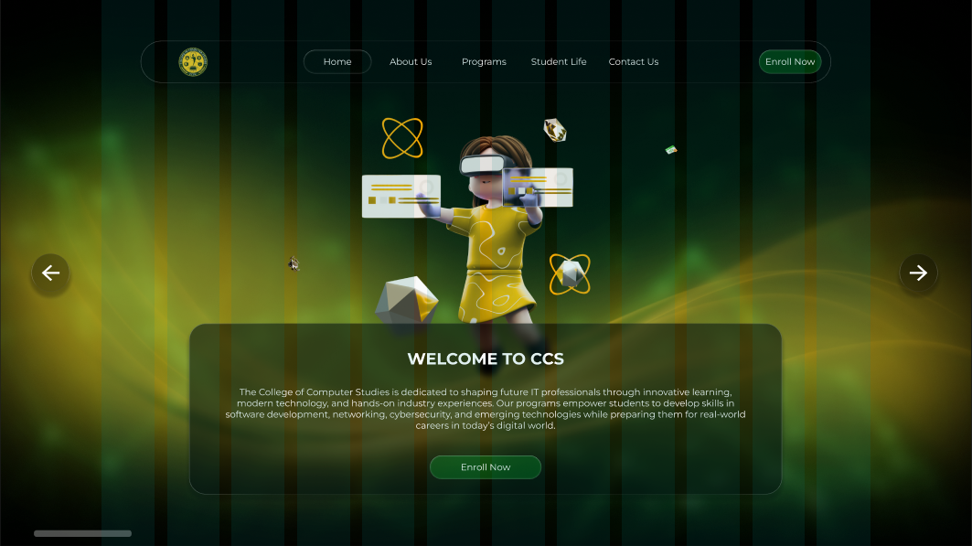
• Contact Page

Color Palette
The color palette consists of shades of green, yellow, black, and white, chosen to reflect a modern and technology-oriented identity. Green and yellow emphasize a contemporary and innovative theme, while dark backgrounds paired with white text create strong contrast for better readability. Overall, the selected colors support a clean, geek-inspired aesthetic that aligns with the branding of the CCS program.

Typography
The typography system uses Montserrat Extra Bold for main headings to create strong emphasis, while Montserrat Light is applied to body text and supporting content for a clean and readable presentation. Hierarchy is established by using Montserrat Regular or Extra Bold for headings and lighter weights for subheadings and body text to maintain clarity and structure. This font choice ensures visual consistency, supports readability, and contributes to a modern and professional overall appearance.

Layout & Grid System
A 12-column grid with 256px margins structures the layout for clarity and alignment. Spacing rules are consistently applied to maintain balance and readability. Each page uses layouts suited to its specific content while maintaining overall harmony.

Iconography & UI Elements
The interface uses minimalistic, outline-based icons to maintain a clean and modern appearance. Buttons follow a consistent size, shape, and set of interaction states, ensuring predictable user interactions across the site. Cards are used to group related content clearly, while forms include clear labels, structured fields, and easily recognizable input areas for ease of use. Additional elements such as indicators and badges are incorporated to highlight important information and guide user attention effectively.

Navigation Style
The website uses a top navigation bar to organize its primary sections, ensuring easy access to core content. Dropdown menus further categorize related pages to maintain clarity and reduce clutter. For mobile layouts, a hamburger menu provides a compact and user-friendly navigation option. A structured footer offers additional links, supporting secondary navigation and improving overall site accessibility.

- Tools and Design Process

Tools Used
Figma served as the project's primary tool, offering a comprehensive workspace for wireframing, graphic design, and prototyping. Its features enabled the team to quickly create layouts, apply styles, and link pages into an interactive prototype. The software also allowed for easy adjustments during the feedback and evaluation stages.

Concept to Prototype Process
The design approach began with brainstorming the overarching theme and defining the target consumers to ensure that the end result met their needs and expectations. The typography, color schemes, and layout styles were then chosen to create a unified visual direction. Wireframes were built to establish the structure and flow of each page before creating high-fidelity screens with detailed images. Once the designs were complete, the pages were linked to create an interactive prototype. The prototype went through numerous rounds of changes, utilizing peer comments and insights from HCI evaluations to improve usability and overall efficacy.

- Design Decisions

Page Structure
Pages were arranged to present information in a logical hierarchy, ensuring that users can navigate intuitively between core sections.

Visual Hierarchy
Contrast, spacing, and size guide user attention from the most important elements to supporting details.

Typography Choices
Montserrat was selected for its readability, versatility, and alignment with a modern academic identity.

Color Usage
Dark backgrounds with green accents create a tech-focused look while maintaining strong contrast for accessibility.

Buttons and UI Components
Buttons use consistent shapes, padding, and states such as hover and active, providing clear visual feedback.

Forms and Links
Forms include clear labels, readable placeholder text, and structured layouts to support error prevention and ease of use.

Usability and Clarity
Navigation patterns, labeling, and layout decisions were made to reduce cognitive load and promote intuitive interaction.

Interaction Flow
Pages are linked smoothly with transitions that help users understand movement between sections. Interaction cues and animations support clarity.

- Application of HCI Concepts

Usability Heuristics
The design uses fundamental usability principles to keep system status visible via hover states, active links, and other interaction indicators. It adheres to common academic and navigation traditions to fit with real-world expectations, allowing users to feel at ease and orientated. Users have clear channels to undo or redo activities, which promotes freedom and control. Uniform color schemes, font, and layout patterns all help to ensure consistency. Form elements are designed to minimize errors by providing clear instructions and logical organization. Navigation prioritizes recognition over memory, decreasing the need for users to memorize information. Well-placed menus make surfing easier, while a clean and simple appearance displays only the most important information. Labeled parts and logical content organization provide further information to help users understand.

Affordance and Signifiers
Clickable elements appear interactive through contrast, shadows, or outline styles. Icons are chosen to represent actions clearly, while input fields visually indicate where typing is expected.

Consistency and Standards
Color usage, icon style, font hierarchy, and component placement remain uniform throughout the site.

Feedback and Visibility
Hover effects, active link states, and form messages provide clear feedback for user actions.

Cognitive Load Reduction
Information is grouped logically, pages follow predictable patterns, and key content is positioned prominently.

Accessibility Considerations
The design incorporates accessibility considerations by ensuring high contrast between text and background to improve visibility for all users. Clear and readable font choices support comfortable viewing across different devices and screen sizes. Alternative text is prepared for images where needed to provide meaningful context for users relying on assistive technologies. Additionally, the layout is structured in a way that can be adapted for keyboard-based navigation, supporting users who may not rely on a mouse for interaction.

Engagement Strategies
Balanced layouts, appealing visuals, interactive elements, and concise content enhance user engagement.

Interaction Styles
The prototype uses navigation-based interaction, menu-driven pathways, and direct manipulation for clickable UI elements.

Information Architecture
Content is organized from broad categories to detailed information, helping users locate content quickly and logically.

- Summary and Lessons Learned

Jhusnine Nicole Mariano – Reflection
Through this project, I discovered that meaningful website design begins with asking the right questions and truly understanding user experiences, which is the foundation of Human-Computer Interaction (HCI). My responsibilities included creating interview questions for alumni and student testimonials, and managing the Organizations, Events and Activities, Testimonials and Alumni Stories, Campus Facilities, and Internship Opportunities sections.
Working with Lawrence, we interviewed a 1st-year BSIT student, while our teammate, senior Calixtro, conducted the 4th-year interview since he had existing connections with those students. One of my biggest challenges was overcoming my initial shyness and unfamiliarity with 1st-year students, which made it difficult to approach and interview them; however, persistence enabled me to successfully complete the interviews.
For the testimonials section, Lawrence handled obtaining approval and communicating with the CCS program staff, as well as gathering survey opinions about the program. He also asked for my feedback to review and validate whether the survey questions were appropriate before they were finalized. In the campus facilities section, I personally photographed the Computer Laboratory and Cisco Lab after receiving proper permission.
These experiences demonstrated that HCI encompasses more than design it requires genuine communication, respect for users, effective collaboration, and perseverance. By overcoming my initial shyness to connect with students and contributing feedback to ensure authentic content, I strengthened my teamwork, communication skills, and ability to genuinely represent the CCS program’s value to users.

Meynard Brian – Reflection
In terms of design, I initially experienced difficulty in deciding which theme, color scheme, and layout to use for the prototype. My goal was to present a technology-oriented concept without compromising functionality or making the interface difficult to navigate. During the first week, our group explored various online design inspirations and followed common layout patterns observed in popular websites. From there, I gradually incorporated design elements that would help the prototype stand out while also considering the project timeline and the feasibility of implementing interactions and animations based on my groupmate’s assigned tasks.
Furthermore, I encountered challenges while using Figma. Although our group was accustomed to creating simple low-fidelity prototypes using Adobe XD, adjusting to Figma required time and practice to fully understand its features. This experience helped me realize the importance of the concepts discussed in our Human-Computer Interaction (HCI) lessons, particularly in prioritizing usability and functionality. I learned that effective design is not solely about visual aesthetics, but also about creating interfaces that are accessible and user-friendly for a wide range of users. Overall, I found the project to be an enjoyable and valuable learning experience, as it allowed me to grow through overcoming these challenges.

Merchell Balane – Reflection
The project was very successful, and our team managed to allocate time and effort for it, regardless of personal responsibilities, heavy workloads, and finals of other subjects. We recognized that everyone had their own academic priorities, so we organized schedules, assigned tasks, and offered assistance where needed.
We continued our communication and progress monitoring despite the limitation of time. This enabled us to be organized and have a smooth workflow. Every single individual put in effort according to their skills, and as a team, we improved the design, made it more user-friendly and applied HCI rules effectively.
In the end, our collaboration showed that working together does not mean being present in the same place but rather understanding the other's circumstances, being adaptable, and being committed to the same goal. Our joint effort made the project a success even though there were challenges.

Aldrin Jose Peña – Reflection
While designing the website, I've learned a lot about wireframing and especially prototyping. I don't even know what components are in figma until I'm forced to learn it. And now, I got the hang of it. I've faced challenges in implementing all my members' ideas into the site, such as automatic carousel and interactive drop down inputs, parallax effects and much more. But I'm proud that in the end, I've actually done it all. I've learned so much in this subject. Because of what I've experienced in alignment and auto layouting, I now plan first before designing an element or a component. Lastly, my team collaboration with my group members is such a thrilling experience. They gave me freedom to express my thoughts and ideas and bring it to the table.

Lawrence Torres – Reflection
For the testimonials section, I coordinated approvals, communicated with CCS program staff, and gathered survey feedback about the program. I also reviewed the survey questions to ensure they were appropriate before finalization.
Despite time constraints, we stayed in close communication and monitored our progress, which kept our workflow smooth and organized. Everyone contributed according to their strengths, and as a team we improved the design, enhanced usability, and applied HCI principles effectively.

Jhon Michael Calixtro – Reflection
I learned that HCI isn’t only about making something look good; it’s about understanding how users will interact with the system or website. This perspective helped me approach design with more purpose.
One challenge I faced was that I’m not the type to start conversations or make the first move in group work. Still, I pushed myself to communicate and cooperate with my teammates.
HCI design thinking improved our project by helping us brainstorm what features were needed and who our target users were. It guided us in making more meaningful design decisions.
This project made me realize how important teamwork is in achieving good results. In real work settings, strong communication is essential to perform tasks effectively.

