Computer Systems Infrastructure and Management

600099

Network Infrastructure

Configuration Report

Brian Davis

Student ID: 201707824

Contents

Problem Breakdown 2

Solution Proposal 3

## Problem Breakdown

The task involves the development of a network infrastructure for the University as part of their new building expansion. The main point of interest for the expansion is to incorporate a relevant and efficient network topology that aims to serve and connect the Engineering and Computer Science departments, by providing expansion upon their already existing building.

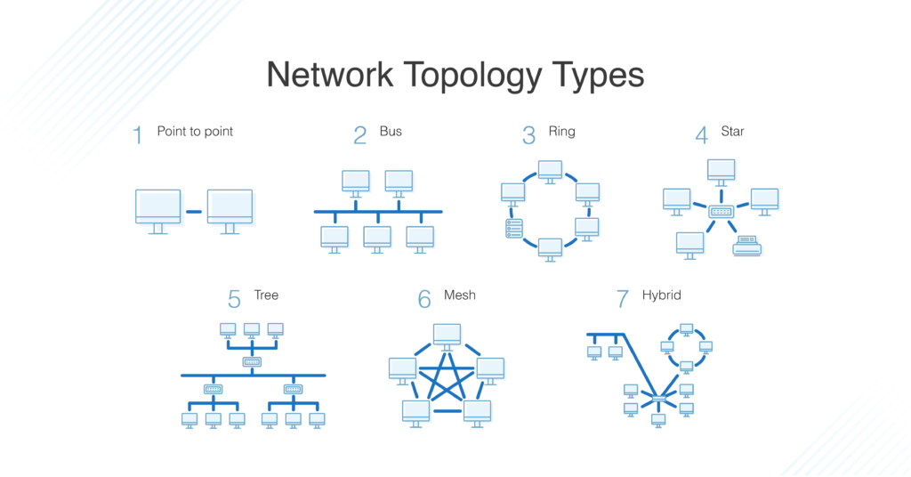The university spans over 2 floors, so there is need to develop a network solution that allows a connection across the different departments, where Computer Science and Engineering share spaces amongst the building. A network needs to be developed and plotted that aims to suits the requirements of the building as well as meeting the requirements of both departments. This will be achieved through the successful use of relevant and efficient network topologies that allow these requirements to be met. The network topology chosen must meet the requirements of the internal structure. An example of the topologies that are available to be used for this can be found in figure 1.

Figure – Available Network Topologies

For this, consideration needs to be taken for the density of the lab spaces, capacity of offices and the potential for wireless connectivity, which will allow expansion across the entire space required. The two departments require their networks to be separate but to also be able to connect and share resources with each other across the space. This connection needs to be available not only for local computers, but where necessary this must also cover the needs of those who use their own devices in the workspaces available.

The network infrastructure solution must allow for the ability to support activities within the computer labs, even when these labs are at capacity. This means that a fast connection needs to be available, but the likelihood that the full potential of network bandwidth will be used to its full potential is not high. Mitigation to allow for this should be in place, to allow for no issues in lab use where capacity is expected to be high, especially in times of deadlines for coursework submissions. Due to the location of the server room and comms room, a high speed wired connection needs to be available between the two spaces to maintain connection throughout.

Traversal from the comms room to the server room consists of a long spanning corridor, whilst the server room is situated opposite of the lift. The corridors span the length of the floors and allow for ample ability to get everywhere, with no visible issues that can be seen from the floor plans regarding navigation. To meet the requirements, the proposal is for a combination of different topologies that allow for easy connection through the building, alongside allowing for future building expansions if these are deemed necessary later down the line.

The aim is to theoretically deploy these chosen topologies to discover what resources will be needed and to gauge expected costs for this expansion. This includes the wiring, devices and additional network equipment that might be needed. Not all spaces within the building are expected to require a connection, but these should have some form of connection available to them regardless of this.

## Solution Proposal