Aura Fizz — How Every Drink Looks
Oct 4, 2026 · @Haze

How to read this doc
This doc shows how all 232 drinks look in the game. The pictures are the same ones players see in the menu, cashier (POS) and kiosk. The look details come straight from the game's live look settings (GlassStyle), so they match what gets served.
Every drink is made of five parts:
- Glass – the cup the drink is served in (see the glass list below).
- Liquid colours – 1 to 4 colours, listed bottom → top. Smooth means the colours blend into each other. Layers means they sit as clear stripes (for example Vietnamese Coffee with condensed milk at the bottom).
- Toppings on the glass – things built into the drink's look, like foam, whipped cream, syrup on the walls, ice, straw, a cherry or a wafer roll.
- Rim fruit – the fruit slice or piece sitting on the rim of the glass.
- Recipe add-ins – pieces that drop into the drink. Right now only the boba drinks have one: the boba pearls at the bottom.
House rules for the look
- Drinks are always solid colour, never see-through. Milky drinks are fully matte. Juice-type drinks (sodas, juices, mocktails, fruit boba) get a light shine only.
- Glasses use the old (original) design. Boba cups keep their own pearl bed.
- Extra toppings are a separate asset. Players pick them at the Topping Station (press Add toppings) and the pieces drop into the drink. Choices are boba pearls, popping boba, jelly, citrus slices, strawberries, berries, fruit cubes, ice and mint. All toppings are matte, not shiny. The pictures in this doc show the drink before any extra toppings.
Glasses used
Glass | Used for
Espresso cup | Espresso, Turkish Coffee
Coffee mug | Most hot coffees, warm milks
Glass mug | Vietnamese Coffee, Sweet Cream Coffee, Golden Aura Latte
Tall glass | Iced coffees
Frappe cup | Coffee Frappe, Java Chip Frappe
Dessert glass | Affogato
Smoothie glass | Smoothies, a few mocktails
Milkshake glass | Milkshakes
Soda glass | Sodas, sparkling grape juices, craft sodas
Float mug | Sarsaparilla Float
Boba cup | All boba drinks
Juice glass | Juices, some mocktails
Milk bottle | Cold milk drinks
Highball glass | Tall mocktails
Hurricane glass | Pineapple Coconut Cooler
Tier colours on the picture sheets: Tasty (grey) · Delish (green) · Mouthwatering (blue) · Scrumptious (purple) · Toothsome (orange) · Luscious (pink) · Delectable (yellow) · Ambrosial (gold).

Drink pictures
One sheet per menu category, in menu order. Each card shows the drink's name and its tier.

Hot Caffeinated Drinks (21)
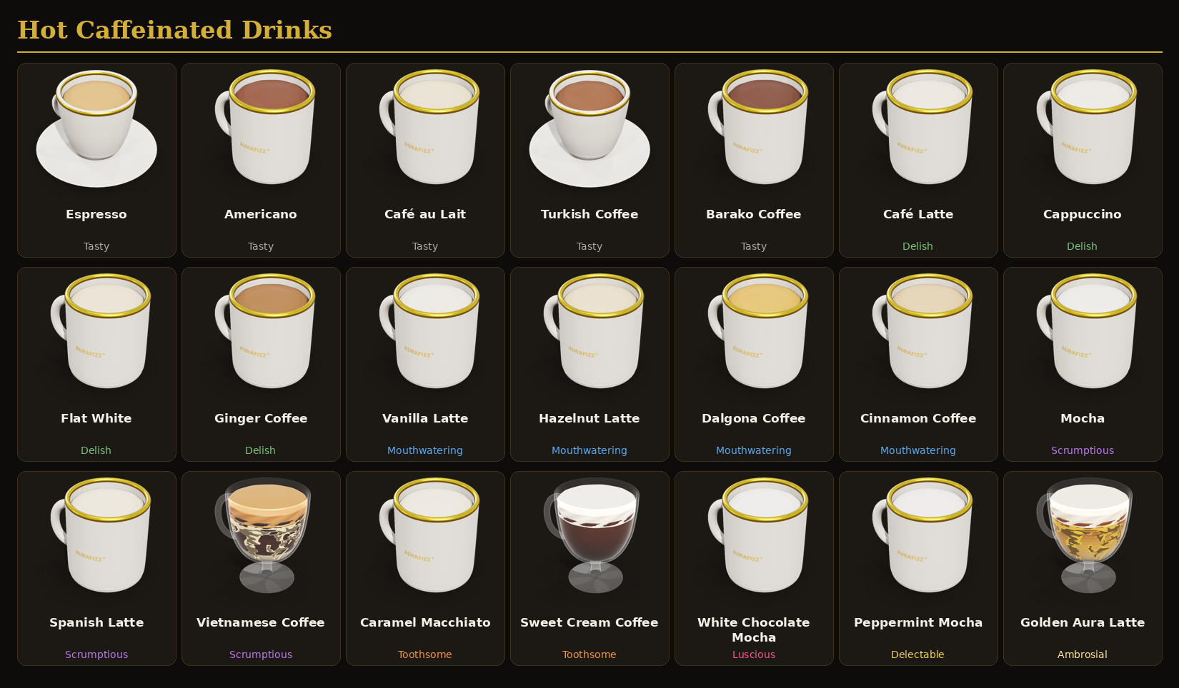

Cold Caffeinated Drinks (21)
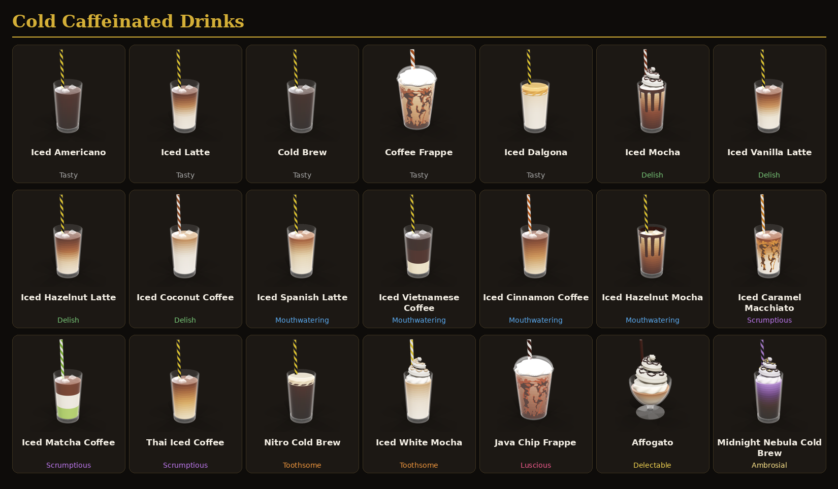

Fruit Smoothie Drinks (21)
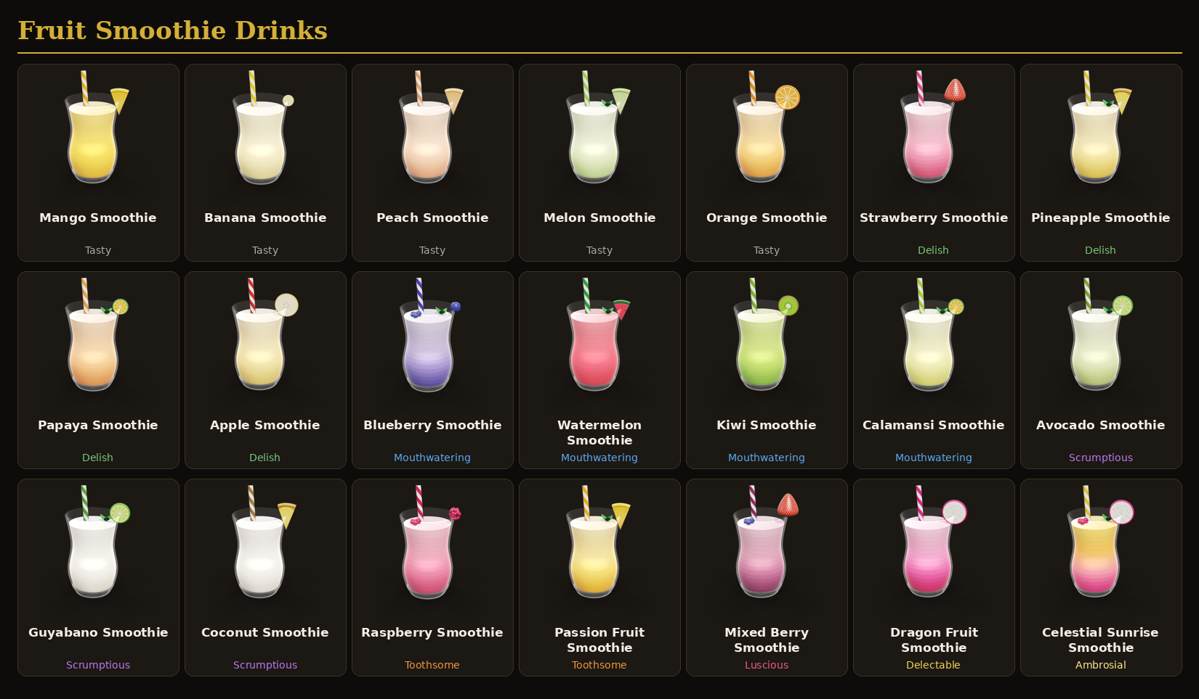

Milkshakes (21)
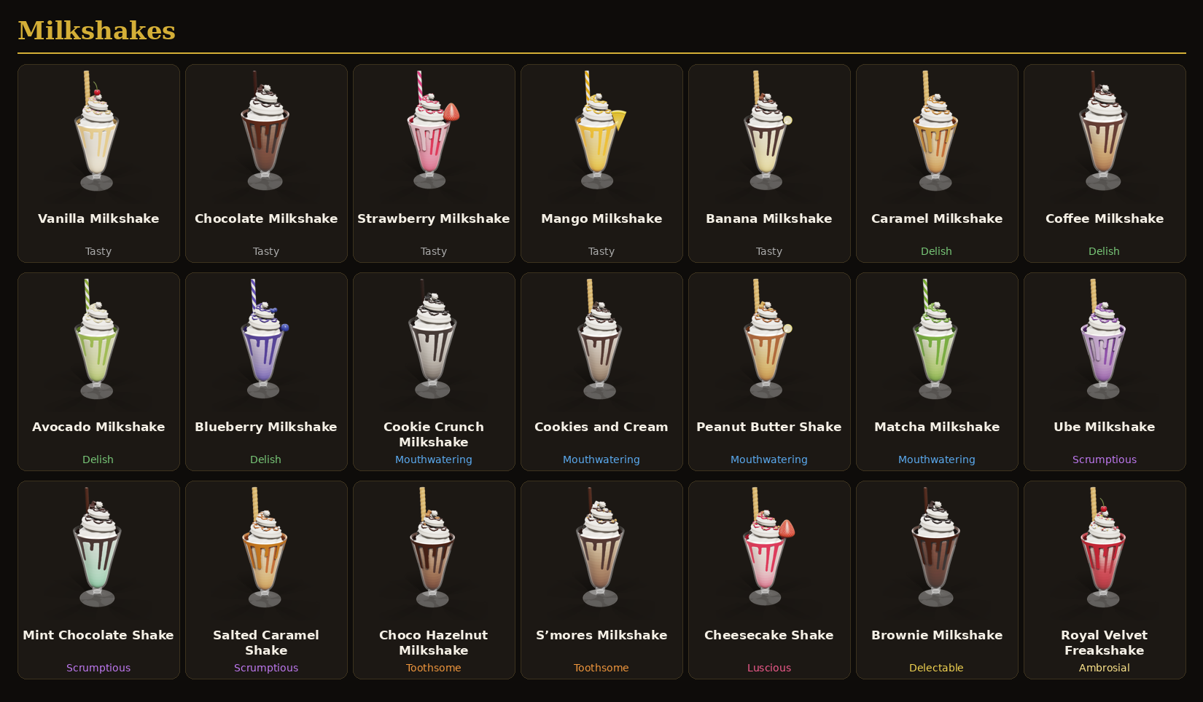

Carbonated Drinks – Cola/Soda (21)
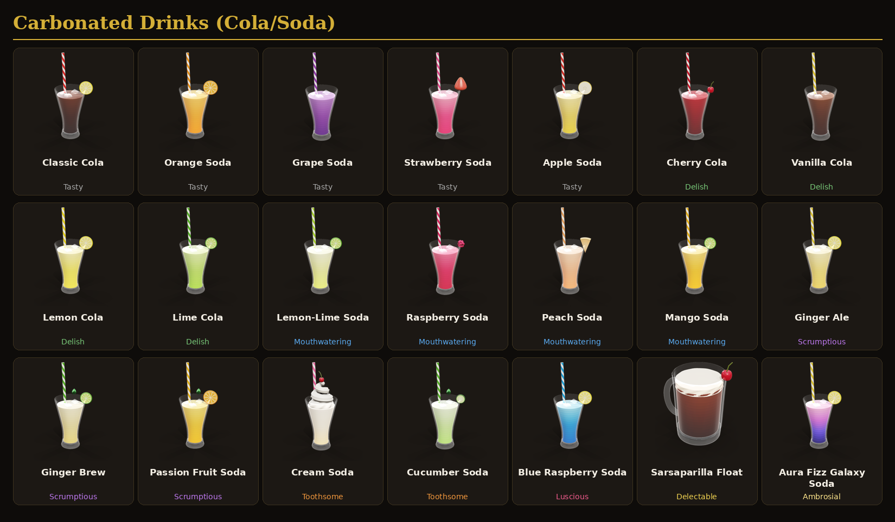

Boba Fruity (21)
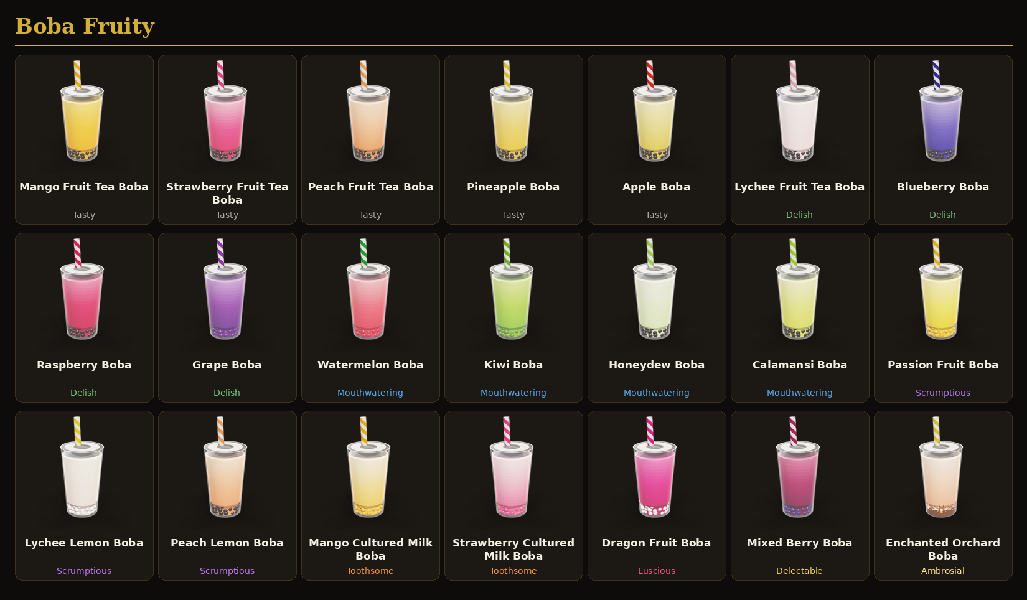

Boba Confectionary (21)
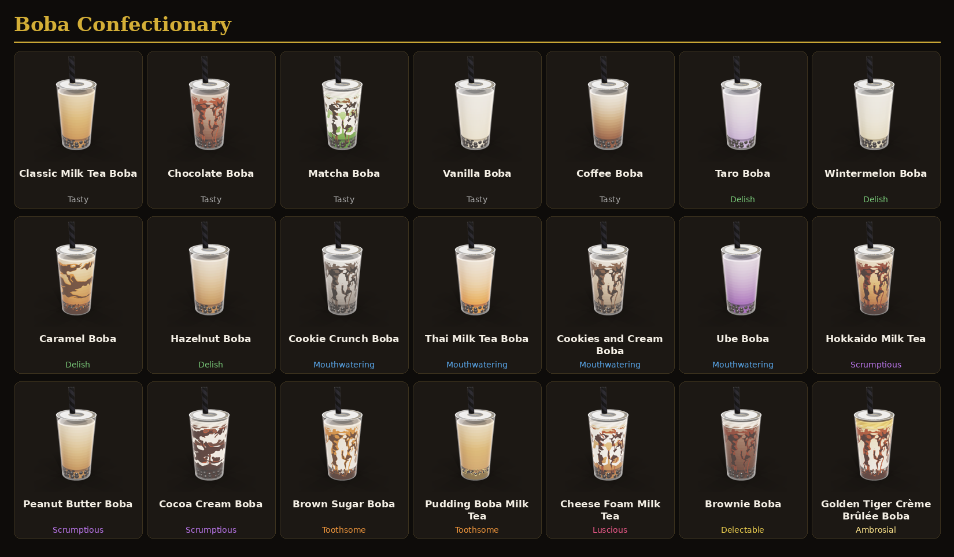

Juices (21)
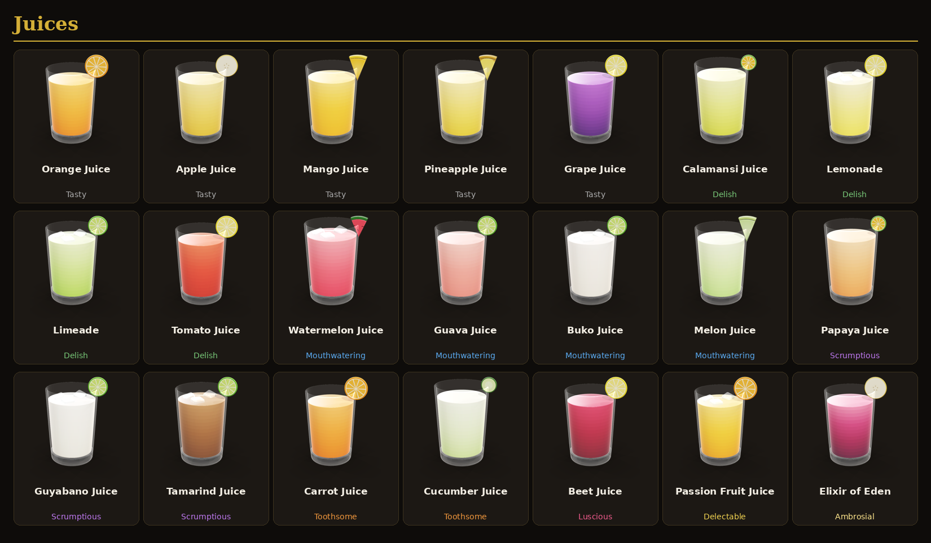

Milk-Based Drinks (21)
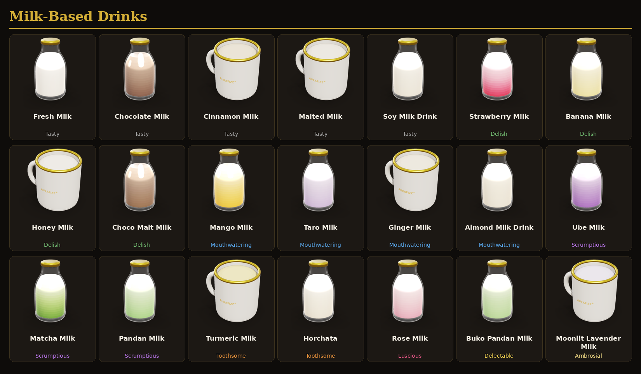

Mocktails (21)
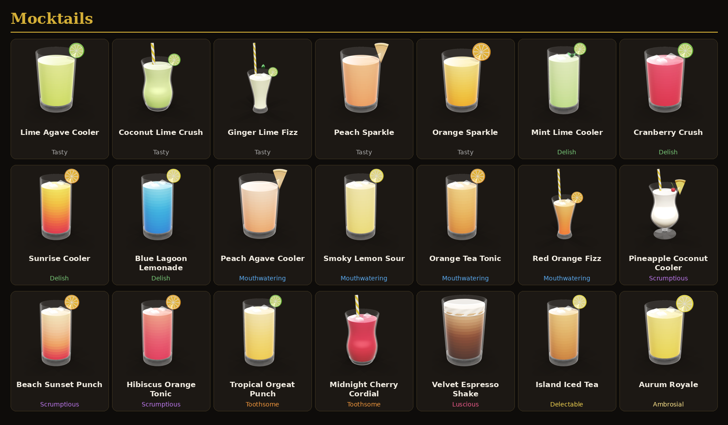

Sparkling Grape Juices (11)
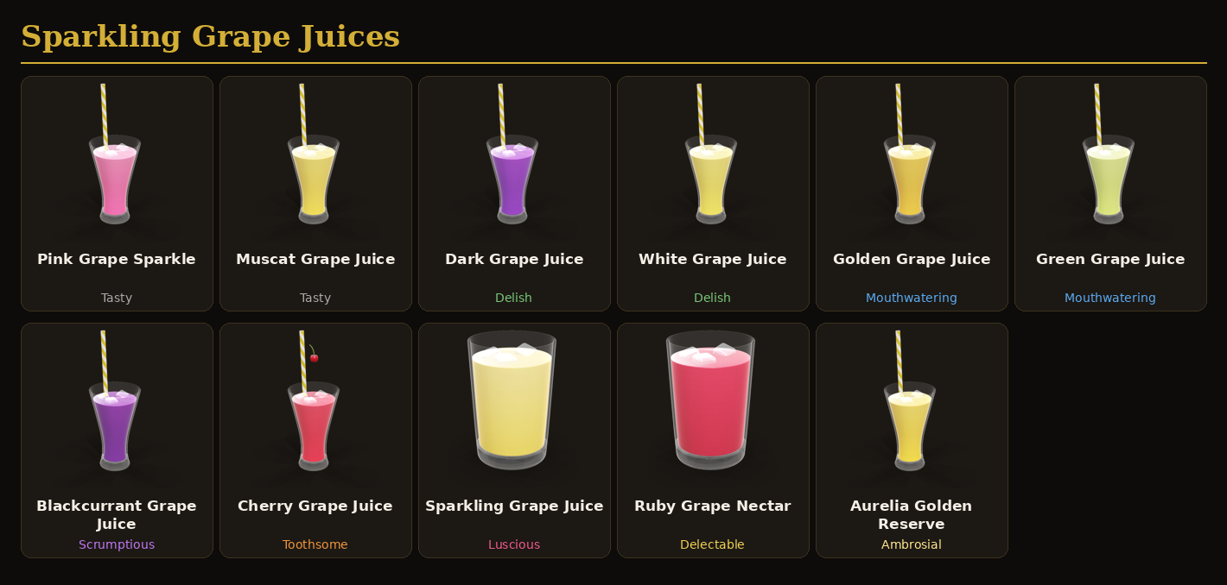

Craft Sodas & Floats (11)
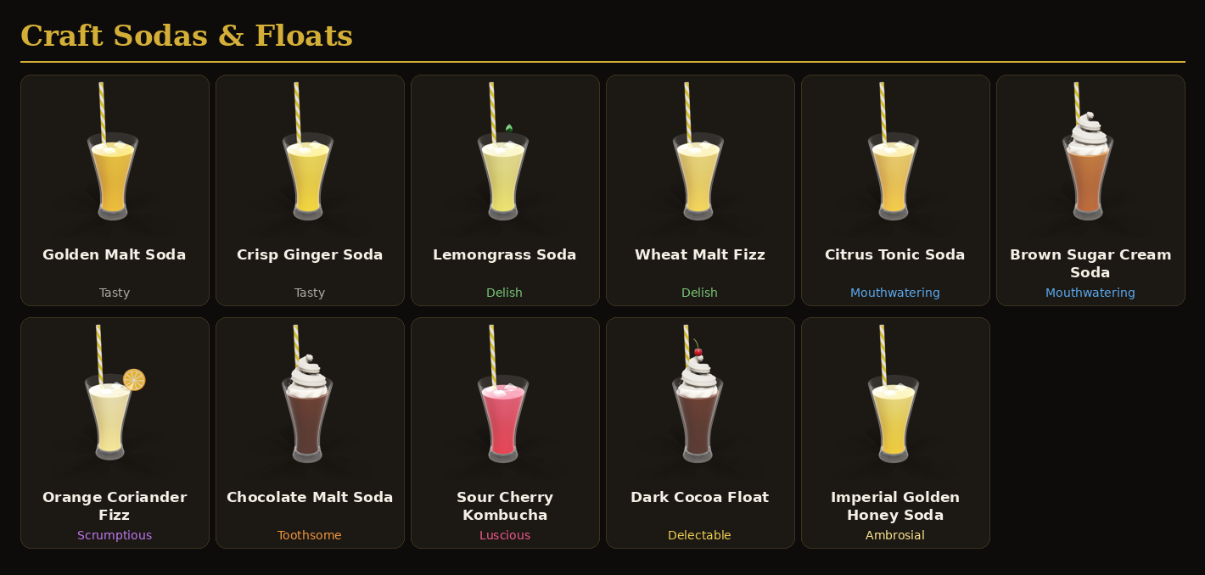

Look details per drink
The exact look of every drink, one table per category. The colour codes are the hex colours used in Studio (paste them into a Color3 or the colour picker). Rim fruit is the piece on the rim of the glass. Add-ins are the pieces that sit inside the drink as part of the recipe; players can add more at the Topping Station.

Hot Caffeinated Drinks
Drink | Tier | Glass | Liquid colours (bottom → top) | Toppings on the glass | Rim fruit | Add-ins
Espresso | Tasty | Espresso cup | #1e0c04 → #3a1a0a | Foam top | — | —
Americano | Tasty | Coffee mug | #1e0c04 → #3a1c0c | Foam top | — | —
Café au Lait | Tasty | Coffee mug | #8a5a36 → #b88a5e | Foam top | — | —
Turkish Coffee | Tasty | Espresso cup | #140804 → #2a1208 | Foam top | — | —
Barako Coffee | Tasty | Coffee mug | #140804 → #2e160a | Foam top | — | —
Café Latte | Delish | Coffee mug | #8a5a36 → #c49a6c | Foam top | — | —
Cappuccino | Delish | Coffee mug | #6a3a1e → #a8744a | Foam top | — | —
Flat White | Delish | Coffee mug | #8a5a36 → #d0aa80 | Foam top | — | —
Ginger Coffee | Delish | Coffee mug | #1e0c04 → #3a1c0c | Foam top | — | —
Vanilla Latte | Mouthwatering | Coffee mug | #8a5a36 → #c9a27a | Foam top | — | —
Hazelnut Latte | Mouthwatering | Coffee mug | #7a4a2a → #b88a5e | Foam top | — | —
Dalgona Coffee | Mouthwatering | Coffee mug | #e9dac4 → #f2e8da | Foam top | — | —
Cinnamon Coffee | Mouthwatering | Coffee mug | #6a3a1e → #a8744a | Foam top | — | —
Mocha | Scrumptious | Coffee mug | #3a1a0c → #6b3a22 | Foam top | — | —
Spanish Latte | Scrumptious | Coffee mug | #8a5a36 → #d0aa80 | Foam top | — | —
Vietnamese Coffee | Scrumptious | Glass mug | #f0dfbd → #3a1a0a → #2a1208 (layers) | Foam top, Syrup streaks inside | — | —
Caramel Macchiato | Toothsome | Coffee mug | #8a5a36 → #c49a6c | Foam top | — | —
Sweet Cream Coffee | Toothsome | Glass mug | #1e0c04 → #3a1a0a → #4a2210 | Foam top | — | —
White Chocolate Mocha | Luscious | Coffee mug | #a8866a → #d8c0a4 | Foam top | — | —
Peppermint Mocha | Delectable | Coffee mug | #3a1a0c → #6b3a22 | Foam top | — | —
Golden Aura Latte | Ambrosial | Glass mug | #f1e4cc → #d8a24a → #6b3414 | Foam top, Syrup streaks inside | — | —

Cold Caffeinated Drinks
Drink | Tier | Glass | Liquid colours (bottom → top) | Toppings on the glass | Rim fruit | Add-ins
Iced Americano | Tasty | Tall glass | #1e0c04 → #2e1408 → #3a1a0a | Ice cubes, Striped straw | — | —
Iced Latte | Tasty | Tall glass | #f2e8da → #e9dac4 → #9a6a44 → #4a2410 | Ice cubes, Striped straw | — | —
Cold Brew | Tasty | Tall glass | #140804 → #241006 → #2e1508 | Ice cubes, Striped straw | — | —
Coffee Frappe | Tasty | Frappe cup | #8a5a3a → #b98a62 → #d9b894 | Whipped cream, Syrup streaks inside, Syrup layer at bottom, Striped straw | — | —
Iced Dalgona | Tasty | Tall glass | #f2eadc → #efe4d2 → #e3c9a6 | Foam top, Ice cubes, Striped straw | — | —
Iced Mocha | Delish | Tall glass | #3a1a0c → #6b3a22 → #c9a07a | Whipped cream, Soft cream drip, Sauce drizzle, Ice cubes, Striped straw | — | —
Iced Vanilla Latte | Delish | Tall glass | #f5ecdc → #f0e2c8 → #a8744a → #5a2e14 | Ice cubes, Striped straw | — | —
Iced Hazelnut Latte | Delish | Tall glass | #efe0c8 → #d9b894 → #8a5530 → #4a2410 | Ice cubes, Striped straw | — | —
Iced Coconut Coffee | Delish | Tall glass | #faf6ee → #efe6d6 → #9a6a44 | Ice cubes, Striped straw | — | —
Iced Spanish Latte | Mouthwatering | Tall glass | #f5e8cc → #e0c49c → #7a4424 | Ice cubes, Striped straw | — | —
Iced Vietnamese Coffee | Mouthwatering | Tall glass | #f0dcb4 → #3a1a0a → #2a1208 (layers) | Ice cubes, Striped straw | — | —
Iced Cinnamon Coffee | Mouthwatering | Tall glass | #e9d2b0 → #b07a4a → #5a2e14 | Ice cubes, Striped straw | — | —
Iced Hazelnut Mocha | Mouthwatering | Tall glass | #3a1a0c → #7a4a2a → #d0a878 | Soft cream drip, Ice cubes, Striped straw | — | —
Iced Caramel Macchiato | Scrumptious | Tall glass | #f5ecdc → #efe2cc → #b07a4a → #6a3514 | Syrup streaks inside, Ice cubes, Striped straw | — | —
Iced Matcha Coffee | Scrumptious | Tall glass | #8fb85a → #f2ecdc → #5a2e14 (layers) | Ice cubes, Striped straw | — | —
Thai Iced Coffee | Scrumptious | Tall glass | #f0d8b0 → #c08a50 → #5a2e14 | Ice cubes, Striped straw | — | —
Nitro Cold Brew | Toothsome | Tall glass | #140804 → #241006 → #3a1c0c | Foam top, Ice cubes, Striped straw | — | —
Iced White Mocha | Toothsome | Tall glass | #f7efe2 → #e8d8c0 → #b08a64 | Whipped cream, Sauce drizzle, Ice cubes, Striped straw | — | —
Java Chip Frappe | Luscious | Frappe cup | #5a3322 → #8a5a44 → #b58d7a | Whipped cream, Syrup streaks inside, Syrup layer at bottom, Striped straw | — | —
Affogato | Delectable | Dessert glass | #f6efe0 → #e9dcc4 → #8a5a36 | Whipped cream, Syrup layer at bottom, Sauce drizzle, Chocolate stick, Mint leaf | — | —
Midnight Nebula Cold Brew | Ambrosial | Tall glass | #120a06 → #2a1408 → #4a2c5a → #8a6ab8 | Whipped cream, Sauce drizzle, Sprinkles, Ice cubes, Striped straw | — | —

Fruit Smoothie Drinks
Drink | Tier | Glass | Liquid colours (bottom → top) | Toppings on the glass | Rim fruit | Add-ins
Mango Smoothie | Tasty | Smoothie glass | #f7b733 → #fac74f → #fcd97a | Striped straw | Mango | —
Banana Smoothie | Tasty | Smoothie glass | #f1dc96 → #f5e6ad → #faf0cc | Striped straw | Banana | —
Peach Smoothie | Tasty | Smoothie glass | #f59f7a → #f8c4a6 → #fbd9c2 | Striped straw | Peach | —
Melon Smoothie | Tasty | Smoothie glass | #b8dc8a → #daebb7 → #eaf4d4 | Mint leaf, Striped straw | Melon | —
Orange Smoothie | Tasty | Smoothie glass | #f59a3a → #f8bc76 → #fbd6a6 | Striped straw | Orange | —
Strawberry Smoothie | Delish | Smoothie glass | #d94a6e → #ee8aa4 → #f7c0cc | Striped straw | Strawberry | —
Pineapple Smoothie | Delish | Smoothie glass | #e8c04a → #eed390 → #f6e6b8 | Mint leaf, Striped straw | Pineapple | —
Papaya Smoothie | Delish | Smoothie glass | #f08a4a → #f5b282 → #f9d0b0 | Mint leaf, Striped straw | Calamansi | —
Apple Smoothie | Delish | Smoothie glass | #e3c46a → #eed390 → #f4e6c0 | Striped straw | Apple | —
Blueberry Smoothie | Mouthwatering | Smoothie glass | #4a3e98 → #988ebf → #c9c0e0 | Berries, Mint leaf, Striped straw | Blueberry | —
Watermelon Smoothie | Mouthwatering | Smoothie glass | #e03a50 → #ef5b6a → #f78a94 | Mint leaf, Striped straw | Watermelon | —
Kiwi Smoothie | Mouthwatering | Smoothie glass | #7ab040 → #a8cc60 → #d0e290 | Striped straw | Kiwi | —
Calamansi Smoothie | Mouthwatering | Smoothie glass | #d8d86a → #e4e69e → #f0f2c8 | Mint leaf, Striped straw | Calamansi | —
Avocado Smoothie | Scrumptious | Smoothie glass | #a8c070 → #d1dca7 → #e6eccc | Mint leaf, Striped straw | Lime | —
Guyabano Smoothie | Scrumptious | Smoothie glass | #ece8d8 → #f4f2e6 → #fbfaf4 | Mint leaf, Striped straw | Lime | —
Coconut Smoothie | Scrumptious | Smoothie glass | #f0ece0 → #f6f3ea → #fcfbf6 | Striped straw | Pineapple | —
Raspberry Smoothie | Toothsome | Smoothie glass | #c8406a → #e27890 → #f2b0c0 | Berries, Striped straw | Raspberry | —
Passion Fruit Smoothie | Toothsome | Smoothie glass | #f5a623 → #facc72 → #fde2a8 | Mint leaf, Striped straw | Mango | —
Mixed Berry Smoothie | Luscious | Smoothie glass | #7a2a5a → #bc7890 → #e0b0c4 | Berries, Striped straw | Strawberry | —
Dragon Fruit Smoothie | Delectable | Smoothie glass | #c8105a → #e976a4 → #f5b8d2 | Striped straw | Dragon fruit | —
Celestial Sunrise Smoothie | Ambrosial | Smoothie glass | #e0257a → #f07a8a → #f7a64a → #fcd46a | Berries, Mint leaf, Striped straw | Dragon fruit | —

Milkshakes
Drink | Tier | Glass | Liquid colours (bottom → top) | Toppings on the glass | Rim fruit | Add-ins
Vanilla Milkshake | Tasty | Milkshake glass | #f0e2c2 → #f6edd7 → #faf4e6 | Whipped cream, Soft cream drip, Sauce drizzle, Sprinkles, Wafer roll, Cherry | — | —
Chocolate Milkshake | Tasty | Milkshake glass | #4a2a1a → #6b4230 → #8f7565 | Whipped cream, Soft cream drip, Sauce drip down outside, Sauce drizzle, Chunks, Chocolate stick | — | —
Strawberry Milkshake | Tasty | Milkshake glass | #e0607e → #ee8aa4 → #f5b8c6 | Whipped cream, Soft cream drip, Sauce drip down outside, Sauce drizzle, Sprinkles, Striped straw | Strawberry | —
Mango Milkshake | Tasty | Milkshake glass | #f5b030 → #facc72 → #fde0a0 | Whipped cream, Soft cream drip, Sauce drizzle, Striped straw | Mango | —
Banana Milkshake | Tasty | Milkshake glass | #efd98a → #f5e6ad → #fbf2d0 | Whipped cream, Soft cream drip, Sauce drizzle, Chunks, Wafer roll | Banana | —
Caramel Milkshake | Delish | Milkshake glass | #b87a3a → #dab280 → #ecd2ac | Whipped cream, Soft cream drip, Sauce drip down outside, Sauce drizzle, Wafer roll | — | —
Coffee Milkshake | Delish | Milkshake glass | #8a5a3a → #c49a6c → #e6cfb0 | Whipped cream, Soft cream drip, Sauce drizzle, Chunks, Chocolate stick | — | —
Avocado Milkshake | Delish | Milkshake glass | #9ab860 → #c8d898 → #e0e8c0 | Whipped cream, Soft cream drip, Sauce drizzle, Mint leaf, Striped straw | — | —
Blueberry Milkshake | Delish | Milkshake glass | #5a4ea8 → #988ebf → #c4bce0 | Whipped cream, Soft cream drip, Sauce drizzle, Berries, Striped straw | Blueberry | —
Cookie Crunch Milkshake | Mouthwatering | Milkshake glass | #5a5450 → #aca9a4 → #e0ddd8 | Whipped cream, Soft cream drip, Sauce drizzle, Cookie crumbs, Chunks, Chocolate stick | — | —
Cookies and Cream | Mouthwatering | Milkshake glass | #6b5a4a → #a8988a → #dcd2c8 | Whipped cream, Soft cream drip, Sauce drizzle, Cookie crumbs, Chunks, Wafer roll | — | —
Peanut Butter Shake | Mouthwatering | Milkshake glass | #b07a3a → #d9b070 → #f0d8a8 | Whipped cream, Soft cream drip, Sauce drizzle, Chunks, Wafer roll | Banana | —
Matcha Milkshake | Mouthwatering | Milkshake glass | #6a9a3a → #a8c878 → #d8e8c0 | Whipped cream, Soft cream drip, Sauce drizzle, Cookie crumbs, Mint leaf, Striped straw | — | —
Ube Milkshake | Scrumptious | Milkshake glass | #7a4a9a → #ac8cbf → #d8c8e4 | Whipped cream, Soft cream drip, Sauce drip down outside, Sauce drizzle, Cookie crumbs, Wafer roll | — | —
Mint Chocolate Shake | Scrumptious | Milkshake glass | #7ec8a0 → #a8dcc0 → #d0eee0 | Whipped cream, Soft cream drip, Sauce drizzle, Chunks, Chocolate stick, Mint leaf | — | —
Salted Caramel Shake | Scrumptious | Milkshake glass | #c08a4a → #dab280 → #efd8b8 | Whipped cream, Soft cream drip, Sauce drip down outside, Sauce drizzle, Cookie crumbs, Wafer roll | — | —
Choco Hazelnut Milkshake | Toothsome | Milkshake glass | #5a3322 → #8f6a50 → #c0a08a | Whipped cream, Soft cream drip, Sauce drip down outside, Sauce drizzle, Chunks, Wafer roll | — | —
S’mores Milkshake | Toothsome | Milkshake glass | #6b4a3a → #9a7a60 → #d8c0a0 | Whipped cream, Soft cream drip, Sauce drizzle, Cookie crumbs, Chunks, Chocolate stick | — | —
Cheesecake Shake | Luscious | Milkshake glass | #e0607e → #f2c0c8 → #fbeee6 | Whipped cream, Soft cream drip, Sauce drizzle, Cookie crumbs, Wafer roll | Strawberry | —
Brownie Milkshake | Delectable | Milkshake glass | #3a1e12 → #5a3322 → #7a5040 | Whipped cream, Soft cream drip, Sauce drip down outside, Sauce drizzle, Chunks, Chocolate stick | — | —
Royal Velvet Freakshake | Ambrosial | Milkshake glass | #8a1a2a → #c8404e → #f2d8d0 | Whipped cream, Soft cream drip, Sauce drip down outside, Sauce drizzle, Sprinkles, Cookie crumbs, Wafer roll, Cherry | — | —

Carbonated Drinks – Cola/Soda
Drink | Tier | Glass | Liquid colours (bottom → top) | Toppings on the glass | Rim fruit | Add-ins
Classic Cola | Tasty | Soda glass | #1e0a04 → #3a1608 → #5a2a10 | Ice cubes, Striped straw | Lemon | —
Orange Soda | Tasty | Soda glass | #f07a10 → #fa9a2e → #fcb85a | Ice cubes, Striped straw | Orange | —
Grape Soda | Tasty | Soda glass | #4a1a6a → #7a3c96 → #a070b8 | Ice cubes, Striped straw | — | —
Strawberry Soda | Tasty | Soda glass | #c8285a → #e8467a → #f28aa8 | Ice cubes, Striped straw | Strawberry | —
Apple Soda | Tasty | Soda glass | #c8a830 → #e0c05a → #f0dc90 | Ice cubes, Striped straw | Apple | —
Cherry Cola | Delish | Soda glass | #4a0810 → #7a1420 → #a01a2a | Ice cubes, Striped straw | Cherry | —
Vanilla Cola | Delish | Soda glass | #2a1008 → #4a2412 → #6a3a1e | Ice cubes, Striped straw | — | —
Lemon Cola | Delish | Soda glass | #e8d040 → #f5e25a → #faf0a0 | Ice cubes, Striped straw | Lemon | —
Lime Cola | Delish | Soda glass | #88c040 → #a8d860 → #d0ec9a | Ice cubes, Striped straw | Lime | —
Lemon-Lime Soda | Mouthwatering | Soda glass | #d0e060 → #e6ec90 → #f4f8c8 | Ice cubes, Striped straw | Lime | —
Raspberry Soda | Mouthwatering | Soda glass | #a8103a → #d4285a → #ea6a8a | Ice cubes, Striped straw | Raspberry | —
Peach Soda | Mouthwatering | Soda glass | #f08a5a → #f9a77e → #fcc8a8 | Ice cubes, Striped straw | Peach | —
Mango Soda | Mouthwatering | Soda glass | #f5a010 → #fdb428 → #fed070 | Ice cubes, Striped straw | Lime | —
Ginger Ale | Scrumptious | Soda glass | #d8b050 → #ecd070 → #f6e6a8 | Ice cubes, Striped straw | Lemon | —
Ginger Brew | Scrumptious | Soda glass | #c8b060 → #e0d090 → #f0e8c0 | Mint leaf, Ice cubes, Striped straw | Lime | —
Passion Fruit Soda | Scrumptious | Soda glass | #e89a10 → #f2b632 → #f8d470 | Mint leaf, Ice cubes, Striped straw | Orange | —
Cream Soda | Toothsome | Soda glass | #e8c890 → #f6edd7 → #fbf6ea | Whipped cream, Cherry, Ice cubes, Striped straw | — | —
Cucumber Soda | Toothsome | Soda glass | #90c860 → #b8e090 → #e0f4cc | Mint leaf, Ice cubes, Striped straw | Cucumber | —
Blue Raspberry Soda | Luscious | Soda glass | #0a5aa8 → #1e8ad6 → #8ad0f4 | Ice cubes, Striped straw | Lemon | —
Sarsaparilla Float | Delectable | Float mug | #2a0e06 → #4a1c0c → #6a2e14 | Foam top | Cherry | —
Aura Fizz Galaxy Soda | Ambrosial | Soda glass | #1a0e5a → #5b4bd6 → #c86ad8 → #f8a8d8 | Ice cubes, Striped straw | Lemon | —

Boba Fruity
Drink | Tier | Glass | Liquid colours (bottom → top) | Toppings on the glass | Rim fruit | Add-ins
Mango Fruit Tea Boba | Tasty | Boba cup | #f59a10 → #fdb428 → #fed070 | Striped straw | — | Boba pearls
Strawberry Fruit Tea Boba | Tasty | Boba cup | #d42a5a → #e8467a → #f4a0b8 | Striped straw | — | Boba pearls
Peach Fruit Tea Boba | Tasty | Boba cup | #e8804a → #f9a77e → #fcd0b0 | Striped straw | — | Boba pearls
Pineapple Boba | Tasty | Boba cup | #e0b030 → #e8c05a → #f2dc98 | Striped straw | — | Boba pearls
Apple Boba | Tasty | Boba cup | #d0b040 → #e0cc70 → #f0e4a8 | Striped straw | — | Boba pearls
Lychee Fruit Tea Boba | Delish | Boba cup | #f0d0d4 → #f3dfe0 → #faf0f0 | Striped straw | — | Boba pearls
Blueberry Boba | Delish | Boba cup | #3a2e88 → #5a4ea8 → #9a90d0 | Striped straw | — | Boba pearls
Raspberry Boba | Delish | Boba cup | #b0184a → #d4285a → #ec7a98 | Striped straw | — | Boba pearls
Grape Boba | Delish | Boba cup | #5a2a7a → #7a3c96 → #b088c8 | Striped straw | — | Boba pearls
Watermelon Boba | Mouthwatering | Boba cup | #e03a50 → #ef5b6a → #f8a0a8 | Striped straw | — | Boba pearls
Kiwi Boba | Mouthwatering | Boba cup | #7ab040 → #9cc84a → #c8e088 | Striped straw | — | Boba pearls
Honeydew Boba | Mouthwatering | Boba cup | #c8e4a0 → #daecba → #eef6dc | Striped straw | — | Boba pearls
Calamansi Boba | Mouthwatering | Boba cup | #c8d050 → #d8e070 → #eef0b0 | Striped straw | — | Boba pearls
Passion Fruit Boba | Scrumptious | Boba cup | #f0c020 → #f5e25a → #faf0a0 | Striped straw | — | Boba pearls
Lychee Lemon Boba | Scrumptious | Boba cup | #f0d8d0 → #f3e8d8 → #fbf6e8 | Striped straw | — | Boba pearls
Peach Lemon Boba | Scrumptious | Boba cup | #f08a5a → #f9a77e → #fcd8b8 | Striped straw | — | Boba pearls
Mango Cultured Milk Boba | Toothsome | Boba cup | #f8b848 → #fdd080 → #fff0d0 | Striped straw | — | Boba pearls
Strawberry Cultured Milk Boba | Toothsome | Boba cup | #e86088 → #f4a0b8 → #fde0e8 | Striped straw | — | Boba pearls
Dragon Fruit Boba | Luscious | Boba cup | #b80a5a → #e0257a → #f070a8 | Striped straw | — | Boba pearls
Mixed Berry Boba | Delectable | Boba cup | #6a1a4a → #96285a → #c86a8a | Striped straw | — | Boba pearls
Enchanted Orchard Boba | Ambrosial | Boba cup | #f59a7a → #f9c0a0 → #fde6d4 | Syrup layer at bottom, Striped straw | — | Boba pearls

Boba Confectionary
Drink | Tier | Glass | Liquid colours (bottom → top) | Toppings on the glass | Rim fruit | Add-ins
Classic Milk Tea Boba | Tasty | Boba cup | #a8703a → #c8965a → #e0c098 | Striped straw | — | Boba pearls
Chocolate Boba | Tasty | Boba cup | #5a3322 → #8f7565 → #b8a090 | Syrup streaks inside, Striped straw | — | Boba pearls
Matcha Boba | Tasty | Boba cup | #4a7a2a → #8ab860 → #d8e8c0 | Foam top, Cream swirl on wall, Syrup streaks inside, Striped straw | — | Boba pearls
Vanilla Boba | Tasty | Boba cup | #e8d8b8 → #f2e8d0 → #faf4e8 | Striped straw | — | Boba pearls
Coffee Boba | Tasty | Boba cup | #6a3a1e → #b08a64 → #f0e4d0 | Striped straw | — | Boba pearls
Taro Boba | Delish | Boba cup | #a890c8 → #cebede → #ece4f2 | Striped straw | — | Boba pearls
Wintermelon Boba | Delish | Boba cup | #d8c8a0 → #eee7ce → #f8f4e6 | Striped straw | — | Boba pearls
Caramel Boba | Delish | Boba cup | #a0602a → #c8965a → #ecd4b0 | Syrup splash, Syrup layer at bottom, Striped straw | — | Boba pearls
Hazelnut Boba | Delish | Boba cup | #9a6a3a → #c8a078 → #e8d4bc | Striped straw | — | Boba pearls
Cookie Crunch Boba | Mouthwatering | Boba cup | #6a6460 → #aca9a4 → #e4e2de | Syrup streaks inside, Striped straw | — | Boba pearls
Thai Milk Tea Boba | Mouthwatering | Boba cup | #e07a2a → #eeb687 → #f8e0c8 | Striped straw | — | Boba pearls
Cookies and Cream Boba | Mouthwatering | Boba cup | #7a6a5a → #bfa990 → #e8dccc | Syrup streaks inside, Striped straw | — | Boba pearls
Ube Boba | Mouthwatering | Boba cup | #7a4a9a → #ac8cbf → #dccce8 | Striped straw | — | Boba pearls
Hokkaido Milk Tea | Scrumptious | Boba cup | #8a5028 → #c8965a → #e8d0b0 | Syrup streaks inside, Syrup layer at bottom, Striped straw | — | Boba pearls
Peanut Butter Boba | Scrumptious | Boba cup | #9a6a3a → #c8a070 → #ecd8b8 | Striped straw | — | Boba pearls
Cocoa Cream Boba | Scrumptious | Boba cup | #2e160c → #4a2a1a → #6b4a3a | Foam top, Cream swirl on wall, Syrup splash, Striped straw | — | Boba pearls
Brown Sugar Boba | Toothsome | Boba cup | #f4eee2 → #f0e6d6 → #e6d2b8 | Syrup streaks inside, Syrup layer at bottom, Striped straw | — | Boba pearls
Pudding Boba Milk Tea | Toothsome | Boba cup | #b08050 → #c8965a → #e6c8a0 | Syrup layer at bottom, Striped straw | — | Boba pearls
Cheese Foam Milk Tea | Luscious | Boba cup | #a0683a → #c8965a → #dcb88a | Foam top, Cream swirl on wall, Syrup streaks inside, Striped straw | — | Boba pearls
Brownie Boba | Delectable | Boba cup | #4a2a1a → #6b4a3a → #8f7565 | Foam top, Syrup streaks inside, Striped straw | — | Boba pearls
Golden Tiger Crème Brûlée Boba | Ambrosial | Boba cup | #f4eee2 → #f2e4c8 → #e8c888 | Foam top, Syrup streaks inside, Syrup layer at bottom, Striped straw | — | Boba pearls

Juices
Drink | Tier | Glass | Liquid colours (bottom → top) | Toppings on the glass | Rim fruit | Add-ins
Orange Juice | Tasty | Juice glass | #f07a10 → #fa9a2e → #fcb85a | — | Orange | —
Apple Juice | Tasty | Juice glass | #d8a830 → #e8c05a → #f0d88a | — | Apple | —
Mango Juice | Tasty | Juice glass | #f5a010 → #fdb428 → #fed070 | — | Mango | —
Pineapple Juice | Tasty | Juice glass | #e0b830 → #f0d060 → #f8e498 | — | Pineapple | —
Grape Juice | Tasty | Juice glass | #4a1a6a → #7a3c96 → #9a5ab8 | — | Lemon | —
Calamansi Juice | Delish | Juice glass | #c0c840 → #d8e070 → #ecf0a8 | — | Calamansi | —
Lemonade | Delish | Juice glass | #f0dc50 → #f5e87a → #faf4b8 | Ice cubes | Lemon | —
Limeade | Delish | Juice glass | #98c850 → #b8dc7a → #dcf0b0 | Ice cubes | Lime | —
Tomato Juice | Delish | Juice glass | #b82a1a → #d8402a → #e86a4a | — | Lemon | —
Watermelon Juice | Mouthwatering | Juice glass | #e03a50 → #ef5b6a → #f88a94 | Ice cubes | Watermelon | —
Guava Juice | Mouthwatering | Juice glass | #e87a70 → #f28b82 → #f8b0a8 | — | Lime | —
Buko Juice | Mouthwatering | Juice glass | #e8e4d6 → #f2eee2 → #faf8f2 | Ice cubes | Lime | —
Melon Juice | Mouthwatering | Juice glass | #a8d878 → #c8e89a → #e4f4c8 | — | Melon | —
Papaya Juice | Scrumptious | Juice glass | #f08a4a → #f5a86a → #f9c898 | — | Calamansi | —
Guyabano Juice | Scrumptious | Juice glass | #e8e8da → #f2f4e8 → #fafbf6 | Ice cubes | Lime | —
Tamarind Juice | Scrumptious | Juice glass | #6a4020 → #8a5a32 → #a87a50 | Ice cubes | Lime | —
Carrot Juice | Toothsome | Juice glass | #e8700a → #f58a2a → #faa858 | — | Orange | —
Cucumber Juice | Toothsome | Juice glass | #b8d888 → #d8ecb8 → #eef8e0 | — | Cucumber | —
Beet Juice | Luscious | Juice glass | #6a0a2a → #9a1a3a → #c83a5a | — | Lemon | —
Passion Fruit Juice | Delectable | Juice glass | #f09010 → #fdb428 → #fed070 | Ice cubes | Orange | —
Elixir of Eden | Ambrosial | Juice glass | #5a0a3a → #8a1a4a → #b83a6a → #e87a9a | — | Apple | —

Milk-Based Drinks
Drink | Tier | Glass | Liquid colours (bottom → top) | Toppings on the glass | Rim fruit | Add-ins
Fresh Milk | Tasty | Milk bottle | #f2ece0 → #f8f4ec | — | — | —
Chocolate Milk | Tasty | Milk bottle | #6b4a3a → #8f7565 → #a8907e | — | — | —
Cinnamon Milk | Tasty | Coffee mug | #e8d8c0 | Foam top | — | —
Malted Milk | Tasty | Coffee mug | #d8c0a0 | Foam top | — | —
Soy Milk Drink | Tasty | Milk bottle | #ece2cc → #f4eee0 | — | — | —
Strawberry Milk | Delish | Milk bottle | #d8284a → #f4a0b4 → #fae0e6 | — | — | —
Banana Milk | Delish | Milk bottle | #f2dc8a → #f5e6ad → #faf2d6 | — | — | —
Honey Milk | Delish | Coffee mug | #f0e0c0 | Foam top | — | —
Choco Malt Milk | Delish | Milk bottle | #7a5a40 → #8f7565 → #b09884 | — | — | —
Mango Milk | Mouthwatering | Milk bottle | #f5b030 → #facc72 → #fdeac8 | — | — | —
Taro Milk | Mouthwatering | Milk bottle | #b8a0d0 → #cebede → #e8def0 | — | — | —
Ginger Milk | Mouthwatering | Coffee mug | #e9d3a7 | Foam top | — | —
Almond Milk Drink | Mouthwatering | Milk bottle | #ece0c6 → #f6edd7 | — | — | —
Ube Milk | Scrumptious | Milk bottle | #8a5aa8 → #ac8cbf → #e2d4ec | — | — | —
Matcha Milk | Scrumptious | Milk bottle | #5a8a2a → #a8c878 → #f0f2e4 | — | — | —
Pandan Milk | Scrumptious | Milk bottle | #8ac070 → #b6d89e → #e0eed4 | — | — | —
Turmeric Milk | Toothsome | Coffee mug | #e8b840 | Foam top | — | —
Horchata | Toothsome | Milk bottle | #ece0c6 → #f6edd7 → #faf6ee | — | — | —
Rose Milk | Luscious | Milk bottle | #e890a4 → #f4c0c9 → #fae4e8 | — | — | —
Buko Pandan Milk | Delectable | Milk bottle | #9ac880 → #b6d89e → #e8f2dc | — | — | —
Moonlit Lavender Milk | Ambrosial | Coffee mug | #c8b0e0 | Foam top | — | —

Mocktails
Drink | Tier | Glass | Liquid colours (bottom → top) | Toppings on the glass | Rim fruit | Add-ins
Lime Agave Cooler | Tasty | Juice glass | #b0d050 → #cce478 | — | Lime | —
Coconut Lime Crush | Tasty | Smoothie glass | #a8d068 → #c4e090 | Striped straw | Lime | —
Ginger Lime Fizz | Tasty | Soda glass | #e8f0c0 | Mint leaf, Ice cubes, Striped straw | Lime | —
Peach Sparkle | Tasty | Juice glass | #f08050 → #f5a070 | — | Peach | —
Orange Sparkle | Tasty | Juice glass | #f5900a → #fab040 → #fcd070 | — | Orange | —
Mint Lime Cooler | Delish | Highball glass | #9ccc70 → #c4e49a | Mint leaf, Ice cubes | Lime | —
Cranberry Crush | Delish | Juice glass | #c8183a → #e0405a | Ice cubes | Lime | —
Sunrise Cooler | Delish | Highball glass | #c81e3c → #f55a2a → #fa9a2a → #fcd24a | Ice cubes | Orange | —
Blue Lagoon Lemonade | Delish | Highball glass | #0a6ac8 → #1e8ad6 → #6ac0f0 | Ice cubes | Lemon | —
Peach Agave Cooler | Mouthwatering | Juice glass | #f08a5a → #f9a77e → #fcc8a8 | — | Peach | —
Smoky Lemon Sour | Mouthwatering | Highball glass | #e8c860 → #f2dc8a | Ice cubes | Lemon | —
Orange Tea Tonic | Mouthwatering | Highball glass | #c8702a → #e0924a → #f0b068 | Ice cubes | Orange | —
Red Orange Fizz | Mouthwatering | Soda glass | #f05a1a → #f58a3a → #f8b060 | Ice cubes, Striped straw | Orange | —
Pineapple Coconut Cooler | Scrumptious | Hurricane glass | #f2e8c8 → #f8f0dc → #fdfaf0 | Cherry, Striped straw | Pineapple | —
Beach Sunset Punch | Scrumptious | Highball glass | #c81e3c → #f07a4a → #f9a77e → #fcd49a | Ice cubes | Orange | —
Hibiscus Orange Tonic | Scrumptious | Highball glass | #d0284a → #e04a5a → #f07a6a | Ice cubes | Orange | —
Tropical Orgeat Punch | Toothsome | Highball glass | #f5b040 → #f8c060 → #fcd890 | Ice cubes | Lime | —
Midnight Cherry Cordial | Toothsome | Smoothie glass | #a0142a → #c8284a | Ice cubes, Striped straw | — | —
Velvet Espresso Shake | Luscious | Juice glass | #3a1c0c → #6a3a1e → #c8a07a | Foam top | — | —
Island Iced Tea | Delectable | Highball glass | #a8642a → #c8864a → #e0a868 | Ice cubes | Lemon | —
Aurum Royale | Ambrosial | Juice glass | #e8c040 → #f2d870 | Ice cubes | Lemon | —

Sparkling Grape Juices
Drink | Tier | Glass | Liquid colours (bottom → top) | Toppings on the glass | Rim fruit | Add-ins
Pink Grape Sparkle | Tasty | Soda glass | #e8508a → #f07aa8 | Ice cubes, Striped straw | — | —
Muscat Grape Juice | Tasty | Soda glass | #e2bc40 → #ecd068 | Ice cubes, Striped straw | — | —
Dark Grape Juice | Delish | Soda glass | #6a2a9a → #8a40b8 | Ice cubes, Striped straw | — | —
White Grape Juice | Delish | Soda glass | #e2c848 → #ecd870 | Ice cubes, Striped straw | — | —
Golden Grape Juice | Mouthwatering | Soda glass | #d8a030 → #e6bc50 | Ice cubes, Striped straw | — | —
Green Grape Juice | Mouthwatering | Soda glass | #b8d060 → #d0e080 | Ice cubes, Striped straw | — | —
Blackcurrant Grape Juice | Scrumptious | Soda glass | #5a1a7a → #7a3098 | Ice cubes, Striped straw | — | —
Cherry Grape Juice | Toothsome | Soda glass | #c8203a → #e04058 | Cherry, Ice cubes, Striped straw | — | —
Sparkling Grape Juice | Luscious | Juice glass | #e2c050 → #eed480 | Ice cubes | — | —
Ruby Grape Nectar | Delectable | Juice glass | #b0183a → #d03050 | Ice cubes | — | —
Aurelia Golden Reserve | Ambrosial | Soda glass | #e8b830 → #f5d060 | Ice cubes, Striped straw | — | —

Craft Sodas & Floats
Drink | Tier | Glass | Liquid colours (bottom → top) | Toppings on the glass | Rim fruit | Add-ins
Golden Malt Soda | Tasty | Soda glass | #d8901a → #f0b030 | Ice cubes, Striped straw | — | —
Crisp Ginger Soda | Tasty | Soda glass | #e8b020 → #f8d050 | Ice cubes, Striped straw | — | —
Lemongrass Soda | Delish | Soda glass | #d8c850 → #e8dc80 | Mint leaf, Ice cubes, Striped straw | — | —
Wheat Malt Fizz | Delish | Soda glass | #e8b040 → #f5d070 | Ice cubes, Striped straw | — | —
Citrus Tonic Soda | Mouthwatering | Soda glass | #f0a030 → #f8c060 | Ice cubes, Striped straw | — | —
Brown Sugar Cream Soda | Mouthwatering | Soda glass | #8a4a1c → #b06a30 | Whipped cream, Striped straw | — | —
Orange Coriander Fizz | Scrumptious | Soda glass | #f0d070 → #f8e4a0 | Ice cubes, Striped straw | Orange | —
Chocolate Malt Soda | Toothsome | Soda glass | #3a1a0c → #5a2e14 | Whipped cream, Striped straw | — | —
Sour Cherry Kombucha | Luscious | Soda glass | #c8283a → #e8506a | Ice cubes, Striped straw | — | —
Dark Cocoa Float | Delectable | Soda glass | #3a1a0c → #5a2e14 | Whipped cream, Cherry, Striped straw | — | —
Imperial Golden Honey Soda | Ambrosial | Soda glass | #e0a020 → #f0c040 → #f8d870 | Ice cubes, Striped straw | — | —

