Aura Fizz — How Every Station Looks
Oct 4, 2026 · @Haze

Drink stations

Fridge
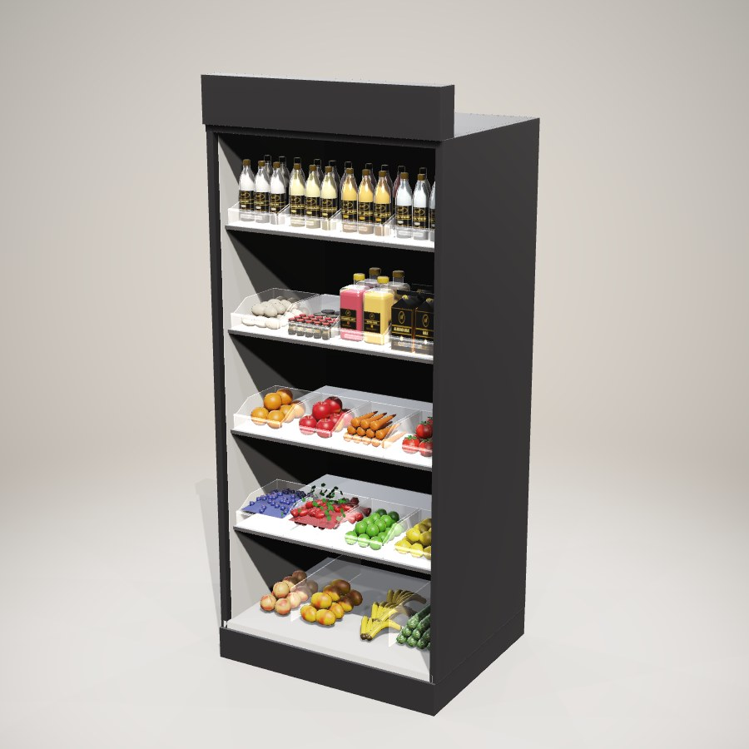

Freezer
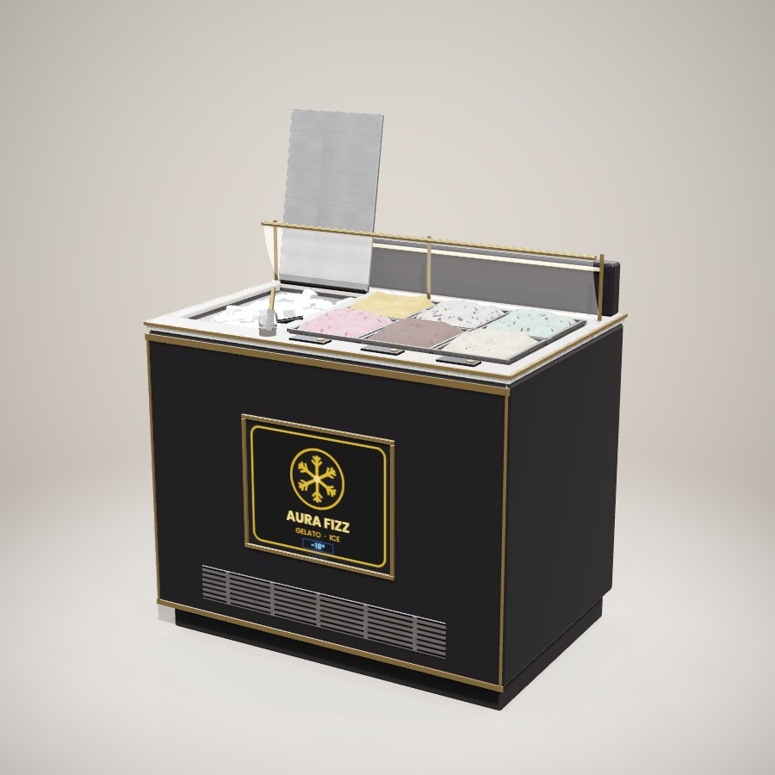

Pantry
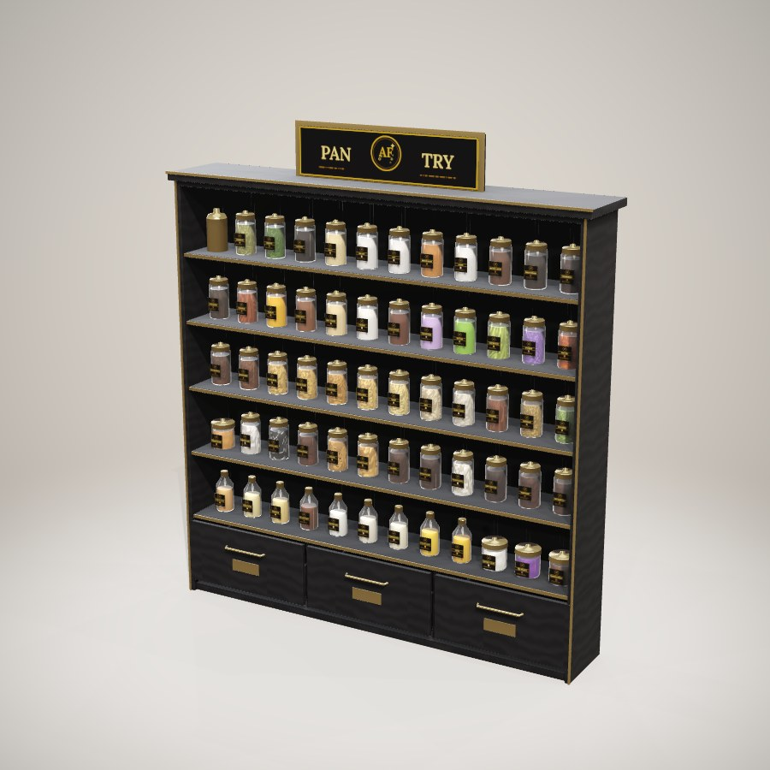

Cup Rack
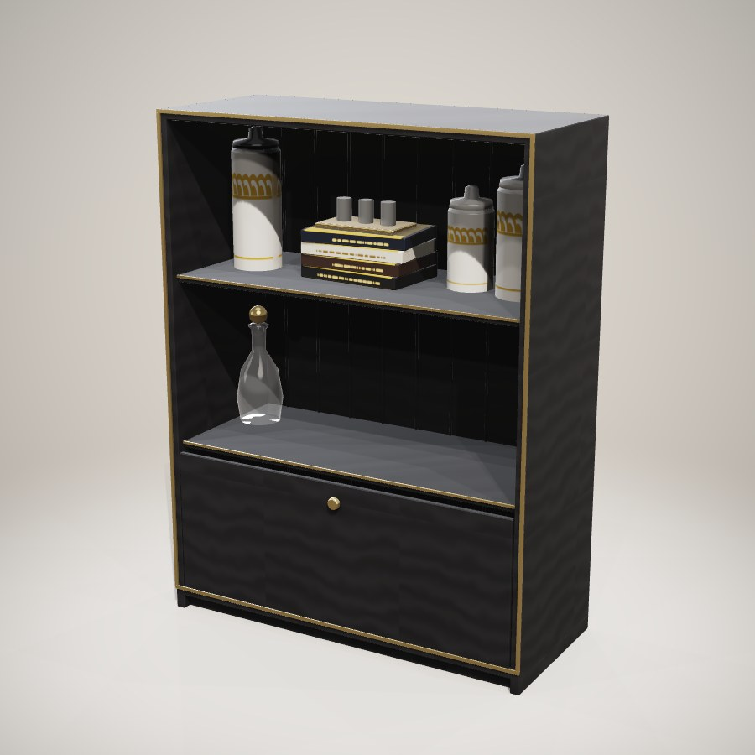

Cutting Board
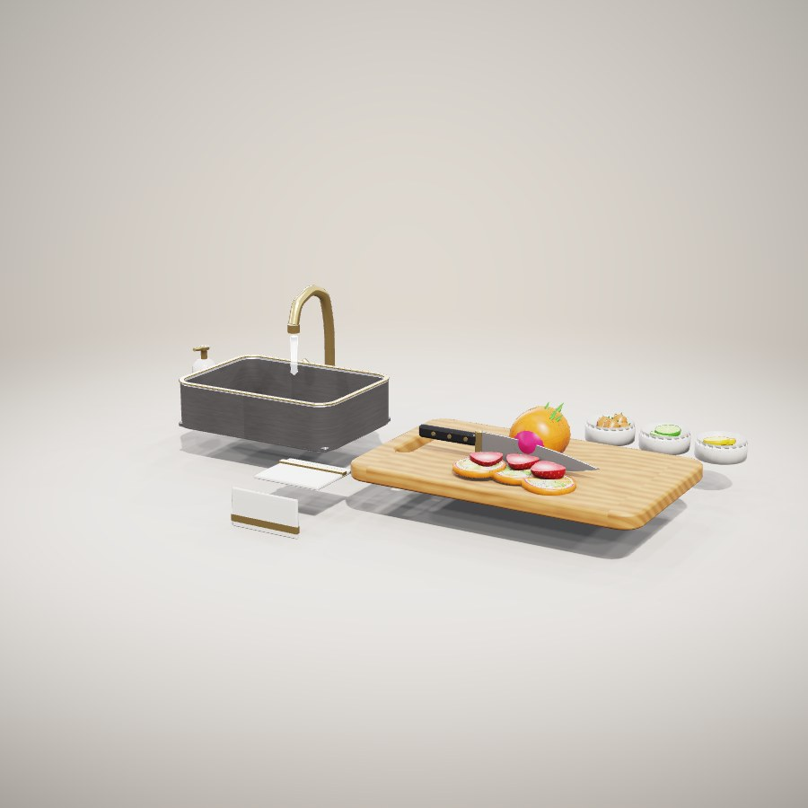

Blender
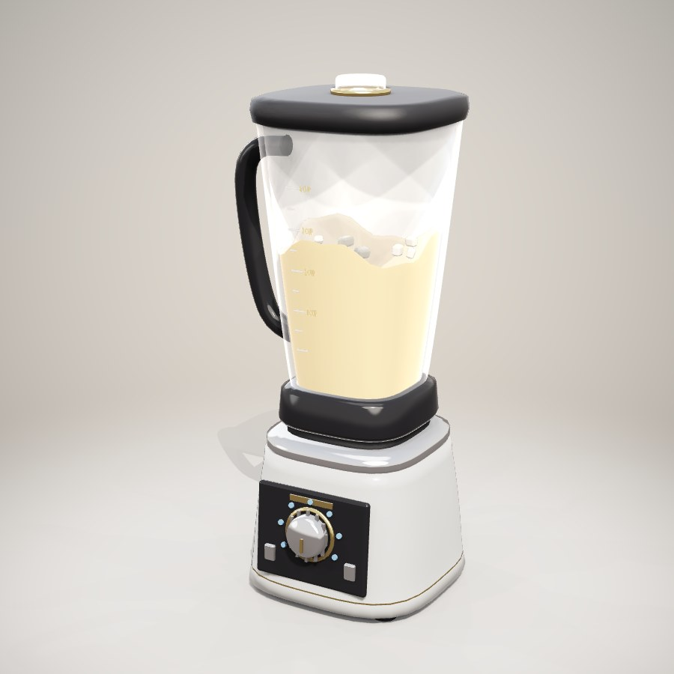

Juicer
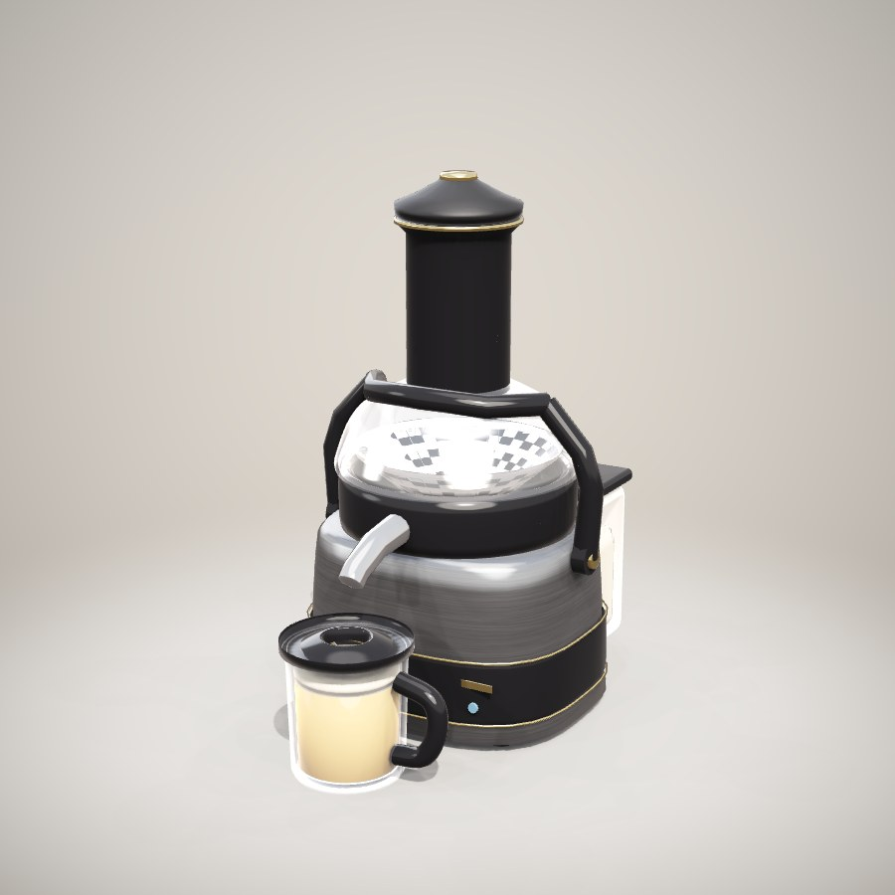

Coffee Machine
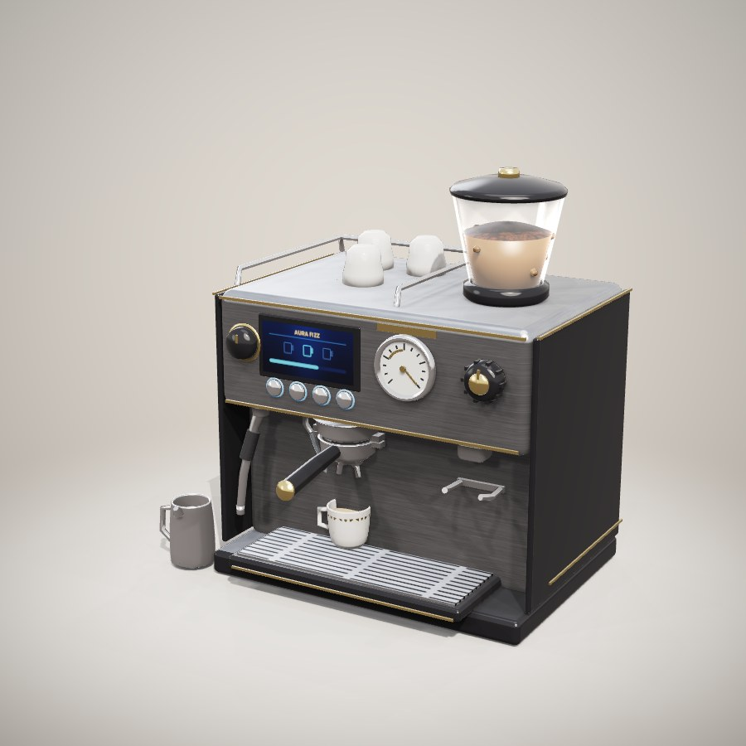

Stove
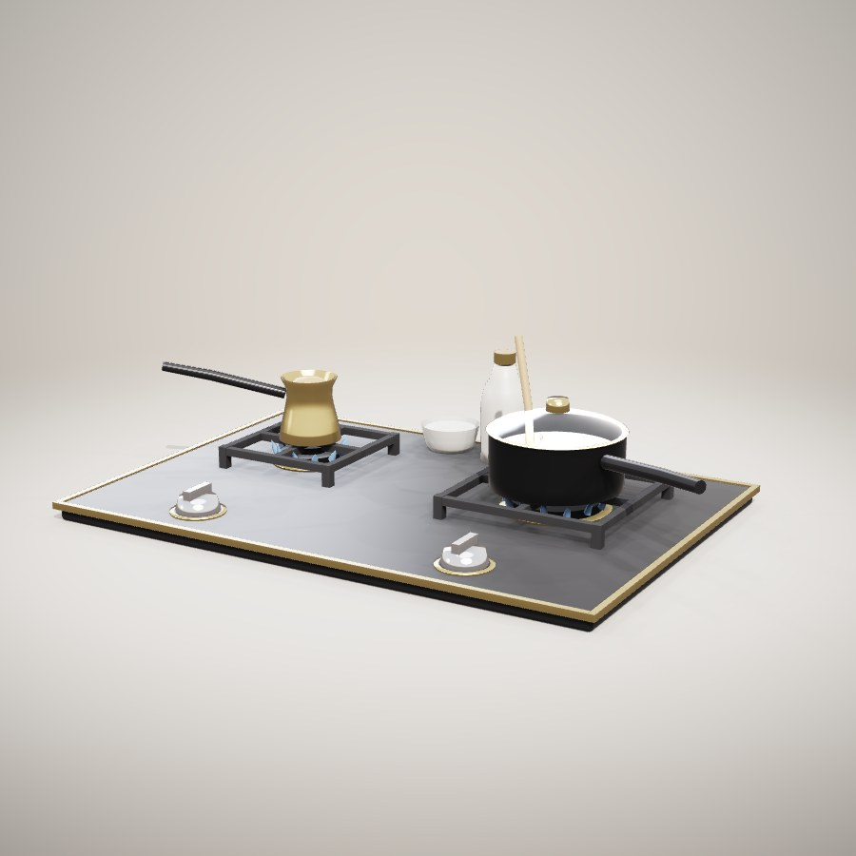

Mixing Station
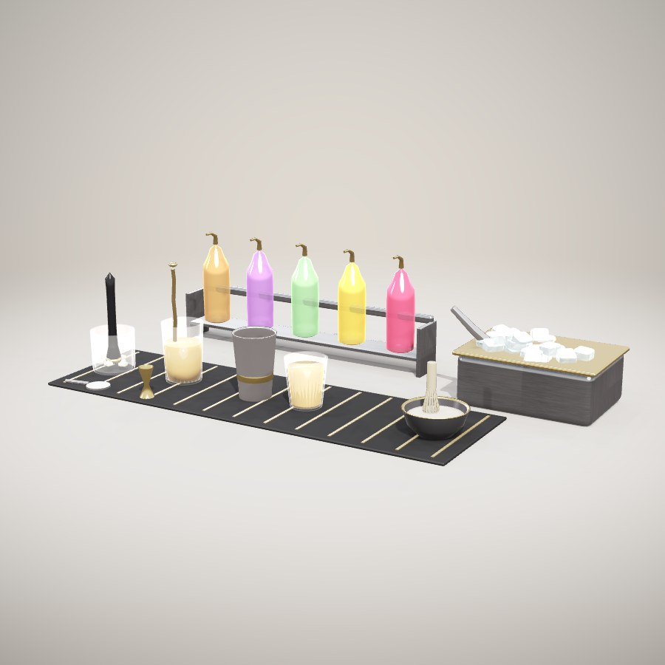

Tea & Boba Station
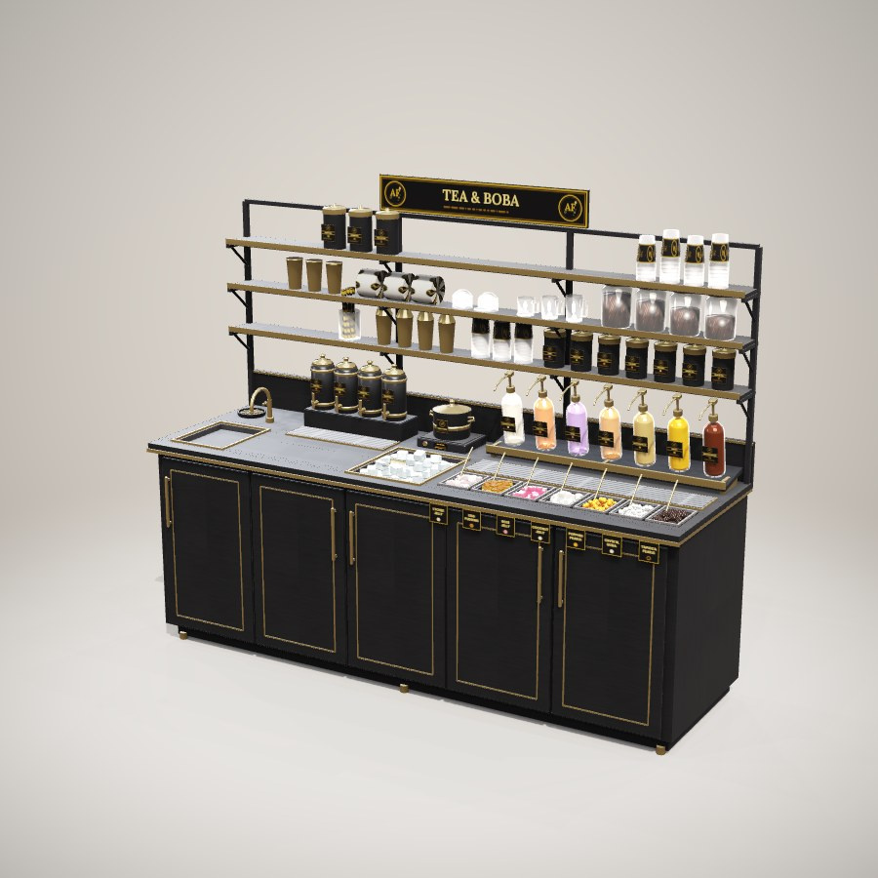

Soda Fountain
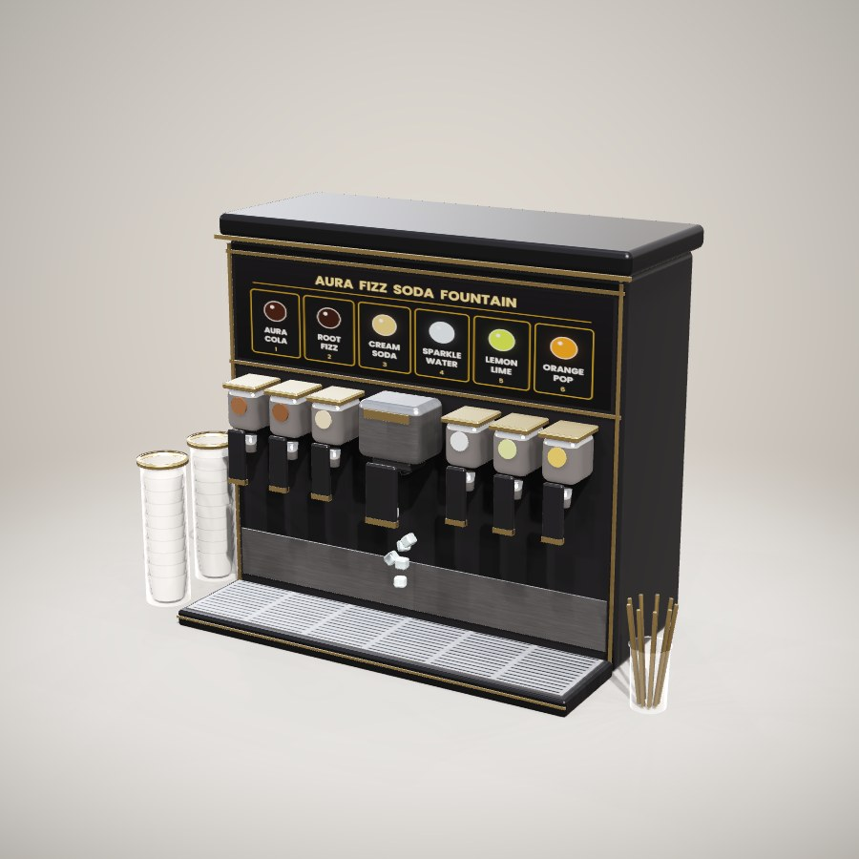

Topping Station
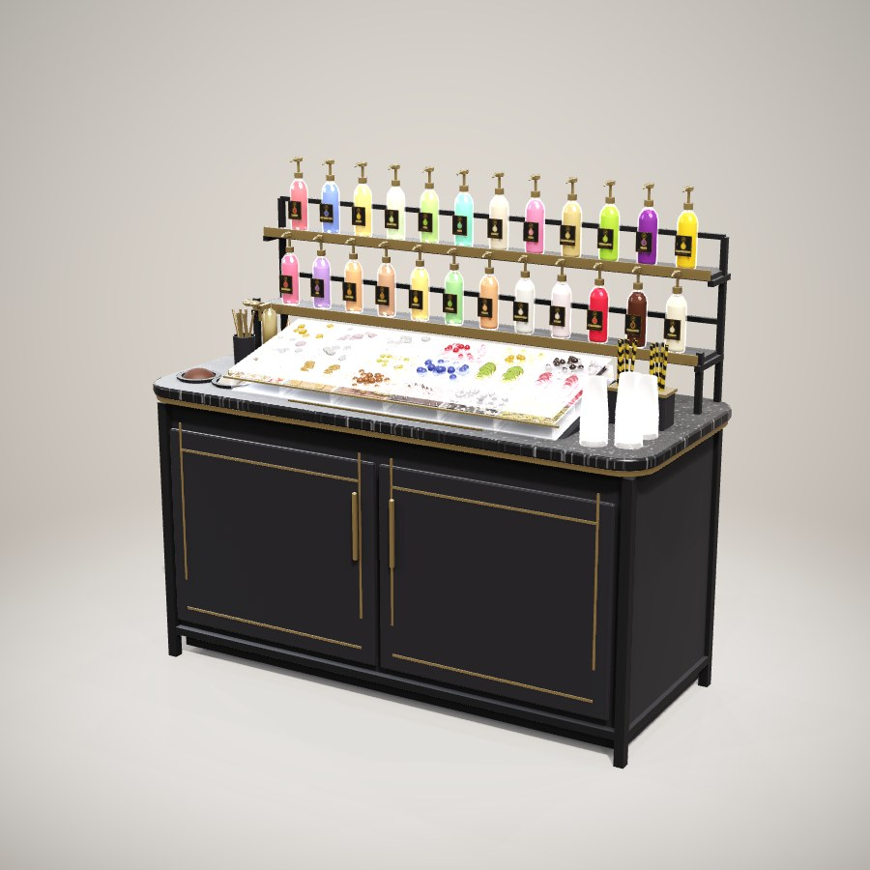

Cup Sealer
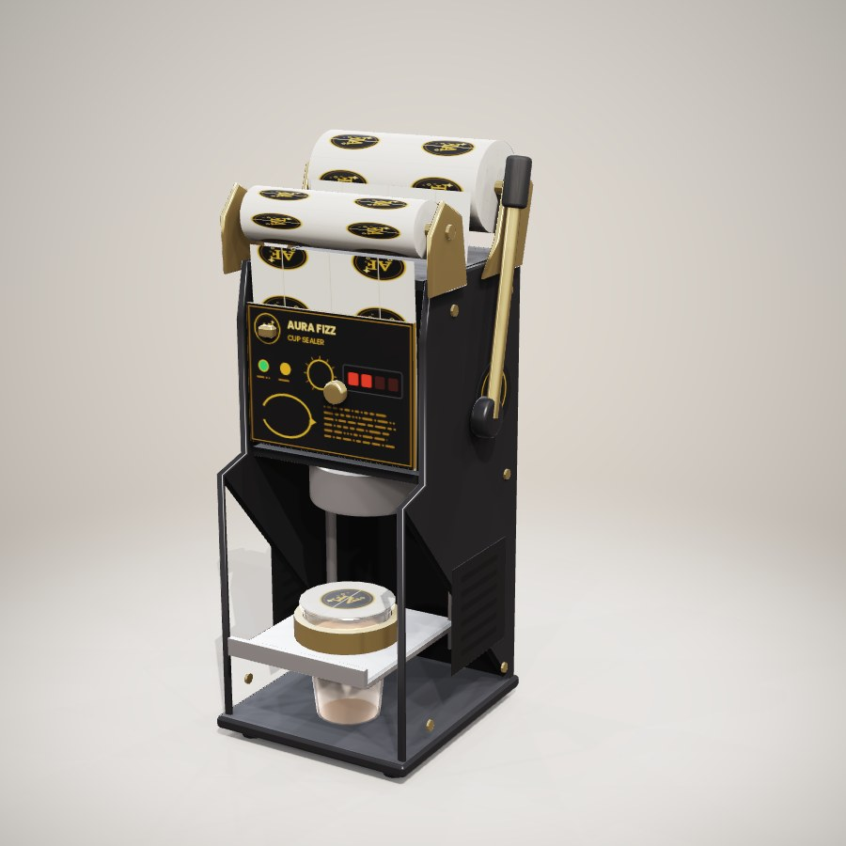

Brew Barrel
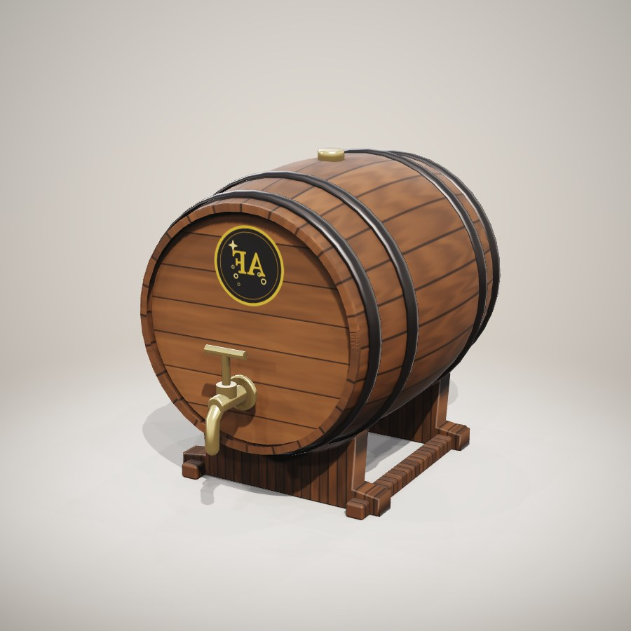

Bar Shelf
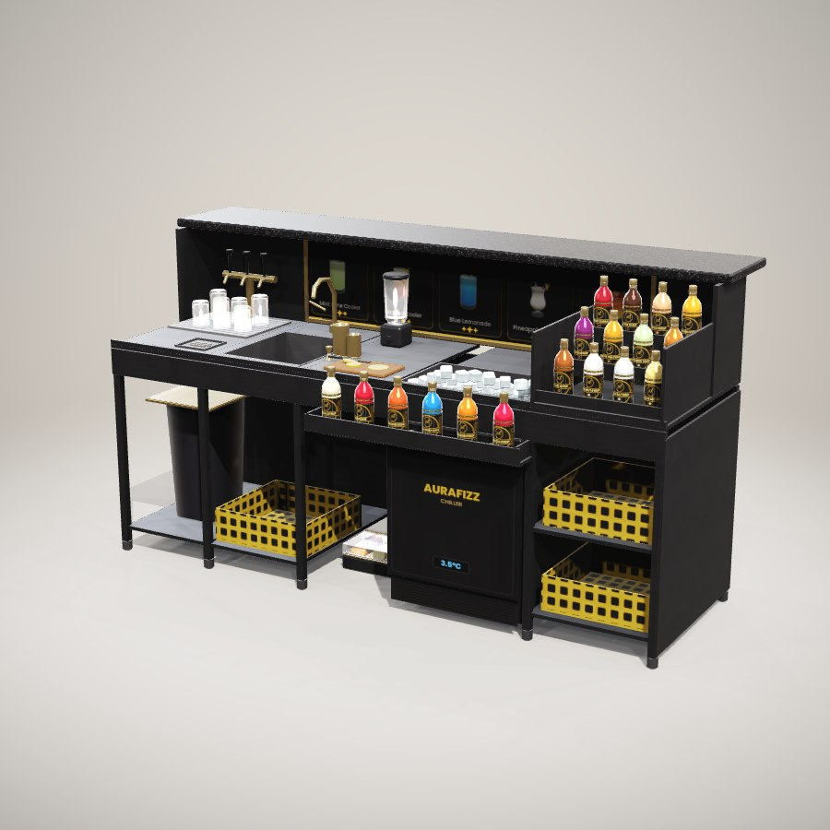

Checkout and serving

Cashier (POS) Terminal
[image: POS Terminal]

Card Terminal
[image: Card Terminal]

Cash Drawer
[image: Cash Drawer]

Receipt Printer
[image: Receipt Printer]

Self-Serve Kiosk
[image: Self-Serve Kiosk]

Trash Can
[image: Trash Can]

