AdLift
  - Advertising Incrementality and Uplift Targeting
Final Project Report
Criteo Uplift Prediction Dataset v2.1 | September 2026
A reproducible benchmark analysis of randomized advertising effects, heterogeneous treatment effect ranking, and budget-constrained targeting decisions.
Data source: Diemert et al. (2018), Criteo Uplift Prediction Dataset v2.1, CC BY-NC-SA 4.0.

Executive Summary
This project evaluates two related questions. First, does randomized advertising assignment increase visits and conversions in the released benchmark population? Second, can an uplift model rank records so that a limited advertising budget captures more incremental outcomes than conventional response targeting? The analysis uses all 13,979,592 released records and evaluates frozen model rankings on a held-out test set of 2,795,749 records.
Advertising assignment produced positive average effects for both outcomes. Visit rate increased by 1.034 percentage points, a 27.1% relative lift. Conversion rate increased by 0.115 percentage points, a 59.4% relative lift. These estimates use randomized treatment assignment and are statistically precise in the released sample.
For Visit targeting, the S-Learner is the best-supported operational ranking. Its global Qini exceeds response propensity by 645 incremental-visit area units, with a 2,000-draw paired 95% interval of 413 to 883. Targeting the top 10% estimates 17,919 incremental visits and improves on response targeting by 3,805 visits, with a paired 95% interval of 2,804 to 4,829. For Conversion, the uplift learners do not beat response propensity; response targeting remains the supported ranking.

Decision question | Evidence-based conclusion
Does advertising create average lift? | Yes for both Visit and Conversion in the released randomized benchmark.
Which uplift learner is preferred? | S-Learner for Visit; it is simpler than the point-Qini-leading pooled X-style model and is not meaningfully worse in paired comparison.
Does uplift improve targeting? | Yes for Visit, especially at 5% and 10% budgets. No demonstrated advantage for Conversion.

Business Question
Response targeting asks who is likely to act. Uplift targeting asks whose behavior advertising is likely to change. This distinction matters when advertising capacity is limited: a high-response user may convert without advertising, while a lower-response user may be persuadable.
The project measures whether a causal ranking can allocate a fixed targeting budget more efficiently than random selection or a response-propensity model. Visit and Conversion are evaluated separately because a ranking that increases traffic may not maximize the rarer downstream conversion outcome.

Data and Experimental Design

Dataset and analysis population
The analysis uses the public Criteo Uplift Prediction Dataset v2.1. After data cleaning, each record contains twelve anonymized pre-treatment features, randomized treatment assignment, post-assignment exposure, Visit, and Conversion. All 13,979,592 records are retained. The unit of analysis is a released benchmark record;

A/B Test Design and Causal Estimand
The first analytical stage is a randomized A/B test at the record level. Treatment assigns the advertising platform to enter the auction and attempt to serve an ad; Control represents no auction participation under that strategy. Visit and Conversion are binary outcomes measured after assignment. The primary estimand is the intent-to-treat effect, E[Y(1) − Y(0)], estimated as the Treatment outcome rate minus the Control outcome rate. Exposure records whether an ad was delivered after assignment, so it is a post-treatment mediator and is not used to redefine the randomized groups.
For each outcome, the two-sided null hypothesis is H₀: pTreatment − pControl = 0. Absolute lift is p₁ − p₀, and relative lift is (p₁ − p₀) / p₀. Uncertainty is summarized with unpooled 95% confidence intervals and two-proportion tests, while observable randomization balance is assessed across the twelve pre-treatment features. No CUPED or regression-adjusted average effect is reported because the release has no validated pre-period outcome or time field suitable for that adjustment.

Train validation and test separation
A seeded hash of the twelve pre-treatment features assigns records to approximately 60% train, 20% validation, and 20% test. Identical feature vectors receive the same hash and cannot cross partitions. Only f0 through f11 may enter a model matrix. Exposure, outcomes, row identifiers, and partition labels are excluded as predictive features.
Partition | Treatment | Control | Permitted use
Train | 7,130,304 | 1,258,910 | Fit model parameters
Validation | 2,375,820 | 418,809 | Early stopping and constrained model development
Test | 2,376,531 | 419,218 | Score frozen models, then evaluate rankings

Data quality checks
The preparation pipeline verifies the expected schema, finite features, binary treatment and outcomes, Conversion nesting within Visit, and the absence of exposed controls. It also checks treatment balance and preserves repeated feature profiles because a feature-level duplicate is not evidence that two released advertising records represent the same event. The largest absolute standardized mean difference across the twelve features is 0.0488.
Figure 1 Standardized feature balance by randomized treatment assignment
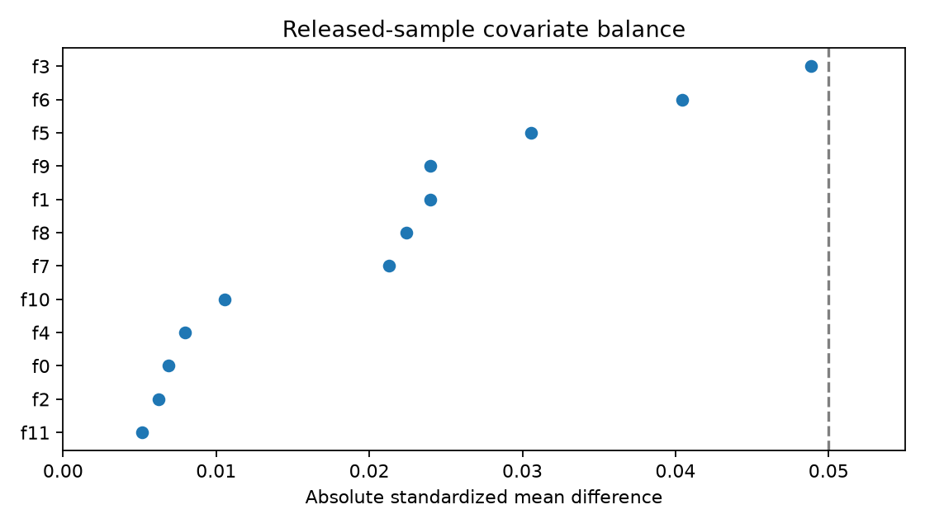

Average Advertising Incrementality
Both outcomes show positive treatment-control differences. Confidence intervals are unpooled analytical 95% intervals and agree closely with treatment-stratified bootstrap intervals. Incremental counts are aggregate counterfactual estimates; no individual record’s treated and untreated outcomes are jointly observable.
Outcome | Control rate | Treatment rate | Absolute lift | 95% interval | Relative lift | Incremental among treated
Visit | 3.820% | 4.854% | 1.034 pp | 1.006 to 1.063 pp | 27.07% | 122,895
Conversion | 0.194% | 0.309% | 0.115 pp | 0.108 to 0.122 pp | 59.45% | 13,687

Figure 2 Randomized treatment-control effects for Visit and Conversion
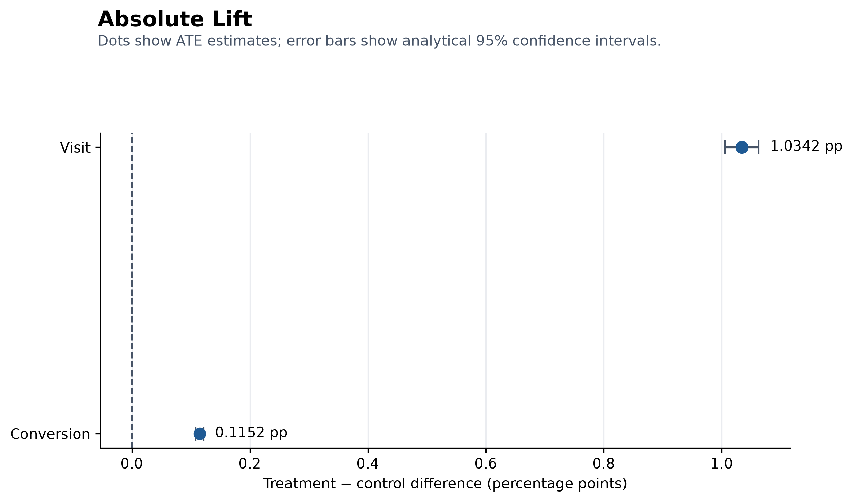

Prediction → Experiment → Policy Validation
The workflow separates three different decision tasks. Response prediction estimates who is likely to Visit or Convert; the randomized A/B test establishes whether advertising creates average causal lift; and uplift modeling ranks whose behavior is most likely to change because of treatment. The selected targeting rule is then compared with random and response-based policies on held-out data and should be validated prospectively in a new randomized policy test before deployment.

Uplift Modeling
Separate LightGBM models are fitted for Visit and Conversion. The S-Learner estimates one response function using features and treatment, then subtracts predictions under treatment and control. The T-Learner fits separate treatment and control response functions. The historical x_learner artifact is a pooled X-style model fitted to imputed-effect pseudo-outcomes; it is not the canonical two-effect-regressor, propensity-blended X-Learner.
Model | Construction | Role in the comparison
S-Learner | One response model scored at treatment 1 and treatment 0 | Simple heterogeneous-effect ranking
T-Learner | Separate response models for treatment and control | Allows arm-specific response functions
Pooled X-style | One effect model fitted to pooled imputed-effect targets | Flexible effect ranking with higher complexity
Response propensity | Predicted factual response probability | Conventional targeting benchmark
Constant and segment baselines | Overall ATE or validation-selected segment effects | Structural reference strategies

Evaluation Logic and Metrics
Individual treatment effects cannot be observed directly. Phase 4 therefore evaluates ranking quality by comparing randomized treatment and control outcomes within score-ranked groups. Group 1 always contains the highest predicted uplift, with a deterministic tie-breaker based on the technical row identifier.
- Selected-group uplift is the treatment outcome rate minus the control outcome rate among selected records.
- Cumulative gain equals the number of selected records multiplied by selected-group uplift.
- AUUC is the area under the cumulative-gain curve.
- Qini is AUUC minus one half of the common 100% gain endpoint, so it measures gain above random targeting.
- Uplift captured divides cumulative gain by the common 100% endpoint.
- Paired bootstrap intervals resample joint fixed-ranking cells so strategy differences remain paired on the same test population.
Every valid ranking must end at Ntest × ATEtest when 100% of the test population is selected. This identity is an important audit check for treatment direction, denominator consistency, and common model populations. The paired bootstrap conditions on the fitted models and fixed ranking bins; it does not include training, model-selection, threshold-selection, or hidden cluster uncertainty.

Model Comparison

Visit ranking
The pooled X-style learner has the highest point Qini, but its paired advantage over the simpler S-Learner is unresolved. Under the prespecified simplicity rule, the S-Learner is preferred. Its Qini is 10,550, exceeding response propensity by 645; the 2,000-draw paired 95% interval for the difference is 413 to 883.
Figure 3 Visit Qini curves relative to random targeting
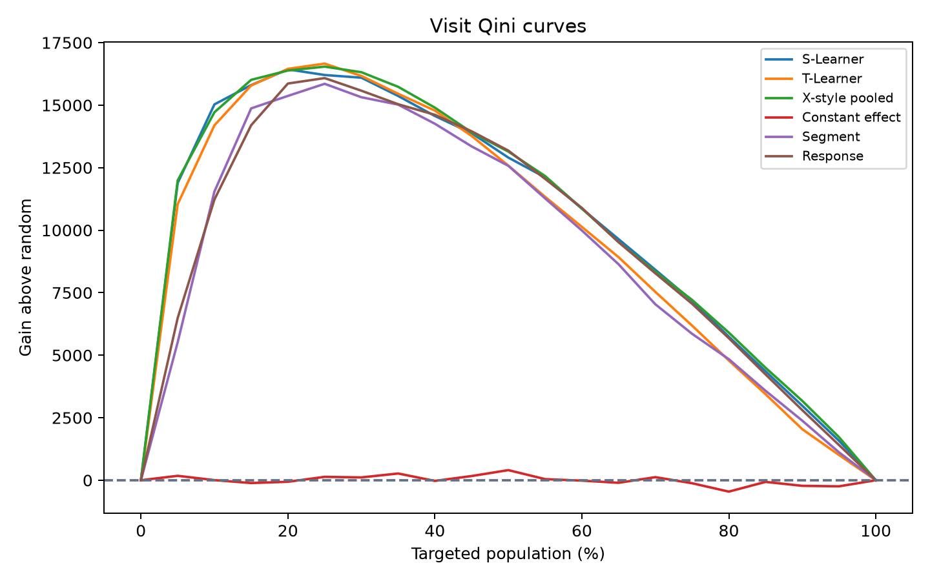

Conversion ranking
The S-Learner leads the uplift learners for Conversion but does not beat response propensity. Its Qini disadvantage is 9.99, with a 2,000-draw paired 95% interval of −18.78 to −0.99. Response propensity is therefore the supported Conversion ranking under this exploratory analysis.
Figure 4 Conversion Qini curves relative to random targeting
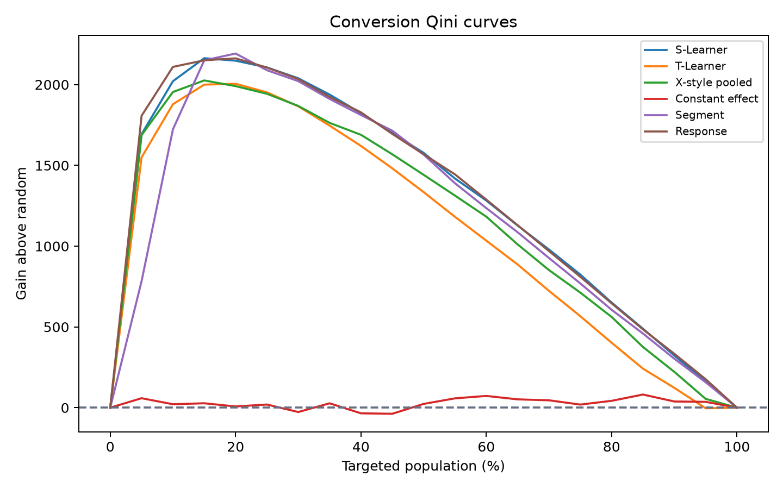

Targeting Decisions
The following tables place every reported targeting fraction on one decision scale. Higher coverage usually increases total incremental outcomes while reducing incremental yield per selected record. Because cost and revenue are unavailable, these tables support capacity scenarios rather than an economically optimal budget.

Visit policy using the S Learner
Target | Selected records | Selected uplift | Incremental visits | Uplift captured | Gain above random
5% | 139,788 | 9.535 pp | 13,329 | 46.1% | 11,884
10% | 279,575 | 6.409 pp | 17,919 | 62.0% | 15,030
20% | 559,150 | 3.972 pp | 22,208 | 76.9% | 16,429
30% | 838,725 | 2.953 pp | 24,765 | 85.7% | 16,097
40% | 1,118,300 | 2.336 pp | 26,123 | 90.4% | 14,565
50% | 1,397,875 | 1.956 pp | 27,349 | 94.7% | 12,902
75% | 2,096,812 | 1.376 pp | 28,846 | 99.8% | 7,176
100% | 2,795,749 | 1.033 pp | 28,893 | 100.0% | 0

At a 10% budget, the ranking captures 62.0% of the estimated full-population endpoint while serving 10% of records. Moving from 10% to 30% increases estimated incremental visits from 17,919 to 24,765, but selected-group uplift falls from 6.409 to 2.953 percentage points.
Figure 5 Visit targeting outcomes at the main budget levels
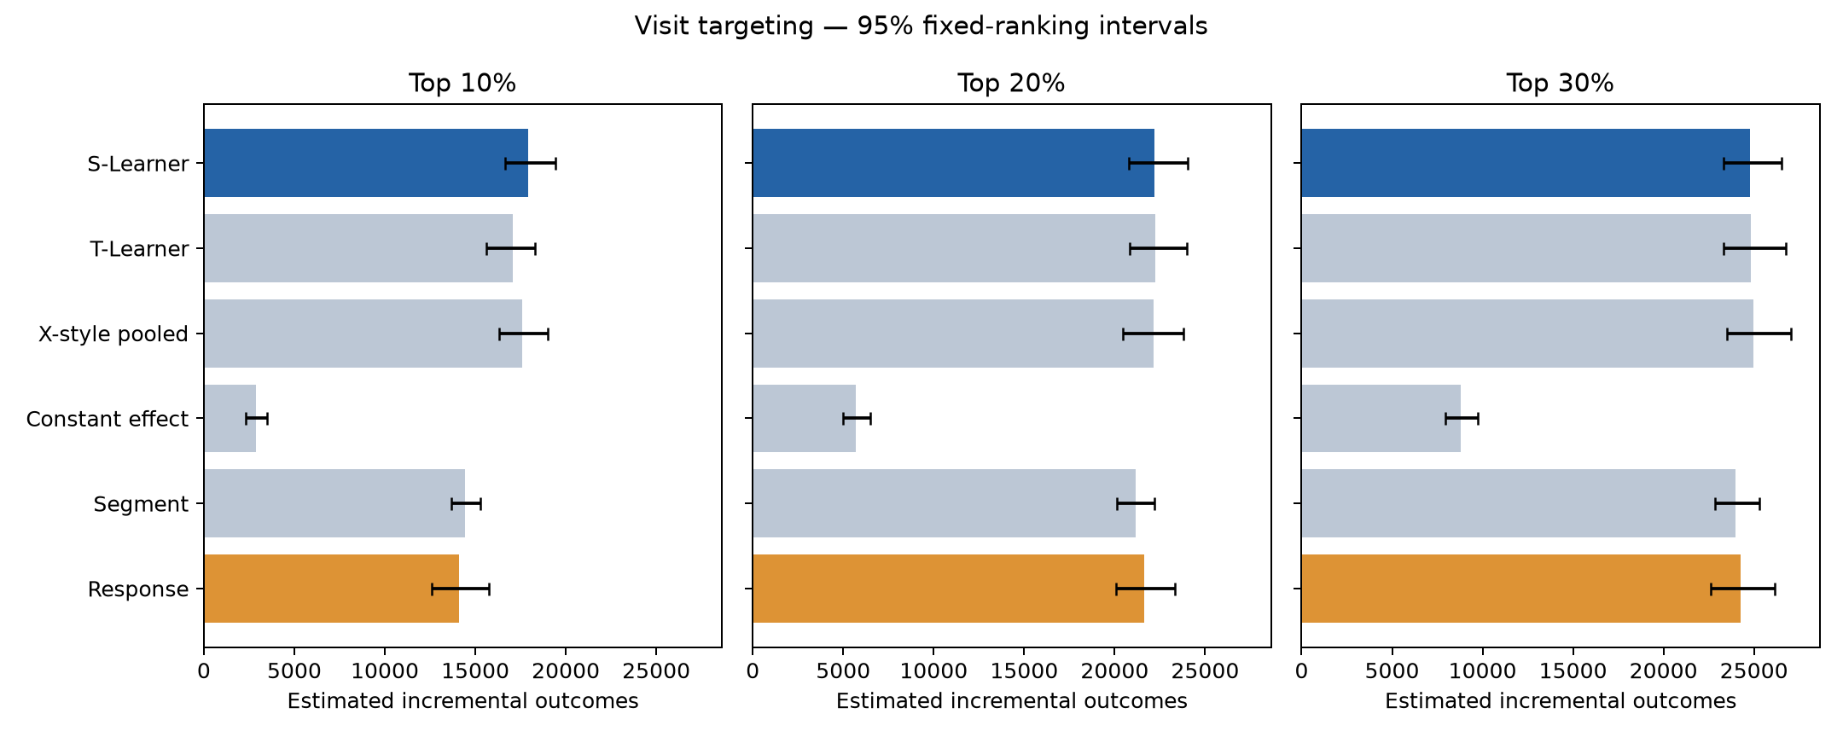

Conversion policy using response propensity
Target | Selected records | Selected uplift | Incremental conversions | Uplift captured | Gain above random
5% | 139,788 | 1.410 pp | 1,972 | 59.8% | 1,807
10% | 279,575 | 0.872 pp | 2,439 | 74.0% | 2,109
20% | 559,150 | 0.505 pp | 2,822 | 85.6% | 2,162
30% | 838,725 | 0.360 pp | 3,023 | 91.7% | 2,034
40% | 1,118,300 | 0.281 pp | 3,147 | 95.5% | 1,828
50% | 1,397,875 | 0.230 pp | 3,217 | 97.6% | 1,569
75% | 2,096,812 | 0.157 pp | 3,283 | 99.6% | 810
100% | 2,795,749 | 0.118 pp | 3,296 | 100.0% | 0

Response propensity is shown because it is the supported Conversion ranking. Its concentration of incremental conversions among high-response records does not establish that an uplift learner improves Conversion targeting.
Figure 6 Conversion targeting outcomes at the main budget levels
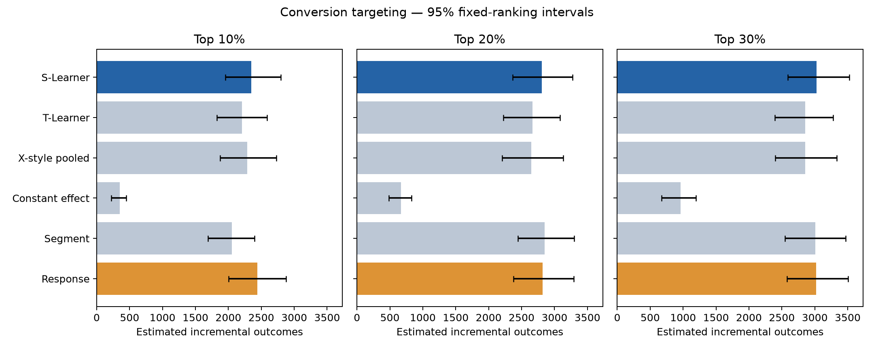

Direct comparison with response targeting
Outcome | Uplift model | Target | Difference | Paired 95% interval | Interpretation
Visit | S-Learner | 5% | +5,400 | 4,400 to 6,452 | Clear uplift advantage
Visit | S-Learner | 10% | +3,805 | 2,804 to 4,829 | Clear uplift advantage
Visit | S-Learner | 20% | +566 | −104 to 1,281 | Unresolved
Visit | S-Learner | 30% | +521 | 46 to 1,029 | Positive but marginal
Conversion | S-Learner | 5% | −114 | −186 to −37 | Response is better
Conversion | S-Learner | 10% | −89 | −147 to −31 | Response is better
Conversion | S-Learner | 20% | −15 | −56 to 28 | Unresolved
Conversion | S-Learner | 30% | +4 | −16 to 27 | Unresolved

The 5% comparison was added after the initial test review. All budget comparisons therefore remain exploratory, even where the fixed-ranking intervals exclude zero.

Cross Objective Policy Comparison
Visit and Conversion S-Learner scores have a Spearman rank correlation of 0.888. At 30% coverage, the policies share 84.7% of selected records. The agreement is high, but the remaining differences can matter for rare conversions. Objective-specific evaluation should therefore be retained rather than assuming one universal advertising ranking.
Figure 7 Overlap between Visit and Conversion targeting policies
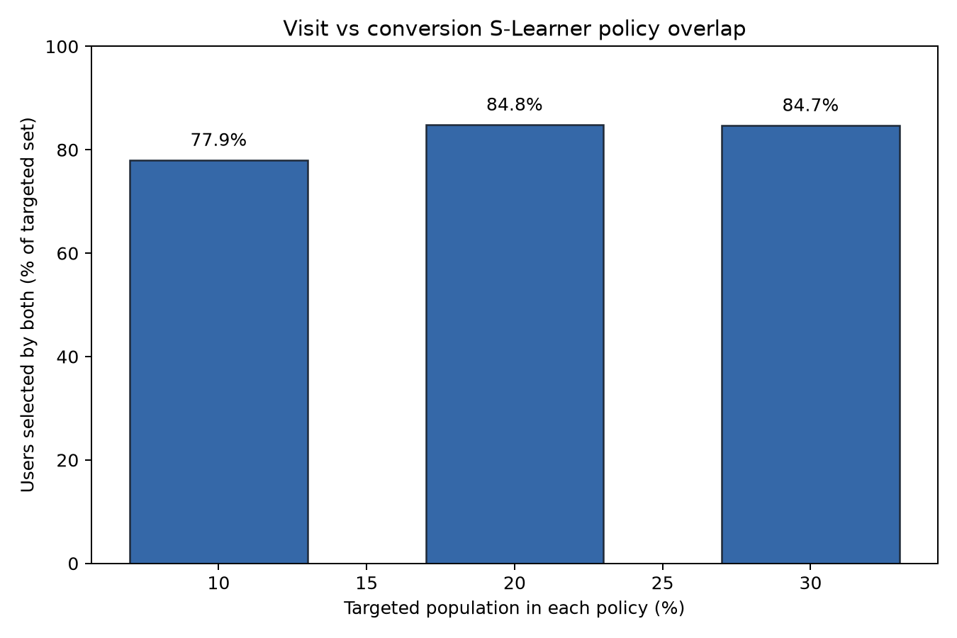

Business Recommendation
For a Visit objective with a constrained budget, advance the S-Learner ranking to prospective validation. The strongest evidence is at 5% and 10% coverage, where it clearly outperforms response targeting. The choice between those budgets must depend on capacity, cost, and value per incremental visit, none of which are available in the public dataset.
For a Conversion objective, retain response propensity as the benchmark challenger. The tested uplift learners do not improve global Qini and perform worse at the tightest budgets. Further Conversion model development should occur on validation data or new data rather than through repeated test-set comparison.

Reproducibility and Audit
The repository separates executable scripts, reusable source modules, reader-facing notebooks, generated result tables, figures, and audit evidence. The environment is declared in pyproject.toml and locked by uv.lock. Raw data and trained artifacts remain local. The checked-in tables and figures can be reviewed without downloading the dataset.
An independent row-level reconciliation recomputed cumulative gain, group effects, AUUC, Qini, and paired uncertainty from 2,795,749 held-out records for each outcome. All 11 analytical guardrail tests pass. The four notebooks execute successfully and contain no code-cell errors. The published result-file fingerprints remained unchanged during the final code refactor.
Audit control | Purpose
Feature allowlist | Prevents exposure, outcome, split, and row-ID leakage
Null test outcomes in score artifacts | Prevents held-out labels from influencing model scoring
Ranking direction and deterministic ties | Ensures the highest scores are selected consistently
Common 100% endpoint | Detects treatment-direction, denominator, or population mismatches
Paired bootstrap differences | Preserves dependence among rankings evaluated on the same records
Independent reconciliation | Recomputes saved tables from row-level scores and outcomes

Conclusion
The randomized experiment shows that advertising creates measurable incremental value, increasing Visit rate by 1.034 percentage points and Conversion rate by 0.115 percentage points. The targeting analysis further demonstrates that this value can be allocated more efficiently when the business objective is Visit growth: targeting the top 10% of records ranked by the S-Learner captures 62.0% of the estimated full-population incremental visits, generating approximately 17,919 incremental visits and 3,805 more than conventional response targeting while serving only 10% of the population. This indicates a meaningful opportunity to reduce unnecessary advertising exposure or concentrate a limited budget on users whose behavior is more likely to change. The same conclusion does not extend to Conversion, where the tested uplift learners fail to outperform response propensity and perform significantly worse at the tightest budgets. The recommended strategy is therefore objective-specific: advance the S-Learner to prospective validation for Visit-focused campaigns, while retaining response propensity as the Conversion benchmark.

