Next.js Rendering Concepts & Data Flow Architecture
A Comprehensive Deep-Dive into Data Flow Timelines, System Components, Caching Tiers & Visual Diagrams
💡 Executive Summary
In modern Next.js (App Router focus, alongside Pages Router paradigms), rendering is no longer a monolithic choice made per project. Instead, Next.js operates on a hybrid, component-level rendering architecture where different routes and even different sections of a single page can be rendered using different strategies: SSG, SSR, ISR, CSR, Streaming, and Partial Prerendering (PPR). Understanding WHERE data is fetched, WHEN it is accessed, and WHAT component serves it is essential to building scalable, high-performance web applications.

Master Rendering Strategy Matrix
Strategy | Data Access Time | Serving Component | Payload Type | TTFB Latency
SSG (Static) | Build Time | CDN / Edge Network | Static HTML + RSC Payload | Ultra Low (~0ms)
SSR (Dynamic) | Request Time | Node.js / Edge Server | Dynamic HTML + RSC Stream | Medium (~50-200ms)
ISR (Regen) | Background Revalidate | CDN + Node.js Data Cache | Revalidated Static HTML | Ultra Low (Stale Hit)
CSR (Client) | Post-Hydration | Browser DOM (fetch/SWR) | JSON Data over REST/GraphQL | Instant Shell, Slow Data
Streaming SSR | Request Time (Chunked) | Node.js Server + React | Progressive HTML + Scripts | Instant Shell (<50ms)
PPR (Partial) | Build + Request Time | CDN Shell + Node Stream | Static Shell + Inline Hole Stream | Instant Shell (0ms)

1. Static Site Generation (SSG) / Static Rendering
Data Access Time: | Build Time (during next build execution or initial deployment)
Access Location / Runtime: | Node.js Build Worker -> Pushed to CDN / Edge Global Storage
Serving Component: | CDN Edge Storage Engine (serves static assets directly without server compute)
Payload Type Returned: | Pre-rendered static HTML document + static `.rsc` payload JSON
Primary Cache Tier: | Full Route Cache (Persisted permanently until next deployment)

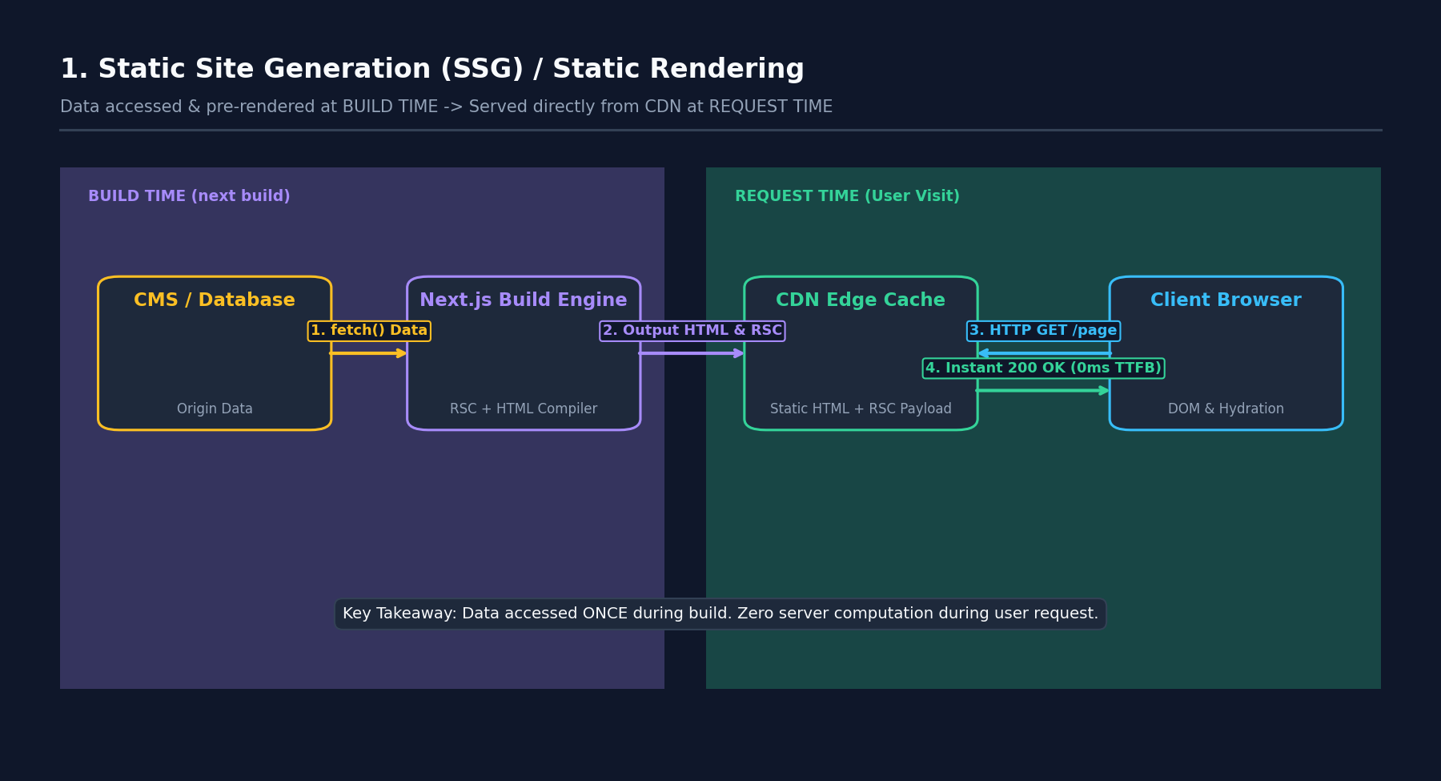
Technical Architecture & Data Flow
Static Site Generation pre-computes HTML and React Server Component (RSC) payloads during build time. When a user requests the route, the Edge CDN returns the pre-generated static files directly from edge memory. This achieves 0ms server execution time and minimum TTFB (Time to First Byte).
Implementation Pattern
// App Router: Static Rendering by default (when no dynamic functions are used)
export default async function Page() {
const data = await fetch('https://api.example.com/posts').then(res => res.json());
return <div>{data.title}</div>;
}

2. Server-Side Rendering (SSR) / Dynamic Rendering
Data Access Time: | Request Time (on every single incoming HTTP GET request from a client browser)
Access Location / Runtime: | Node.js Server Runtime OR Edge Runtime (evaluating live request headers, cookies, params)
Serving Component: | Next.js RSC Execution Engine + Server Runtime Environment
Payload Type Returned: | Dynamically rendered HTML stream + serialized RSC payload
Primary Cache Tier: | Bypasses Full Route Cache. May read from Data Cache if specific fetch calls are cached.

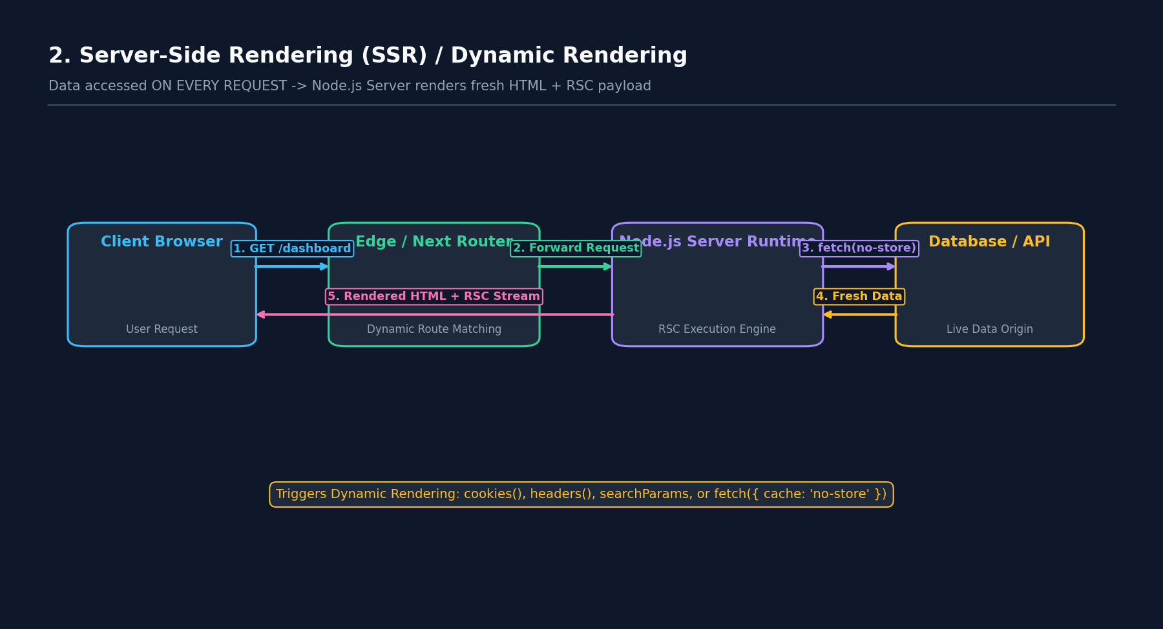
Technical Architecture & Data Flow
Dynamic Rendering executes on the server for every incoming request. It is automatically triggered when a page accesses request-specific context like cookies(), headers(), searchParams, or calls fetch() with { cache: 'no-store' } or revalidate: 0. This ensures users always receive real-time, up-to-the-second data.
Implementation Pattern
import { cookies } from 'next/headers';
export default async function DynamicPage() {
const cookieStore = cookies();
const token = cookieStore.get('token');
const res = await fetch('https://api.example.com/user', { cache: 'no-store' });
const user = await res.json();
return <div>Welcome {user.name}</div>;
}

3. Incremental Static Regeneration (ISR)
Data Access Time: | Background Revalidation Time (triggered by time interval or on-demand webhook)
Access Location / Runtime: | CDN Edge (serves stale) -> Next.js Data Cache Background Worker (re-fetches origin)
Serving Component: | Next.js Data Cache Manager + Node.js Background Regenerator
Payload Type Returned: | Updated Static HTML + Updated RSC Payload
Primary Cache Tier: | Data Cache + Full Route Cache (Stale-While-Revalidate pattern)

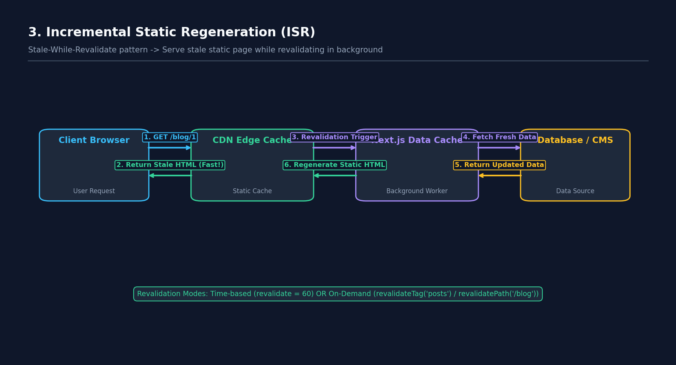
Technical Architecture & Data Flow
ISR enables static pages to be updated in the background without needing a full site rebuild. Next.js serves stale static content immediately to the requesting user while asynchronously triggering a background regeneration in the Node.js server. Once regenerated, the CDN cache is updated for subsequent visitors.
Implementation Pattern
// Time-based ISR (Revalidate every 60 seconds)
export const revalidate = 60;
// On-Demand ISR (via Server Action or API route)
import { revalidateTag, revalidatePath } from 'next/cache';
revalidateTag('posts-tag');
revalidatePath('/blog');

4. Client-Side Rendering (CSR) & React Hydration
Data Access Time: | Post-Hydration Time (executes inside the browser AFTER initial page load)
Access Location / Runtime: | Client Browser V8 Engine (using fetch(), SWR, React Query, or Axios)
Serving Component: | Browser DOM + React Client Runtime (useState, useEffect, Event Listeners)
Payload Type Returned: | Raw JSON data payload from API endpoints
Primary Cache Tier: | Browser HTTP Cache / In-memory React State / SWR Cache

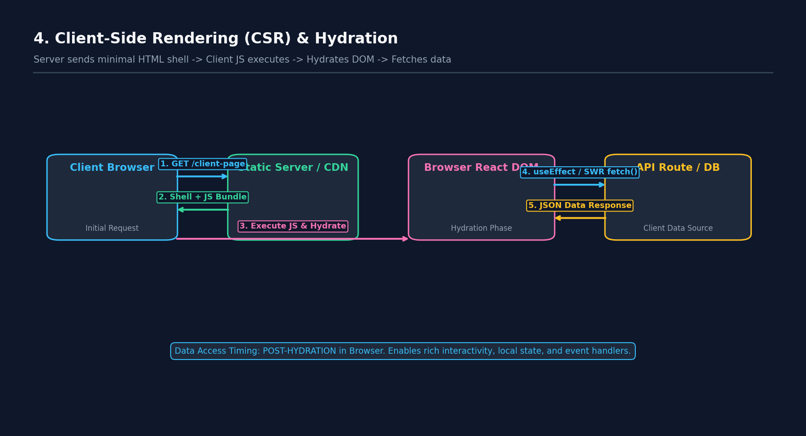
Technical Architecture & Data Flow
Client-Side Rendering delegates data fetching and UI rendering to the user's browser. The server returns a lightweight HTML shell and JavaScript bundle. Once downloaded, React hydrates the DOM nodes, attaches event handlers, and executes useEffect or data-fetching hooks to populate state.
Implementation Pattern
'use client';
import { useState, useEffect } from 'react';
export default function ClientComp() {
const [data, setData] = useState(null);
useEffect(() => {
fetch('/api/data').then(res => res.json()).then(setData);
}, []);
return <div>{data ? data.value : 'Loading...'}</div>;
}

5. React Server Components (RSC) vs Client Components Architecture
Data Access Time: | Server Component Execution: Server Request Time. Client Component Execution: Browser Hydration Time.
Access Location / Runtime: | RSC: Node.js Server Environment. Client Components: Browser DOM.
Serving Component: | React Server Components Serializer Engine vs Client Hydration Engine
Payload Type Returned: | Specialized ASCII-serialized RSC Stream Payload containing component hierarchy and props
Primary Cache Tier: | Server Component execution results cached in Full Route Cache; Client component JavaScript bundled into client chunks.

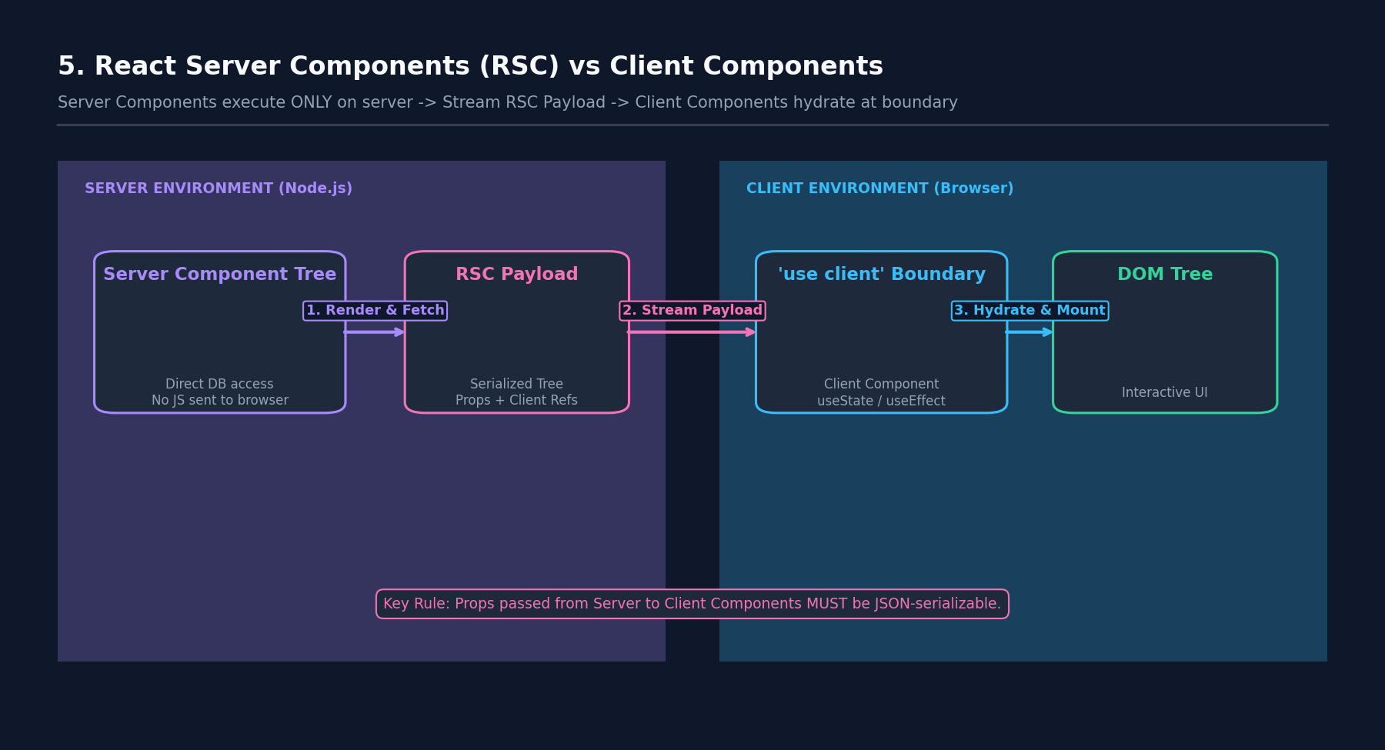
Technical Architecture & Data Flow
In App Router, all components are Server Components by default. Server Components execute strictly on the server, have zero impact on client JS bundle size, and can directly access databases/file systems. Client Components marked with 'use client' define boundary points where React hydrates interactive DOM nodes.
Implementation Pattern
// Server Component (default)
import DbClient from '@/lib/db';
import ClientButton from './ClientButton'; // 'use client'
export default async function Page() {
const users = await DbClient.users.findMany(); // Direct DB access
return <ClientButton initialCount={users.length} />;
}

6. Streaming SSR with React Suspense
Data Access Time: | Request Time (Progressively streamed over time as promises resolve)
Access Location / Runtime: | Node.js Server -> Network Stream -> Client Browser DOM
Serving Component: | React Streaming Compiler + HTTP 1.1/2 Chunked Transfer Encoding
Payload Type Returned: | Initial Page Shell HTML chunk -> Followed by out-of-order inline <template> script chunks
Primary Cache Tier: | Full Route Cache disabled for dynamic chunks; Static outer layout can be cached.

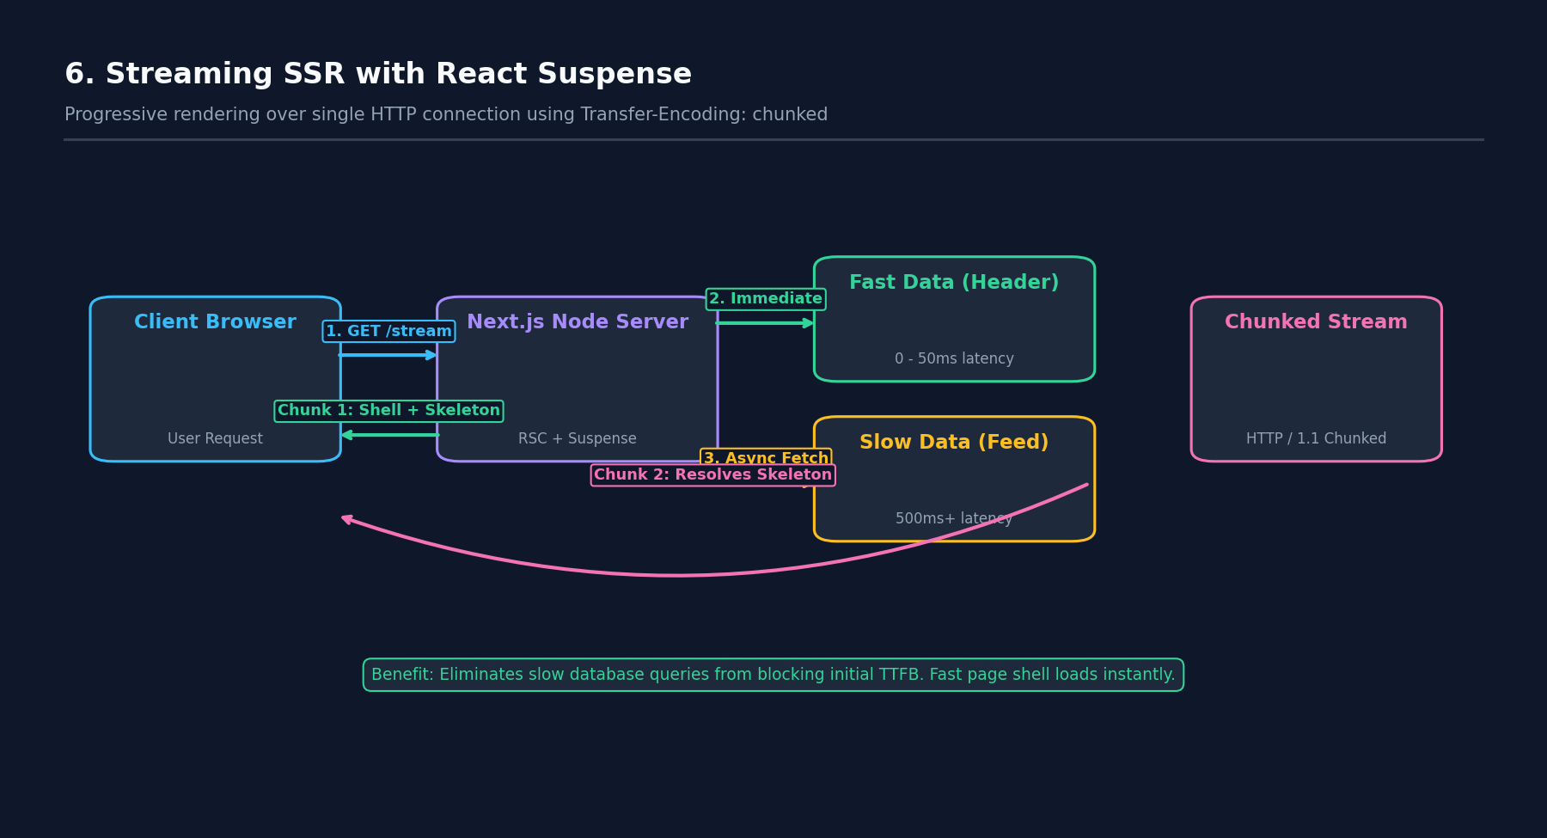
Technical Architecture & Data Flow
Streaming breaks down a page's HTML into smaller chunks. The server sends the layout shell and fallback skeletons immediately (0-50ms). As slow data queries complete on the server, React streams inline JavaScript chunks that swap out the skeletons with fully rendered HTML without requiring a full page refresh.
Implementation Pattern
import { Suspense } from 'react';
import SlowFeed from './SlowFeed';
import LoadingSkeleton from './LoadingSkeleton';
export default function Page() {
return (
<div>
<h1>Instant Header Shell</h1>
<Suspense fallback={<LoadingSkeleton />}>
<SlowFeed />
</Suspense>
</div>
);
}

7. Partial Prerendering (PPR)
Data Access Time: | Static Shell: Build Time. Dynamic Holes: Request Time stream.
Access Location / Runtime: | CDN Edge (serves static shell) + Node.js Server (streams dynamic holes)
Serving Component: | Next.js PPR Runtime Engine (combines static edge cache with dynamic Node stream)
Payload Type Returned: | Unified single HTTP response containing static HTML shell + streamed dynamic slots
Primary Cache Tier: | Static shell cached permanently at CDN Edge; Dynamic slots fetched live per request.

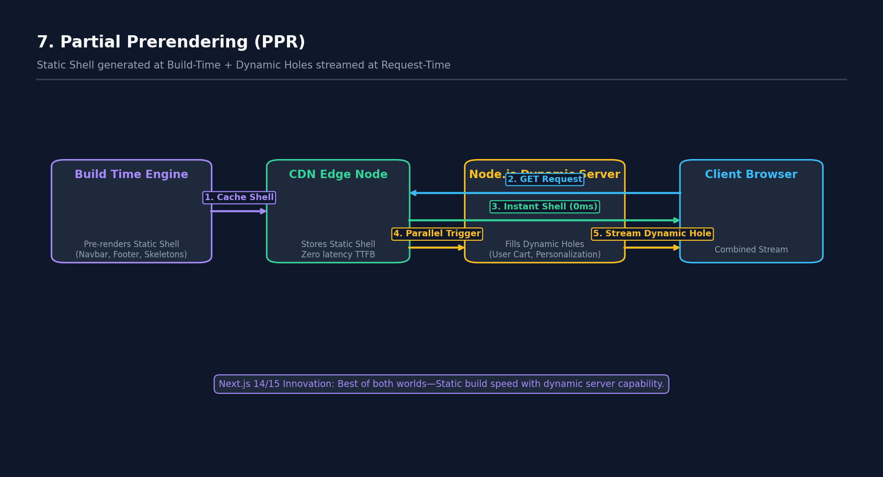
Technical Architecture & Data Flow
Partial Prerendering (PPR) solves the traditional dilemma between static and dynamic rendering. At build time, Next.js pre-renders a static visual shell around Suspense boundaries. At request time, the CDN serves this shell instantly (0ms TTFB), while the server streams dynamic personalized content into the embedded holes over the same HTTP request.
Implementation Pattern
// next.config.js: experimental: { ppr: true }
// Page uses static layout + dynamic Suspense fallback holes automatically!

8. Server Actions & Data Mutations Flow
Data Access Time: | Mutation Time (User form submission, button click, or optimistic trigger)
Access Location / Runtime: | Client Browser -> HTTP POST -> Node.js Server Action RPC Endpoint -> Database
Serving Component: | Next.js Server Action RPC Handler + Data Cache Invalidators (revalidatePath)
Payload Type Returned: | HTTP POST multipart/form-data payload -> Returns updated RSC Stream Payload
Primary Cache Tier: | Triggers targeted invalidation of Data Cache & Full Route Cache tags

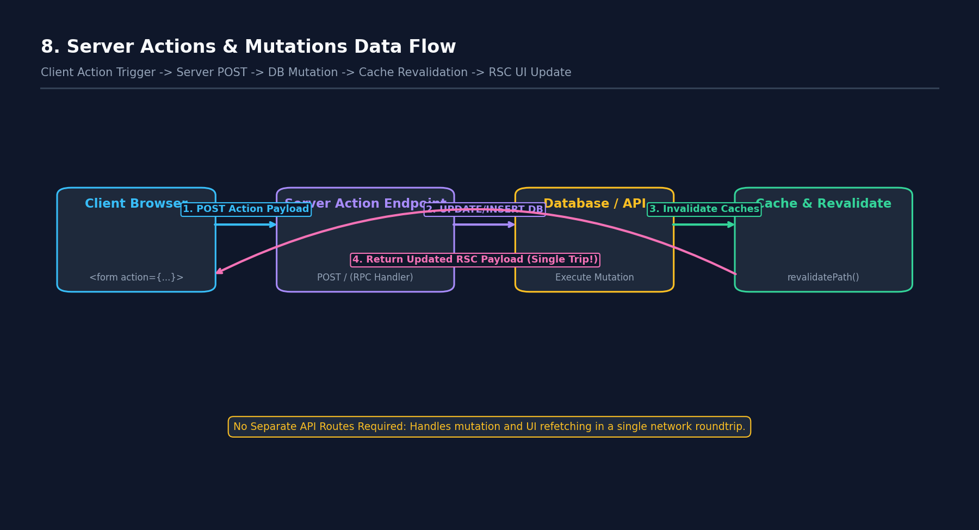
Technical Architecture & Data Flow
Server Actions provide type-safe asynchronous server functions called directly from client or server components. When invoked, Next.js dispatches an HTTP POST request to a specialized server RPC endpoint. The server executes the mutation, invalidates relevant cache tags, and streams back the re-rendered RSC tree in a single network roundtrip.
Implementation Pattern
// app/actions.ts
'use server';
import { revalidateTag } from 'next/cache';
export async function updateCart(formData: FormData) {
await db.cart.update(...);
revalidateTag('cart-items');
}

9. Next.js 4-Tier Caching Architecture
Data Access Time: | Evaluated sequentially across Request Time, Build Time, and Navigation Time
Access Location / Runtime: | Browser Memory (Router Cache) -> Server Disk (Full Route Cache) -> Persistent Cache (Data Cache) -> React Render Pass (Memoization)
Serving Component: | Next.js Multi-Tier Caching System
Payload Type Returned: | HTML, RSC Payloads, and raw JSON fetch results
Primary Cache Tier: | Four distinct cache layers working in sequence to minimize origin server load

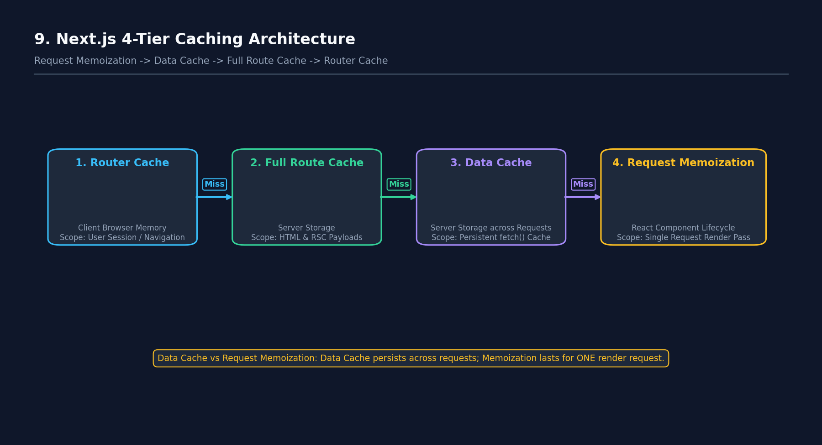
Technical Architecture & Data Flow
Next.js features four distinct caching mechanisms:
1. Router Cache (Client): In-memory browser cache storing RSC payloads during a user session.
2. Full Route Cache (Server): Stores HTML and RSC payloads for static routes on server disk.
3. Data Cache (Server): Cross-request persistent cache for fetch() requests.
4. Request Memoization (React): Deduplicates identical fetch() calls within a single component render pass.
Implementation Pattern
// 1. Request Memoization: Duplicate calls in same render pass execution are deduplicated
fetch('https://api.com/user'); // Executed once
fetch('https://api.com/user'); // Deduplicated from memory
// 2. Data Cache persistent configuration
fetch('https://api.com/user', { next: { revalidate: 3600, tags: ['user'] } });

10. Link Prefetching & Client Router Cache
Data Access Time: | Pre-fetch Time (when <Link> enters browser viewport prior to user click)
Access Location / Runtime: | Client Browser Intersection Observer -> Edge CDN -> Client Router Cache
Serving Component: | Next.js Client Router + Intersection Observer Module
Payload Type Returned: | Optimized prefetch `.rsc` payload bundle
Primary Cache Tier: | Client-side Router Cache (In-Memory for session duration)

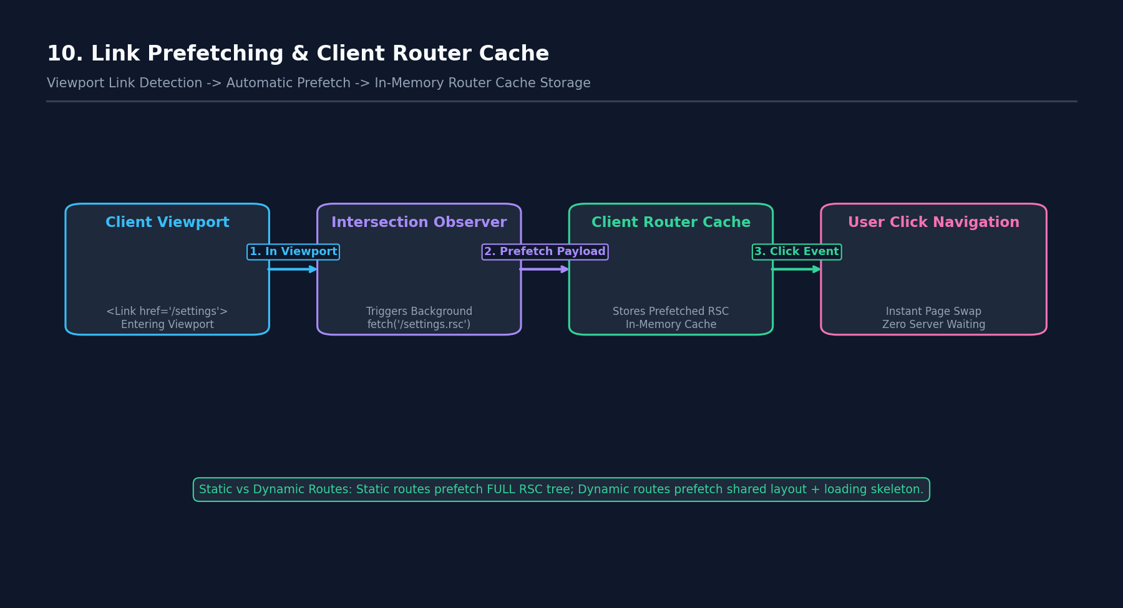
Technical Architecture & Data Flow
Next.js automatically pre-fetches routes as <Link> components appear in the user's viewport. For static routes, the full RSC payload is prefetched. For dynamic routes, a partial payload containing shared layouts and loading skeletons is prefetched. When clicked, navigation occurs instantly from browser memory without awaiting a server response.
Implementation Pattern
import Link from 'next/link';
// Automatically prefetched when scrolled into viewport
<Link href="/dashboard/analytics" prefetch={true}>
Analytics Dashboard
</Link>

11. Edge Runtime vs Node.js Server Runtime
Data Access Time: | Request Execution Time
Access Location / Runtime: | Global Edge CDN (V8 Isolates, 300+ locations) vs Regional Node.js Central Server
Serving Component: | Next.js Edge Middleware Runtime vs Full Node.js HTTP Server Environment
Payload Type Returned: | Dynamic HTML / RSC Payloads / Middleware HTTP Redirects
Primary Cache Tier: | Edge Cache integration vs Regional Server Data Cache

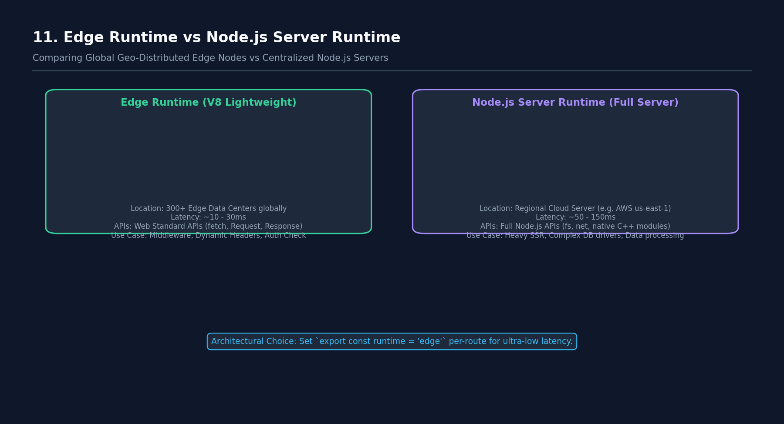
Technical Architecture & Data Flow
Next.js offers two server execution runtimes:
- Edge Runtime: Built on lightweight V8 isolates. Distributed globally close to users (low latency ~10ms). Supports Web Standard APIs (fetch, Request, Response).
- Node.js Runtime: Full Node.js environment supporting all npm C++ packages, native filesystem (fs), and native database TCP driver pools.
Implementation Pattern
// Select Edge Runtime for ultra-low latency per route
export const runtime = 'edge';
export default async function EdgePage() {
return <div>Rendered at global Edge node!</div>;
}

