Curry Co. SOD Analysis

Hazel Daniels

14 March 2021

# Reading and manipulating data

SODSites <- read_xlsx("BasicData.xlsx",1)  
SODSite.ord <- SODSites[-c(31),,drop = F]   
#removing HD-4331 as it skews results strongly  
  
# Subsetting data  
AllSites <- SODSites[-c(74,76,77,80,81,82,86,95,96,97),,drop = F]   
#removing HD-4376, 4378, 4379, 4382, 4383, 4384, 4388, 4397, 4398, 4399 as these sites were measured before and after treatment (removing treated data). Removing these duplicate sites to a data subset for separate analysis.  
AllSites$TrtBin <- as.factor(AllSites$TrtBin)  
  
NA1 <- subset(AllSites, AllSites$Lineage == "NA1")  
  
AllSeeds <- read_xlsx("BasicData.xlsx",2)  
AllSeeds <- AllSeeds[-13]   
#removing CE as it skews results strongly  
AllSeeds <- AllSeeds[-c(31),,drop = F]   
#removing HD-4331 as it skews results strongly  
AllSeeds$TrtBin <- as.factor(AllSeeds$TrtBin)  
AllSeeds$WFBin <- as.factor(AllSeeds$WFBin)  
AllSeeds$VegBin <- as.factor(AllSeeds$VegBin)  
AllSeeds$SoilBin <- as.factor(AllSeeds$SoilBin)  
  
AllFire <- read_xlsx("BasicData.xlsx",3)  
AllFire$RX <- as.factor(AllFire$RX)  
  
EU1wide <- read_xlsx("BasicData.xlsx",4)  
  
EU1long <- read_xlsx("BasicData.xlsx",5)

# Visualization by Analysis Group

OCW <- st_as_sf(map("state", plot = FALSE, fill = TRUE,   
 crs = 4326, agr = "constant"))  
OCW <- OCW[c(4,36,46),,]  
OCW$area <- as.numeric(st_area(OCW))  
OCW$ID <- toTitleCase(OCW$ID)  
OCW$X <- c(-124.1,-124.1, -124.1)  
OCW$Y <- c(41.99, 43, 44)  
OCW$X2 <- c(-123,-123, -122.5)  
OCW$Y2 <- c(41, 44, 46.5)  
  
LatLong <- SODSites %>% select(`New Site`,   
 Lineage,   
 TrtBin,   
 Latitude,   
 Longitude)  
LatLong$Grp <- c(1,2,2,2,2,2,2,2,2,2,2,2,2,2,2,2,3,3,2,1,3,3,3,2,2,2,2,3,1,1,2,2,2,2,3,3,1,2,1,2,2,3,2,1,2,2,2,2,2,1,2,1,2,3,2,2,2,2,2,2,2,2,2,2,2,2,2,2,2,2,2,1,1,3,1,3,3,1,1,3,3,3,1,1,1,3,1,1,1,1,1,1,1,1,3,3,3,1)  
LatLong$Latitude <- as.numeric(LatLong$Latitude)  
LatLong$Longitude <- as.numeric(LatLong$Longitude)  
LatLong$Longitude <- LatLong$Longitude + 0.05   
#forced offset since the layers weren't playing nice :(  
LatLong <- st_as_sf(LatLong, coords = c("Longitude", "Latitude"),  
 crs = 4326, agr = "constant")  
  
  
ORci <- data.frame(state = rep("Oregon", 2),   
 city = c("Brookings", "Gold Beach"),   
 lat = c(42.0526, 42.4073),   
 lng = c(-124.22, -124.37))  
ORci <- st_as_sf(ORci, coords = c("lng", "lat"), remove = FALSE,   
 crs = 4326, agr = "constant")  
  
inset <- ggplot(data = OCW)+  
 geom_sf(fill = "cornsilk")+  
 geom_text(data = OCW, aes(X2, Y2, label = ID), size = 3)+  
 coord_sf(xlim = c(-124.5, -121.5), ylim = c(41, 47))+  
 geom_rect(xmin = -124.5, xmax = -124,   
 ymin = 42, ymax = 42.5,  
 fill = NA, colour = "black", size = 1) +  
 theme(panel.grid.major = element_line(color = gray(0.5),   
 linetype = "dashed",size = 0.5),   
 panel.background = element_rect(fill = "aliceblue"),  
 axis.ticks = element_blank(),  
 axis.text.x = element_blank(),   
 axis.text.y = element_blank(),  
 axis.title.x = element_blank(),  
 axis.title.y = element_blank())  
  
map <- ggplot(data = OCW)+  
 geom_sf(fill = "antiquewhite1")+  
 geom_sf(data = LatLong, size = 3, shape = 22, aes(fill=factor(Grp)))+  
 geom_sf(data = ORci)+  
 geom_text(data = OCW, aes(X, Y, label = ID), size = 4)+  
 geom_text_repel(data = ORci,   
 aes(x = lng, y = lat, label = city),   
 fontface = "bold",   
 nudge_x = c(-0.05,0.05), nudge_y = c(-0.01,-0.01))+  
 scale_fill_viridis_d(option = "plasma",   
 name = "Analysis Groups",   
 breaks = c("1", "3", "2"),   
 labels = c("EU1", "EU1 Resample", "NA1"))+  
 annotation_scale(location = "bl", width_hint = 0.4)+  
 annotation_north_arrow(location = "tl", which_north = "true",   
 pad_x = unit(0.3, "in"), pad_y = unit(0.35, "in"),  
 style = north_arrow_fancy_orienteering)+  
 coord_sf(xlim = c(-124.5, -124), ylim = c(42, 42.5))+  
 xlab("Longitude")+ylab("Latitude")+  
 theme(panel.grid.major = element_line(color = gray(0.5),   
 linetype = "dashed",size = 0.5),   
 panel.background = element_rect(fill = "aliceblue"),  
 legend.position = c(0.17,0.17))  
  
mapinset <- ggdraw(map) +  
 draw_plot(inset, width = 0.45, height = 0.45, x = 0.565, y = 0.53)  
  
ggsave(filename = "MapInset.png",  
 mapinset,  
 width = 6.5,  
 height = 6.5,  
 dpi = 300,  
 units = "in",  
 device = 'png')

# EU1 NA1 Mixed Group

## Visualizing Data

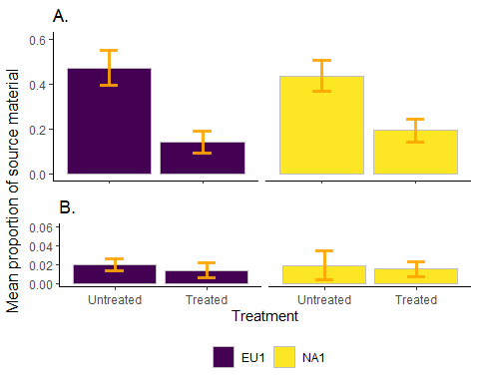

## Veg Mix

V1 <- lm(VegProp~Lineage*TrtBin,data = AllSites)  
  
anova(V1)

## Analysis of Variance Table  
##   
## Response: VegProp  
## Df Sum Sq Mean Sq F value Pr(>F)   
## Lineage 1 0.0398 0.03984 0.4389 0.5095   
## TrtBin 1 1.6465 1.64646 18.1391 5.328e-05 ***  
## Lineage:TrtBin 1 0.0378 0.03785 0.4170 0.5202   
## Residuals 84 7.6245 0.09077   
## ---  
## Signif. codes: 0 '***' 0.001 '**' 0.01 '*' 0.05 '.' 0.1 ' ' 1

summary(V1)

##   
## Call:  
## lm(formula = VegProp ~ Lineage * TrtBin, data = AllSites)  
##   
## Residuals:  
## Min 1Q Median 3Q Max   
## -0.47186 -0.19310 -0.05405 0.20690 0.60690   
##   
## Coefficients:  
## Estimate Std. Error t value Pr(>|t|)   
## (Intercept) 0.47186 0.06423 7.346 1.21e-10 ***  
## LineageNA1 -0.03563 0.08985 -0.397 0.69270   
## TrtBin1 -0.32900 0.10300 -3.194 0.00198 **   
## LineageNA1:TrtBin1 0.08588 0.13299 0.646 0.52021   
## ---  
## Signif. codes: 0 '***' 0.001 '**' 0.01 '*' 0.05 '.' 0.1 ' ' 1  
##   
## Residual standard error: 0.3013 on 84 degrees of freedom  
## Multiple R-squared: 0.1844, Adjusted R-squared: 0.1553   
## F-statistic: 6.332 on 3 and 84 DF, p-value: 0.0006355

summ(V1)

## MODEL INFO:  
## Observations: 88  
## Dependent Variable: VegProp  
## Type: OLS linear regression   
##   
## MODEL FIT:  
## F(3,84) = 6.33, p = 0.00  
## R² = 0.18  
## Adj. R² = 0.16   
##   
## Standard errors: OLS  
## -------------------------------------------------------  
## Est. S.E. t val. p  
## ------------------------ ------- ------ -------- ------  
## (Intercept) 0.47 0.06 7.35 0.00  
## LineageNA1 -0.04 0.09 -0.40 0.69  
## TrtBin1 -0.33 0.10 -3.19 0.00  
## LineageNA1:TrtBin1 0.09 0.13 0.65 0.52  
## -------------------------------------------------------

# Least Squares Means  
V1.lsm <- lsmeans(V1,"TrtBin")  
V1LSM <- as.data.frame(V1.lsm)  
  
#Least Squares Means visualization  
pLSV <- ggplot(V1LSM,aes(x = TrtBin,  
 y = lsmean,  
 fill = TrtBin,  
 ymin = lower.CL,  
 ymax = upper.CL))+  
 geom_bar(stat = "identity",position = "dodge",color = "gray",width = 0.9)+  
 ylim(0,0.6)+  
 ggtitle("Vegetation")+  
 scale_fill_viridis_d(name = "Lineage",guide = FALSE,)+  
 scale_x_discrete(name = "Treatment",  
 breaks = c("0","1"),  
 labels = c("0" = "Untreated","1" = "Treated"))+  
 theme_classic()+  
 theme(axis.title.x = element_blank(),  
 axis.text.x = element_blank(),  
 axis.title.y = element_blank())  
   
pLSVV <- pLSV+geom_errorbar(width = 0.2,colour = "orange",alpha = 0.9,size = 1.3)  
  
#Contrasts  
V1.c <- contrast(V1.lsm,list(TvU = c(-1,1)))  
V1.c

## contrast estimate SE df t.ratio p.value  
## TvU -0.286 0.0665 84 -4.302 <.0001   
##   
## Results are averaged over the levels of: Lineage

#correlations of random effects not included in the model  
VC1 <- cor.test(AllSites$VegProp,AllSites$YrSinceTrt, method = c("pearson","kendall","spearman"))  
VC11 <- cor.test(AllSites$VegProp,AllSites$TotalTO, method = c("pearson","kendall","spearman"))  
VC111 <- cor.test(AllSites$VegProp,AllSites$Num_Seedlings, method = c("pearson","kendall","spearman"))  
VC1111 <- cor.test(AllSites$VegProp,AllSites$SoilBin, method = c("pearson","kendall","spearman"))  
VC1

##   
## Pearson's product-moment correlation  
##   
## data: AllSites$VegProp and AllSites$YrSinceTrt  
## t = -1.6704, df = 86, p-value = 0.09848  
## alternative hypothesis: true correlation is not equal to 0  
## 95 percent confidence interval:  
## -0.37286767 0.03341372  
## sample estimates:  
## cor   
## -0.1772691

VC11

##   
## Pearson's product-moment correlation  
##   
## data: AllSites$VegProp and AllSites$TotalTO  
## t = 0.83633, df = 86, p-value = 0.4053  
## alternative hypothesis: true correlation is not equal to 0  
## 95 percent confidence interval:  
## -0.1219169 0.2937354  
## sample estimates:  
## cor   
## 0.08981887

VC111

##   
## Pearson's product-moment correlation  
##   
## data: AllSites$VegProp and AllSites$Num_Seedlings  
## t = -1.1365, df = 86, p-value = 0.2589  
## alternative hypothesis: true correlation is not equal to 0  
## 95 percent confidence interval:  
## -0.32286202 0.09009204  
## sample estimates:  
## cor   
## -0.1216456

VC1111

##   
## Pearson's product-moment correlation  
##   
## data: AllSites$VegProp and AllSites$SoilBin  
## t = 2.6705, df = 86, p-value = 0.009055  
## alternative hypothesis: true correlation is not equal to 0  
## 95 percent confidence interval:  
## 0.0714214 0.4595330  
## sample estimates:  
## cor   
## 0.2767242

#correlation between soil and veg!

## Soil Mix

S1 <- glm(SoilBin~Lineage*TrtBin,family = "binomial",data = AllSites)  
  
anova(S1)

## Analysis of Deviance Table  
##   
## Model: binomial, link: logit  
##   
## Response: SoilBin  
##   
## Terms added sequentially (first to last)  
##   
##   
## Df Deviance Resid. Df Resid. Dev  
## NULL 87 91.816  
## Lineage 1 2.85043 86 88.965  
## TrtBin 1 0.15705 85 88.808  
## Lineage:TrtBin 1 0.94502 84 87.863

summary(S1)

##   
## Call:  
## glm(formula = SoilBin ~ Lineage * TrtBin, family = "binomial",   
## data = AllSites)  
##   
## Deviance Residuals:   
## Min 1Q Median 3Q Max   
## -0.9508 -0.6945 -0.6152 -0.5287 2.0184   
##   
## Coefficients:  
## Estimate Std. Error z value Pr(>|z|)   
## (Intercept) -0.5596 0.4432 -1.263 0.207   
## LineageNA1 -1.3375 0.7614 -1.757 0.079 .  
## TrtBin1 -0.7397 0.7878 -0.939 0.348   
## LineageNA1:TrtBin1 1.0682 1.1161 0.957 0.339   
## ---  
## Signif. codes: 0 '***' 0.001 '**' 0.01 '*' 0.05 '.' 0.1 ' ' 1  
##   
## (Dispersion parameter for binomial family taken to be 1)  
##   
## Null deviance: 91.816 on 87 degrees of freedom  
## Residual deviance: 87.863 on 84 degrees of freedom  
## AIC: 95.863  
##   
## Number of Fisher Scoring iterations: 4

summ(S1)

## MODEL INFO:  
## Observations: 88  
## Dependent Variable: SoilBin  
## Type: Generalized linear model  
## Family: binomial   
## Link function: logit   
##   
## MODEL FIT:  
## <U+03C7>²(3) = 3.95, p = 0.27  
## Pseudo-R² (Cragg-Uhler) = 0.07  
## Pseudo-R² (McFadden) = 0.04  
## AIC = 95.86, BIC = 105.77   
##   
## Standard errors: MLE  
## -------------------------------------------------------  
## Est. S.E. z val. p  
## ------------------------ ------- ------ -------- ------  
## (Intercept) -0.56 0.44 -1.26 0.21  
## LineageNA1 -1.34 0.76 -1.76 0.08  
## TrtBin1 -0.74 0.79 -0.94 0.35  
## LineageNA1:TrtBin1 1.07 1.12 0.96 0.34  
## -------------------------------------------------------

# Contrast statement  
S1.lsm <- lsmeans(S1,"TrtBin")  
S1.lsm

## TrtBin lsmean SE df asymp.LCL asymp.UCL  
## 0 -1.23 0.381 Inf -1.97 -0.482  
## 1 -1.43 0.408 Inf -2.23 -0.634  
##   
## Results are averaged over the levels of: Lineage   
## Results are given on the logit (not the response) scale.   
## Confidence level used: 0.95

S1LSM <- as.data.frame(S1.lsm)  
S1LSM

## TrtBin lsmean SE df asymp.LCL asymp.UCL  
## 1 0 -1.228368 0.3807101 Inf -1.974546 -0.4821899  
## 2 1 -1.433949 0.4080161 Inf -2.233646 -0.6342525

#Least Squares Means visualization  
pLSS <- ggplot(S1LSM,aes(x = TrtBin,  
 y = lsmean,  
 fill = TrtBin,  
 ymin = asymp.LCL,  
 ymax = asymp.UCL))+  
 geom_bar(stat = "identity",position = "dodge",color = "gray",width = 0.9)+  
 ylim(-2.5,0)+  
 ggtitle("Soil")+  
 scale_fill_viridis_d(name = "Lineage",guide = FALSE,)+  
 scale_x_discrete(name = "Treatment",  
 breaks = c("0","1"),  
 labels = c("0" = "Untreated","1" = "Treated"))+  
 theme_classic()+  
 theme(axis.title.y = element_blank())  
   
pLSSS <- pLSS+geom_errorbar(width = 0.2,colour = "orange",alpha = 0.9,size = 1.3)  
  
#Combining veg and soil plots  
pLSVS <- ggarrange(pLSVV,pLSSS,ncol = 1,nrow = 2)  
plotLSVS<- annotate_figure(pLSVS,left = text_grob("Least Squares Mean",rot = 90))  
plotLSVS

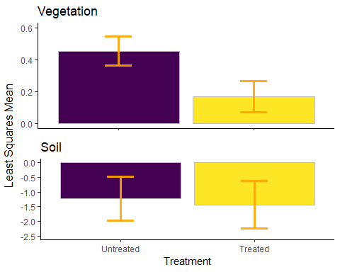

ggsave(filename = "LSM.png",  
 plotLSVS,  
 width = 6.5,  
 height = 5,  
 dpi = 300,  
 units = "in",  
 device = 'png')  
  
#Contrasts  
S1.c <- contrast(S1.lsm,list(TvU = c(-1,1)))  
S1.c

## contrast estimate SE df z.ratio p.value  
## TvU -0.206 0.558 Inf -0.368 0.7126   
##   
## Results are averaged over the levels of: Lineage   
## Results are given on the log odds ratio (not the response) scale.

#correlations of random effects not included in the model  
SC1 <- cor.test(AllSites$SoilBin,AllSites$YrSinceTrt, method = c("pearson","kendall","spearman"))  
SC11 <- cor.test(AllSites$SoilBin,AllSites$TotalTO, method = c("pearson","kendall","spearman"))  
SC111 <- cor.test(AllSites$SoilBin,AllSites$Num_Seedlings, method = c("pearson","kendall","spearman"))  
SC1

##   
## Pearson's product-moment correlation  
##   
## data: AllSites$SoilBin and AllSites$YrSinceTrt  
## t = -0.66715, df = 86, p-value = 0.5065  
## alternative hypothesis: true correlation is not equal to 0  
## 95 percent confidence interval:  
## -0.2770337 0.1397882  
## sample estimates:  
## cor   
## -0.07175484

SC11

##   
## Pearson's product-moment correlation  
##   
## data: AllSites$SoilBin and AllSites$TotalTO  
## t = -0.020186, df = 86, p-value = 0.9839  
## alternative hypothesis: true correlation is not equal to 0  
## 95 percent confidence interval:  
## -0.2115225 0.2073601  
## sample estimates:  
## cor   
## -0.002176686

SC111

##   
## Pearson's product-moment correlation  
##   
## data: AllSites$SoilBin and AllSites$Num_Seedlings  
## t = -1.256, df = 86, p-value = 0.2125  
## alternative hypothesis: true correlation is not equal to 0  
## 95 percent confidence interval:  
## -0.33426265 0.07740132  
## sample estimates:  
## cor   
## -0.1342167

## V Mix Assumptions

plot(V1)

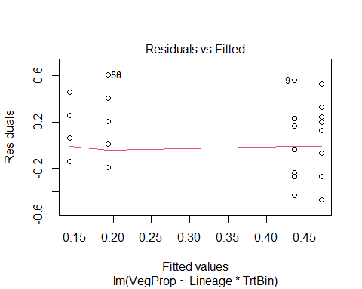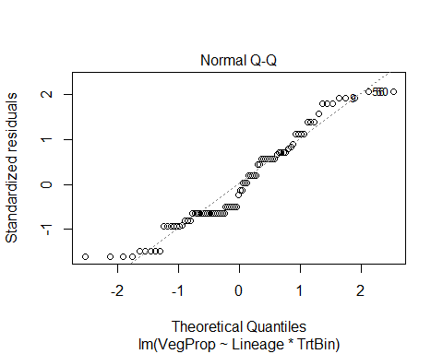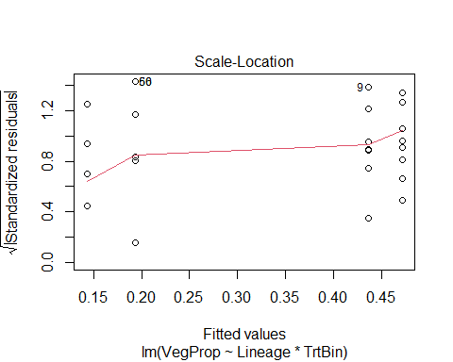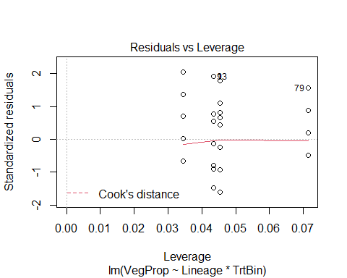

gvlma(V1)

##   
## Call:  
## lm(formula = VegProp ~ Lineage * TrtBin, data = AllSites)  
##   
## Coefficients:  
## (Intercept) LineageNA1 TrtBin1 LineageNA1:TrtBin1   
## 0.47186 -0.03563 -0.32900 0.08588   
##   
##   
## ASSESSMENT OF THE LINEAR MODEL ASSUMPTIONS  
## USING THE GLOBAL TEST ON 4 DEGREES-OF-FREEDOM:  
## Level of Significance = 0.05   
##   
## Call:  
## gvlma(x = V1)   
##   
## Value p-value Decision  
## Global Stat 5.533e+00 0.2368 Assumptions acceptable.  
## Skewness 2.024e+00 0.1548 Assumptions acceptable.  
## Kurtosis 2.295e+00 0.1298 Assumptions acceptable.  
## Link Function 1.629e-14 1.0000 Assumptions acceptable.  
## Heteroscedasticity 1.214e+00 0.2706 Assumptions acceptable.

#linearity  
ggplot(AllSites,aes(TrtBin,VegProp))+   
 stat_smooth(method = "loess")+   
 stat_smooth(method = "lm",color = "red",fill = "red",alpha = .25)+   
 geom_point()

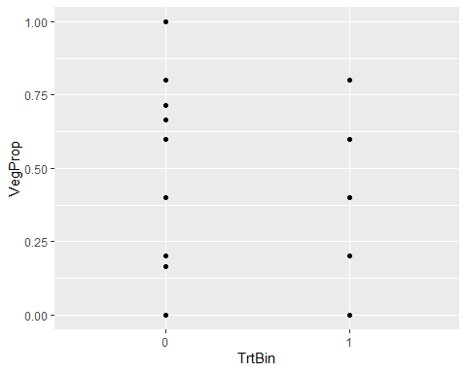

#constant variance  
spreadLevelPlot(V1)

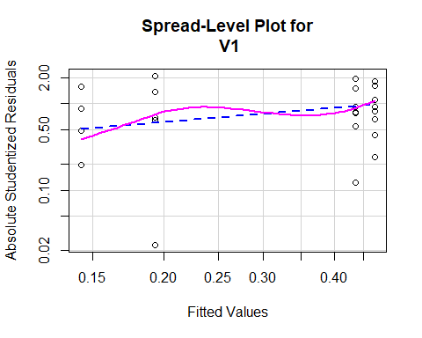

##   
## Suggested power transformation: 0.4389184

#normality of residuals  
V1.resi <- qqPlot(V1,main = "QQ Plot")

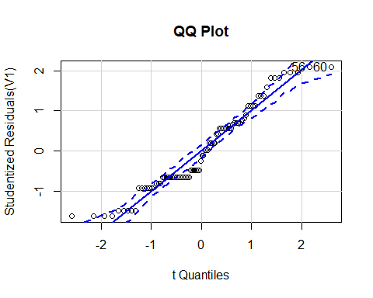

V1.res <- studres(V1)  
hist(V1.res,freq = FALSE,main = "Distribution of Studentized Residuals")  
V1.xfit <- seq(min(V1.res),max(V1.res),length = 40)  
V1.yfit <- dnorm(V1.xfit)  
lines(V1.xfit,V1.yfit)

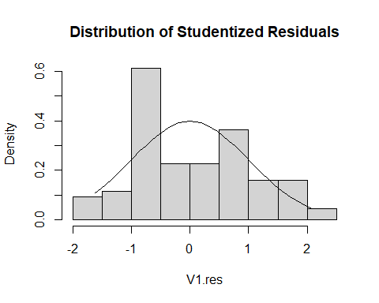

#multicollinearity  
vif(V1)

## Lineage TrtBin Lineage:TrtBin   
## 1.891843 2.570100 3.788390

sqrt(vif(V1))>2

## Lineage TrtBin Lineage:TrtBin   
## FALSE FALSE FALSE

#outliers  
AllSites$Vleverage <- hatvalues(V1)  
ggplot(AllSites,aes(Plot,Vleverage))+geom_point()+ylim(0,1)+xlab("test")

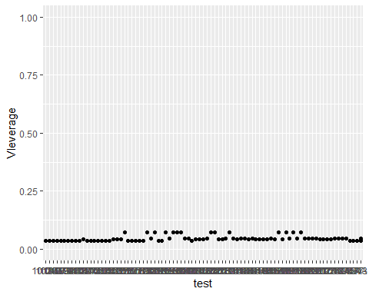

## S Mix Assumptions

plot(S1)

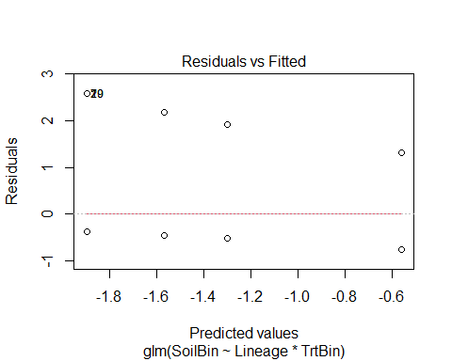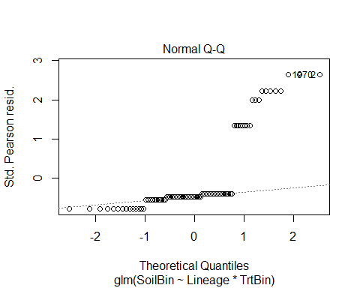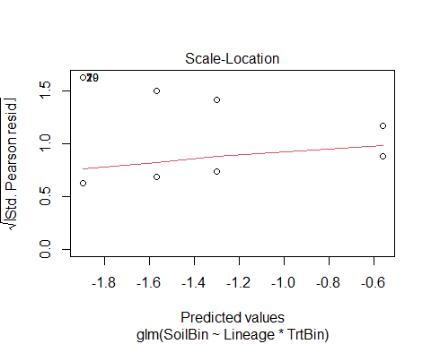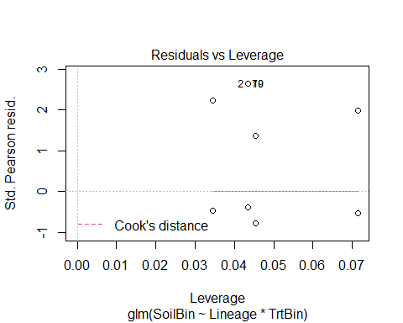

#linearity  
ggplot(AllSites,aes(SoilBin,TrtBin))+   
 stat_smooth(method = "loess")+   
 stat_smooth(method = "lm",color = "red",fill = "red",alpha = .25)+   
 geom_point()

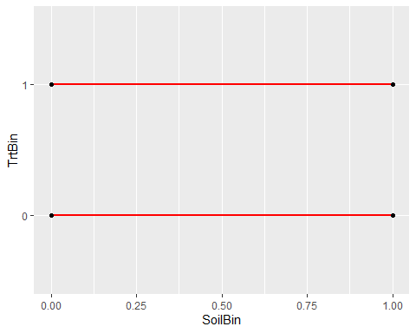

#constant varience  
spreadLevelPlot(S1)

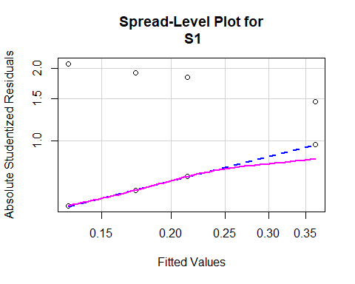

##   
## Suggested power transformation: 0.4185762

#normality of residuals  
S1.resi <- studres(S1)  
hist(S1.resi,freq = FALSE,main = "Distribution of Studentized Residuals")  
S1.xfit <- seq(min(S1.resi),max(S1.resi),length = 40)  
S1.yfit <- dnorm(S1.xfit)  
lines(S1.xfit,S1.yfit)

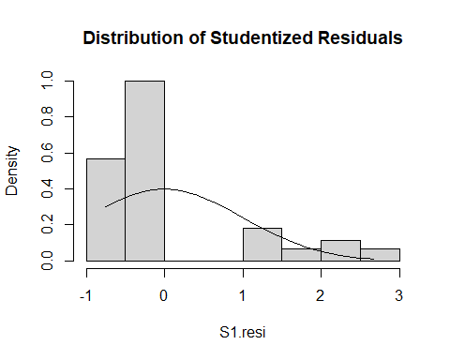

#assumption violated?  
  
#multicollinearity  
vif(S1)

## Lineage TrtBin Lineage:TrtBin   
## 2.052357 2.186696 3.651894

sqrt(vif(S1))>2

## Lineage TrtBin Lineage:TrtBin   
## FALSE FALSE FALSE

#outliers  
AllSites$Sleverage <- hatvalues(S1)  
ggplot(AllSites,aes(Plot,Sleverage))+geom_point()+ylim(0,1)+xlab("test")

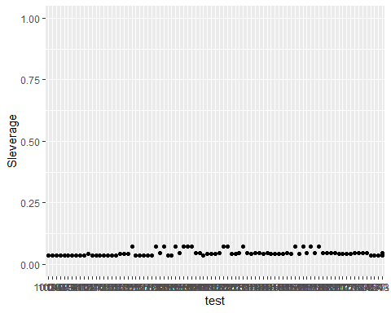

# EU1 Repeated Measures

## EU1 Veg

V2 <- lme(VegProp~TrtBin,random = ~1|Plot,data = EU1long)  
  
anova(V2)

## numDF denDF F-value p-value  
## (Intercept) 1 9 16.286969 0.0029  
## TrtBin 1 9 8.684625 0.0163

summary(V2)

## Linear mixed-effects model fit by REML  
## Data: EU1long   
## AIC BIC logLik  
## 24.68194 28.24342 -8.340968  
##   
## Random effects:  
## Formula: ~1 | Plot  
## (Intercept) Residual  
## StdDev: 0.08728716 0.3273545  
##   
## Fixed effects: VegProp ~ TrtBin   
## Value Std.Error DF t-value p-value  
## (Intercept) 0.5314286 0.1071354 9 4.960343 0.0008  
## TrtBin -0.4314286 0.1463974 9 -2.946969 0.0163  
## Correlation:   
## (Intr)  
## TrtBin -0.683  
##   
## Standardized Within-Group Residuals:  
## Min Q1 Med Q3 Max   
## -1.5033354 -0.3755643 -0.2234416 0.2972945 2.5651355   
##   
## Number of Observations: 20  
## Number of Groups: 10

V.dt <-array(c(1,0,8,1),  
 dim = c(2,2),  
 dimnames = list(  
 Time1 = c("FirstPos","FirstNeg"),  
 Time2 = c("ThenPos","ThenNeg")))  
V.dt

## Time2  
## Time1 ThenPos ThenNeg  
## FirstPos 1 8  
## FirstNeg 0 1

mcnemar.test(V.dt,y = NULL,correct = FALSE)

##   
## McNemar's Chi-squared test  
##   
## data: V.dt  
## McNemar's chi-squared = 8, df = 1, p-value = 0.004678

## EU1 Soil

S2 <- lme(SoilBin~TrtBin,random = ~1|Plot,data = EU1long)  
  
anova(S2)

## numDF denDF F-value p-value  
## (Intercept) 1 9 10.755896 0.0095  
## TrtBin 1 9 1.975647 0.1934

summary(S2)

## Linear mixed-effects model fit by REML  
## Data: EU1long   
## AIC BIC logLik  
## 37.05803 40.61952 -14.52902  
##   
## Random effects:  
## Formula: ~1 | Plot  
## (Intercept) Residual  
## StdDev: 0.002064555 0.4772562  
##   
## Fixed effects: SoilBin ~ TrtBin   
## Value Std.Error DF t-value p-value  
## (Intercept) 0.5 0.1509231 9 3.312946 0.0090  
## TrtBin -0.3 0.2134355 9 -1.405577 0.1934  
## Correlation:   
## (Intr)  
## TrtBin -0.707  
##   
## Standardized Within-Group Residuals:  
## Min Q1 Med Q3 Max   
## -1.0476670 -0.5762123 -0.4190347 1.0476435 1.6762366   
##   
## Number of Observations: 20  
## Number of Groups: 10

S.dt <-array(c(1,1,4,4),  
 dim = c(2,2),  
 dimnames = list(  
 Time1 = c("FirstPos","FirstNeg"),  
 Time2 = c("ThenPos","ThenNeg")))  
S.dt

## Time2  
## Time1 ThenPos ThenNeg  
## FirstPos 1 4  
## FirstNeg 1 4

mcnemar.test(S.dt,y = NULL,correct = FALSE)

##   
## McNemar's Chi-squared test  
##   
## data: S.dt  
## McNemar's chi-squared = 1.8, df = 1, p-value = 0.1797

# NA1 Wildfire

## NA1 Veg

V3 <- lm(VegProp~RX,data = AllFire)  
  
anova(V3)

## Analysis of Variance Table  
##   
## Response: VegProp  
## Df Sum Sq Mean Sq F value Pr(>F)   
## RX 3 1.0706 0.35687 4.1361 0.01095 *  
## Residuals 48 4.1416 0.08628   
## ---  
## Signif. codes: 0 '***' 0.001 '**' 0.01 '*' 0.05 '.' 0.1 ' ' 1

summary(V3)

##   
## Call:  
## lm(formula = VegProp ~ RX, data = AllFire)  
##   
## Residuals:  
## Min 1Q Median 3Q Max   
## -0.43623 -0.24000 -0.04444 0.16377 0.56377   
##   
## Coefficients:  
## Estimate Std. Error t value Pr(>|t|)   
## (Intercept) 0.43623 0.06125 7.122 4.78e-09 ***  
## RX1 -0.19623 0.09749 -2.013 0.0498 *   
## RX2 -0.11623 0.14494 -0.802 0.4266   
## RX3 -0.39179 0.11549 -3.392 0.0014 **   
## ---  
## Signif. codes: 0 '***' 0.001 '**' 0.01 '*' 0.05 '.' 0.1 ' ' 1  
##   
## Residual standard error: 0.2937 on 48 degrees of freedom  
## Multiple R-squared: 0.2054, Adjusted R-squared: 0.1557   
## F-statistic: 4.136 on 3 and 48 DF, p-value: 0.01095

summ(V3)

## MODEL INFO:  
## Observations: 52  
## Dependent Variable: VegProp  
## Type: OLS linear regression   
##   
## MODEL FIT:  
## F(3,48) = 4.14, p = 0.01  
## R² = 0.21  
## Adj. R² = 0.16   
##   
## Standard errors: OLS  
## ------------------------------------------------  
## Est. S.E. t val. p  
## ----------------- ------- ------ -------- ------  
## (Intercept) 0.44 0.06 7.12 0.00  
## RX1 -0.20 0.10 -2.01 0.05  
## RX2 -0.12 0.14 -0.80 0.43  
## RX3 -0.39 0.12 -3.39 0.00  
## ------------------------------------------------

# Contrast statement  
levels(AllFire$RX)

## [1] "0" "1" "2" "3"

# 0 - No Wildfire or Treatment  
# 1 - Only Treatment  
# 2 - Only Wildfire  
# 3 - Both Wildfire and Treatment  
  
#Least Squares Means  
V3.lsm <- lsmeans(V3,~RX,adjst = "tukey")  
V3.lsm

## RX lsmean SE df lower.CL upper.CL  
## 0 0.4362 0.0612 48 0.3131 0.559  
## 1 0.2400 0.0758 48 0.0875 0.392  
## 2 0.3200 0.1314 48 0.0559 0.584  
## 3 0.0444 0.0979 48 -0.1524 0.241  
##   
## Confidence level used: 0.95

V3LSM <- as.data.frame(V3.lsm)  
V3LSM

## RX lsmean SE df lower.CL upper.CL  
## 1 0 0.43623188 0.06124896 48 0.3130826 0.5593812  
## 2 1 0.24000000 0.07584326 48 0.0875069 0.3924931  
## 3 2 0.32000000 0.13136439 48 0.0558742 0.5841258  
## 4 3 0.04444444 0.09791323 48 -0.1524233 0.2413122

#Contrasts  
V3.c <- contrast(V3.lsm,list(  
 "0 v. 1" = c(1,-1,0,0), #difference is RX  
 "2 v. 3" = c(0,0,1,-1), #difference is RX  
 "1 v. 2" = c(0,-1,1,0), #difference is both  
 "0 v. 3" = c(1,0,0,-1), #difference is both  
 "0 v. 2" = c(1,0,-1,0), #difference is WF; NS b/c small n & wide CI?  
 "1 v. 3" = c(0,1,0,-1), #difference is WF  
 "1&3 v. 2" = c(0,-0.5,1,-0.5), #both RX to WF w/o RX  
 "1&3 v. 0" = c(1,-0.5,0,-0.5), #both RX to noWF or RX  
 "2&3 v. 0" = c(1,0,-0.5,-0.5), #both WF to noWF or RX  
 "2&3 v. 1" = c(0,1,-0.5,-0.5))) #both WF to RX w/o WF  
V3.c

## contrast estimate SE df t.ratio p.value  
## 0 v. 1 0.1962 0.0975 48 2.013 0.0498   
## 2 v. 3 0.2756 0.1638 48 1.682 0.0991   
## 1 v. 2 0.0800 0.1517 48 0.527 0.6003   
## 0 v. 3 0.3918 0.1155 48 3.392 0.0014   
## 0 v. 2 0.1162 0.1449 48 0.802 0.4266   
## 1 v. 3 0.1956 0.1239 48 1.579 0.1209   
## 1&3 v. 2 0.1778 0.1452 48 1.224 0.2269   
## 1&3 v. 0 0.2940 0.0871 48 3.376 0.0015   
## 2&3 v. 0 0.2540 0.1023 48 2.483 0.0166   
## 2&3 v. 1 0.0578 0.1116 48 0.518 0.6072

V3CON <- as.data.frame(V3.c)  
V3CON <- V3CON[c(1,5,4,3,6,2,8,7,9,10),]  
  
p.VWF <- ggplot(V3CON,aes(x = contrast,  
 y = estimate,  
 fill = contrast,  
 ymin = estimate-SE,  
 ymax = estimate+SE))+  
 geom_bar(stat = "identity",position = "dodge",color = "gray")+  
 scale_fill_viridis_d()+theme_classic()+  
 scale_x_discrete(name = "Contrast Statement",  
 guide = guide_axis(angle = 20),  
 labels = c(  
 "0 v. 1" = "None v. RX",  
 "0 v. 2" = "None v. WF",  
 "0 v. 3" = "None v. Both",  
 "1 v. 2" = "RX v. WF",  
 "1 v. 3" = "RX v. Both",  
 "2 v. 3" = "WF v. Both",  
 "1&3 v. 2" = "RX + Both v. WF",  
 "1&3 v. 0" = "RX + Both v. None",  
 "2&3 v. 0" = "WF + Both v. None",  
 "2&3 v. 1" = "WF + Both v. RX"))+  
 scale_y_continuous("Least Squares Mean",  
 limits = c(-0.1,0.55),  
 breaks = c(-0.1,0,0.1,0.2,0.3,0.4,0.5))+  
 theme(legend.position = "none",  
 text = element_text(size = 15))+  
 geom_errorbar(width = 0.2,colour = "orange",alpha = 0.9,size = 1.3)+  
 geom_text(aes(x = contrast,y = estimate+SE+0.01,  
 label = c("*","","**","","","","**","","*","")),  
 size = 5,position = position_dodge(.5))  
#+coord_flip() to flip X and Y  
p.VWF

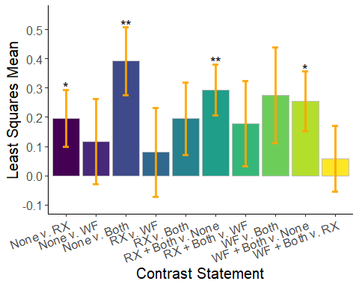

ggsave(filename = "WFVeg.png",  
 p.VWF,  
 width = 6.5,  
 height = 5,  
 dpi = 300,  
 units = "in",  
 device = 'png')  
  
#Correlations of random effects not included in the model  
VC3 <- cor.test(AllFire$VegProp,AllFire$TotalTO,method = c("pearson","kendall","spearman"))  
VC33 <- cor.test(AllFire$VegProp,AllFire$SoilProp,method = c("pearson","kendall","spearman"))  
VC3

##   
## Pearson's product-moment correlation  
##   
## data: AllFire$VegProp and AllFire$TotalTO  
## t = 1.093, df = 50, p-value = 0.2796  
## alternative hypothesis: true correlation is not equal to 0  
## 95 percent confidence interval:  
## -0.1253661 0.4086259  
## sample estimates:  
## cor   
## 0.1527605

VC33 #correlation between soil and veg!

##   
## Pearson's product-moment correlation  
##   
## data: AllFire$VegProp and AllFire$SoilProp  
## t = 3.2198, df = 50, p-value = 0.002256  
## alternative hypothesis: true correlation is not equal to 0  
## 95 percent confidence interval:  
## 0.1595480 0.6174743  
## sample estimates:  
## cor   
## 0.4144049

## NA1 Soil

S3 <- glm(SoilBin~RX,data = AllFire)  
  
anova(S3)

## Analysis of Deviance Table  
##   
## Model: gaussian, link: identity  
##   
## Response: SoilBin  
##   
## Terms added sequentially (first to last)  
##   
##   
## Df Deviance Resid. Df Resid. Dev  
## NULL 51 6.7692  
## RX 3 1.2272 48 5.5420

summary(S3)

##   
## Call:  
## glm(formula = SoilBin ~ RX, data = AllFire)  
##   
## Deviance Residuals:   
## Min 1Q Median 3Q Max   
## -0.6000 -0.1333 -0.1304 0.0000 0.8696   
##   
## Coefficients:  
## Estimate Std. Error t value Pr(>|t|)   
## (Intercept) 0.130435 0.070852 1.841 0.07181 .   
## RX1 0.002899 0.112771 0.026 0.97960   
## RX2 0.469565 0.167666 2.801 0.00733 **  
## RX3 -0.130435 0.133599 -0.976 0.33380   
## ---  
## Signif. codes: 0 '***' 0.001 '**' 0.01 '*' 0.05 '.' 0.1 ' ' 1  
##   
## (Dispersion parameter for gaussian family taken to be 0.1154589)  
##   
## Null deviance: 6.7692 on 51 degrees of freedom  
## Residual deviance: 5.5420 on 48 degrees of freedom  
## AIC: 41.148  
##   
## Number of Fisher Scoring iterations: 2

summ(S3)

## MODEL INFO:  
## Observations: 52  
## Dependent Variable: SoilBin  
## Type: Linear regression   
##   
## MODEL FIT:  
## <U+03C7>²(3) = 1.23, p = 0.01  
## Pseudo-R² (Cragg-Uhler) = 0.33  
## Pseudo-R² (McFadden) = 0.25  
## AIC = 41.15, BIC = 50.90   
##   
## Standard errors: MLE  
## ------------------------------------------------  
## Est. S.E. t val. p  
## ----------------- ------- ------ -------- ------  
## (Intercept) 0.13 0.07 1.84 0.07  
## RX1 0.00 0.11 0.03 0.98  
## RX2 0.47 0.17 2.80 0.01  
## RX3 -0.13 0.13 -0.98 0.33  
## ------------------------------------------------  
##   
## Estimated dispersion parameter = 0.12

# Contrast statement  
S3.lsm <- lsmeans(S3,~RX,adjst = "tukey")  
S3.lsm

## RX lsmean SE df asymp.LCL asymp.UCL  
## 0 0.130 0.0709 Inf -0.00843 0.269  
## 1 0.133 0.0877 Inf -0.03862 0.305  
## 2 0.600 0.1520 Inf 0.30216 0.898  
## 3 0.000 0.1133 Inf -0.22199 0.222  
##   
## Confidence level used: 0.95

S3LSM <- as.data.frame(S3.lsm)  
S3LSM

## RX lsmean SE df asymp.LCL asymp.UCL  
## 1 0 1.304348e-01 0.07085163 Inf -0.008431865 0.2693014  
## 2 1 1.333333e-01 0.08773404 Inf -0.038622233 0.3052889  
## 3 2 6.000000e-01 0.15195982 Inf 0.302164222 0.8978358  
## 4 3 -1.665335e-16 0.11326416 Inf -0.221993682 0.2219937

S3.c <- contrast(S3.lsm,list(  
 "0 v. 1" = c(-1,1,0,0), #difference is RX  
 "2 v. 3" = c(0,0,1,-1), #difference is RX  
 "1 v. 2" = c(0,-1,1,0), #difference is both  
 "0 v. 3" = c(1,0,0,-1), #difference is both  
 "0 v. 2" = c(-1,0,1,0), #difference is WF; NS b/c small n & wide CI?  
 "1 v. 3" = c(0,1,0,-1), #difference is WF  
 "1&3 v. 2" = c(0,-0.5,1,-0.5), #both RX to WF w/o RX  
 "1&3 v. 0" = c(1,-0.5,0,-0.5), #both RX to noWF or RX  
 "2&3 v. 0" = c(-1,0,0.5,0.5), #both WF to noWF or RX  
 "2&3 v. 1" = c(0,-1,0.5,0.5))) #both WF to RX w/o WF  
S3.c

## contrast estimate SE df z.ratio p.value  
## 0 v. 1 0.0029 0.113 Inf 0.026 0.9795   
## 2 v. 3 0.6000 0.190 Inf 3.166 0.0015   
## 1 v. 2 0.4667 0.175 Inf 2.660 0.0078   
## 0 v. 3 0.1304 0.134 Inf 0.976 0.3289   
## 0 v. 2 0.4696 0.168 Inf 2.801 0.0051   
## 1 v. 3 0.1333 0.143 Inf 0.931 0.3520   
## 1&3 v. 2 0.5333 0.168 Inf 3.175 0.0015   
## 1&3 v. 0 0.0638 0.101 Inf 0.633 0.5268   
## 2&3 v. 0 0.1696 0.118 Inf 1.433 0.1518   
## 2&3 v. 1 0.1667 0.129 Inf 1.291 0.1968

S3CON <- as.data.frame(S3.c)  
S3CON <- S3CON[c(1,5,4,3,6,2,8,7,9,10),]  
  
p.SWF <- ggplot(S3CON,aes(x = contrast,  
 y = estimate,  
 fill = contrast,  
 ymin = estimate-SE,  
 ymax = estimate+SE))+  
 geom_bar(stat = "identity",position = "dodge",color = "gray")+  
 scale_fill_viridis_d()+theme_classic()+  
 scale_x_discrete(name = "Contrast Statement",  
 guide = guide_axis(angle = 20),  
 labels = c(  
 "0 v. 1" = "None v. RX",  
 "0 v. 2" = "None v. WF",  
 "0 v. 3" = "None v. Both",  
 "1 v. 2" = "RX v. WF",  
 "1 v. 3" = "RX v. Both",  
 "2 v. 3" = "WF v. Both",  
 "1&3 v. 2" = "RX + Both v. WF",  
 "1&3 v. 0" = "RX + Both v. None",  
 "2&3 v. 0" = "WF + Both v. None",  
 "2&3 v. 1" = "WF + Both v. RX"))+  
 scale_y_continuous("Least Squares Mean",  
 limits = c(-0.11,0.8),  
 breaks = c(-0.1,0,0.2,0.4,0.6,0.8))+  
 theme(legend.position = "none",  
 text = element_text(size = 15))+  
 geom_errorbar(width = 0.2,colour = "orange",alpha = 0.9,size = 1.3)+  
 geom_text(aes(x = contrast,y = estimate+SE+0.01,  
 label = c("","**","","**","","**","","**","","")),  
 size = 5,position = position_dodge(.5))  
#+coord_flip() to flip X and Y  
p.SWF

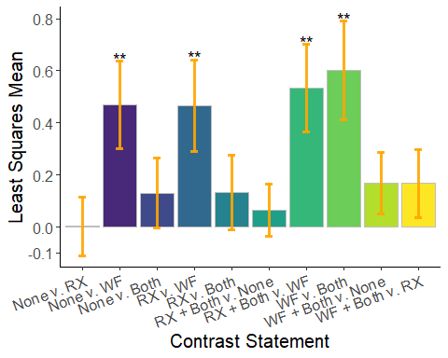

ggsave(filename = "WFSoil.png",  
 p.SWF,  
 width = 6.5,  
 height = 5,  
 dpi = 300,  
 units = "in",  
 device = 'png')  
  
#correlations of random effects not included in the model  
SC3 <- cor.test(AllFire$VegProp,AllFire$TotalTO,method = c("pearson","kendall","spearman"))  
SC33 <- cor.test(AllFire$VegBin,AllFire$SoilBin,method = c("pearson","kendall","spearman"))  
SC3

##   
## Pearson's product-moment correlation  
##   
## data: AllFire$VegProp and AllFire$TotalTO  
## t = 1.093, df = 50, p-value = 0.2796  
## alternative hypothesis: true correlation is not equal to 0  
## 95 percent confidence interval:  
## -0.1253661 0.4086259  
## sample estimates:  
## cor   
## 0.1527605

SC33 #correlation between soil and veg!

##   
## Pearson's product-moment correlation  
##   
## data: AllFire$VegBin and AllFire$SoilBin  
## t = 2.7735, df = 50, p-value = 0.007774  
## alternative hypothesis: true correlation is not equal to 0  
## 95 percent confidence interval:  
## 0.1024579 0.5802294  
## sample estimates:  
## cor   
## 0.3651484

## NA1 V Assumptions

plot(V3)

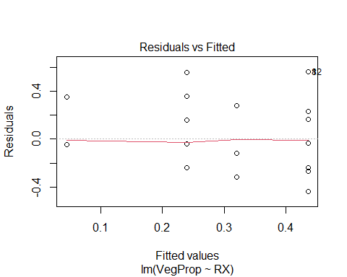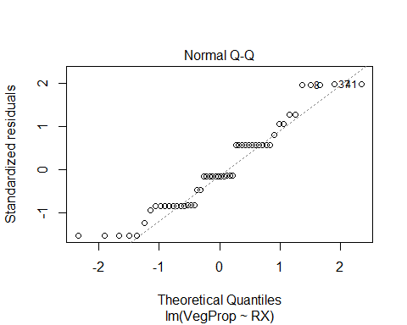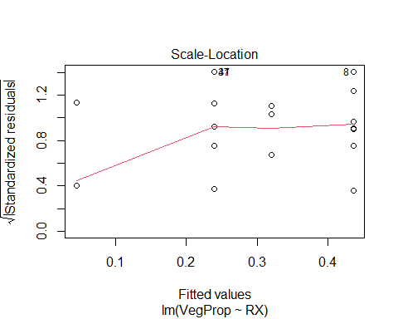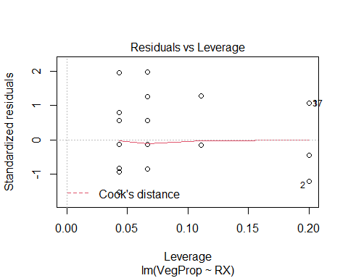

gvlma(V3)

##   
## Call:  
## lm(formula = VegProp ~ RX, data = AllFire)  
##   
## Coefficients:  
## (Intercept) RX1 RX2 RX3   
## 0.4362 -0.1962 -0.1162 -0.3918   
##   
##   
## ASSESSMENT OF THE LINEAR MODEL ASSUMPTIONS  
## USING THE GLOBAL TEST ON 4 DEGREES-OF-FREEDOM:  
## Level of Significance = 0.05   
##   
## Call:  
## gvlma(x = V3)   
##   
## Value p-value Decision  
## Global Stat 3.127e+00 0.5368 Assumptions acceptable.  
## Skewness 1.354e+00 0.2445 Assumptions acceptable.  
## Kurtosis 8.049e-01 0.3696 Assumptions acceptable.  
## Link Function -6.622e-16 1.0000 Assumptions acceptable.  
## Heteroscedasticity 9.674e-01 0.3253 Assumptions acceptable.

#constant variance  
spreadLevelPlot(V3)

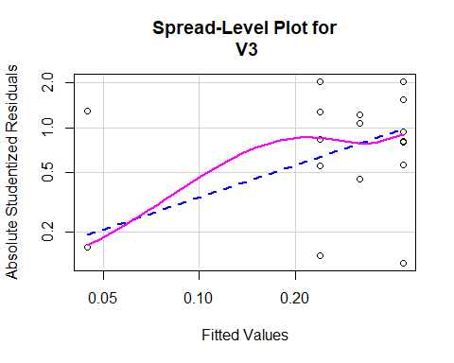

##   
## Suggested power transformation: 0.2873349

#normality of residuals  
V3.resi <- qqPlot(V3, main = "QQ Plot")

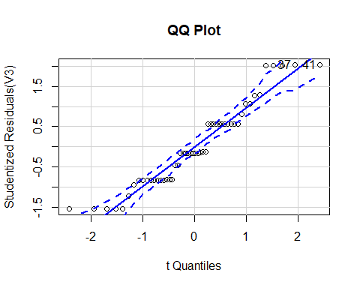

V3.res <- studres(V3)  
hist(V3.res, freq = FALSE,  
 main = "Distribution of Studentized Residuals")  
V3.xfit <- seq(min(V3.res), max(V3.res), length = 40)  
V3.yfit <- dnorm(V3.xfit)  
lines(V3.xfit,V3.yfit)

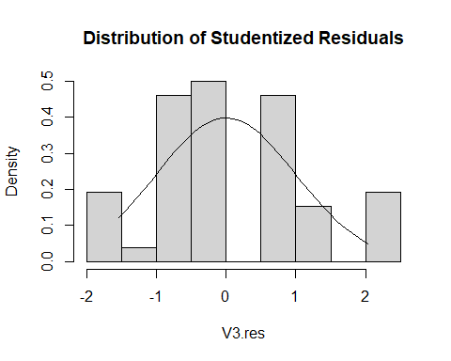

#outliers  
AllFire$WVleverage <- hatvalues(V3)  
ggplot(AllFire,aes(`New Site`,WVleverage))+  
 geom_point()+ylim(0,1)+xlab("test")

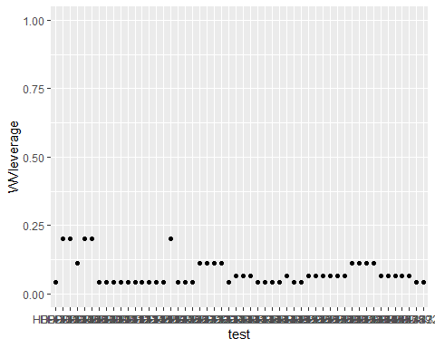

## NA1 S Assumptions

plot(S3)

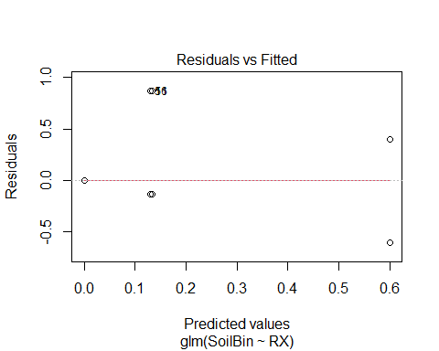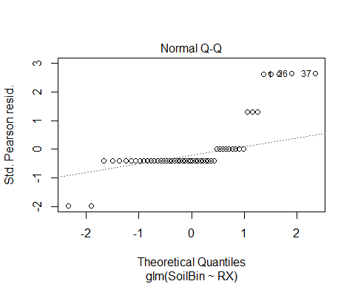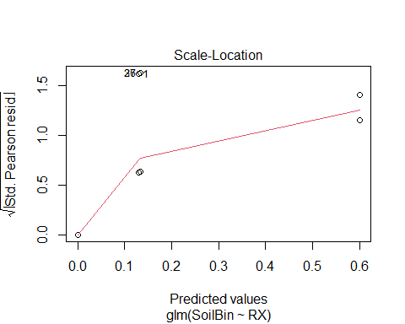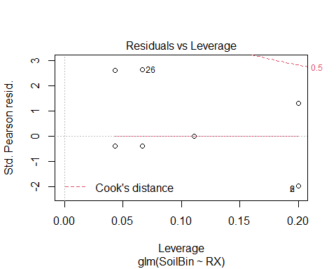

#constant variance  
spreadLevelPlot(S3)

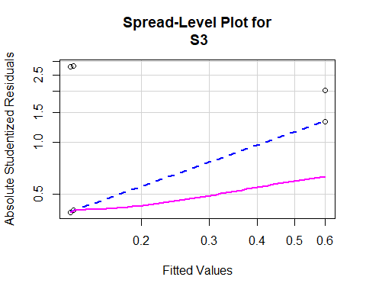

##   
## Suggested power transformation: 0.1937396

#normality of residuals  
S3.res <- studres(S3)  
hist(S3.res,freq = FALSE,  
 main = "Distribution of Studentized Residuals")  
S3.xfit <- seq(min(S3.res),max(S3.res),length = 40)  
S3.yfit <- dnorm(S3.xfit)  
lines(S3.xfit,S3.yfit)

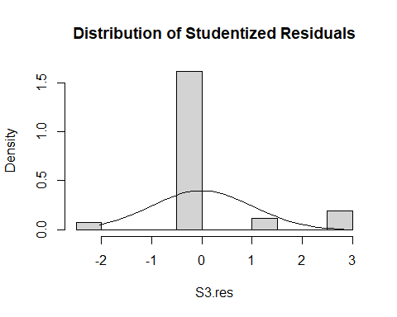

#outliers  
AllFire$WSleverage <- hatvalues(S3)  
ggplot(AllFire,aes(`New Site`,WSleverage))+  
 geom_point()+ylim(0,1)+xlab("test")

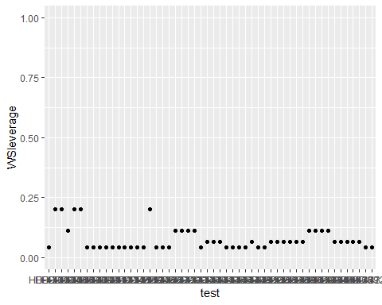

# Seedling Diversity

## Alpha Diversity

PCASeeds <- AllSeeds[-(2:6)]  
PCASeeds <- column_to_rownames(PCASeeds, var = "New Site")  
  
#different alpha diversity statistics  
AllSeeds$Shannon <- diversity(PCASeeds,index = "shannon")  
  
hist(AllSeeds$Shannon)

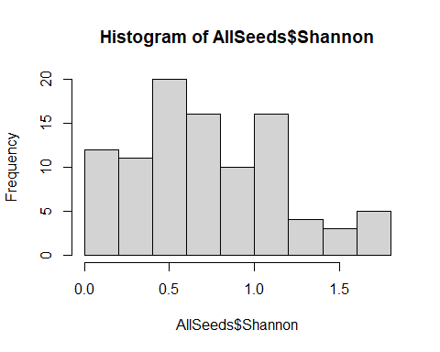

ggplot(AllSeeds,aes(x = TrtBin,y = Shannon))+geom_boxplot()

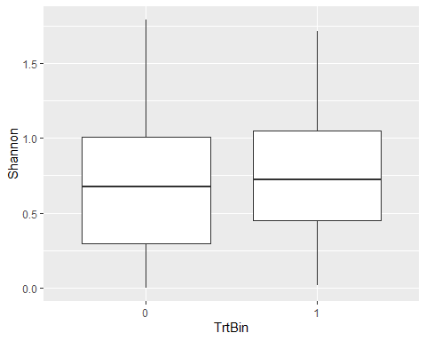

#TrtBin  
#anova  
ShaTrt.a <- aov(Shannon~TrtBin,AllSeeds)  
summary.lm(ShaTrt.a)

##   
## Call:  
## aov(formula = Shannon ~ TrtBin, data = AllSeeds)  
##   
## Residuals:  
## Min 1Q Median 3Q Max   
## -0.76525 -0.32909 -0.03974 0.30769 1.11930   
##   
## Coefficients:  
## Estimate Std. Error t value Pr(>|t|)   
## (Intercept) 0.67246 0.06444 10.436 <2e-16 ***  
## TrtBin1 0.10719 0.08801 1.218 0.226   
## ---  
## Signif. codes: 0 '***' 0.001 '**' 0.01 '*' 0.05 '.' 0.1 ' ' 1  
##   
## Residual standard error: 0.4323 on 95 degrees of freedom  
## Multiple R-squared: 0.01538, Adjusted R-squared: 0.005012   
## F-statistic: 1.484 on 1 and 95 DF, p-value: 0.2262

#Tukey  
ShaTrt.t <- HSD.test(ShaTrt.a,"TrtBin")  
print(ShaTrt.t)

## $statistics  
## MSerror Df Mean CV  
## 0.1868441 95 0.7299247 59.21908  
##   
## $parameters  
## test name.t ntr StudentizedRange alpha  
## Tukey TrtBin 2 2.807569 0.05  
##   
## $means  
## Shannon std r Min Max Q25 Q50 Q75  
## 0 0.6724602 0.4378136 45 0.00000000 1.791759 0.2974449 0.6730117 1.005387  
## 1 0.7796537 0.4274007 52 0.01440241 1.711127 0.4518937 0.7248200 1.050752  
##   
## $comparison  
## NULL  
##   
## $groups  
## Shannon groups  
## 1 0.7796537 a  
## 0 0.6724602 a  
##   
## attr(,"class")  
## [1] "group"

#Lineage  
#anova  
ShaLin.a <- aov(Shannon~Lineage,AllSeeds)  
summary.lm(ShaLin.a)

##   
## Call:  
## aov(formula = Shannon ~ Lineage, data = AllSeeds)  
##   
## Residuals:  
## Min 1Q Median 3Q Max   
## -0.73192 -0.31801 -0.02219 0.30728 1.05984   
##   
## Coefficients:  
## Estimate Std. Error t value Pr(>|t|)   
## (Intercept) 0.73192 0.06423 11.396 <2e-16 ***  
## LineageNA1 -0.00380 0.08858 -0.043 0.966   
## ---  
## Signif. codes: 0 '***' 0.001 '**' 0.01 '*' 0.05 '.' 0.1 ' ' 1  
##   
## Residual standard error: 0.4356 on 95 degrees of freedom  
## Multiple R-squared: 1.937e-05, Adjusted R-squared: -0.01051   
## F-statistic: 0.00184 on 1 and 95 DF, p-value: 0.9659

#Tukey  
ShaLin.t <- HSD.test(ShaLin.a,"Lineage")  
print(ShaLin.t)

## $statistics  
## MSerror Df Mean CV  
## 0.1897583 95 0.7299247 59.6791  
##   
## $parameters  
## test name.t ntr StudentizedRange alpha  
## Tukey Lineage 2 2.807569 0.05  
##   
## $means  
## Shannon std r Min Max Q25 Q50 Q75  
## EU1 0.7319225 0.4329312 46 0 1.791759 0.4466879 0.7271935 0.9990772  
## NA1 0.7281228 0.4380117 51 0 1.711127 0.4078067 0.6931472 1.0433702  
##   
## $comparison  
## NULL  
##   
## $groups  
## Shannon groups  
## EU1 0.7319225 a  
## NA1 0.7281228 a  
##   
## attr(,"class")  
## [1] "group"

#Site  
#anova  
ShaSite.a <- aov(Shannon~`New Site`,AllSeeds)  
summary(ShaSite.a)

## Df Sum Sq Mean Sq  
## `New Site` 96 18.03 0.1878

#Tukey  
#not possible as there are 0 df remaining  
  
compare_alpha <- function(AllSeeds,grouping_var) {  
 AllSeeds$Shannon <- diversity(PCASeeds,index = "shannon")  
 AllSeeds$grouping <- AllSeeds[[grouping_var]]  
 anova_result <- aov(Shannon~grouping,AllSeeds)  
 tukey_result <- HSD.test(anova_result,"grouping",group = TRUE)  
 group_data <- tukey_result$groups[order(rownames(tukey_result$groups)),]  
 my_plot <- ggplot(AllSeeds,aes(x = grouping,y = Shannon))+  
 geom_text(data = data.frame(),  
 aes(x = rownames(group_data),  
 y = max(AllSeeds$Shannon)+1,  
 label = group_data$groups),  
 col = 'black',  
 size = 10)+  
 geom_boxplot()+  
 ggtitle("Alpha diversity")+  
 xlab(grouping_var)+  
 ylab("Alpha diversity index (Shannon)")  
 return(my_plot)  
}  
  
compare_alpha(AllSeeds,"Lineage")

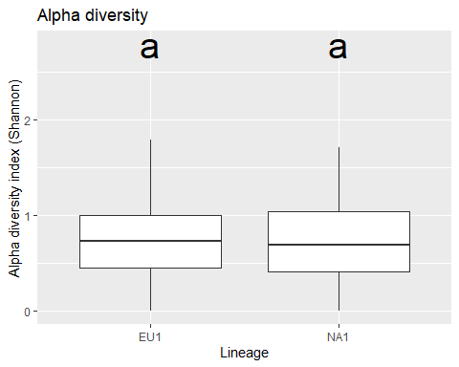

compare_alpha(AllSeeds,"TrtBin")

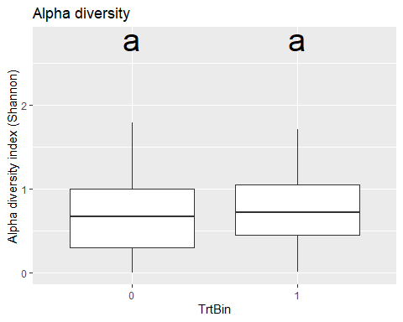

compare_alpha(AllSeeds,"WFBin")

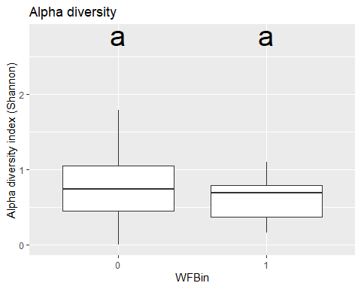

compare_alpha(AllSeeds,"VegBin")

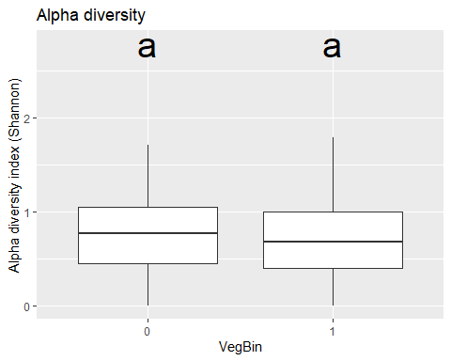

compare_alpha(AllSeeds,"SoilBin")

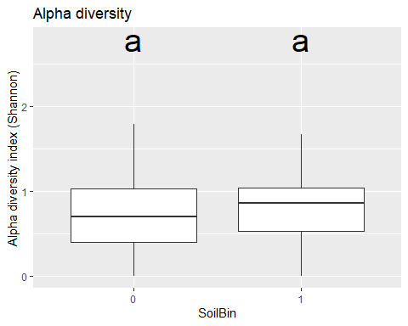

## Beta Diversity

### PCA

PCA <- rda(PCASeeds,scale = FALSE)  
barplot(as.vector(PCA$CA$eig)/sum(PCA$CA$eig))

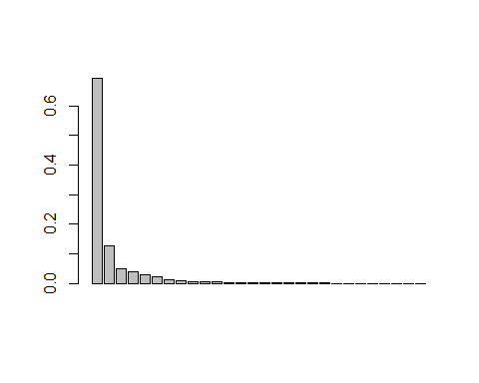

sum((as.vector(PCA$CA$eig)/sum(PCA$CA$eig))[1:2]) # 82%

## [1] 0.8187015

sitePCA <- PCA$CA$u # Site scores  
speciesPCA <- PCA$CA$v # Species scores  
  
biplot(PCA,choices = c(1,2),type = c("text","points"),xlim = c(-5,10))

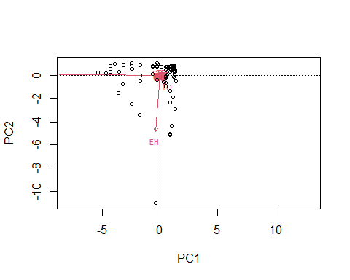

# biplot of axis 1 vs 2  
  
biplot(PCA,choices = c(1,3),type = c("text","points"))

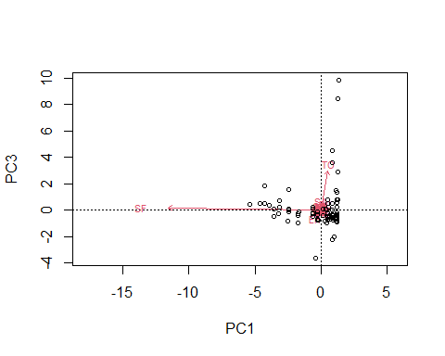

# biplot of axis 1 vs 3

### PCoA

DistSeed <- vegdist(PCASeeds,method = "bray")  
PCOA <- pcoa(DistSeed)  
  
barplot(PCOA$values$Relative_eig[1:10])

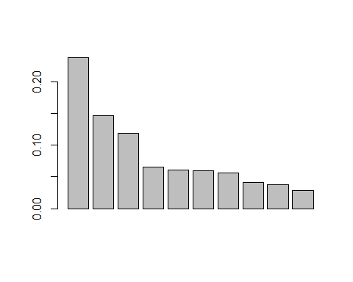

sum((as.vector(PCOA$values$Relative_eig)/sum(PCOA$values$Relative_eig))[1:5]) #63%

## [1] 0.6308943

biplot.pcoa(PCOA,PCASeeds)

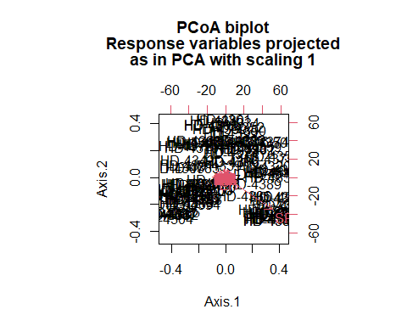

### NMDS

NMDS <- metaMDS(PCASeeds,  
 k = 2,  
 trymax = 100,  
 trace = F,  
 autotransform = FALSE,  
 distance = "bray")  
  
EFvars <- c("New Site",  
 "Lineage",  
 "Latitude",  
 "Longitude",  
 "VegBin",  
 "SoilBin",  
 "YrSinceTrt",  
 "TrtBin")  
  
EFSites <- SODSite.ord[EFvars]  
  
ef <- envfit(NMDS,EFSites,permutations = 999,na.rm = TRUE)  
  
data.scores <- as.data.frame(scores(NMDS))  
data.scores$Site <- rownames(data.scores)  
data.scores$Treatment <- AllSeeds$TrtBin  
data.scores$Lineage <- AllSeeds$Lineage  
data.scores$VegBin <- AllSeeds$VegBin  
data.scores$SoilBin <- AllSeeds$SoilBin  
  
species.scores <- as.data.frame(scores(NMDS, "species"))  
species.scores$Species <- rownames(species.scores)  
  
nmds.un <- data.scores[data.scores$Treatment == "0",  
 ][chull(data.scores  
 [data.scores$Treatment == "0",   
 c("NMDS1", "NMDS2")]), ]  
nmds.tr <- data.scores[data.scores$Treatment == "1",  
 ][chull(data.scores  
 [data.scores$Treatment == "1",   
 c("NMDS1", "NMDS2")]), ]  
hull.data <- rbind(nmds.un, nmds.tr)  
  
p.nmds <- ggplot()+   
 geom_polygon(data = hull.data,  
 aes(x = NMDS1, y = NMDS2,  
 fill = Treatment,  
 group = Treatment),  
 alpha = 0.3)+  
 geom_point(data = data.scores,  
 aes(x = NMDS1, y=NMDS2,  
 shape = as.factor(Lineage),  
 color = Treatment),  
 size=4)+  
 geom_text(data = species.scores,  
 aes(x = NMDS1, y = NMDS2,  
 label = Species),  
 alpha = 0.5)+  
 coord_equal()+  
 labs(shape = "Lineage")+  
 scale_fill_viridis(discrete = TRUE, labels = c("0" = "Untreated","1" = "Treated"))+  
 scale_color_viridis(discrete = TRUE, begin = 0.3, end = 0.8, labels = c("0" = "Untreated","1" = "Treated"))+  
 theme_classic()+  
 theme(axis.text.x = element_blank(),  
 axis.text.y = element_blank(),  
 axis.ticks = element_blank(),  
 axis.title.x = element_text(size=18),  
 axis.title.y = element_text(size=18),  
 panel.background = element_blank(),  
 panel.grid.major = element_blank(),  
 panel.grid.minor = element_blank(),  
 plot.background = element_blank())  
p.nmds

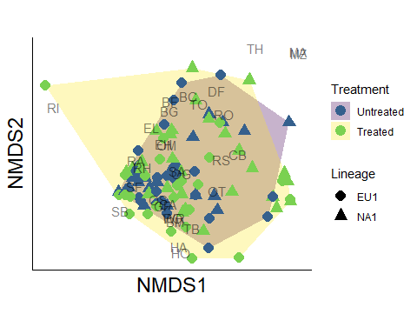

ggsave(filename = "NMDS.png",  
 p.nmds,  
 width = 6.5,  
 height = 5,  
 dpi = 300,  
 units = "in",  
 device = 'png')

### PERMANOVA

PER.div <- adonis2(PCASeeds~TrtBin*Lineage,data = EFSites,   
 permutations = 999,method = "bray")  
PER.div

## Permutation test for adonis under reduced model  
## Terms added sequentially (first to last)  
## Permutation: free  
## Number of permutations: 999  
##   
## adonis2(formula = PCASeeds ~ TrtBin * Lineage, data = EFSites, permutations = 999, method = "bray")  
## Df SumOfSqs R2 F Pr(>F)   
## TrtBin 1 0.624 0.01902 1.8837 0.056 .  
## Lineage 1 0.622 0.01895 1.8768 0.064 .  
## TrtBin:Lineage 1 0.756 0.02303 2.2805 0.028 *  
## Residual 93 30.817 0.93901   
## Total 96 32.819 1.00000   
## ---  
## Signif. codes: 0 '***' 0.001 '**' 0.01 '*' 0.05 '.' 0.1 ' ' 1

# overall tests  
PER2.div <- adonis2(PCASeeds~TrtBin*Lineage,data = EFSites,  
 permutations = 999,method = "bray",by = NULL)  
PER2.div

## Permutation test for adonis under reduced model  
## Permutation: free  
## Number of permutations: 999  
##   
## adonis2(formula = PCASeeds ~ TrtBin * Lineage, data = EFSites, permutations = 999, method = "bray", by = NULL)  
## Df SumOfSqs R2 F Pr(>F)   
## Model 3 2.002 0.06099 2.0136 0.002 **  
## Residual 93 30.817 0.93901   
## Total 96 32.819 1.00000   
## ---  
## Signif. codes: 0 '***' 0.001 '**' 0.01 '*' 0.05 '.' 0.1 ' ' 1

#### By Treatment

T.disp <- betadisper(DistSeed, group = EFSites$TrtBin)  
permutest(T.disp)

##   
## Permutation test for homogeneity of multivariate dispersions  
## Permutation: free  
## Number of permutations: 999  
##   
## Response: Distances  
## Df Sum Sq Mean Sq F N.Perm Pr(>F)   
## Groups 1 0.15451 0.154507 6.8432 999 0.011 *  
## Residuals 95 2.14493 0.022578   
## ---  
## Signif. codes: 0 '***' 0.001 '**' 0.01 '*' 0.05 '.' 0.1 ' ' 1

plot(T.disp, hull = FALSE, ellipse = TRUE) #sd ellipse

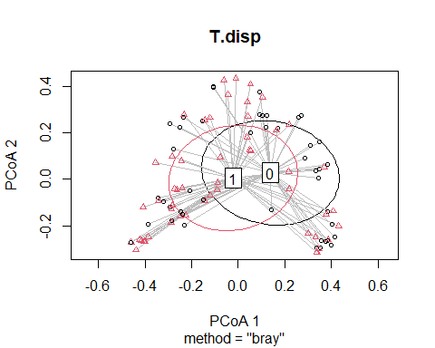

T.cent <- data.frame(grps = rownames(T.disp$centroids),  
 data.frame(T.disp$centroids))  
T.vec <- data.frame(group = T.disp$group,  
 data.frame(T.disp$vectors))  
T.vec$Lineage <- AllSeeds$Lineage  
  
seg.un <- T.vec[T.vec$group == "0",]  
seg.tr <- T.vec[T.vec$group == "1",]  
seg.u <- cbind(seg.un[,1:3],  
 T.cent[rep(1:nrow(T.cent),   
 as.data.frame(table(seg.un$group))$Freq),2:3])  
seg.t <- cbind(seg.tr[,1:3],  
 T.cent[rep(1:nrow(T.cent),   
 as.data.frame(table(seg.tr$group))$Freq),2:3])  
names(seg.u)<-c("group","v.PCoA1","v.PCoA2","PCoA1","PCoA2")  
names(seg.t)<-c("group","v.PCoA1","v.PCoA2","PCoA1","PCoA2")  
seg.data <- rbind(seg.u, seg.t)  
  
un.hull<-seg.data[seg.data$group=="0",1:3][chull(seg.data[seg.data$group=="0",2:3]),]  
tr.hull<-seg.data[seg.data$group=="1",1:3][chull(seg.data[seg.data$group=="1",2:3]),]  
trt.hull<-rbind(un.hull,tr.hull)  
  
panel.un <- ggplot()+   
 geom_polygon(data=trt.hull[trt.hull=="0",],  
 aes(x=v.PCoA1,y=v.PCoA2),  
 colour="black",alpha=0,linetype="dashed")+  
 geom_segment(data=seg.data[seg.data$group == "0",],  
 aes(x=v.PCoA1,xend=PCoA1,y=v.PCoA2,yend=PCoA2),  
 alpha=0.30)+   
 geom_point(data=T.cent[1,1:3],  
 aes(x=PCoA1,y=PCoA2),  
 size=4,colour="red",shape=16)+  
 geom_point(data=seg.data[seg.data$group == "0",],  
 aes(x=v.PCoA1,y=v.PCoA2),size=2,shape=16)+  
 labs(title="A.",x="",y="")+  
 coord_cartesian(xlim = c(-0.5,0.5), ylim = c(-0.5,0.5))+  
 theme_bw()+   
 theme(legend.position="none")  
panel.tr <- ggplot()+   
 geom_polygon(data=trt.hull[trt.hull=="1",],  
 aes(x=v.PCoA1,y=v.PCoA2),  
 colour="black",alpha=0,linetype="dashed")+  
 geom_segment(data=seg.data[seg.data$group == "1",],  
 aes(x=v.PCoA1,xend=PCoA1,y=v.PCoA2,yend=PCoA2),  
 alpha=0.30)+   
 geom_point(data=T.cent[2,1:3],  
 aes(x=PCoA1,y=PCoA2),  
 size=4,colour="red",shape=17)+   
 geom_point(data=seg.data[seg.data$group == "1",],  
 aes(x=v.PCoA1,y=v.PCoA2),size=2,shape=17)+  
 labs(title="B.",x="",y="")+  
 coord_cartesian(xlim = c(-0.5,0.5), ylim = c(-0.5,0.5))+  
 theme_bw()+   
 theme(legend.position="none")  
panel.all <- ggplot()+   
 geom_polygon(data=trt.hull,  
 aes(x=v.PCoA1,y=v.PCoA2),  
 colour="black",alpha=0,linetype="dashed")+  
 geom_segment(data=seg.data,  
 aes(x=v.PCoA1,xend=PCoA1,y=v.PCoA2,yend=PCoA2),  
 alpha=0.30)+   
 geom_point(data=T.cent[,1:3],  
 aes(x=PCoA1,y=PCoA2,shape=grps),  
 size=4,colour="red")+   
 geom_point(data=seg.data,  
 aes(x=v.PCoA1,y=v.PCoA2,shape=group),size=2)+  
 labs(title="C.",x="",y="")+  
 coord_cartesian(xlim = c(-0.5,0.5), ylim = c(-0.5,0.5))+  
 theme_bw()+   
 theme(legend.position="none")  
  
p.perT <- ggarrange(panel.un,panel.tr,panel.all,ncol = 3,nrow = 1)  
p.perT

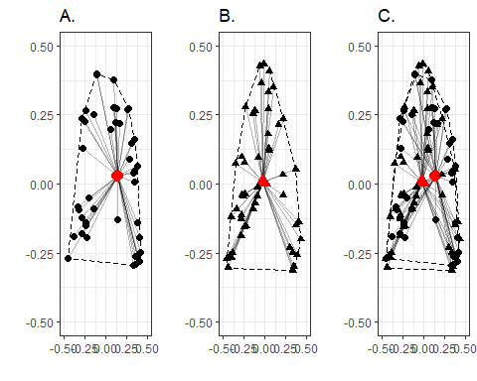

ggsave(filename = "Perm_Trt.png",  
 p.perT,  
 width = 6.5,  
 height = 2,  
 dpi = 300,  
 units = "in",  
 device = 'png')

#### By Lineage

L.disp <- betadisper(DistSeed, group = EFSites$Lineage)  
permutest(L.disp)

##   
## Permutation test for homogeneity of multivariate dispersions  
## Permutation: free  
## Number of permutations: 999  
##   
## Response: Distances  
## Df Sum Sq Mean Sq F N.Perm Pr(>F)  
## Groups 1 0.00602 0.0060159 0.2374 999 0.612  
## Residuals 95 2.40775 0.0253447

plot(L.disp, hull = FALSE, ellipse = TRUE) #sd ellipse

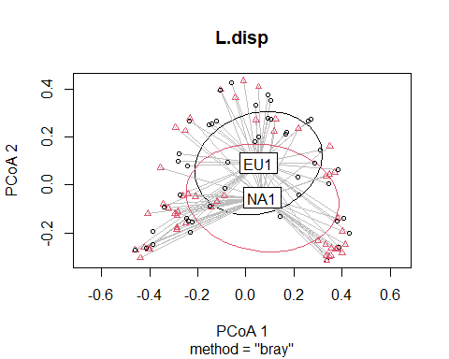

L.cent <- data.frame(grps = rownames(L.disp$centroids),  
 data.frame(L.disp$centroids))  
L.vec <- data.frame(group = L.disp$group,  
 data.frame(L.disp$vectors))  
L.vec$Lineage <- AllSeeds$Lineage  
  
seg.eu <- L.vec[L.vec$group == "EU1",]  
seg.na <- L.vec[L.vec$group == "NA1",]  
seg.eu <- cbind(seg.eu[,1:3],  
 L.cent[rep(1:nrow(L.cent),   
 as.data.frame(table(seg.eu$group))$Freq),2:3])  
seg.na <- cbind(seg.na[,1:3],  
 L.cent[rep(1:nrow(L.cent),   
 as.data.frame(table(seg.na$group))$Freq),2:3])  
names(seg.eu)<-c("group","v.PCoA1","v.PCoA2","PCoA1","PCoA2")  
names(seg.na)<-c("group","v.PCoA1","v.PCoA2","PCoA1","PCoA2")  
lin.data <- rbind(seg.eu, seg.na)  
  
eu.hull<-lin.data[lin.data$group=="EU1",1:3][chull(lin.data[lin.data$group=="EU1",2:3]),]  
na.hull<-lin.data[lin.data$group=="NA1",1:3][chull(lin.data[lin.data$group=="NA1",2:3]),]  
lin.hull<-rbind(eu.hull,na.hull)  
  
panel.eu <- ggplot()+   
 geom_polygon(data=lin.hull[lin.hull=="EU1",],  
 aes(x=v.PCoA1,y=v.PCoA2),  
 colour="black",alpha=0,linetype="dashed")+  
 geom_segment(data=lin.data[lin.data$group == "EU1",],  
 aes(x=v.PCoA1,xend=PCoA1,y=v.PCoA2,yend=PCoA2),  
 alpha=0.30)+   
 geom_point(data=L.cent[1,1:3],  
 aes(x=PCoA1,y=PCoA2),  
 size=4,colour="red",shape=16)+  
 geom_point(data=lin.data[lin.data$group == "EU1",],  
 aes(x=v.PCoA1,y=v.PCoA2),size=2,shape=16)+  
 labs(title="A.",x="",y="")+  
 coord_cartesian(xlim = c(-0.5,0.5), ylim = c(-0.5,0.5))+  
 theme_bw()+   
 theme(legend.position="none")  
panel.na <- ggplot()+   
 geom_polygon(data=lin.hull[lin.hull=="NA1",],  
 aes(x=v.PCoA1,y=v.PCoA2),  
 colour="black",alpha=0,linetype="dashed")+  
 geom_segment(data=lin.data[lin.data$group == "NA1",],  
 aes(x=v.PCoA1,xend=PCoA1,y=v.PCoA2,yend=PCoA2),  
 alpha=0.30)+   
 geom_point(data=L.cent[2,1:3],  
 aes(x=PCoA1,y=PCoA2),  
 size=4,colour="red",shape=17)+   
 geom_point(data=lin.data[lin.data$group == "NA1",],  
 aes(x=v.PCoA1,y=v.PCoA2),size=2,shape=17)+  
 labs(title="B.",x="",y="")+  
 coord_cartesian(xlim = c(-0.5,0.5), ylim = c(-0.5,0.5))+  
 theme_bw()+   
 theme(legend.position="none")  
panel.L <- ggplot()+   
 geom_polygon(data=lin.hull,  
 aes(x=v.PCoA1,y=v.PCoA2),  
 colour="black",alpha=0,linetype="dashed")+  
 geom_segment(data=lin.data,  
 aes(x=v.PCoA1,xend=PCoA1,y=v.PCoA2,yend=PCoA2),  
 alpha=0.30)+   
 geom_point(data=L.cent[,1:3],  
 aes(x=PCoA1,y=PCoA2,shape=grps),  
 size=4,colour="red")+   
 geom_point(data=lin.data,  
 aes(x=v.PCoA1,y=v.PCoA2,shape=group),size=2)+  
 labs(title="C.",x="",y="")+  
 coord_cartesian(xlim = c(-0.5,0.5), ylim = c(-0.5,0.5))+  
 theme_bw()+   
 theme(legend.position="none")  
  
p.perL <- ggarrange(panel.eu,panel.na,panel.L,ncol = 3,nrow = 1)  
p.perL

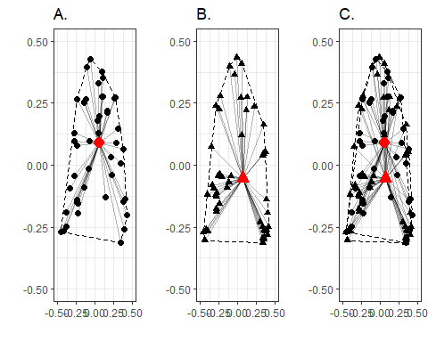

ggsave(filename = "Perm_Lin.png",  
 p.perL,  
 width = 6.5,  
 height = 2,  
 dpi = 300,  
 units = "in",  
 device = 'png')