**Conceptual Model Design**

**Description**

I am expanding upon the model I created for assignment one by adding the coast guard ship from the paper, “Modeling a Major Maritime Disaster Scenario using the Universal Modeling Framework for Sequential Decisions” [1]. In the paper a coast guard ship arrives to provide medical aid to the evacuees, but has a maximum capacity of 50 people standing. Policies for who to load and unload the ship are based upon the triage status of the evacuees. By adding this model of the coast guard ship I aim to replicate the results found from the case study conducted in the paper.

**Model**

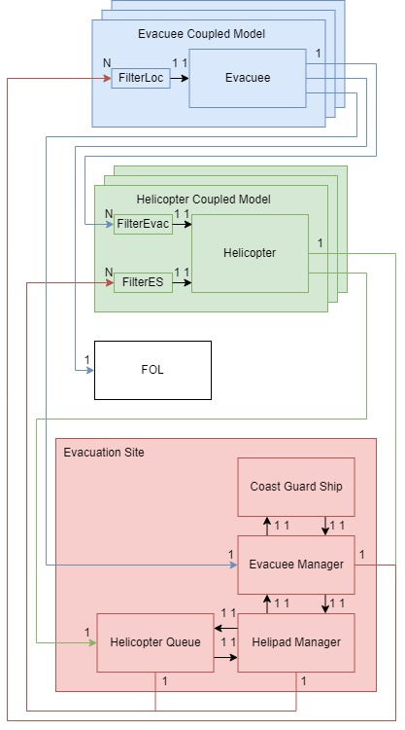

**Components**

It has the same components as the earlier model but with an added Coast Guard Ship atomic model that accepts a Boolean input from the Evacuee Manager model and sends a Boolean output to the Evacuee Manager. In this way it is a part of the Evacuation Site coupled model. The coast guard ship model keeps track of when the coast guard ship arrives, when it loads people on board, and when people must disembark. The evacuee manager model manages the loading and unloading policies. The evacuee model now has a new location represented by the coast guard ship. If they are in the ship their triage status improves instead of deteriorating.

**References**

[1] M. Rempel, “Modelling a major maritime disaster scenario using the universal modelling framework for sequential decisions”, Safety Science, Volume 171, 2024, 106379, ISSN 0925-7535, <https://doi.org/10.1016/j.ssci.2023.106379>.

**Specification Document**

**Coupling Scheme**

|  |  |
| --- | --- |
| **Atomic Models** | **Coupled Models** |
| FilterLoc, FilterEvac, FilterES, Evacuee, Helicopter, FOL, Helicopter Queue, Helipad Manager, Evacuee Manager, Coast Guard Ship | Evacuee Coupled, Helicopter Coupled, Evacuation Site |

The coupling scheme is unchanged except for the coast guard ship model now being coupled with the evacuee manager. It has one Boolean input from the evacuee manager, and one Boolean output to the evacuee manager.

**Coupled Models Formal Specification**

Only the Evacuation Site is different so only it will be listed here.

Evacuation Site=

< X, Y, {HelicopterQueue, HelipadManager, EvacueeManager, CoastGuardShip}, EIC, EOC, IC, SELECT >

X = inEvac, inHelo

Y = outHelo, outEvac

EIC = {(EvacuationSite.inEvac, EvacueeManager.inEvac), (EvacuationSite.inHelo, HelicopterQueue.inHelo)}

EOC = {(HelicopterQueue.outHelo, EvacuationSite.outHelo), (HelipadManager.outHelo, EvacuationSite.outHelo), (EvacueeManager.outEvac, EvacuationSite.outEvac)

IC = {(HelicopterQueue.outHM, HelipadManager.inHQ), (HelipadManager.outHQ, HelicopterQueue.inHM), (HelipadManager.outEM, EvacueeManager.inHM), (EvacueeManager.outHM, HelipadManager.inEM), (EvacueeManager.outCGS, CoastGuardShip.in), (CoastGuardShip.out, EvacueeManager.inCGS)}

SELECT : ({HelicopterQueue, HelipadManager, EvacueeManager, CoastGuardShip}) = HelicopterQueue

({HelipadManager, EvacueeManager, CoastGuardShip}) = HelipadManager

({EvacueeManager, CoastGuardShip}) = CoastGuardShip

**Atomic Models Formal Specification/Model Testing**

Only the Evacuee, Evacuee Manager, and Coast Guard Ship models are different, so only those models’ DEVS graphs are shown here.

Evacuee Model

Evacuee Manager model

Coast Guard Ship

Unit tests were completed for each atomic model. Then the unit tests for each coupled model were updated and completed successfully. Lastly integration testing was completed for the top model where bugs were found in the Evacuee Manager model and corrected. One such bug was how more people were being loaded on to the ship than the ship’s capacity should allow. This was an easy fix completed by replacing the max capacity value with the capacity that would be currently available on board the ship every time evacuees were loaded on board.

**Experiments**

Experiment type 1 from the paper, “Modeling a Major Maritime Disaster Scenario using the Universal Modeling Framework for Sequential Decisions” revolves around testing the impact of deploying 1, 3, or 6 helicopters on the number of lives saved, given the coast guard ship might arrive immediately or at any time up to a week later. Like in the paper I plan to collect the expected number of lives saved with each experiment type. In the paper they conduct 30 trials per experiment type as parts of the model are decided randomly. This is likely because under the central limit theorem this is considered the minimum number of samples to have a normal distribution. I would like to have a similar if not smaller confidence interval than those obtained for each experiment type in the paper, but when I conduct only 30 trials the confidence interval I receive is higher. As each simulation takes less than a second to run I have chosen to run 100 trials for each experiment type. The confidence intervals are now within the desired range. The following table shows the expected values and their 95% confidence intervals for each experiment type.

|  |  |  |  |
| --- | --- | --- | --- |
| 100 Trials Each | Expected Number of Lives Saved (95% CI) | | |
| Ship Arrival Time (h) | 1 Helo | 3 Helos | 6 Helos |
| 0 | 167.18 ± 0.7153 |  |  |
| 12 | 159.71 ± 0.6859 |  |  |
| 24 | 153.06 ± 0.6806 |  |  |
| 36 | 143.75 ± 0.6606 |  |  |
| 48 | 135.56 ± 0.5397 |  |  |
| 60 | 127.12 ± 0.5615 |  |  |
| 72 | 119.51 ± 0.5095 |  |  |
| 84 | 114.1 ± 0.5692 |  |  |
| 96 | 104.81 ± 0.7040 |  |  |
| 108 | 101.8 ± 0.5770 |  |  |
| 120 | 101.9 ± 0.5651 |  |  |
| 132 | 101.79 ± 0.5511 |  |  |
| 144 | 101.85 ± 0.5678 |  |  |
| 156 | 101.73 ± 0.5029 |  |  |
| 168 | 101.94 ± 0.5646 |  |  |
| No Arrival |  |  |  |