Requirements and Environment setup:

When running the application for the first time, first the user must have download and installed a python “IDE” (integrated development environment) such as visual studio code, with a compatible version of python and preferably Git for ease of pulling the repository from the artefact link here: (https://github.com/HazelHS/Msc-COM7016-Project-Artifcat-2414420-Hazel-Hanson-Stewart)
Once the artefact files have been acquired and the root folder has been opened in the users IDE of choice as a new workspace, a new .venv or virtual environment must be created to download and install the dependencies required for the application to run correctly.
This can be done by either accessing the python extension in VScode, or by running the command “python -m venv [the path to where the .venv should be stored e.g. /path/to/new/virtual/environment]” in the python console (more information about this step can be found here: https://docs.python.org/3/library/venv.html).
Once the .venv has been created, the next step is to install the required dependencies. This can be done by typing into the python console window “pip install –r dependencies.txt”, the dependenices.txt file where the requirements are being pulled from, is located in the root directory of the repository, and also contains a short description of each dependencies purpose and use in the application (see below).
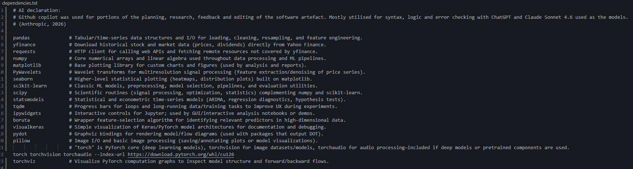
Figure 1: dependencies.txt, with comments.
From here, when the console has finished installing and there are no errors the user is free to run and execute the application by using the command “py ./Model_Designer.py”. This opens the Model Designer which is the entry point for the application and location in the repositories root directory, the whole applications functionality is accessible from this GUI window.

How to use and navigate the Model Designer:

When running the Model Designer the main window will be displayed, it has five main functions each with its own individual purposes and nuances for operation. Each of these five functions are delineated as the “Pipeline Stages” as seen below.
Starting from the top then working down, each row represents the five main stages in this applications AI model standardised production framework. Each of the five rows contains their own individual configuration and setup that should be conducted in order to best prime the subsequent section in the production pipeline.
The “Refresh All” button below the last section here under “Model Evaluation Method” will refresh the list of scripts that the program recognises as valid scripts that it can run. The “Console Output” section reads out the python code that the program is currently executing or has previously executed in the session, with a “Stop” button to halt execution and a “Clear” button to clear the console readout.
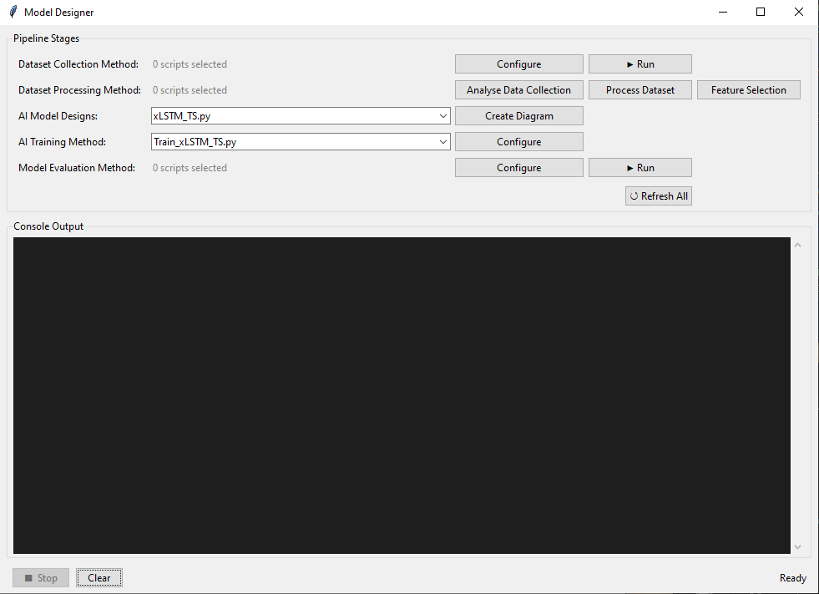
Figure 2: Model Designer, main window.

Dataset Collection Method:

Before progressing onto the further stages of the pipeline production, the user must first create / collect a dataset to be used in the AI Models training and evaluation. By clicking on the “Configure” button of the “Dataset Collection Method” section, to the left of its “Run” button, the user will be greeted with a new window.
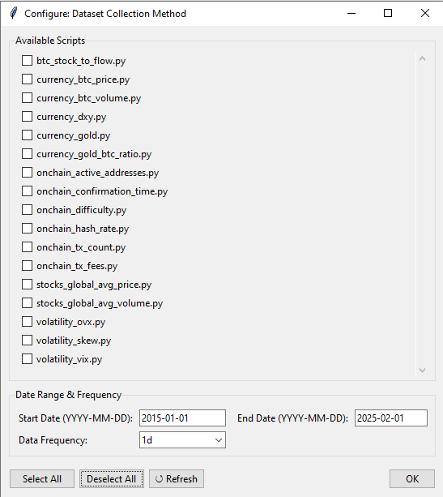
Figure 3: Dataset Collection Method, Configuration Window.
This is the window that is used to select which features to be initially collected for inclusion in the dataset to be created, the “Available Scripts” section shows all the scripts that were auto-detected from the folder location: “\Dataset_Modules\Dataset_Collection” in the root directory. If more scripts are added (or removed) from said folder they will be updated in this list each time the program is closed and re-opened, or when clicking on the “Refresh” button at the bottom of the window. These scripts will produce a single feature dataset each, for example the “currency_btc_price.py” script pulls the historical price data for Bitcoin from the specified date range, and produce a two column “.csv” file with the date/time as the first and the btc ticket prices as the second.
All the included scripts will collect data from either “yfinance” or “blockchain.info” (more in-depth details about how these scripts function is included in the “Adding scripts for Dataset Collection” section). Each script can be selected by clicking on their corresponding checkbox, with multiple scripts able to be selected at one time. The “Date Range & Frequency” section below, describes the start and end date time frame that each feature will try to collect for, with the “Date Frequency” being the interval that each data entry will be for (hourly, daily, weekly etc).
The date range and frequency that the “yfinance” API accepts varies depending on the market ticket, as such there may be some market tickets that will through errors if the frequency and date range does not match the API’s expected input for said ticket. The console output window should attempt to indicate this however it is a limitation with the API itself.
Once all the features that the user wishes to include in the dataset is selected with the desired date range and frequency, clicking the “OK” button and return to the previous window and click the “Run” button for the Dataset Collection Method. This will execute all the selected scripts and combine each scripts single column feature, into a single “.csv” file correctly ordered by date from earliest to latest, and saves that file into this folder location (\Dataset_Modules\dataset_output) with a relevant naming convention.

Dataset Processing Method:

The next step is to begin the dataset cleaning and processing steps, on the Dataset Processing Method row in the main window for the Model Designer there are three buttons for “Analyse Data Collection”, “Process Dataset” and “Feature Selection”. It would be wise to first starting with “Analyse Data Collection”, as the data pulled from the API’s in the previous step in the pipeline may not always have complete entries, outliers or other irregularities. Once again clicking on the “Analyse Data Collection” button will open a new window that will populate with scripts of a related functionality in the “available Analysis Scripts” section (in this case, the folder they populate from is found here: \Dataset_Modules\Dataset_Processing_Methods\Dataset_Analysis_Methods).
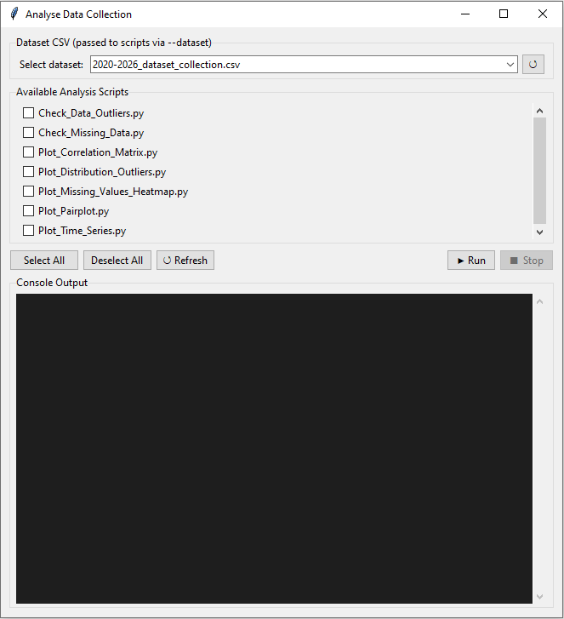
Figure 4: Analyse Data Collection window.
The “Dataset CSV (passed to scripts via --dataset)” section is a drop down menu where the user can select a dataset (a list populated from the dataset output directory: \Dataset_Modules\dataset_output) of which to perform the analysis on, using the scripts listed in the below section with checkboxes. The included analysis scripts all perform functionality described by their name, both prefix “Check_” scripts for missing data and outliers will only run in the console output window below (Use the “Run button as before to execute all selected scripts), while all of the “Plot_” prefix scripts will generate graph plots of the dataset using the “seaborn” and “matplot“ libraries allowing the user to save and adjust the plotted graphs as needed.
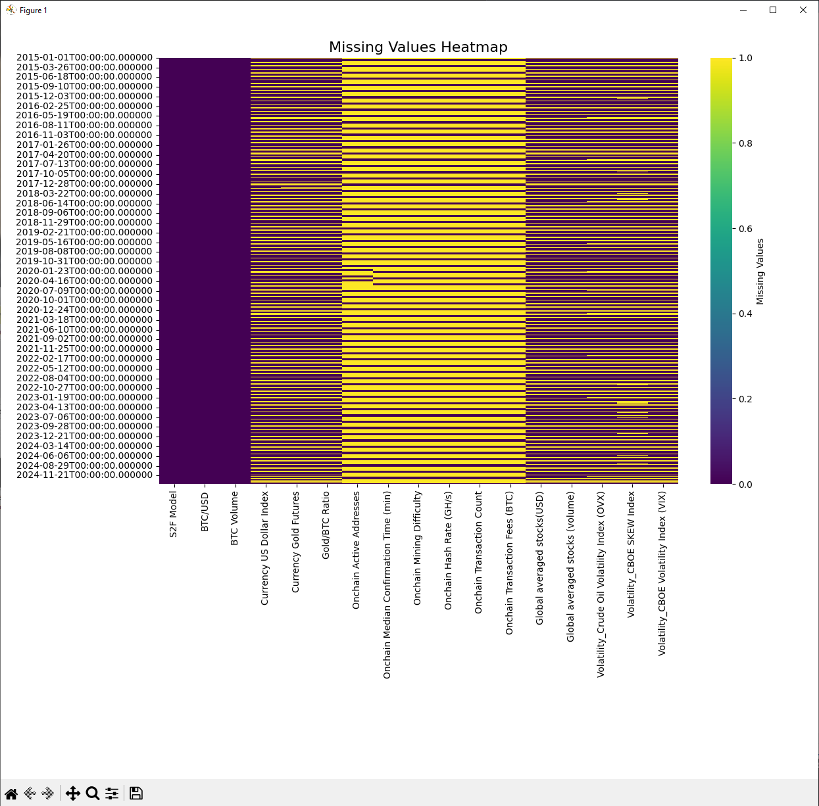
Figure 5: Example, Plot Missing Values Heatmap.

Once the user has understood and analysed the dataset, the next step (if required) is to close the Analyse Data Collection window, return again to the main window and navigate to the “Process Dataset” button, which of course opens its corresponding interface. This new window is identical except for the “Available Scripts” section states “Processing” instead of “Analysis” and will populate from the “Dataset_Processing_Methods” folder instead of the analysis methods folder (\Dataset_Modules\Dataset_Processing_Methods).
There are four included Processing scripts, two for “de-noising” (described in more detail in the report, and code comments) with one for plotting the noise removed from the dataset as well as performing it on and saving the result as a new “.csv” dataset, and the other for just the de-noising without the plot. The other two scripts are for normalising the full “.csv” dataset, and the other for interpolating linearly fill values into missing entries from the neighbouring existing values and saving as a new “.csv” dataset.
The final window that can be accessed for Dataset Processing Methods is the “Feature Selection” button, this is the most “optional” step in the pipeline as it is not necessarily required and depending on the specifics on the experiment being conducted may not even be needed (for example, single feature datasets). Never the less, there are three scripts included for feature selection, which once again take a selected dataset from a drop down window as an input and also additionally take a “Target Column” from another drop down (which will populate from the selected .csv file) which will treat said column as the target that the AI Model chosen in subsequent steps would also be intended to use as its target column for training.
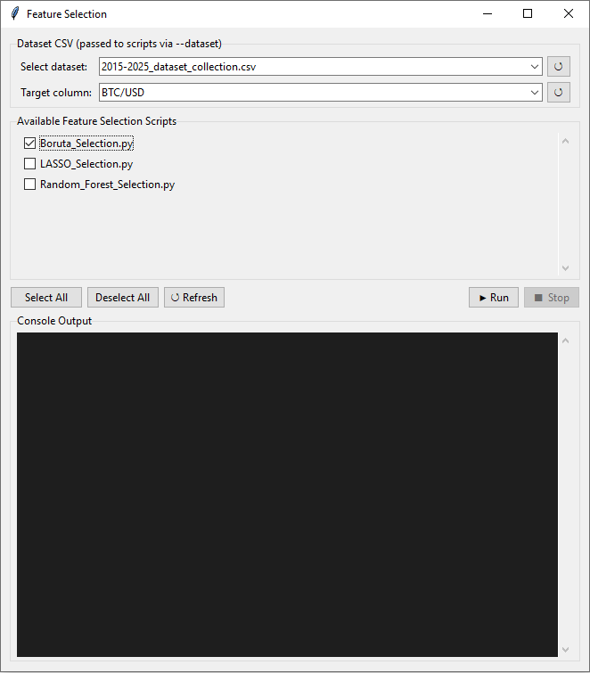
Figure 6: Feature Selection window.

Once any combination of feature selection scripts have been selected and run using the “Run” button, a plot graph will be generated to demonstrate the executed feature selection algorithms “importance” or chosen features to include in the final dataset, to be saved and exported to the dataset output folder for use in the subsequent training and evaluation pipeline steps.
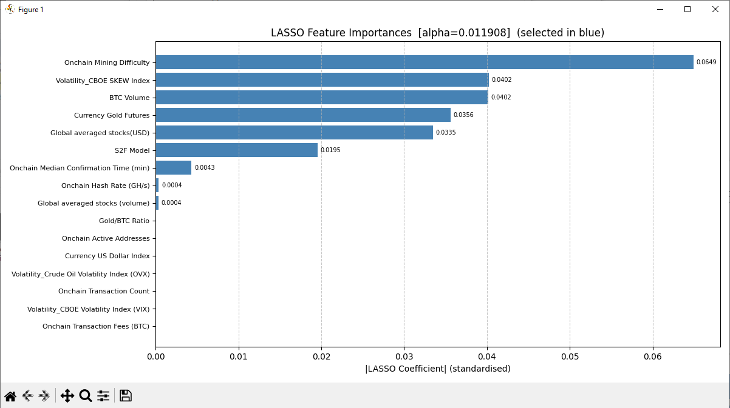
Figure 7: Feature Selection, Plot example.

AI Model Designs:

There is only one button to be used in the AI Model Design pipeline section, and that is the “Create Diagram”. This section uses a drop down menu as found in the previously discussed portions of the manual, in this case populated from the Model Designs folder (\AI_Modules\Model_Designs). The single script that is executed when this pipeline section is ran with the selected AI Model from the drop down menu as the input, is the “model_node_disaplay.py” script found in this folder location: “\AI_Modules\Model_Map_Diagram”. This script creates a model map diagram of the selected model, by using the several visualisation python libraries in conjunction with pytorch, to visually represent the AI models key design characteristics. Such as, how many node clusters and of what “type”, with each node in the diagram scales for approximate node density.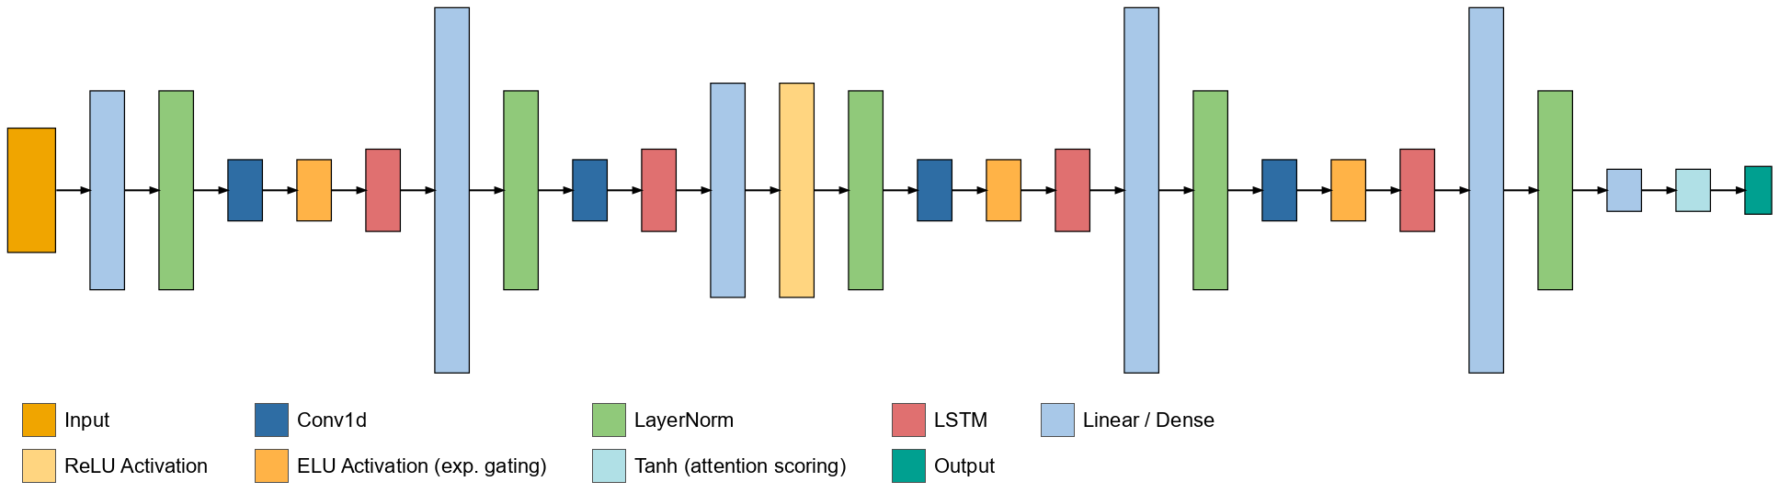
Figure 8: xLSTM-TS Model Diagram, example.

The node type and colour may need to be specifically added into the code to be recognised for correct inclusion in the output when new models are added into the software, below is an example in the script showing where and how new clusters can be included:
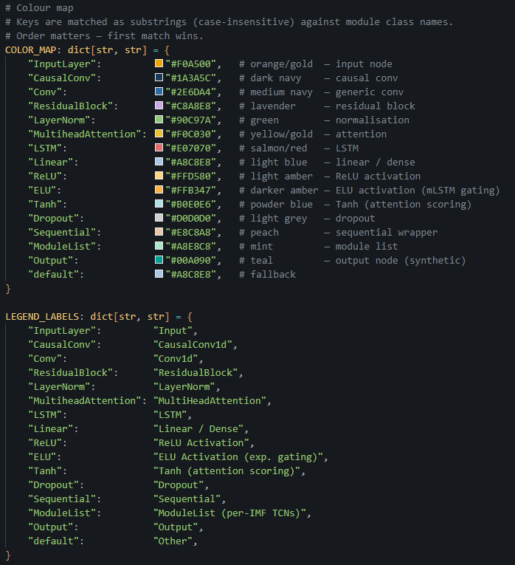
Figure 9: model_node_display.py, code example.

AI Training Method:

When starting the AI Model Training portion of the pipeline, before clicking on the Configure button for that row, the user must selection both the AI Model Designs drop down and that corresponding Models training script. This is because of the complexity in how the scripts are needed to be constructed in order for them to be functional, fewer than expected aspects of their design was possible to have been constructed entirely modularly and as interchangeable as desired. As a result, while there is still some shared functionality with “train_utils.py”, the training models still require bespoke custom scripts for each model.
However once both scripts matching the same model have been selected for both AI Training Methods and AI Model Designs, the user may click on the Configure button to open the Model training window.

Below is an example of both the MEMD-TCN Model Training Configuration window and the xLSTM-TS Training window.
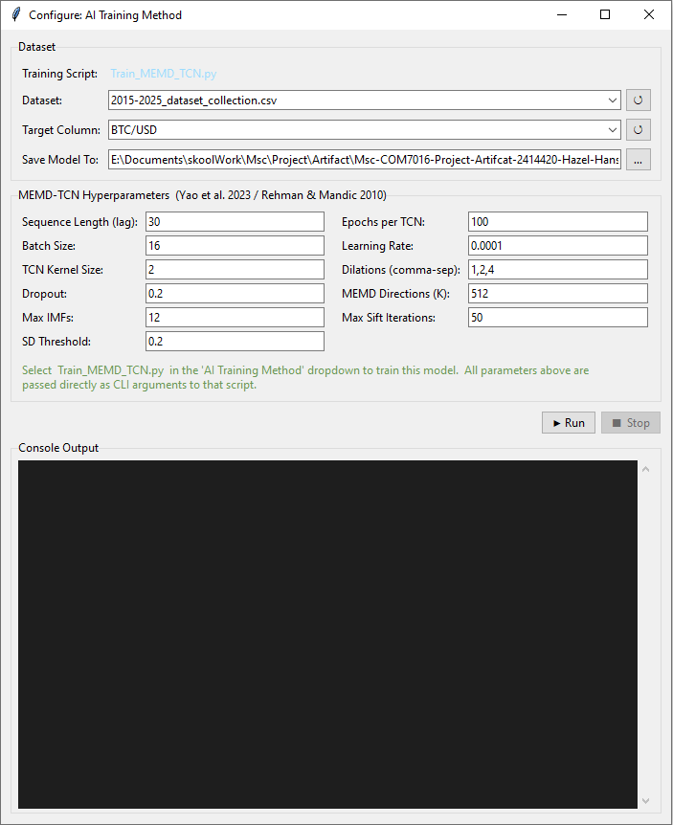
Figure 10: MEMD-TCN Model Training, configure window.
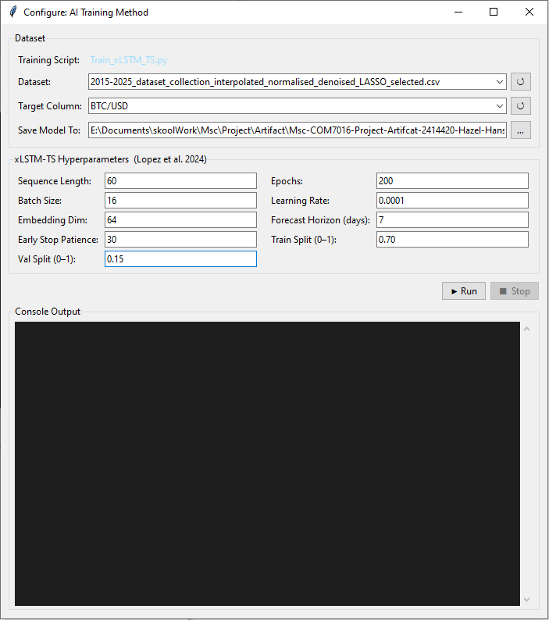
Figure 11: xLSTM-TS Model Training, configure window.

Looking at both of these windows, the “Dataset” section is the same across both of them. The first drop down is for selecting the dataset that the model will be trained with, it is important to note that the dataset selected for the model will mean result in the saved model will expect the same number of feature dimensions when used for evaluation in subsequent steps. So it may be important to not which dataset was specifically used for training.
The second drop down is for selection of the target feature, this is the feature that the model will be trained to predict. Lastly the last input in the Dataset section is the location on the user’s computer where they would like to save the model file too, with defaults set in the repository.
The next section in the Configuration window for the model training is the model hyper parameter and related model specific configuration settings, which are populated from the .py scripts themselves and unique to each model. The ease of access for these configurations is important for rapid experimentation and iterations, fine tuning for a models ideal performance for each specific dataset can be a time consuming process or may wish to be significantly scaled down for demonstration purposes.
Once the Model Training Configuration settings have been set, the user must click on the “Run” button within the Configuration window to execute the scripts.

Model Evaluation Method:

The final step in the pipeline process is the Model Evaluation section, where inside the Configuration window, the user will find all the Evaluation scripts included under “Availble Scripts” which once again is populated from a repository folder (\Evaluation_Modules\Evaluation_Metrics).
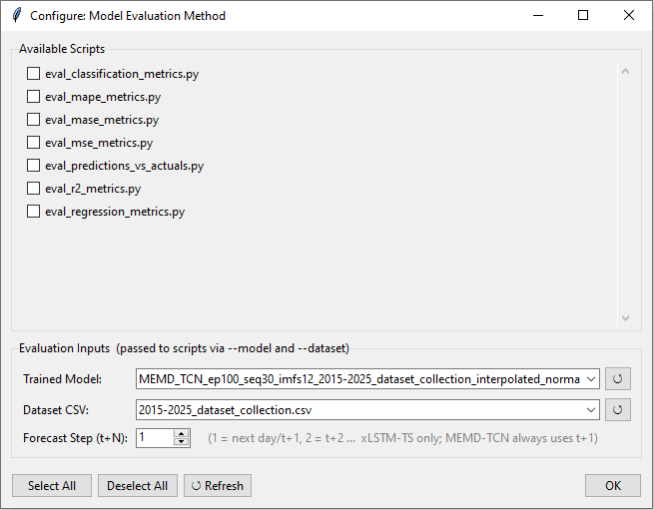
Figure 12: Model Evaluation Method, Configuration window.

The “Available Scripts” section functions as the previous windows where selecting scripts with the checkboxes will execute them once the “Run” button is pressed, in this case within the previous main Model Designer window after all the settings have been set and the “OK” button has been pressed. Each script has been named accordingly with only “eval_classification_metrics.py” and “eval_regression_metrics.py” which evaluate combinations at a time and categorised as such, with the first evaluating for “Accuracy”, “Precision”, “Recall” and “F1 Score” and the later “Means Absolute Error (MAE)” and “Root Mean Squared Error (RMSE)”.
The bottom section of this window for “Evaluation Inputs (Passed to scripts via – model and dataset)” is need first to select the trained model file that was previously created in the previous pipeline step, and then to select the Dataset .csv file that the model in question was trained with (or other compatible .csv dataset file). Lastly the “Forecasting Steps (t+N)” as noted by the grey tooltip, is primarily for only the xLSTM-TS model as its designed for multiple time horizon predictions (more than one day of price forecasting predictions for example), while the MEMD-TCN model is hard coded for only one. This change is most notable when using the “evel_predictions_vs_actuals.py” evaluation method.
Once any combination of evaluation methods has been selected and ran with the appropriate dataset and model settings, a Seaborn library plot graph will appear just as with the previous sections plots, which the user may choose to save or adjust as need.

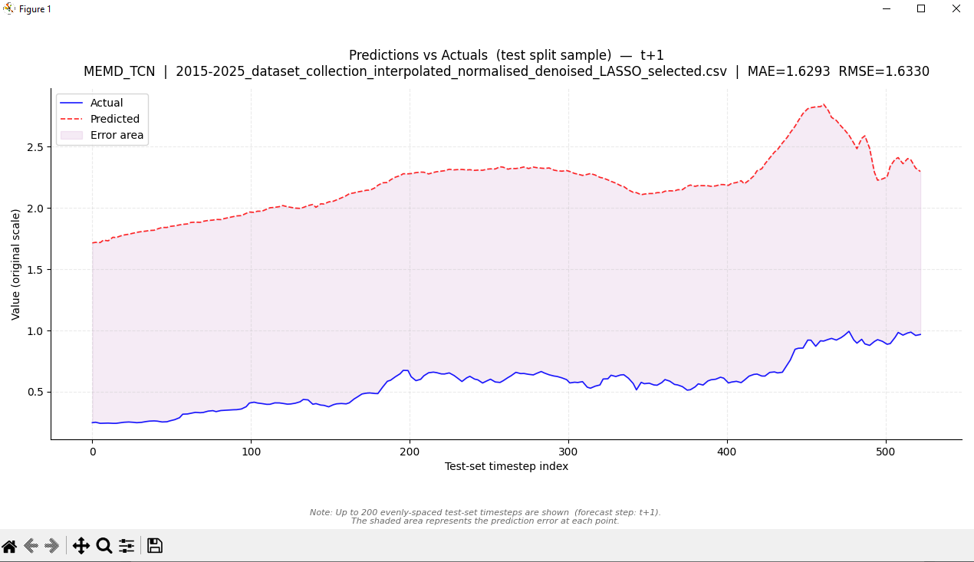
Figure 13: Evaluation Method Example, Predictions vs. Actuals.

Scripting:

Adding scripts for Dataset Collection
When creating a new single column / feature dataset python script, the structure to follow is quite simple. First a new “.py” file must be created in the “/Dataset_Modules/Dataset_Collection” folder, inside this new file (preferably edited within an IDE such as VScode) the user will need to produce python code for collecting data from a source API (such as yfiannce for an example) in the same way as they would normally from scratch. However the inputs for what data to collect must be setup as inputs from the interface scripts, which are done using the “argarse” python library.
It may be beneficial for the user to copy and paste the contents of one of the other existing data collection scripts as a template, to help understand how this is designed. Below are some of the contents of “currency_btc_price.py” to demonstrate.
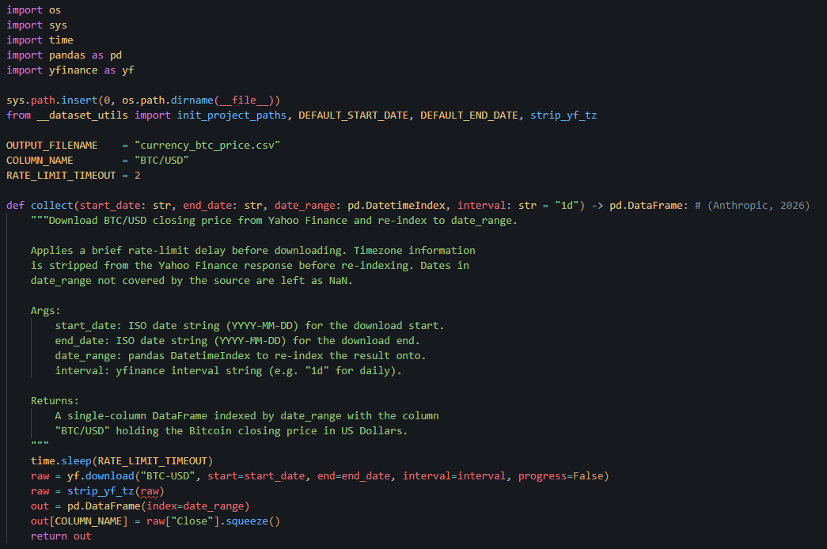
Figure 14: Scripting Example for Data Collection, from "currency_btc_price.py"
The “dataset_utils.py” sets the default start, end and frequency inputs and as well as handling “df” (data frame) formatting, and returns

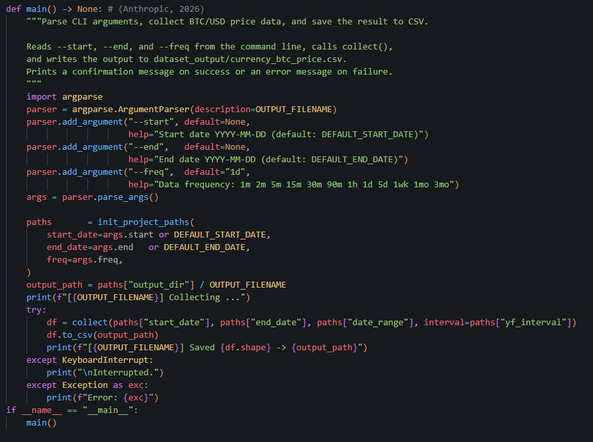
Figure 15: Scripting Example for Data Collection, from "currency_btc_price.py"

Adding Scripts for Dataset Processing
Adding Scripts for additional AI Model Designs
Adding Scripts for additional Model Evaluations

