1. Rating data:

Home > Get Data > Compustat - Capital IQ > Capital IQ > S&P Credit Ratings > Entity Ratings

Query Form:

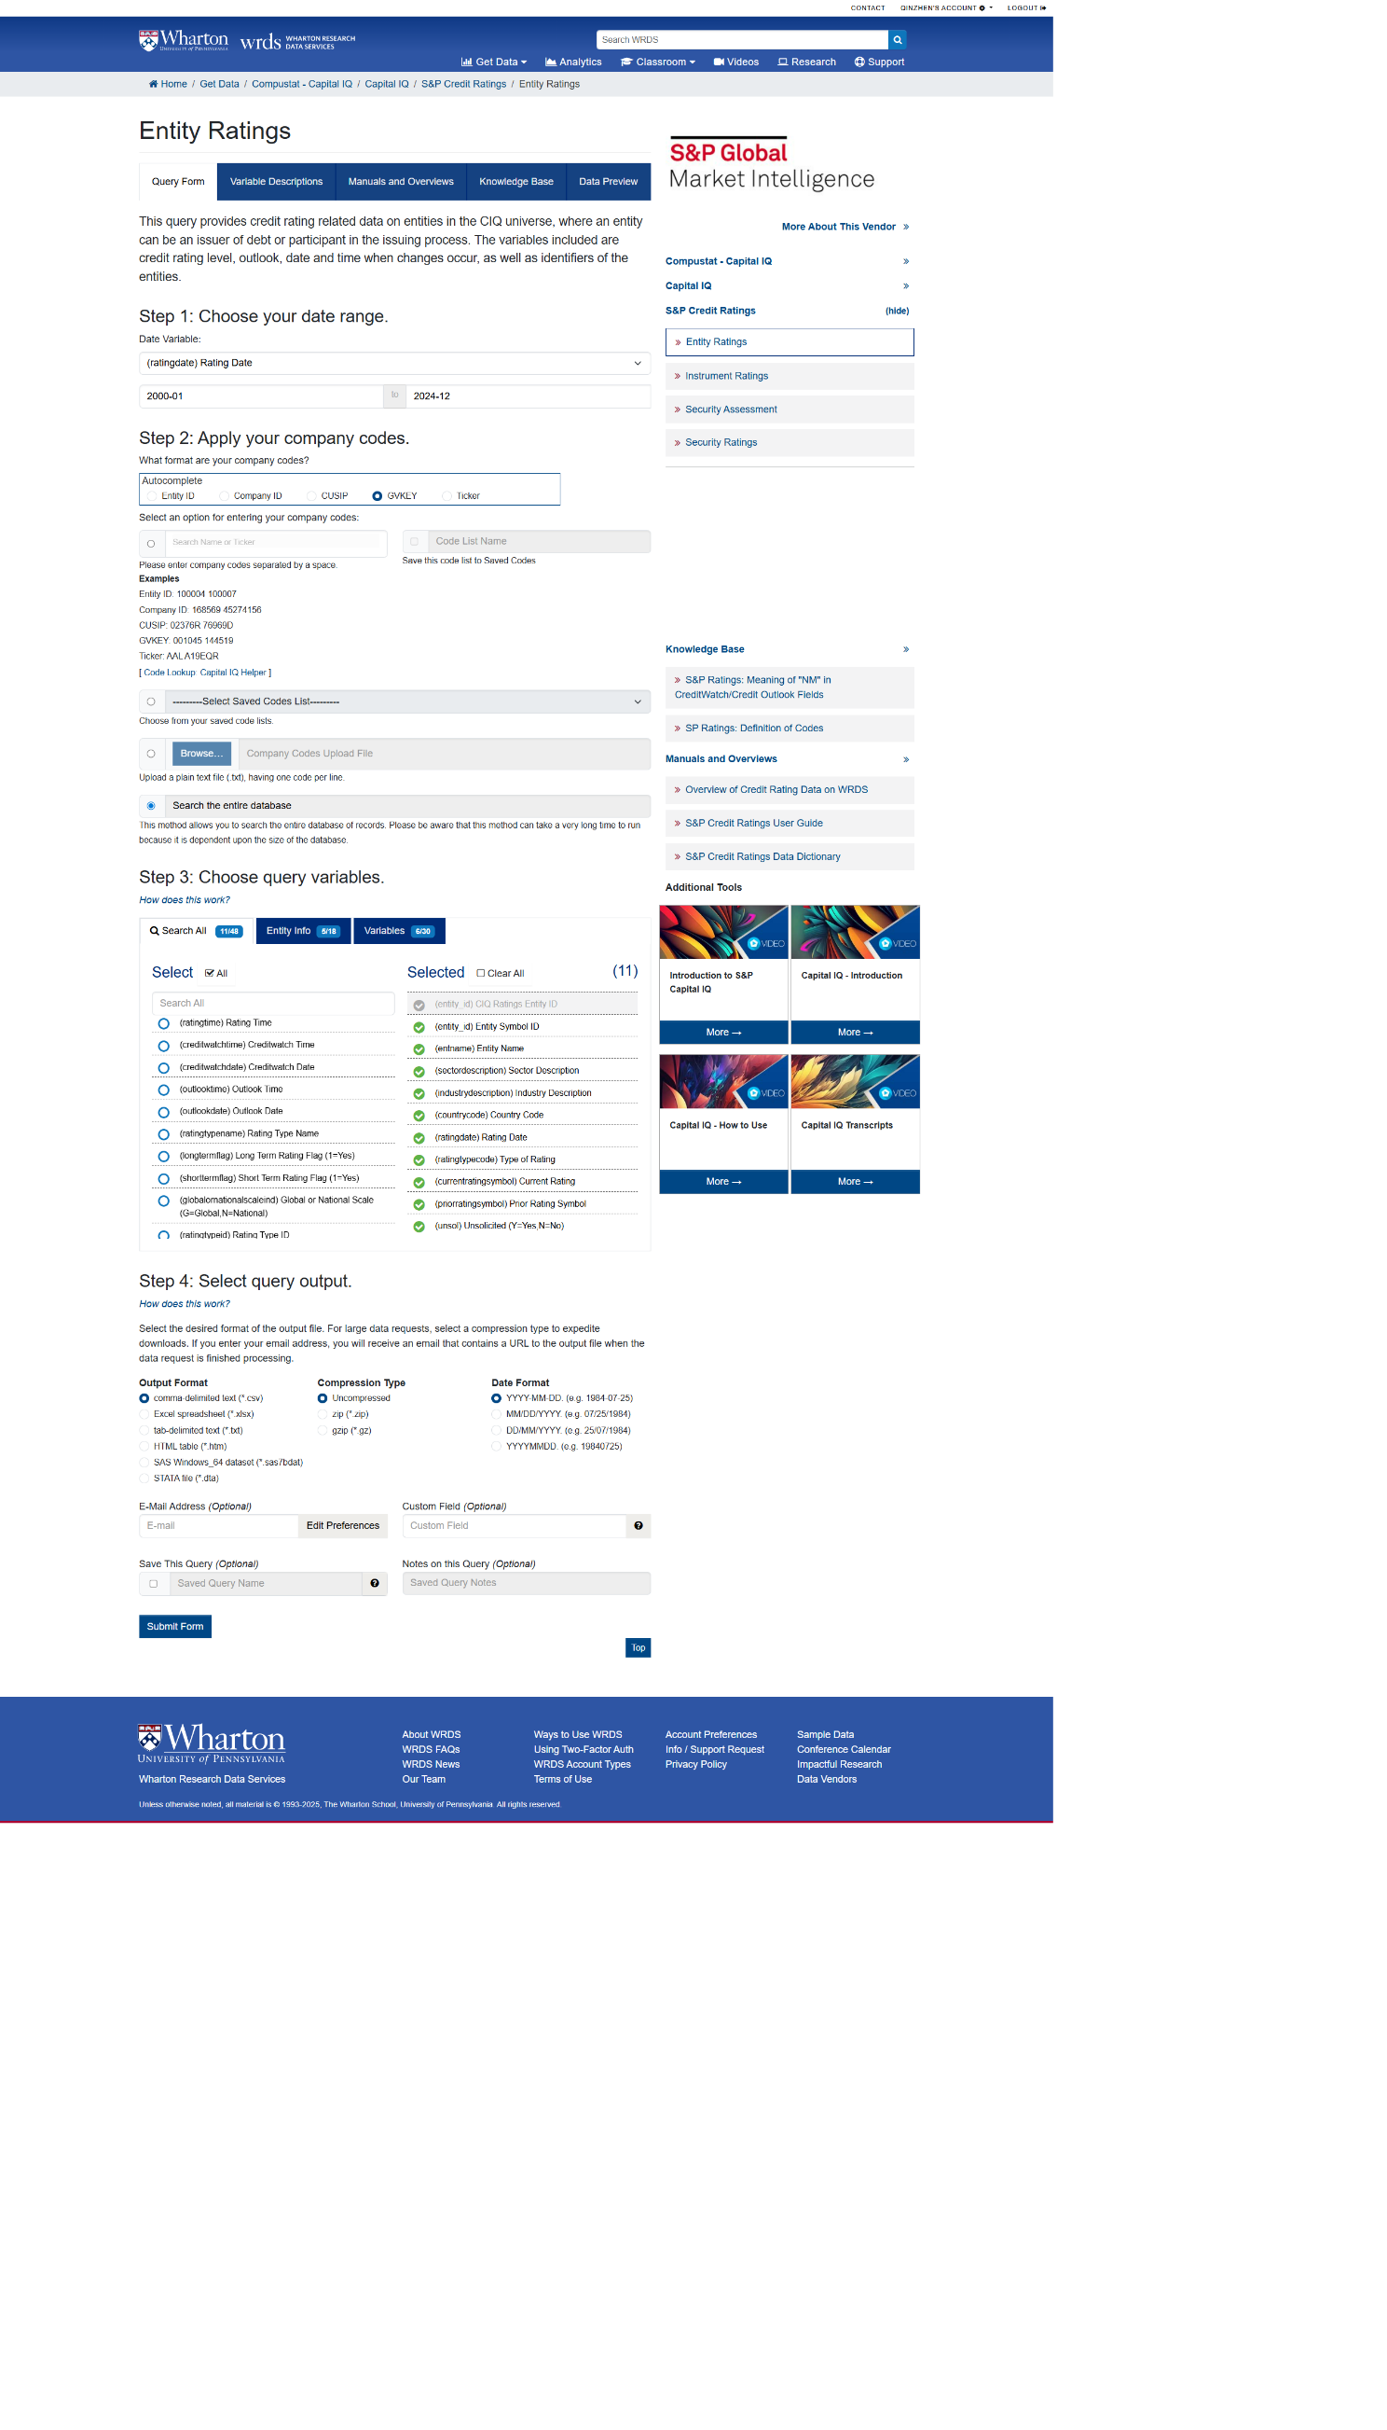

1. Financial data
   1. Global financial data

Home > Get Data > Compustat - Capital IQ > Compustat > Global > Fundamentals Annual

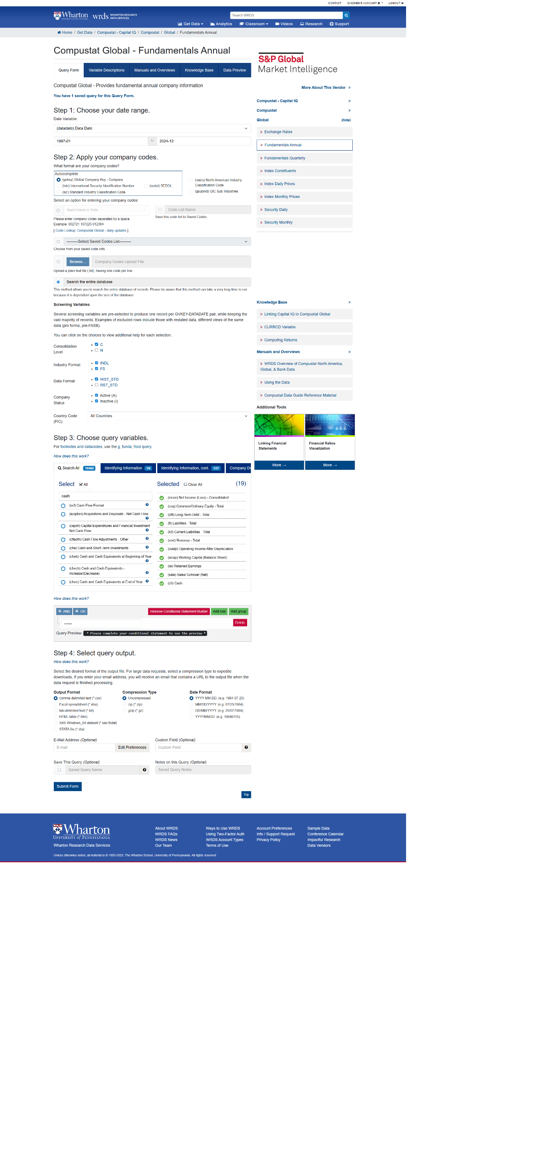

* 1. North America financial data

Home > Get Data > Compustat - Capital IQ > Compustat > North America > Fundamentals Annual

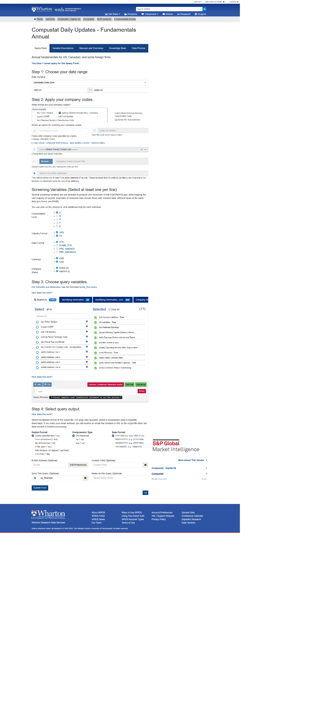

1. Stock price
   1. Global stock price

Home > Get Data > Compustat - Capital IQ > Compustat > Global > Security Daily

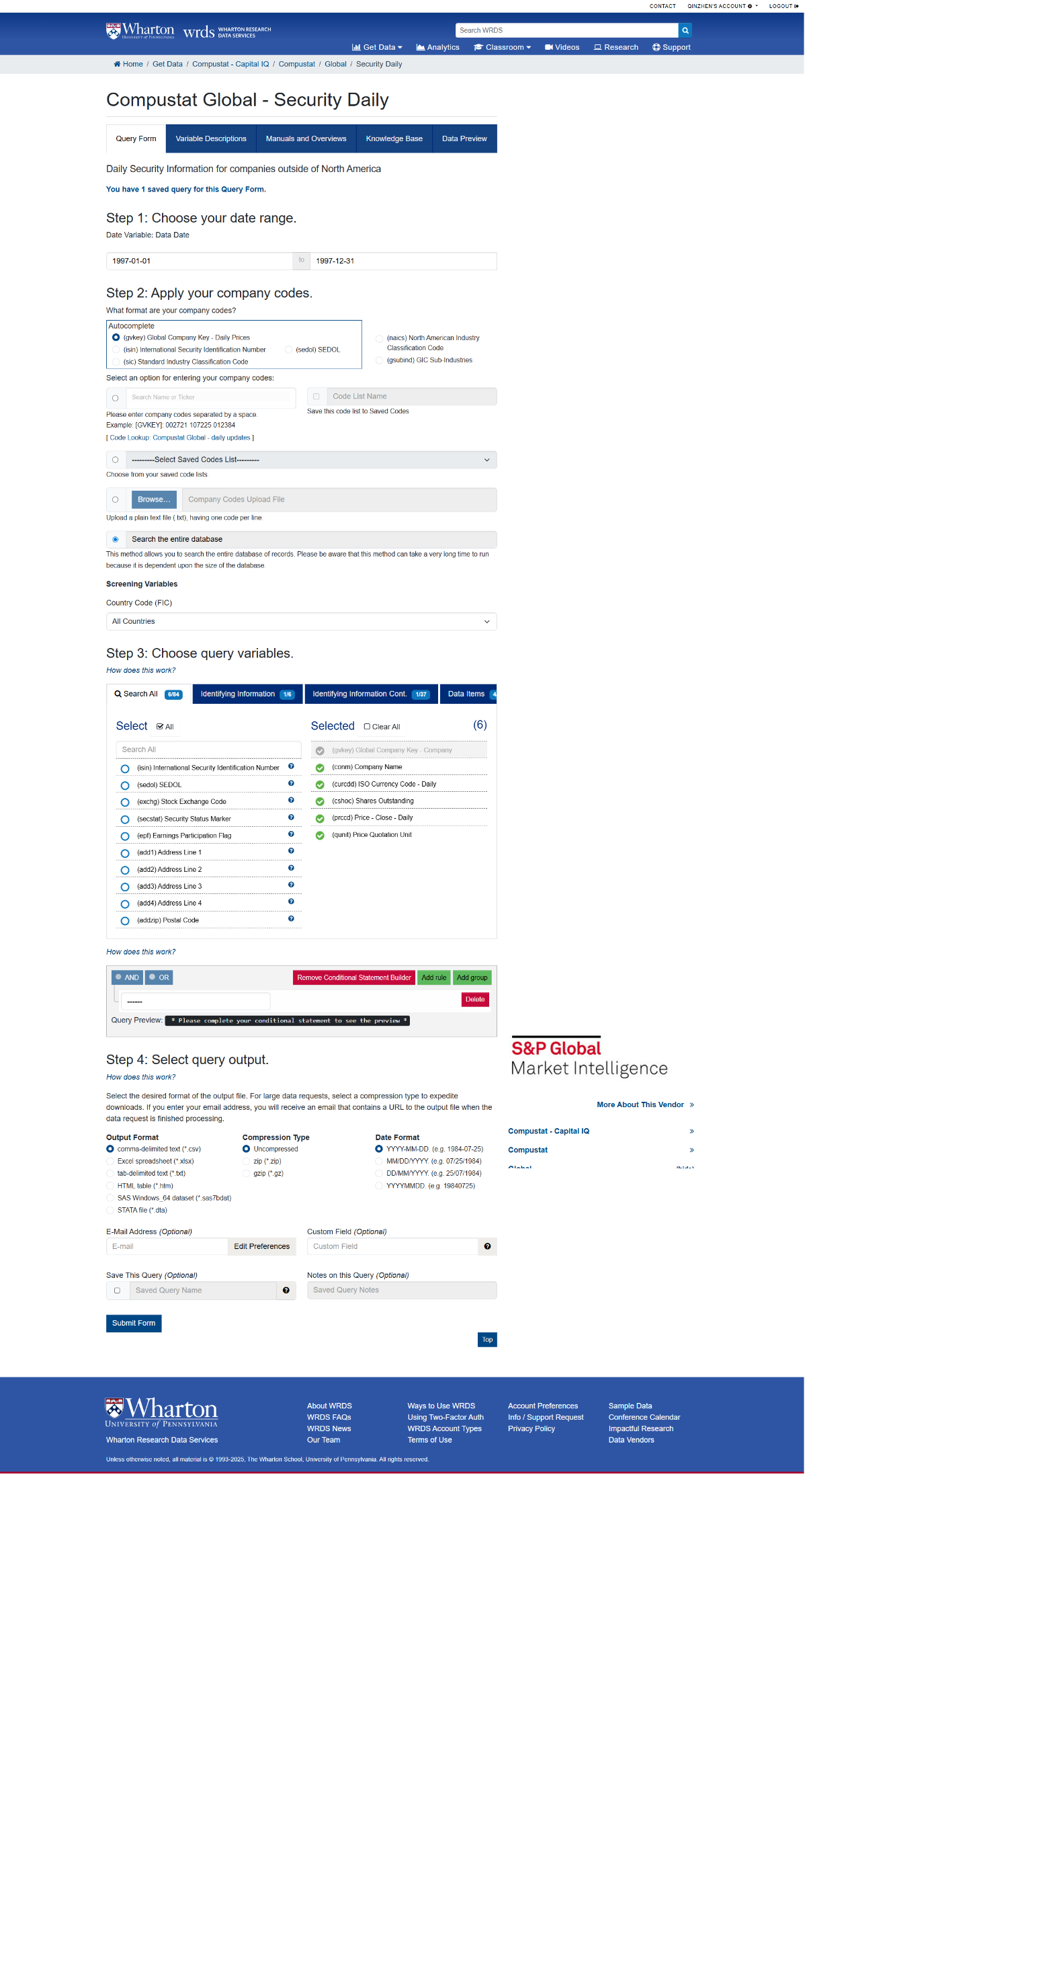

* 1. North America stock price

Home > Get Data > Compustat - Capital IQ > Compustat > North America > Security Daily

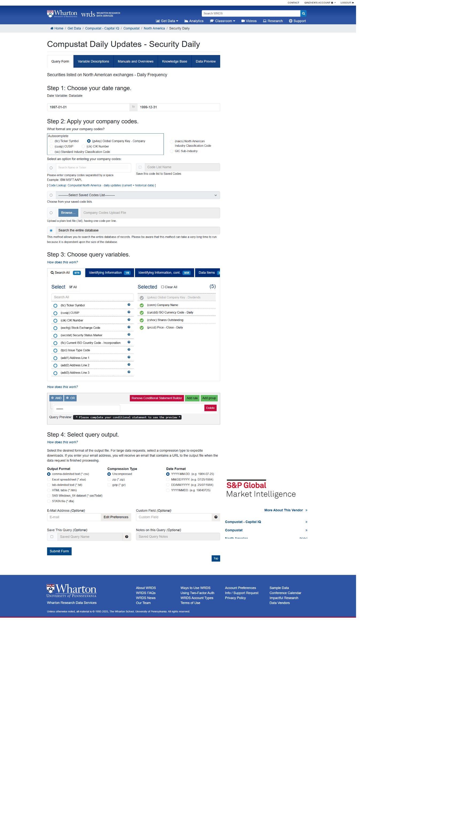

1. Exchange rate

Home > Get Data > Compustat - Capital IQ > Compustat > Global > Exchange Rates

