**System Requirements:**

* **Node.js** installed on your computer. (if **Node.js** is not yet installed on your computer, see **How To Install Node.js On My Computer**)
* **Vue.js Framework** installed in your computer. (if **Vue.js Framework** is not yet installed on your computer, see **How To Install Vue.js Framework**)
* Text Editor (ex. VSCode or Notepad++).

**STEPS:**

Unzip the project.

Open cmd and navigate to your project.

Type **npm run install**

After installing the dependencies, type **npm run serve**Then press **Enter.**

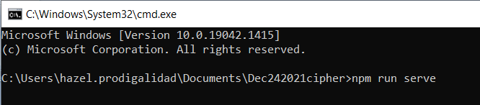

Then wait for the application to be served. Then you will see:

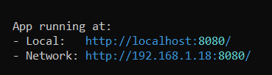

It means your project is already running at [**http://localhost:8080**](http://localhost:8080)

Open your browser and type [**http://localhost:8080**](http://localhost:8080)

Then the page will be displayed.

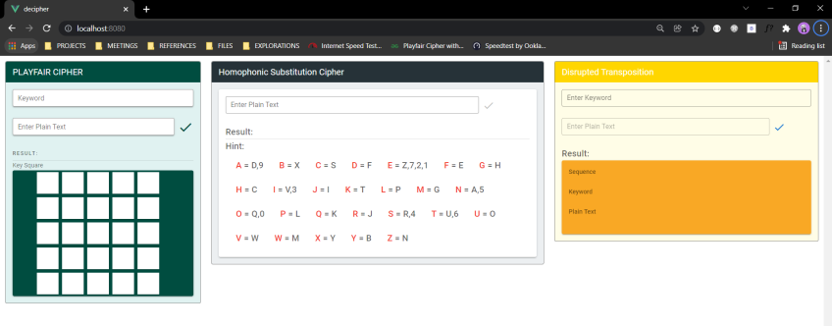

**How To Install Node.js On My Computer**

**Step 1:** Go to <https://nodejs.org/en/>

**Step 2:** Then click **Recommended For Most Users**

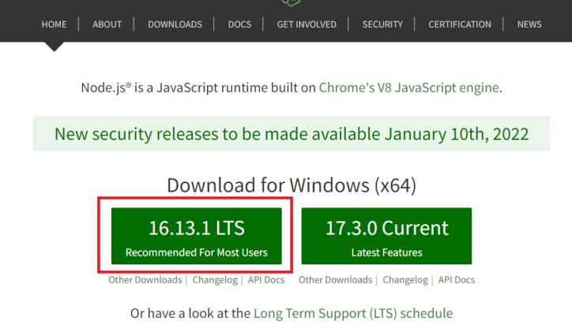

**Step 3:** Wait until the downloading process is finished, then install it.

**Step 4:** Check if the Node.js is already installed on your computer.(see **How To Check Node.js On My Computer.**)

**How To Check Node.js On My Computer**

**Step 1:** Open CMD then type **node –version**. Then you will see your Node.js version.

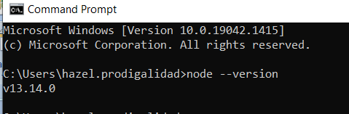

**How To Install Vue.js Framework**

**Step 1:** Open CMD then type: **npm install –g @vue/cli**

**Step 2:** Wait until the installation process is finished.

**Step 3:** Check if the Vue.js Framework is already installed on your computer.(see **How To Check Vue.js On My Computer.**)

**How To Check Vue.js On My Computer**

**Step 1:** Open CMD then type **vue –version**. Then you will see your **Vue.js** version.

