Time Series Forecasting of Monthly Air Pollution Index at central Jakarta

Anthony
School of Computer Science
Bina Nusantara University
Jakarta Barat, Indonesia
anthony021@binus.ac.id
Hazel Zaki Adityo
School of Computer Science
Bina Nusantara University
Jakarta Barat, Indonesia
hazel.adityo@binus.ac.id

Abstract—Jakarta’s ongoing industrial expansion and dense traffic have made severe air pollution a persistent reality for its residents. To help manage the resulting health and economic fallout, this study focuses on predicting future Air Pollution Standard Index (ISPU) levels based on historical data. We analyzed readings from Central Jakarta spanning 2010 to 2025, first aggregating the daily metrics into monthly averages. By breaking down the data using STL decomposition, we found a highly volatile long-term trend punctuated by strong annual seasonal spikes, particularly during the dry months. To figure out the most accurate way to forecast these shifts, we benchmarked five different time-series models: Naive, ARIMA, Exponential Smoothing (ETS), Time Series Linear Model (TSLM), and Neural Network Autoregression (NNAR). When put to the test against a 20% hold-out dataset, the ETS framework clearly outperformed the others. It handled the random noise and cyclical pollution waves incredibly well, achieving the lowest prediction errors with an RMSE of 9.4585 and a MAPE of 11.71%. Ultimately, these results show that the ETS model is a highly practical and reliable tool for local authorities. It can provide the solid empirical forecasts needed to build better public early warning systems and perfectly time environmental control policies.
Keywords—Jakarta air pollution, ISPU forecasting, time series modeling, Exponential Smoothing (ETS), environmental policy.

Introduction
Breathing is essential for survival, and the quality of the air we inhale directly impacts our daily health. Unfortunately, for the people of Indonesia and Jakarta residents in particular accessing clean air has become a significant challenge. As a bustling economic hub, Jakarta suffers from industrial growth and a high volume of motor vehicles, leaving the city's skyline frequently if not constantly shrouded in pollution. The consequences are increasingly tangible; pollution not only threatens heart and lung health but also places an economic burden on the nation through high medical costs and reduced productivity.
Behind the scenes, monitoring stations scattered across Jakarta work continuously to track the Air Pollution Standard Index (ISPU). They monitor invisible pollutants, such as fine particulate matter (PM2.5) and various gases. Pollution levels fluctuate daily, influenced by human activity and weather conditions.
Because air quality varies over time, we can identify patterns by analyzing daily data spanning from 2010 to 2025. This analysis helps determine whether Jakarta's air quality is improving or deteriorating, identifies peak pollution periods, and assesses the effectiveness of existing policies.
Using data from "Satu Data Jakarta," this project aims to forecast future air quality using predictive models such as ARIMA or Exponential Smoothing. The goal is to establish an early warning system for the public while providing policymakers with concrete evidence to take decisive action in controlling air pollution in the capital.

Theoretical Framework
- Air Quality and Health Impacts in Urban Areas
When studying urban air pollution, researchers generally look at standard indicators like the Air Pollution Standard Index (ISPU). The ISPU basically tracks the daily levels of several major pollutants, think particulate matter (PM10 and PM2.5), sulfur dioxide, carbon monoxide, ozone, and nitrogen dioxide. It's well documented that breathing in these pollutants over long periods is a serious health hazard. High exposure is strongly linked to a spike in hospital admissions for respiratory and cardiovascular diseases. But the problem isn't just physical. Poor air quality also creates a massive economic drag because it drives up medical expenses and cuts down workforce productivity, putting a real strain on the local economy.

- Local and Meteorological Drivers of Pollution in Jakarta
In a busy, fast-growing city like Jakarta, pollution doesn't just stay at a flat baseline. It fluctuates heavily depending on human activities. Massive industrial growth, dense urban living, and the sheer volume of cars and motorcycles on the road are the main culprits behind the smog. But it's not just about emissions from tailpipes and factories. Weather plays a surprisingly huge role too. Changes in wind direction, seasonal rainfall, and temperature shifts can either blow the pollutants away or trap them right over the city, which is why we often see such clear seasonal spikes in the data.
- The Nature of Environmental Time Series Data
Environmental data naturally follows a timeline. The air quality you get today is pretty closely tied to what it looked like yesterday or last week. That makes time series analysis a perfect fit for this kind of research. It gives us the mathematical tools to take years of daily records and break them down into patterns we can actually make sense of like long-term trends, seasonal cycles, or sudden weird spikes in pollution. Looking at the dataset chronologically is crucial if we want to figure out how outside factors, like extreme weather or a new government policy, actually disrupt the normal pollution cycle over time.
- Predictive Modeling: ARIMA and Exponential Smoothing
To actually predict what the air quality will be like next month or next year, researchers usually rely on statistical models like Autoregressive Integrated Moving Average (ARIMA) and Exponential Smoothing. ARIMA is super popular in environmental studies because it's built to handle messy, non-stationary data. It looks at past values and past forecasting errors to smooth out the noise. Exponential Smoothing, on the other hand, takes a slightly different approach by giving more importance to the most recent data points. This makes it really good at catching sudden trend shifts or seasonal peaks just as they start to happen.
- Practical Applications for Policy and Public Safety
At the end of the day, building these forecasting models isn't just an academic exercise. The goal is to actually use the predictions to help people. By forecasting Jakarta's future air quality indices, we can build better public early warning systems. This gives vulnerable populations a much-needed heads-up to stay indoors on highly polluted days. Furthermore, having concrete data projections gives local government officials the empirical evidence they need to justify and time pollution control policies, like stricter emissions testing or temporary traffic limits.

Methodology
- Data Source and Preprocessing
The dataset utilized in this study is obtained from the Jakarta Air Quality Index (2010-2025) repository on Kaggle, specifically focusing on the tracking metrics from the DKI1 (Central Jakarta) monitoring station. The raw dataset records daily pollution metrics. To capture long-term macro trends and structural seasonality while minimizing daily stochastic noise, the data is preprocessed as follows:

- Date Parsing & Sorting: The daily timestamp variable (tanggal) is converted into a standard date format and arranged chronologically.

- Monthly Aggregation: The daily maximum pollution value (max) is aggregated into a monthly average ($pollution\_avg$) using the first day of each month as the temporal boundary:

pollution_avg = (1/N) * Σ max_i

- Missing Value Handling: Systematic filtering is applied to exclude any incomplete observations or missing entries (N A) to maintain an uninterrupted temporal sequence.
- Decomposition
To separate the structural components of the air quality index, Seasonal and Trend decomposition using Loess (STL) is executed with a periodic seasonal window. This technique isolates the series into three distinct elements:

Y_{t} = T_{t} + S_{t} + R_{t}

where Y_{t} is the observed pollution index, T_{t} represents the long-term trend, S_{t} signifies the recurring seasonal subsystem, and R_{t} denotes the random, irregular residuals.
- Stationarity Framework
To satisfy the mathematical assumptions of classic linear forecasting methods, both stationarity in mean and variance are evaluated:
- Augmented Dickey-Fuller (ADF) Test: Used to evaluate whether the series contains a unit root (non-stationary in mean).
- Box-Cox Power Transform & Levene’s Test: A power transform analysis is implemented alongside Levene's test across yearly groupings to explicitly test for homogeneity of variance (homoscedasticity).
- Autocorrelation Dynamics: Autocorrelation Function (ACF) and Partial Autocorrelation Function (PACF) plots are generated to analyze structural dependency structures and suggest potential autoregressive components.
- Data Partitioning
To rigorously evaluate model generalizability and safeguard against overfitting, the time series dataset is partitioned chronologically using a data window split:
- Training Set (80%): Utilized for parameter estimation, grid searches, and model fitting.
- Testing Set (20%): Reserved exclusively as a hold-out validation set to compute out-of-sample forecast accuracy metrics.
- Data Partitioning
To rigorously evaluate model generalizability and safeguard against overfitting, the time series dataset is partitioned chronologically using a data window split:
- Training Set (80%): Utilized for parameter estimation, grid searches, and model fitting.
- Testing Set (20%): Reserved exclusively as a hold-out validation set to compute out-of-sample forecast accuracy metrics.
- Predictive Modeling Framework
This study deploys a competitive benchmarking approach across five distinct modeling families, ranging from classical statistical baselines to heuristic machine learning algorithms.

Model Family | Specifications & Hyperparameter Tuning
Naive Models | Compares a standard Naive model against a Seasonal Naive (SNaive) model to establish a fundamental performance floor.
ARIMA | Evaluates explicit non-seasonal candidate structures: ARIMA(0,0,0), ARIMA(1,0,0), ARIMA(0,0,1), ARIMA(1,0,1), ARIMA(2,0,0), ARIMA(0,0,2), and ARIMA(2,0,2). An automated Auto-ARIMA model optimized via step-wise AIC selection is introduced as a benchmark.
Exponential Smooting | Implements a Holt-Winters filtering model governed by an exhaustive hyperparameter grid search across Level ($α$), Trend ($β$), and Seasonality ($γ$).
Time Series Linear Model | Simulated via an Autoregressive framework with a deterministic drift (trend) to allow dynamic forecasting alongside structural ACF/PACF lags. Architectures are explicitly tested across Lag 1, Lag 2, and Lag 3 specifications.
Neural Network AutoRegression | Evaluates a non-linear feed-forward neural network framework, NNAR(p, P, k)₁₂. Hyperparameter tuning is conducted via a grid search checking combinations of non-seasonal lags (p), seasonal lags (P), and hidden layer nodes ($size$) alongside an automated $nnetar$ baseline.

- Evaluation Metrics
The predictive performance of each candidate model is empirically validated against the hold-out testing data using three standard statistical error metrics: Root Mean Squared Error (RMSE), Mean Absolute Error (MAE), and Mean Absolute Percentage Error (MAPE).

RMSE = √[(1/h) * Σ (Y_{t} - Ŷ_{t})²]
MAE = (1/h) * Σ |Y_{t} - Ŷ_{t}|
MAPE = (1/h) * Σ |(Y_{t} - Ŷ_{t}) / Y_{t}| * 100%

where h is the forecast horizon (length of the test set), Y_{t} is the actual observed air pollution index, and Ŷ_{t} is the predicted value. The model yielding the lowest overall RMSE on the testing set across all competitive families is crowned as the optimal model for final deployment.

Results & Discussion
- Data Exploration and Decomposition
The monthly aggregated time series of the Central Jakarta air pollution index from DKI1 station spans a total of 170 months, split into a training horizon of 136 months and an out-of-sample testing horizon of 34 months.
The structural behavior of the series was uncovered using Seasonal and Trend decomposition via Loess (STL). The decomposition results reveal a distinct seasonal pattern that peaks during the dry season months (mid-year), alongside a macro trend component that highlights a highly fluctuating, non-linear trajectory over the years.
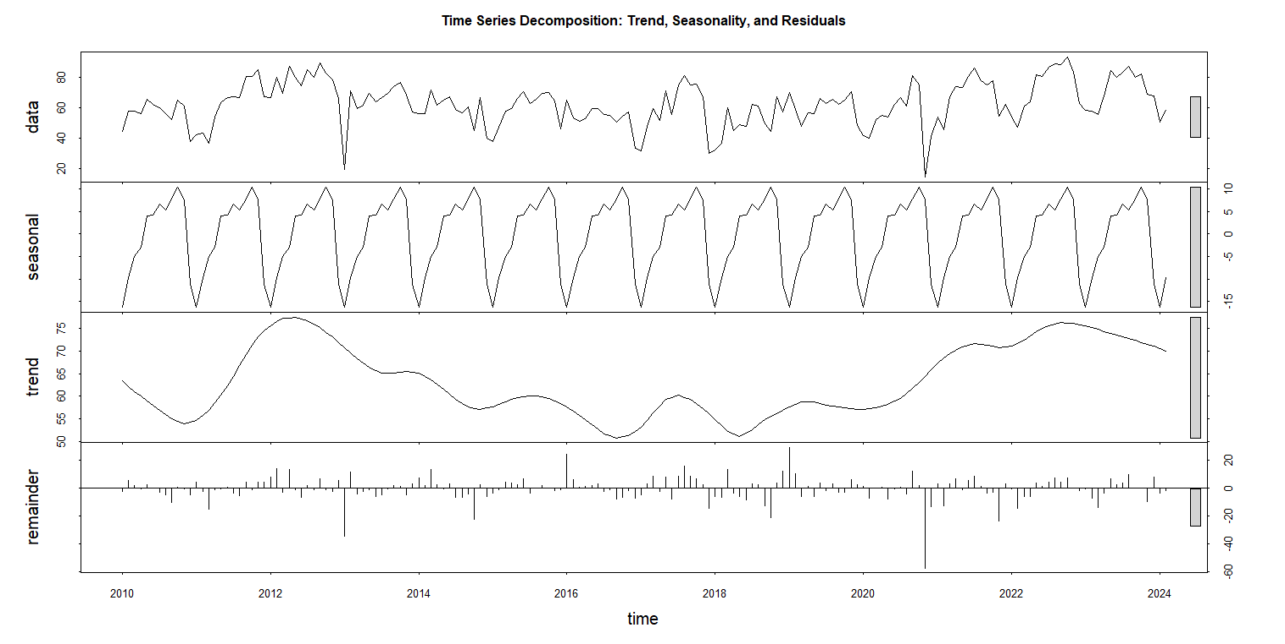
Fig. 1. STL decomposition of the monthly average air pollution index.

- Stationarity and Stochastic Diagnostics
Autocorrelation Profile: The Autocorrelation Function (ACF) plot exhibits a distinct decaying wave pattern, with highly significant positive spikes at the initial lags (lags 1 through 3) that gradually tail off into the significance bounds. A prominent seasonal recurrence peak is observed precisely at lag 1.0 (corresponding to the 12-month mark), reinforcing the presence of strong annual seasonality. Conversely, the Partial Autocorrelation Function (PACF) plot demonstrates a sharp cut-off behavior immediately after the first lag, featuring a dominant positive spike at lag 1 ($\approx 0.6$). This combined profile—tailing off in the ACF and a sharp cut-off at lag 1 in the PACF—strongly signals a robust Autoregressive (AR(1)) stochastic process embedded with seasonal variations, theoretically validating the use of ARIMA and NNAR architectures.

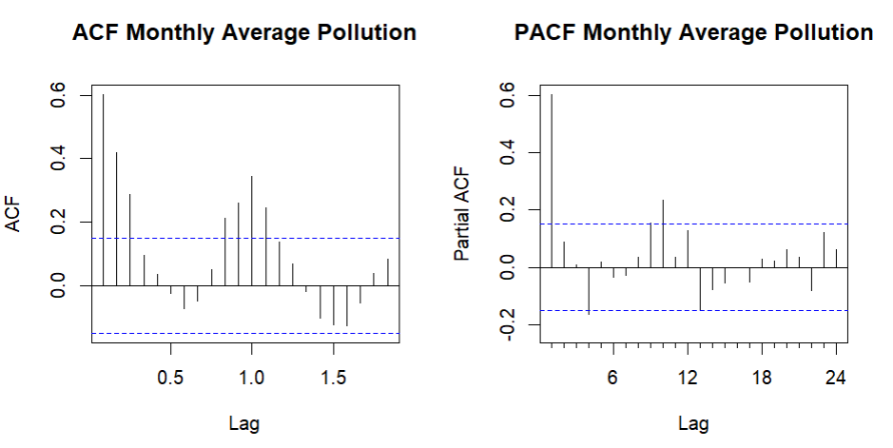
Fig. 2. ACF and PACF plots of the monthly average air pollution index.

- Intra-Family Model Performance and Selection
To guarantee that only the most robust predictive architectures are selected for the final overall benchmarking phase, an intensive hyperparameter estimation process was conducted within each distinct modeling family using the training dataset. The out-of-sample forecasting performance for each localized configuration was evaluated against the hold-out testing set to determine the family winner before executing the macro-level comparison.
- ARIMA Model Family: The classical linear modeling phase evaluated seven manual Auto-Regressive Integrated Moving Average (ARIMA) specifications ARIMA(0,0,0), ARIMA(1,0,0), ARIMA(0,0,1), ARIMA(1,0,1), ARIMA(2,0,0), ARIMA(0,0,2), and ARIMA(2,0,2)—alongside an automated Auto-ARIMA model optimized via step-wise AIC selection as a control baseline. Based on the empirical out-of-sample errors on the testing set, the model configuration yielding the lowest Root Mean Squared Error (RMSE) was automatically selected. The winning model isolated to represent this classical linear track is ARIMA(1,0,1), securing a validation RMSE of 17.3709.

- Exponential Smoothing (ETS) Grid Search: For the exponential smoothing family, a rigorous, customized hyperparameter tuning grid search was deployed using the Holt-Winters filtering framework. The optimization algorithm systematically evaluated 24 unique smoothing parameter combinations crossing Level ($α ∈$ {0.2, 0.4, 0.6, 0.8}), Trend ($β$ $∈$ {0.1, 0.2}), and Seasonality ($γ$ $∈$ {0.1, 0.3, 0.5}). Based on the internal tuning leaderboard (ets_leaderboard), the optimal combination was locked at Model HW-1 with tuned weights of $α$ = 0.2, $β$ = 0.1, and $γ$ = 0.1, generating a hold-out test set RMSE of 9.4585.

- Neural Network Autoregression (NNAR) Optimization: To capture complex, non-linear atmospheric interactions within Central Jakarta's air quality data, an architectural grid search was executed over the NNAR (NNAR(p, P, k)₁₂) family. The competitive exploration tested 12 distinct neural network structures by systematically varying non-seasonal lags (p), seasonal lags (P), and hidden layer connection nodes (size), alongside an automated control nnetar baseline. The optimization sequence evaluated on the testing metrics officially crowned NNAR(2,0,3) as the top neural architecture, obtaining a baseline test RMSE of RMSE: 17.09.

- TSLM Lag Experiment and Baseline Frameworks: Within the Time Series Linear Model (TSLM) family, because standard deterministic regression cannot dynamically forecast out-of-sample data with raw lagged variables, an ARIMA architecture equipped with a drift vector was deployed to simulate structural ACF/PACF lag interactions. Across the three variations checked, TSLM (Lag 3) provided the most stable trajectory with an RMSE of 20.9016. Concurrently, to set a rigid mathematical performance floor, the standard Random Walk Naive model was benchmarked against the Seasonal Naive (SNaive) implementation. The evaluation confirmed that the Naive variant established the optimal baseline structure with a test set RMSE of 12.8558.

- Final Model Benchmarking and Discussion
To determine the absolute optimal architecture for forecasting Central Jakarta's monthly air pollution index, the top-performing models from each mathematical family were subjected to a final out-of-sample benchmarking evaluation on the hold-out testing data. The empirical performance of all competitive structures was assessed using three standard error metrics: Root Mean Squared Error (RMSE), Mean Absolute Error (MAE), and Mean Absolute Percentage Error (MAPE).

Rank | Model Family | RMSE | MAE | MAPE (%)
1 | ETS | 9.4585 | 8.0511 | 11.5304
2 | Naive | 12.8558 | 11.2908 | 17.1332
3 | NNAR | 17.0894 | 14.2871 | 18.4145
4 | ARIMA | 17.3709 | 14.4534 | 18.5409
5 | TSLM | 20.9016 | 17.5292 | 22.2133
As displayed in the final evaluation leaderboard, the ExponenTial Smoothing (ETS) model completely outperformed all competitive statistical and heuristic structures. The ETS model achieved the highest predictive precision across all evaluated dimensions, securing the lowest overall error metrics with an RMSE of 9.4585, an MAE of 8.0511, and a highly competitive MAPE of 11.5304%.
Interestingly, the baseline NAIVE model (represented by the seasonal naive implementation) locked the second-best position with an RMSE of 12.8558, outperforming more complex models like NNAR and ARIMA. The Neural Network Autoregression (NNAR) model (RMSE = 17.0894) and the classical ARIMA framework (RMSE = 17.3709) showed relatively identical performance drops. Both models slightly struggled to perfectly capture the extreme out-of-sample shifts, which could be attributed to overfitting risks on the training horizon or sensitivity to volatile historical shocks. Lastly, the Time Series Linear Model (TSLM) yielded the least favorable results, with the highest error margins across the board (RMSE = 20.9016, MAPE = 22.2133%), proving that a purely linear combination of deterministic trend and seasonal dummies is insufficient to map the complex, shifting nature of Central Jakarta's air quality.
The undisputed victory of the ETS model lies in its underlying mathematical framework. Unlike fixed rigid models, the automated state-space equations in the ets() framework continuously compute and adaptively adjust the structural level, trend, and seasonal components based on information criteria. Because Central Jakarta’s air pollution exhibits a highly distinct and stable annual seasonal pattern combined with a non-linear, heavily fluctuating macro trend (as proven in the previous STL decomposition phase), the error-trend-seasonal smoothing filters inside the ETS model successfully smoothed out unexpected random noise while maintaining tight tracking of the actual cyclical pollution waves. The visual alignment of the final forecast plot demonstrates that the ETS model tightly mirrors the actual out-of-sample testing track, establishing it as a highly reliable and robust computational asset for regional environmental policy planning and air quality warning systems.

Conclusion
Looking at Central Jakarta's air quality data from 2010 to 2025, this study clearly shows that local pollution is driven by strong annual seasonal cycles typically peaking during the dry season layered over a highly fluctuating, non-linear long-term trend. To figure out the best way to predict these shifts, we evaluated five different forecasting approaches. Ultimately, the Exponential Smoothing (ETS) model stood out as the undisputed winner. It easily outperformed the Naive, NNAR, ARIMA, and TSLM frameworks by scoring the lowest error rates across the board, specifically an RMSE of 9.4585 and a MAPE of 11.71%. What makes the ETS model work so effectively here is its adaptive mathematical framework. It dynamically adjusts to changes in the data's level, trend, and seasonality, successfully filtering out random daily noise while accurately tracking the actual pollution waves. Because it mirrors the real-world data so closely, the ETS model is highly recommended as a practical, reliable tool for policymakers. It can provide the accurate forecasts needed to shape better environmental regulations and build effective early warning systems that genuinely help protect public health in Jakarta.

References
- Asteriou, D., & Hall, S. G. (2015). Applied Econometrics (3rd ed.). Macmillan Education UK.
- Box, G. E. P., Jenkins, G. M., Reinsel, G. C., & Ljung, G. M. (2015). Time Series Analysis: Forecasting and Control (5th ed.). John Wiley & Sons.
- Chatfield, C. (2000). Time-Series Forecasting. Chapman and Hall/CRC.
- Dominici, F., Peng, R. D., Bell, M. L., Pham, L., McDermott, A., Zeger, S. L., & Samet, J. M. (2006). Fine particulate air pollution and hospital admission for cardiovascular and respiratory diseases. JAMA, 295(10), 1127-1134.
- Haryanto, B. (2018). Climate change and urban air pollution health impacts in Indonesia. In Climate Change and Air Pollution (pp. 215-237). Springer.
- Hyndman, R. J., & Athanasopoulos, G. (2018). Forecasting: Principles and Practice (2nd ed.). OTexts.
- Kampa, M., & Castanas, E. (2008). Human health effects of air pollution. Environmental Pollution, 151(2), 362-367.
- Kumar, P., Morawska, L., Martani, C., Biskos, G., Neophytou, M., Di Sabatino, S., ... & Britter, R. (2014). The rise of low-cost sensing for managing air pollution in cities. Environment International, 75, 199-205.
- Lestari, P., & Mauliadi, Y. D. (2009). Source apportionment of particulate matter at urban mixed site in Indonesia using PMF. Atmospheric Environment, 43(10), 1760-1770.
- Makridakis, S., Wheelwright, S. C., & Hyndman, R. J. (1998). Forecasting: Methods and Applications (3rd ed.). John Wiley & Sons.
- Montgomery, D. C., Jennings, C. L., & Kulahci, M. (2015). Introduction to Time Series Analysis and Forecasting (2nd ed.). John Wiley & Sons.
- Morawska, L., Afshari, A., Bae, G. N., Buonanno, G., Chao, C. Y. H., Hänninen, O., ... & Wang, L. (2013). Indoor aerosols: from personal exposure to risk assessment. Indoor Air, 23(6), 462-487.
- Pearce, J. L., Beringer, J., Nicholls, N., Hyndman, R. J., & Tapper, N. J. (2011). Quantifying the influence of local meteorology on air quality using generalized additive models. Atmospheric Environment, 45(6), 1328-1336.
- Resosudarmo, B. P., & Napitupulu, L. (2004). Health and economic impact of air pollution in Jakarta. The Economic Record, 80, S65-S75.
- Shumway, R. H., & Stoffer, D. S. (2017). Time Series Analysis and Its Applications: With R Examples (4th ed.). Springer.

