AOL TSA
Anthony_Hazel
2026-06-28

R Markdown
This is an R Markdown document. Markdown is a simple formatting syntax for authoring HTML, PDF, and MS Word documents. For more details on using R Markdown see http://rmarkdown.rstudio.com.
When you click the Knit button a document will be generated that includes both content as well as the output of any embedded R code chunks within the document. You can embed an R code chunk like this:
library(readr)
library(tidyverse)
## Warning: package 'tidyverse' was built under R version 4.5.3
## Warning: package 'lubridate' was built under R version 4.5.3
## ── Attaching core tidyverse packages ──────────────────────── tidyverse 2.0.0 ──
## ✔ dplyr 1.2.0 ✔ purrr 1.2.1
## ✔ forcats 1.0.1 ✔ stringr 1.6.0
## ✔ ggplot2 4.0.2 ✔ tibble 3.3.1
## ✔ lubridate 1.9.5 ✔ tidyr 1.3.2
## ── Conflicts ────────────────────────────────────────── tidyverse_conflicts() ──
## ✖ dplyr::filter() masks stats::filter()
## ✖ dplyr::lag() masks stats::lag()
## ℹ Use the conflicted package (<http://conflicted.r-lib.org/>) to force all conflicts to become errors
library(lubridate)
library(forecast)
library(tseries)
## Warning: package 'tseries' was built under R version 4.5.3
## Registered S3 method overwritten by 'quantmod':
## method from
## as.zoo.data.frame zoo
library(car)
## Loading required package: carData
##
## Attaching package: 'car'
##
## The following object is masked from 'package:dplyr':
##
## recode
##
## The following object is masked from 'package:purrr':
##
## some
library(lmtest)
## Loading required package: zoo
##
## Attaching package: 'zoo'
##
## The following objects are masked from 'package:base':
##
## as.Date, as.Date.numeric
library(FinTS)
## Warning: package 'FinTS' was built under R version 4.5.3
##
## Attaching package: 'FinTS'
##
## The following object is masked from 'package:forecast':
##
## Acf
# 1. DATA PREPARATION AND CLEANING
df <- read.csv("C:/Users/user.DESKTOP-53CHBBN/Downloads/ispu_dki1 (1).csv")
df <- df %>%
mutate(tanggal = as.Date(tanggal)) %>%
arrange(tanggal)
df_monthly <- df %>%
mutate(month_col = floor_date(tanggal, "month")) %>%
group_by(month_col) %>%
summarise(pollution_avg = mean(max, na.rm = TRUE)) %>%
filter(!is.na(pollution_avg))
# 2. TIME SERIES OBJECT CREATION
start_year <- year(min(df_monthly$month_col))
start_month <- month(min(df_monthly$month_col))
ts_pollution <- ts(df_monthly$pollution_avg, start = c(start_year, start_month), frequency = 12)
plot(ts_pollution,
main = "Monthly Average Air Pollution Index (DKI1 Station)",
ylab = "Pollution Value (Max)",
xlab = "Year",
col = "blue",
lwd = 2)
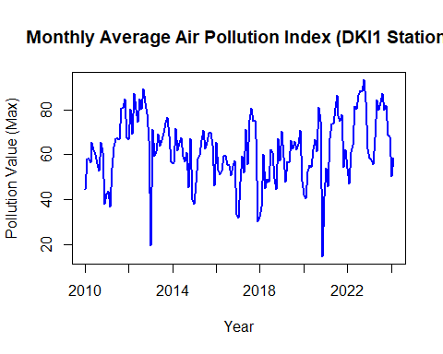
# 3. DECOMPOSITION (TREND & SEASONALITY)
decomposition <- stl(ts_pollution, s.window = "periodic", robust = TRUE)
plot(decomposition, main = "Time Series Decomposition: Trend, Seasonality, and Residuals")
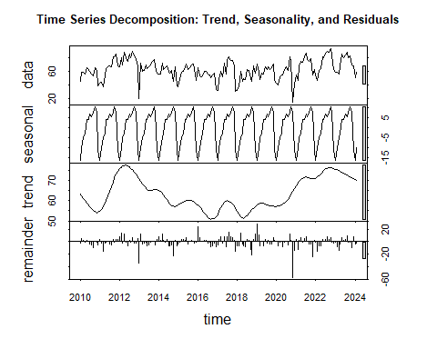
# 4. ANOMALY DETECTION
anomalies <- tsoutliers(ts_pollution)
if(length(anomalies$index) > 0) {
cat("Pollution anomalies found at time series index: ")
print(anomalies$index)
anomaly_times <- time(ts_pollution)[anomalies$index]
cat("\nTime of anomalies:\n")
print(anomaly_times)
plot(ts_pollution,
main = "Air Pollution Anomaly Detection",
ylab = "Pollution Value",
xlab = "Year",
col = "darkgray")
points(anomaly_times, ts_pollution[anomalies$index],
col = "red", pch = 19, cex = 1.5)
legend("topleft", legend = c("Pollution Data", "Anomaly / Outlier"),
col = c("darkgray", "red"), pch = c(1, 19))
} else {
cat("No anomalies detected.\n")
}
## No anomalies detected.
# 5. STATIONARITY TEST (RAW DATA)
adf_test <- adf.test(ts_pollution)
## Warning in adf.test(ts_pollution): p-value smaller than printed p-value
print(adf_test)
##
## Augmented Dickey-Fuller Test
##
## data: ts_pollution
## Dickey-Fuller = -4.5993, Lag order = 5, p-value = 0.01
## alternative hypothesis: stationary
cat("\n--> Variance Stationarity Check (Power Transform):\n")
##
## --> Variance Stationarity Check (Power Transform):
print(summary(powerTransform(ts_pollution)))
## bcPower Transformation to Normality
## Est Power Rounded Pwr Wald Lwr Bnd Wald Upr Bnd
## ts_pollution 1.4267 1 0.9433 1.9101
##
## Likelihood ratio test that transformation parameter is equal to 0
## (log transformation)
## LRT df pval
## LR test, lambda = (0) 45.53454 1 1.4997e-11
##
## Likelihood ratio test that no transformation is needed
## LRT df pval
## LR test, lambda = (1) 3.248496 1 0.071489
df_monthly$year_group <- as.factor(year(df_monthly$month_col))
levene_test <- leveneTest(pollution_avg ~ year_group, data = df_monthly)
print(levene_test)
## Levene's Test for Homogeneity of Variance (center = median)
## Df F value Pr(>F)
## group 14 1.5661 0.09453 .
## 155
## ---
## Signif. codes: 0 '***' 0.001 '**' 0.01 '*' 0.05 '.' 0.1 ' ' 1
par(mfrow=c(1,2))
Acf(ts_pollution, main = "ACF Monthly Average Pollution")
Pacf(ts_pollution, main = "PACF Monthly Average Pollution")
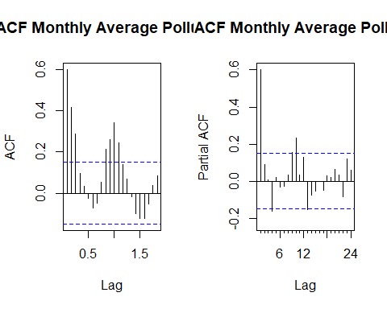
par(mfrow=c(1,1))
# 6. DATA SPLITTING (TRAIN & TEST)
cat("\n=== DATA SPLITTING ===\n")
##
## === DATA SPLITTING ===
split_idx <- floor(0.8 * length(ts_pollution))
train_data <- window(ts_pollution, end = time(ts_pollution)[split_idx])
test_data <- window(ts_pollution, start = time(ts_pollution)[split_idx + 1])
h_test <- length(test_data)
cat("Total Data :", length(ts_pollution), "months\n")
## Total Data : 170 months
cat("Train Data :", length(train_data), "months\n")
## Train Data : 136 months
cat("Test Data :", h_test, "months\n\n")
## Test Data : 34 months
# 7. MODELING (TRAIN DATA ONLY)
cat("\n=== 7A. ARIMA MODELING ===\n")
##
## === 7A. ARIMA MODELING ===
# Estimating ARIMA Candidates
arima_000 <- Arima(train_data, order = c(0,0,0))
arima_100 <- Arima(train_data, order = c(1,0,0))
arima_001 <- Arima(train_data, order = c(0,0,1))
arima_101 <- Arima(train_data, order = c(1,0,1))
arima_200 <- Arima(train_data, order = c(2,0,0))
arima_002 <- Arima(train_data, order = c(0,0,2))
arima_202 <- Arima(train_data, order = c(2,0,2))
arima_auto <- auto.arima(train_data) # as a benchmark
rmse_arima_candidates <- c(
"ARIMA(0,0,0)" = accuracy(forecast(arima_000, h = h_test), test_data)["Test set", "RMSE"],
"ARIMA(1,0,0)" = accuracy(forecast(arima_100, h = h_test), test_data)["Test set", "RMSE"],
"ARIMA(0,0,1)" = accuracy(forecast(arima_001, h = h_test), test_data)["Test set", "RMSE"],
"ARIMA(1,0,1)" = accuracy(forecast(arima_101, h = h_test), test_data)["Test set", "RMSE"],
"ARIMA(2,0,0)" = accuracy(forecast(arima_200, h = h_test), test_data)["Test set", "RMSE"],
"ARIMA(0,0,2)" = accuracy(forecast(arima_002, h = h_test), test_data)["Test set", "RMSE"],
"ARIMA(2,0,2)" = accuracy(forecast(arima_202, h = h_test), test_data)["Test set", "RMSE"],
"ARIMA(Auto)" = accuracy(forecast(arima_auto, h = h_test), test_data)["Test set", "RMSE"]
)
cat("--> RMSE Evaluation Results (ARIMA):\n")
## --> RMSE Evaluation Results (ARIMA):
print(sort(rmse_arima_candidates))
## ARIMA(1,0,1) ARIMA(2,0,0) ARIMA(2,0,2) ARIMA(Auto) ARIMA(1,0,0) ARIMA(0,0,2)
## 17.37095 17.37323 17.38834 17.44282 17.46076 17.63249
## ARIMA(0,0,1) ARIMA(0,0,0)
## 17.75014 17.81074
# Select best ARIMA automatically
best_arima_name <- names(sort(rmse_arima_candidates))[1]
cat("\n--> Best ARIMA Model:", best_arima_name, "\n")
##
## --> Best ARIMA Model: ARIMA(1,0,1)
best_arima <- arima_101
cat("\n=== EXPONENTIAL SMOOTHING GRID SEARCH ===\n")
##
## === EXPONENTIAL SMOOTHING GRID SEARCH ===
# parameter yang mau dicoba (alpha, beta, gamma)
alphas <- c(0.2, 0.4, 0.6, 0.8)
betas <- c(0.1, 0.2)
gammas <- c(0.1, 0.3, 0.5)
# dataframe kosong untuk simpan hasil
ets_leaderboard <- data.frame(
Model = character(),
Alpha = numeric(),
Beta = numeric(),
Gamma = numeric(),
RMSE = numeric(),
MAE = numeric(),
MAPE = numeric(),
stringsAsFactors = FALSE
)
counter <- 1
# Mulai Looping
for(a in alphas) {
for(b in betas) {
for(g in gammas) {
tryCatch({
# Fit model
fit <- HoltWinters(train_data, alpha = a, beta = b, gamma = g)
fc <- forecast(fit, h = h_test)
acc <- accuracy(fc, test_data)
# Masukkan ke tabel
ets_leaderboard <- rbind(ets_leaderboard, data.frame(
Model = paste0("HW-", counter),
Alpha = a,
Beta = b,
Gamma = g,
RMSE = round(acc["Test set", "RMSE"], 2),
MAE = round(acc["Test set", "MAE"], 2),
MAPE = round(acc["Test set", "MAPE"], 2)
))
counter <- counter + 1
}, error = function(e){
})
}
}
}
# dari RMSE terkecil ke terbesar
ets_leaderboard <- ets_leaderboard[order(ets_leaderboard$RMSE), ]
rownames(ets_leaderboard) <- NULL
print(ets_leaderboard)
## Model Alpha Beta Gamma RMSE MAE MAPE
## 1 HW-1 0.2 0.1 0.1 9.46 8.05 11.53
## 2 HW-2 0.2 0.1 0.3 9.78 8.33 11.78
## 3 HW-3 0.2 0.1 0.5 10.73 8.90 12.76
## 4 HW-5 0.2 0.2 0.3 15.84 12.74 19.61
## 5 HW-4 0.2 0.2 0.1 16.48 13.16 20.24
## 6 HW-6 0.2 0.2 0.5 17.31 13.83 21.18
## 7 HW-9 0.4 0.1 0.5 19.55 15.67 24.36
## 8 HW-8 0.4 0.1 0.3 20.13 16.08 25.09
## 9 HW-7 0.4 0.1 0.1 23.95 19.72 30.20
## 10 HW-15 0.6 0.1 0.5 33.65 28.76 43.62
## 11 HW-14 0.6 0.1 0.3 38.20 33.13 49.80
## 12 HW-13 0.6 0.1 0.1 40.88 35.85 53.44
## 13 HW-12 0.4 0.2 0.5 42.19 35.64 53.27
## 14 HW-11 0.4 0.2 0.3 44.80 38.06 56.85
## 15 HW-19 0.8 0.1 0.1 47.16 42.01 62.18
## 16 HW-20 0.8 0.1 0.3 51.15 45.81 67.79
## 17 HW-21 0.8 0.1 0.5 51.43 46.00 68.20
## 18 HW-10 0.4 0.2 0.1 53.97 46.21 68.44
## 19 HW-18 0.6 0.2 0.5 69.59 60.37 89.25
## 20 HW-17 0.6 0.2 0.3 79.05 69.29 101.86
## 21 HW-16 0.6 0.2 0.1 83.15 73.32 107.32
## 22 HW-22 0.8 0.2 0.1 88.32 78.45 114.57
## 23 HW-23 0.8 0.2 0.3 97.54 86.80 126.73
## 24 HW-24 0.8 0.2 0.5 99.13 88.11 128.75
cat("\n------------------------------------------------------\n")
##
## ------------------------------------------------------
cat("Best Model:", ets_leaderboard$Model[1],
"| RMSE:", ets_leaderboard$RMSE[1], "%\n")
## Best Model: HW-1 | RMSE: 9.46 %
cat("------------------------------------------------------\n")
## ------------------------------------------------------
best_ets <- HoltWinters(train_data, alpha = 0.2, beta = 0.1, gamma = 0.1)
tslm_lag1 <- Arima(train_data, order=c(1,0,0), include.drift=TRUE) # Lag 1
tslm_lag2 <- Arima(train_data, order=c(2,0,0), include.drift=TRUE) # Lag 1 & 2
tslm_lag3 <- Arima(train_data, order=c(3,0,0), include.drift=TRUE) # Lag 1, 2 & 3
rmse_tslm_candidates <- c(
"TSLM (Lag 1)" = accuracy(forecast(tslm_lag1, h = h_test), test_data)["Test set", "RMSE"],
"TSLM (Lag 2)" = accuracy(forecast(tslm_lag2, h = h_test), test_data)["Test set", "RMSE"],
"TSLM (Lag 3)" = accuracy(forecast(tslm_lag3, h = h_test), test_data)["Test set", "RMSE"]
)
cat("--> RMSE Evaluation Results (TSLM + Lags):\n")
## --> RMSE Evaluation Results (TSLM + Lags):
print(sort(rmse_tslm_candidates))
## TSLM (Lag 3) TSLM (Lag 2) TSLM (Lag 1)
## 20.90156 20.99174 21.23226
best_tslm_name <- names(sort(rmse_tslm_candidates))[1]
best_tslm_models <- list("TSLM (Lag 1)"=tslm_lag1, "TSLM (Lag 2)"=tslm_lag2, "TSLM (Lag 3)"=tslm_lag3)
best_tslm <- best_tslm_models[[best_tslm_name]]
cat("\n--> Best TSLM/Lag Model:", best_tslm_name, "\n")
##
## --> Best TSLM/Lag Model: TSLM (Lag 3)
cat("\n====================================================================\n")
##
## ====================================================================
cat("FAMILY: NEURAL NETWORK AUTOREGRESSION (NNAR) FAMILY\n")
## FAMILY: NEURAL NETWORK AUTOREGRESSION (NNAR) FAMILY
set.seed(123)
nnar_params <- list(
list(p=1, P=0, size=2), list(p=2, P=0, size=2), list(p=3, P=0, size=2),
list(p=2, P=0, size=3), list(p=5, P=0, size=3), list(p=7, P=0, size=4),
list(p=10, P=0, size=5), list(p=1, P=1, size=2), list(p=3, P=1, size=2),
list(p=5, P=1, size=3), list(p=7, P=1, size=4), list(p=10, P=1, size=5)
)
nnar_leaderboard <- data.frame(
Model = character(), RMSE = numeric(), MAE = numeric(), MAPE = numeric(),
stringsAsFactors = FALSE
)
nnar_models_saved <- list()
tryCatch({
nnar_auto <- nnetar(train_data)
fc_auto <- forecast(nnar_auto, h = h_test)
acc_auto <- accuracy(fc_auto, test_data)
nnar_leaderboard <- rbind(nnar_leaderboard, data.frame(
Model = "NNAR Auto",
RMSE = round(acc_auto["Test set", "RMSE"], 2),
MAE = round(acc_auto["Test set", "MAE"], 2),
MAPE = round(acc_auto["Test set", "MAPE"], 2)
))
nnar_models_saved[["NNAR Auto"]] <- nnar_auto
}, error = function(e){})
for(params in nnar_params) {
p_val <- params$p
P_val <- params$P
size_val <- params$size
model_name <- paste0("NNAR(", p_val, ",", P_val, ",", size_val, ")")
tryCatch({
fit_nnar <- nnetar(train_data, p = p_val, P = P_val, size = size_val)
fc_nnar <- forecast(fit_nnar, h = h_test)
acc_nnar <- accuracy(fc_nnar, test_data)
nnar_leaderboard <- rbind(nnar_leaderboard, data.frame(
Model = model_name,
RMSE = round(acc_nnar["Test set", "RMSE"], 2),
MAE = round(acc_nnar["Test set", "MAE"], 2),
MAPE = round(acc_nnar["Test set", "MAPE"], 2)
))
nnar_models_saved[[model_name]] <- fit_nnar
}, error = function(e){})
}
nnar_leaderboard <- nnar_leaderboard[order(nnar_leaderboard$RMSE), ]
rownames(nnar_leaderboard) <- NULL
print(nnar_leaderboard, row.names = FALSE, right = TRUE)
## Model RMSE MAE MAPE
## NNAR(2,0,3) 17.09 14.29 18.41
## NNAR(7,1,4) 17.14 13.72 18.05
## NNAR(3,0,2) 17.38 14.61 18.84
## NNAR(3,1,2) 17.63 14.77 18.88
## NNAR(1,1,2) 17.98 14.86 18.88
## NNAR Auto 18.08 14.99 19.03
## NNAR(2,0,2) 18.26 15.12 19.26
## NNAR(1,0,2) 18.33 15.19 19.35
## NNAR(10,1,5) 20.11 16.86 21.98
## NNAR(5,0,3) 21.08 17.64 22.35
## NNAR(10,0,5) 22.27 18.84 24.30
## NNAR(5,1,3) 22.33 18.68 23.68
## NNAR(7,0,4) 23.93 19.92 25.53
cat("--------------------------------------------------------------------\n")
## --------------------------------------------------------------------
# model dengan RMSE terbaik
best_nnar_model_name <- nnar_leaderboard$Model[1]
best_nnar_rmse <- nnar_leaderboard$RMSE[1]
cat("Best Model:", best_nnar_model_name, "| RMSE:", best_nnar_rmse, "\n")
## Best Model: NNAR(2,0,3) | RMSE: 17.09
cat("====================================================================\n")
## ====================================================================
best_nnar <- nnar_models_saved[[best_nnar_model_name]]
cat("\n====================================================================\n")
##
## ====================================================================
cat("FAMILY: NAIVE & SEASONAL NAIVE FAMILY\n")
## FAMILY: NAIVE & SEASONAL NAIVE FAMILY
# Bikin model Naive biasa dan Seasonal Naive
naive_regular <- naive(train_data, h = h_test)
naive_seasonal <- snaive(train_data, h = h_test)
# akurasi data test
acc_naive <- accuracy(naive_regular, test_data)
acc_snaive <- accuracy(naive_seasonal, test_data)
# dataframe
naive_leaderboard <- data.frame(
Model = c("Naive", "Seasonal Naive"),
RMSE = c(acc_naive["Test set", "RMSE"], acc_snaive["Test set", "RMSE"]),
MAE = c(acc_naive["Test set", "MAE"], acc_snaive["Test set", "MAE"]),
MAPE = c(acc_naive["Test set", "MAPE"], acc_snaive["Test set", "MAPE"]),
stringsAsFactors = FALSE
)
# Set 2 angka di belakang koma
naive_leaderboard$RMSE <- round(naive_leaderboard$RMSE, 2)
naive_leaderboard$MAE <- round(naive_leaderboard$MAE, 2)
naive_leaderboard$MAPE <- round(naive_leaderboard$MAPE, 2)
# Urut RMSE terkecil
naive_leaderboard <- naive_leaderboard[order(naive_leaderboard$RMSE), ]
rownames(naive_leaderboard) <- NULL
# Print tabel tanpa nomor urut baris
print(naive_leaderboard, row.names = FALSE, right = TRUE)
## Model RMSE MAE MAPE
## Naive 12.86 11.29 17.13
## Seasonal Naive 22.87 17.63 24.03
cat("--------------------------------------------------------------------\n")
## --------------------------------------------------------------------
# Best Model berdasarkan RMSE
best_naive_name <- naive_leaderboard$Model[1]
if(best_naive_name == "Naive") {
best_naive_rmse <- round(acc_naive["Test set", "RMSE"], 4)
model_naive <- naive_regular
} else {
best_naive_rmse <- round(acc_snaive["Test set", "RMSE"], 4)
model_naive <- naive_seasonal
}
cat("Best Model:", best_naive_name, "| RMSE:", best_naive_rmse, "\n")
## Best Model: Naive | RMSE: 12.8558
cat("====================================================================\n")
## ====================================================================
# 8. FORECASTING FOR TEST DATA (USING WINNERS)
fc_arima <- forecast(best_arima, h = h_test)
fc_ets <- forecast(best_ets, h = h_test)
fc_tslm <- forecast(best_tslm, h = h_test)
fc_nnar <- forecast(best_nnar, h = h_test)
fc_naive <- model_naive
# 9. ACCURACY EVALUATION (FINAL LEADERBOARD)
cat("\n==========================================\n")
##
## ==========================================
cat("FINAL MODEL EVALUATION LEADERBOARD\n")
## FINAL MODEL EVALUATION LEADERBOARD
forecast_list <- list(
"ARIMA" = fc_arima,
"ETS" = fc_ets,
"TSLM" = fc_tslm,
"NNAR" = fc_nnar,
"NAIVE" = fc_naive
)
leaderboard <- data.frame(Model = character(), RMSE = numeric(), MAE = numeric(), MAPE = numeric(), stringsAsFactors = FALSE)
for (model_name in names(forecast_list)) {
acc <- accuracy(forecast_list[[model_name]], test_data)
leaderboard <- rbind(leaderboard, data.frame(
Model = model_name,
RMSE = round(acc["Test set", "RMSE"], 4),
MAE = round(acc["Test set", "MAE"], 4),
MAPE = round(acc["Test set", "MAPE"], 4)
))
}
# Sort by RMSE
leaderboard <- leaderboard[order(leaderboard$RMSE), ]
rownames(leaderboard) <- NULL
print(leaderboard)
## Model RMSE MAE MAPE
## 1 ETS 9.4585 8.0511 11.5304
## 2 NAIVE 12.8558 11.2908 17.1332
## 3 NNAR 17.0894 14.2871 18.4145
## 4 ARIMA 17.3709 14.4534 18.5409
## 5 TSLM 20.9016 17.5292 22.2133
best_overall <- leaderboard$Model[1]
cat("\nTHE BEST OVERALL MODEL IS:", best_overall, "\n")
##
## THE BEST OVERALL MODEL IS: ETS
# 10. FORECAST RESULTS (PLOTTING BEST OVERALL MODEL)
best_forecast <- forecast_list[[best_overall]]
plot(best_forecast,
main = paste("Air Pollution Forecast vs Actual Data -", best_overall),
ylab = "Pollution Value", xlab = "Year",
flty = 1, shadecols = c("#ffcccc", "#ff9999"))
lines(test_data, col = "red", lwd = 2)
legend("topleft", legend = c(paste(best_overall, "Forecast"), "Actual Data (Test)"),
col = c("blue", "red"), lty = 1, lwd = 2)
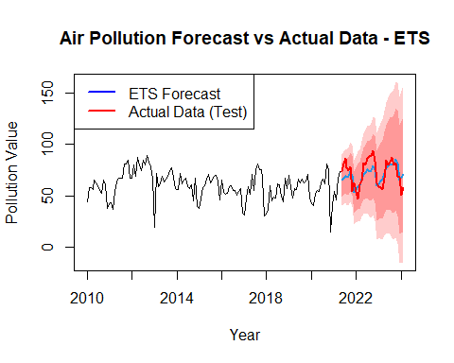
# ---------------------------------------------------------
# 11A. PERBANDINGAN RMSE
par(mfrow=c(1,1), mar=c(5, 5, 4, 2) + 0.1)
bar_colors <- ifelse(leaderboard$Model == best_overall, "firebrick", "steelblue")
bp <- barplot(leaderboard$RMSE,
names.arg = leaderboard$Model,
col = bar_colors,
main = "Leaderboard RMSE (Semua Model pada Data Test)",
ylab = "Nilai RMSE",
xlab = "Metode Forecast",
ylim = c(0, max(leaderboard$RMSE) * 1.2), # Naikin batas atas biar text ngga kepotong
las = 1)
text(x = bp, y = leaderboard$RMSE,
label = round(leaderboard$RMSE, 2),
pos = 3, cex = 1, col = "black", font = 2)
legend("topright", legend = c(paste("Best Model:", best_overall), "Kandidat Lain"),
fill = c("firebrick", "steelblue"), cex = 0.9)
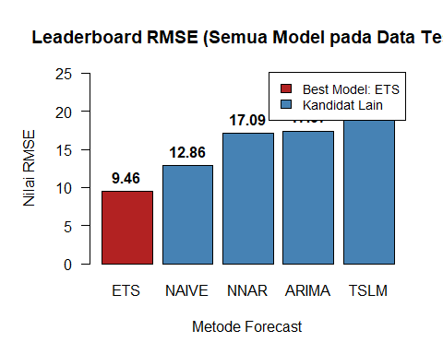
par(mfrow=c(2,3))
plot_forecast_individual <- function(fc_model, model_name, test_data) {
plot(fc_model,
main = paste("Forecast:", model_name),
ylab = "Pollution Value", xlab = "Year",
flty = 1, shadecols = c("#ffcccc", "#ff9999"))
lines(test_data, col = "red", lwd = 2)
legend("topleft", legend = c("Forecast", "Actual Data"),
col = c("blue", "red"), lty = 1, lwd = 2, cex = 0.7)
}
# Generate plot masing-masing
plot_forecast_individual(fc_arima, "ARIMA", test_data)
plot_forecast_individual(fc_ets, "ETS", test_data)
plot_forecast_individual(fc_tslm, "TSLM", test_data)
plot_forecast_individual(fc_nnar, "NNAR", test_data)
plot_forecast_individual(fc_naive, "NAIVE", test_data)
par(mfrow=c(1,1))
