# Name: Hazem Ali Mohamed Ali

# B.N: 274

# Date: 7/6/2020

Topic: **Big Data**

**Github Linke:**

**Github Page :**

**Application Brief:**

Big Data is a phrase used to mean a massive volume of both structured and unstructured data that is so large it is difficult to process using traditional database and software techniques. In most enterprise scenarios the volume of data is too big or it moves too fast or it exceeds current processing capacity.

Big Data has the potential to help companies improve operations and make faster, more intelligent decisions. The data is collected from a number of sources including emails, mobile devices, applications, databases, servers and other means. This data, when captured, formatted, manipulated, stored and then analyzed, can help a company to gain useful insight to increase revenues, get or retain customers and improve operations.

**References**

1. **Hilbert, Martin; López, Priscila (2011).**[**"The World's Technological Capacity to Store, Communicate, and Compute Information"**](http://www.martinhilbert.net/WorldInfoCapacity.html)**. Science. 332 (6025): 60–65.**[**Bibcode**](https://en.wikipedia.org/wiki/Bibcode_(identifier))**:[2011Sci...332...60H](https://ui.adsabs.harvard.edu/abs/2011Sci...332...60H).**[**doi**](https://en.wikipedia.org/wiki/Doi_(identifier))**:**[**10.1126/science.1200970**](https://doi.org/10.1126%2Fscience.1200970)**.**[**PMID**](https://en.wikipedia.org/wiki/PMID_(identifier))[**21310967**](https://pubmed.ncbi.nlm.nih.gov/21310967)**. Retrieved 13 April 2016.**
2. [**^**](https://en.wikipedia.org/wiki/Big_data#cite_ref-2)**Breur, Tom (July 2016). "Statistical Power Analysis and the contemporary "crisis" in social sciences". Journal of Marketing Analytics. 4 (2–3): 61–65.**[**doi**](https://en.wikipedia.org/wiki/Doi_(identifier))**:**[**10.1057/s41270-016-0001-3**](https://doi.org/10.1057%2Fs41270-016-0001-3)**.**[**ISSN**](https://en.wikipedia.org/wiki/ISSN_(identifier))[**2050-3318**](https://www.worldcat.org/issn/2050-3318)**.**
3. [**^**](https://en.wikipedia.org/wiki/Big_data#cite_ref-3)**boyd, dana; Crawford, Kate (21 September 2011).**[**"Six Provocations for Big Data"**](http://osf.io/nrjhn/)**. Social Science Research Network: A Decade in Internet Time: Symposium on the Dynamics of the Internet and Society.**[**doi**](https://en.wikipedia.org/wiki/Doi_(identifier))**:**[**10.2139/ssrn.1926431**](https://doi.org/10.2139%2Fssrn.1926431)

# Screenshots:

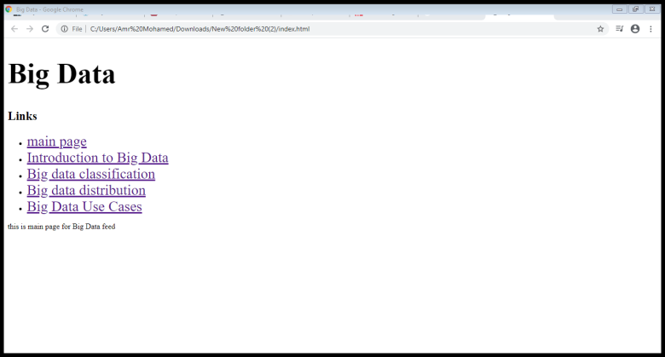

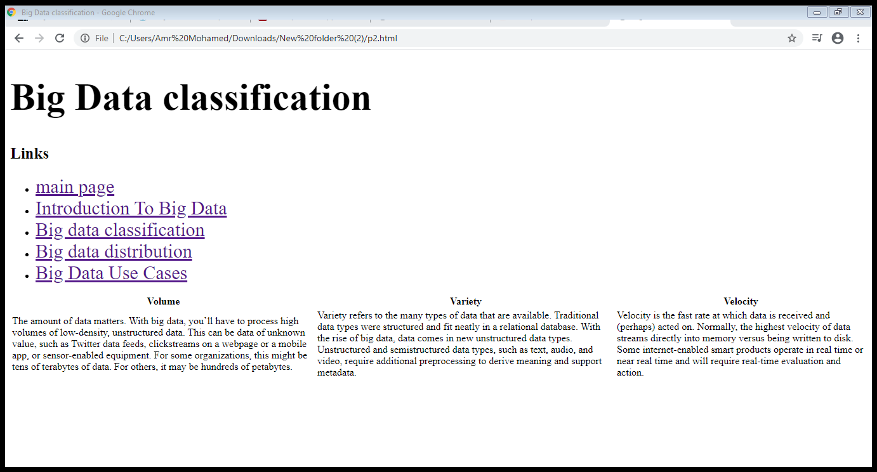

**Source Code:**

