Practical Project for Network Fundamentals Course

Personal Information
- Name: Hazem Hamdi Mahmoud Abdelqader
- University: Nahda University (NUB)
- Faculty: Faculty of Engineering
- Department: Communications and Electronics Engineering

Contact Details
- Phone: +20 106 238 6571
- Email: hazemhamdypersonal@gmail.com
- GitHub: github.com/Hazem-Hamd

A company consists of three main branches as follows:
1. Main Branch (BR-1) This is a one-story building consisting of several departments as follows:
- Human Resources Department, containing employees.
- Marketing Department, containing 50 employees.
- Accounting Department, containing 25 employees.
- Procurement Department, containing 13 employees.
- IT (Informatics) Department, containing 1 employee.
2. Branch 2 (BR-2)
- It has the exact same design as Branch BR-1 and is located 50 km away from the first branch.
3. Branch 3 (BR-3)
- It has the same design as the previous two branches and is located 200 km away from the first branch.
Data Center & ISP
- There is a "BR-Data Center" building located next to the main branch, containing the following:
  - DHCP server
  - DNS server
  - TFTP server
- There is also an Internet Service Provider (ISP) that allows the company's clients across all different branches to connect to the Internet.

Internal and External Design
Internal Design for Branches (BR1 - BR2 - BR3):
- Each department contains a switch, to which all devices within the same department are connected as explained previously.
- All these switches are connected to a single central switch (Core-Switch) using at least two cables.
- Each Core Switch is connected to the router of its respective branch.
External Design:
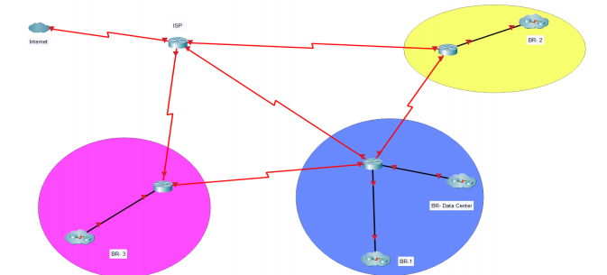
- The external diagram consists of the Internet, the ISP, BR-3 , BR-Data Center , and BR-2.
- The symbol in the diagram represents the internal structure of the network as previously explained.

Project Requirements
- Topology Design: Design the previously mentioned topology on the Packet Tracer simulation program.
- IP Subnetting: Subnet the logical addresses in each department so that there is no significant waste of addresses (you are required to place three devices within each department).
- DHCP vs Static IP: Distribute all logical IP addresses to all PC devices only by using the DHCP server, while giving the servers and router interfaces fixed Static IPs.
- EtherChannel: Use EtherChannel technology between the floor switches and the central switch in all branches (two lines or more).
- Port Security: Apply Port Security technology on one of the switches and justify the reason for using this service.
- VLAN & VTP: Create VLANs for all types of employees and use VTP technology to distribute them across all switches.
- SSH Access: Ensure the device located in the IT department can access any router in any branch and change its configurations using SSH.
- Routing: Apply the routing algorithm you deem appropriate between all routers (Static or Dynamic).
- TFTP Backups: Store all router configurations on the TFTP server and explain the benefit of this service.
- Default Route: Apply the Default Route technique to establish a connection between the routers of all branches and the Internet Service Provider (ISP).
- Access Control List (ACL): Use the Access Control List service to allow only the device located in the IT department within the main branch (BR1) to connect (Ping) to all devices located in all departments across all branches.

Important Notes
- Accuracy in choosing the types of cables used and their speeds must be taken into consideration.
- Choose the correct addresses and ensure there is no significant waste in logical addresses.
- Place notes/labels on the design in the simulator distinguishing the static addresses, subnet masks, and prominent important notes for ease of understanding and interactivity.
- The interview will be conducted by asking about the project and all topics covered in the lectures, so that all students in each group will be questioned.
- The maximum number of students per group is strictly 5, and no group should have fewer than 4 students, provided that all group members attended classes during the year with the same instructor.
- Interview dates will be determined later, and a Form will be sent subsequently through which all groups will be registered.

