**Triggers**

-What are triggers?

SQL Server triggers are special stored procedures that are executed automatically in response to the database object, database, and server events.

SQL Server provides three types of triggers:

1-Data manipulation language (DML) triggers which are invoked automatically in response to INSERT, UPDATE, and DELETE events against tables.

2-Data definition language (DDL) triggers which fire in response to CREATE, ALTER, and DROP statements.

3-Logon triggers which fire in response to LOGON events.

Creating a trigger in SQL Server -

The CREATE TRIGGER statement allows you to create a new trigger that is fired automatically whenever an event such as INSERT, DELETE, or UPDATE occurs against a table.

-INSTEAD OF Trigger

an INSTEAD OF trigger skips a DML statement and execute other statements.

-DDL Trigger

SQL Server DDL triggers respond to server or database events rather than to table data modifications. These events created by the Transact-SQL statement that normally starts with one of the following keywords CREATE, ALTER, DROP, GRANT, DENY, REVOKE, or UPDATE STATISTICS.

-DISABLE TRIGGER

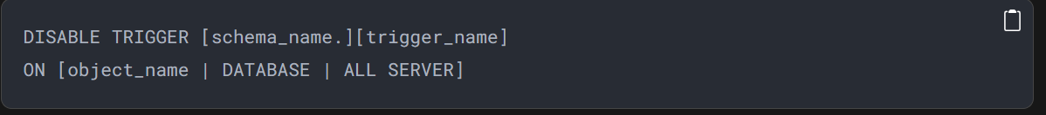

-ENABLE TRIGGER

-List All Triggers

-DROP TRIGGER

