IEEE P802.19
Wireless Coexistence

Project | IEEE P802.19 Coexistence TAG
Title | Estimation of Packet Error Rate Caused by Interference using Analytic Techniques – A Coexistence Assurance Methodology
Date Submitted | [September 28, 2005]
Source | [Stephen J. Shellhammer]  [Qualcomm, Inc.]  [5775 Morehouse Drive]  [San Diego, CA 92121] | Voice: [(858) 658-1874]  E-mail: [shellhammer@ieee.org]
Re: | []
Abstract | [This document is a submission for an analytic coexistence assurance (CA) methodology. Revision 1 has added material for calculating PER utilizing post-FEC BER]
Purpose | []
Notice | This document has been prepared to assist the IEEE P802.19. It is offered as a basis for discussion and is not binding on the contributing individual(s) or organization(s). The material in this document is subject to change in form and content after further study. The contributor(s) reserve(s) the right to add, amend or withdraw material contained herein.
Release | The contributor acknowledges and accepts that this contribution becomes the property of IEEE and may be made publicly available by P802.19.

Table of Contents
1 Background 4
2 Introduction 4
3 Definitions and Terminology 4
4 Acronyms 4
5 Overview 5
6 Geometric Model 5
7 Path Loss Model 7
8 PHY Layer Model 8
8.1 First order PHY Model 10
8.2 Simulation based PHY Model 12
9 Temporal Model 13
9.1 Temporal Collision 13
9.2 Probability Calculations Utilizing on SER 14
9.3 Simplification of Probability Calculations 17
9.4 Limits of PER Formula 18
9.5 Probability Calculations Utilizing on BER 18
9.6 Simplification of Probability Calculations 19
9.7 Random Pulse Model 21
10 Calculation of Performance Metrics 21
11 Examples 22
11.1 Example 1 – BPSK with Periodic Interference Pulses 22
11.2 Example 2 – QAM with Periodic Interference Pulses 29
11.3 Example 3 – BPSK with Random Interference Pulses 34
12 Step by Step Summary of the Model 36
12.1 Step 1 – Select a Geometric Model 36
12.2 Step 2 – Select a Path Loss Model 37
12.3 Step 3 – Develop Symbol Error Rate Formula 37
12.4 Step 4 – Develop Temporal Model 37
12.5 Step 5 – Develop Packet Error Rate Formula 38
12.6 Step 6 – Calculate and Plot PER and other Performance Metrics 38
13 References 38

List of Figures
Figure 1 : Geometry of Networks 6
Figure 2 : Path Loss Function 8
Figure 3 : General Structure of a Wireless Packet 9
Figure 4 : Packet Structure 10
Figure 5 : Illustration of Packet Collision 13
Figure 6 : Packet Collision with Packets shorter than Interference Pulses 15
Figure 7 : Packet Collision with Packets longer than Interference Pulses 16
Figure 8 : Timing of Packets and Interference Pulses in Example 1 23
Figure 9 : BPSK Symbol Error Rate 24
Figure 10 : PER Curve for Example 1 26
Figure 11 : Illustration of Coexistence Figures of Merit 27
Figure 12 : Throughput Curve for Example 1 28
Figure 13 : Latency Curve for Example 1 29
Figure 14 : SER for BPSK, QPSK, 16QAM and 64QAM 30
Figure 15 : Timing of Packets and Interference Pulses in Example 2 for QPSK 31
Figure 16 : PER Curve for Example 2 32
Figure 17 : Throughput Curve for Example 2 33
Figure 18 : Latency Curve for Example 2 34
Figure 19 : Cumulative Distribution Function for Number of Symbol Collisions 35
Figure 20 : Cumulative Distribution Function for Number of Symbol Collisions 36

List of Tables
Table 1: Figures of Merit for Example 2 32

Background
This document is a submission in response to the call for submissions [1] on Coexistence Assurance Methodology. The IEEE 802 Policies and Procedures require development of a Coexistence Assurance (CA) document when developing a draft wireless standard for unlicensed operation [2].

Introduction
This document describes a methodology for estimating the packet error rate (PER) in a wireless network due to interference from another wireless network. Some preliminary concepts we presented in a previous submission [3]. These ideas have been more fully developed here and examples of how to utilize this methodology have been included.

In an analytic model it may be necessary to make some simplifying assumptions relative to a more detailed simulation model. However, one is likely to be able to obtain results from an analytic model quicker than with a simulation model. It is also possible to combine some of the analytic techniques descried here with simulation techniques.

Definitions and Terminology

Affected Wireless Network | The wireless network whose performance is affected by the presence of the interfering wireless network. A CA document shows the effect of the interfering wireless network on the affected wireless network.
Interfering Wireless Network | The wireless network causing interference

Acronyms
The following are new acronyms used in this document.

AWN | Affected Wireless Network
BE | Bit error after FEC
BER | Bit error rate after FEC
FEC | Forward error correction
IWN | Interfering Wireless Network
PE | Packet Error
PER | Packet Error Rate
SE | Symbol Error
SER | Symbol Error Rate
SIR | Signal to interference ratio

Overview

A method of estimating the packet error rate caused by interference is introduced. This estimate of the packet error rate is then used to derive estimates of the performance metrics of the network, like throughput and latency. This model can be mixed with other models if portions of the model are not available analytically. For example, if there is not an analytic expression for the symbol error rate (SER) then a simulation can be used to find the symbol error rate, and the results of that simulation can be used in conjunction with the other parts of this model to estimate the packet error rate (PER) and ultimately the performance metrics, like throughput and latency.

The model begins with a geometric model of the affected wireless network and the interfering wireless network. In this model there are typically only two stations in each of these networks; however, a more complex geometric model could be used.

There is a path loss model that is used to estimate the average signal to interference ratio at the affected wireless network. Given transmit power of both the signal and the interferer once can use the path loss model to calculate the signal to interference ratio.

The PHY layer model calculates the symbol error rate (SER) on the affected wireless network as a function of the signal to interference ratio, assuming the interferer is transmitting continuously.

The temporal model converts the symbol error rate into the packet error rate. The interferer is modeled as a pulse generator with known statistical characteristics.

Finally, once the packet error rate has been calculated that result is used to estimate the relevant performance metrics, like throughput and latency.

Geometric Model
The geometric model describes the location of the nodes for both the affected wireless network (AWN) and the interfering wireless network (IWN). Implicit in specifying the location of the network nodes, is specifying the number of nodes in each network. In this document the simplest configuration is used, in which each network has two nodes. Also, to simplify the analysis it is assumed that one node from each network is nearby a node from the other network and that the other node in each of the networks is farther away. That allows us to focus on the interference between one node of the IWN and one node of the AWN. Figure 1 shows the recommended geometry of nodes for both the AWN and IWN.

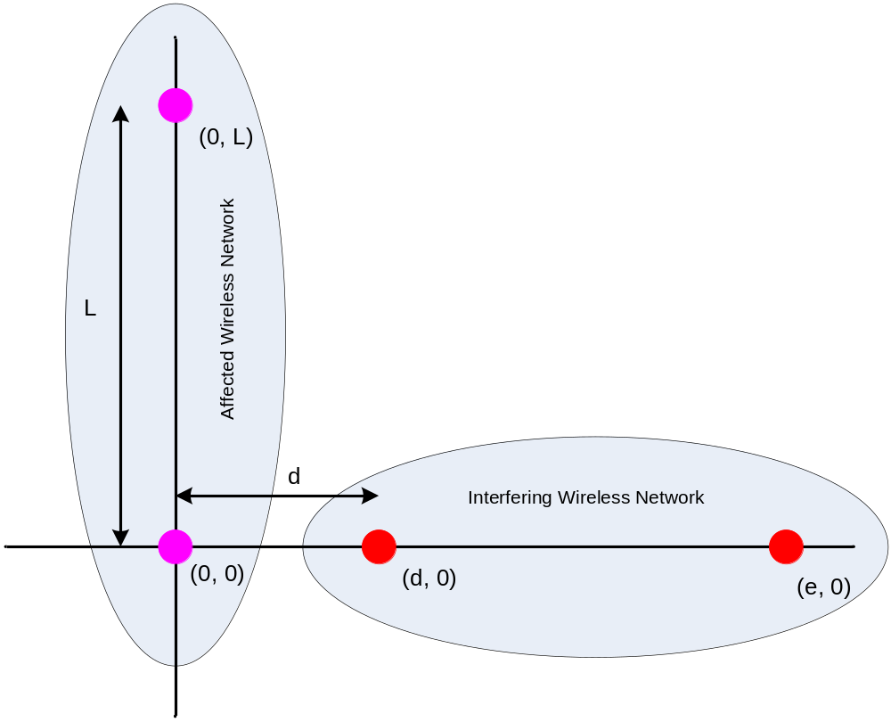

Figure 1 : Geometry of Networks

In this figure, the nodes along the y-axis are the nodes of the affected wireless network (AWN) while the nodes along the x-axis are the nodes of the interfering wireless network (IWN).

The distance L affects the receive signal power level within the affected wireless network. The distances d and e affect the interference power level received at the AWN.

In this geometry, if the distance L is large then the only node in the AWN that is affected by the IWN is the node at the origin. Also, in this geometry, if the distance e is large then the only node in the IWN that affects the AWN is the node at location (d, 0).

The intent of using this geometry is to isolate the interference between one node in the IWN and one node in the AWN. There are two primary distances that can be varied to illustrate the effect of interference. The distance L models the distance between devices in the affected network. For example, L can be used to model the distance between an AP and a non-AP STA if the AWN is an 802.11 WLAN. The distance d models the separation between the closest nodes in the AWN and the IWN. For example, d can be used to model the separation between an 802.11 STA and a WPAN device, which are both mobile and can easily lead to these devices coming within close proximity.

Path Loss Model
The distances in the geometric model can be translated into signal attenuation using a path loss model, which is typically an equation mapping separation distance to attenuation. Several possible path loss models can be used. One path loss model that is recommended for indoor usage is a piecewise linear model that represents free space path loss up to 8 meters and beyond 8 meters is representative of a more cluttered environment. As an example, in the 2.4 GHz band the following path loss formula was used in the 802.15.2 recommended practice [4].

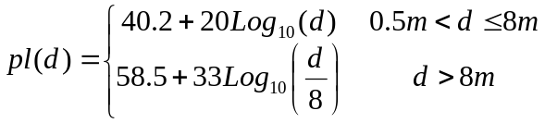

Depending on which frequency band the networks are using and what environment they are expected to be used in you may use the appropriate path loss model. The path loss formula is plotted in Figure 2.

By knowing the transmission power of the signal and the distance between nodes in the affected wireless network one can calculate the receive power.

Similarly given the transmission power of the interferer one can calculate the interference power at the affected wireless network.

Using the geometry of Figure 1 we have the following formula for the signal to interference ratio (SIR) in dB, at the station located at the origin,

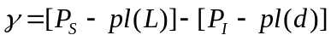

Where γ is the signal to interference ratio (SIR) in dB. The transmit signal power is given by P_{S} in dB. The interferer transmit power is given by P_{I} in dB. The distance between the two nodes in the affected wireless network is L and the distance between the two nodes in the interfering wireless network is d. In the above formula it is assumed that only the node in the interfering wireless network closest to the origin impacts the affected wireless network. This could be extended to include the impact of both nodes in the interfering wireless network, in which case there would be different values of the signal to interference ratio based on which node in the interfering wireless network is transmitting.

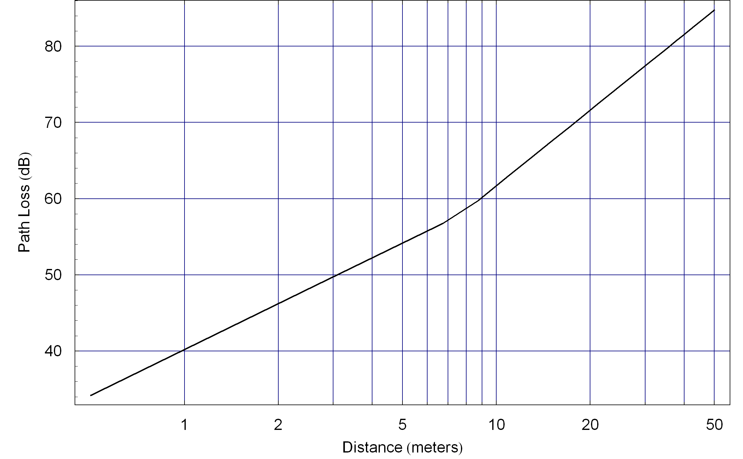

Figure 2 : Path Loss Function

PHY Layer Model

The purpose of the PHY layer model is to calculate the symbol error rate (SER) on the affected wireless network as a function of the signal to interference ratio. If binary forward error correction (FEC) is used then it may not be practical to determine the SER since the error correction is performed at the bit level. Then the PHY layer model calculates the bit error rate after FEC.

In this model it is assumed that the interference is continuous. The temporal model takes into effect the dynamic nature of the interferer.

In the geometric model shown in Figure 1 it is assumed that the packets sent from the station at the origin to the station at location (0, L) are not affected by the interference, and hence have zero (or negligibly small) symbol error rate (SER). So we are only concerned about the SER in packets transmitted from the station at location (0, L) to the station at the origin.

Most wireless packets have a structure as shown in Figure 3, where there is a preamble followed by data.

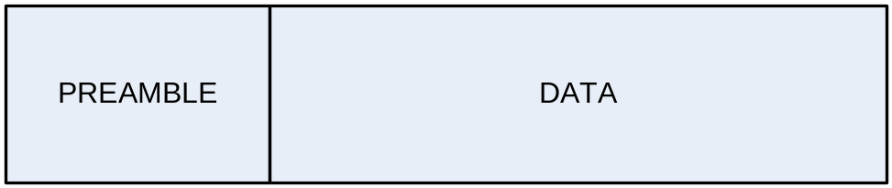

Figure 3 : General Structure of a Wireless Packet

In most designs the preamble is short and transmitted at a different modulation and coding rate than the data, so that the performance of the transmission is generally limited by the performance of the data portion of the packet. This is somewhat true when considering interference, but not always true. At low SIR the errors typically occur in the data portion of the packet, so it is reasonable to ignore errors in the preamble. At higher SIR there are also errors in the preamble and if the interference only collides with the preamble it would be a mistake to ignore the preamble. In this simplified model we will treat the packet as one homogeneous object to avoid complications. The model could be extended to address the different levels of robustness of the preamble and the data; however, it is not clear that added complexity of the model would lead to dramatically different results. The most conservative approach is to treat the packet as a single homogenous object whose length is the total length of the preamble and the data and whose modulation and coding is the same as the data. This approach is accurate at low SIR, where the data is sent a modulation and code rate comparable to that used in the preamble. A less conservative approach is to ignore the presence of the preamble entirely and only consider errors in the data section. This approach is accurate at high SIR, where the data is sent using a higher order modulation and higher code rate, so the preamble is much more robust than the data.

Figure 4 illustrates the structure of the packet that will be assumed in this model. It consists of a sequence of symbols of equal duration. This is typical of the data section of a packet. The length can be extended to approximately include the effect of the preamble.

The packet consists of N symbols each of duration T. It is assumed that these symbols are sent using a common modulation and code rate.

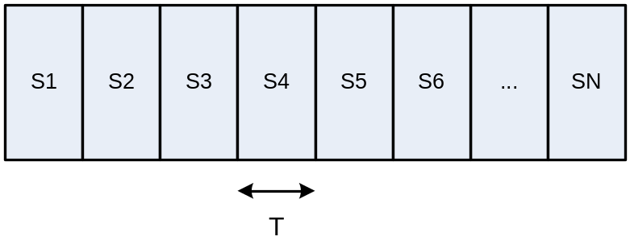
Figure 4 : Packet Structure

The PHY model assumes that this packet is received by the station at the origin in the geometric model and that continuous interference is received simultaneously.

The PHY model gives an expression for the symbol error rate. Let us introduce a little notation. Let SE be the event that there is a symbol error. Then the symbol error rate is defined as the probability of this event,

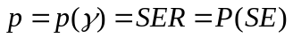

Since this SER will be used frequently we also call it p. It is a function of the SIR but often we will suppress the argument of γ to simplify the notation.

If binary FEC is used it may be more practical to calculate the bit error rate (BER) after FEC. We define the BER after FEC as,

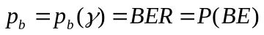

First order PHY Model
The simplest approach that can be used to develop a formula for the symbol error rate is to use an additive white noise approximation. This may be a good approximation in cases of wideband noise and not such a good approximation in other cases. If there is reason to believe this approximation is not accurate to within several dB then a more accurate model may be needed and it is recommended that some PHY layer simulations be used to develop the SER function, as suggested in Section 8.2. In particular, if binary FEC is used then it is unlikely that an analytic expression is available for the symbol error rate or bit error rate. Hence a simulation-based approach should be used.

In this approach one starts with the symbol-error-rate (SER) function that assumes that the noise source is additive white Gaussian noise (AWGN). So it is only necessary to find the proper conversion so we can use a formula that is based on a signal-to-noise ratio represented as E_{S}/N₀, when we are given the SIR.

The fundamental principal of this approach is to equate the interference power in the receiver, after the receive filter, with the equivalent noise power after the receive filter.

We need to relate the signal energy in a symbol with the symbol power. This relationship is given by,
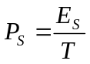
Next let us look at the noise power after the receive filter. The power spectral density of the noise is N₀/2 for all frequencies. For a symbol period of T the noise equivalent bandwidth of the receive filter is,
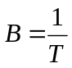

The noise power after the receiver filter is given by,

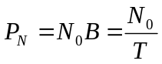

We can now express the important ratio E_{S}/N₀ in terms of the signal power and the noise power after the receiver,

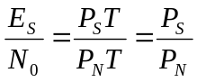

Next let us calculate the interference power after the receive filter. This depends on the bandwidth of the interferer. If the bandwidth of the interferer is less than the bandwidth of the receive filter then the power after the receive filter,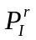, is the same as the power before the receive filter.

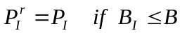

However, if the bandwidth of the interferer greater than the bandwidth of the receive filter then the power after the receive filter is scaled accordingly,

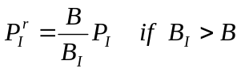

Now the final step is to replace the value of the noise power after the receive filter with the value of the interference signal after the receive filter,

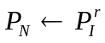
Making that substitution we get the following substitution for the important ratio, E_{S}/N₀,

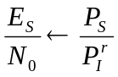

Therefore, when the interference bandwidth is less than or equal to the signal bandwidth we have the following substitution,

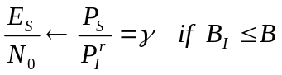

If however, the bandwidth of the interference is greater than the signal bandwidth need to scale accordingly,

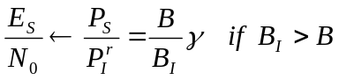

Given this substitution for E_{S}/N₀ in the SER formula using AWGN we now have a SER formula based on SIR.

Simulation based PHY Model
If the there is reason to believe that the first order PHY model would not be accurate to within several dB then it is possible to simulate the receiver in the presence of the interference and develop a series of points on a SER curve. Those points can be used to develop a formula for the SER function using a simple interpolation function.

In digital communication systems with binary forward error correction (FEC) codes it may not be practical to estimate the symbol error rate. This is because before mapping the data into symbols the information bits are converted into coded bits. When a symbol is received in error the decoder attempts to recover the information bits. Hence the appropriate metric is actually the bit error rate (BER) after FEC decoding, which we will often refer to as post-FEC BER.

In particular, if binary FEC is used then a simulation should be used to develop the BER after FEC. The values from that simulation can be used for the BER versus SIR formula. An actual formula can be fit to the data points or an interpolation can be used for value of SIR not calculated in the simulation.

Another common reason for using a simulation-based PHY model is to more easily model channel effects like multipath fading.

Temporal Model

This portion of the model converts from symbol error rate (SER) to packet error rate (PER) by considering the temporal aspect of both the affected wireless network and the interfering wireless network.

Temporal Collision
The packets sent over affected wireless network may, or may not, collide in time with the pulses coming from the interfering wireless network. And when there is a collision, part or all of the packet may collide with an interfering pulse.

illustrates a packet collision.

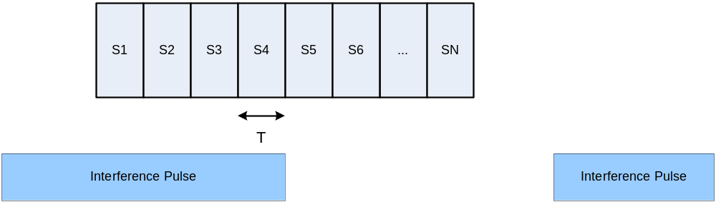

Figure 5 : Illustration of Packet Collision

You can see in this illustration that four of symbols in the packet collide with one of the interference pulses. Clearly, there are other possibilities. There are probabilities associated with the different possibilities. Those probabilities are used to calculate the symbol error rate.

Probability Calculations Utilizing on SER
This section describes how to set up the packet error rate calculations, utilizing SER. The next section shows some techniques that can be used to simplify these calculations.

Let us introduce some notation. The packet error event is called PE. The packet error rate (PER) is then the probability of this event,

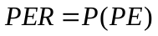

Let M be the number of symbols that collide with an interference pulse. M is a random variable with probability mass function,

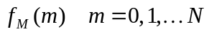

Where N is the number of symbols in the packet. By the principal of Total Probability [5] we can write,

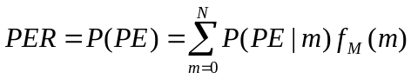

The conditional probability of not having a packet error is the probability that all the symbols are correct. So the conditional probability of a packet error is one minus the probability of no symbol errors,

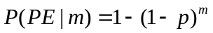
Therefore, the PER formula becomes,

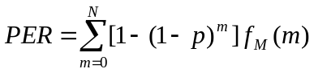

Next we need to find the probability mass function for the random variable M. This probability mass function depends on the duration of the packet, the duration of the interference pulses and the duty cycle of the interference pulses.

In many cases the probability mass function takes on a special form. We will illustrate with two cases.

CASE 1 – Packet shorter than interference pulses
Figure 6 illustrates this case. The figure shows two interference pulses of equal duration. When the packet occurs relative to the interference pulses is a random process. This figure shows three possibilities. In possibility 1 the packet collides completely with one of the interference pulses. In possibility 2 the packet does not collide with an interference pulse. And in possibility 3 the packet partially collides with the pulse. We can relate these cases to the value of colliding symbols. In possibility 1 the number of colliding symbols is N. In possibility 2 the number of colliding symbols is zero. And finally, in possibility 3 the number of colliding symbols is less than N.

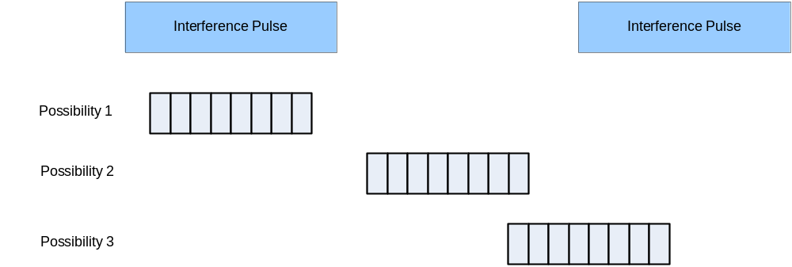

Figure 6 : Packet Collision with Packets shorter than Interference Pulses

If the pulses are of fixed duration we can see that the probability mass function will take on a special form,

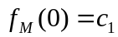

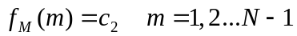

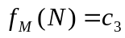

There is some probability of no collision. There is also some probability of a full collision. The interesting situation in this case is that the probability of m collisions for m between one and N-1 is constant. When this is true we can simplify our probability calculations, as will be shown in Section 9.2.

The packet error rate for this case is given by,

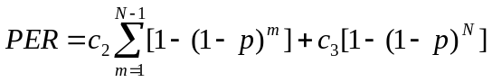

CASE 2 – Packet longer than interference pulses
Figure 7 illustrates this case. The figure shows two interference pulses of equal duration. There three cases here are slightly different. Since the packet is longer than an interference pulse there is a maximum number of symbol collisions in the packet. Let us call this number K.

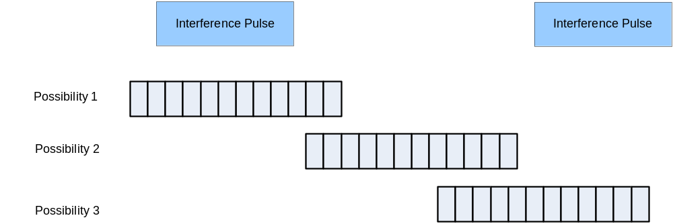

Figure 7 : Packet Collision with Packets longer than Interference Pulses

If the pulses are of fixed duration we can see that the probability mass function will take on a similar form to the previous case. The only difference is that the maximum number of symbol collisions is K not N. We can use this form for both cases, since we can let K be equal to N if appropriate.

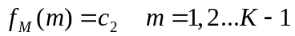

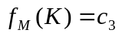

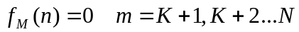

Then the packet error rate is given by,

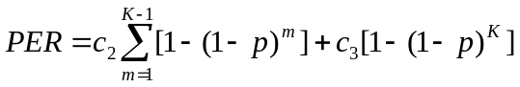

We will see in the next section that if the probability mass function is uniform over an interval of values of m we can simplify the formula for the packet error rate.

Simplification of Probability Calculations
In many of the cases there is a portion of the probability mass function that is uniform. There were two examples shown in the previous section. In this section we will show how to simplify that portion of the PER formula.

Let us focus on the term in the PER formula, which we will call α for now,

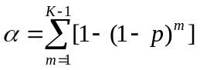

The first observation we have is that we can start the summation at m=0 since the argument of the summation is zero for m=0,

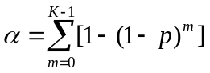

Next we can pull out the constant,
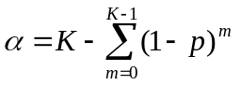

Now we can use a standard algebraic identity,

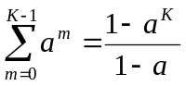

Applying this formula to alpha we get,

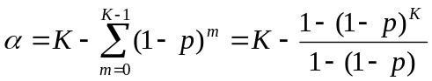

Which simplifies to,

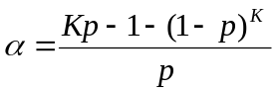

Summarizing, we have the following simplification which we can use in our PER formula,

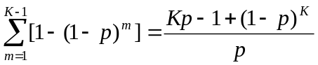

Therefore, if the PER takes on the form listed (figure out how to add equation numbers) then the PER formula becomes,

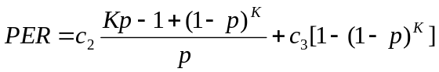

Limits of PER Formula
We can investigate the PER formula for several limits and gain insight into the properties of the PER curves under those limiting conditions. The two cases are: very small SER and very large SER.

If we let the SER tend to zero we can easily see the PER tends to zero,

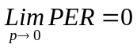

The more interesting case is when the SER gets large. Using the simplified formula for the PER we get,

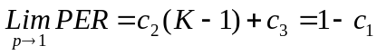

Probability Calculations Utilizing on BER

This section describes how to set up the packet error rate calculations, utilizing BER. The approach is similar to what was done using SER, however, the formulas do not simplify as nicely. However, this is the approach that is likely to be use when binary FEC is used in the design. The reason for the complexity is that pulses interfere with a group of symbols but after FEC we typically know the BER and not the SER.

Just as before we have a probability mass function for the number of symbol collisions and we use the Total Probability formula,

Recall that we are conditioning on m symbol collisions. Now since we know the post-FEC BER and not the SER the formula for the conditional PER is a little more complicated.

Let us introduce some notation. The coded bits are mapped to symbols in groups. The number of coded bits in each symbol is N_{CBPS}. The FEC has a code rate which we will call R. Then the number of information bits in each symbol is referred to as N_{BPS}. The number of information bits per symbol and the number of coded bits per symbol are related by the FEC code rate,

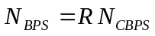

We will represent the post-FEC bit error rate as,

We need to determine conditional packet error rate using the BER instead of the SER. The number of information bits in m symbols is m N_{BPS}. The probability of no packet error conditioned on m symbol collisions is the probability that all the information bits encoded in those m symbols are correct,

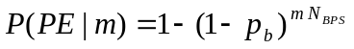

The PER is then written as,

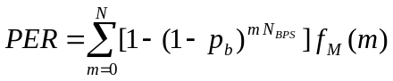

This is a similar but different expression for the PER in terms of SER. The term 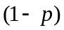 has been replaced by the term 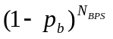.

Simplification of Probability Calculations
This section is similar to Section 9.3 where the PER formula using SER was simplified. This section simplifies the PER formula that utilizes post-FEC BER.
Just as was done with the PER formula using SER, if there is periodic interference pulses we can simplify the PER formula. Assume that the probability mass function of the number of symbol collisions take on the following format,

Then the packet error rate is given by,

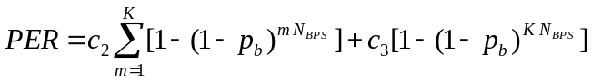

We can simplify this formula. As before we focus on the summation term,

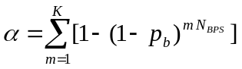

We can add in the term for m=0 without changing anything, and factor out the constant term.

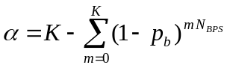

Then,

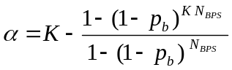

This does not simplify as well as the case when we have the SER, however, we can still write down the PER formula,

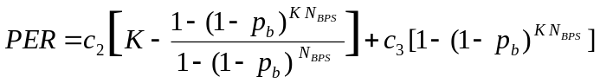

Random Pulse Model

The form of the probability mass function for the symbol collisions given previously is straightforward to compute assuming the pulses are of fixed duration with fixed spacing. If however, that is not a good model for the interference pulses then it is possible to model the pulses as a stochastic process of varying pulse duration and varying spacing.

If one cannot analytically calculate the probability mass function for the number of symbol collisions then a short simulation can be developed to estimate the probability mass function. Then that PMF can be utilized in the formula for the PER. It may not be possible to use the simplifications from Section 9.3; however, the general formula for the PER using total probability still applied and does not require extensive computation time to evaluate.

Calculation of Performance Metrics
There are many possible performance metrics that may be impacted by interference and the exact selection of which performance metrics to focus on depends upon which applications are running on the affected wireless network.

In this section we will describe a method of estimating the impact on throughput and latency using our estimate of the packet error rate.

The throughput is the average number of bits per second transported over the link in the affected wireless network. Since that depends on the detail of that network let us define TP₀ as the base throughput without any interference present. Then the throughput with interference present is the original throughput times the probability of each packet going though correctly. Therefore, the throughput is given by,

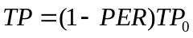

The latency is the average time it takes for a message to be transferred from one station in the affected wireless network to the other node. Just like for throughput the exact value of the latency depends on the details of the network. So similarly to what we did for throughput let us define the latency without any interference as τ₀. The latency with interference is the latency without interference divided by the probability that a packet will be received correctly. Hence the latency with interference is given by,

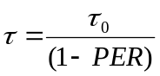

A similar approach can be taken with other performance parameters. However, in most cases showing the impact of interference on the packet error rate, the throughput and the latency is often sufficient.

Examples
The examples given here are chosen to illustrate the process. They are not specific standard but rather simple examples that can be used to explain how the methodology works.

The first example is a binary phase shift keying (BPSK) system with interference pulses of the same duration as the BPSK packets.

The second example is an extension of the first example, where the modulation is extended to use higher order quadrature amplitude modulation (QAM), where the number of bits in the packet remains the same. This demonstrates two effects: the effect of using a higher order modulation requiring higher signal-to-interference ratio and the effect of shorter packets leading to lower probability of collision.

Example 1 – BPSK with Periodic Interference Pulses
This example consists of two wireless networks, each with two stations. The geometric model is that given in Figure 1, with the distance between stations in the affected wireless network is L = 30 meters. In this example, the affected wireless network is a WLAN-type network with one access point and one mobile station. It is assumed that the station at the origin is the mobile station and the other station is the access point. The interfering wireless network is a WPAN-type network with two mobile stations. We will use the simplifying assumption that only the network closes to the origin has any appreciable interference on the affected wireless network. Similarly, it is assumed that the only station in affected wireless network that is affected by the interference is the station at the origin.

In this example the affected wireless network is transmitting at 20 dBm using binary phase shift keying (BPSK). Each packet contains 128 Kbytes or 1024 bits. The packets are being transmitted from the AP to the mobile station at the origin. It is assumed that the acknowledgements sent from the mobile unit to the AP arrive unaffected by the interference due to distances involved.

The interfering wireless network is a WPAN-type network which transmits at 0 dBm. The interference wireless network is transmitting pulses of duration exactly the same as the packets sent by the affected wireless network. We will only consider pulses sent by the station closest to the origin, and will assume that any pulses sent by the other station do not cause significant interference. We will assume that the pulses are sent at regular intervals with a 25% duty cycle. Figure 8 illustrates the timing of this example.

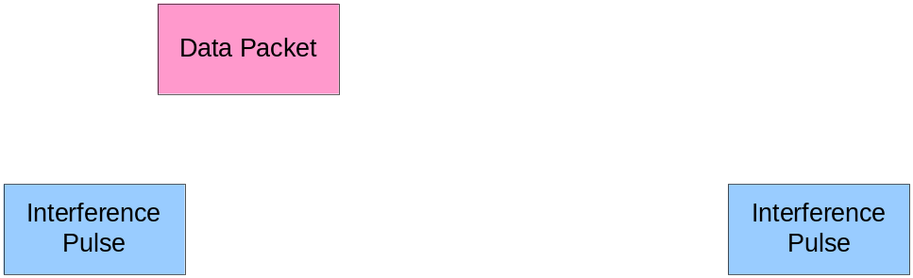

Figure 8 : Timing of Packets and Interference Pulses in Example 1

In this example we assume that we have co-channel interference with the same bandwidth (or smaller) than the bandwidth of the signal. So we can set the SIR to be equal to the SNR in the formula for the symbol error rate of BPSK. The SER formula for BPSK obtained from any digital communication book is [6],

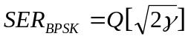

Where the Q function is the integral of the tail of a normalized Gaussian probability density function,
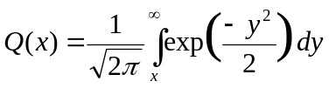

The BPSK symbol error rate is plotted in Figure 9 as a function of the SIR.

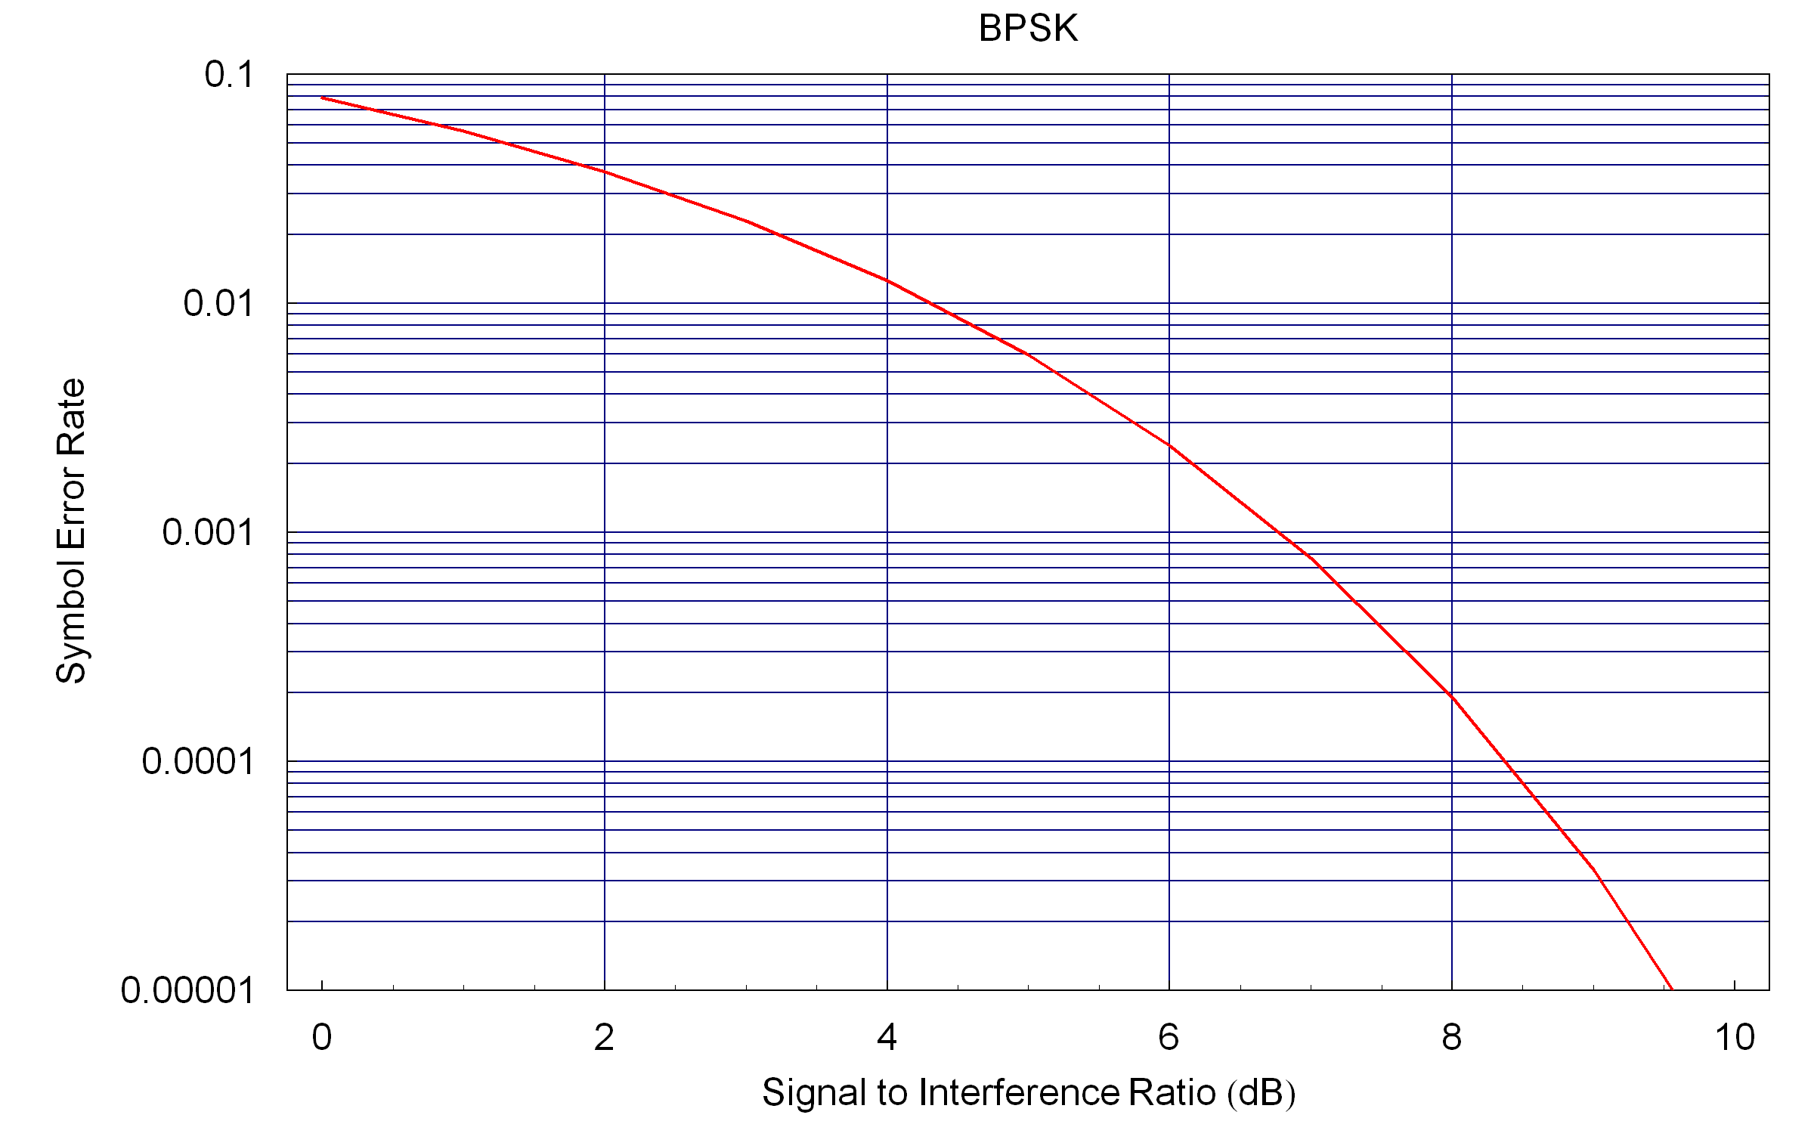

Figure 9 : BPSK Symbol Error Rate

The symbol error rate must be converted into packet error rate using the Total Probability expression, which requires the probability mass function for the number of symbol collisions. The duration of the packet is 1024T, where T is the symbol period. The duration of the interference pulse is also 1024T. The spacing between pulses is 3072T, since there is a 25% duty cycle. We need the probability mass function of the number of symbol collisions (M), which takes on values between zero and 1024.

It is easiest to use the discrete time reference and allow the packet to begin on any one of 4096 possible offsets from the beginning of a pulse. This assumes a uniform distribution of when the packet can occur, which is a reasonable assumption.

The probability of all 1024 symbols colliding is one in 4096 so we have,

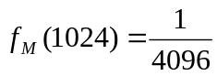

The probability of collision for other non-zero values turns out to be twice that value. This can be seen by shifting one symbol to the right and one symbol to the left, which both result in a collision of 1023 symbols. So we have,

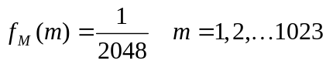

And that leave the probability of no symbol collisions as what is remaining. Thus the probability of no collision is,

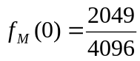

If we substitute these values into the calculation we developed in Section 9.2 we get,

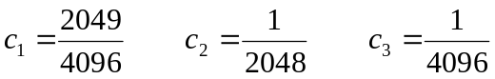

The resulting PER formula is,

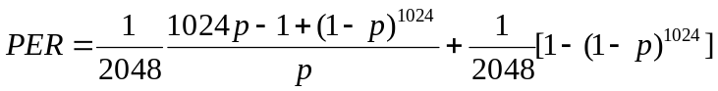

We then apply the path loss formula given in Section 7, use the power calculations to calculate the SER (p) and substitute this into the formula for the PER. Figure 10 shows the resulting PER curve for this example.

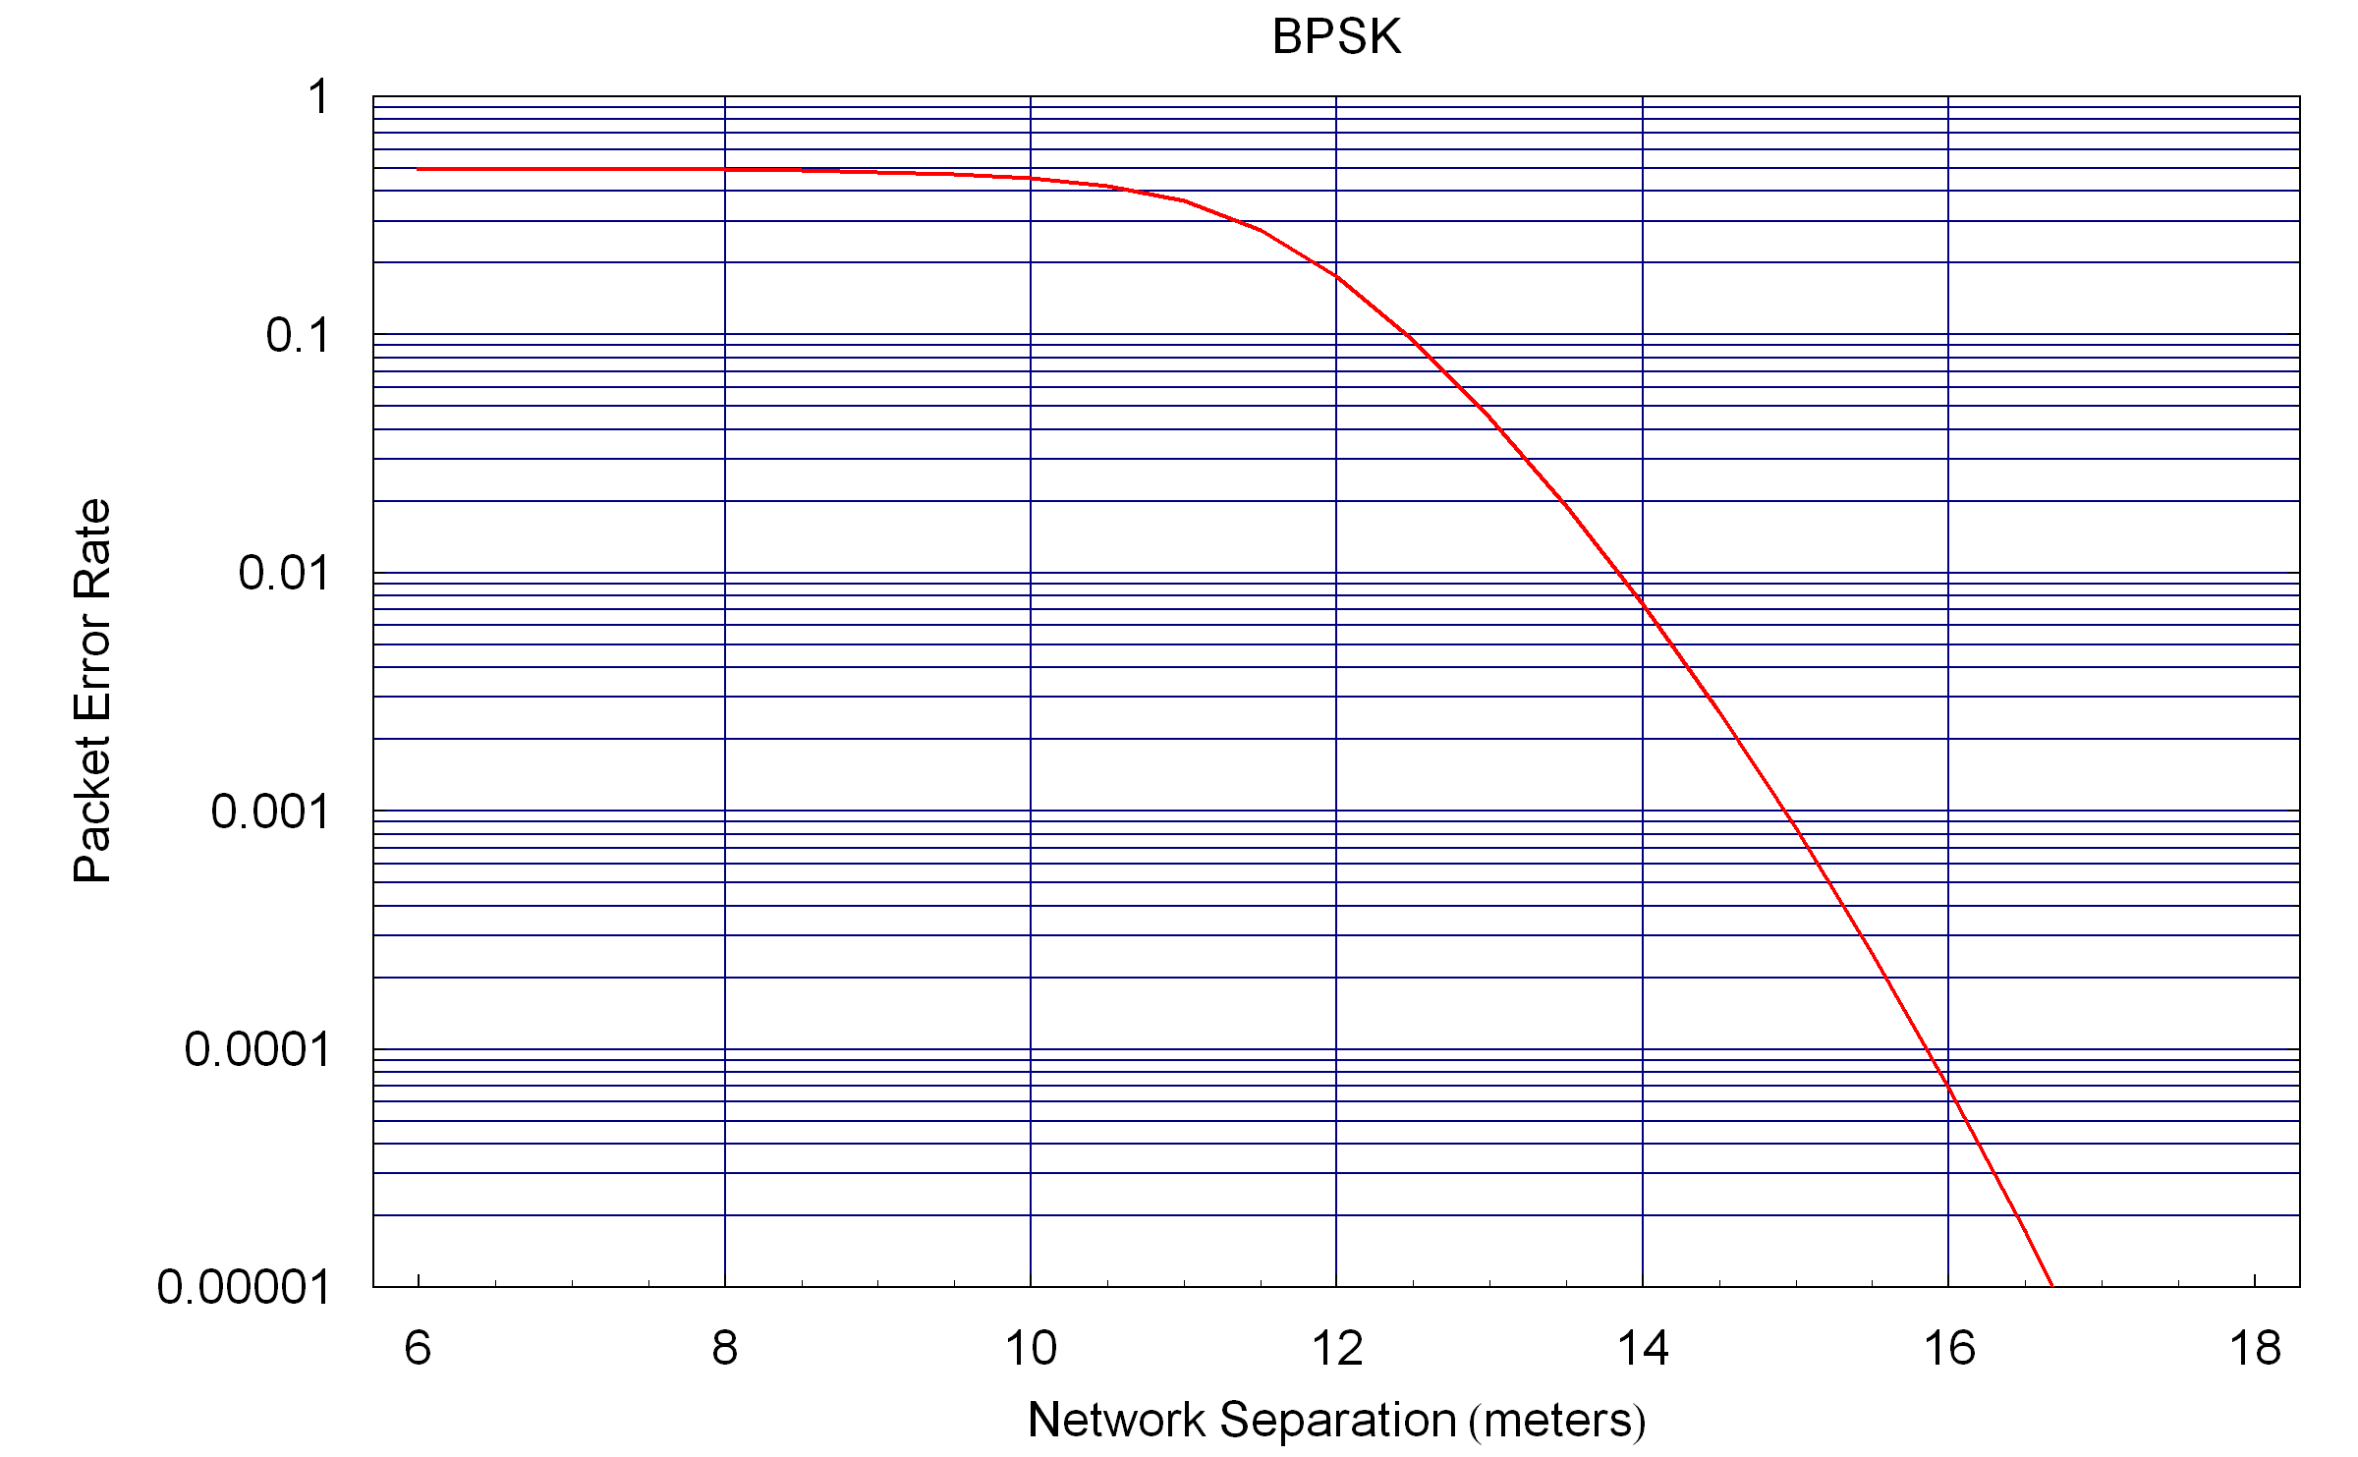

Figure 10 : PER Curve for Example 1

From this example we can observe that at large separation there is low PER, as would be expected. As the separation is reduced the PER grow and finally reaches a limit. This suggests two interesting figures of merit. How close the networks can get before the PER starts to become significant (which is a matter of opinion and application) and the maximum PER as the networks get very close. These two parameters are illustrated in Figure 11.

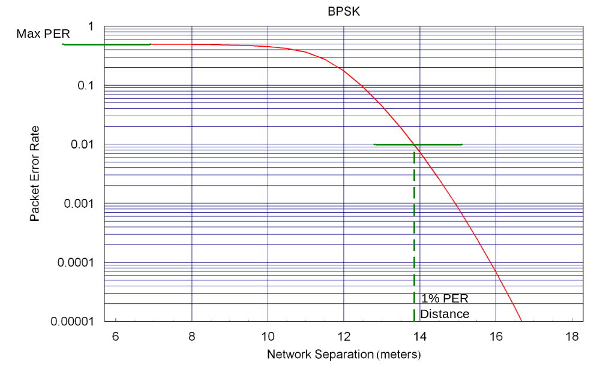
Figure 11 : Illustration of Coexistence Figures of Merit

Based on this illustration we would suggest two coexistence figures of merit, for this scenario. One would be the separation between networks at which point there is a 1% PER. The other would be the maximum PER. We can derive the maximum PER using the limiting formula for the PER. In this example we get,

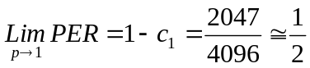

The PER curves can be used to calculate the impact of interference on throughput and latency. The exact values of throughput and latency depend on the application and so in this example we will normalize the throughput and latency, which corresponds to setting the throughput and latency without interference equal to unity. So we have TP₀ = 1 and τ₀ = 1.

The plots of the normalized throughput and latency for this example are shown in Figure 12 and Figure 13, respectively.

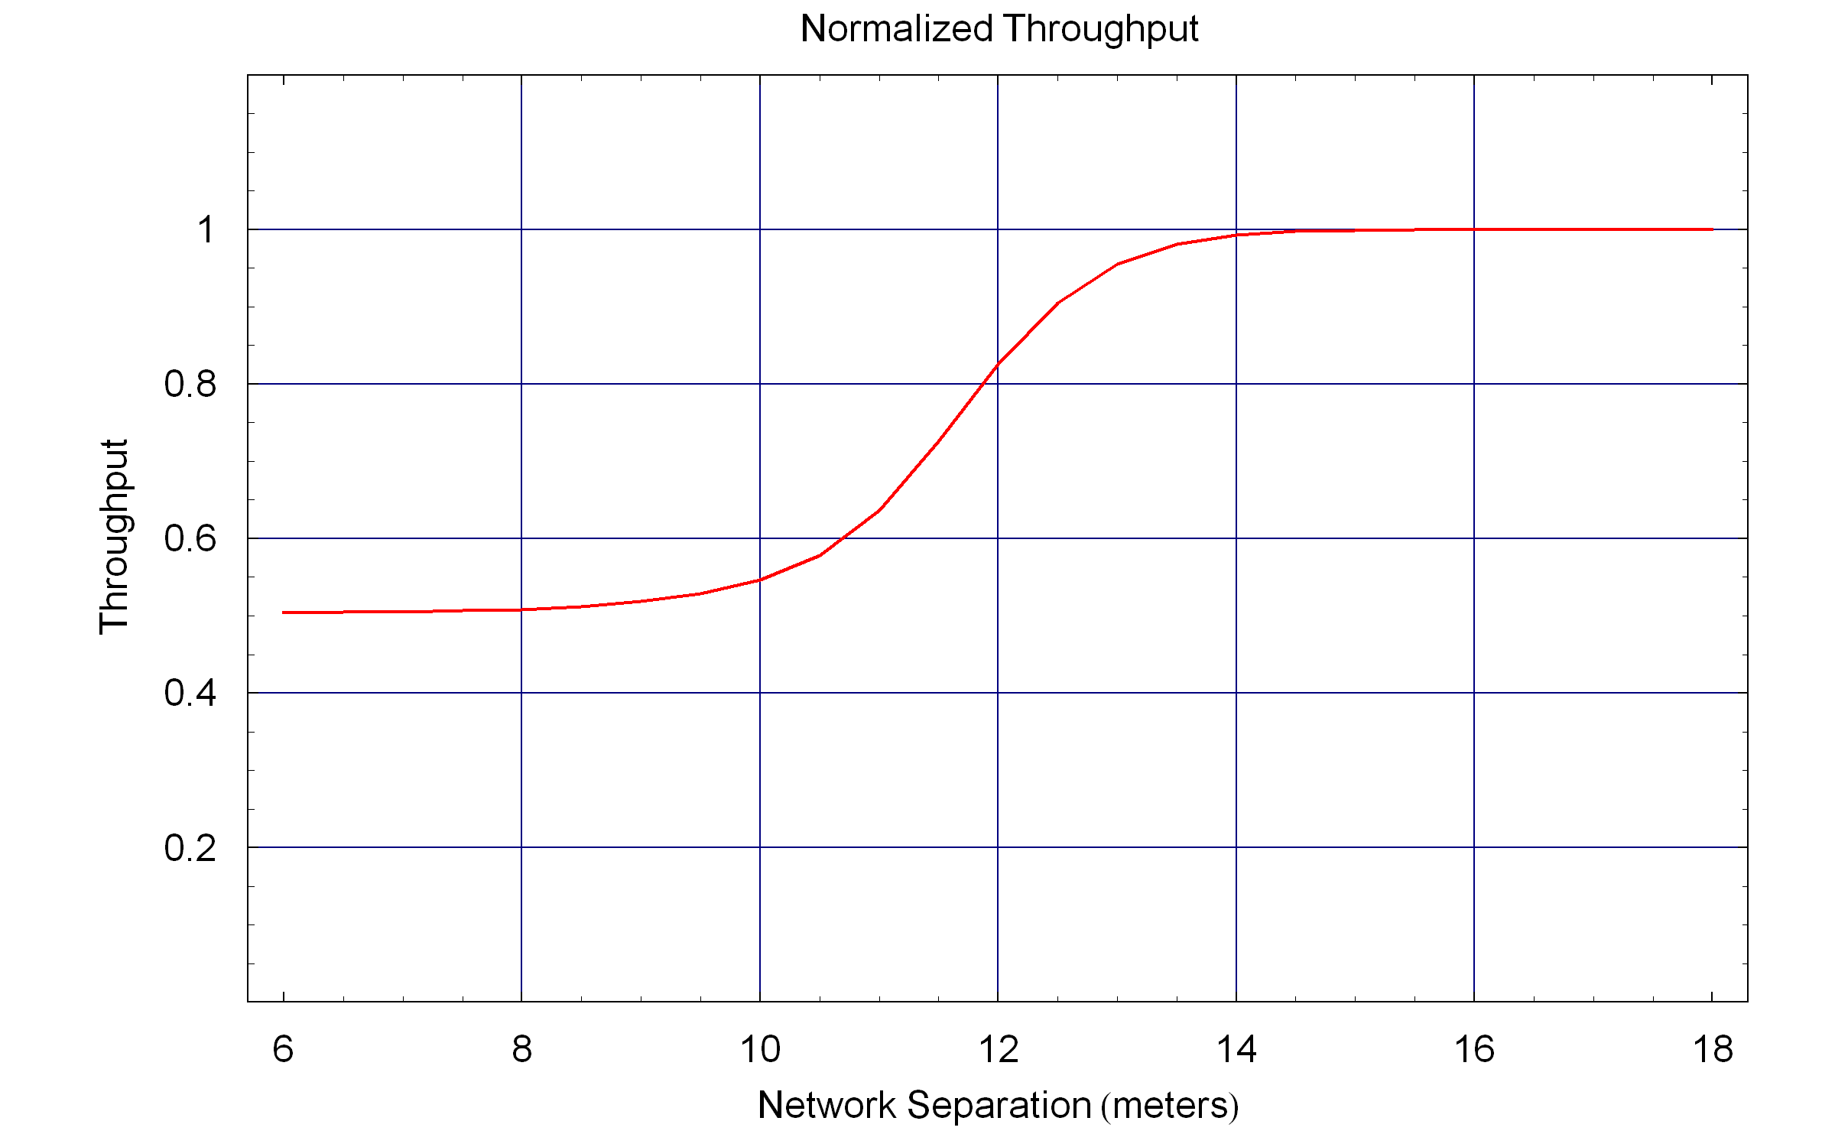

Figure 12 : Throughput Curve for Example 1

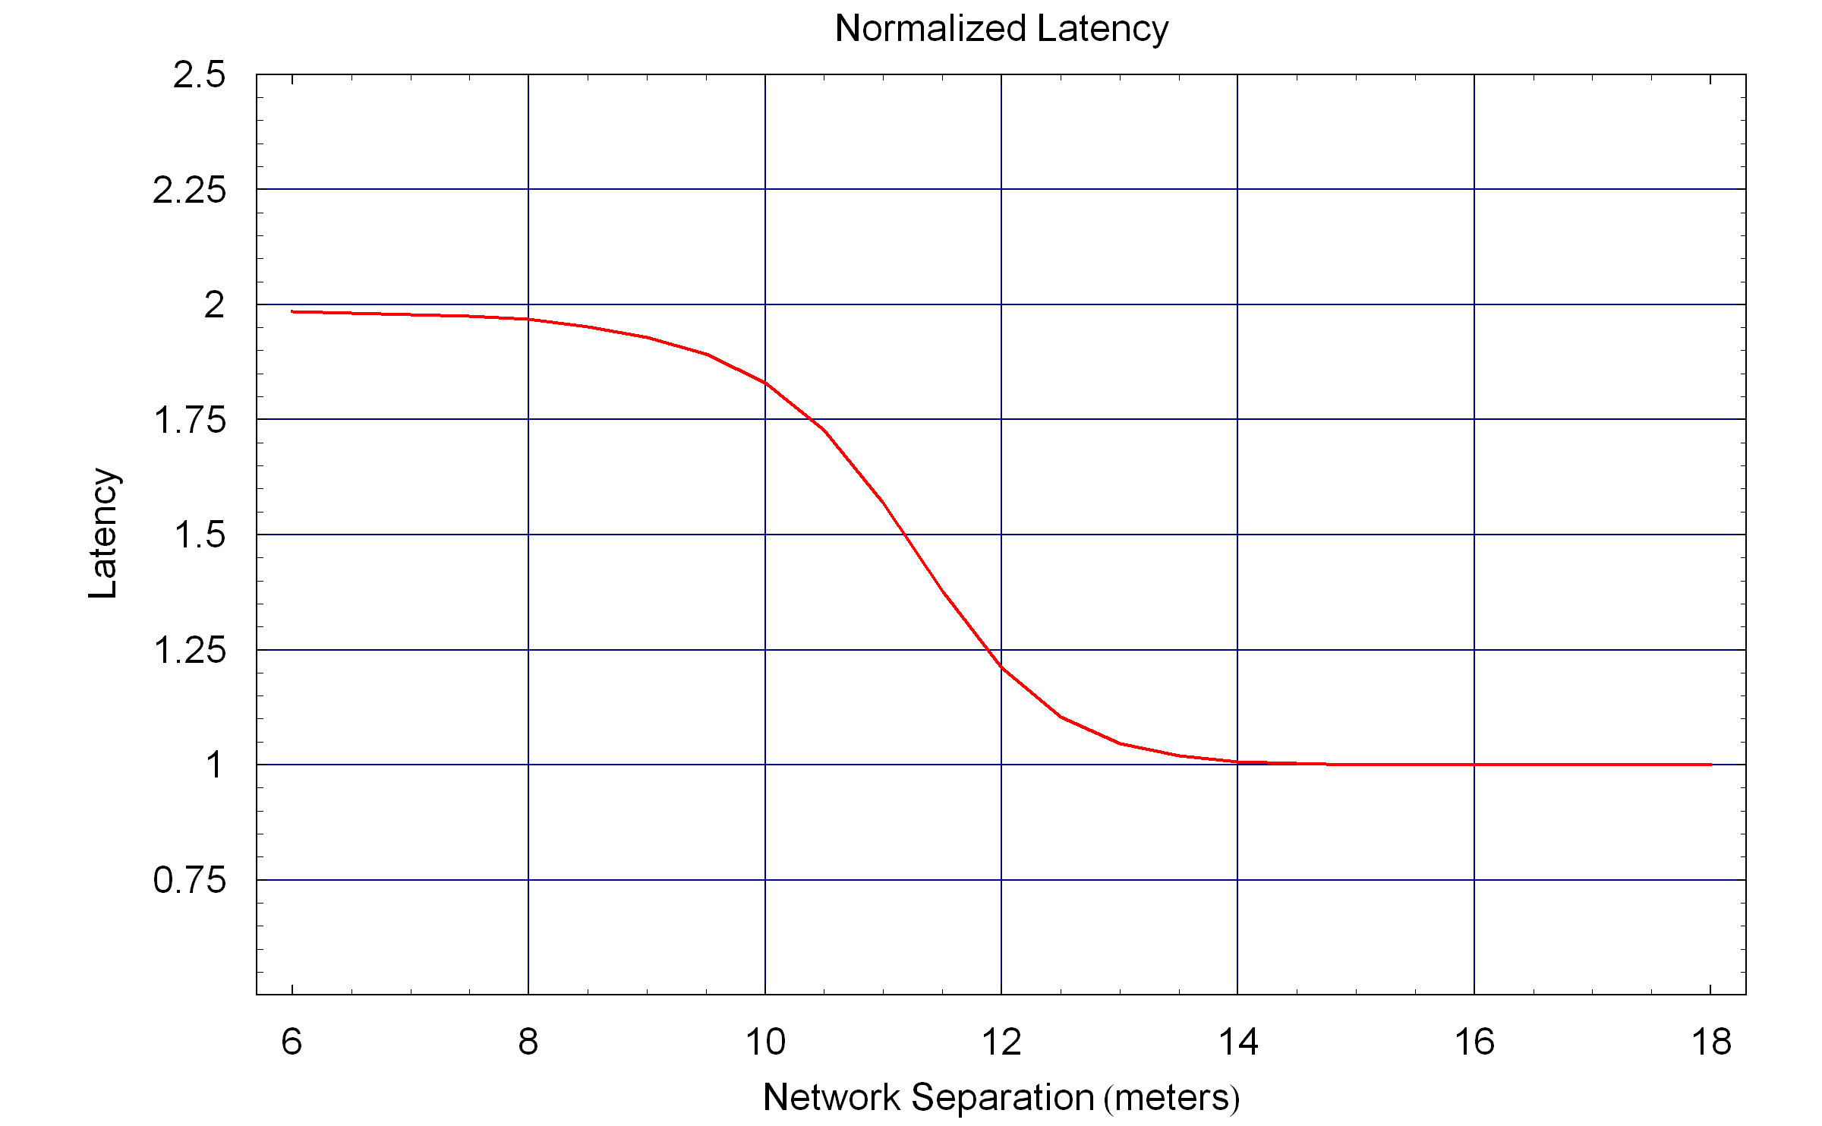

Figure 13 : Latency Curve for Example 1

Example 2 – QAM with Periodic Interference Pulses
This example is an extension of the previous example, where we include higher order quadrature amplitude modulation (QAM). In addition to BPSK we include quadrature phase shift keying (QBSK), QAM with 16 symbols (16QAM) and QAM with 64 symbols (64QAM). We can find the symbol error rate formula in a communication book [6].

The symbol error rate formula for the QPSK is,

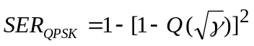

The symbol error rate formula for the 16QAM is,

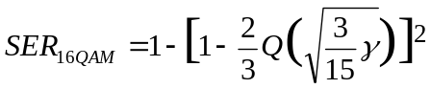

The symbol error rate formula for the 64QAM is,

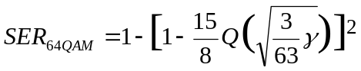

The SER curves for the four modulations used in this example are given in Figure 14,

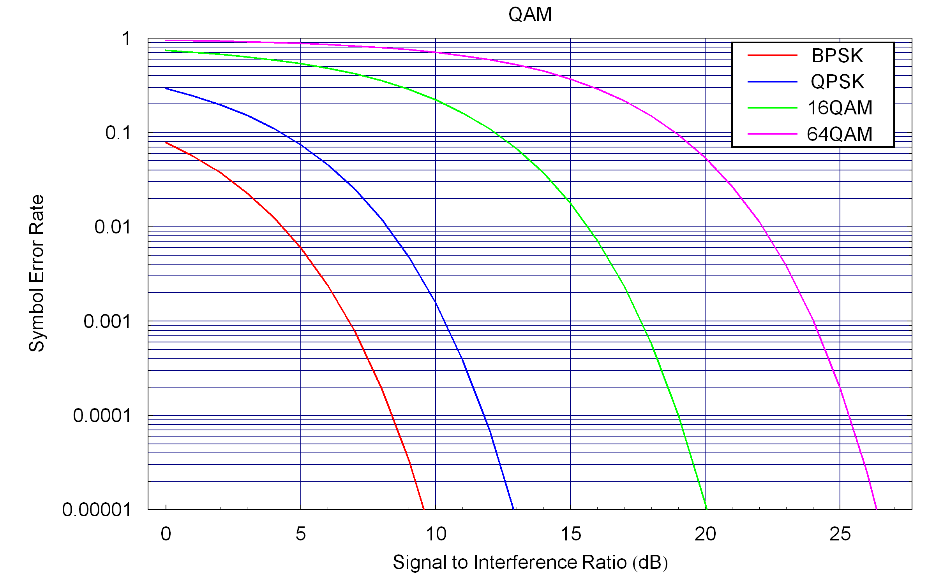

Figure 14 : SER for BPSK, QPSK, 16QAM and 64QAM

To convert from SER to PER we need the probability mass function of the number of symbol collisions. We will show how to derive the PMF for the QPSK packet. The extension to the 16QAM and 64QAM is straightforward.

In this example, we fix the number of bits in the packet at 128 Kbytes, so as we increase the modulation order the number of symbols decreases. For QPSK there are 512 symbols. Figure 15 illustrates the timing for QPSK in this example.

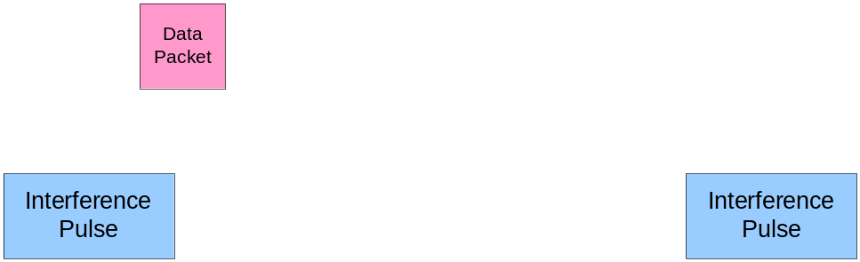

Figure 15 : Timing of Packets and Interference Pulses in Example 2 for QPSK

In this case of QPSK with 512 symbols, of the 4096 possible offset there are 513 that result in all 512 symbols colliding with the interference pulse, therefore we have,

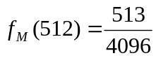

For m equal to any number between one and 511, of the 4096 offsets there are two possible cases of m symbol collisions, therefore we have,

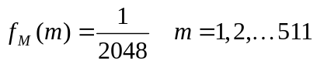

Finally, by knowing these values of the PMF we can find out the value at m=0, so we have,

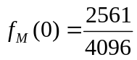

The same process can be applied to the 16QAM which has 256 symbols and 64QAM which has 128 symbols.
The resulting PER curves for all four modulations is show in Figure 16.

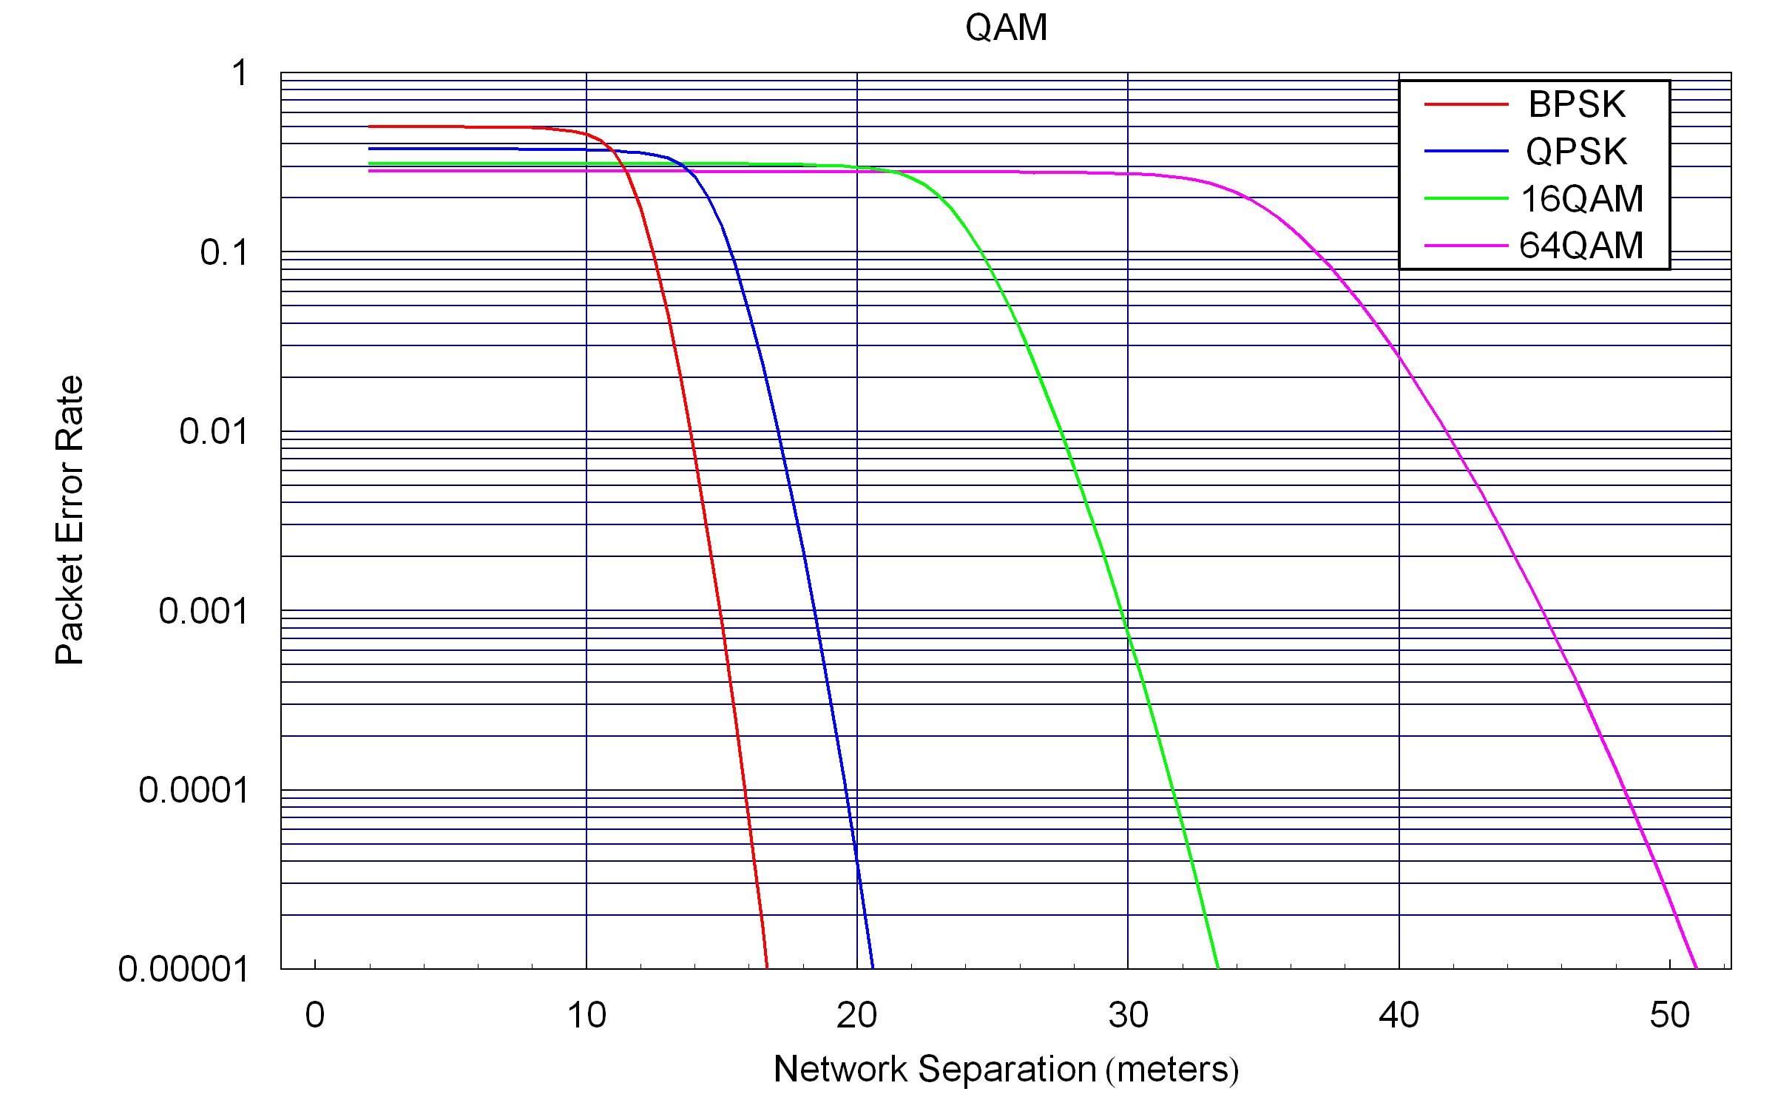

Figure 16 : PER Curve for Example 2

From this figure we can see that as we use higher order modulation the distance at which the interference has an impact is larger. However, in this example since we kept the number of bytes in the packet fixed, the duration of the packet decreased. This results in a lower value for the maximum PER value.

The two proposed figures of merit (1% PER distance and Max PER) are listed in Table 1 for the four cases.

 | 1% PER Distance (meters) | Maximum PER
BPSK | 13.8 | 0.499
QPSK | 17.1 | 0.374
16QAM | 27.5 | 0.312
64QAM | 41.7 | 0.281

Table 1: Figures of Merit for Example 2

The plots for the normalized throughput and latency are shown in Figure 17 and Figure 18, respectively.

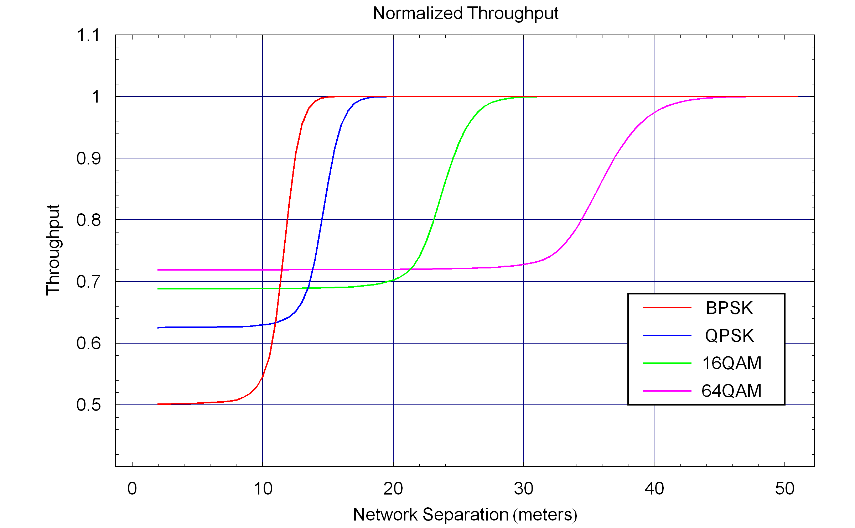

Figure 17 : Throughput Curve for Example 2

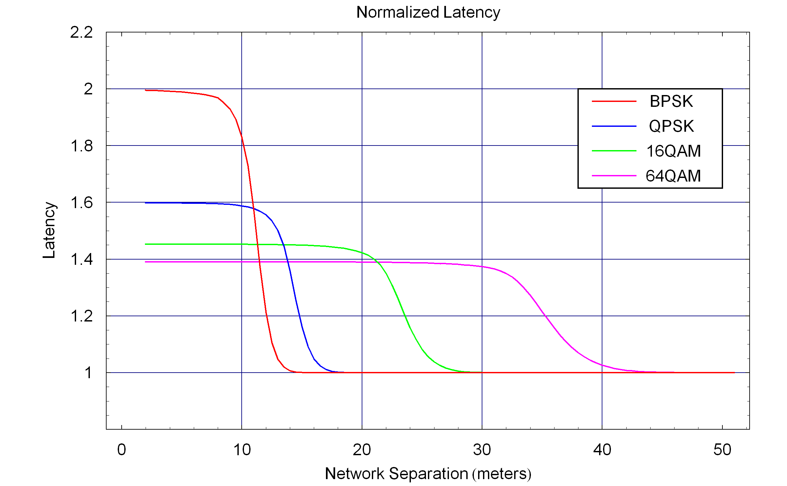
Figure 18 : Latency Curve for Example 2

Example 3 – BPSK with Random Interference Pulses
This example is similar to Example 1 using BPSK but instead of using fixed interference pulse durations and pulse separation the pulse duration and separation are random variables. In order to enable comparison with example the average value of these two random variables are selected to be the same as the fixed values in Example 1.

The pulse width is a uniform random variable between 512T and 1536T. The spacing between pulses is uniformly distributed between 2048T and 4096T. Hence the average pulse duration is 1024T and the average spacing between pulses is 3072T, just as in Example 1.

For this example the probability mass function of the number of symbol collisions, M, was determined through simulation. The cumulative distribution function was calculated based on the PMF. This was also done though simulation for Example 1 and the results were consistent with the theoretical values.

The cumulative distribution function for the number of symbol collisions is plotted in Figure 19 for both Example 1 and Example 3. You can see that the CDF of the two examples are similar but with some differences.

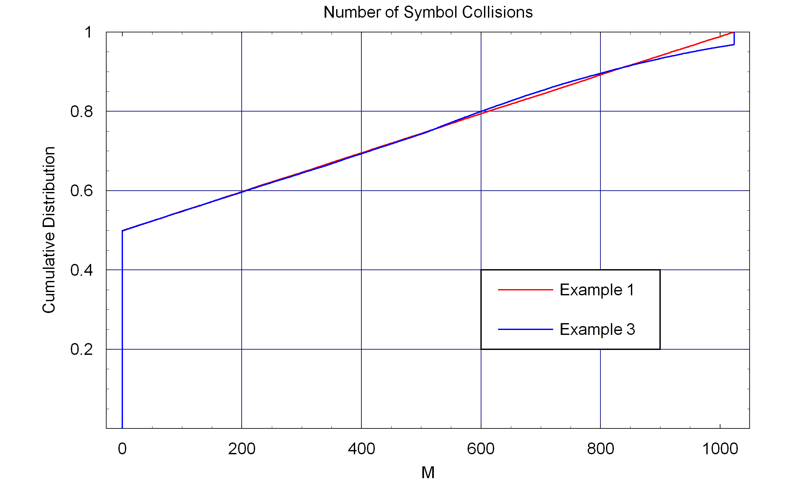

Figure 19 : Cumulative Distribution Function for Number of Symbol Collisions

Since the CDF for these two examples are similar we expect the PER curve to be similar. The PER curves for both examples are shown in Figure 20. We see that the two curves are almost identical. This gives us an indication that in many cases we can use the periodic model and the resulting PER curve will not differ significantly from the random model.

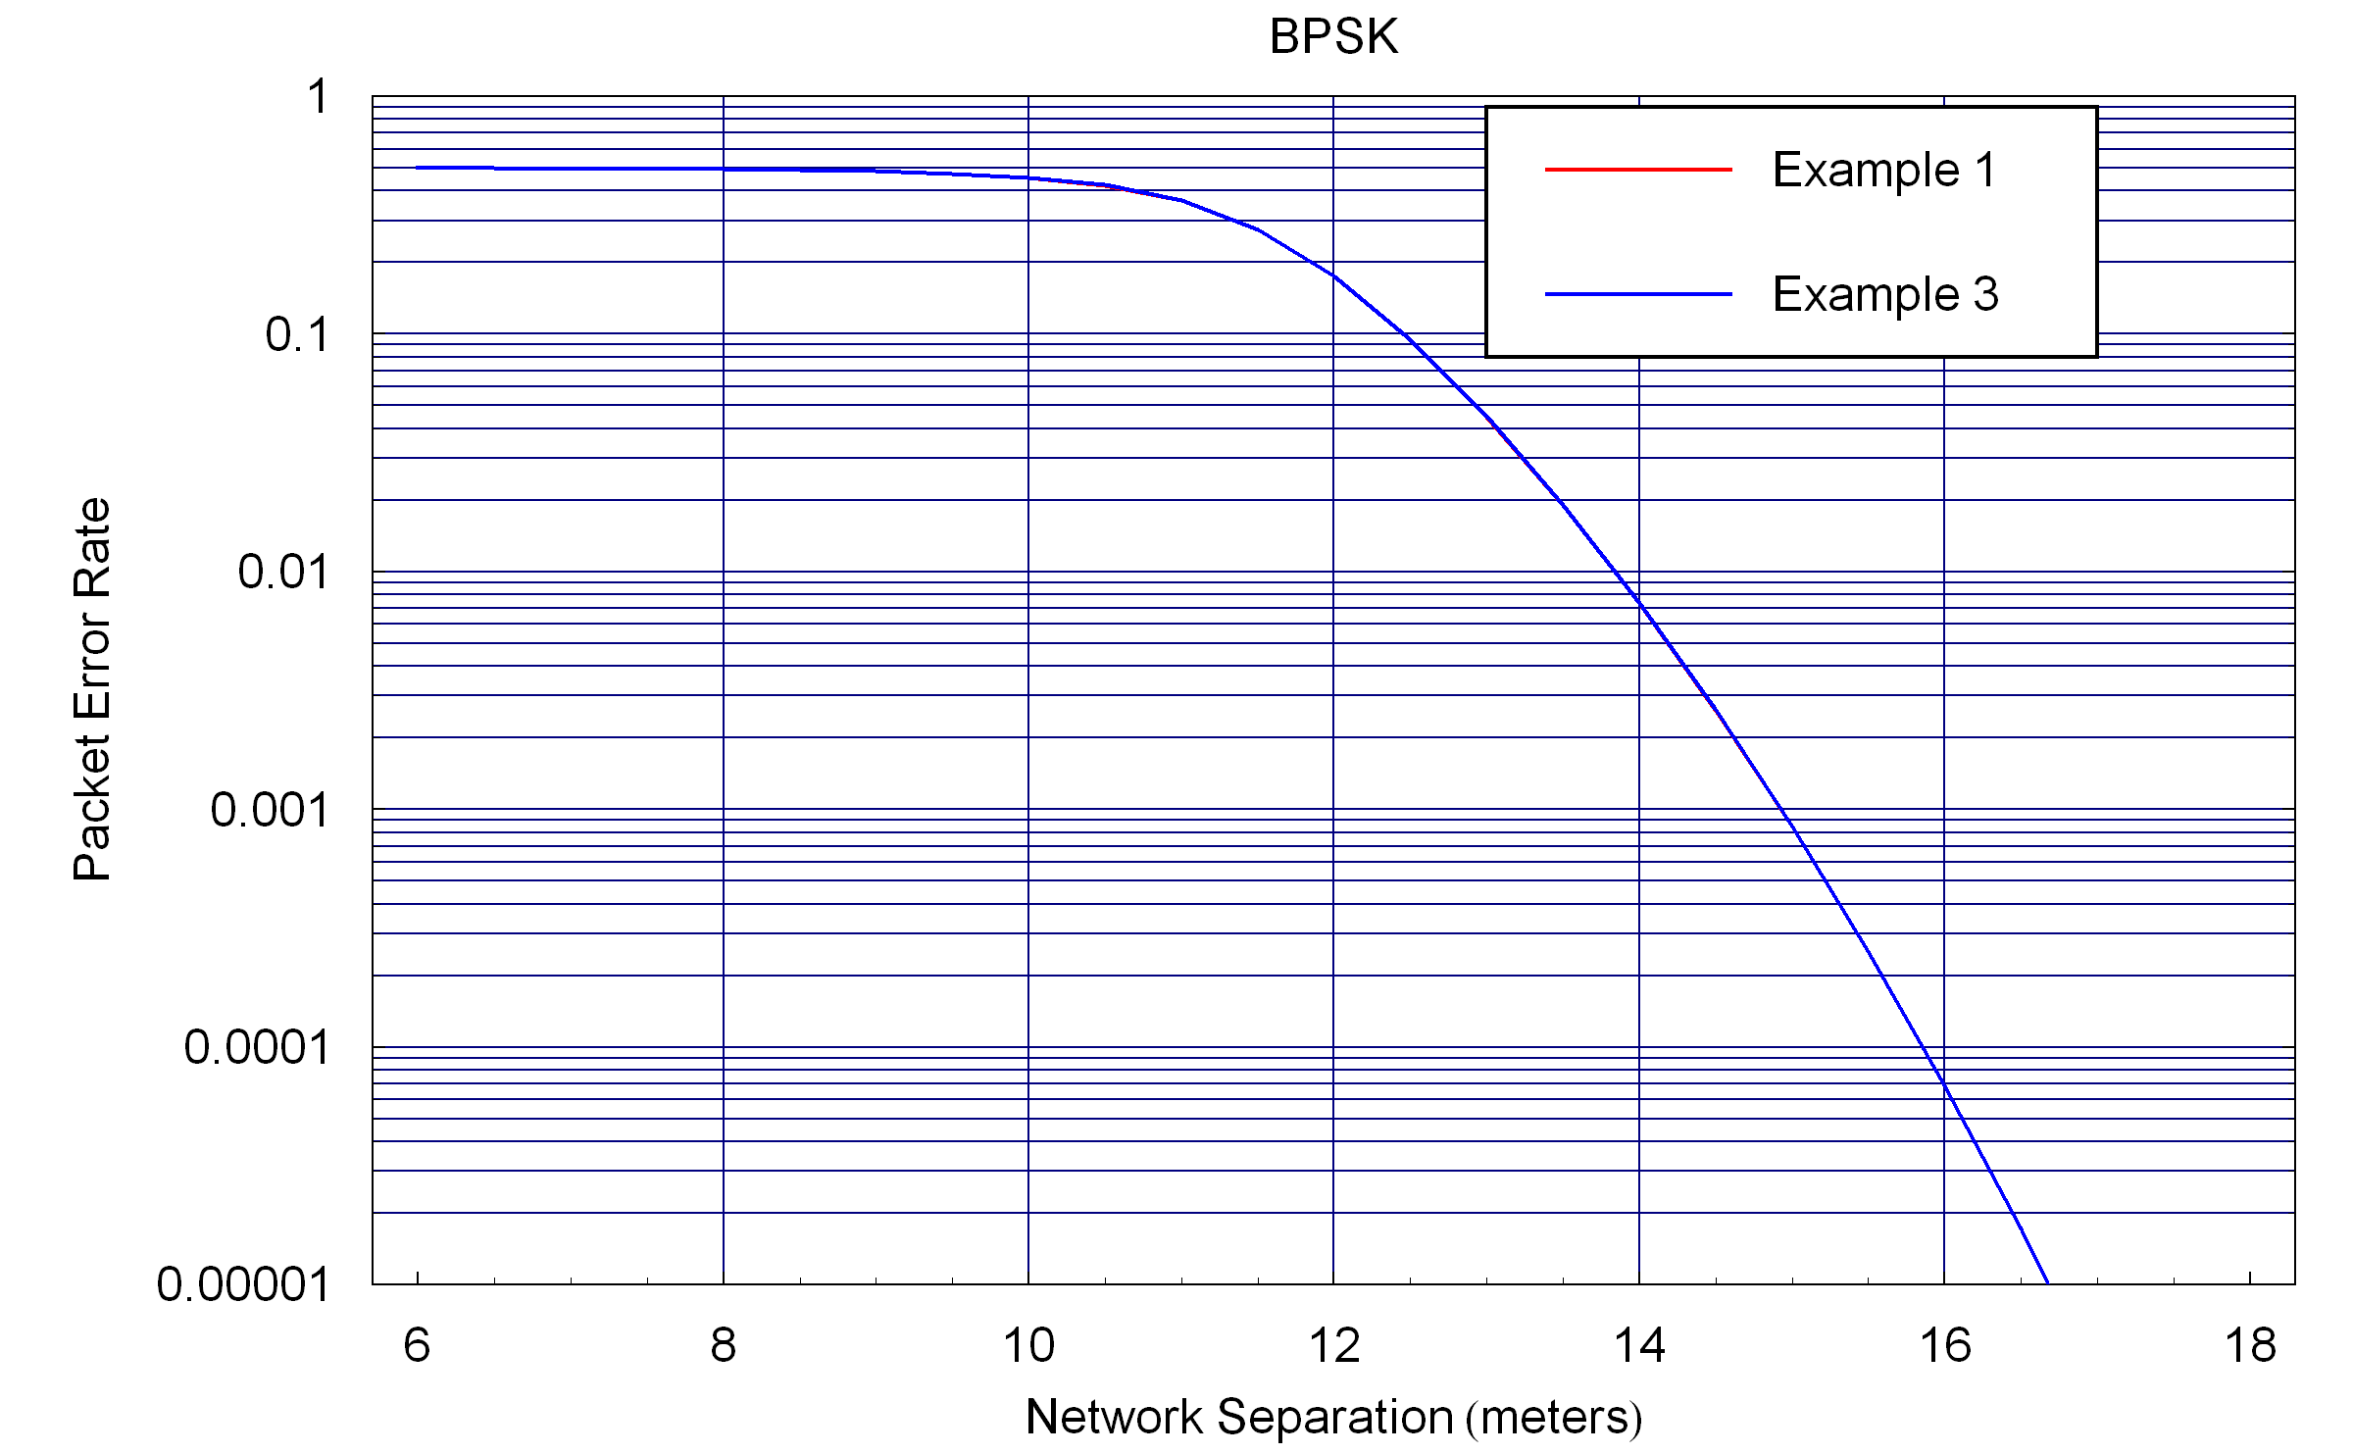

Figure 20 : Cumulative Distribution Function for Number of Symbol Collisions

Step by Step Summary of the Model
This section summarizes the steps used in estimating the PER and other performance metrics due to interference.

Step 1 – Select a Geometric Model
The first step is to select a geometric model of the two wireless networks. This consists of selecting the number of stations in both the affected wireless network and the interfering wireless network. It also involves selecting the locations of all the stations. It is recommended that if there is one primary station in the affected wireless network that is the station primarily impacted by the interference that this station be placed at the origin. Also in selecting the locations of the stations you are deciding how many stations are impacted by interference and similarly how many stations in the interfering wireless network transmit pulses that may cause measurable interference. There should be one station (or possibly several stations) in the interfering wireless network whose location varies so that the effect of distance between that station and the station primarily affected by the interference can be observed.

Also, there is where any direction antenna aspects need to be considered. Is the transmission from the stations omni-directional or is the gain directionally dependent.

Step 2 – Select a Path Loss Model
Then a path loss model is selected. There is likely a path loss model that has already been considered in the development of the proposed standard under development.

Step 3 – Develop Symbol Error Rate Formula
The next step is to develop a formula for the symbol error rate as a function of the signal-to-interference ratio. This is where the modulation and coding of the affected wireless network are considered. Also, one must consider the bandwidth of the interference relative to the bandwidth of the signal. One needs to consider if the interference is co-channel with the signal or adjacent channel.

There are two basic approaches that can be used in this step. If an analytic expression is available that can be applied then the expression can be used taking into account signal and interference bandwidths. However, in more complex systems it is unlikely an analytic expression is available. But often simulations are available since they are often developed when developing a standard. Using this simulation develop a table for the SER versus the SIR. That table can be converted into an expression for the SER using interpolation of table values as needed.

Step 4 – Develop Temporal Model
The next step is to develop a temporal model of both the affected wireless network and the interfering wireless network.

For the affected wireless network you need to determine the symbol duration and number of symbols in a packet. These parameters may depend on the selection of the modulation and code rate as well as the number of information bits embedded in the packet.

For the interfering wireless network you need to select the duration of the interference pulse. This duration may be a fixed number of a random variable. You also need to select the separation between pulses, which may also be a fixed number or a random variable.

It is simplest to normalize all the durations to multiples of the symbol period. Then all the durations are integer multiples of the symbol period, which simplifies the subsequent analysis.

Step 5 – Develop Packet Error Rate Formula
From the temporal model you then determine the probability mass function for the number of symbol collisions. For fixed pulse durations and pulse separation this can be completed in a straightforward manner as was done in the examples. If the pulse duration and spacing are random variables then a short simulation can be developed to estimate the probability mass function.

Given the probability mass function you develop a formula for the PER in terms of the SER. You should utilize the simplifying expressions of Section 9.3 if possible.

Step 6 – Calculate and Plot PER and other Performance Metrics
Using the geometric model, you vary the distance parameter specifying the distance between stations in the affected wireless network and the interfering wireless network. Let us call this distance d.

For each value of d
- Calculate the SIR at the station located at the origin
- Using the SIR calculate the SER
- Using the PER formula calculate the PER
- Using the PER value calculate other performance metrics like throughput and latency

Repeat the above steps for a range of values of d and plot the PER, throughput and latency as a function of the distance d.

References
- S. J. Shellhammer, Call for submissions for the coexistence assurance methodology, IEEE 802.19-04/0007r3, February 8, 2004.
- IEEE 802 Policies and Procedures, March 21, 2005.
- S. J. Shellhammer, An analytic coexistence assurance model, IEEE 802.19-04/0038r1, January 2005.
- IEEE Std 802.15.2-2003, IEEE Recommended Practice for Information technology -Telecommunications and information exchange between systems - Local and metropolitan area networks - Specific requirements. Part 15.2: Coexistence of Wireless Personal Area Networks with Other Wireless Devices Operating in Unlicensed Frequency Bands, August 28, 2003.
- A. Papoulis, Probability, Random Variables, and Stochastic Processes, Third Edition, McGraw Hill, 1991.
- J. Proakis and M. Salehi, Communication Systems Engineering, Second Edition, 2001.

