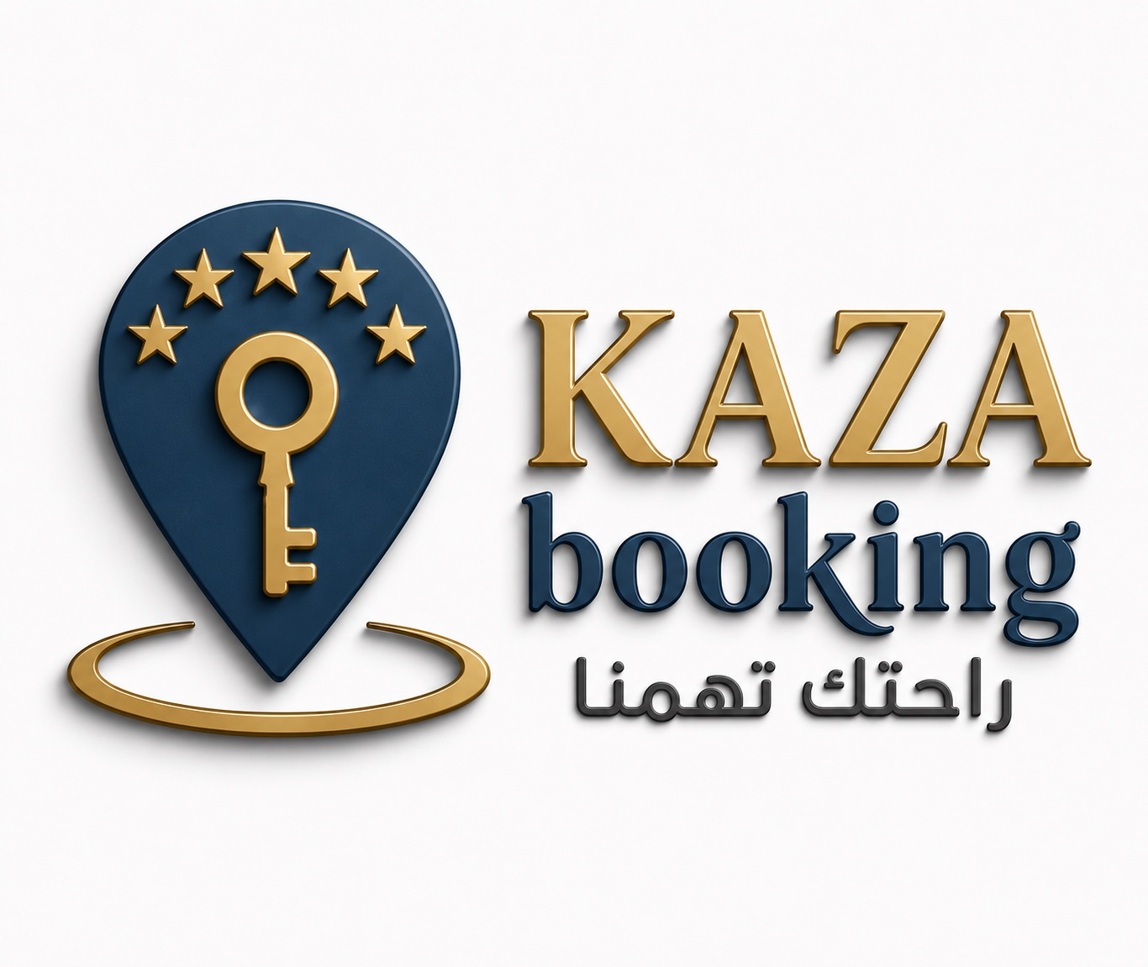

KAZA Booking
Premium Vacation Rental Management & Hospitality Services

About KAZA Booking
KAZA Booking is a premium vacation rental and hospitality management company specializing in maximizing rental income while preserving and protecting owners' real estate assets.

Executive Leadership
Under the leadership of Mr. Ashraf Khalil, Chief Executive Officer, with extensive hospitality experience managing major international hotel brands including Mövenpick, InterContinental, Holiday Inn, Tolip Sokhna, and hospitality operations for Palm Hills projects.

Core Services
Property Management, Revenue Management, Dynamic Pricing, Professional Marketing, Guest Services, Housekeeping, Maintenance Coordination, and Transparent Financial Reporting.

Investment Metrics
Occupancy Rate, ADR, RevPAR, GOP, and ROI.

Target Markets
New Alamein, North Coast, Ain Sokhna, Cairo, and Egypt's premium leisure destinations.

Our Promise
We Treat Your Property as Our Own.

