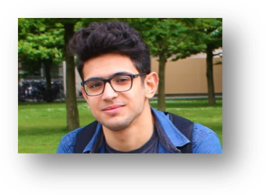
Ji Darwish
Streetname, No. youremail@gmail.com
Zipcode, City your cell no.

Bio
I am a junior full stack web developer looking for new experiences and a part-time job to compliment my university studies.
Areas of expertise:
(Include technical skills, other professional skills, personal strengths)

- Web-development | - Java | - Self-motivation
- Software-development  - JavaScript | - Node.js  - Ability to work under pressure | - Decision Making  - Adaptability
- React.js | - Communication

Education:
Institution: Amsterdam University of Applied Science 01/09/2017 - now
Bachelor in ICT Cyber security

Additional Training:
Institution: Hack your future 30/07/2017 – 18/03/2018
HackYourFuture is a coding school that gives refugees the opportunity to build and improve their programming skills. Over the course of six months professional developers teach HTML, CSS, JS, Node, React.js and MySQL. In addition, problem-solving skills and team work are emphasized throughout the curriculum. In the last six weeks students build a final project to put into practice what they have learned.

Project: Hyfer
Hyfer is an application where all HackYourFuture students can follow their course schedule and find an overview of their homework. It is also provides teachers insights, for instance to verify which modules are taught. Finally, students can obtain their train tickets and submit a P2P review of their class-mates’ homework. Hyfer is built using React.js, JavaScript, HTML, CSS, MySQL and NodeJs.

Link to the project on Github: https://github.com/HackYourFuture/hyfer

Experience:
Store: FBI fashion store – Aleppo 01/06/2013 – 30/06/2015
I was responsible for customer interaction and sales, as well as tracking the inventory of the store.

Languages:

Arabic, fluent mother tongue.

English, fluent B2 level

Dutch, fluent B2 level

