**Chapter1**

**Introduction**

**1.1 Introduction**

This chapter we are going to discuss the following questions:

-What is the problem we are trying to solve?

-What is the current solution?

-What is our solution and its benefits?

- What technologies are in use?

-What are the project phases?

**1.2 Problem definition:**

all around the world companies are developing smart devices in smart houses like TVs, speakers, fridges, door locks ... etc. but if we striped these houses from those devices we will end up with a dumb house,  
plus smart devices are expensive,  
Egyptian market is still developing and not ready for these kind of prices.  
  
and ( according to [a study of Northern California](https://www.nrdc.org/sites/default/files/home-idle-load-IP.pdf)by the Natural Resources Defense Council. That means that devices that are not “turned off” but in standby or sleep mode can use up to the equivalent of 50% power plants’ worth of electricity and cost more than $19 billion in electricity bills every year.  
And there’s an environmental cost: Overall electricity production represents about [37 percent of all carbon dioxide emissions](https://www.eia.gov/tools/faqs/faq.cfm?id=77&t=3), one of the main contributors to climate change.

And all smart devices must in standby to allow user to control it with his smart phoneSo, wasting energy is another problem to solve.

**1.3 Current solution:**

Our solution is using non-smart devices as cheaper alternatives for the smart ones  
So Smart houses must start with smart circuit breakers and smart outlets,  
with a controller (Arduino for example ) connected to network (through ethernet ),  
the controller is built-in the electrical wiring of the house,  
there will be a main controller connected to the circuit breakers   
and children controllers in every room connected to outlets.By using mobile application   
we can assign specific outlet to a device  
then control it turn it off or on or set a timer   
 this is efficient cause it will save money spent on overpriced smart devices   
and it save power

**1.4 Benefits:**

1- This product aims to give the user more control over more than one device at the same time and helps make homes smarter and safer,

it has advantages over nowadays devices such as:

a) less cost, the system's resources are cheap.

b) less electrical waste.

c) there is no need to replace the cheap devices with new more expensive ones.

d) less consumable power, it controls the electrical source itself, so devices aren't on sleep mode like most new smart devices.

e)calculate the usage of electricity.

**1.5 Smart circuit breaker objectives**

Although the potential of smart circuit breaker is big and

somehow ambiguous, we started this project the

objectives in mind :

1. Providing new way to control the circuit breaker
2. Control the devices from remote places
3. Make it easy for user to know his device state from anywhere
4. Make the user to know his consumption

Example of the same product at market but it more expensive and controls on only one electrical device:

**1.6 Technologies in use**

Arduino   
network configuration   
android  
xml

**1.7 Project approach**

Smart circuit breaker is an android application and it allow user to access his home network from any where

When enter user will find the status of his devices and his electricity usage, he can set timers and control the state by voice commands

**1.8 Applications examples**

-Turn your lights on and off remotely or create a lighting schedule. With this solution, your home will look like it’s occupied — even if you’re thousands of miles away.  
-Morning chaos is the norm in many households. Instead of worrying that you left the curling iron

on, turn it off remotely. You can also use a smart outlet to turn the curling iron on each weekday morning at a particular time, so it’s ready for you

-Rather than rushing home to prepare your dinner, fire up your slow cooker from your office. This way, dinner is waiting when you arrive home from work.  
  
Time for tea or coffee? Simply use your android app to schedule your kettle or coffee maker to turn on before you get out of bed in the morning.

-Do you sometimes find yourself sleeping through an alarm clock? Use a smart outlet to turn your lights on automatically too. The combination of your alarm clock plus lights, might help you wake up easier.

-Air conditioners and central air have become commonplace in many homes. However, [ceiling fans](https://www.makeuseof.com/tag/simple-ways-automate-ceiling-fan/) are also important in keeping cool since they can circulate the air around your home. You guessed it, use a smart outlet to schedule times when the fans are on.

- air conditioners. Yes, you can control them remotely

-All kids deserve a little break before doing homework each day. But when playtime is over, use your smart outlet to switch off the TV or gaming console.

-If you’re worried about family members making their way to the bathroom in the dark, consider using nightlight or lamp when motion is detected in the hallway or if a door is opened.

With a little bit of planning, smart outlets can also be used to control lawn and irrigation systems in your home — especially effective if you want them to stay watered on a schedule while you are on vacation.

**1.9 Project phases**

**1- setting the stage:**

Finalize study process:

* Terms of reference.
* Public consultation plan.

**2- Opportunity and rationale:**

* Introduce study.
* Provide synopsis of existing and future conditions.
* Provide background work including technology analysis.

**3- Long list of options:**

* Develop and finalize evaluation framework foe route and station options.
* Develop long list of station options.

**4- recommended options:**

* Analyze and evaluate short list of options.
* Identify draft recommended options.

**What is scrum ?**

Scrum is a framework within which people can address complex adaptive problems, while productively and creatively delivering products of the highest possible value.

Scrum itself is a simple framework for effective team collaboration on complex products.  Scrum co-creators Ken Schwaber and Jeff Sutherland have written [The Scrum Guide](http://www.scrumguides.org/) to explain Scrum clearly and succinctly.  This Guide contains the definition of Scrum. This definition consists of Scrum’s roles, events, artifacts, and the rules that bind them together.

**Scrum is:**

* Lightweight
* Simple to understand
* Difficult to master

### Scrum Glossary

The [Scrum Glossary](https://www.scrum.org/resources/scrum-glossary) is meant to represent an overview of Scrum-related terms.  Some of the mentioned terms are not mandatory in Scrum, but have been added because they are commonly used in Scrum.

To learn more about the Scrum framework, to identify which of these terms are required elements of Scrum and to understand how the mentioned elements are connected, we highly recommend that you reference [The](http://www.scrumguides.org/)[Scrum Guide](http://www.scrumguides.org/).  To learn more about terms specific to software development teams using Scrum and agile software development techniques, reference the [Professional Scrum Developer glossary](https://www.scrum.org/resources/professional-scrum-developer-glossary).

### The Scrum Framework

Scrum is simple.  It is the opposite of a big collection of interwoven mandatory components. Scrum is not a methodology. Scrum implements the scientific method of empiricism. Scrum replaces a programmed algorithmic approach with a heuristic one, with respect for people and self-organization to deal with unpredictability and solving complex problems.  The below graphic represents Scrum in Action as described by Ken Schwaber and Jeff Sutherland in their book Software in 30 Days taking us from planning through software delivery.

### The Scrum Values

[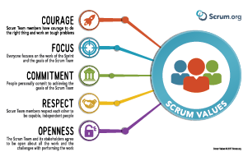](https://www.scrum.org/resources/scrum-values-poster)

Although always considered to be a part of Scrum and often written about, in July 2016, the Scrum Values were added to The Scrum Guide.  These values include Courage, Focus, Commitment, Respect, and Openness.  Read the [Scrum Guide](http://www.scrumguides.org/) to learn more about these values, how they apply to Scrum and [download](https://www.scrum.org/resources/scrum-values-poster) this poster.

### The Roles of the Scrum Team

The Scrum Team consists of a [Product Owner](https://www.scrum.org/resources/what-is-a-product-owner), the [Development Team](https://www.scrum.org/resources/what-is-a-scrum-development-team), and a [Scrum Master](https://www.scrum.org/resources/what-is-a-scrum-master). Scrum Teams are self-organizing and cross-functional. Self-organizing teams choose how best to accomplish their work, rather than being directed by others outside the team. Cross-functional teams have all competencies needed to accomplish the work without depending on others not part of the team. The team model in Scrum is designed to optimize flexibility, creativity, and productivity.

### The Scrum Events

Prescribed events are used in Scrum to create regularity and to minimize the need for meetings not defined in Scrum. All events are time-boxed. Once a Sprint begins, its duration is fixed and cannot be shortened or lengthened. The remaining events may end whenever the purpose of the event is achieved, ensuring an appropriate amount of time is spent without allowing waste in the process.  The Scrum Events are:

* [Sprint](https://www.scrum.org/resources/what-is-a-sprint-in-scrum)
* [Sprint Planning](https://www.scrum.org/resources/what-is-sprint-planning)
* [Daily Scrum](https://www.scrum.org/resources/what-is-a-daily-scrum)
* [Sprint Review](https://www.scrum.org/resources/what-is-a-sprint-review)
* [Sprint Retrospective](https://www.scrum.org/resources/what-is-a-sprint-retrospective)

**Scrum Development: What’s Involved?**

The Scrum model suggests that projects progress via a series of sprints. In keeping with an agile methodology, sprints are timeboxed to no more than a month long, most commonly two weeks.

Scrum methodology advocates for a planning meeting at the start of the sprint, where team members figure out how many items they can commit to, and then create a sprint backlog – a list of the tasks to perform during the sprint.

During an agile Scrum sprint, the Scrum team takes a small set of features from idea to coded and tested functionality. At the end, these features are done, meaning coded, tested and integrated into the evolving product or system.

On each day of the sprint, all team members should attend a daily Scrum meeting, including the Scrum Master and the product owner. This meeting is time boxed to no more than 15 minutes. During that time, team members share what they worked on the prior day, will work on that day, and identify any impediments to progress.

The Scrum model sees daily scrums as a way to synchronize the work of team members as they discuss the work of the sprint.

At the end of a sprint, the team conducts a sprint review during which the team demonstrates the new functionality to the PO or any other stakeholder who wishes to provide feedback that could influence the next sprint.

This feedback loop within Scrum software development may result in changes to the freshly delivered functionality, but it may just as likely result in revising or adding items to the product backlog.

Another activity in Scrum project management is the sprint retrospective at the end of each sprint. The whole team participates in this meeting, including the Scrum Master and PO. The meeting is an opportunity to reflect on the sprint that has ended, and identify opportunities to improve.

**The Agile Scrum Project: Main Roles**

Even if you are new to Scrum, you may have heard of a role called the Scrum Master. The ScrumMaster is the team's coach, and helps Scrum practitioners achieve their highest level of performance.

In the Scrum process, a ScrumMaster differs from a traditional project manager in many ways, including that this role does not provide day-to-day direction to the team and does not assign tasks to individuals.

A good Scrum Master shelters the team from outside distractions, allowing team members to focus maniacally during the sprint on the goal they have selected.

While the Scrum Master focuses on helping the team be the best that it can be, the product owner works to direct the team to the right goal. The product owner does this by creating a compelling vision of the product, and then conveying that vision to the team through the product backlog.

The product owner is responsible for prioritizing the backlog during Scrum development, to ensure it’s up to par as more is learned about the system being built, its users, the team and so on.

The third and final role in Scrum project management is the Scrum team itself. Although individuals may join the team with various job titles, in Scrum, those titles are insignificant. Scrum methodology states that each person contributes in whatever way they can to complete the work of each sprint.

This does not mean that a tester will be expected to re-architect the system; individuals will spend most (and sometimes all) of their time working in whatever discipline they worked before adopting the agile Scrum model. But with Scrum, individuals are expected to work beyond their preferred disciplines whenever doing so would be for the good of the team.

**Chapter 2**

**Planning ,**

**Analysis**

**and Design**

**Project name :**

Smart circuit breaker

### The project Purpose

The purpose for building this project is to build a single circuit breaker which can protect from multiple electrical faults as discussed above.Due to lack of knowledge in circuit breakers and cost not everyone can avail all types of circuit breakers for protection. And moreover the circuit breakers used don't got any way to understand whether its operational or faulty(except RCD/RCCB), Smart Circuit Breaker got this reporting functionality which will alert user before any electrical accident for any faults within Smart circuit breaker itself. So it not called 'Smart'!

**Smart circuit-breakers for energy-efficient homes**

* IN THE future, homes will use electricity much more sensibly than they do now: turning the lights off automatically when no one is around; adjusting the heating regularly to suit a householder’s daily routine; making sure the electric car is charged up using off-peak rates; even drawing power from the car’s battery in the event of a grid outage. A variety of plug-in devices can already do some of these things. Yet lurking in every home, usually in a dark cupboard or down in the basement, is a humble piece of equipment that, with a bit of tweaking, could replace them all with a single command center.
* The equipment concerned is often referred to as a fuse box, although nowadays it is unlikely to use actual fuses—strands of wire that cut off the current by melting in the event of a power surge. Instead, such boxes contain a panel of electromechanical switches called circuit breakers. Typically, a breaker contains an electromagnet through which the current flows. If that flow exceeds a set level, the electromagnet becomes sufficiently energized to throw a mechanical switch, which breaks the circuit. A circuit breaker responds faster than a fuse, and can also be reset manually instead of having to be replaced.

**Sponsor :**

* DR.NERMIN ABDELWAHAB EL-BAHNASAWY
* Team members
* Faculty of electronic engineering
* MENOFIA university

**Business need :**

* Multi tasking device
* Devices with less electrical waste
* Device with less cost

**Business Value :**

**Tangible value :**

User need to purchase some features of the app

**In-Tangible Value :**

* Save time and effort
* User-friendly User interface
* Fast and Accessible
* Control devices easily

**Special Issues or constraints**

* Mobile phone that runs Android system
* Internet connection
* App need to run on multiple devices with screen size variation
* app can set timers and control the state by voice commands
* Smart circuit breaker device which control on electrical devices
* User can change the device name
* User can know the state of the device

**Technical feasibility**

Smart circuit breaker app is feasible technically,although there is some risk :

* familiarity with the application
* User might do not know how to make the full use of the application
* The mobile application should be familiar to anyone

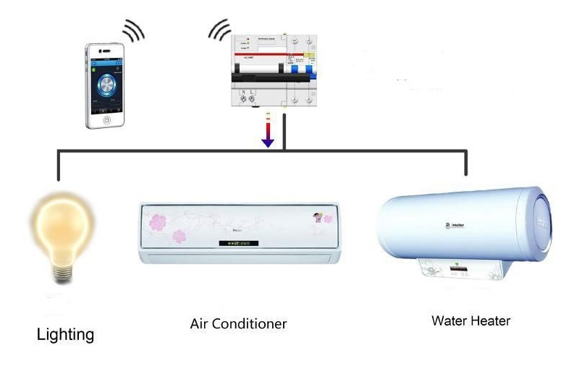

**Overview diagram**

**What is Trello?**

* Trello is a collaboration tool that organizes your projects into boards. In one glance, Trello tells you what's being worked on, who's working on what, and where something is in a process.
* Imagine a white board, filled with lists of sticky notes, with each note as a task for you and your team. Now imagine that each of those sticky notes has photos, attachments from other data sources like BitBucket or Salesforce, documents, and a place to comment and collaborate with your teammates. Now imagine that you can take that whiteboard anywhere you go on your smartphone, and can access it from any computer through the web. That's Trello!

**Tasks**

**Hardware**

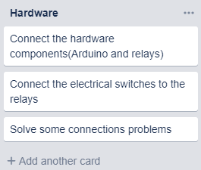

**Software**

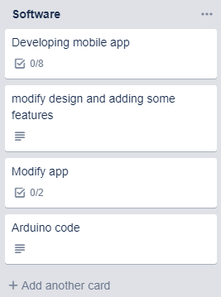

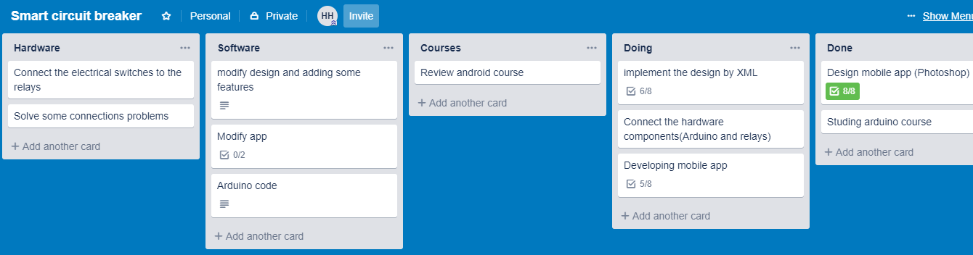



**Staffing plan**

|  |  |  |
| --- | --- | --- |
| **Role** | **Description** | **Assigned to** |
| **Scrum master** | Scrum masters do this by helping everyone understand scrum theory,practices,rules and values.Scrum Master is a servant-leader for the Scrum Team | Hazemhammad |
| **UI/Ux** | **UX design** refers to user experience design, while **UI design** stands for user interface design. Both of these are crucial to an IT product and need to work closely together. Despite being very integral to each other, the roles themselves are quite different, involving distinct processes. | Maryam shaheen  Hazemhammad |
| **Android developer** | An **Android developer** is responsible for developing applications for devices powered by the Android operating system. Due to the fragmentation of this ecosystem, an Android developer must pay special attention to the application’s compatibility with multiple versions of Android and device types. They must also have a strong understanding of the patterns and practices that revolve around such a platform. | Omar magdy  Nerminelsobky |
| **hardware** | A person involved with the design, implementation and testing of hardware (circuits, components, systems, etc.). | Mohamed gamal  Rania turki |

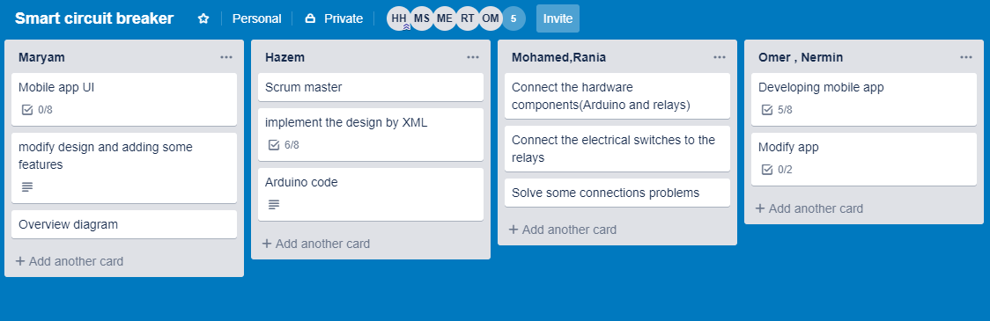

Responsibilities organization through trello

**Work plan**

|  |  |  |  |  |
| --- | --- | --- | --- | --- |
| **Goal 1:**  **Create a system to control home devices with low cost and less consumable power.** | | **Measures of Effectiveness:**  **Reliability, Low cost, speed, low consumable power.** | | |
| **Objectives** | **Activities Planned to Meet Objectives** | | **Staff/Partnership Member(s) Responsible** | **Completed by:**  **(month & year)** |
| Control devices | Design circuits to control the power source of each device. | | Hardware Team | Nov-Dec  2018 |
| Connect the system components together | Design a network to connect devices together | | Network Team | Jan  2019 |
| Make the system responsive | Write the Arduino code that responds to the user actions | | Software Team | Jan-Feb  2019 |

|  |  |  |  |  |
| --- | --- | --- | --- | --- |
| **Goal 2:**  **Give the user full control of the system.** | | **Measures of Effectiveness:**  **Reliability, interactive and impressive user interface, speed.** | | |
| **Objectives** | **Activities Planned to Meet Objectives** | | **Staff/Partnership Member(s) Responsible** | **Completed by:**  **(month & year)** |
| Impressive user interface | Design a good user interface | | Software Team | Jan  2019 |
| Full user control | Develop the app to give the user full control over the devices | | Software Team | Frb-Mar  2019 |
| Connect the app with the hardware system | Connect the app with the hardware system using real IP | | Software & Network Teams | Mar  2019 |

|  |  |  |  |  |
| --- | --- | --- | --- | --- |
| **Goal 3:**  **Improve the system** | | **Measures of Effectiveness:**  **Reliability, user satisfaction.** | | |
| **Objectives** | **Activities Planned to Meet Objectives** | | **Staff/Partnership Member(s) Responsible** | **Completed by:**  **(month & year)** |
| Improve user interface and interactivity | Add voice commands | | Software Team | Apr  2019 |
| Give more information | Calculate and display electricity consumption | | Software & Hardware Teams | Apr-May  2019 |

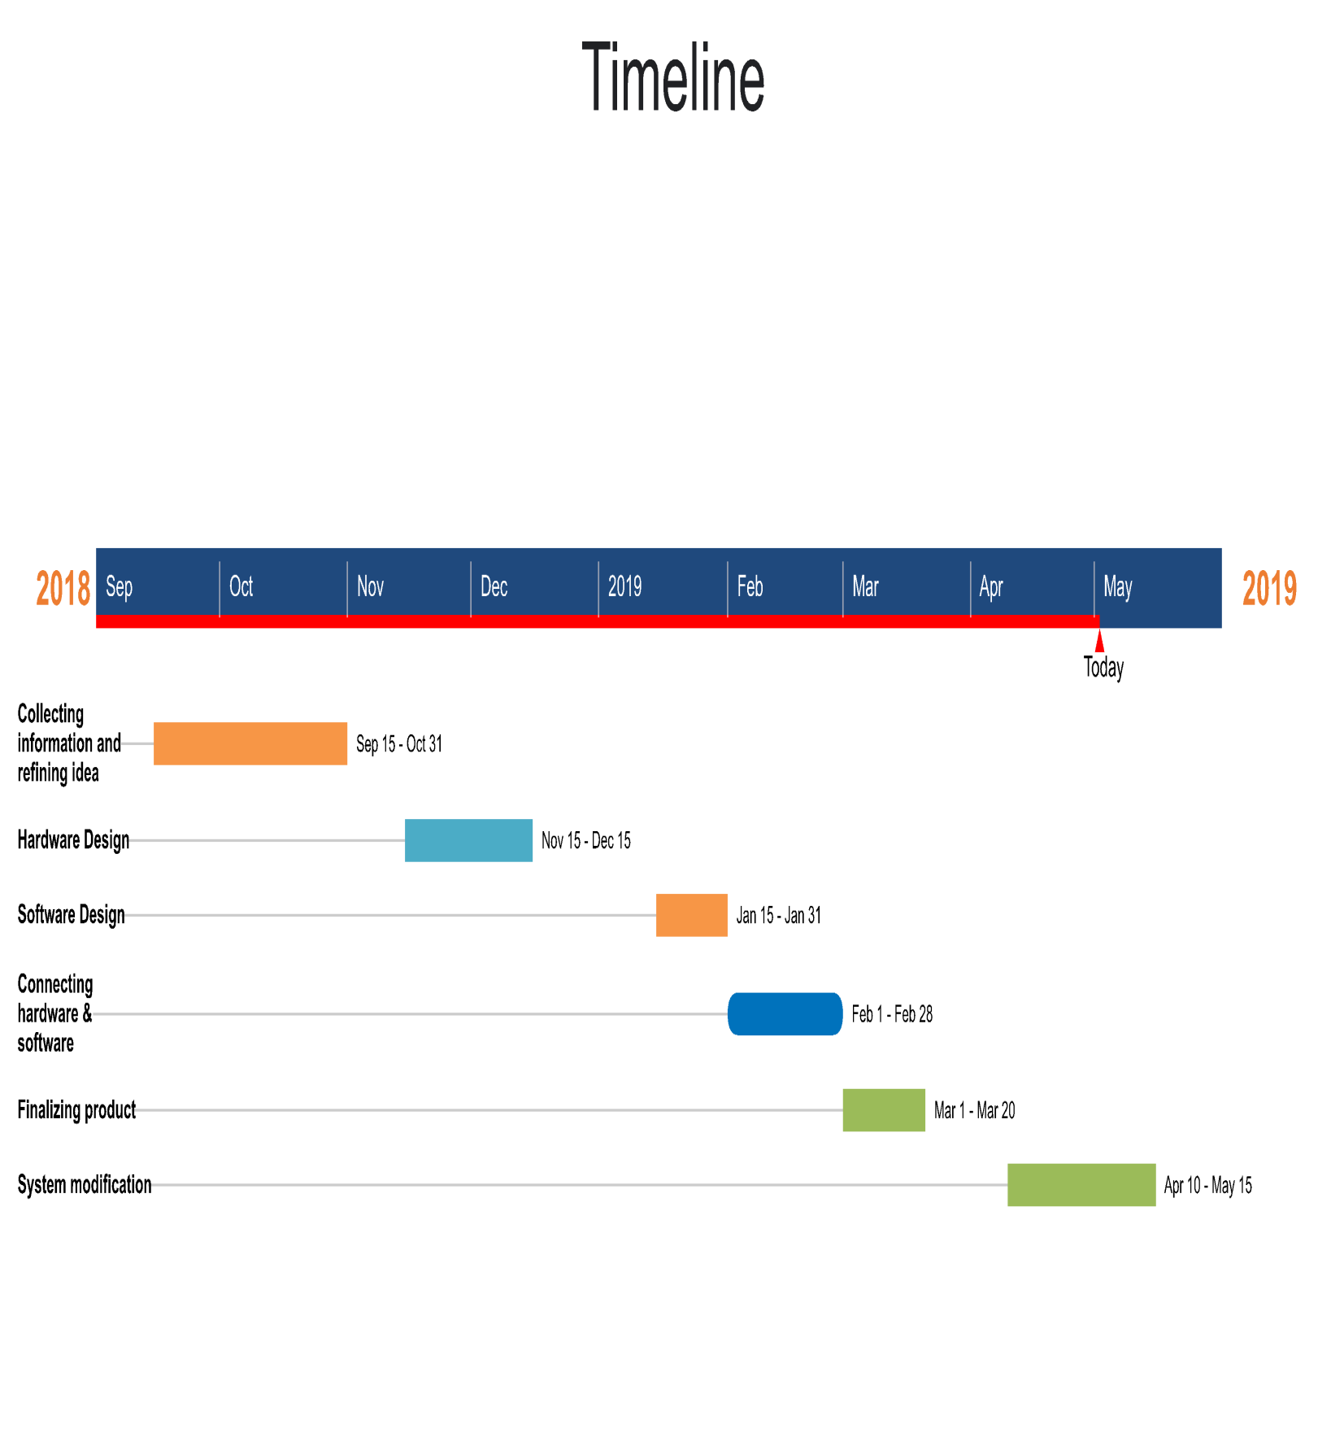

**Requirement gathering :**

The requirements are description of features and functionalities of the target system

Requirements convey the exceptions of users from product . The requirements can be obvious or hidden . Known or unknown , expected or unexpected from client's point of view

**Functional requirements :**

User can control his circuit breaker

user can know his consumption

user can know device state

user can control devices by voice command

**Non functional requirements :**

* Availability
* Data integrity
* Response time
* Scalability
* Security
* Fault tolerance
* Documentation

**Project architecture:**

after studying the prototypes and the use cases and fully understanding it was the right time to design the project architecture.

* **App:**

Google recently introduced architecture components which includes Live Data and View Model which facilitates developing Android app using MVVM pattern.   
we used MVVM architecture for our app which is an acronym for model-view-view model.   
MVVM facilitates a separation of development of the graphical user interface via a GUI code from development of the business logic or back-end logic (the data model).

MVVNI has mainly the following layers:

and since our platform is an android application, we had to separate the architectures of both as following:

**a :Model:**

Model represents the data and business logic of the app. One of the recommended implementation strategies of this layer, is to expose its data through observables to be decoupled completely from View Model or any other observer/consumer (this will be illustrated in our MVVM sample app below).

**B : View Model:**

View Model interacts with model and prepares observable(s) that can be observed by View. View Model can optionally provide hooks for the view to pass events to the model.  
 One of the important implementation strategies of this layer is to decouple it from the View i.e.   
View Model should not be aware about the view who is interacting with.

**C : View:**

Finally the view role in this pattern is to observe (or subscribe to) a View Model observable to get data in order to update UI elements accordingly. the following diagram shows MVVM components and basic interactions.

**Repository**  
  
This class is the single source of truth for all of our app's data and acts as a clean API for the UI to communicate with. View Models simply request data from the repository. They do not need to worry about whether the repository should load from the database or network. or how or when to persist the data. The repository manages all of this. As part of this responsibility, the repository is a mediator between the different data sources.

**Remote Network Data Source**

Manages data from a remote data source, such as the Internet.

**Hardware**  
  
manage to apply the action the user wants to.

**User interface design**

* User Interface Design is the discipline of designing software interfaces for devices, ideally with a focus on maximizing efficiency, responsiveness and aesthetics to foster a good [user experience](https://www.everyinteraction.com/definition/user-experience/).
* UI design is typically employed for products or services that require interaction for the user to get what they need from the experience. The interface should allow a user to perform any required tasks to complete the function of the product or service.
* An interface is a point of interaction between the user and the hardware and/or software they are using.[UI](https://www.everyinteraction.com/definition/user-interface/) design is the skill employed to visual the interface used to complete the task it is designed for Good [**UI**](https://www.everyinteraction.com/definition/user-interface/) design facilitates making the completion of tasks as frictionless as possible.

# What is Rapid Prototyping

# software prototyping is the activity of creating prototypes of software applications i.e..incomplete versions of the software program being developed .It is an activity that can occur in software development and is comparable to prototyping as known from other fields ,such as mechanical engineering or manufacturing.

# and first phase of rapid prototyping is drawing low fidelity wireframes which are essentially drawings of what the app might look like .

# The following images shows our way in low-fidelity wireframes :

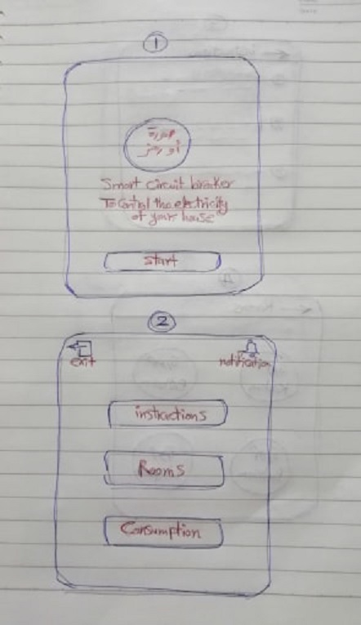

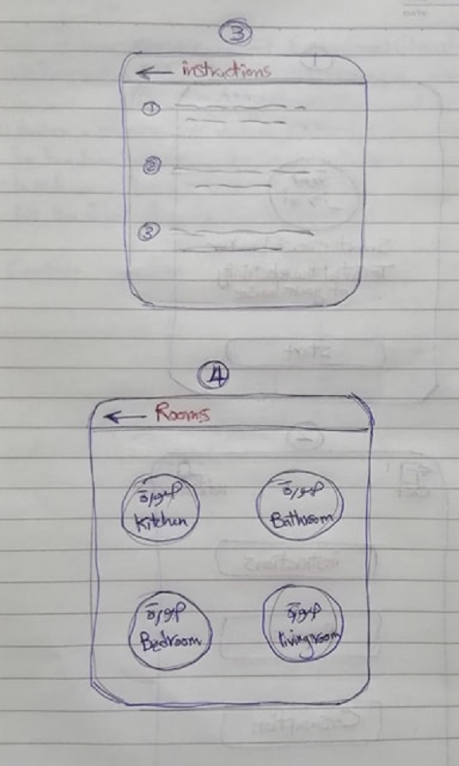

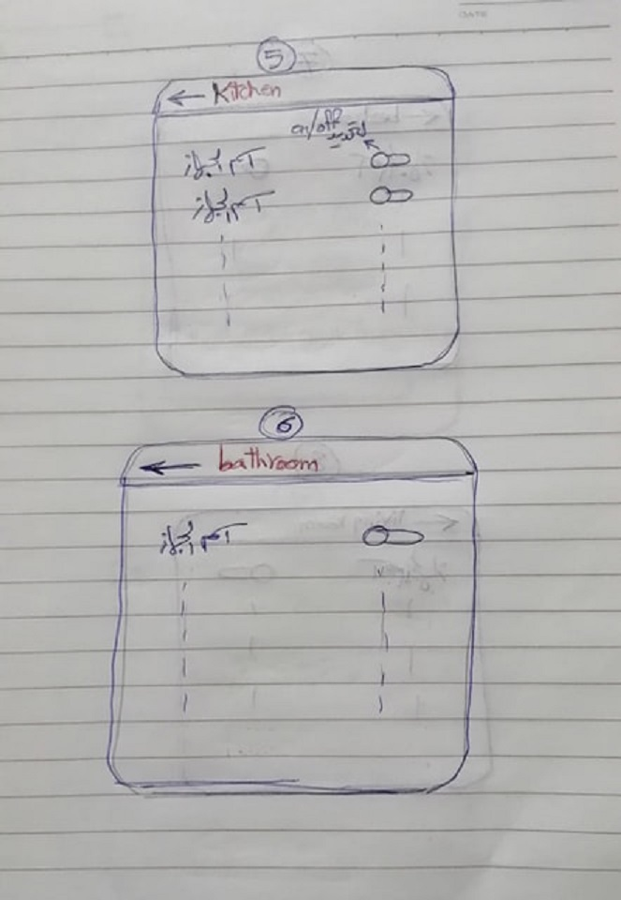

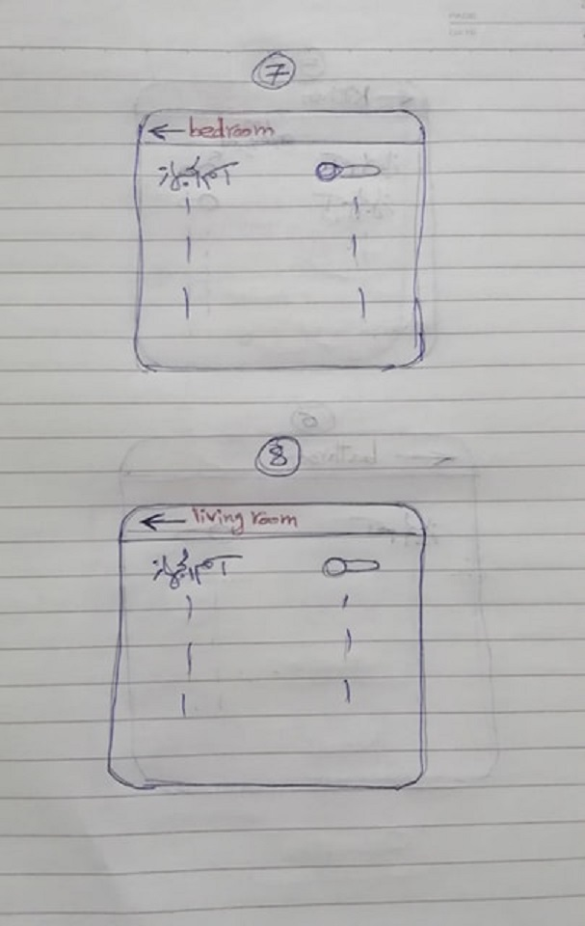

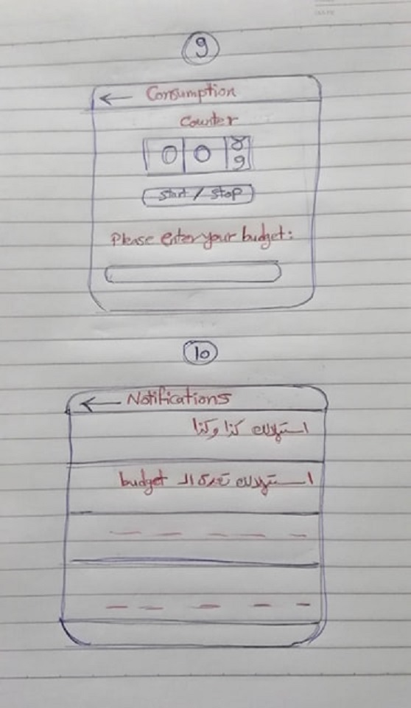

**Chapter 3**

**Implementation of smart circuit breaker**

**Hardware phase**

the hardware component we used :

* Arduino UNO R3
* Arduino ethernet shield
* YwRobot 4 relay(4-Channel 5V relay module)
* Current sensor ACS712
* POE cable
* Router
* Electrical Wires

**Arduino UNO R3**

The Arduino Uno R3 is a microcontroller board based on a removable, dual-inline- package (DIP) ATmega328 AVR microcontroller. It has 20 digital input/output pins (of which 6 can be used as PWM outputs and 6 can be used as analog inputs). Programs can be loaded on to it from the easy-to-use Arduino computer program. The Arduino has an extensive support community, which makes it a very easy way to get started working with embedded electronics. The R3 is the third, and latest, revision of the Arduino Uno.

**overview about it:-**

The Arduino Uno is a microcontroller board based on the ATmega328. It has 20 digital input/output pins (of which 6 can be used as PWM outputs and 6 can be used as analog inputs), a 16 MHz resonator, a USB connection, a power jack, an in-circuit system programming (ICSP) header, and a reset button. It contains everything needed to support the microcontroller; simply connect it to a computer (or appropriate wall power adapter) with a USB cable or power it with a AC-to-DC adapter or battery to get start

The Uno differs from all preceding boards in that it does not use the FTDI USB-to-serial driver chip. Instead, it features an ATmega16U2 programmed as a USB-to-serial converter. This auxiliary microcontroller has its own USB bootloader, which allows advanced users to reprogram it

The Arduino has a large support community and an extensive set of support libraries and hardware add-on “shields” (e.g. you can easily make your Arduino wireless with our Wixel shield), making it a great introductory platform for embedded electronics. Note that we also offer a Spark Fun Inventor’s Kit, which includes an Arduino Uno along with an assortment of components (e.g. breadboard, sensors, jumper wires, and LEDs) that make it possible to create a number of fun introductory projects

This is the 3rd revision of the Uno (R3), which has a number of changes:

The USB controller chip changed from ATmega8U2 (8K flash) to ATmega16U2 (16K flash). This does not increase the flash or RAM available to sketches.

Three new pins were added, all of which are duplicates of previous pins. The I2C pins (A4, A5) have been also been brought out on the side of the board near AREF. There is a IOREF pin next to the reset pin, which is a duplicate of the 5V pin.

The reset button is now next to the USB connector, making it more accessible when a shield is used.

**Technical specifications:-**

* Microcontroller: Microchip ATmega328P
* Operating Voltage: 5 Volts
* Input Voltage: 7 to 20 Volts
* Digital I/O Pins: 14 (of which 6 provide PWM output)
* Analog Input Pins: 6
* DC Current per I/O Pin: 20 mA
* DC Current for 3.3V Pin: 50 mA
* Flash Memory: 32 KB of which 0.5 KB used by bootloader
* SRAM: 2 KB
* EEPROM: 1 KB
* Clock Speed: 16 MHz
* Length: 68.6 mm
* Width: 53.4 mm
* Weight: 25 g

**Pins :**

**General Pin functions**

LED: There is a built-in LED driven by digital pin 13. When the pin is HIGH value, the LED is on, when the pin is LOW, it's off.

VIN: The input voltage to the Arduino/Genuino board when it's using an external power source (as opposed to 5 volts from the USB connection or other regulated power source). You can supply voltage through this pin, or, if supplying voltage via the power jack, access it through this pin.

5V: This pin outputs a regulated 5V from the regulator on the board. The board can be supplied with power either from the DC power jack (7 - 20V), the USB connector (5V), or the VIN pin of the board (7-20V). Supplying voltage via the 5V or 3.3V pins bypasses the regulator, and can damage the board.

3V3: A 3.3 volt supply generated by the on-board regulator. Maximum current draw is 50 mA.

GND: Ground pins.

IOREF: This pin on the Arduino/Genuino board provides the voltage reference with which the microcontroller operates. A properly configured shield can read the IOREF pin voltage and select the appropriate power source or enable voltage translators on the outputs to work with the 5V or 3.3V.

Reset: Typically used to add a reset button to shields which block the one on the board.

**Special Pin Functions**

Each of the 14 digital pins and 6 Analog pins on the Uno can be used as an input or output, using pinMode(),digitalWrite(), and digitalRead() functions. They operate at 5 volts. Each pin can provide or receive 20 mA as recommended operating condition and has an internal pull-up resistor (disconnected by default) of 20-50k ohm. A maximum of 40mA is the value that must not be exceeded on any I/O pin to avoid permanent damage to the microcontroller.The Uno has 6 analog inputs, labeled A0 through A5, each of which provide 10 bits of resolution (i.e. 1024 different values). By default they measure from ground to 5 volts, though is it possible to change the upper end of their range using the AREF pin and the analogReference() function.

In addition, some pins have specialized **functions**:

Serial / UART: pins 0 (RX) and 1 (TX). Used to receive (RX) and transmit (TX) TTL serial data. These pins are connected to the corresponding pins of the ATmega8U2 USB-to-TTL Serial chip.

External Interrupts: pins 2 and 3. These pins can be configured to trigger an interrupt on a low value, a rising or falling edge, or a change in value.

PWM (Pulse Width Modulation): 3, 5, 6, 9, 10, and 11 Can provide 8-bit PWM output with the analogWrite() function.

SPI (Serial Peripheral Interface): 10 (SS), 11 (MOSI), 12 (MISO), 13 (SCK). These pins support SPI communication using the SPI library.

TWI (Two Wire Interface) / I²C: A4 or SDA pin and A5 or SCL pin. Support TWI communication using the Wire library.

AREF (Analog REFerence): Reference voltage for the analog inputs

**Communication :**

The Arduino/Genuino Uno has a number of facilities for communicating with a computer, another Arduino/Genuino board, or other microcontrollers. The ATmega328 provides UART TTL (5V) serial communication, which is available on digital pins 0 (RX) and 1 (TX). An ATmega16U2 on the board channels this serial communication over USB and appears as a virtual com port to software on the computer. The 16U2 firmware uses the standard USB COM drivers, and no external driver is needed. However, on Windows, a .inf file is required. The Arduino Software (IDE) includes a serial monitor which allows simple textual data to be sent to and from the board. The RX and TX LEDs on the board will flash when data is being transmitted via the USB-to-serial chip and USB connection to the computer (but not for serial communication on pins 0 and 1). A SoftwareSerial library allows serial communication on any of the Uno's digital pins.

Automatic (Software) Reset

Rather than requiring a physical press of the reset button before an upload, the Arduino/Genuino Uno board is designed in a way that allows it to be reset by software running on a connected computer. One of the hardware flow control lines (DTR) of the ATmega8U2/16U2 is connected to the reset line of the ATmega328 via a 100 nanofarad capacitor. When this line is asserted (taken low), the reset line drops long enough to reset the chip.

This setup has other implications. When the Uno is connected to a computer running Mac OS X or Linux, it resets each time a connection is made to it from software (via USB). For the following half-second or so, the bootloader is running on the Uno. While it is programmed to ignore malformed data (i.e. anything besides an upload of new code), it will intercept the first few bytes of data sent to the board after a connection is opened.

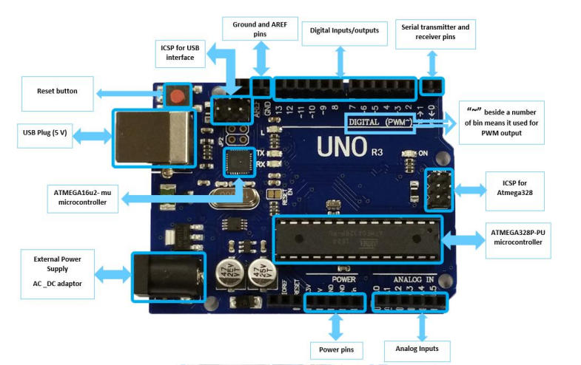

**Arduino UNO R3 in the project :**

We used it for controlling the Relay which simulate the Circuit breaker.

**Arduino Ethernet Shield :-**

The Arduino Ethernet Shield allows an Arduino board to connect to the internet. It is based on the Wiznet W5100 ethernet chip (datasheet). The Wiznet W5100 provides a network (IP) stack capable of both TCP and UDP. It supports up to four simultaneous socket connections

**overview about it :-**

* The Arduino Ethernet shield allows an Arduino board to connect to the internet using the Ethernet library and to read and write an SD card using the SD library.
* The Arduino Ethernet shield allows you to connect your Arduino projects to the internet. Simply plug it in to your network (via ethernet cable) and begin talking to the world wide web. It can be programmed to act as a web-server (delivering web pages), or as a client pushing information to a web service (be it twitter or your own website). The possibilities are truly astonishing. and with the onboard SD card-slot can be quite powerful by hosting up full websites.
* The Arduino Ethernet shield has a library so you don’t need to think of details how Ethernet chip is controlled. This library allows an Arduino board to connect to the internet. It can serve as either a server accepting incoming connections or a client making outgoing ones. The library supports up to four concurrent connection (incoming or outgoing or a combination).
* The ethernet shield adds IP communication, acting as a client or as a server based on the Wiznet W5100 ethernet chip (datasheet) . The most well-known protocols are supported right out of the box, including TCP, UDP and ICMP. Several enthousiasts have added support for even more protocols, such as DHCP and NTP

**Features**

* With this Ethernet Shield, your Arduino board can be used to connect to the Internet.
* Can be used as server or client.
* Directly plug puzzle board, no soldering required.
* Directly supported by Arduino official Ethernet Library.
* Adds a micro-SD card slot, to store files for serving over the network.
* Supports up to four simultaneous socket connections.
* Uses the Ethernet library to write sketches which connect to the internet using the shield.

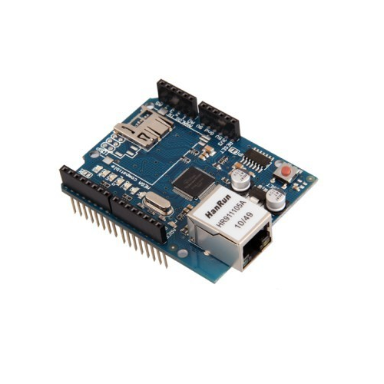

**YwRobot 4 relay:-**

This is a 5V 4-channel relay interface board, and each channel needs a 15-20mA driver current. It can be used to control various appliances and equipment with large current. It is prepared with high-current relays that work under AC250V 10A or DC30V 10A. It has a standard interface that can be controlled directly by microcontroller.

The 4-Channel Relay Driver Module makes it simple and convenient to drive loads such as 12V relays from simple 5V digital outputs of your Arduino compatible board or other microcontroller.

**Pin Description:-**

Input:

VCC: Positive supply voltage

GND: Ground

IN1--IN4: Relay control port

Output:

Connect a load, DC 30V/10A,AC 250V/10A

**The connections between the relay module and the Arduino are really simple:-**

GND: goes to ground.

IN1: controls the first relay (it will be connected to an Arduino digital pin)

IN2: controls the second relay (it should be connected to an Arduino digital pin if you are using this second relay. ...

VCC: goes to 5V.

**Features**

* There are four fixed screw holes at each corner of the board, easy for install and fix. The diameter of the hole is 3.1mm
* High quality Single relay is used with single pole double throw, a common terminal, a normally open terminal, and a normally closed terminal
* Optical coupling isolation, good anti-interference.
* Closed at low level with indicator on, released at high level with indicator off
* VCC is system power source, and JD_VCC is relay power source. Ship 5V relay by default. Plug jumper cap to use
* The maximum output of the relay: DC 30V/10A, AC 250V/10A

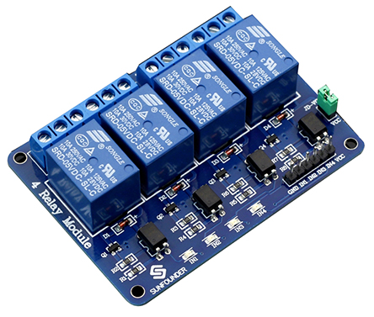

**ACS712 current sensor:-**

ACS712 current sensor operates from 5V and outputs analog voltage proportional to current measured on the sensing terminals. You can simple use a microcontroller ADC to read the values. ... The low resistance internal conductor allows for sensing up to 20 A continuous current. Providing typical output error of 1%.

**Features and Benefits**

* Low-noise analog signal path
* Device bandwidth is set via the new FILTER pin
* 80 kHz bandwidth
* Total output error 1.5% at TA= 25°C
* Small footprint, low-profile SOIC8 package
* 2.1 kVRMS minimum isolation voltage from pins 1-4 to pins 5-8
* 5.0 V, single supply operation
* 66 to 185 mV/A output sensitivity
* Output voltage proportional to AC or DC currents
* Factory-trimmed for accuracy
* Extremely stable output offset voltage
* Nearly zero magnetic hysteresis
* Ratio metric output from supply voltage

**Description:-**

ACS712 provides economical and precise solutions for AC or DC current sensing in industrial,commercial, and communications systems. The device package allows for easy implementation by the customer.Typical applications include motor control, load detection and management, switched-mode power supplies, and overcurrent fault protection.The device consists of a precise, low-offset, linear Hall sensor circuit with a copper conduction path located near the surface of the die. Applied current flowing through this copper conduction path generates a magnetic field which is sensed by the integrated Hall IC and converted into a proportional voltage. Device accuracy is optimized through the close proximity of the magnetic signal to the Hall transducer. A precise, proportional voltage is provided by the low-offset,

chopper-stabilized BiCMOS Hall IC, which is programmed for accuracy after packaging.The output of the device has a positive slope (>VIOUT(Q)) when an increasing current flows through the primary copper conduction path (from pins 1 and 2, to pins 3 and 4), which is the path used for current sensing. The internal resistance of this conductive path is 1.2 m? typical, providing low power

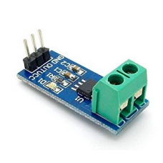

**Connect sensor to arduin**

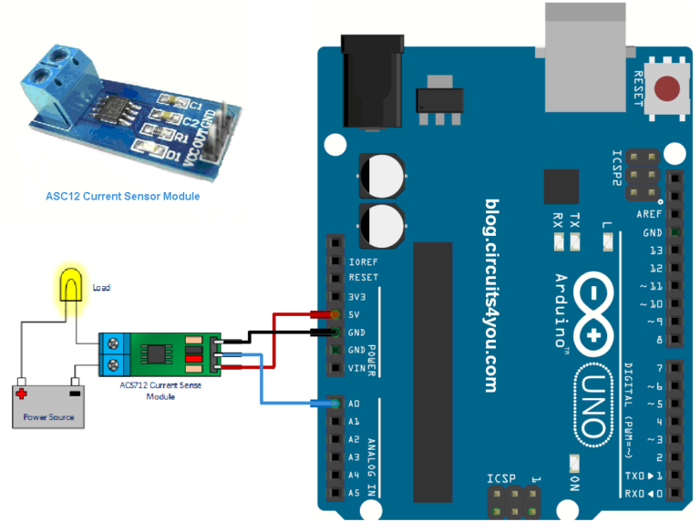

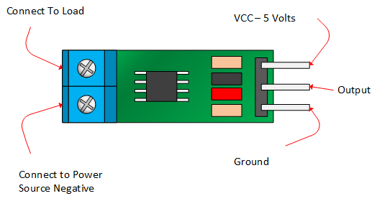

**Power over Ethernet**

**Power over Ethernet** or **POE** describes any of several [standard](https://en.wikipedia.org/wiki/Technical_standard) or [ad-hoc](https://en.wikipedia.org/wiki/Ad-hoc) systems which pass [electric power](https://en.wikipedia.org/wiki/Electric_power) along with data on [twisted pair Ethernet](https://en.wikipedia.org/wiki/Ethernet_over_twisted_pair) cabling. This allows a single cable to provide both data connection and electric power to devices such as [wireless access points](https://en.wikipedia.org/wiki/Wireless_access_point), [IP cameras](https://en.wikipedia.org/wiki/IP_camera), and [VoIP phones](https://en.wikipedia.org/wiki/VoIP_phone)

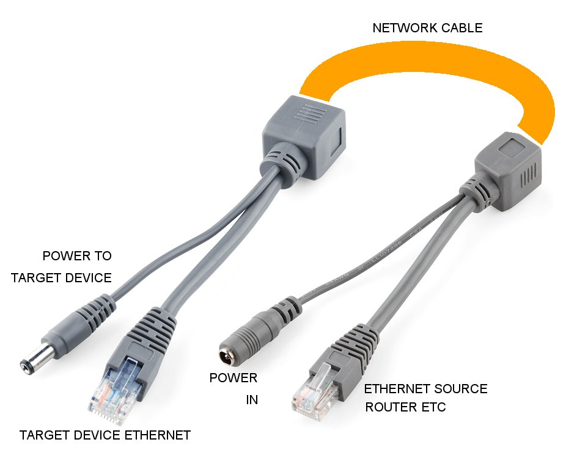.

**Router**

* We used the router to make the connection between the arduino and the mobile application.
* The arduino ethernet shield connected to router through POE cable and the application connected to the router through WIFI.
* we can send command from the mobile application to the arduinoto control any device and this network is public so we can control the circuit breaker from remote places.

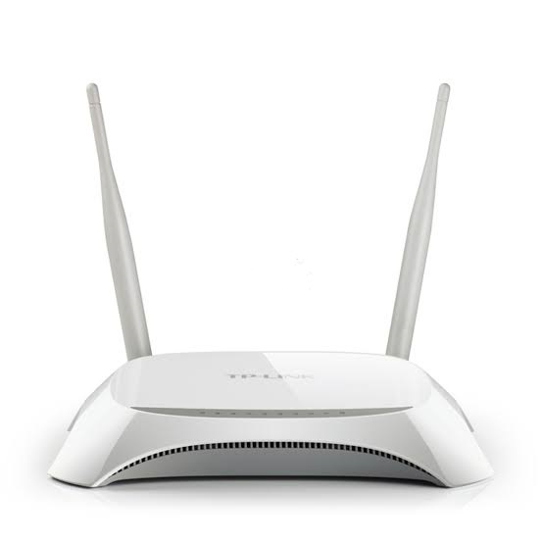

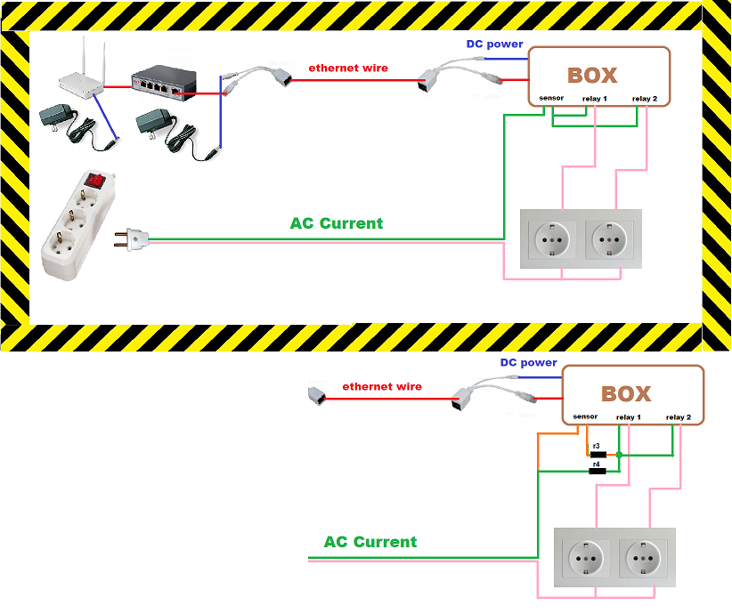

**Figure**

This figure showing the connection between component

and it's distribution on a wood board

**The following image is the connection between compenent :**

**Arduino and YwRobot 4 Relay :**

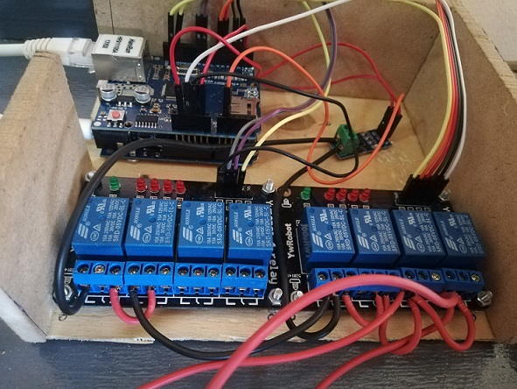

**Arduino , POE cable and the Route**

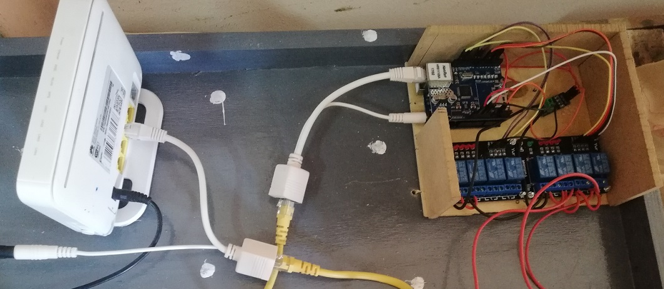

**Testing**

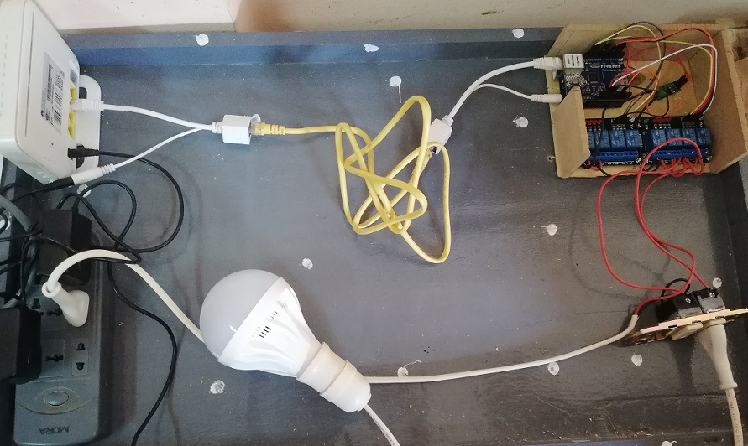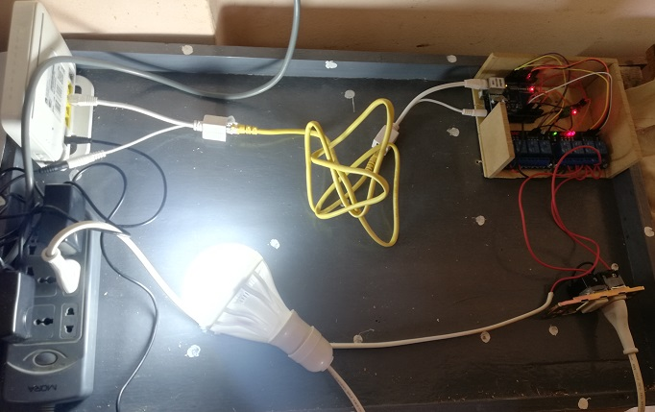

**3.2 Software phase**

at this phase we created :

* 1. Arduino code
  2. Mobile application

**1. Arduino code**

we used arouino software for writing the code and upload it on the board.

**Code :**

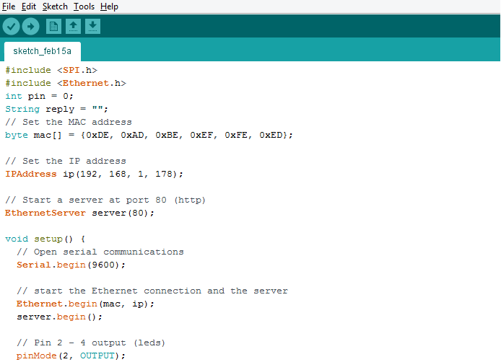

**Figure**

in this figure we set the arduino IP and set the output pins of the arduino .

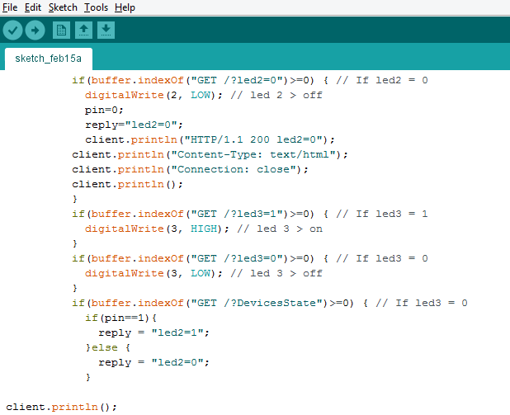

**Figure**

in this figure we handled the request from the mobile application to make an action

and send reply to the mobile application.

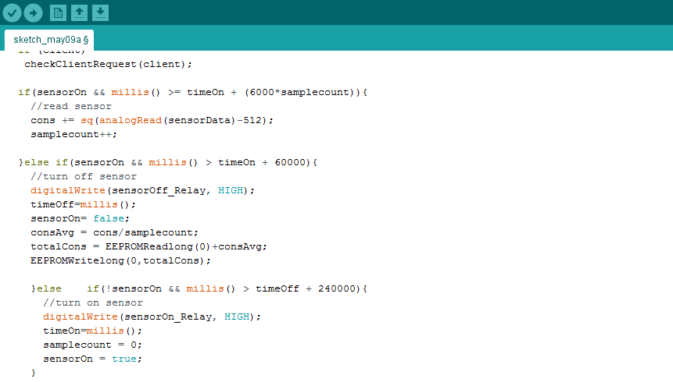

**Figure**

In this figure shows the code of the sensor that calculate current to know the

consumption of the user .

**Android studio**

Android Studio is the official integrated development environment ([IDE](https://searchsoftwarequality.techtarget.com/definition/integrated-development-environment)) for Android application development. It is based on the [IntelliJ IDEA](https://www.theserverside.com/definition/IntellJ-IDEA),a [Java](https://www.theserverside.com/definition/Java) integrated development environment for software, and incorporates its code editing and developer tools.

android studio offers even more features that enhance your productivity when building android apps,such as :

* [Gradle](https://en.wikipedia.org/wiki/Gradle)-based build support
* Android-specific [refactoring](https://en.wikipedia.org/wiki/Code_refactoring) and quick fixes
* [Lint](https://en.wikipedia.org/wiki/Lint_(software)) tools to catch performance, usability, version compatibility and other problems
* [ProGuard](https://en.wikipedia.org/wiki/ProGuard_(software)) integration and app-signing capabilities
* Template-based wizards to create common Android designs and components

**Project structure**

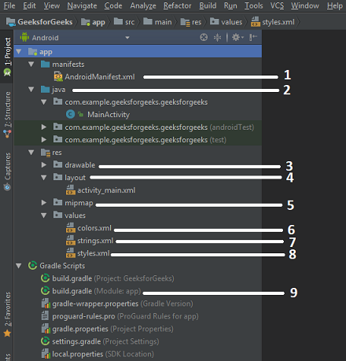

**1. AndroidManifest.xml**: it stored in the root directory of its project hierarchy. The manifest file is an important part of our app because it defines the structure and metadata of our application. This file includes nodes for each of the Activities, Services, Content Providers and Broadcast Receiver that make the application and using Intent Filters and Permissions, determines how they co-ordinate with each other and other applications.

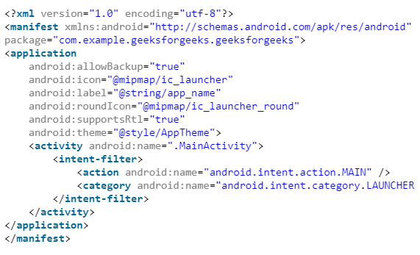

**2. Java**: The Java folder contains the Java source code files. These files are used as a controller for controlled UI (Layout file). It gets the data from the Layout file and after processing that data output will be shown in the UI layout. It works on the backend of an Android application.

**3. drawable**: A Drawable folder contains resource type file (something that can be drawn). Drawables may take a variety of file like Bitmap (PNG, JPEG), Nine Patch, Vector (XML), Shape, Layers, States, Levels, and Scale.

**4. layout**: A layout defines the visual structure for a user interface, such as the UI for an Android application. This folder stores Layout files that are written in XML language. You can add additional layout objects or widgets as child elements to gradually build a View hierarchy that defines your layout file.

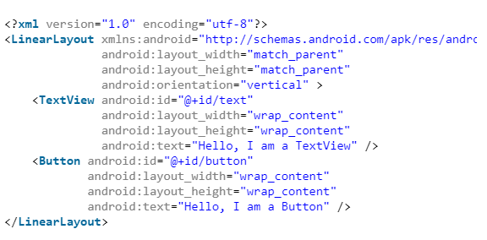

**6.colors.xml**: colors.xml file contains color resources of the Android application. Different color values are identified by a unique name that can be used in the Android application program.

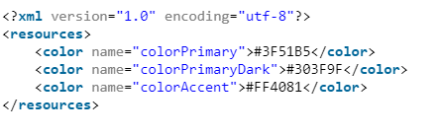

**7.strings.xml**: The strings.xml file contains string resources of the Android application. The different string value is identified by a unique name that can be used in the Android application program. This file also stores string array by using XML language.

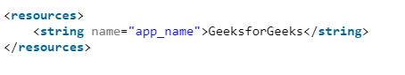

**8.styles.xml**: The styles.xml file contains resources of the theme style in the Android application. This file is written in XML language.

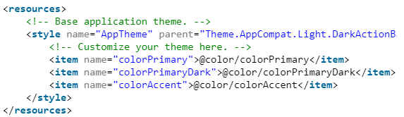

**9.build.gradle(Module: app)**: This defines the module-specific build configurations.

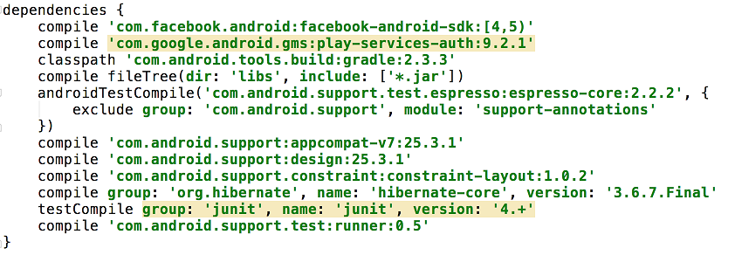

**Android | build.gradle**

Gradle is a build system (open source) which is used to automate building, testing, deployment etc. “Build.gradle” are scripts where one can automate the tasks. For example, the simple task to copy some files from one directory to another can be performed by Gradle build script before the actual build process happens.

**Why is Gradle needed?**

Every Android project needs a gradle for generating an apk from the *.*java and .xml files in the project. Simply put, a gradle takes all the source files (java and XML) and apply appropriate tools, e.g., converts the java files into dex files and compresses all of them into a single file known as apk that is actually used.

**Features of Gradle**

The following is the list of features that Gradle provides.

* **Language for dependency based programming** − The declarative language lies on a top of a general purpose task graph, which you can fully leverage in your build.
* **Structure your build** − Gradle finally allows you to apply common design principles to your build. It will give you a perfect structure for build, SO that you can design well-structured and easily maintained, comprehensible build.
* **Deep API** − Using this API it allows you to monitor and customize its configuration and execution behavior to its core.
* **Gradle scales** − Gradle can easily increases their productivity, from simple and single project builds to huge enterprise multi-project builds.
* **Multi-project builds** − Gradle supports for multi-project builds and it supports partial builds. If you build a subproject Gradle takes care of building all the subprojects that it depends on.
* **Different ways to manage your builds** − Gradle supports different strategies to manage your dependencies.
* **Gradle is the first build integration tool** − Gradle fully supported for your ANT tasks, Maven and lvy repository infrastructure for publishing and retrieving dependencies. Gradle also provides a converter for turning a Maven pom.xml to Gradle script.

**Mobile application**

**About smart circuit breaker mobile app**

This application used for controlling the smart circuit breaker .

Some instructions for using this app:

* Click on the room you want to control it's electrical devices states.
* Enter the name of each device and control the state of the device by clicking on the toggle switch.
* in the consumption page , you have a counter showing yout consumption of electricity , a place to write your budget and a notification will be sent to you with your consumption ( watt and pounds ) and alerts you when you exceed your budget.

**Voice search**

we added this feature to the mobile application and it allows the user to control the devices by voice command the is being sent to the mobile application .

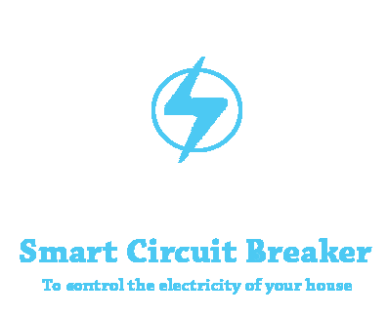

in **mobile application** it divided into two parts is :

1. Front-End coding.
2. Back-End coding.

**Front-End coding**

first we made the design of application on Photoshop and convert it to **XML.**

**XML :** using android's xml you can design UI layouts and the screen elements they contain.

**Application design**

**Start acticity :**

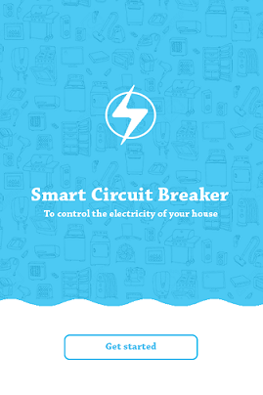

**Start activity XML code :**

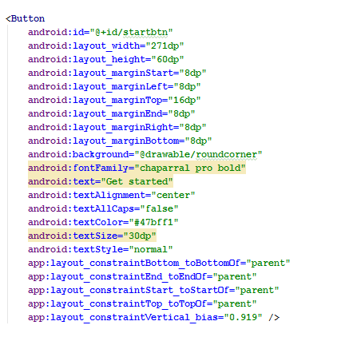

**Main activity :**

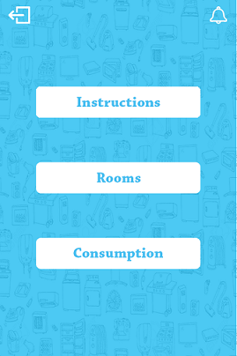

**Main activity XML code :**

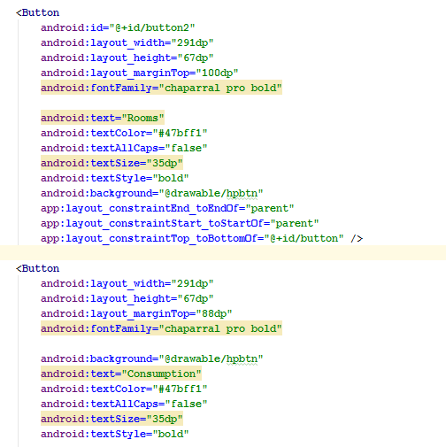

**Rooms activity :**

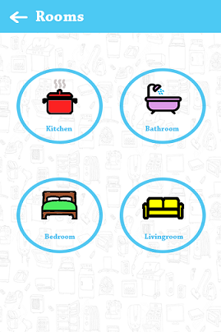

**Rooms activity XML code:**

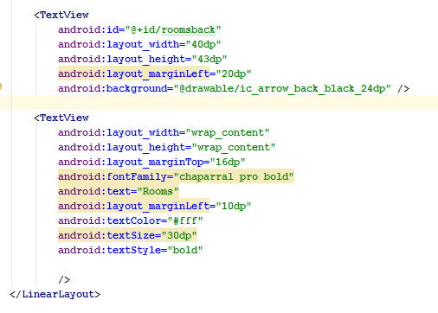

**Kitchen activity :**

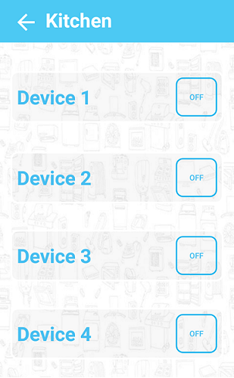

**Kitchen activity XML code :**

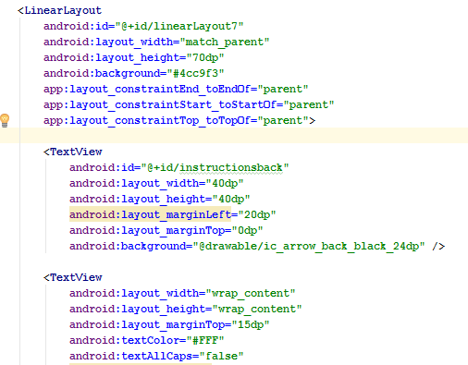

**2. Back-End coding**

We used Java programming language for developing the mobile application.

**Code example :**

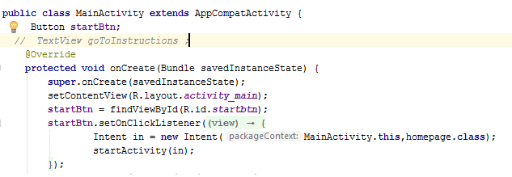

**Creating the network**

* First we connect the mobile application by giving it the same IP of the arduino to control it via internet.
* Handle the request that arduino will receive it to make specified action.
* Waiting the reply from arduino (Device status)

To make this network public we must use **static IP**

**It's code :**

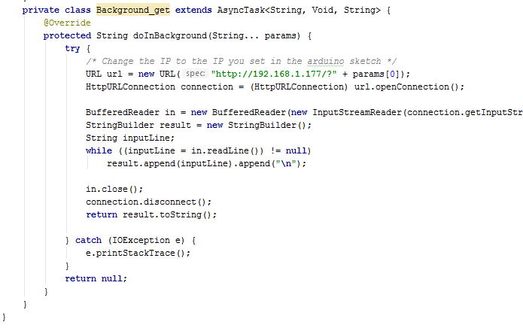

**Voice search**

Voice search is a speech recognition technology that allows users to search by saying terms aloud rather than typing them into a search field. The proliferation of smart phones and other small, Web-enabled mobile devices has spurred interest in voice search.

**Applications of voice search include:**

* Making search engine queries.
* Clarifying specifics of the request.
* Requesting specific information, such as a stock quote or sports score.
* Launching programs and selecting options.
* Searching for content in audio or video files.

Voice search also facilitates multiple rounds of interaction during automatic system clarification requests. Voice search is considered an open-domain question-answering system because of its interactive nature.

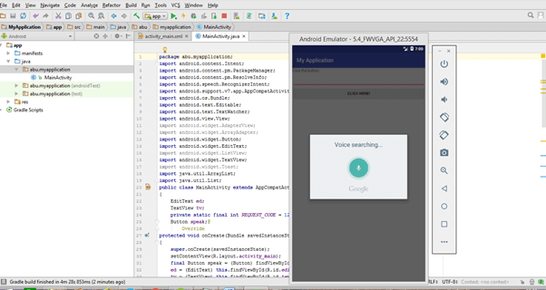

**Voice search java code :**

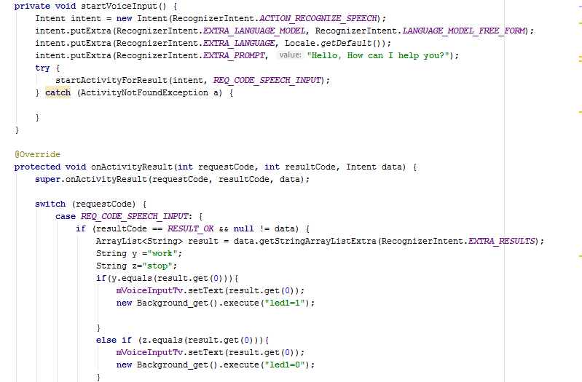

In this figure the application take the voice command from the user and send it to arduino to make an action.

**Git and github**

* Git is a VCS — Version Control System. What that really means is, Git helps us manage our project files. One of the primary things that git does and also the primary reason it exists is to keep track of the entire history of things that you are working on.
* This is especially helpful for software developers because when you are working on a project you first build a basic version of it and then try to improve it by adding new features (or) just experiment with things. This whole process of experimenting with new features is incredibly error prone and you might wanna revert back to your original code.
* This is where Version Control comes into play, it automatically tracks every minute change in your project and allows us to revert back to a previous version no matter how many times you changed your files.
* Another awesome thing that Git allows to do is, it allows people to work together on the same project at the same time without disturbing each other’s files. Collaboration is all the more easier with Git.Team members can work on different features and easily merge changes.
* Git is easy to learn and has a lightning fast performance. It outclasses other Version Control Systems like SubVersion with features like cheap and local branching, convenient staging areas and multiple workflows.

### Some Basic Terminology

* **Repository:**A Git Repository, or a repo, is a folder that you’ve told Git to help you track file changes.
* **Branch:** A branch is an independent line of development. You can think of it as a brand new working directory.
* **Fork:**A fork is a personal copy of another user’s repository that lives on your account.
* **Clone:** A clone is simply a copy of a repository that lives on your computer instead of on a server.
* **Commit:** A commit is a set of one or more changes to a file(or a set of files). Every time you save, it creates a unique ID(“hash”) which helps it keep track of the history.
* **Master:** The default development branch. Whenever you create a git repo, a branch named “master” is created which becomes the default active branch.

**Our repository on github**

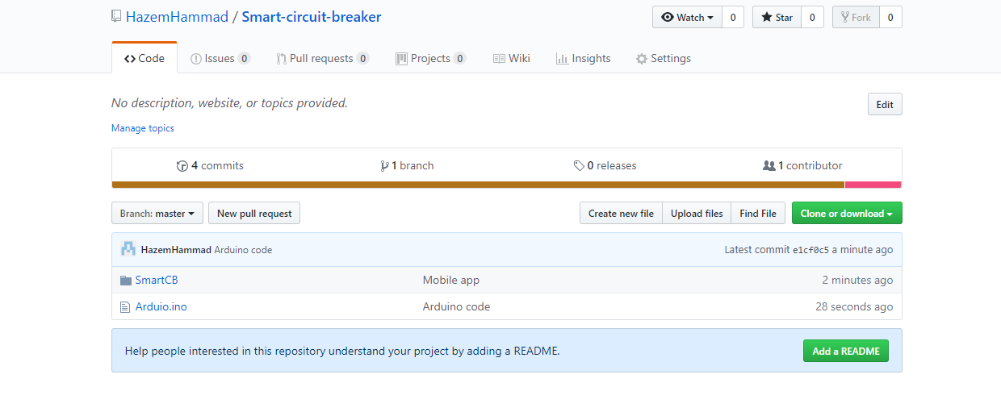



**Coding Workspace**

before we starting in coding project we determined what is the workspace that we will deal with. our project is divided into two parts :

1. **Mobile application**
2. **Arduino code**

**Mobile application workspace**

in this track we used android studio workspace for coding

صوره

**Arduino**

In this track we used arduino for coding.

صوره

صوره المشروع وهو شغال

**Chapter4**

**Conclusion**

**4.1 Our journey :**

- This graduation project is the last step in our educational journey , it contains the essence of all the five years we have spent in college .

- We have passed through many stages in this project from creating the team , getting the idea , the analysis , the design , testing and finally the implementation of the project and making it works successfully .

- We have faced many happy moments and bad moments ,too .

**- There is no doubt that we have faced many obstacles and problems such as :**

1. Getting a good idea that helps society .

2. The arrangement of meetings .

3. Components leakage in the surrounded environment .

4. Dealing with some software and hardware components like installing android studio .

5. Our little experience with some hardware components .

- But what doesn’t kill you makes you stronger .

**4.2 What we have learned :**

- Everyone has learned many skills that will help him in the future like :

**4.2.1 Technical skills :**

1 . Following software engineering cycle .

2 . Dealing with Arduino and its shield .

3 . Dealing with relays .

4 . Dealing with current sensor .

5 . Design the user interface for the mobile application using Photoshop and XML .

6 . Creating a whole mobile application and making our design active ( android development ) .

7 . Dealing with network field and components ( Wi-Fi module and router ) .

8 . Connecting all software and hardware components to get a final prototype .

9 . Dealing with github .

**4.2.2 Non-technical skills :**

1 . How to search and get an idea that is suitable for market .

2 . How to handle problems and find a solution .

3 . Teamwork and co-operation .

4 . Dealing with deadline ( finishing a task on time properly ) .

5 . How to search the internet to get what we need for the project .

**4.3 Mistakes we have made :**

1 . We took a long time to search ideas and determine which one to go with .

2 . The internet problem in college wasn’t expected .

3 . Irregular meetings .

4 . Designing and making complex electronic circuits at the beginning instead of using a simple component .

5 . Wrong distribution of tasks among team members at the beginning .

6 . We have only made a prototype without implementing the project in real life .

7 . Some unneeded costs and wasted time .

**4.4 What we are seeking from our project :**

- The main purpose of our project is to provide easy and comfort with a small size and suitable cost .

- The smart circuit breaker allows people to control their electric devices’ state in each room in their house easily using a mobile app and Wi-Fi .

- Reducing the electricity consumption is one of the important purposes of the smart circuit breaker .

- You can know your electricity consumption and be warned if you exceed the budget you entered in the app ( saves your money ).

- It provides an easy maintenance than the normal circuit breaker .

-  A traditional breaker is designed to automatically interrupt an electric circuit when it detects excessive current. Its role is to protect the system from overloads, short circuits and insulation failure. A smart circuit breaker will not only protect the system, it will also include advanced functionality, wireless connectivity and metering capabilities. This will allow the smart breaker to be monitored and controlled remotely, provide real-time feedback on any connected assets, notifying operators of any overloads or other potential faults.

**4.5 Smart circuit breaker and the future :**

- The energy transmission and distribution industry is evolving. The ‘smart grid’ concept holds much promise and has become a critical goal for many utility providers in helping to manage electricity needs .

- A critical part of making smart grids a reality is the installation of smart circuit breakers .

- This next generation of switchgear and circuit breakers takes advantage of integrated electronics so that power supplies can be monitored and controlled remotely- opening up efficiency and productivity gains for operators .

- But that’s not the only benefit. By using encrypted internet codes each circuit can be monitored individually allowing for a broad analysis of a building’s power consumption .

- With societal concerns regarding environmental degradation high on the agenda, the utilization of smart circuit breakers will also bring about significant savings regarding energy usage.

- As you can imagine, such capabilities could be a game changer, altering the business models of utility providers as well as improving the consumer experience of electricity services.

- With all of these benefits, upgrading to smart circuit breakers seems like an intelligent option.

**4.6 References:**

1. User Interface design for mobile app :

<https://youtu.be/6j6PhIxVx4Y>

<https://www.color-hex.com/>

<https://www.pinterest.com/>

2. Android development :

<https://developer.android.com/>

3. Arduino :

<https://www.arduino.cc/>

<https://youtu.be/DNuWN_nvtA4>

4. Current sensor :

<https://youtu.be/KvQCUfHF-OU>

5. Githubrepository :

<https://github.com/HazemHammad/Smart-circuit-breaker?fbclid=IwAR0o4S2Lob02CSir8o9ihysrYHE-ZZZzngUP_TOeTMTe7RcTGnUVPcnKVSQ>

**نبذة عن المشروع :**

عباره عن التحكم في كهرباء المنزل مباشره من قاطع الكهرباء (لوحه التحكم الرئيسية) عن طريق مجموعه من الاردوينو متصلة مع بعضها بشبكة من خلال الانترنت ، مثلا للتحكم في إضاءة غرف المنزل او تشغيل الأجهزه الكهربية ويكون التحكم عن طريق تطبيق علي الموبايل باستخدام خدمة الواي فاي ،و يمكن للمستخدم أيضا معرفة استهلاكه للكهرباء و تحديد ميزانية لها إذا تعداها يرسل له تطبيق الموبايل إنذار ، وهذا أمر فعال لأنه سيوفر الأموال التي يتم إنفاقها على الأجهزة الذكية ذات الأسعار العالية ويوفر الطاقة أيضا.

**أعضاء الفريق :**

- حازم السيد مصطفي حماد .

- رانيا جمعه عبد الجيد تركي .

- عمر مجدي محمود عبد البر .

- محمد جمال خليل رمضان .

- مريم أيمن أنور شاهين .

- نرمين محمد عبد المنعم السبكي .

**تحت إشراف :**

د / نرمين عبد الوهاب البهنساوي