College of Engineering and Technology
Web Engineering Department
Arab Academy for Science, Technology and Maritime Transport — AAST
PROJECT DOCUMENTATION
Web Engineering

Project Title:
Aether Threads — Contemporary Clothing E-Commerce Platform

Supervised By | Dr. / Prof. Amr Aly Fahmy
Course | Web Engineering
Semester | 8
Academic Year | 2025–2026

Table of Contents

1. Project Team

1.1 Team Members
Full Name | College ID | Role / Responsibility | Email
Hazem Mohab | 221005429 | Database & DevOps Engineer | hazemmohabmaher@gmail.com
Omar Mohamed Abobakr | 221006182 | Backend Developer | omarabobakrr123@gmail.com
Mohamed Ahmed Abdellah | 221004454 | Frontend Developer | mohamed313hp@gmail.com
— | — | — | —
— | — | — | —

1.2 Sub-Group Distribution
Divide the team into sub-groups based on project layers or modules.
Sub-Group | Member(s) | Module / Layer | Key Deliverable
Frontend | Mohamed Ahmed Abdellah | UI / UX, Pages, Components | Responsive web pages
Backend | Omar Mohamed Abobakr | API, Auth, Business Logic | REST API endpoints
Database | Hazem Mohab | Schema, Queries, ORM | DB design & migrations
DevOps / QA | Hazem Mohab | Deployment, Testing | CI/CD pipeline & test reports

2. Introduction & Problem Statement

2.1 Background
Provide context about the domain or field your web application addresses. Explain the current landscape, existing solutions, and why this project is needed.
The Egyptian fashion and streetwear industry has grown significantly over the past decade, with local independent brands such as TWENTYSEVEN, HAXEL, and Salty Studios gaining strong recognition among youth audiences. Despite this growth, most brands rely on social media for product discovery and manual ordering via DMs or phone calls, creating a fragmented and inefficient purchase experience. Aether Threads addresses this gap by providing a dedicated, professionally built e-commerce platform tailored to contemporary Egyptian streetwear, delivering a seamless end-to-end shopping experience from product discovery to order confirmation.

2.2 Problem Statement
Describe the core problem your web application solves. Be specific and concise.
- Egyptian streetwear brands lack a centralized online storefront, forcing customers to shop through social media DMs or fragmented third-party marketplaces.
- Existing platforms offer poor product browsing experiences with no category filtering, no color/size selectors, no image galleries, and no real-time stock management.
- Customers have no reliable way to track order status, view order history, or manage their accounts after placing a purchase.
- Small and mid-size brands lack affordable tools to manage their product catalog, upload images, and handle orders without developer intervention.

2.3 Motivation
Explain why solving this problem matters and what impact the solution will have on users or the target audience.
Aether Threads was built to empower Egyptian streetwear brands with a professional online presence that matches the quality of their products. By building a full-stack e-commerce platform from scratch, this project demonstrates the practical application of modern web engineering principles—RESTful API design, JWT authentication, relational database modeling, cloud deployment, and responsive UI development—in a real-world product context.

3. Project Objectives
By the end of this project, the team will have achieved the following measurable goals:
- Build a fully responsive Single Page Application (SPA) using React 18 and Tailwind CSS, supporting mobile and desktop viewports from 320px to 1440px.
- Implement secure user authentication using JWT access tokens and a refresh token mechanism, with role-based access control differentiating customer and admin permissions.
- Design and develop a RESTful API with 20+ endpoints covering products, categories, cart management, orders, and admin operations.
- Design a normalized PostgreSQL database with 8 tables and manage schema evolution through Knex.js migrations and seed files.
- Deploy the complete application to production—frontend on Vercel and backend on Railway—with proper CORS configuration and environment variable management.
- Build a fully functional admin dashboard enabling product creation, image upload via Multer, and real-time order status management without requiring code changes.

4. Technology Stack
List every technology, library, and tool used in the project.
Layer | Technology / Tool | Purpose / Notes
Frontend Framework | React 18 + Vite 5 | UI rendering & routing
Styling | Tailwind CSS v3 | Component styling
Backend Framework | Node.js + Express.js | Server-side logic & APIs
Database | PostgreSQL 15 | Data persistence
ORM / ODM | Knex.js (SQL query builder) | Database interaction layer
Authentication | JWT (jsonwebtoken) + bcrypt | User auth & sessions
Version Control | Git + GitHub / GitLab | Source code management
Deployment | Vercel (Frontend) + Railway (Backend + DB) | Hosting & CI/CD
Testing | Supertest + Postman | Unit / integration / E2E tests
File Upload | Multer v2 | Product image upload and static file serving via Express

5. System Architecture & Design

5.1 High-Level Architecture
Describe how the major components of your application interact (client, server, database, external APIs, etc.).
The application follows a three-tier architecture: (1) React 18 SPA deployed on Vercel; (2) Express.js RESTful API deployed on Railway, serving business logic and static uploaded images; (3) PostgreSQL relational database hosted on Railway. Vercel rewrites proxy all /api/* and /uploads/* requests to the Railway backend URL, eliminating cross-origin issues. Middleware stack: Helmet (security headers), CORS (*.vercel.app whitelist), express-rate-limit (10 req/min on auth), express-validator (input sanitization), JWT authenticate guard, global error handler.
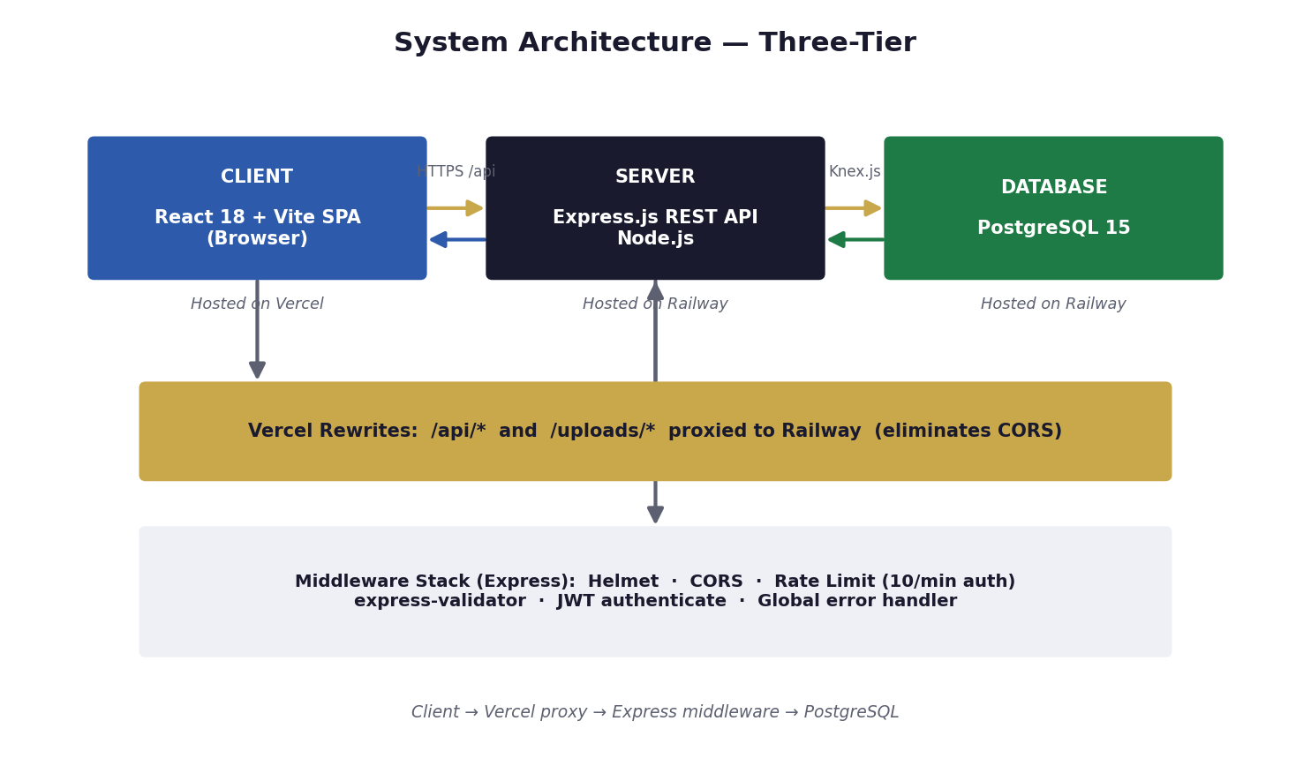

5.2 Frontend Architecture
Describe the component structure, routing strategy, and state management approach.
- Pages: Home, Shop (filterable product listing), Product Detail (color/size selector + image gallery), Cart, Checkout, Order Confirmation, Account Orders, Login, Register, Admin Dashboard, Admin Products (CRUD + image upload), Admin Orders.
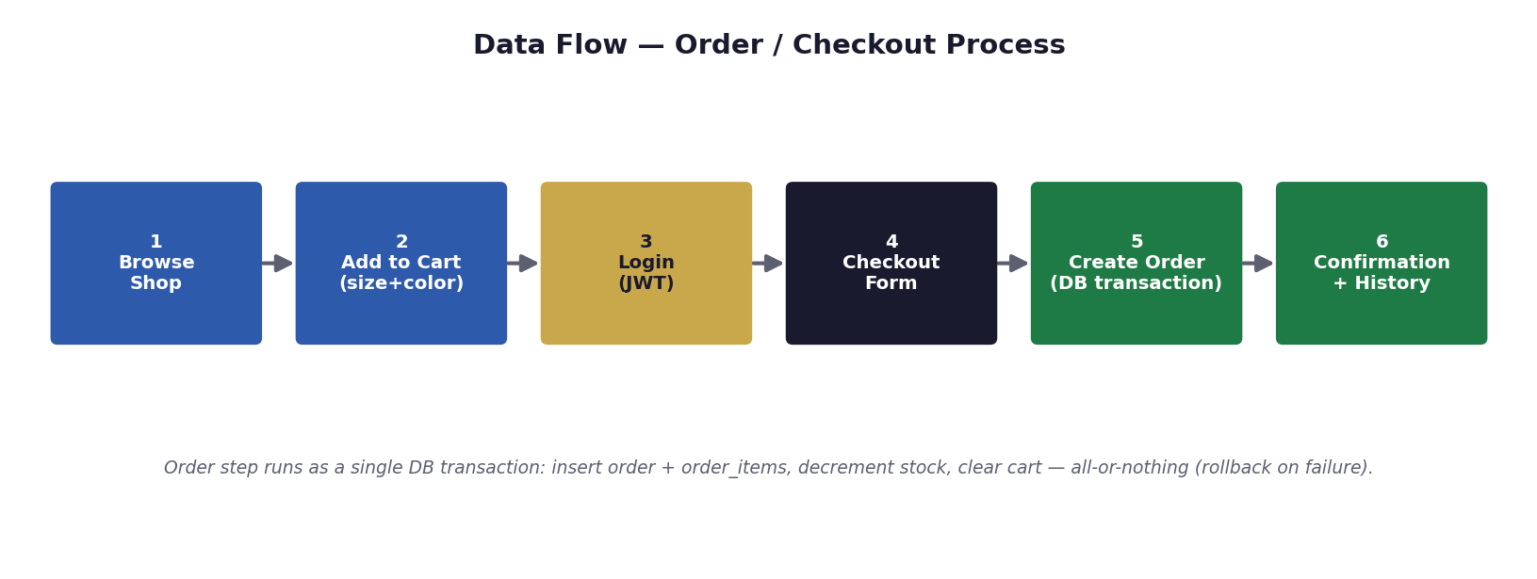
- State management: React Context API — AuthContext manages user session and JWT token; CartContext manages persistent cart data fetched from the API on login.
- Routing: React Router v6 with ProtectedRoute HOC that redirects unauthenticated users. Admin routes additionally verify role === "admin" before rendering.

5.3 Backend Architecture
Describe the API design, middleware, and server structure.
- RESTful API with base path /api/v1/, organized by resource: /auth, /products, /cart, /orders, /admin.
- Module-based structure: each domain has routes.js, controller.js, and service.js. This promotes separation of concerns and makes each module independently testable and maintainable.
- Middleware: Helmet, CORS (*.vercel.app), express-rate-limit (auth routes), express-validator, JWT authenticate, global notFound + errorHandler.

5.4 Database Schema
Describe the main entities, relationships, and key fields.
6-table PostgreSQL schema: users (role enum: customer/admin, bcrypt password_hash), categories (self-referential parent_id for subcategories), products (price, stock_qty, image_url, and JSONB columns: colors, sizes, color_images, image_gallery), cart_items (user_id, product_id, quantity, size, color), orders (status enum, subtotal, tax, shipping, total, JSONB shipping_address), order_items (quantity, size, color, unit_price snapshot). Users, products, cart_items, orders and order_items use UUID primary keys; categories uses an auto-increment integer key. All tables include created_at and updated_at timestamps.
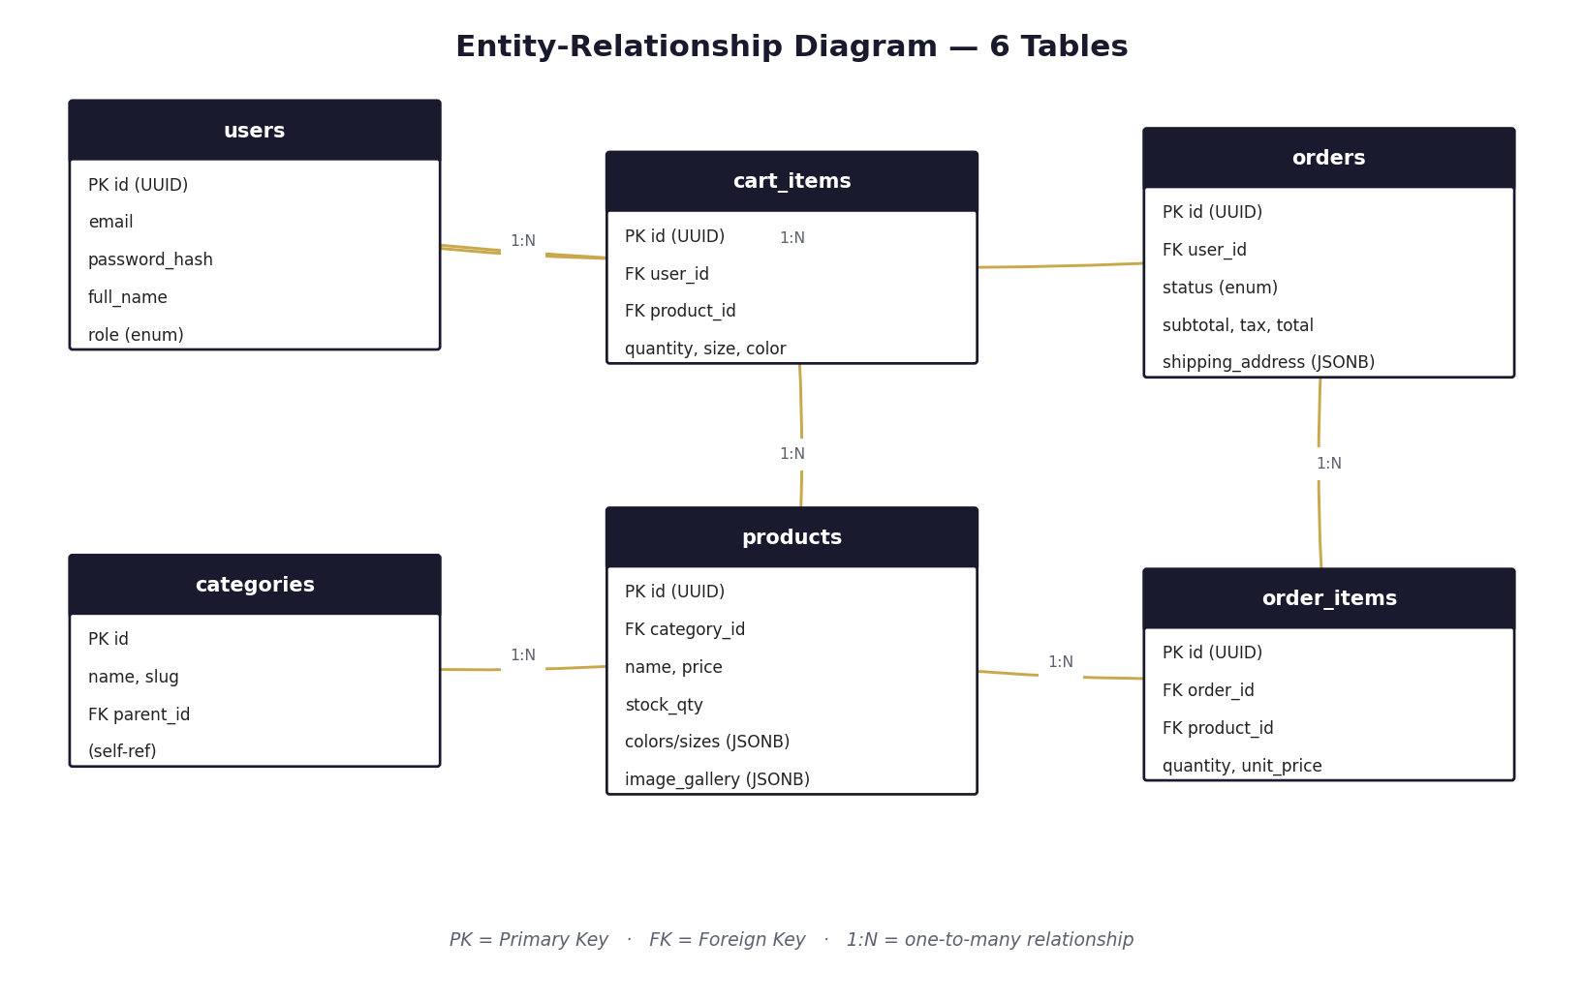

6. Project Steps & Phases
Outline each development phase with its tasks and expected outputs.
Phase | Step / Task | Expected Output / Deliverable
Phase 1 | Project planning, requirements gathering, wireframes | SRS document, wireframes, approved scope
Phase 2 | Database schema design, API contract definition | ERD, API documentation (Swagger / Postman collection)
Phase 3 | Environment setup, project scaffolding, Git workflow | Initialized repo, CI/CD pipeline, branch strategy
Phase 4 | Backend development — models, routes, controllers | Working API endpoints with Postman tests
Phase 5 | Frontend development — pages, components, integration | Functional UI connected to backend API
Phase 6 | Authentication, authorization, security hardening | Secure login, protected routes, role-based access
Phase 7 | Testing — unit, integration, and end-to-end | Test reports, bug fixes
Phase 8 | Deployment, performance optimization, final demo | Live URL, final report, presentation slides

7. Group Task Distribution
Assign each feature or module to a team member. Update the Status column as the project progresses.
Module / Feature | Assigned Member(s) | Sub-Group | Status
UI Layout & Navigation | Mohamed Ahmed Abdellah | Frontend | Completed
Authentication Pages | Mohamed Ahmed Abdellah | Frontend | Completed
Dashboard / Main Feature | Mohamed Ahmed Abdellah | Frontend | Completed
Auth API (Register/Login) | Omar Mohamed Abobakr | Backend | Completed
Core Business Logic API | Omar Mohamed Abobakr | Backend | Completed
Database Design & Seeding | Hazem Mohab | Database | Completed
Deployment & Hosting | Hazem Mohab | DevOps | Completed
Testing & QA | Omar Mohamed Abobakr | QA | Completed
Product Image Upload & Admin Dashboard | Hazem Mohab | Full-Stack | Completed

8. Development Timeline
Adjust weeks to match your actual course schedule.
Week | Phase / Task | Responsible Sub-Group | Deliverable
1 | Kickoff — requirements, wireframes, planning | All | SRS + Wireframes
2 | DB schema design & API contract | Backend + Database | ERD + API Docs
3 | Environment setup, scaffolding, Git workflow | All | Running dev environment
4 | Backend API development — Phase 1 | Backend | Auth + core endpoints
5 | Frontend development — Phase 1 | Frontend | Core pages & components
6 | Integration — frontend ↔ backend | All | Connected application
7 | Testing, bug fixes, optimization | QA + All | Test reports
8 | Deployment + final demo + report submission | DevOps + All | Live app + Final report

9. Full Project Documentation

9.1 Features & Functional Requirements
List every feature the application must support.
- User registration and login with JWT access tokens, a refresh token mechanism, and bcrypt password hashing.
- Product browsing with multi-parameter filtering: category, type, color, size, price range, keyword search, and new arrivals flag.
- Persistent shopping cart linked to authenticated user accounts, with per-item color and size selection.
- Complete checkout flow: shipping address form, Cash on Delivery or Card payment, order confirmation page, and order history.
- Admin dashboard with full product CRUD, Multer image upload, order listing, and order status management. All admin endpoints protected by JWT + role verification.

9.2 Non-Functional Requirements
- Performance — API response under 300ms for standard product listing and filter queries under normal load.
- Security — bcrypt hashing (cost factor 10), Helmet headers, rate limiting (10 req/min on auth), input validation (express-validator), short-lived JWT + refresh token mechanism.
- Scalability — Stateless JWT-based API (no server sessions) enabling horizontal scaling. Knex.js connection pooling (min 2, max 10).
- Accessibility — Semantic HTML, keyboard navigation support, and sufficient color contrast ratios.
- Responsiveness — Mobile-first Tailwind CSS design. Dedicated mobile nav with horizontal-scroll category strip. Tested 320px to 1440px.

9.3 API Documentation
Document your main API endpoints. Add more rows as needed.
Endpoint | Method | Description | Auth Required | Response
/api/v1/auth/register | POST | Register a new user | No | 201 Created
/api/v1/auth/login | POST | Login and receive JWT token | No | 200 OK + token
/api/v1/auth/me | GET | Get current user profile | Yes | 200 OK
/api/v1/products | GET | List products with filters (category, type, color, size, minPrice, maxPrice, search, isNewArrival, page, limit) | No | 200 OK + paginated results

9.4 UI/UX Design Notes
Describe the design language, color palette, typography, and key user flows.
- Color palette — Navy #1A1A2E (brand primary), Gold #C9A84C (accent), White #FFFFFF (background), Light Gray #F9F9F9 (section fills), Dark #111111 (body text).
- Typography — System font stack. 14px base body, uppercase tracking-widest for nav and labels. Weights: 300 (display), 400 (body), 600 (CTAs).
- Key flows: (1) Home → Shop → Product Detail → Cart → Checkout → Confirmation. (2) Register/Login → Order History. (3) Admin → Manage Products + Orders.
Live app: https://aether-threads-7zmz.vercel.app | GitHub: https://github.com/HazemMohab/aether-threads | API: https://aether-threads-production.up.railway.app

9.5 Testing Plan
Test Type | Tool / Method | Scope | Pass Criteria
Unit Testing | Jest (configured) | Functions, utils | Framework configured; core logic verified
Integration Testing | Postman | API endpoints | All endpoints return 2xx/4xx
E2E Testing | Manual browser testing | Critical user flows | All critical flows verified manually
Responsiveness | Chrome DevTools | Mobile & desktop | No layout breaks

9.6 Deployment & DevOps
- Hosting — Frontend: Vercel (https://aether-threads-7zmz.vercel.app). Backend + PostgreSQL: Railway (https://aether-threads-production.up.railway.app).
- CI/CD — Vercel auto-deploys frontend on every GitHub push to main. Railway auto-deploys backend and runs knex migrate:latest before server start.
- Environment variables — .env file for dev (gitignored). Production: DATABASE_URL, JWT_SECRET, JWT_REFRESH_SECRET, CLIENT_URL set in Railway dashboard; VITE_API_URL set in Vercel dashboard.
- URLs — Frontend: https://aether-threads-7zmz.vercel.app | API: https://aether-threads-production.up.railway.app | GitHub: https://github.com/HazemMohab/aether-threads

10. Submission Checklist
☐ System architecture diagram completed
☐ Database ERD finalized and approved
☐ All API endpoints documented (Swagger / Postman collection)
☐ Frontend pages implemented and responsive
☐ Backend API tested and returning correct responses
☐ Authentication and authorization working correctly
☐ Frontend and backend fully integrated
☐ Database seeded with sample data
☐ Unit tests written and passing
☐ End-to-end tests covering critical flows
☐ Application deployed to production URL
☐ Environment variables secured (no secrets in repo)
☐ Code reviewed and merged to main branch
☐ Final project report completed and formatted
☐ Presentation slides prepared
☐ Live demo rehearsed by all team members

