CIE 552 mini-project 1

Team#2

Ahmed Mahmoud Abd-Elmoniem 201800683

Hazem Muhammad Tarek 201800283

**Algorithm**

1. Image filtering:

* Firstly, the filter gets padded so it has the same size as the image.
* FFT is taken for the filter after getting padded.
* FFT is taken for the image.
* The filter is applied to the image by multiplying the result of step 2 and step 3 then taking the I-FFT for the result.
* Incase of colored images, FFT is done separately for each of the red, blue, and green frequencies then it gets multiplied to the result of step 2 then I-FFT is taken for each of them then every color is put to its assigned channel (channel 0 for Blue, channel 1 for Green, and channel 2 for Red).

1. Hybrid images:

* The filter implemented in part 1 is applied to the 1st image to obtain its low frequencies.
* The filter implemented in part 1 is applied to the 2nd image to obtain its low frequencies.
* The high frequencies of the 2nd image are obtained by subtracting the low frequencies from the original image.
* Then the result of the previous step is added to the result of the 1st step to obtain the hybrid image.

**Extra credit**

* FFT-based convolution was used.

**Results**

* Hybrid image of a dog and a cat.

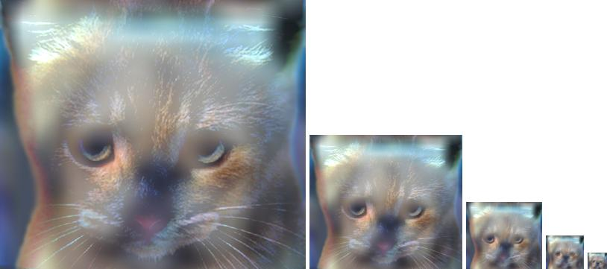

* Hybrid image of Marylin and Einstein.

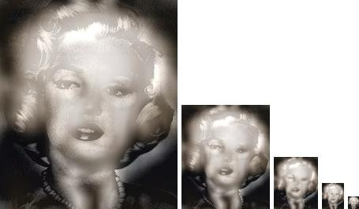

* Hybrid image of a fish and a submarine.

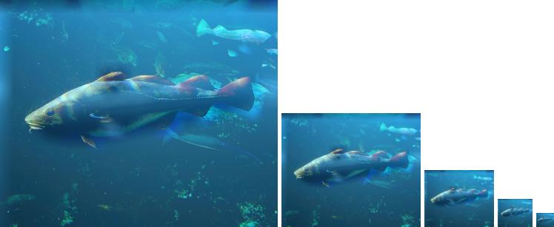

* Hybrid image of a bicycle and motor bike.



* Hybrid image of a plane and a bird

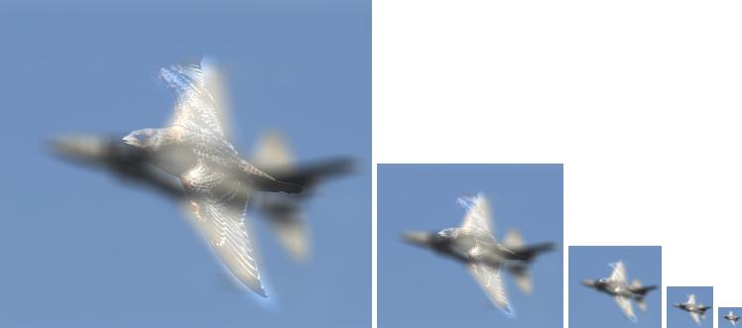

**Questions**

**Q1** Explicitly describe image convolution: the input, the transformation, and the output. Why is it useful for computer vision?

In image processing, convolution is the process of transforming an image by applying a filter over each pixel and its local neighbors across the entire image. The filter is a matrix of values whose size and values determine the transformation effect of the convolution process. It is important in computer vision because it is used to modify images (blurring) and find relevant structures (edge detection).

**Q2** What is the difference between convolution and correlation? Construct a scenario which produces a different output between both operations.

Convolution and correlation are similar mathematical operations. Correlation is also a convolution operation between the two signals but one of the signals is inverted. So, in correlation process one of the signals is phase shifted by 180 degrees.. for example, in signals and systems correlation is the degree of similarity between two signals while convolution is used to express the relation between the input and the output of an LTI system.

**Q3** What is the difference between a high pass filter and a low pass filter in how they are constructed, and what they do to the image? Please provide example kernels and output images.

HPFs allow signals of frequency more than the cut-off frequency to pass through while LPFs allow signals of frequency less than the cut-off frequency to pass through. HPF detects the sharp edges in the image while LPF blurs and makes the image more smooth by eliminating the high frequencies.

* Original image.

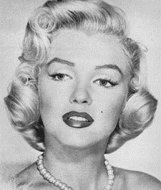

* Blurred image.

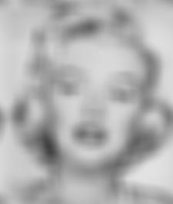

* High frequency image

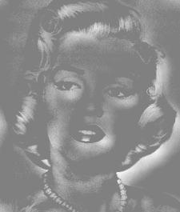

**Q4** How does computation time vary with filter sizes from 3 × 3 to 15 × 15 (for all odd and square sizes), and with image sizes from 0.25 MPix to 8 MPix (choose your own intervals)? Measure both using scipy.ndimage.convolve or scipy.ndimage.correlate to produce a matrix of values. Use the skimage.transform module to vary the size of an image. Use an appropriate charting function to plot your matrix of results, such as Axes3D.scatter or Axes3D.plot surf ace. Do the results match your expectation given the number of multiply and add operations in convolution?

The computation time should increase by increasing the size of the filter since the convolution operation is done by the element-wise multiplication then summation so by increasing the size of the filter the number of mathematical operations(addition and multiplication) increases which will consequently increase the computation time.