Stochastic Processes Calculator

Name: Hazem Muhammad Tarek.

ID: 201800283.

Part I

Results of the analysis of  using the stochastic processes calculator:

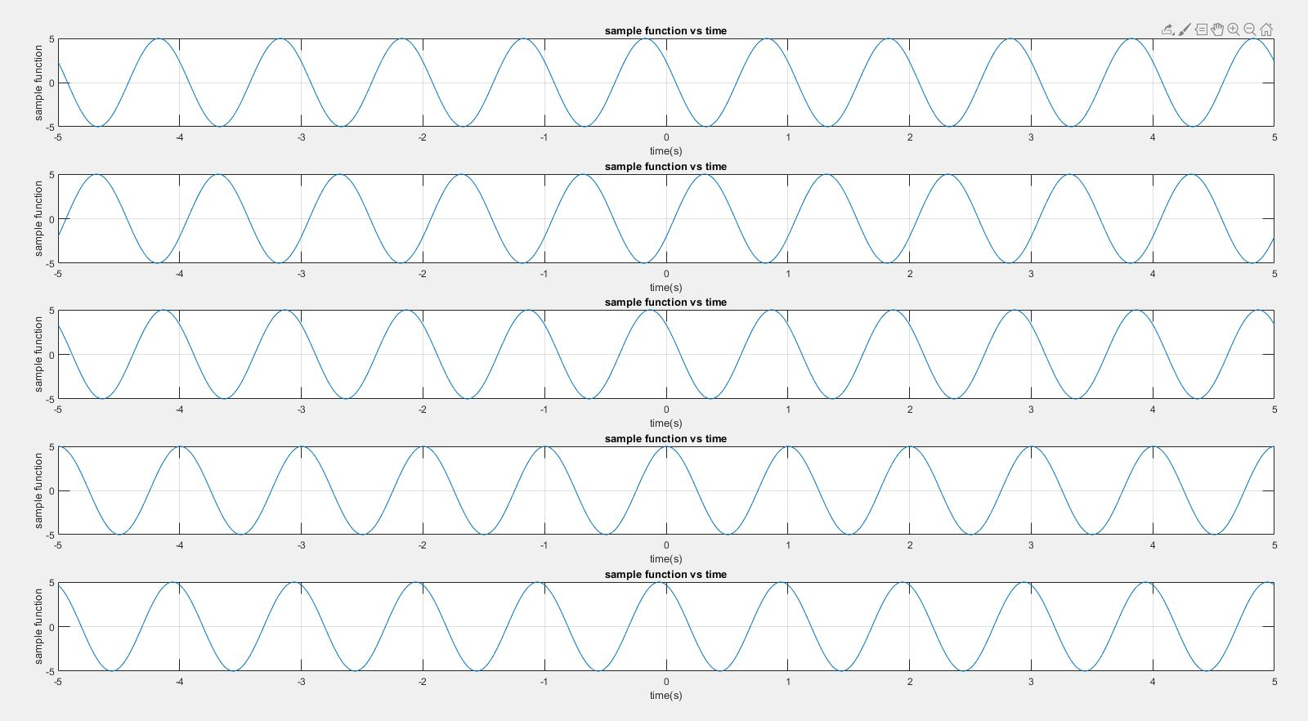

A plot of 5 random sample functions of the process where theta takes random values from -π to π.

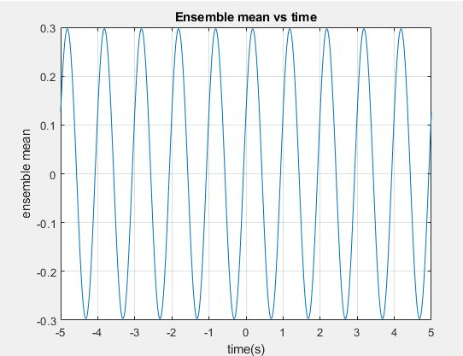

A plot of the ensemble mean of the random process It can be seen there is a small shift at t = 0 because takes random values from -π to π and the average equals zero. Also, taking more sample functions gets the value of the mean closer to zero.

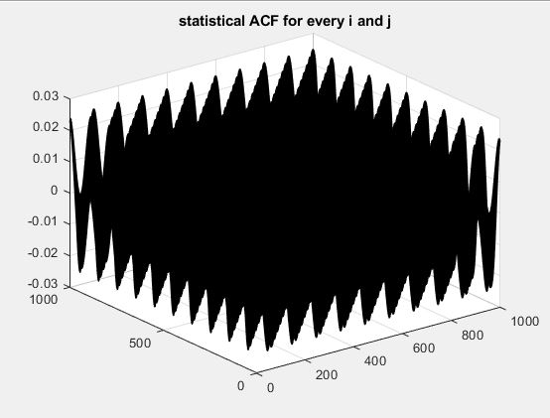

A 3D- plot for the Statistical ACF of the process where i and j are the horizontal axes and the vertical axis is the Statistical ACF.

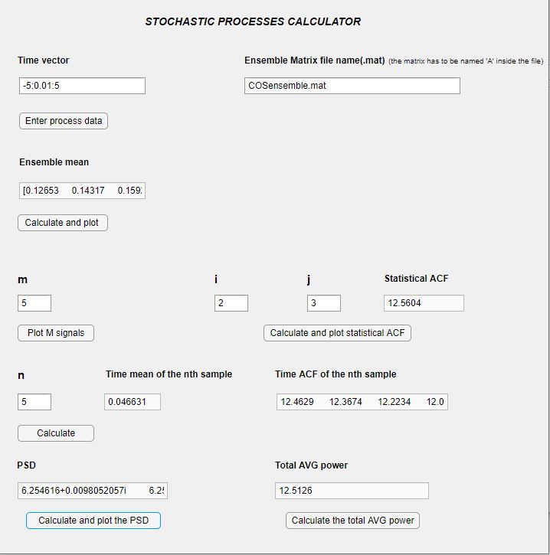UI results which show the time mean and the Time ACF for the random process where the time mean is very close to zero but not exactly zero because for the time mean to be zero the ensemble matrix has to be of infinite size. It can also be seen from the results that the Statistical ACF and the time ACF are almost equal and the same for the time mean and the ensemble mean which implies that the process is WSS and ergodic.

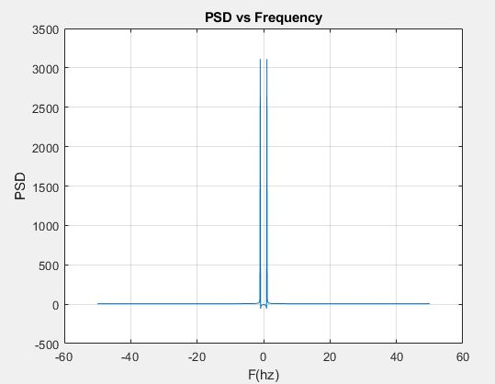

A plot of the power spectral density of the random process

Which is two delta functions at -1 and 1.

Part II

PNRZ Process:

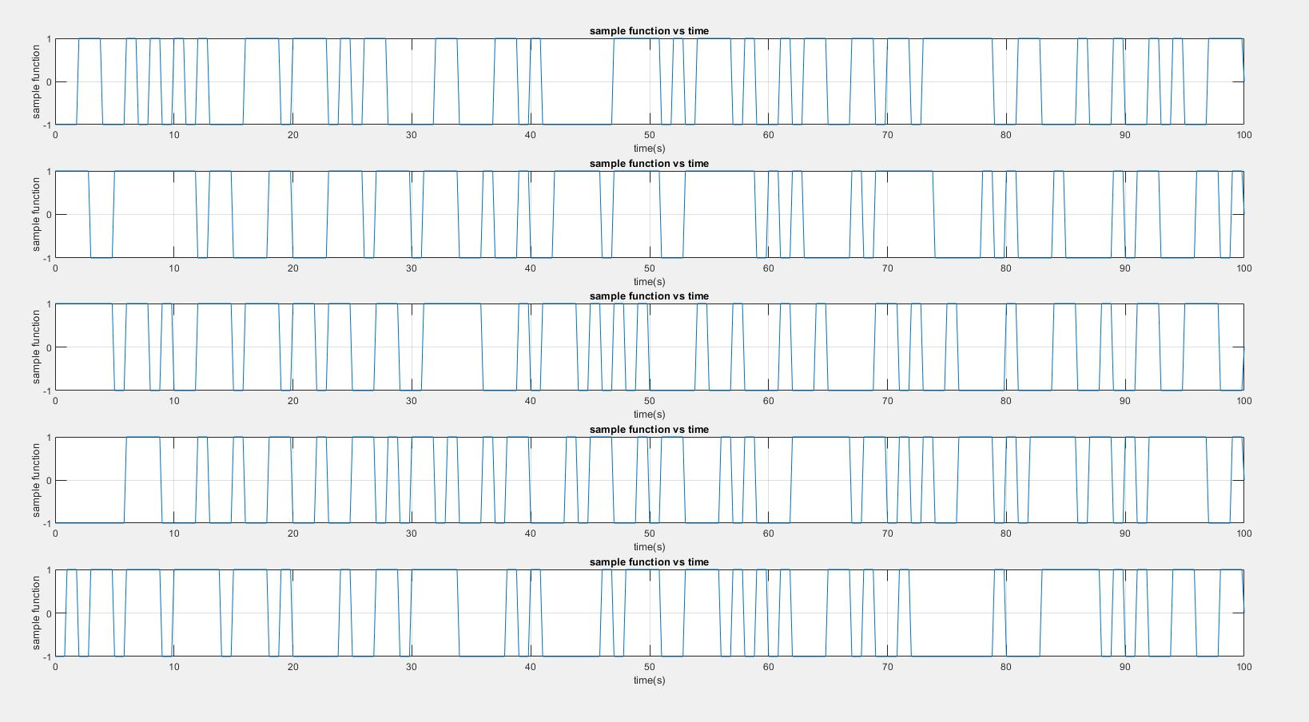

A plot of 5 random sample functions of the PNRZ process.

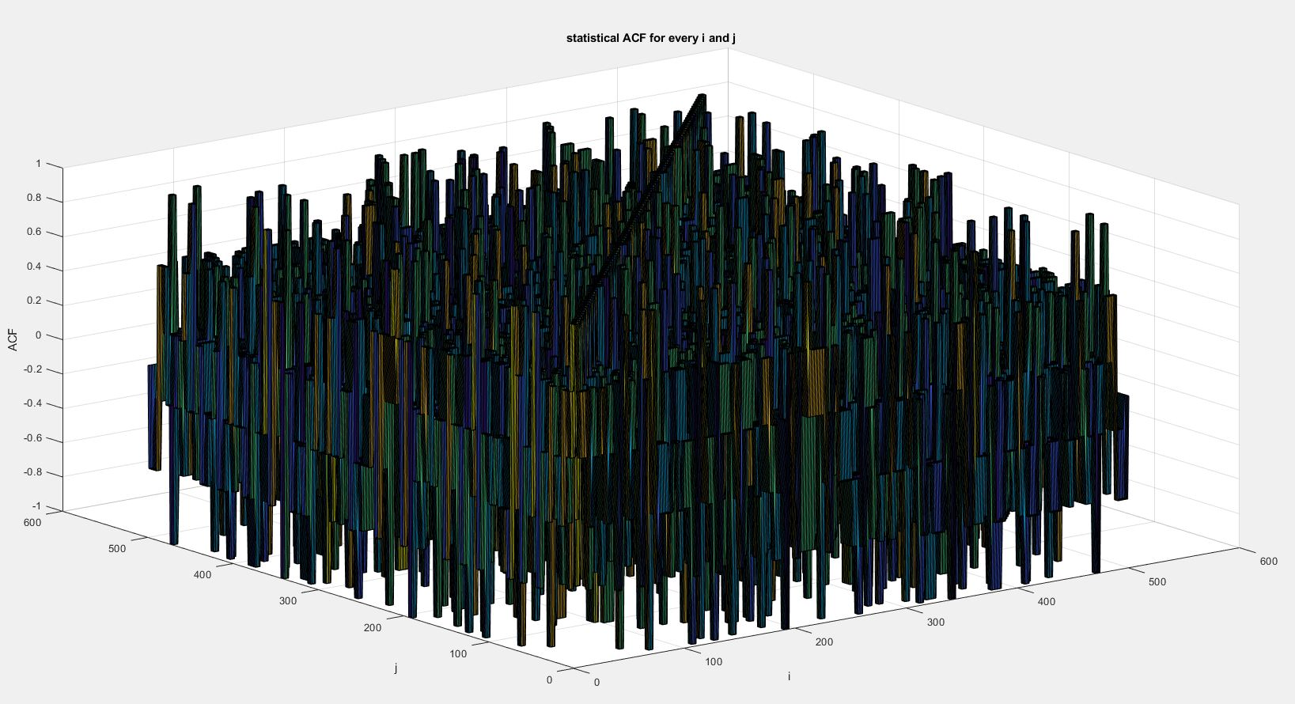

A 3D-plot of the statistical ACF of the PNRZ process where i and j are the horizontal axes and the ACF is the vertical axis where .

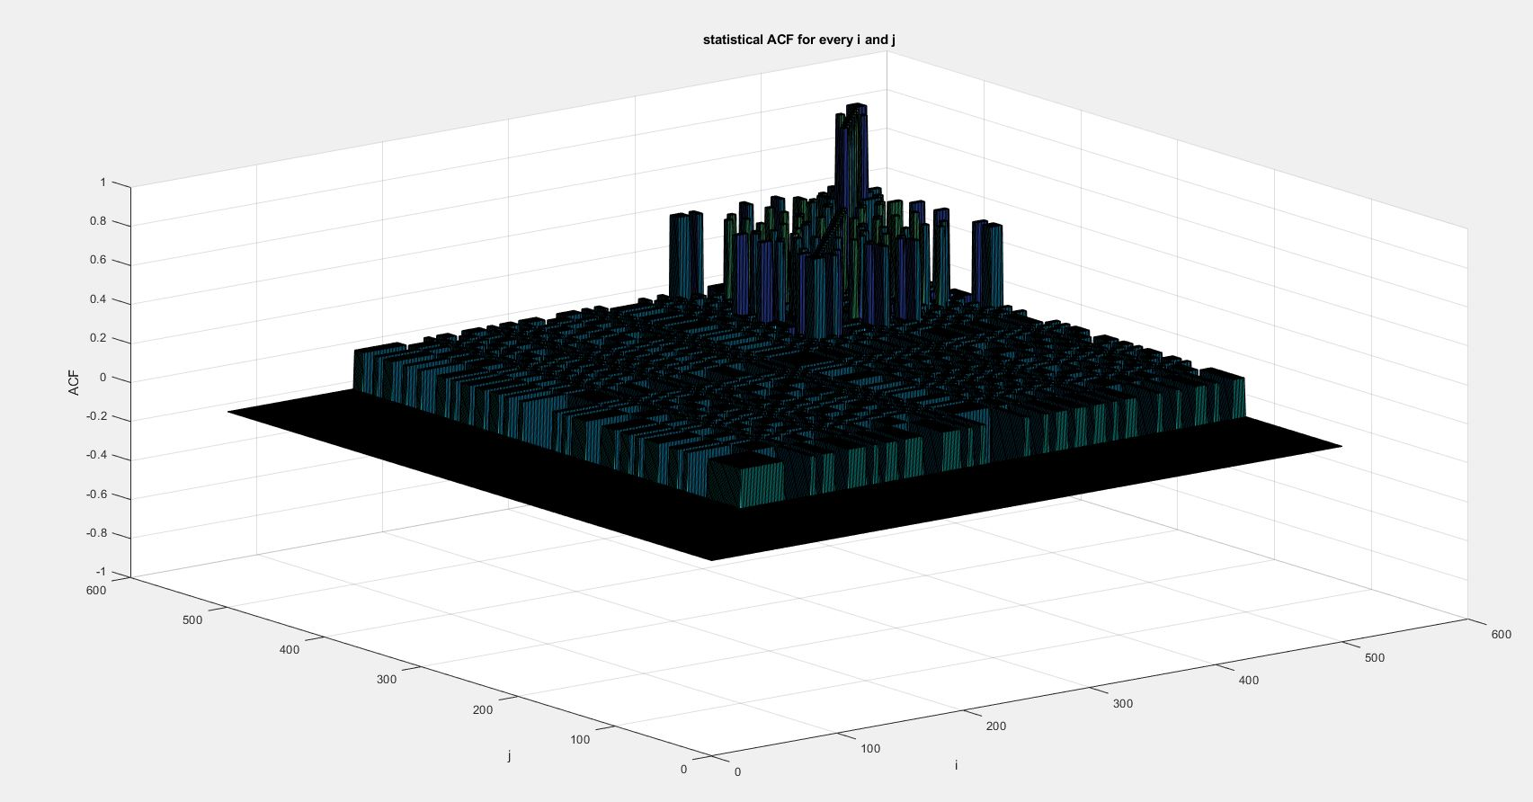

A 3D-plot of the statistical ACF of the PNRZ process where i and j are the horizontal axes and the ACF is the vertical axis where .

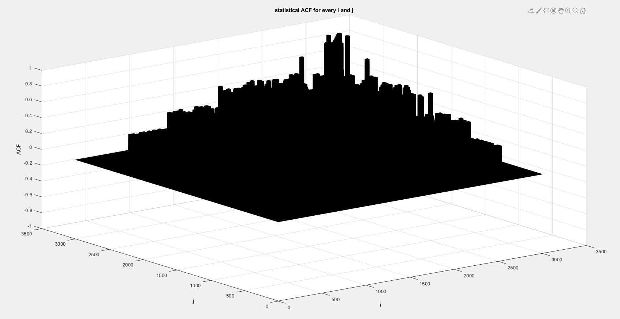

A 3D-plot of the statistical ACF of the PNRZ process where i and j are the horizontal axes and the ACF is the vertical axis where .

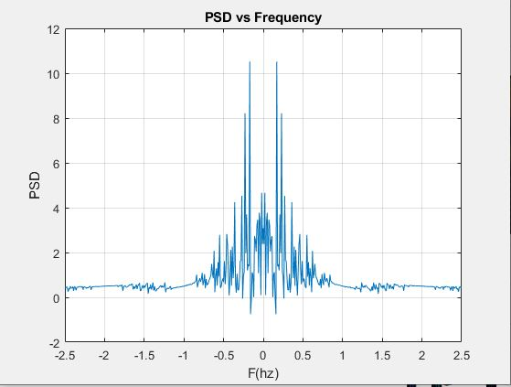

PSD of the PNRZ process at

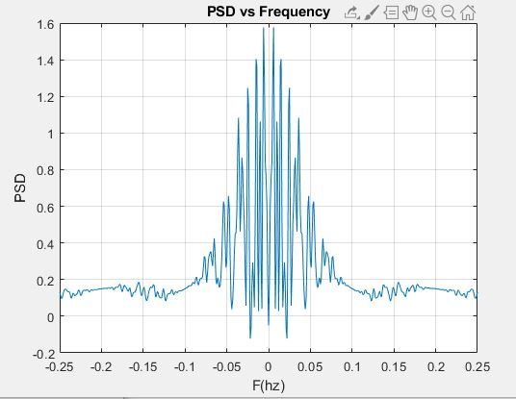

PSD of the PNRZ process at

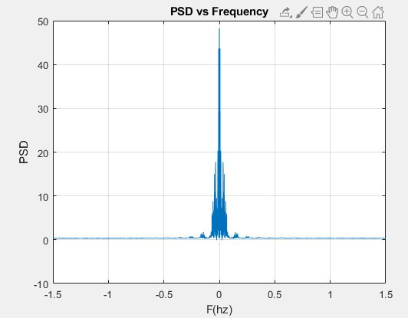

PSD of the PNRZ process at

UNRZ Process:

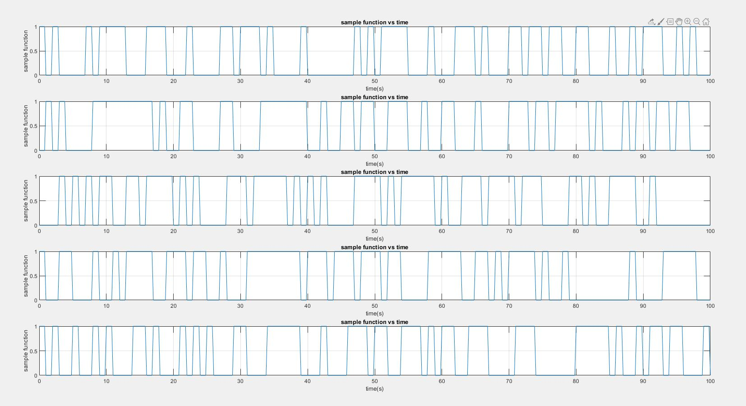

A plot of 5 random sample functions of the UNRZ process.

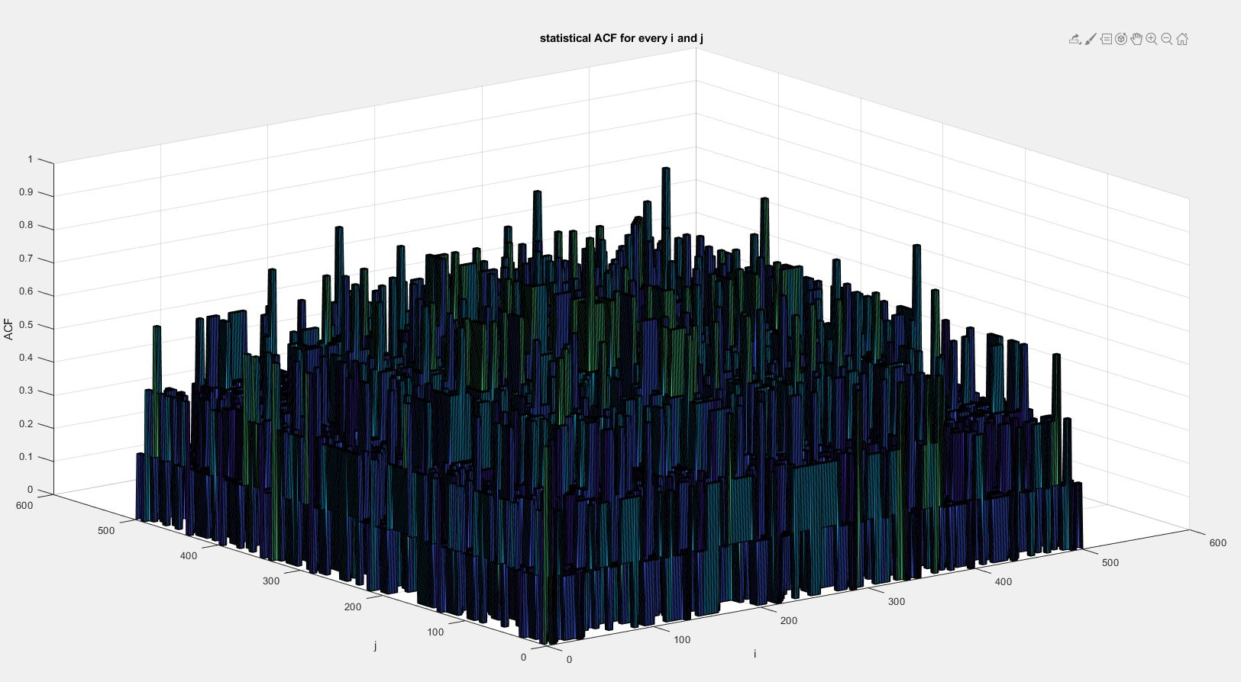

A 3D-plot of the statistical ACF of the UNRZ process where i and j are the horizontal axes and the ACF is the vertical axis where .

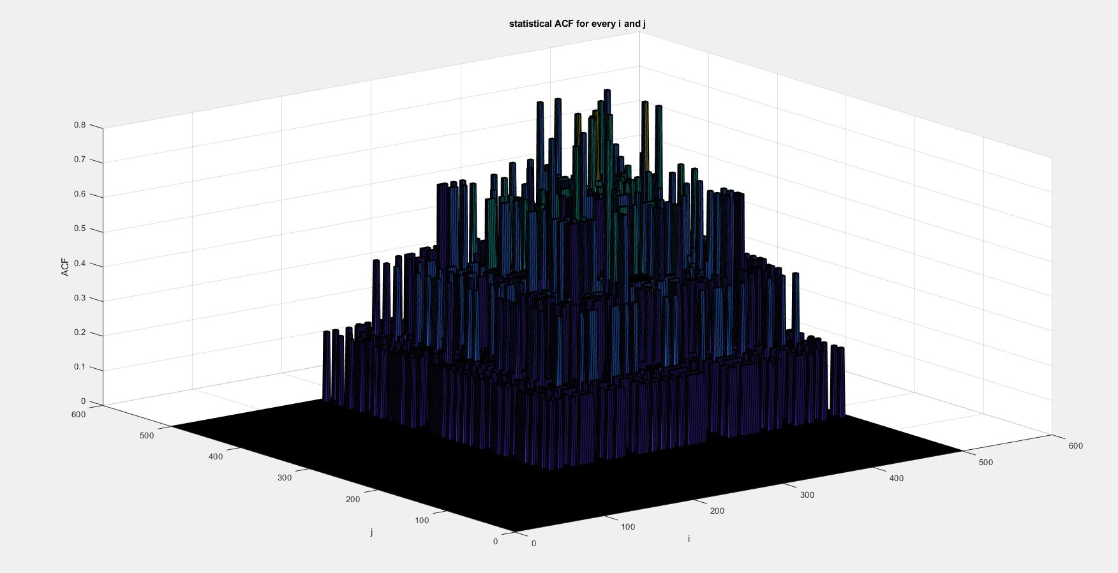

A 3D-plot of the statistical ACF of the UNRZ process where i and j are the horizontal axes and the ACF is the vertical axis where .

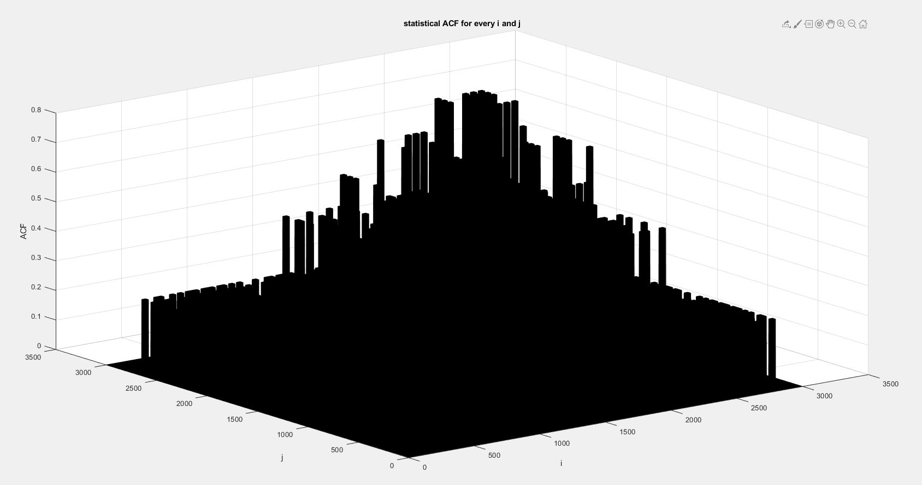

A 3D-plot of the statistical ACF of the UNRZ process where i and j are the horizontal axes and the ACF is the vertical axis where .

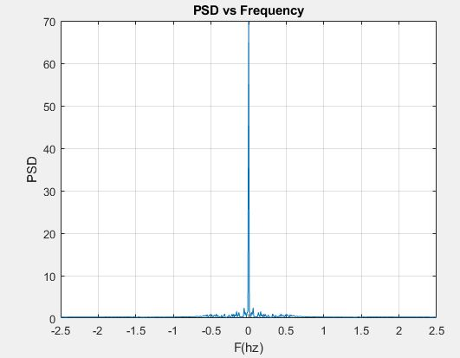

PSD of the UNRZ process at

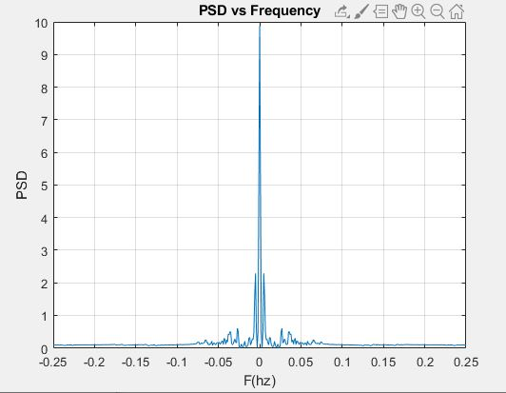

PSD of the UNRZ process at

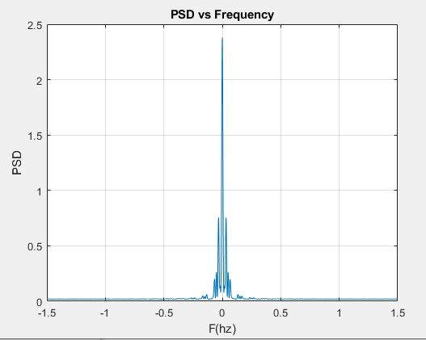

PSD of the UNRZ process at

Manchester Process:

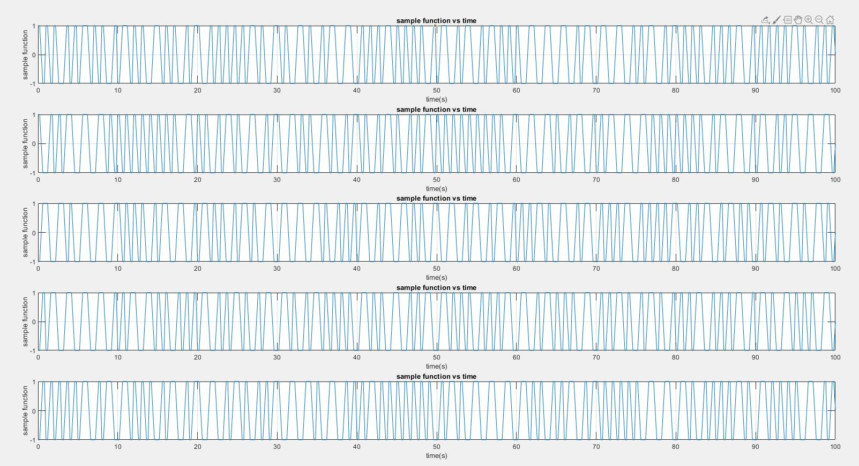

5 random samples of the Manchester process.

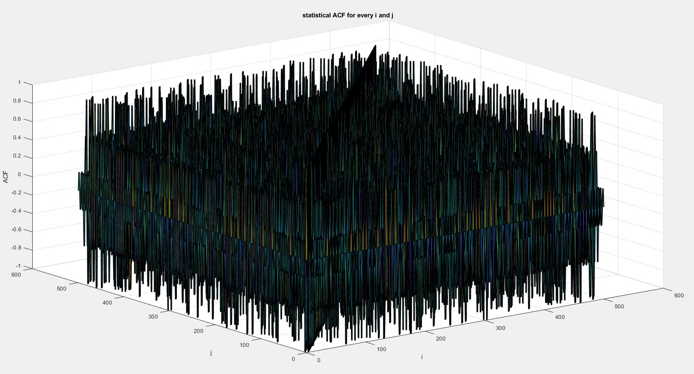

A 3D-plot of the statistical ACF of the Manchester process where i and j are the horizontal axes and the ACF is the vertical axis where .

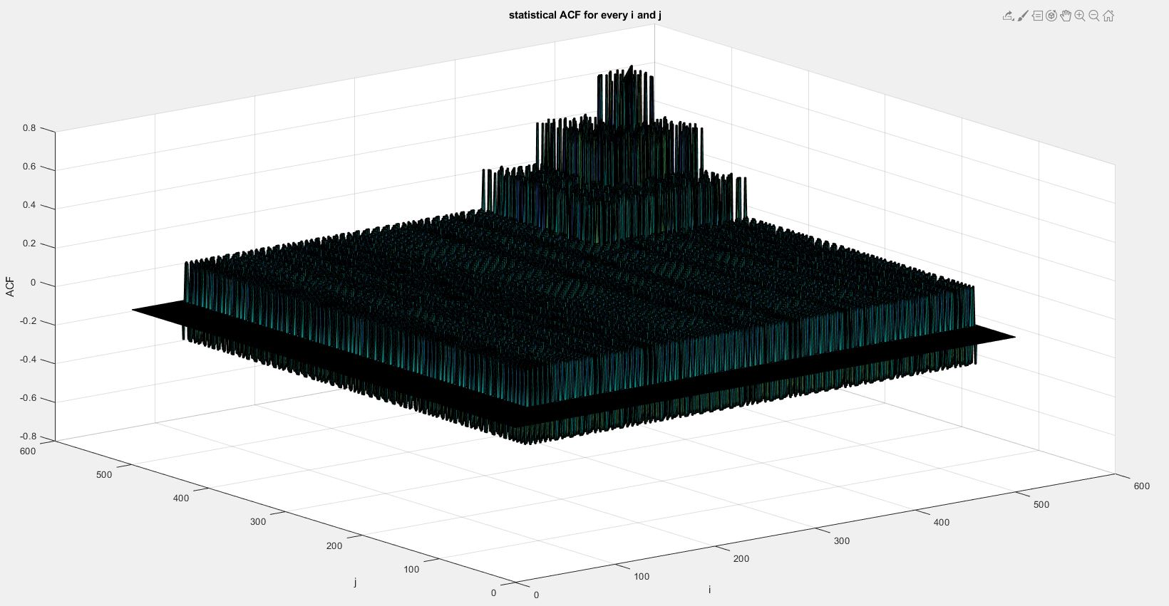

A 3D-plot of the statistical ACF of the Manchester process where i and j are the horizontal axes and the ACF is the vertical axis where .

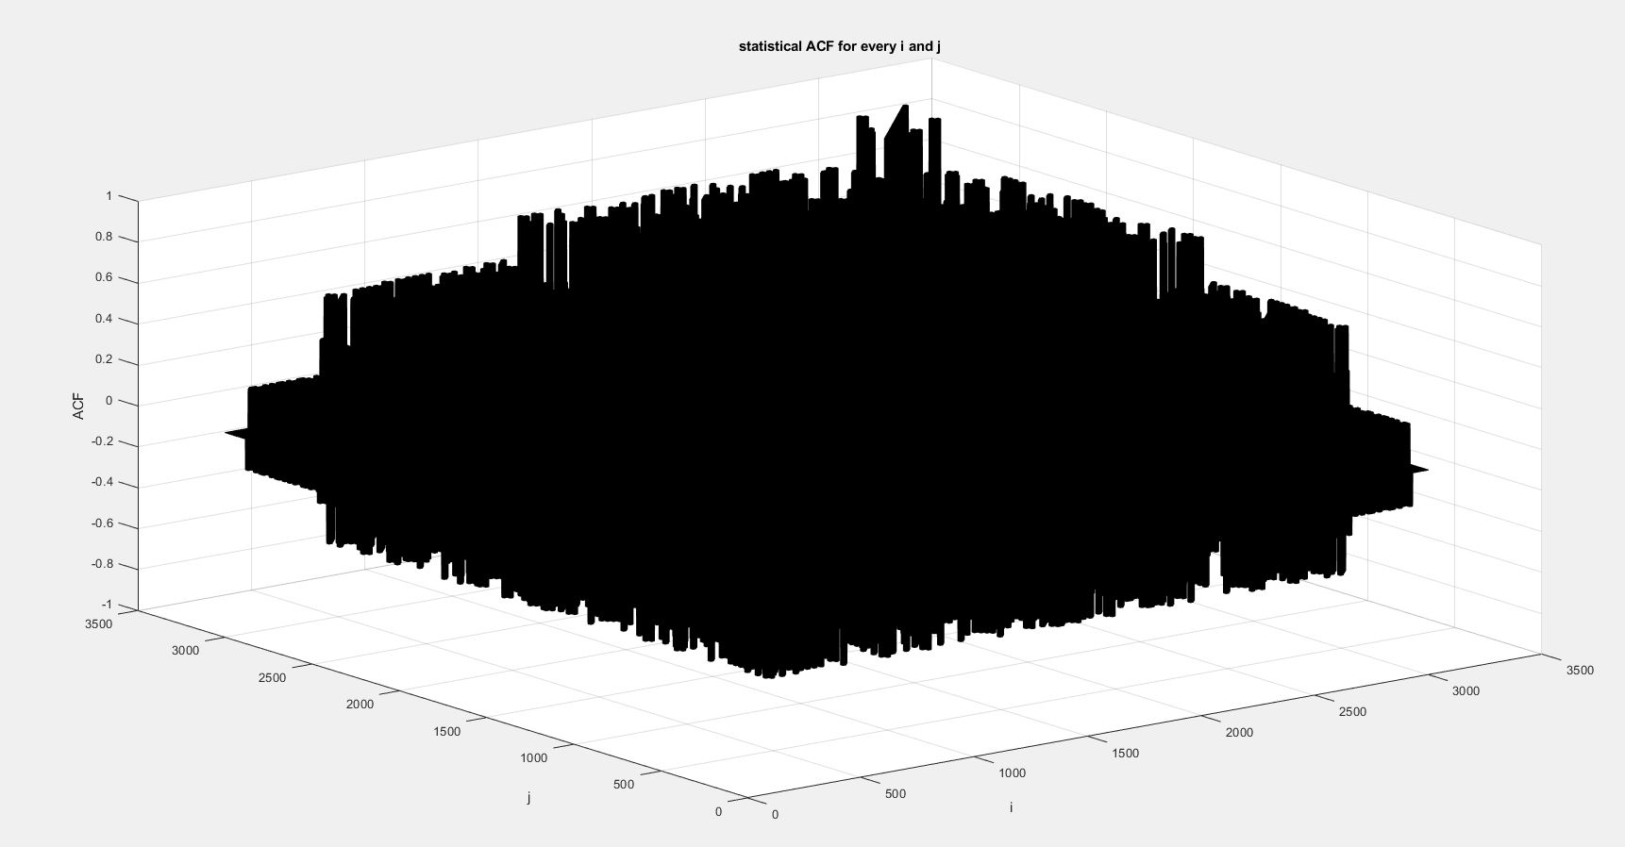

A 3D-plot of the statistical ACF of the Manchester process where i and j are the horizontal axes and the ACF is the vertical axis where .

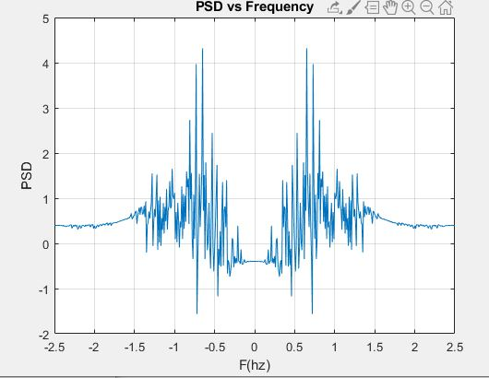

PSD of the Manchester process at

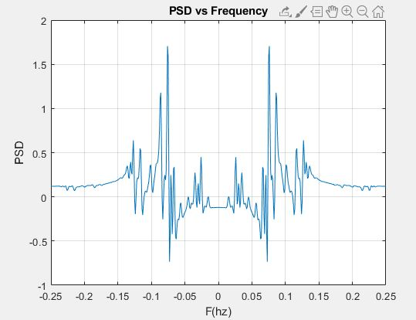

PSD of the Manchester process at

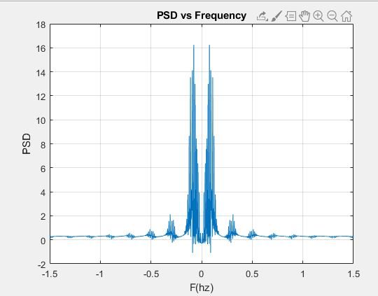

PSD of the Manchester process at

**Notes:**

-Regarding the case of the Manchester process has twice the bandwidth of the unipolar NRZ and polar NRZ code as the pulses are half the width.

-when entering the ensemble matrix in the GUI it has to be loaded from a .mat file where the ensemble matrix is named “A”.

**References:**

Yuriy Skalko (2021). Line coding: Manchester, unipolar and polar RZ, unipolar NRZ (https://www.mathworks.com/matlabcentral/fileexchange/41320-line-coding-manchester-unipolar-and-polar-rz-unipolar-nrz), MATLAB Central File Exchange.