Superstore Sales
Chapter 1: Project Planning & Management
1.1 Project Proposal
Project Title: Intelligent Business Intelligence Dashboard for Superstore Sales Analysis.
Executive Summary: The retail industry generates massive amounts of data daily. Without proper analysis, this data remains an untapped resource. This project aims to develop a comprehensive interactive dashboard using Microsoft Power BI to analyze the sales data of a US-based Superstore. The system will provide actionable insights into sales trends, profit margins, customer behavior, and shipping efficiency, enabling stakeholders to make data-driven decisions to maximize profitability and minimize operational costs.
Objectives:
- Visualize Historical Data: To transform raw sales data into meaningful visual representations (Charts, Maps, Matrices).
- Identify Key Trends: To detect seasonal patterns in sales and identify high-performing products.
- Monitor KPIs: To track critical metrics such as Total Sales, Total Profit, Quantity Sold, and Average Discount in real-time.
- Geographical Analysis: To pinpoint profitable regions and underperforming states using geospatial analysis.
- Customer Segmentation: To understand the buying behavior of different segments (Consumer, Corporate, Home Office).
Scope:
- In-Scope: Analysis of Sales, Profit, Discount, and Quantity data. Coverage of US regions (South, West, East, Central). Time period analysis (Years, Quarters, Months).
- Out-of-Scope: Inventory management, predictive machine learning models (Phase 2), and integration with live ERP systems.
1.2 Project Plan (Timeline)
Phase | Task Name | Start Date | End Date | Duration
Planning | Project Proposal & Selection | 21/09/2025 | 25/09/2025 | 5 Days
Planning | Requirement Gathering | 26/09/2025 | 30/09/2025 | 5 Days
Analysis | Data Collection & Understanding | 01/10/2025 | 05/10/2025 | 5 Days
Analysis | Data Cleaning (ETL in Power Query) | 06/10/2025 | 10/10/2025 | 5 Days
Design | Data Modeling (Star Schema) | 11/10/2025 | 15/10/2025 | 5 Days
Design | UI/UX Wireframing | 16/10/2025 | 20/10/2025 | 5 Days
Implementation | Building Charts & Visuals | 21/10/2025 | 30/10/2025 | 10 Days
Implementation | DAX Calculations | 01/11/2025 | 05/11/2025 | 5 Days
Testing | Data Validation & User Testing | 06/11/2025 | 10/11/2025 | 5 Days
Closing | Final Documentation & Presentation | 11/11/2025 | 24/11/2025 | 14 Days

1.3 Task Assignment & Roles
Team Member | Role | Responsibilities
[Your Name] | Project Manager / BI Developer | Overseeing project timeline, defining scope, and developing core Power BI reports.
[Member 2] | Data Analyst | Data cleaning, writing DAX measures, and validating data accuracy.
[Member 3] | UI/UX Designer | Designing dashboard layout, selecting color palettes, and ensuring usability.
[Member 4] | Documentation Specialist | Creating project documentation, user manuals, and final presentation.
1.4 Risk Assessment & Mitigation
Risk ID | Risk Description | Probability | Impact | Mitigation Strategy
R-01 | Data Inconsistency: The raw dataset may contain missing values or duplicates. | High | High | Implement robust ETL processes using Power Query to clean and standardize data before loading.
R-02 | Performance Issues: The dashboard may become slow with large datasets. | Medium | High | Use Star Schema modeling and optimized DAX measures; avoid using calculated columns where possible.
R-03 | Scope Creep: Adding too many features may delay the deadline. | Medium | Medium | Strictly adhere to the defined scope and prioritize "Must-Have" requirements.
R-04 | Tool Limitation: Power BI free version limitations. | Low | Low | Use available features in Power BI Desktop and ensure the .pbix file is optimized.

1.5 KPIs (Key Performance Indicators)
The dashboard includes four primary KPIs that provide a comprehensive overview of business performance across sales, customer engagement, and order behavior. These indicators help stakeholders evaluate the current health of the Superstore and identify areas for improvement.

1. Total Sales – 728.66K
Description
Total Sales represents the overall revenue generated within the selected time period. It aggregates all sales transactions and serves as a primary measurement of business performance.
Importance
- Measures the company’s financial strength and growth over time.
- Helps management evaluate whether revenue targets are being met.
- Supports forecasting and strategic decision-making regarding pricing, marketing, and operations.
How It Is Calculated
Total Sales = SUM(Sales)
Interpretation
With total sales of 728.66K, the business demonstrates strong revenue generation. This indicates healthy demand for products and reflects the effectiveness of sales and marketing strategies.

2. Total Orders – 1,727
Description
Total Orders indicates the number of individual purchase transactions completed. It reflects customer activity and market engagement.
Importance
- Helps assess the sales volume and operational workload.
- Allows the business to understand purchasing frequency and seasonal patterns.
- Serves as a key input in calculating other performance metrics such as Average Order Value.
How It Is Calculated
Total Orders = COUNT(Order ID)
Interpretation
The store processed 1,727 orders, showing a solid volume of transactions. A higher number of orders typically suggests stable customer activity and consistent demand.

3. Average Order Value (AOV) – 421.92
Description
Average Order Value measures the average amount a customer spends per order. It combines the effects of pricing, product mix, and customer purchasing behavior.
Importance
- Essential for understanding customer spending patterns.
- Helps determine whether upselling and cross-selling strategies are effective.
- Useful for forecasting revenue and setting sales targets.
How It Is Calculated
AOV = Total Sales ÷ Total Orders
Interpretation
An AOV of 421.92 indicates that customers spend a relatively high amount per transaction. This suggests strong product value perception and potentially successful pricing strategies.

4. Total Customers – 705
Description
Total Customers reflects the number of unique customers who made purchases. It is a key indicator of the company's market reach and customer base size.
Importance
- Helps evaluate customer acquisition and retention performance.
- Indicates how well the business is expanding into new customer segments.
- Supports customer lifetime value (CLV) and profitability analysis.
How It Is Calculated
Total Customers = DISTINCT COUNT(Customer ID)
Interpretation
A total of 705 unique customers shows a broad and diverse customer base. This suggests successful outreach and marketing initiatives, as well as strong market presence.
Chapter 2: Literature Review
2.1 Introduction
Business Intelligence (BI) has become an essential component for organizations seeking to analyze their operations and make data-driven decisions. Visualization tools such as Power BI, Tableau, and Qlik provide interactive dashboards that help transform raw data into meaningful insights. This chapter reviews the foundational concepts of data analytics, the role of dashboards in decision-making, and previous works related to retail sales analysis.

2.2 Business Intelligence (BI) Overview
Business Intelligence refers to technologies, applications, and practices used to collect, analyze, and visualize business information. BI solutions help organizations:
- Identify trends and patterns
- Improve operational efficiency
- Support strategic decision-making
- Monitor KPIs and business performance in real-time

2.3 Data Visualization in Decision Making
Dashboards convert complex datasets into charts, KPIs, and visual summaries that allow managers and analysts to quickly understand business performance. Effective visualizations help users detect anomalies, identify category performance, and track sales and order trends.

2.4 Retail Analytics and Sales Dashboards
Retail analytics focuses on analyzing customer transactions, product performance, and market trends. Prior works show that companies rely heavily on visual dashboards to manage:
- Sales performance
- Customer segmentation
- Category analysis
- Regional performance
The Superstore dataset is widely used for BI demonstrations due to its rich structure.

2.5 Related Studies and Tools
Several studies highlight the importance of interactive dashboards:
- KPIs such as sales, orders, and customer metrics support business growth evaluation.
- BI tools automate cleaning, modeling, and reporting.
- Superstore dashboards commonly analyze region, segment, category, and time-based performance.

2.6 Summary
The literature suggests that BI dashboards play a crucial role in simplifying complex data and supporting informed decisions.

Chapter 3: Requirements Gathering

3.1 Introduction
This chapter outlines stakeholders, requirements, and use cases necessary to design and implement the Superstore Sales Dashboard using Power BI.

3.2 Stakeholder Analysis
- Business Manager: Needs insights on performance, trends, and sales activity.
- Data Analyst: Needs structured data to build the dashboard.
- Sales Team: Needs visibility on top-selling products and order activity.
- IT Team: Ensures data connectivity and access.

3.3 User Stories
- As a business manager, I want to view KPIs to monitor sales performance.
- As an analyst, I want to filter sales by category and region to identify trends.
- As a sales team member, I want to know which products drive the most revenue.

3.4 Use Cases
Use Case 1: View KPI Summary
Actor: Business Manager
Outcome: Quick performance assessment.

Use Case 2: Analyze Sales by Category
Actor: Sales Analyst
Outcome: Identify best and worst performers.

Use Case 3: Explore Regional Performance
Actor: Manager/Analyst
Outcome: Understand geographic trends.

3.5 Functional Requirements
- Import and clean Superstore dataset.
- Build KPIs: Total Sales, Orders, AOV, Customers.
- Visualize sales by region, category, segment, and time.
- Provide interactivity through filters and drill-down.

3.6 Non-Functional Requirements
Performance: Dashboard should refresh quickly.
Usability: Clear visuals and consistent colors.
Reliability: Clean data with correct loading.
Security: Access control for dataset modifications.
3.7 Summary
These requirements guide the development of the Superstore Sales Dashboard and ensure it meets user needs and business expectations.

Chapter 4: System Analysis & Design

4.1 Problem Statement & Objectives
Problem Statement
The Superstore retail business generates a large volume of daily transactional data. Currently, stakeholders rely on raw spreadsheets and disconnected data sources, making it difficult to monitor Key Performance Indicators (KPIs), track regional sales trends, and identify top-performing products or customers efficiently. There is a critical need for a centralized, interactive visualization tool to support data-driven decision-making and reduce manual reporting time.

Project Goals
- Sales Monitoring: Track Total Sales, Order Volume, and Average Order Value (AOV) over time to identify seasonal trends.
- Regional Analysis: Compare performance across different states and regions to optimize supply chain and marketing efforts.
- Product Intelligence: Identify top-selling categories and sub-categories to manage inventory effectively.
- Customer Insights: Analyze customer segments and identify top 10 high-value customers.
Use Case & Actors
- Primary Actors: Sales Managers, Business Analysts, Executives.
- Key Interactions: Filtering data by Year/Month, drilling down into product categories, and exporting detailed order reports.
Functional Requirements
- The system must calculate and display Month-over-Month (MoM) growth.
- The system must provide dynamic filtering capabilities (Slicers) for time periods and categories.
- The system must allow geographic visualization of sales data.

4.2 Database Design & Data Modeling
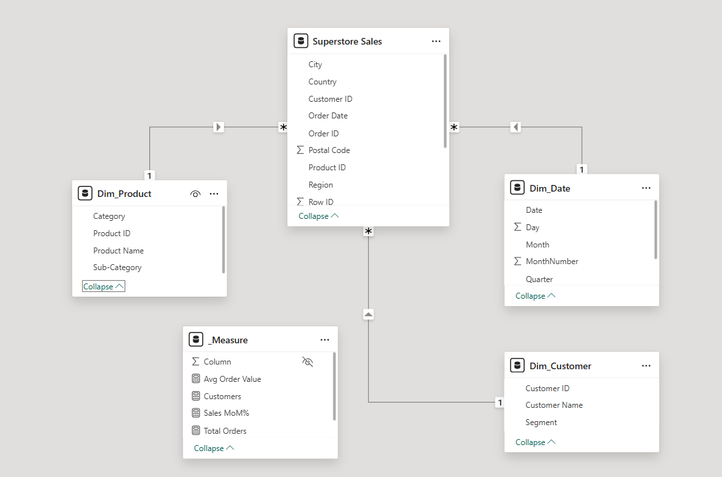
Architecture: Star Schema
The data model is designed using the Star Schema methodology, which is optimized for analytical queries and reporting performance in Power BI. This design minimizes redundancy and simplifies DAX calculations.
ER Diagram & Schema Description
- Fact Table: Superstore Sales
  - Contains quantitative transactional data (e.g., Sales, Quantity, Profit, Row ID) and Foreign Keys connecting to dimension tables.

- Dimension Tables:
  - Dim_Product: Contains descriptive attributes for products (Product ID, Name, Category, Sub-Category).
  - Dim_Customer: Contains customer details (Customer ID, Name, Segment).
  - Dim_Date: A dedicated calendar table established to support Time Intelligence functions (Year, Month, Quarter).
- Measure Table: _Measure
  - A centralized virtual table created to host all DAX calculations, ensuring the model remains organized.

Relationships
- One-to-Many (1:*) Relationships:
Established between the unique keys in Dimension tables and the corresponding foreign keys in the Fact table.
- Cardinality:
Single-direction cross-filters flowing from Dimensions to the Fact table to ensure accurate aggregation.

4.3 Data Flow & System Behavior
Data Flow Process (DFD Context)
- Data Ingestion:
Raw transactional data is imported from flat files (Excel/CSV).
- Data Transformation (Power Query):
  - Data cleaning (type detection, removing duplicates).
  - Normalization: Splitting the master table into Fact and Dimension tables.
- Modeling & Logic:
Establishing relationships and creating DAX calculations.
- Visualization:
Rendering data into interactive dashboards.
Key DAX Measures & Business Logic
The system utilizes Data Analysis Expressions (DAX) to perform dynamic calculations. The following core measures define the project's logic:
- Total Sales: Calculates the sum of gross revenue.
Total Orders: Counts the unique number of orders placed (using DISTINCTCOUNT to handle multiple line items per order).

Total Customers: Tracks the unique number of active customers.
Average Order Value (AOV): Represents the average revenue generated per single order.
Sales MoM% (Month-over-Month Growth): Calculates the percentage growth or decline in sales compared to the previous month using Time Intelligence variables.
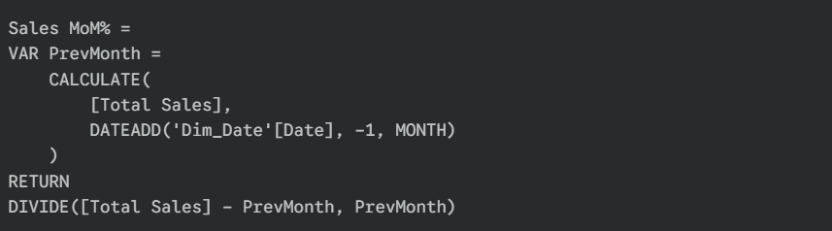
4.4 UI/UX Design & Prototyping
User Interface Layout
The dashboard features a consistent layout with a custom sidebar navigation menu, allowing users to switch seamlessly between analytical views. A unified header contains global slicers (Year, Month) for context persistence.
Dashboard Pages
- Overview Page:
  - Purpose: Executive summary of business health.
  - Key Visuals: KPI Cards (Total Sales, Orders, AOV, Customers), Sales Trend Line Chart, Donut Chart for Customer Segments, and a Bar Chart for Top 10 Customers.
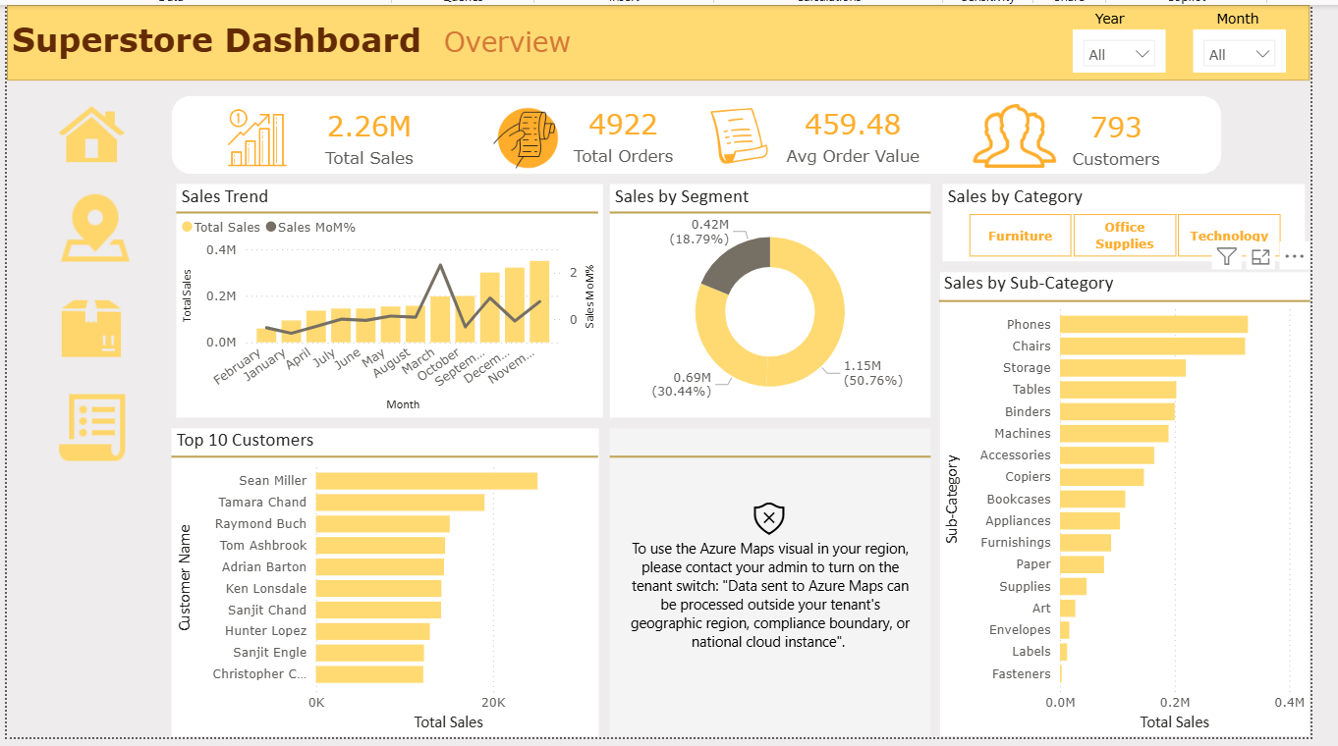
- Regional Analysis Page:
  - Purpose: Geographic performance tracking.
  - Key Visuals: Azure Map visual for spatial distribution, State-wise Matrix table, and Monthly Sales Trends by region
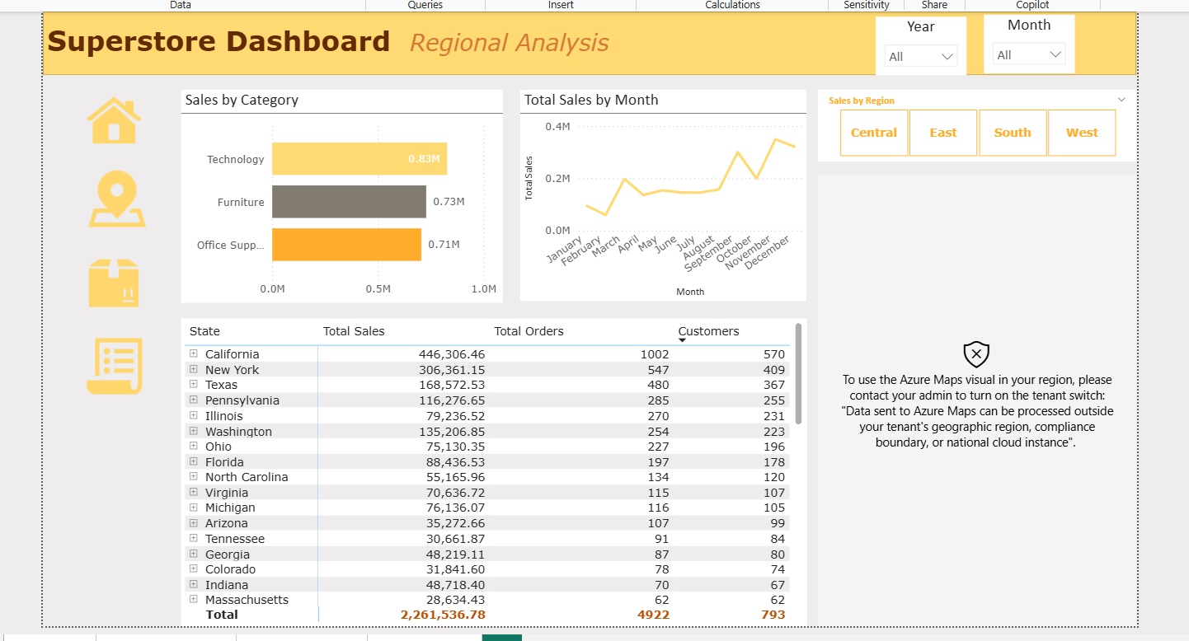
- Product Analysis Page:
  - Purpose: Inventory and product performance insights.
  - Key Visuals: Scatter Plot (Total Sales vs. Avg Order Value), Product Search Bar, and Decomposition Trees or Bar Charts for Category performance
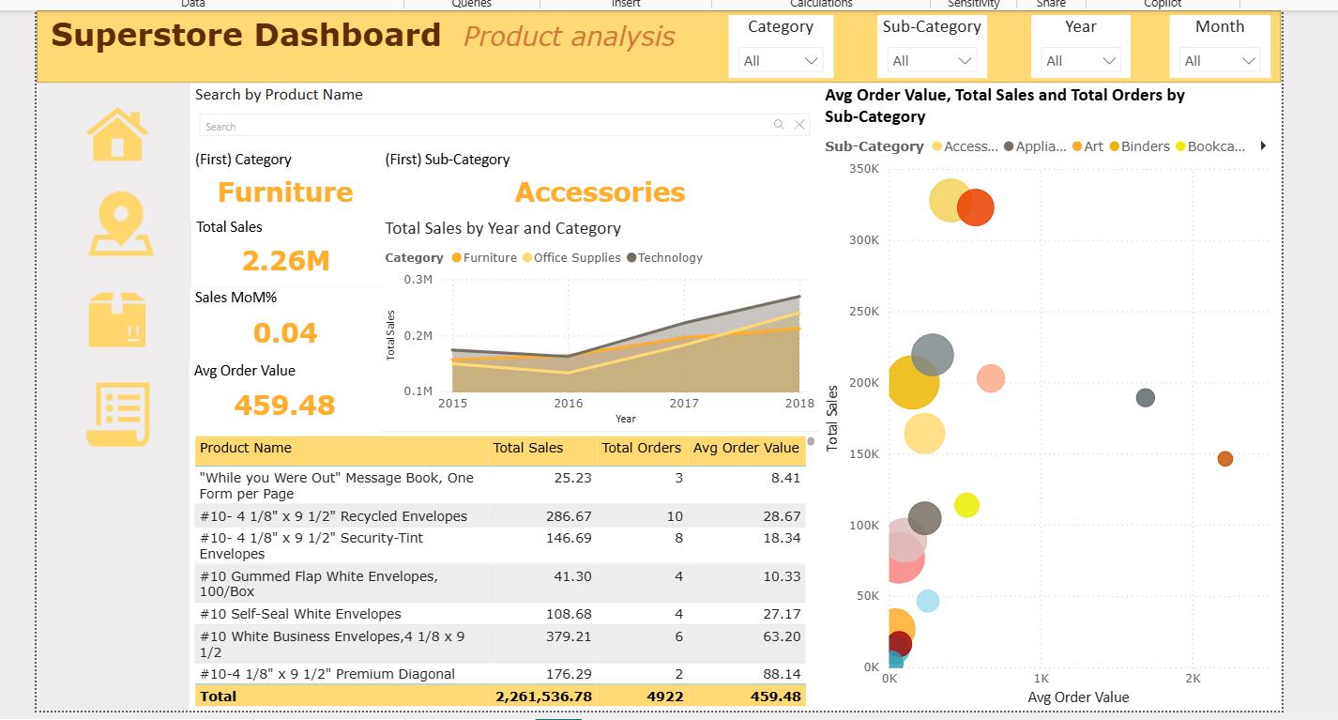
- Order Details Page:
  - Purpose: Granular transactional auditing.
  - Key Visuals: Detailed tabular view with Date Pickers (Start/End Date) for specific transaction lookups.
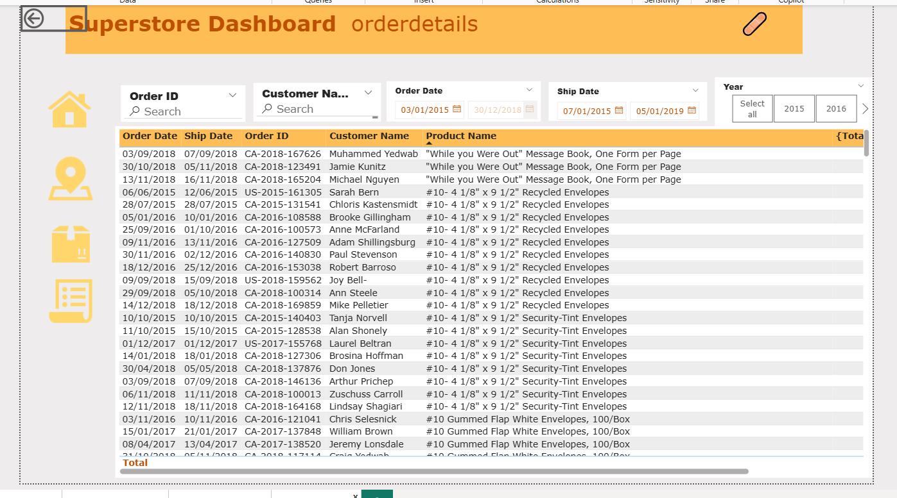
Design Guidelines
- Color Palette:
A primary Gold/Yellow theme is used to highlight key metrics, ensuring high contrast and brand consistency.
- Interactivity:
Cross-filtering is enabled across all visuals; clicking a data point on one chart filters the rest of the page.
4.4 System Deployment & Integration
Technology Stack
- Frontend/Visualization: Microsoft Power BI Desktop.
- Data Transformation (ETL): Power Query Editor (M Language).
- Analytical Engine: DAX (Data Analysis Expressions).
- Data Source: Flat File (Excel/CSV).
Deployment Strategy
The solution is developed as a .pbix file. For production, it is designed to be published to the Power BI Service (Cloud), allowing for scheduled data refreshes and secure web-based access for stakeholders.

Chapter 5: Implementation (Source Code & Execution)

i. Source Code Structure & Best Practices
Structured & Well-Commented Code
Unlike traditional software, the "source code" in this Business Intelligence solution consists of Data Analysis Expressions (DAX) for logic and Power Query (M Language) for data transformation.
- Measure Organization: All calculation logic is decoupled from physical tables and centralized in a dedicated empty table named _Measure. This ensures the model is clean and maintainable.
- Comments: Complex DAX formulas include inline comments explaining variables and logic flow (e.g., defining PrevMonth variables for Time Intelligence).
Naming Conventions
The project adheres to strict industry-standard naming conventions to ensure readability:
- Dimensions: Prefixed with Dim_ (e.g., Dim_Product, Dim_Customer).
- Measures: Named using clear business terminology (e.g., Total Sales, Avg Order Value) rather than technical database field names.
- CamelCase: Used for internal variables within DAX formulas for consistency.
Modular Code & Reusability
- Base Measures: Fundamental calculations like [Total Sales] and [Total Orders] are created as base measures.
- Measure Branching: Complex KPIs (like Sales MoM%) reference these base measures rather than rewriting the aggregation logic. This ensures that if a definition changes, it updates globally across the dashboard.
Error Handling
- Division Safety: The DIVIDE() function is utilized instead of the standard division operator (/) to automatically handle divide-by-zero errors, returning BLANK or an alternate result instead of crashing a visual.

ii. Version Control & Collaboration
Version Control Repository
The project source file (.pbix), raw datasets, and documentation are hosted in a remote repository (GitHub) to ensure version history and backup.
- Repository Structure:
  - /Data: Contains the raw Excel/CSV source files.
  - /Dashboard: Contains the latest version of the Superstore Dashboard.pbix.
  - /Docs: Contains documentation and assets.
Commit History
Changes are tracked with meaningful commit messages, such as:
- "Initialized Data Model with Star Schema structure"
- "Added Time Intelligence measures for Month-over-Month analysis"
- "Finalized UI layout for Regional Analysis page"

iii. Deployment & Execution
System Requirements
To run the dashboard locally, the following environment is required:
- Operating System: Windows 10 or Windows 11.
- Software: Microsoft Power BI Desktop (Latest Version recommended).
- Hardware: Minimum 4GB RAM (8GB recommended for optimal performance).
Installation & Configuration Steps
- Download: Clone the repository or download the Superstore Dashboard.pbix file.
- Install Software: Ensure Microsoft Power BI Desktop is installed from the Microsoft Store or official website.
- Data Connection:
  - Open the .pbix file.
  - If the source data path has changed, go to Transform Data > Data Source Settings and update the file path to point to the local Superstore Sales.xlsx file.
  - Click Refresh to load the latest data into the model.
Execution Guide
- Navigation: Use the sidebar icons on the left to navigate between Overview, Regional, and Product pages.
- Interactivity: Hold Ctrl and click to multi-select filters. Hover over charts to see Tooltips with detailed metrics.
- Drill-Down: On the Product Analysis page, right-click on a Category bar to drill down into Sub-Categories.
Deployment Link
- Local File: https://github.com/HazemWaelll/Power-BI-Final-Project-DEPI

