**CAAL – LAB 9, 10, 11**

**Hazim Ghulam Farooq**

**25148**

**GITHUB-LINL:** <https://github.com/Hazim16274/COMPUTER-ARCH-AND-ASSEMBLY-LANG>

Q.1

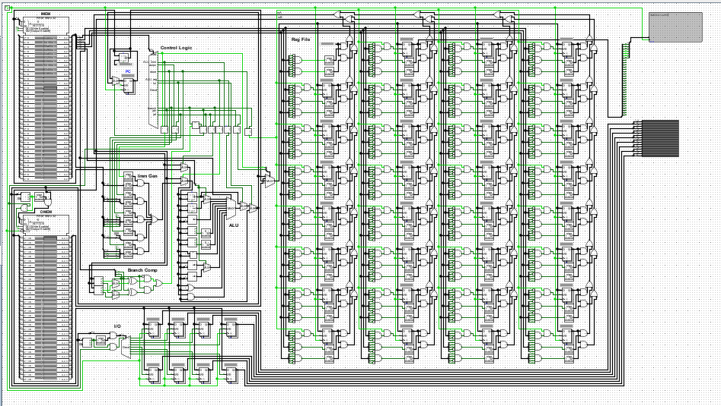

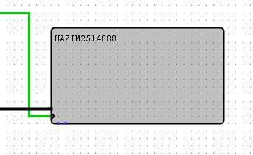

Q.2

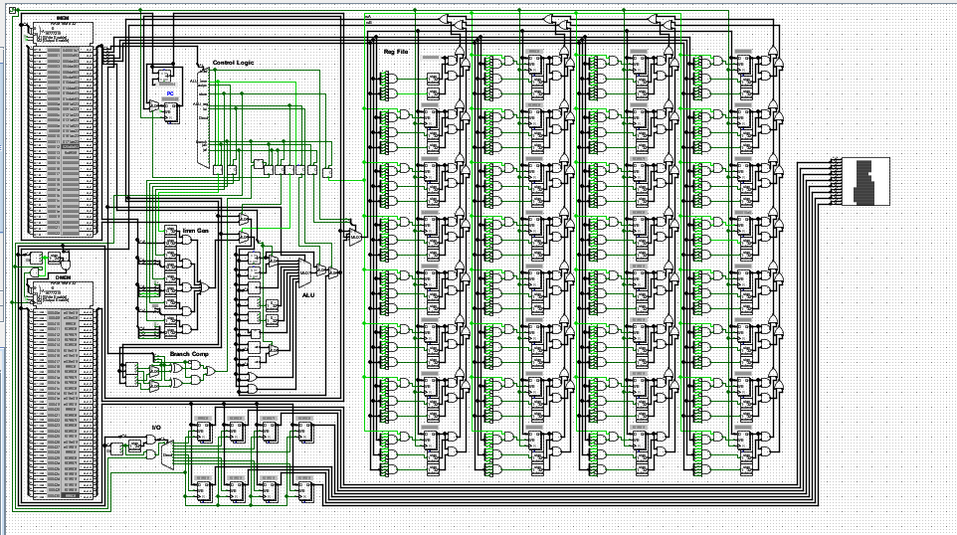

Q.3

