**HARSHA WALIA**

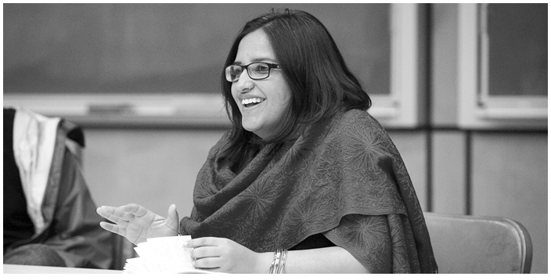

AREA: MIGRANT JUSTICE

PERCEPTION: CANADA SHOULD PROVIDE CITIZENSHIP STATUS TO ALL MIGRANT WORKERS

Harsha Walia is a [social justice](http://en.wikipedia.org/wiki/Social_justice) activist and journalist who is best known for co-founding the [Vancouver](http://en.wikipedia.org/wiki/Vancouver) chapter of [No One Is Illegal](http://en.wikipedia.org/wiki/No_one_is_illegal). Walia's writings have appeared in over fifty journals, anthologies, and magazines, including [Briarpatch](http://en.wikipedia.org/wiki/Briarpatch" \o "Briarpatch), Canadian Dimension, [Feministing](http://en.wikipedia.org/wiki/Feministing" \o "Feministing), [FUSE Magazine](http://en.wikipedia.org/wiki/Fuse_(magazine)), [Left Turn](http://en.wikipedia.org/wiki/Left_Turn), People of Color Organize, [Rabble](http://en.wikipedia.org/wiki/Rabble), [Z Magazine](http://en.wikipedia.org/wiki/Z_Magazine), The Winter We Danced, and others. She has contributed essays to academic journals including [Race and Class](http://en.wikipedia.org/wiki/Race_and_Class), as well as chapters in the anthologies Power of Youth: Youth and community-led activism in Canada; Beautiful Trouble: A Toolbox for Revolution; and Organize! Building from the Local for Global Justice[[1]](http://en.wikipedia.org/wiki/Harsha_Walia#cite_note-goodreads-1) She is the author of the bookUndoing Border Imperialism, which indigenous rights activist [Roxanne Dunbar-Ortiz](http://en.wikipedia.org/wiki/Roxanne_Dunbar-Ortiz) has called, "the first extended work on immigration that refuses to make [First Nations](http://en.wikipedia.org/wiki/First_Nations)sovereignty invisible.

Walia has made a number of presentations to the [United Nations](http://en.wikipedia.org/wiki/United_Nations) on social and economic justice issues and is a commentator and speaker at conferences, campuses, and media outlets across North America. Most recently, Walia has organized protests against the non-consensual filming of undocumented immigrants being arrested on the television show [Border Security: Canada's Front Line](http://en.wikipedia.org/wiki/Border_Security:_Canada%27s_Front_Line). Walia asserted that [National Geographic](http://en.wikipedia.org/wiki/National_Geographic_(magazine)), the distributor of the show, was profiting from “the violence of detention and deportation.” Award-winning author [Naomi Klein](http://en.wikipedia.org/wiki/Naomi_Klein) has called Walia “one of Canada’s most brilliant and effective political organizers.”