

UNIVERSITI MALAYSIA TERENGGANU

FACULTY OF OCEAN ENGINEERING TECHNOLOGY & INFORMATICS

SEMESTER 2 2022/2023

FRONT-END PROGRAMMING

CSM 3103

LAB 1 REPORT

PREPARED FOR:

DR. RABIEI BIN MAMAT

PREPARED BY:

MOHAMAD HAZIM BIN MOHD SHAKRI (S61770)

Task 1

3. Evaluate the output

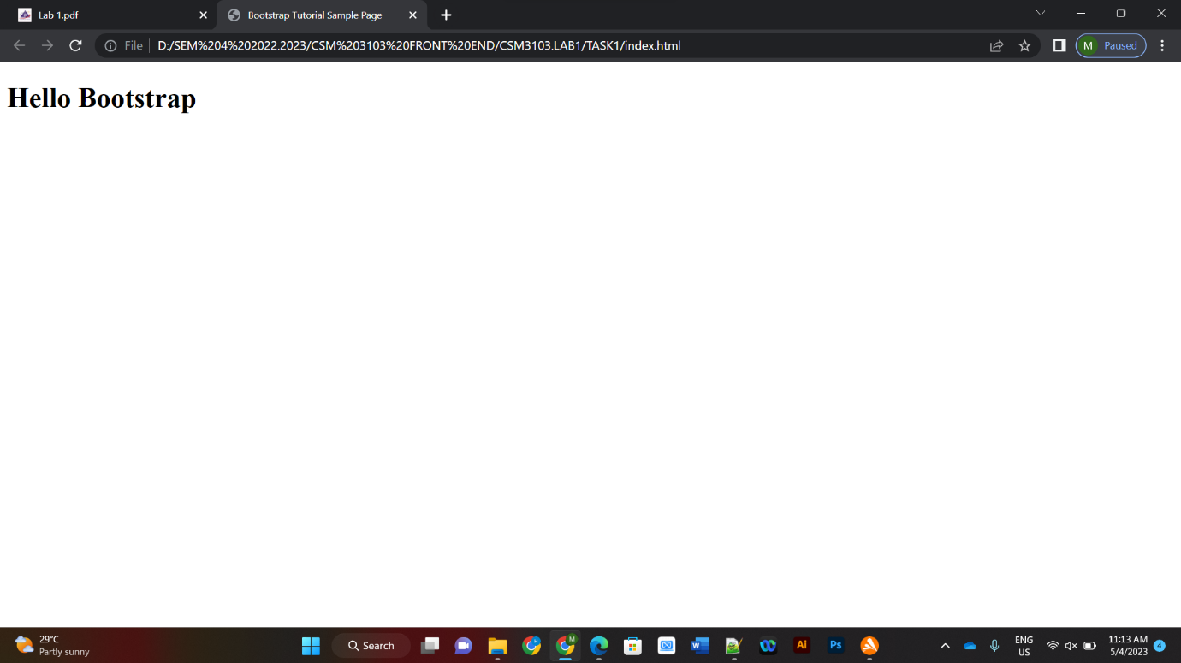

5. Evaluate your result and compare the output with step (3)



- Slightly no difference between the output

Task 2

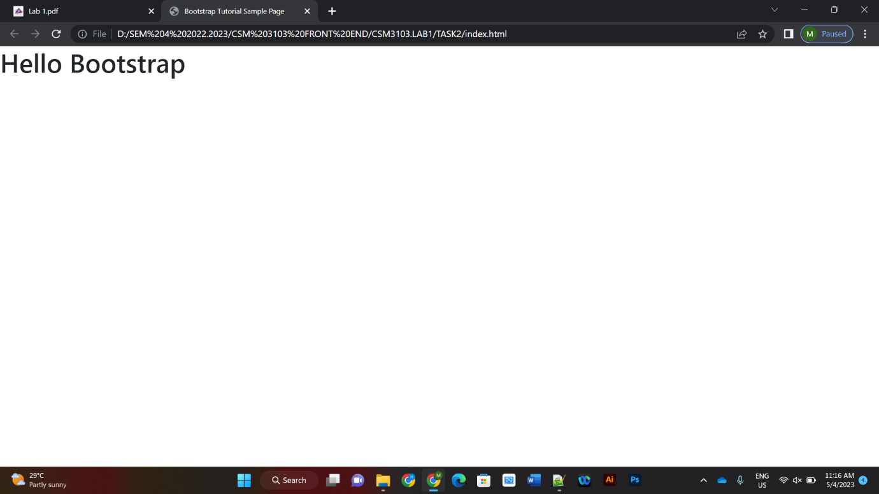

4. What is your conclusion?

- The type of font has been changed.

Task 3

3.b Save and evaluates the result

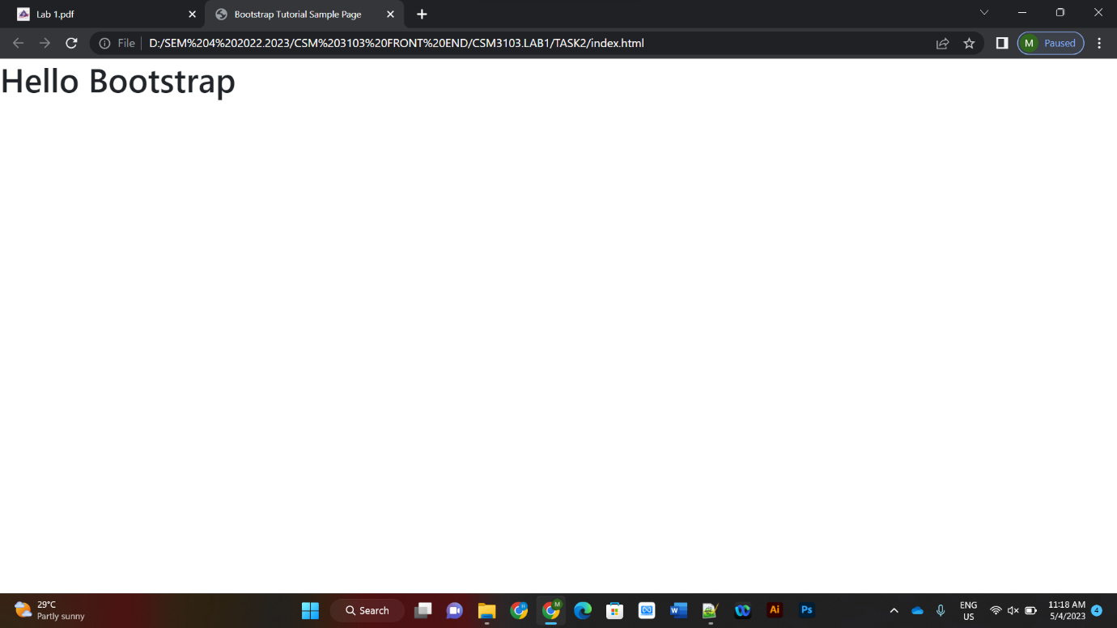

3.e Now our page is much better

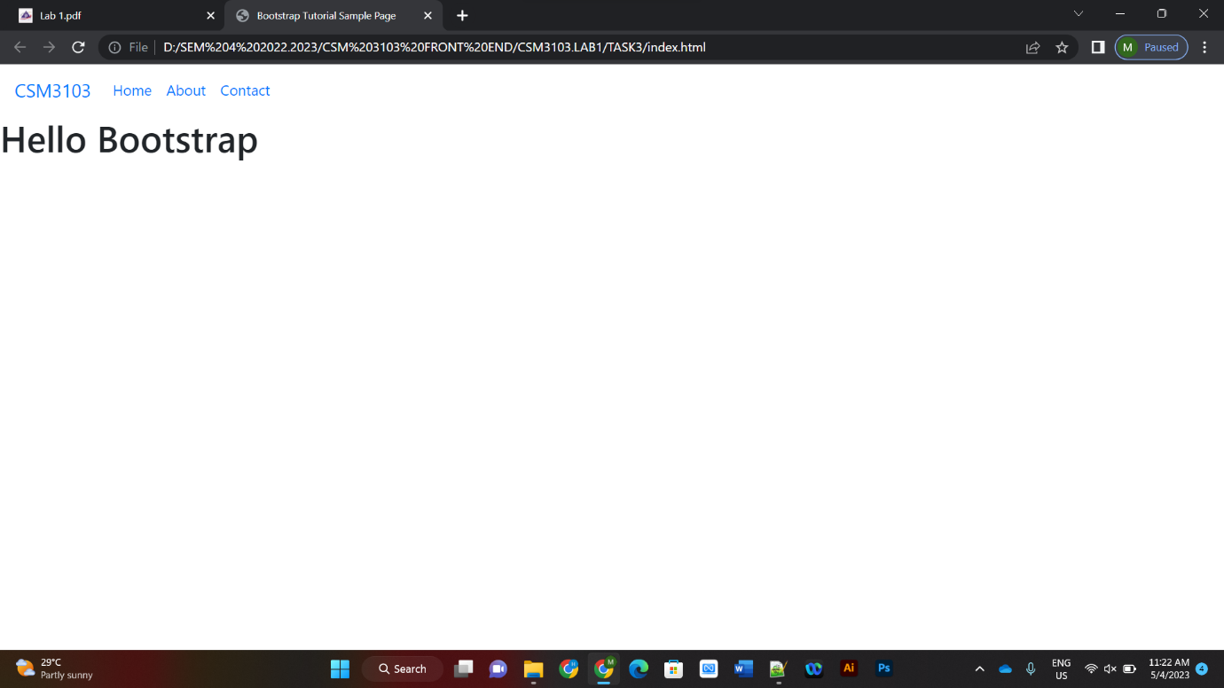

3.i Evaluate the results

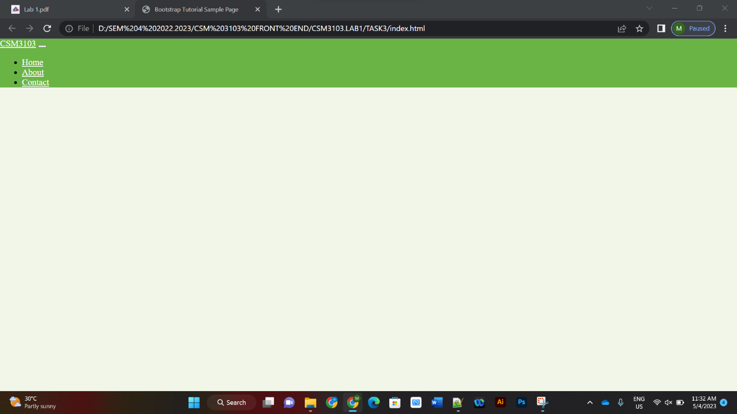

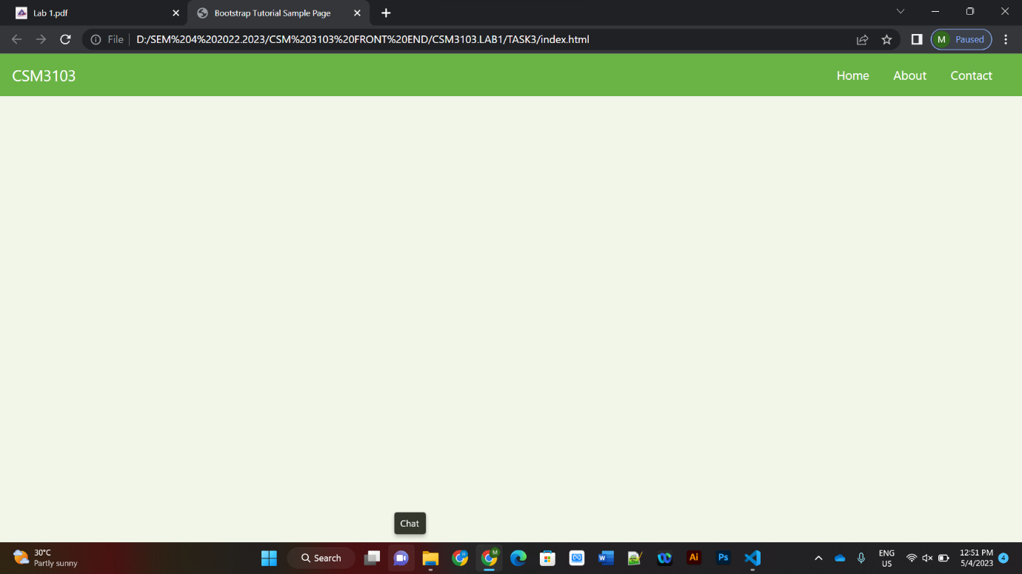

7. Add some description on header

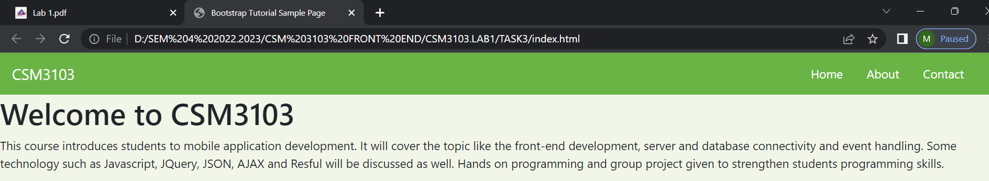

7.a What do you think about the result?

- The description is sorted well under the header.

10. Adding the button to description

- Result:

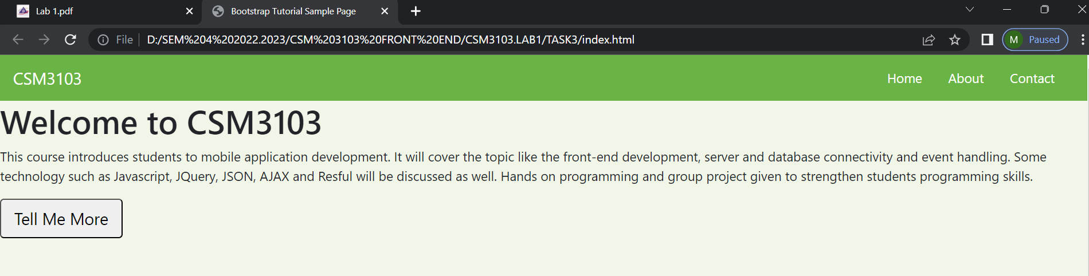

11. Prepare the main content

b. setup a three columns section

e. Add feature-titles class to each of image title

g. Add a contact form inside the last column by the following code

- Result:

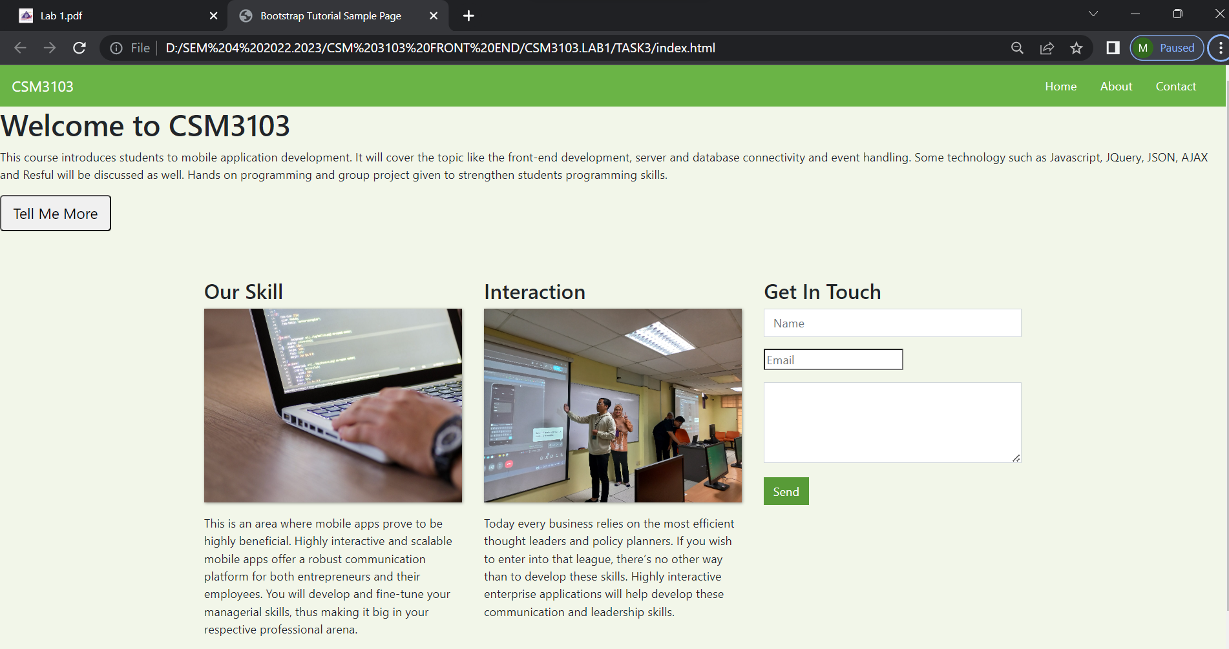

Task 4

4. Apply the bootstrap grid classes

a. The 4 cookie products should appear side by side in one row on large screen

b. The cookies should appear one per row on medium and smaller screens

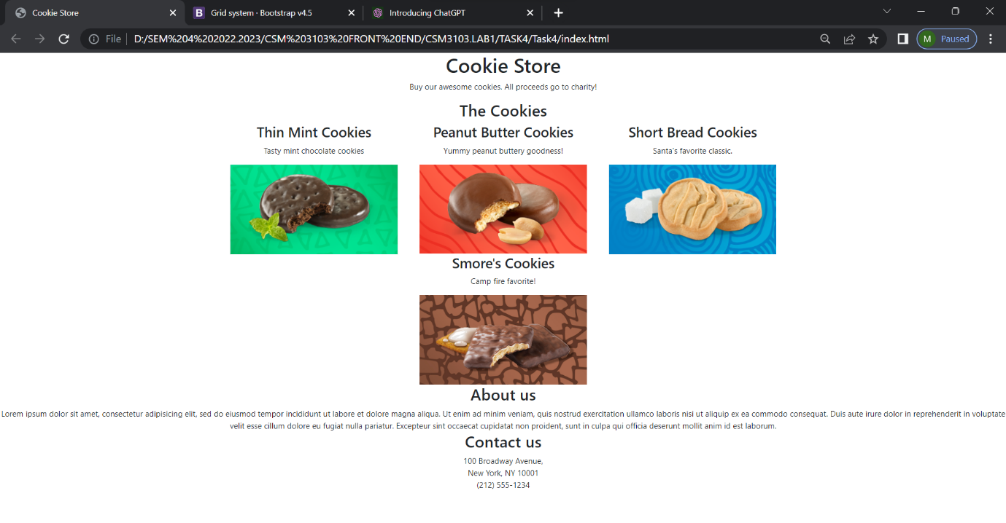

5. Apply styling to make the page responsive as follows.

a. On large screen

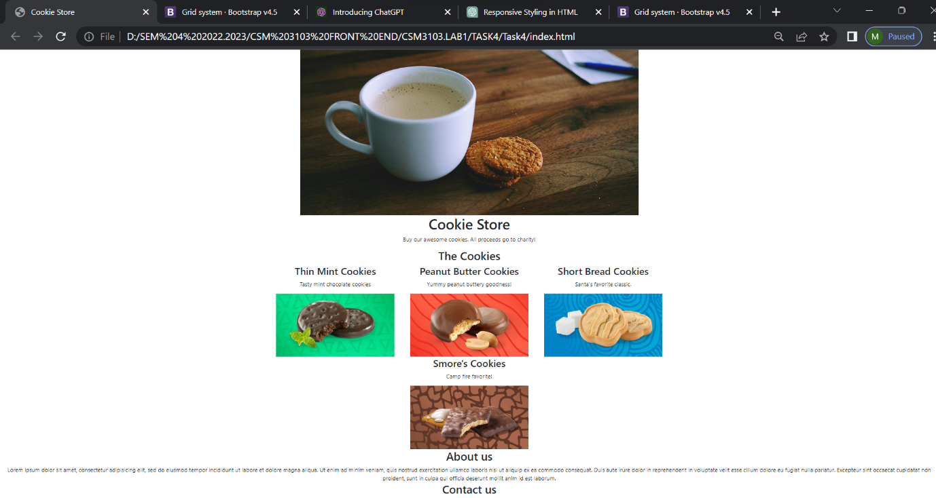

b. On medium and smaller screen

