

UNIVERSITI MALAYSIA TERENGGANU

FACULTY OF OCEAN ENGINEERING TECHNOLOGY & INFORMATICS

SEMESTER 2 2022/2023

FRONT-END PROGRAMMING

CSM 3103

LAB 2 REPORT

PREPARED FOR:

DR. RABIEI BIN MAMAT

PREPARED BY:

MOHAMAD HAZIM BIN MOHD SHAKRI (S61770)

**TASK 1**

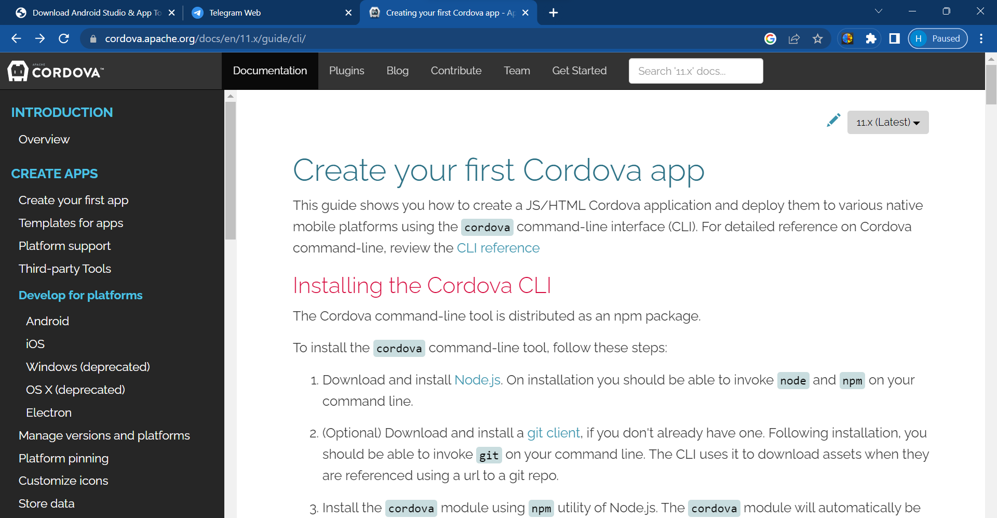

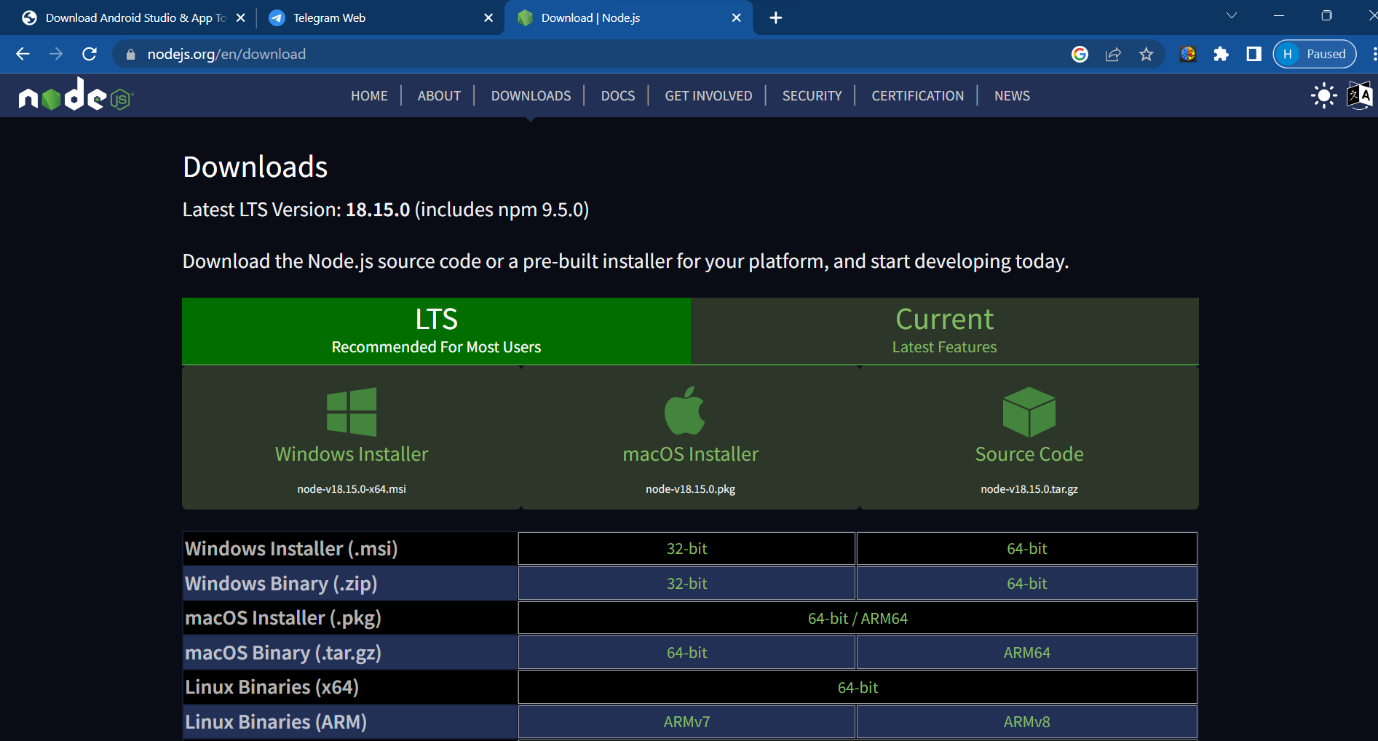

**TASK 2**

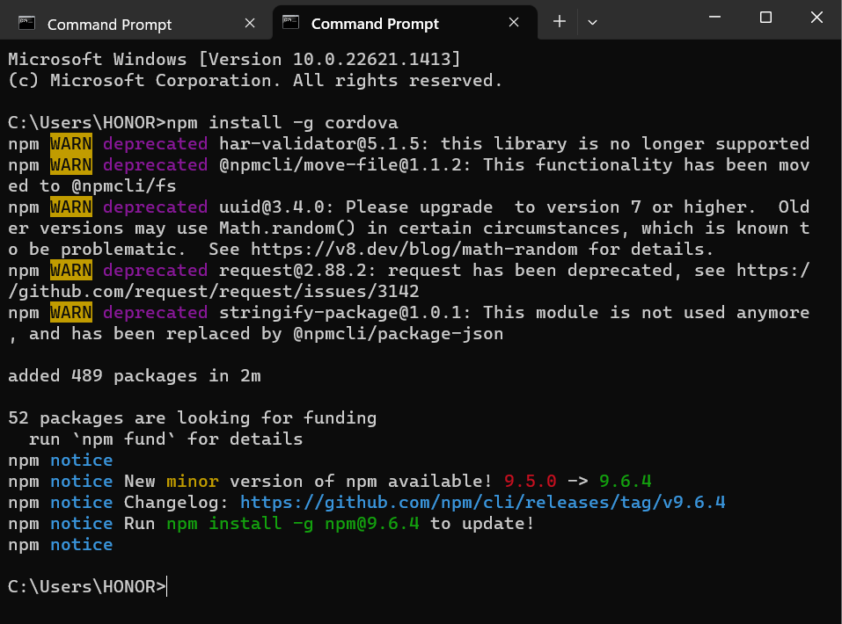

**TASK 3**

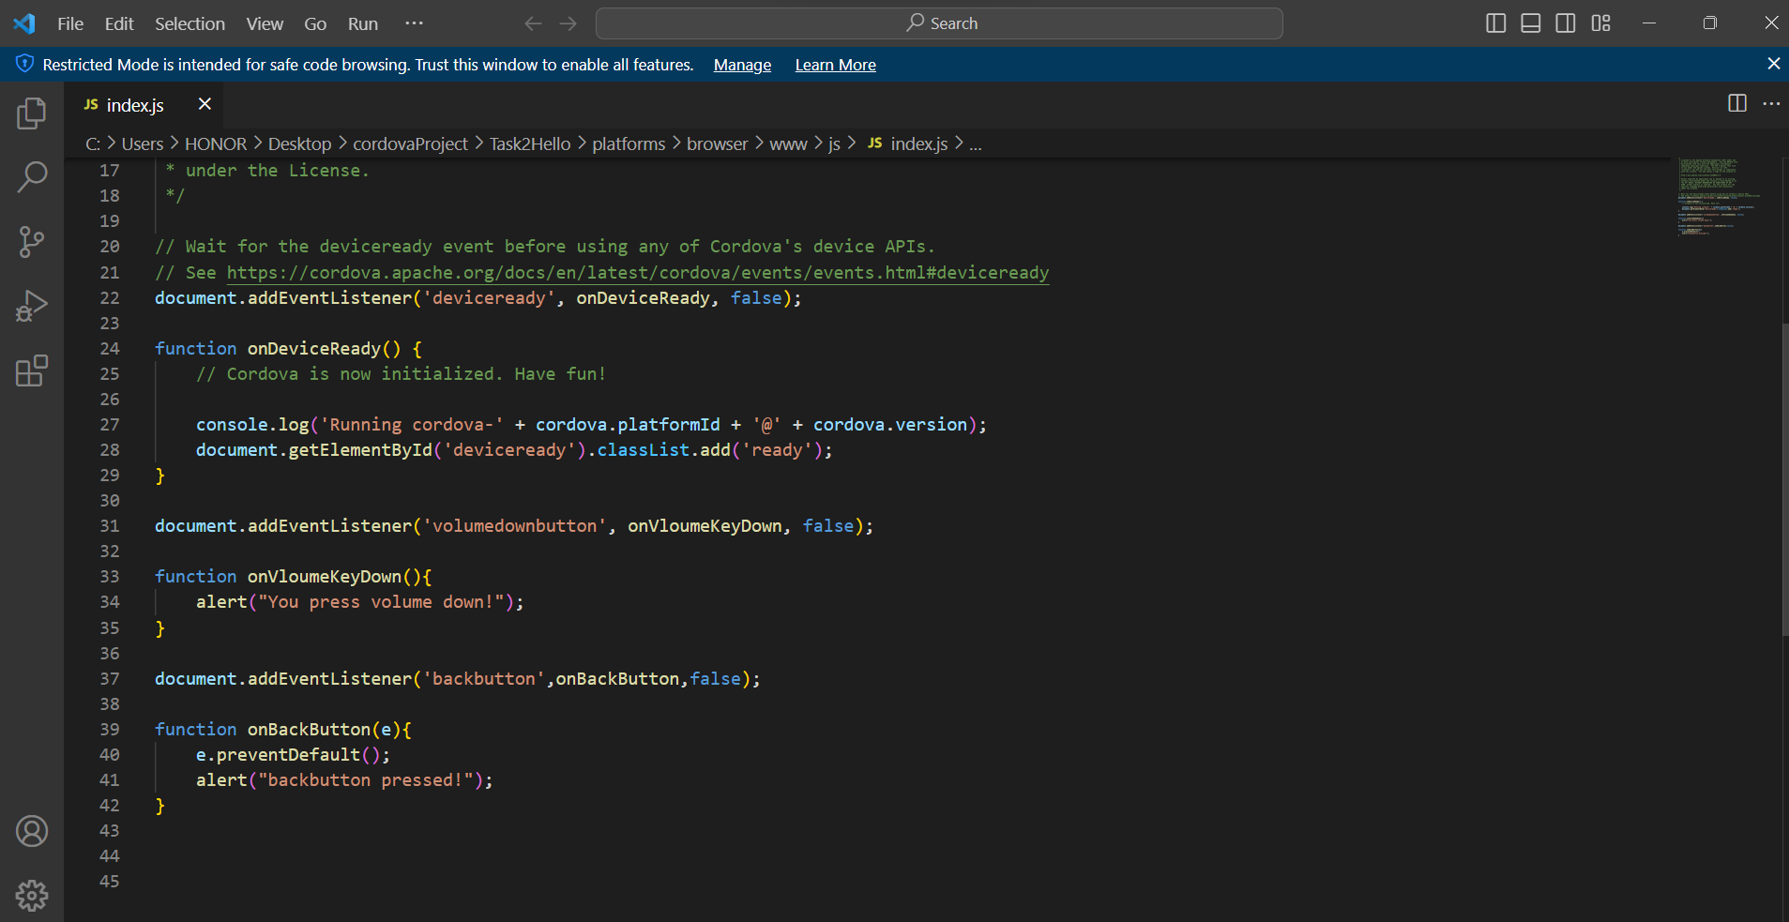

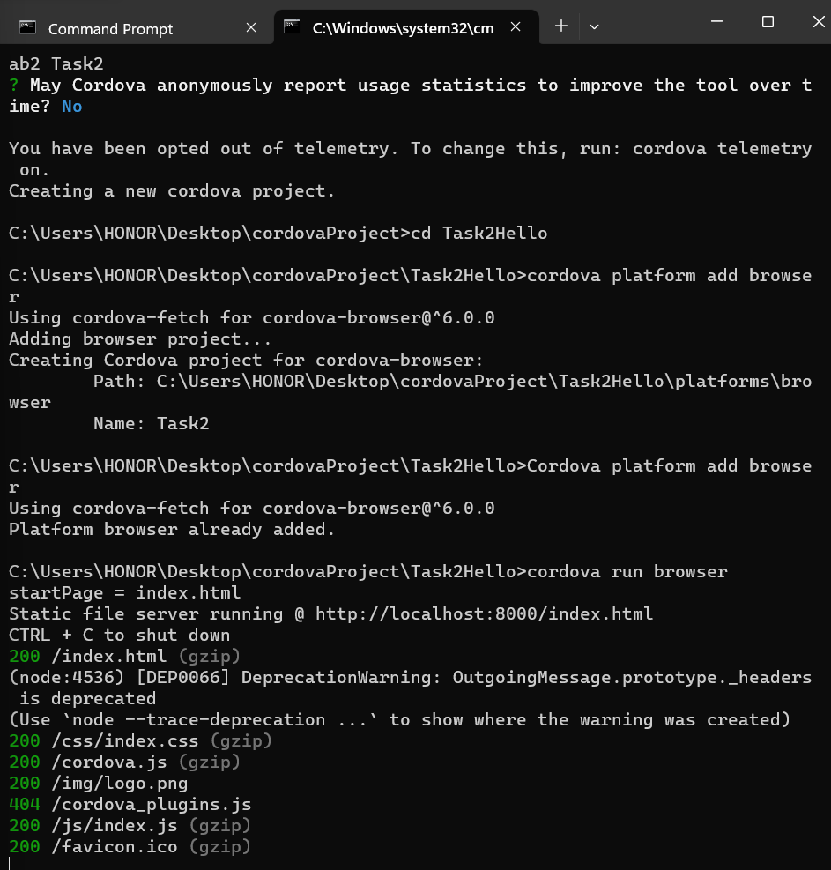

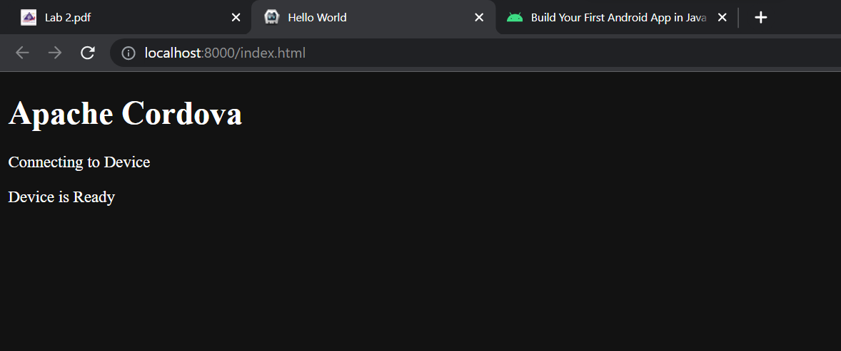

**TASK 4**

