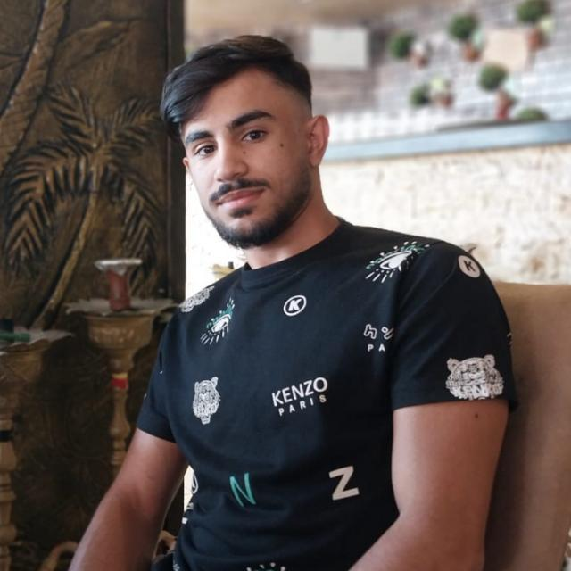

***SUMMARY***

***LANGUAGES***

* English
* Arabic
* +961 78 905 718
* [hazimehussein43@gmail.com](mailto:hazimehussein43@gmail.com)
* Lebanon, South, Ankoun

***Hussein Hazime***

Hello, my name is Hussein Hazime, and I am a computer science student at the Islamic University of Lebanon (IUL) with a focus on Full Stack development. I am working towards becoming a Software Engineer in the future. As a student, I am seeking job opportunities as a Full Stack developer to gain valuable experience and to better understand the labor market. Thank you for considering my application.

***MY Skills***

* **Programming Languages**: C,C++, Python, JavaScript , PHP.
* **Database**: MongoDB, MySQL.
* **Version Control**: Git.
* **CSS Frameworks:** Bootstrap.
* **Web Development Frameworks**: React Js Node Js, Express Js.
* Excellent communication and teamwork abilities.
* Strong problem-solving and analytical skills.
* Familiarity with responsive web design principles.

***Some Projects***

1. <https://github.com/HazimeHsen/template3> (Html & Css).
2. <https://github.com/HazimeHsen/Cyborge> (React Js).
3. <https://github.com/HazimeHsen/Shop> (MERN Stack)