CSN6224 Computer Networks Lab Test
Please follow the below instructions to complete all the network configuration tasks (Total 11 tasks) for this lab test
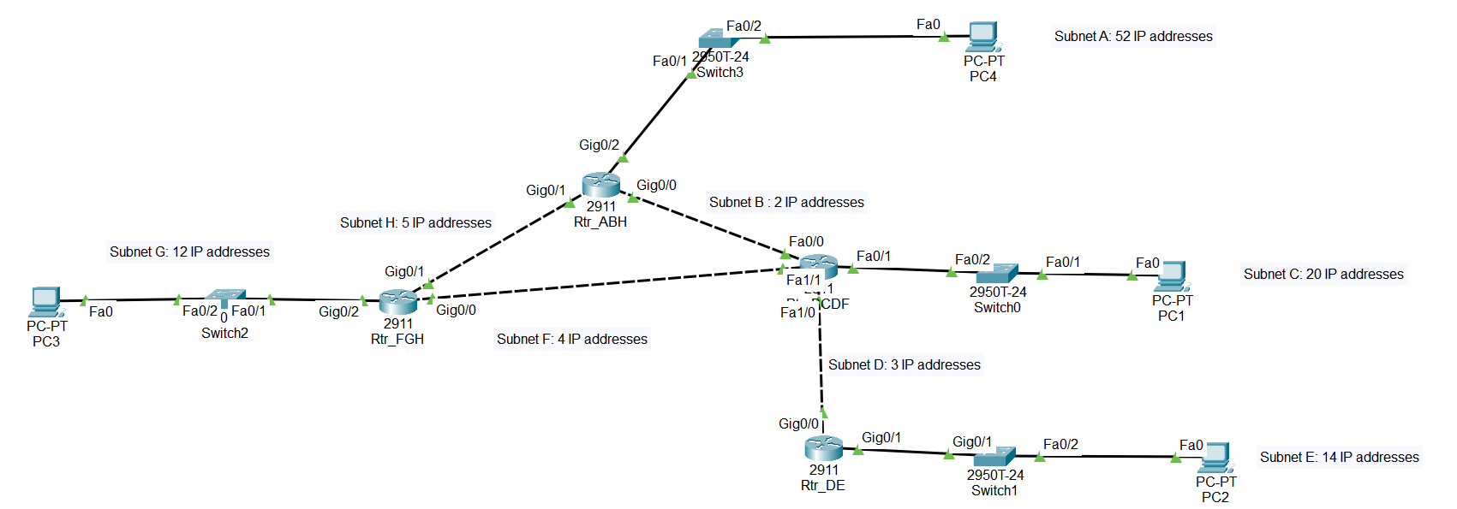
The number of IP addresses required by each subnet in the topology diagram is given below:
Subnet A: 52 IP addresses
Subnet B: 2 IP addresses
Subnet C: 20 IP addresses
Subnet D: 3 IP addresses
Subnet E: 14 IP addresses
Subnet F: 4 IP addresses
Subnet G: 12 IP addresses
Subnet H: 5 IP addresses

You are given with an IP address block: 215.15.15.0/24
You need to use subnetting to assign IP addresses to subnets from A to H. For your own reference, please ensure that you have recorded down each subnet information (subnet address, IP address range of the subnet, and broadcast address) clearly.

TASK 1: Configure the routers with basic configurations
- Configure the routers with hostnames Rtr_ABH, Rtr_BCDF, Rtr_DE and Rtr_FGH respectively.

TASK 2: Configure the PC1 and Default Gateway in Subnet C
- Configure the IP address for the Default Gateway using the first usable IP address of Subnet C.
- Configure the IP address for the PC1 using the last usable IP address of Subnet C.
- Ensure all links are UP in Subnet C.

TASK 3: Configure the PC2 and Default Gateway in Subnet E
- Configure the IP address for the Default Gateway using the first usable IP address of Subnet E.
- Configure the IP address for the PC2 using the Second usable IP address of Subnet E.
- Ensure all links are UP in Subnet E.

TASK 4: Configure the PC3 and Default Gateway in Subnet G
- Configure the IP address for the Default Gateway using the last usable IP address of Subnet G.
- Configure the IP address for the PC3 using the first usable IP address of Subnet G.
- Ensure all links are UP in Subnet G.

TASK 5: Configure the PC4 and Default Gateway in Subnet A
- Configure the IP address for the Default Gateway using the last usable IP address of Subnet A.
- Configure the IP address for the PC4 using the first usable IP address of Subnet A.
- Ensure all links are UP in Subnet A.

TASK 6: Configure the TWO (2) interfaces with IP addresses in Subnet B
- Router Rtr_ABH, interface Gig0/0: First usable IP address of Subnet B.
- Router Rtr_BCDF, interface Fa0/0: Last usable IP address of Subnet B.

TASK 7: Configure the TWO (2) interfaces with IP addresses in Subnet D
- Router Rtr_BCDF, interface Fa1/0: First usable IP address of Subnet D.
- Router Rtr_DE, interface Gig0/0: Last usable IP address of Subnet D.

TASK 8: Configure the TWO (2) interfaces with IP addresses in Subnet F
- Router Rtr_BCDF, interface Fa1/1: First usable IP address of Subnet F.
- Router Rtr_FGH, interface Gig0/0: Last usable IP address of Subnet F.

TASK 9: Configure the TWO (2) interfaces with IP addresses in Subnet H
- Router Rtr_FGH, interface Gig0/1: First usable IP address of Subnet H.
- Router Rtr_ABH, interface Gig0/1: Last usable IP address of Subnet H.

TASK 10: Configure OSPF routing
- Enable OSPF routing in each router (all routers in area 0 and Priority ID as 1).

TASK 11: Connectivity Test
- Send Simple PDU from PC1 to PC3, PC3 to PC2, PC2 to PC4 and PC4 to PC1.
- Ensure all PDUs shows successful delivery.
- Save your file with the filename as “CSN6224 lab Test – StudentID.pka” and submit the file to the eBwise/Form link provided.

Solution:
Subnet | Hosts | Network/CIDR | Mask | 1st Usable | Last Usable | Broadcast
A | 52 | 215.15.15.0/26 | 255.255.255.192 | 215.15.15.1 | 215.15.15.62 | 215.15.15.63
C | 20 | 215.15.15.64/27 | 255.255.255.224 | 215.15.15.65 | 215.15.15.94 | 215.15.15.95
E | 14 | 215.15.15.96/28 | 255.255.255.240 | 215.15.15.97 | 215.15.15.110 | 215.15.15.111
G | 12 | 215.15.15.112/28 | 255.255.255.240 | 215.15.15.113 | 215.15.15.126 | 215.15.15.127
H | 5 | 215.15.15.128/29 | 255.255.255.248 | 215.15.15.129 | 215.15.15.134 | 215.15.15.135
F | 4 | 215.15.15.136/29 | 255.255.255.248 | 215.15.15.137 | 215.15.15.142 | 215.15.15.143
D | 3 | 215.15.15.144/29 | 255.255.255.248 | 215.15.15.145 | 215.15.15.150 | 215.15.15.151
B | 2 | 215.15.15.152/30 | 255.255.255.252 | 215.15.15.153 | 215.15.15.154 | 215.15.15.155

Marking Scheme:
Components | Item | Score
IP addresses | 36 | 36
Other (hostname) | 4 | 4
Routing | 16 | 16
Connectivity | 4 | 4
Total |  | 60
% |  | 100

