**Home:**

Welcome to Budget-Friendly Car Rental in Malaysia

Drive From Only RM6/Hour. Any Car, Anywhere.

Be car-free, live carefree. Discover flexible connectivity by renting a car hourly, daily, weekly, or even monthly anywhere in Malaysia, all made easy on the SOCAR car rental app.

**Example:**

**Welcome to Budget-Friendly Car Rental in Malaysia**

**Drive From Only RM6/Hour.  
Any Car, Anywhere.**

**Be car-free, live carefree.**Discover flexible connectivity by renting a car hourly, daily, weekly, or even monthly anywhere in Malaysia, all made easy on the SOCAR car rental app.

**Go Anywhere in 5 Easy Ways With Our Best Car Rental Services**

**Roundtrip**

With SOCAR’s round trip, drive as you please and navigate through your daily activities with ease. Just book a SOCAR car at any preferred zone, and pick up the car once your booking is confirmed. At the end of your reservation period, return the SOCAR back to the same pick up zone. Run errands, commute to work, and enjoy your leisure time conveniently wherever you are.

**Car Name And Price**

|  |  |  |
| --- | --- | --- |
| No. | Name | Price |
|  | HONDA BR-V | RM15.50/H |
|  | HONDA CR-V | RM20.00/H |
|  | HONDA HR-V | RM20.00/H |
|  | PERODUA AXIA | RM9.90/H |
|  | PERODUA BEZZA | RM12.50/H |
|  | PERODUA MYVI | RM10.90/H |
|  | PROTON IRIS | RM10.90/H |
|  | PROTON X50 | RM15.50/H |
|  | PROTON X70 | RM20.00/H |
|  | TOYOTA INNOVA | RM20.00/H |
|  | TOYOTA RUSH | RM22.90/H |
|  | TOYOTA VELLFIRE | RM39.90/H |
|  | TOYOTA VIOS | RM15.00/H |
|  | TOYOTA WISH | RM20.00/H |
|  | TOYOTA YARIS | RM11.90/H |
|  | VOLKWAGEN PASSAT | RM15.00/H |
|  | VOLKWAGEN POLO | RM11.90/H |
|  | VOLKSWAGEN TIGUAN | RM15.50/H |
|  | MAZDA CX-5 | RM22.20/H |
|  | HYUNDAI TUCSON | RM15.50/H |
|  | KIA PICANTO | RM10.90/H |

**Zones:**

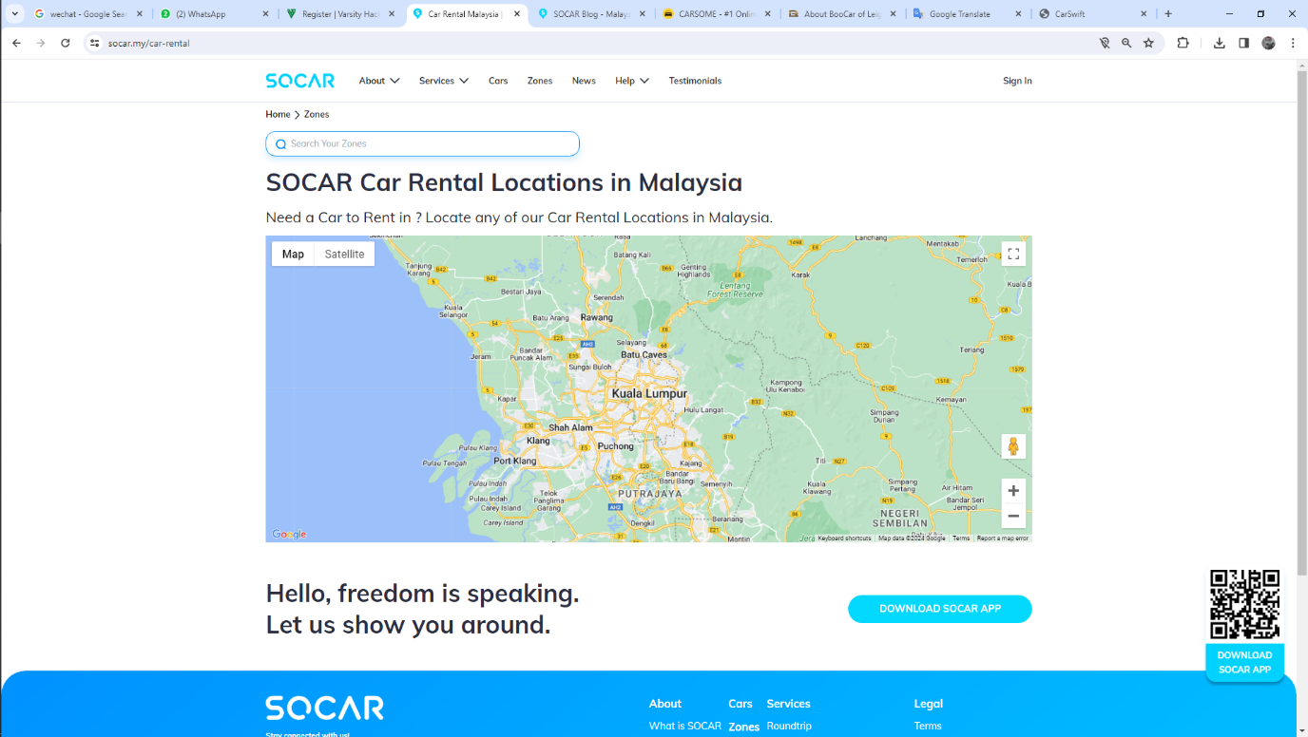

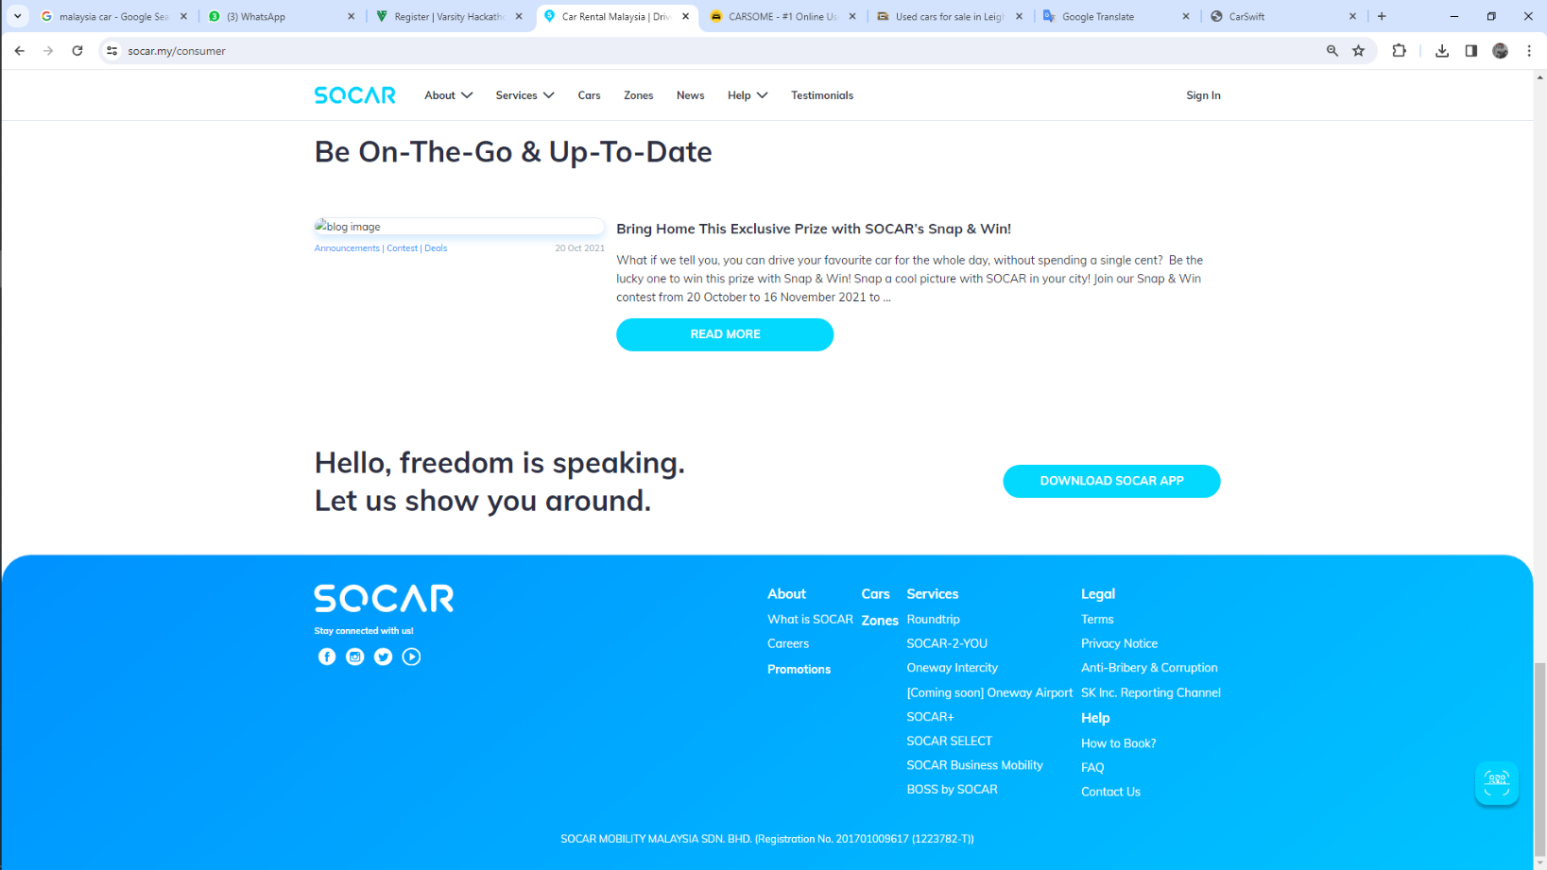**About Us:**

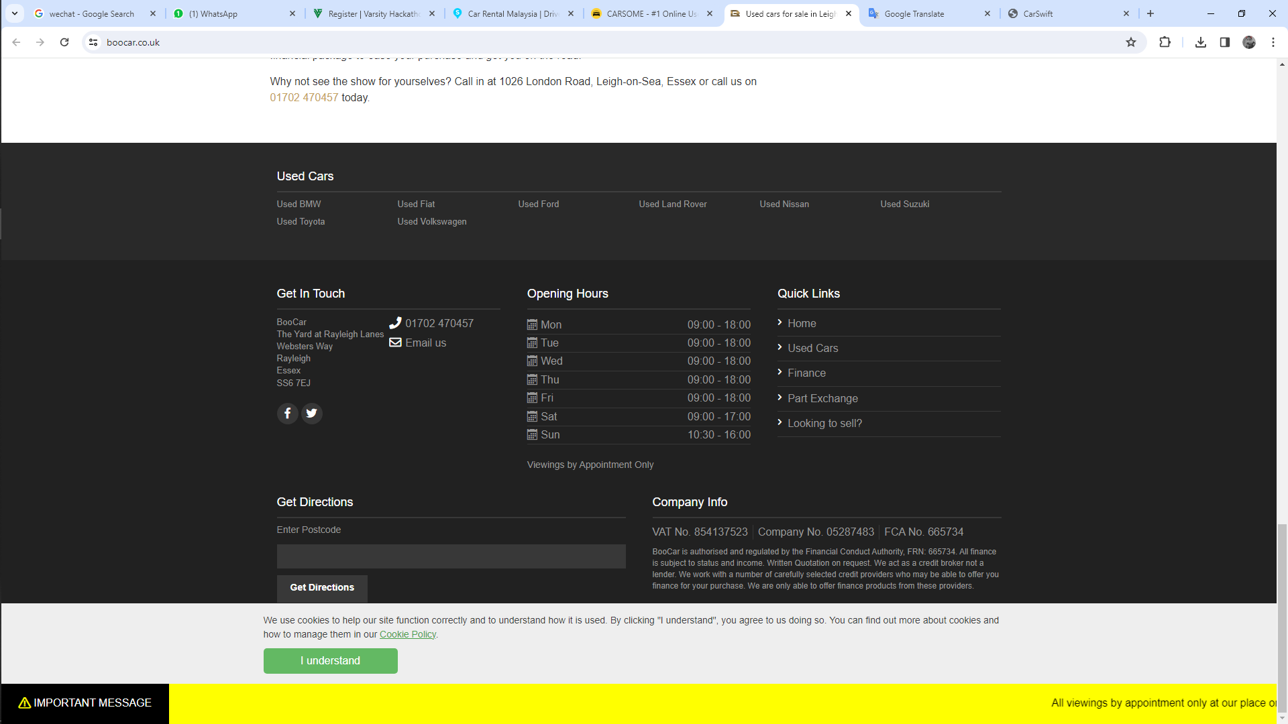

**Contact Us:**

