WEEKLY ASSIGNMENT 2
Total Time: 2 Hrs
Total Marks: 100
- Short Questions (Best of 10) (Total Marks: 10x2 = 20)
- What are the elements that can constitute class?
- What is the difference between interface and an abstract class explain with code example?
- What is the order of execution if different constructors explain with code example?
- How namespaces exhibit OOP properties explain with code example?
- What is the difference between a variable and a property in c#, How does the CLR handles the C# properties explain with code example?
- Explain with code example the use of ‘this’ keyword?
- Explain with code example the use of ‘base’ keyword?
- Discuss the merits and demerits of boxing and unboxing explain with code example?
- How can you define a nested class explain with code example?
- Explain with example what is interface boxing and its benefits?
- What is the difference between override and new keyword in method overriding explain with code example?

- Objective Questions (15x1= 15 Marks)
- Which interface facts is correct in C#.NET?
a) Interfaces cannot be inherited
b) Interfaces consists of data static in nature and static methods
c) Interfaces consists of only method declaration
d) None of the mentioned
- What an interface cannot have in C#.NET?
a) Properties
b) Methods
c) Structures
d) Events
- Select the correct statement among the given statements?
a) One class could implement only one interface
b) Properties could be declared inside an interface
c) Interfaces cannot be inherited
d) None of the mentioned
- Choose among the following what makes interface different from classes?
a) Unlike classes, interfaces consist of only declaration but not implementation
b) Interfaces cannot be used directly like classes to create new objects
c) Interfaces consists of declaration of methods, properties events and type definitions
d) All of the mentioned
- Access specifiers which can be used for an interface are?
a) Public
b) Protected
c) Private
d) All of the mentioned
- What is the right interface implementation from following?
a)
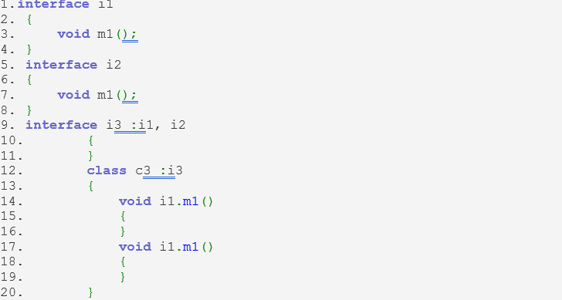
b)
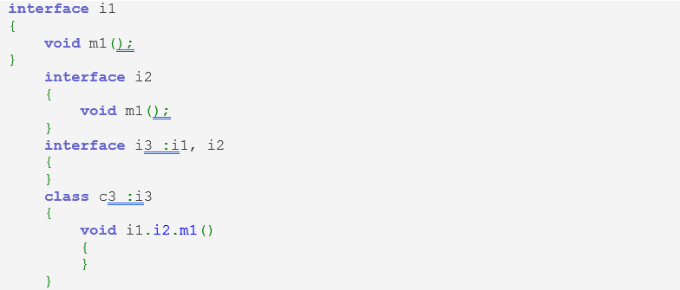
c)
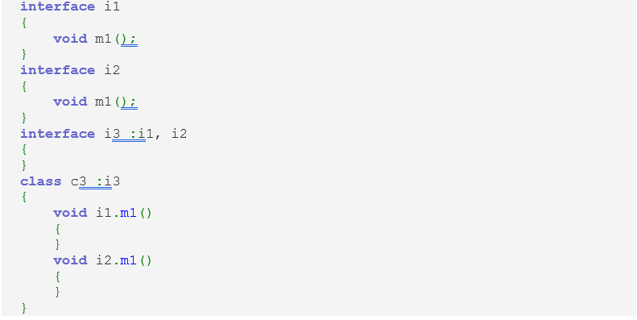
d) All of the mentioned
- What will be the output of the following C# code?
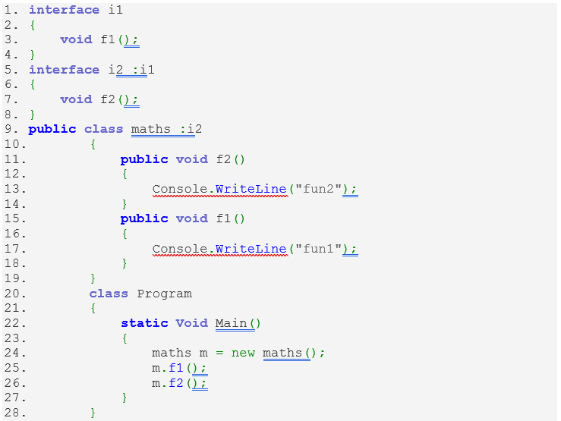
a) fun2
b) fun1
c) fun1
fun2
d) fun2
fun1
- inheritance in C# .NET what is wrong from following statements?
a) In inheritance chain, object construction begins from base class towards derived class
b) Inheritance cannot extend base class functionality
c) A derived class object contains all base class data
d) All of the mentioned
- Which of the following functionality is facilitated by inheritance mechanism?
a) Use the existing functionality of base class
b) Override the existing functionality of base class
c) Implements new functionality in derived class
d) All of the mentioned
- What will be size of the object created depicted by C# code snippet?
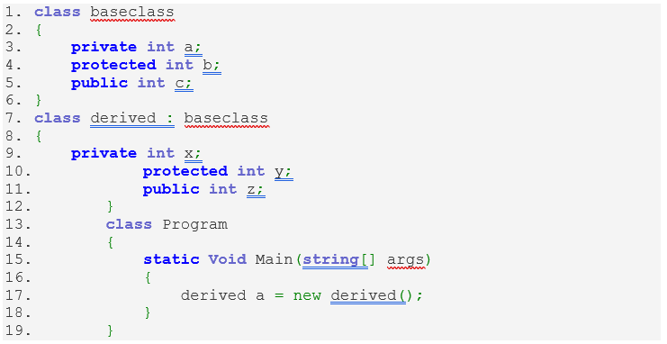
a) 20 bytes
b) 12 bytes
c) 16 bytes
d) 24 bytes
- What will be the output of the following C# code?
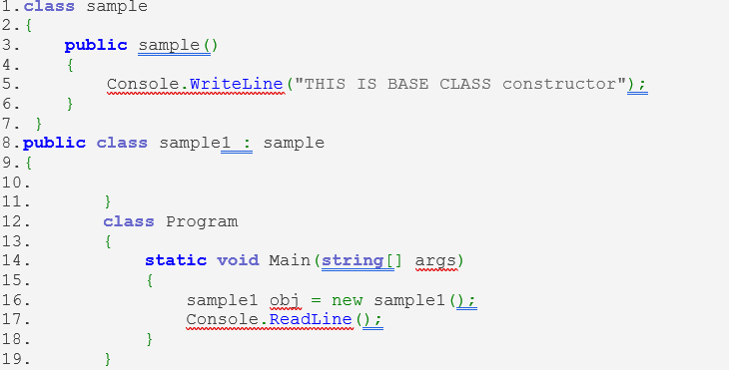
a) Code executes successfully prints nothing
b) This is base class constructor
c) Compile time error
d) None of the mentioned
- What will be the output of the following C# code?
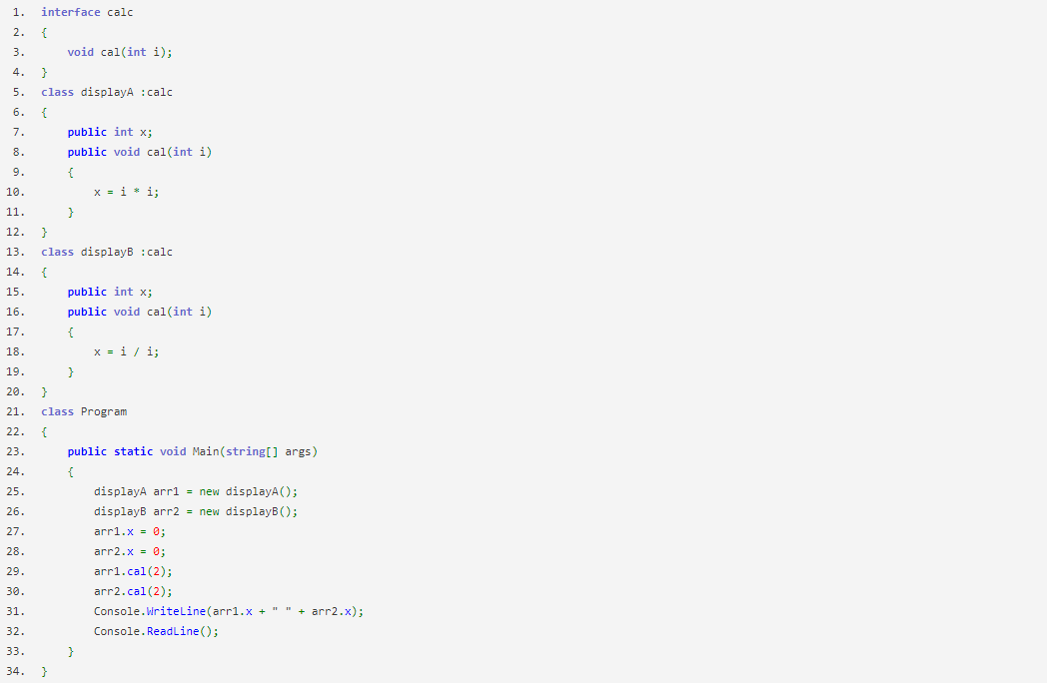
a) 0 0
b) 2 2
c) 4 1
d) 1 4
- What will be the Correct statement in the following C# code?
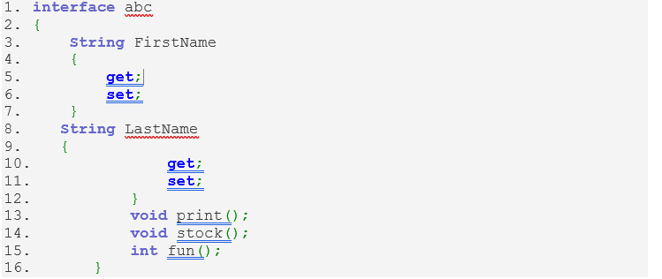
a) Functions should be declared inside an interface
b) It is workable code
c) Properties cannot be declared inside an interface
d) None of the mentioned

- The following C# code is run on single level of inheritance. What will be the Correct statement in the following C# code?
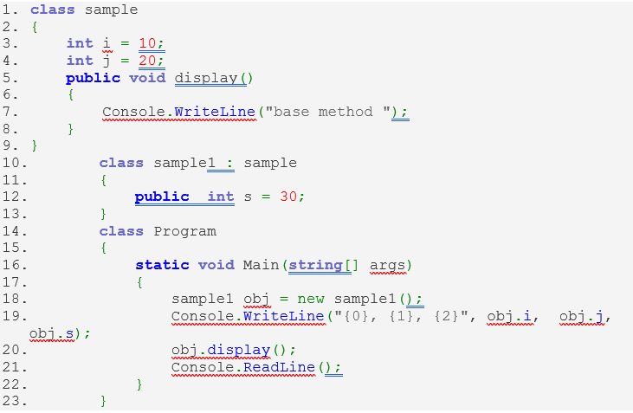
a)10, 20, 30
base method
b) 10, 20, 0
c) compile time error
d) base method
- Which of the following functionality is facilitated by inheritance mechanism?
a) Use the existing functionality of base class
b) Override the existing functionality of base class
c) Implements new functionality in derived class
d) All of the mentioned

- Programming Questions (Answer any 4) – (15x4 = 60)
- This C# Program Displays Cost of a Rectangle Plot Using Inheritance.
- The program should take one input from user cost for sq. foot during start of the application
- Once the execution start it asks the user to input the length and breadth of the rectangle in an infinite loop and displays the final cost. User can press q to quit the application
- The program should have a rectangle class to store the dimension, a Land Calculator class to store the cost for sq. feet and final cost.

- Write a C# program which has a class called Line which has following characteristics (start point and end point).
- Each point is defined by a structure coordinate in a x-y plane (x is the x coordinate and y are the y coordinate).
- The class should provide two methods Display () which shows the starting and end point of the line and the slope ()- which displays the slope of the line.

- Write a C# program with 3 classes which represent different travel classes (First class, second class and third class).
- Each classes implements the same interface which has a property about the cost per kilometre, a method to calculate the total cost given the distance of travel.
A user will be asked to enter the distance of travel and upon entering the value he will be asked to select the class of travel (First/Second/Third) depending on his answer the final cost of his journey will be calculated.

- Write a sample C# program for Processing fee calculator
- A customer can make a purchase in one of 3 ways (credit card/ debit card/ bank transfer)
- Each different type of payments is represented by an enumeration
- Each type of payment methods has predefined processing fee percentage of 2.2%, 1.3%, 0.75% respectively.
- Each type of payment methods is represented by an interface which has following properties processing fee, purchase price and final price which cannot be changed outside of the class. (all 3 interfaces have same property names and functions)
- Final class payment gateway implements all the 3 interfaces and have a display method which shows the breakdown of the price.
The final output is a user makes a purchase and asked to enter the price of the product.
In second step he must select the mode of payment and a final breakdown cost is displayed.
- Write program which has a defined class and has a method with following signature
object ManipulateObj(object obj)
The method behaves in following way
- If we call “ManipulateObj” with a string type it will return the reverse of the string.
- If we call “ManipulateObj” with an integer it will return the square of the integer
- If we call “ManipulateObj” with a double it will return the decimal part of it.
- If we call “ManipulateObj” with a bool it will return the inverse of the variable.
Finally, all the return value from the method should be converted to their native type and stored.
The final program should ask user to enter a value and the user input is passed to the method the output is printed with the “type” information.
- Write a C# program with following construct
- An interface which defines “Speed”, “Engine capacity”, “Torque” and a method ShowBikeInformation()
- A Benelli Bike class which implements the interface and provide read-only the basic values for each field.
- An enumeration which includes following values “LedLight”, “ABS”, “USD Suspension”, “Launch Control”, “Cruise Control”, “Traction Control”
- Another interface which defines List<string> SpecialFeatures(explanation for each type in the enumeration) and an indexer which returns a particular safety feature explanation when we pass the respective enumeration value
- A Benelli Roadster series which inherits from Benelli Bike class and implements the second interface. However, it has updated specs compared to its base class (20% increment to all base values).
- A final Benelli Special Edition Roadster Series Bike which cannot be inherited further and has an updated spec from its base class (5% more values compared to Benelli Roadster. Additionally, It has an updated explanation for SpecialFeatures compared to its base class.

The output program asks the user to select one of the vehicle types and displays the vehicle characteristics. Additionally, it also displays the list of special features it has (if any) and asks user to select a special feature to get more information about it.

- Design Question (1x5 = 5 marks)
Imagine You oversee a running a canteen where you serve 3 types of servings breakfast, lunch, dinner.
Each serving can be further divided into 3 types (basic, normal and luxury)
Each type of servings has a base price and for upper variants (you demand 10% and 30% extra respectively).
Moreover, the price of your meal is 25% premium over weekends.
Design a system where it has three components
- Customer who can choose a meal and pay the price
- A billing system which keeps a record of each sale
- Owner who needs to have an option of setting the base price of each meal, view all the sales, total sale amount, segregation of bills based on type etc.
How are you going to design the system using the concepts you have been taught (class, interface, inheritance, Enums etc.). (No code required only design is expected)

