Calibration
The smartband device was recalibrated prior to data collection to ensure optimal measurement accuracy. Calibration was conducted using known loads ranging from 0 kg to 3 kg, with additional calibration points at 0.05 kg intervals from 0 kg to 0.5 kg. Each calibration load was measured over five trials, and the average measurement was calculated for each load. The resulting average values were plotted to evaluate the relationship between the applied load and the measured output. As shown in Figure 1 and Figure 2, the measured values demonstrated minimal deviation from the expected values, indicating satisfactory calibration performance.

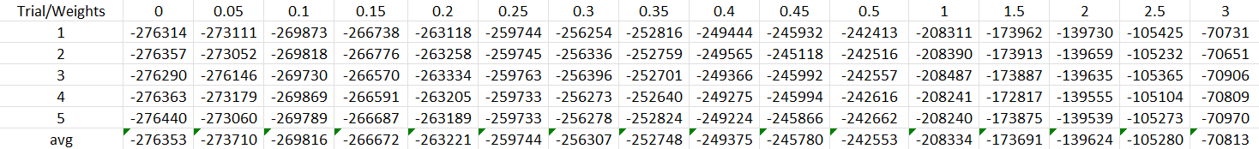
Figure 1: Calibration Results
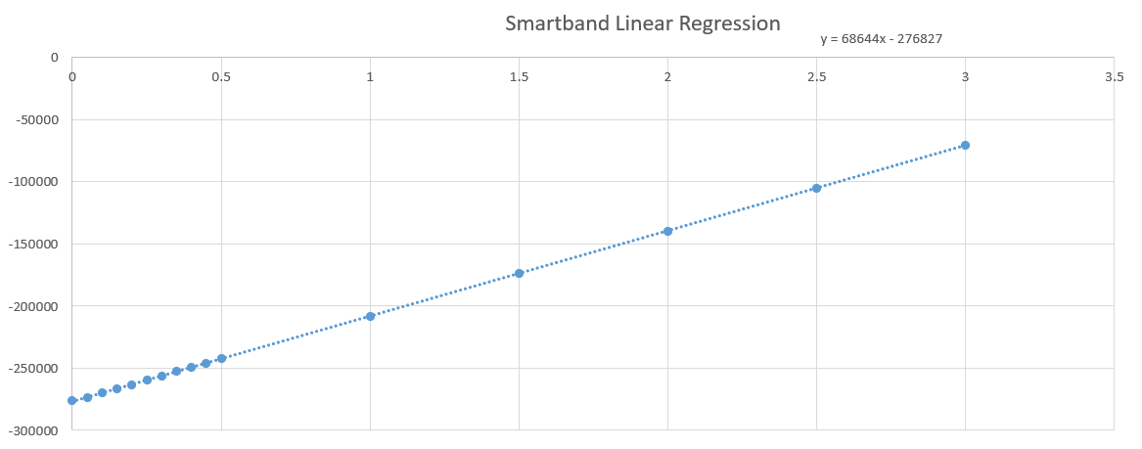
Figure 2: Linear Regression of Smartband Device
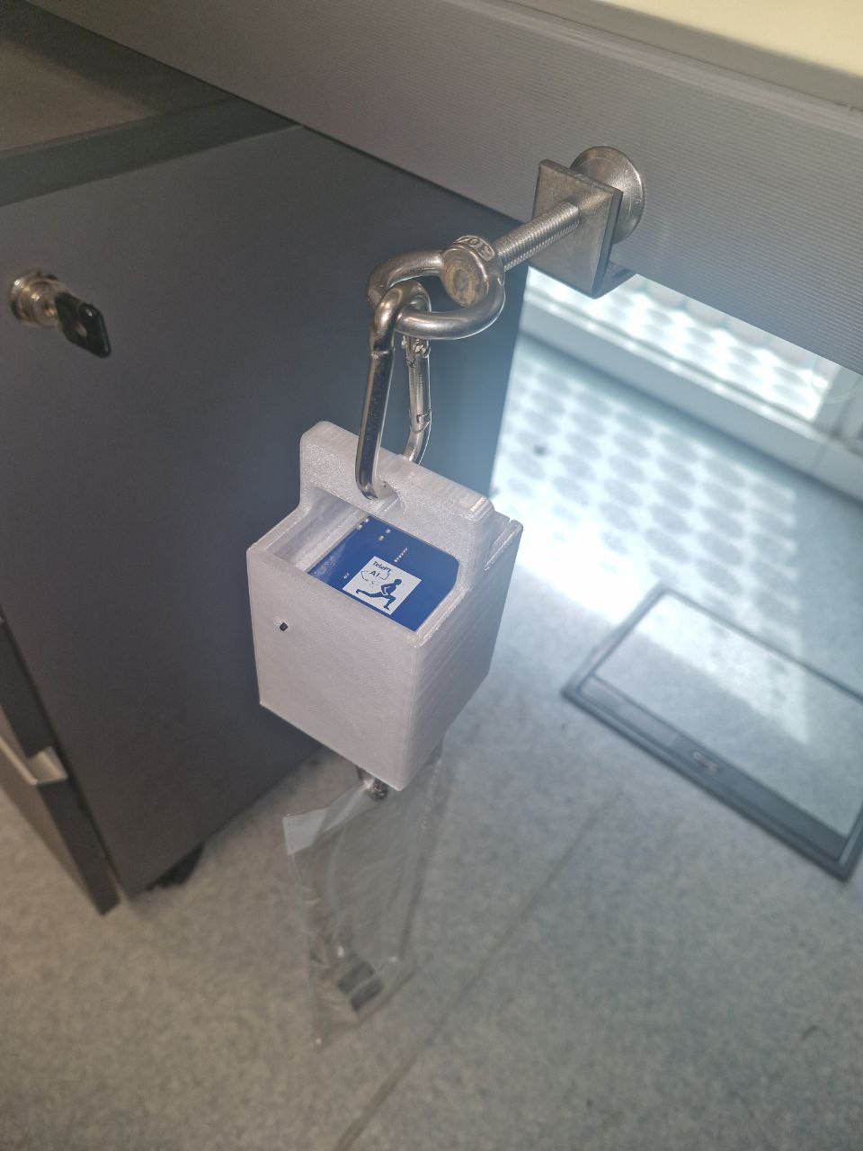
Figure 3: Device Calibration Setup

Easyforce and Smartband Strength Measurement
Following calibration, a series of muscle strength tests were conducted to evaluate the measurement accuracy of the smartband. The tests comprised Right Elbow Flexion (REF), Left Elbow Flexion (LEF), Right Shoulder Flexion (RSF), and Right Shoulder Abduction (RSA). For each test, the smartband was connected in conjunction with an EasyForce dynamometer as shown in Figure 4, which served as the reference device. Both devices were positioned within the same testing configuration such that the applied force was simultaneously measured by the smartband and EasyForce. The corresponding measurements obtained from both devices were recorded for subsequent comparison and validation of the smartband's muscle strength measurements.

As shown in 5 a total of 30 strength test trials were conducted, comprising 9 REF trials, 9 LEF trials, 6 RSF trials, and 6 RSA trials. The percentage error between the Smartband and EasyForce measurements was calculated for each trial to assess the measurement accuracy of the Smartband. The recorded percentage error ranged from -0.006% to 5.12%, with an average error of 1.75% across all 30 trials.

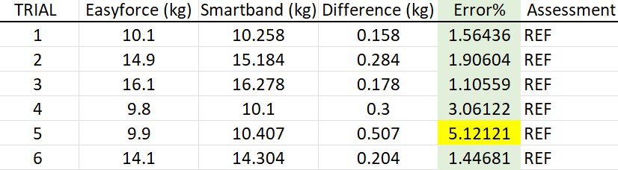
Figure 5: EasyForce vs Smartband

