|  |  |
| --- | --- |
| Name: | Muhammad Haziq Bin Hayazi |
| Matrics No.: | 2023116297 |
| Class: | CDCS2405B |
| Course Subject: | ICT602 |
| Assignment | Individual Assignment-Output for Mobile Application |

Output 1:

Output 2:

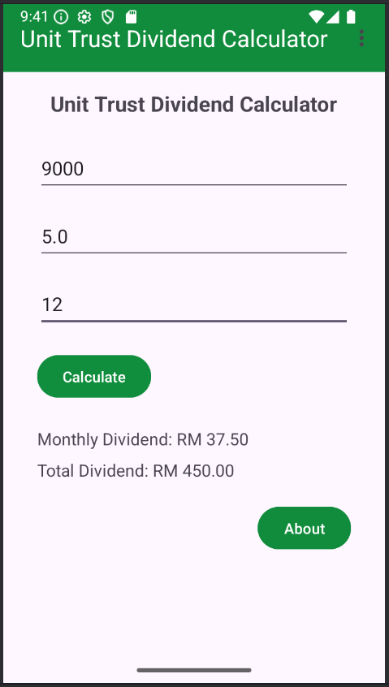

Output 3:

