# Instructions

The web development team has requested that each of the team members is granted access to login to the CentOS system you have created previously. Set each user’s default password to Pa$$w0rd.

The list of users is as follows:

|  |  |  |
| --- | --- | --- |
| Full Name | Username | Position |
| Divya Bodine | dbodine | Lead Developer |
| Taylor Dahl | tdahl | Lead Developer |
| Williams Dorsey | nwilliams | Web Developer |
| Roy Abogye | rabogye | Web Developer |
| Nikki Reed | nreed | Application Developer |
| Rama Rubino | rrubino | Application Developer |

Each user should be placed into a group based on their position. The Lead Developers should be members of all groups and be given “sudo” access to the system.

The following positions should have the ability to edit files in their respective directories listed below. Keep in mind this is for a web application. This means the “world” will need read and execute permissions to each folder:

Lead Developers

/development and all subfolders

Web Developers

/development/website

/development/website/images

Application Developers

/development/website/js

# Screenshots

Paste the required screen shots under each description.

1. Show all users accounts in the /etc/passwd file.

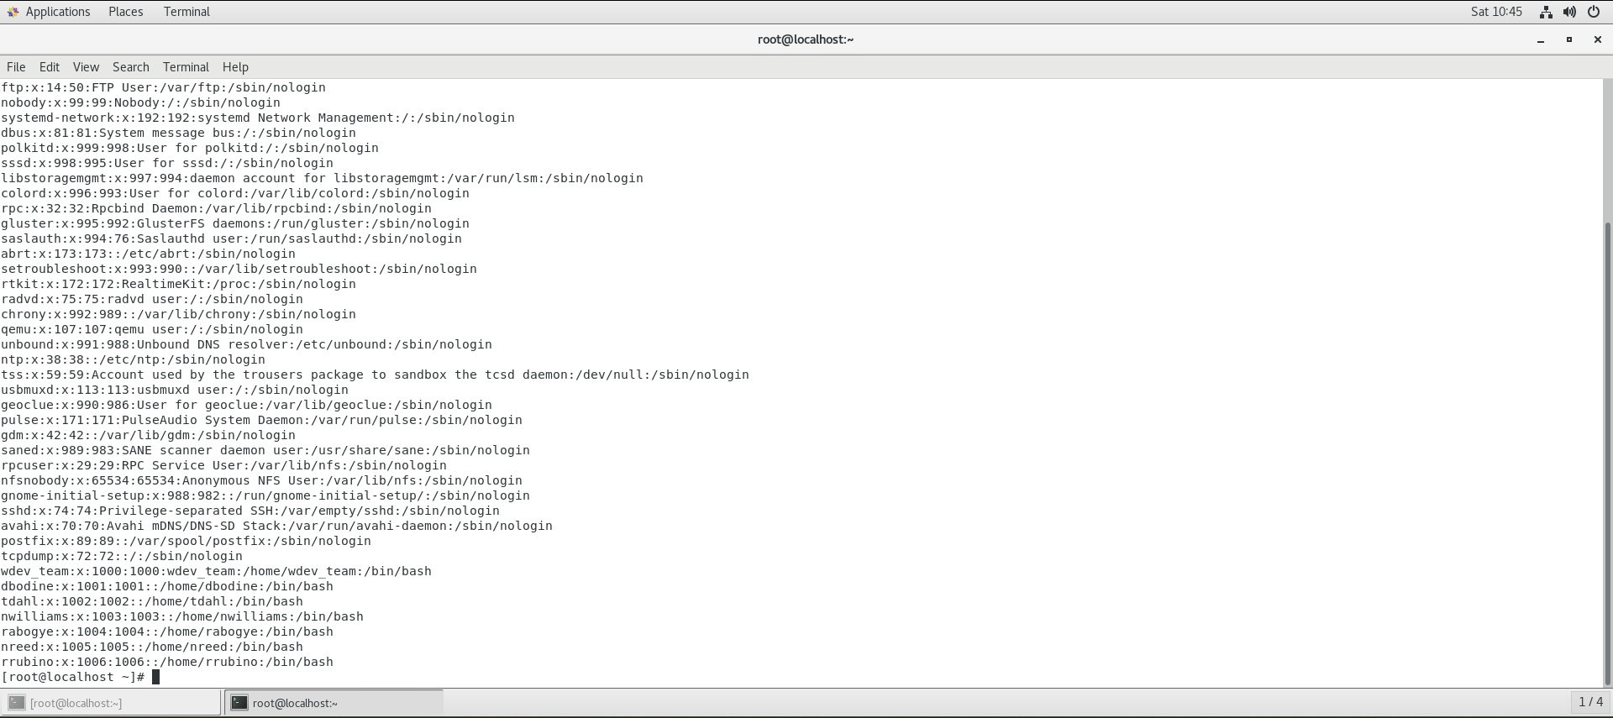

2. Show all users password hashes in the /etc/shadow file.

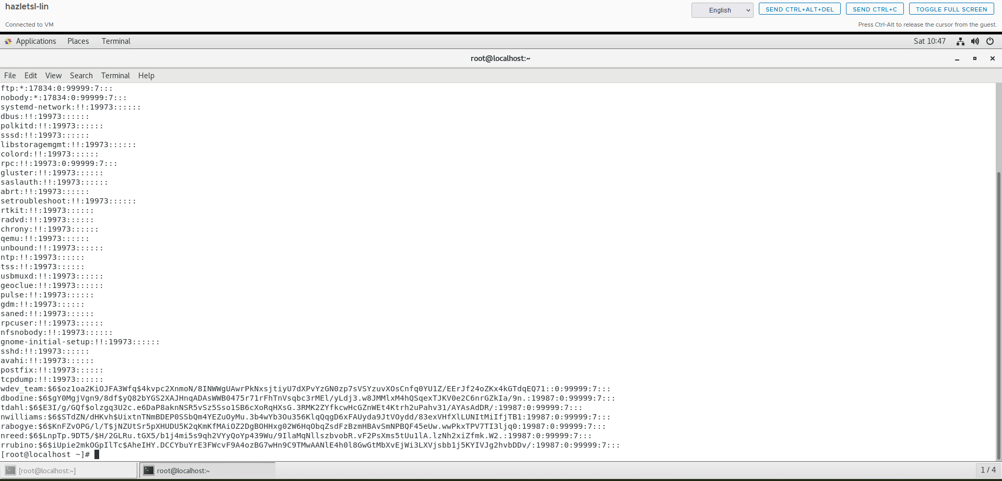

3. Show all groups and group membership in the /etc/group file.

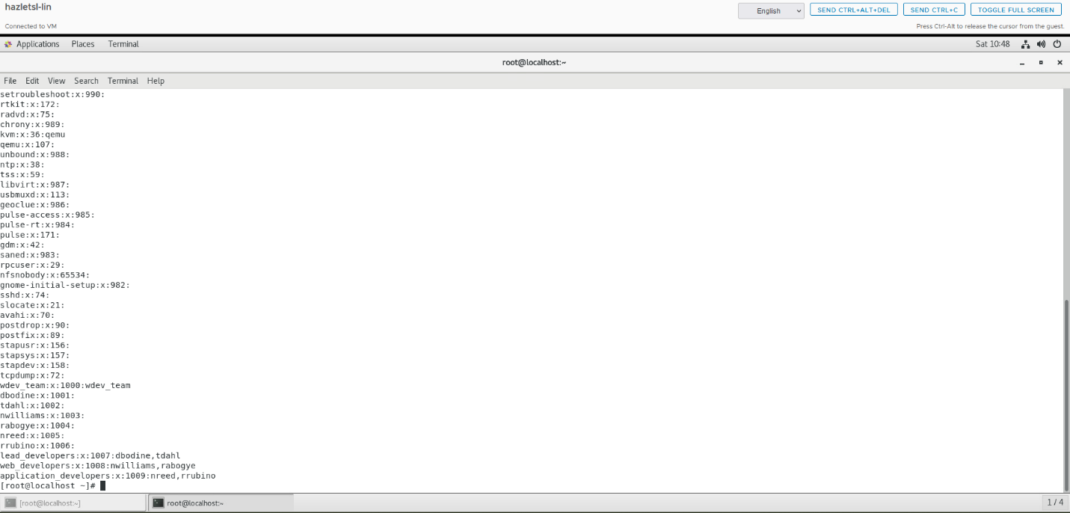

4. Show the “sudo” permission in the “sudoers” file.

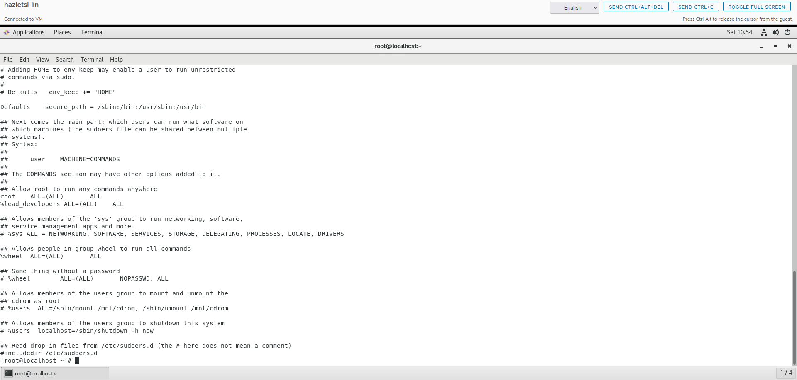

5. Show the permissions in a long listing format for the /development director and each sub-directory.

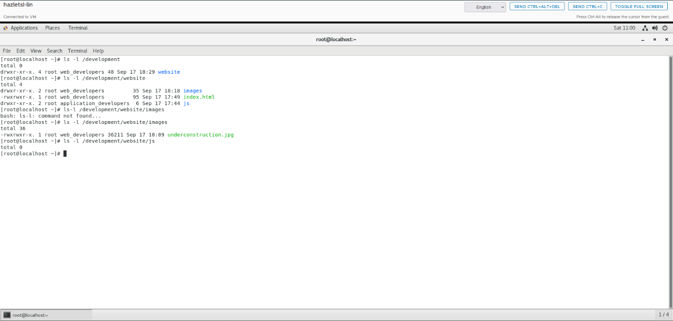

# Documentation

Record and explain all the steps you took to complete the task. Include any commands used, screen shots showing GUI interfaces, or any other information that would help you recreate the task.

**Note: You will be allowed to use this documentation to help you complete future assignments.**

* Created users by running these commands:

sudo useradd -m dbodine -s /bin/bash

sudo useradd -m tdahl -s /bin/bash

sudo useradd -m nwilliams -s /bin/bash

sudo useradd -m rabogye -s /bin/bash

sudo useradd -m nreed -s /bin/bash

sudo useradd -m rrubino -s /bin/bash

* set each user’s password to Pa$$w0rd running these commands:

echo "dbodine:Pa$$w0rd" | sudo chpasswd

echo "tdahl:Pa$$w0rd" | sudo chpasswd

echo "nwilliams:Pa$$w0rd" | sudo chpasswd

echo "rabogye:Pa$$w0rd" | sudo chpasswd

echo "nreed:Pa$$w0rd" | sudo chpasswd

echo "rrubino:Pa$$w0rd" | sudo chpasswd

* created the necessary groups running these commands:

sudo groupadd lead_developers

sudo groupadd web_developers

sudo groupadd application_developers

* added users to their respective groups by running these commands:

sudo usermod -aG lead_developers dbodine

sudo usermod -aG lead_developers tdahl

sudo usermod -aG web_developers nwilliams

sudo usermod -aG web_developers rabogye

sudo usermod -aG application_developers nreed

sudo usermod -aG application_developers rrubino

* edited the sudoers file using visudo by running:

sudo visudo

* added the following line for the group permissions under root ALL=(ALL) ALL :

%lead_developers ALL=(ALL) ALL

* created the necessary directories for the web application ran these commands to create them:

sudo mkdir -p /development/website/images

sudo mkdir -p /development/website/js

* changed the ownership of the directories by running these commands:

sudo chown -R root:web_developers /development/website

sudo chown -R root:application_developers /development/website/js

* set the permissions for the directories by running these commands:

sudo chmod -R 775 /development/website

sudo chmod -R 775 /development/website/js

* checked the permissions and ownership to ensure everything is set correctly ran these commands to verify:

ls -l /development

ls -l /development/website

ls -l /development/website/js

* displayed all user accounts by running this command. Then took screenshot:

cat /etc/passwd

* checked the password hashes by running this command. Then took screenshot:

sudo cat /etc/shadow

* show all groups and their memberships by running this command. Then took screenshot:

cat /etc/group

* checked the sudo permissions in the sudoers file by running this command. Then took screenshot:

sudo cat /etc/sudoers

checked the contents of the /development/website/js directory by running these commands. Then took screenshot:

ls -l /development

ls -l /development/website

ls -l /development/website/images

ls -l /development/website/js

Completed lab.