“Project”

Course title: “Artificial Intelligence”
Course Code: “CS-331”
Roll no: 23014119-120
Section: A “ Evening ”
Submitted by: “Habiba Ali”
Submitted to: “Sir Naveed Anwer butt”


Phase 1 Documentation

- Decision Tree

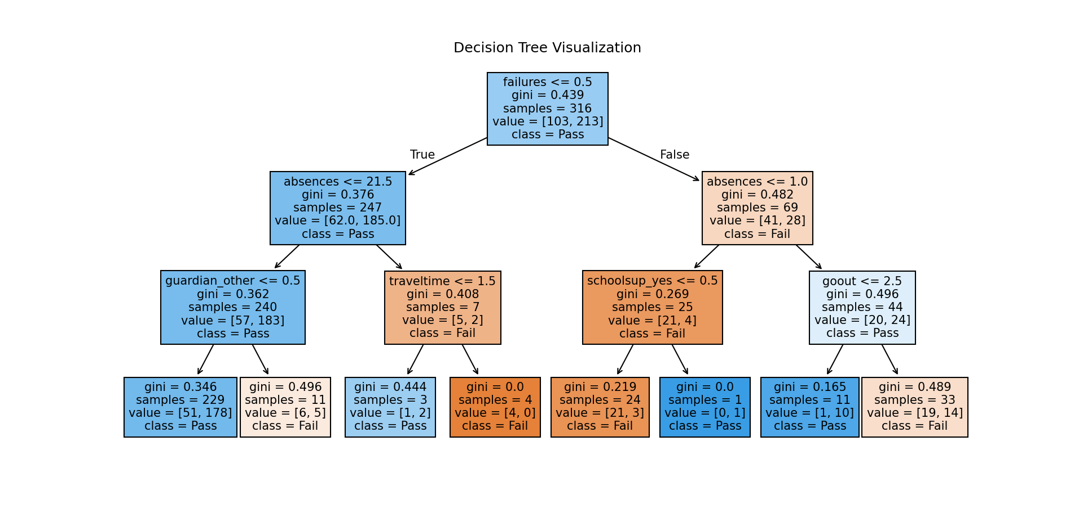

- Model Performance Comparison Table

Model | Train Accuracy | Test Accuracy | Precision | Recall | F1-Score
Scratch Tree | 0.911 | 0.696 | 0.733 | 0.846 | 0.786
Decision Tree | 0.763 | 0.747 | 0.735 | 0.962 | 0.833
Random Forest | 1.000 | 0.658 | 0.681 | 0.904 | 0.777
Extra Trees | 1.000 | 0.646 | 0.676 | 0.885 | 0.767
Gradient Boosting | 0.956 | 0.684 | 0.721 | 0.846 | 0.779
XGBoost | 1.000 | 0.722 | 0.759 | 0.846 | 0.800
LightGBM  CatBoost | 0.997  0.873 | 0.709  0.696 | 0.738  0.700 | 0.865  0.942 | 0.796  0.803

- Confusion Matrics

