“Project”

Course title: “Artificial Intelligence”
Course Code: “CS-331”
Roll no: 23014119-120
Section: A “ Evening ”
Submitted by: “Habiba Ali”
Submitted to: “Sir Naveed Anwer butt”


Department of Computer Science

Github link:
https://github.com/Hb4315/Student_Performance_Prediction-/upload
Phase 2 Documentation

Student Performance Prediction :-
In this phase, the Student Performance dataset was used to predict whether a student will pass or fail based on academic and demographic features. The final grade (G3) was converted into a binary target variable, where students scoring 10 or above were labeled as Pass and others as Fail. Categorical features were encoded using one-hot encoding, and the dataset was split into training and testing sets. A Gaussian Naïve Bayes classifier was implemented as the primary model due to its simplicity and efficiency, and its performance was evaluated using accuracy, precision, recall, and F1-score. A Decision Tree classifier was also applied for comparison. Additionally, a confusion matrix was generated to analyze correct and incorrect predictions. The results show that Naïve Bayes provides reliable performance and serves as an effective baseline model for student performance prediction.
By implementing implementing Naïve Bayes using Bayesian Theorem
Deliverables:
- Confusion matrix
- Performance metrics
- Comparison with Decision Tree

      - Interpreted Confusion Matrix
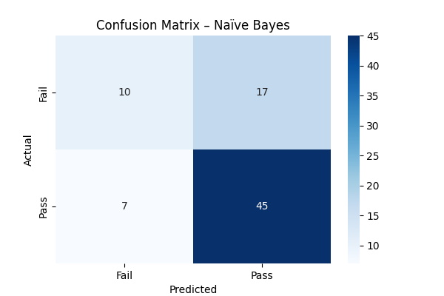

      - Performance Metrics (Naïve Bayes)
Given Results:
- Precision : 0.726
- Recall : 0.865
- F1-score : 0.789

      - Comparison with Decision Tree
Model | Precision | Recall | F1-score
Naïve Bayes | 0.726 | 0.865 | 0.789
Decision Tree | 0.735 | 0.962 | 0.833

