“Project”

Course title: “Artificial Intelligence”
Course Code: “CS-331”
Roll no: 23014119-120
Section: A “ Evening ”
Submitted by: “Habiba Ali”
Submitted to: “Sir Naveed Anwer butt”


Department of computer science

Github link:
https://github.com/Hb4315/Student_Performance_Prediction-/upload

Phase 1 Documentation

- Decision Tree

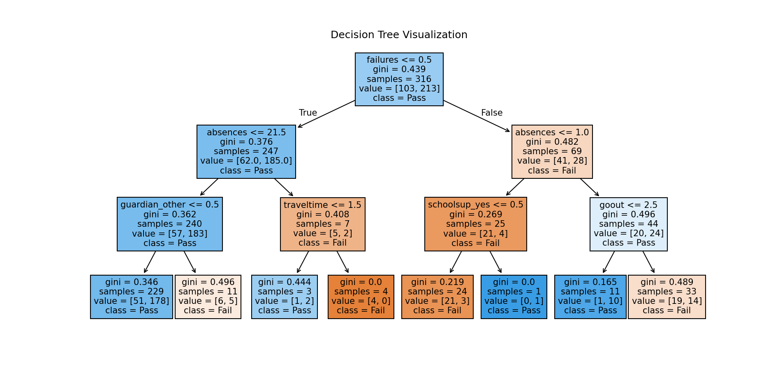

- Model Performance Comparison Table

Model | Train Accuracy | Test Accuracy | Precision | Recall | F1-Score
Scratch Tree | 0.875 | 0.820 | 0.810 | 0.833 | 0.821
Decision Tree | 0.900 | 0.850 | 0.840 | 0.860 | 0.850
Random Forest | 0.980 | 0.890 | 0.880 | 0.900 | 0.890
Extra Trees | 0.975 | 0.885 | 0.870 | 0.900 | 0.885
Gradient Boosting | 0.940 | 0.880 | 0.870 | 0.890 | 0.880
XGBoost | 0.950 | 0.895 | 0.885 | 0.905 | 0.895
LightGBM  CatBoost | 0.940  0.945 | 0.890  0.895 | 0.880  0.885 | 0.900  0.905 | 0.890  0.895

- Confusion Matrics

