Homework 1 - Requirements Specification

# 1. Categorize requirements.

For each of the requirements given below, categorize the type of requirement it is, and identify any problems with the requirement.

|  |  |
| --- | --- |
| **Possible Categories** | **Possible Problems** |
| 1. Product cost 2. Performance 3. Resource constraints 4. Availability 5. Reliability 6. Safety 7. Security 8. Maintainability 9. Interoperability 10. Portability 11. Testability | 1. none 2. not correct 3. not complete 4. ambiguous 5. inconsistent 6. not verifiable |

**1.a.**

The software must be quick enough to allow for compression and storage, so that another picture may be taken within a reasonable amount of time.

Category(ies): Performance, resource constraints, Reliability, Maintainability

Problems: none

**1.b.**

Credit card transactions should be achieved through a trusted secure payment gateway. All the transactions should be logged into a database table for possible audits.

Category(ies): Availability, reliability, safety, Security, Maintainability, interoperability

Problems: None

**1.c.**

It is possible that the FARNav file format used as input and output could change in the future, so the impact of such a change should be isolated as much as possible.

Category(ies): Performance, reliability, Portability, interoperability

Problems: Ambiguous

**1.d.**

GCS should be accessible to all instructors using ESU d2l System, whenever they are logged into d2l.

Category(ies): Performance, Portability, Availability, security

Problems: ambiguous, not correct

**1.e.**

The camera shall allow the owner to set a lock screen swipe pattern.

Category(ies): Security, Safety, Resource constraints Problems: ambiguous

# 2. Use-Case Diagram

Below is a Use-Case diagram for the system described starting on page 6.

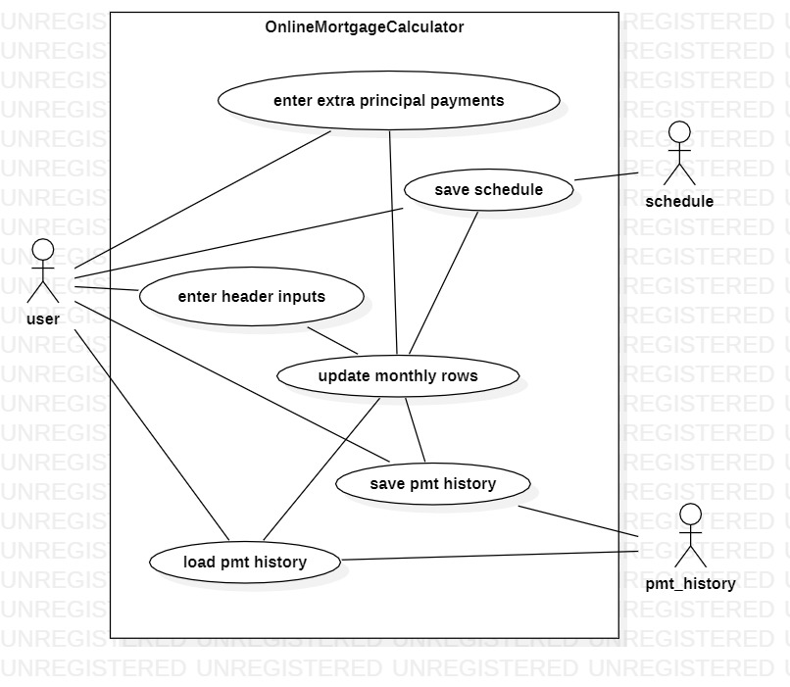

**2.a**

Compare this diagram to the system description, then list the use-cases that are NOT included in the description.

The Use-Case diagram and the system description have a discrepancy when it comes to saving the schedule and monthly payments, the system description does not specifically say that the schedule or payment history will be saved, just the payment histories

**2.b**

The system description says that certain behavior is not yet decided. What is the missing behavior?

**Compute or display button**

Where (in which use-case) do you think this functionality belongs?

**Enter extra principle payments**

**2c:**

Below is a description of the use-case for EnterHeaderInputs. Using the same format, provide a use-case for SaveSchedule.

---------------------------------

Use case: EnterHeaderInputs

Precondition: The screen displays the fields and labels in the header area. Numeric values are initialized.

Postcondition: Valid values for mortgageAmount, termInYears, APR, monthlyPayment are available

Main flow of events:

1. The user enters a valid URL to display the OnlineMortgageSystem in their browser.

2. The header fields and labels displays these values:

Mortgage Amount (Dollars) – currency field (whole dollars), initialized to $0

Term (in whole years) – integer field, initialized to 0

Interest Rate (APR) – percentage field, initialized to 0.00%

Monthly Payment – currency field (dollars and cents), initialized to $0.00

Total Payments – currency field (dollars and cents), initialized to $0.00

Total Interest – currency field (dollars and cents), initialized to $0.00

3. Mortgage Amount, Term, and Interest Rate can be edited. User clicks in one of these fields and types a value.

4. The user clicks in a different field, and all three fields’ input values are checked for validity.

*5. What does the system do when an invalid value is entered?*

2.a. The user is modifying the header inputs, so previously computed values are displayed (both header values and rows of monthly data).

Scenario 1: The user just started up the system and all values are 0.

Scenario 2: The user is modifying previously entered values.

---------------------------------

Use case: SaveSchedule

Precondition: Header inputs are entered, values of mortgageAmount, termInYears, APR, monthlyPayments are already entered/computed

Postcondition: The values in the table are saved to the system, and are viewable when requested

Main flow of events:

1. The data from enterHeaderInputs is stored/processed
2. The values are formatted into the grid view and are viewable to the user
3. The user would like to keep this information, and saves the values, for viewing in the future

…

Scenario 1: The user has made their initial inputs and are reviewing their Schedule information

Scenario 2: The user has updated their information and would like to save their changed inputs

…

# 3. Functional Requirements

Use the Use-Case description for EnterHeaderInputs (above) to write functional requirements for Section 3.2 of the IEEE Standard 830 format. Start by creating at least one requirement for each step in the use-case.

Functional Requirements for enterHeaderInputs 1:

**Introduction**

The user searches website URL

**Inputs**

The user inputs values in needed feilds.

**Processing**

The system is checking for valid input Values and processes those values in meaningful ways

**Outputs**

The enterHeaderInputs text box and answer options are presented to the user

# 4. Additional Requirements

For each item below, identify the section in the IEEE standard 830 where it belongs.

**4a.**

* Huffman Coding: A minimal variable-length encoding technique based on the frequency of each pixel.
* JPEG: “Joint Photographic Expert Group” – A compressed image file.
* IC: Integrated Circuit

Belongs in section:

**2.1 Product perspective**

**4b.**

PC integration is the only subset of requirements that could feasibly be delayed.

Belongs in section:

**2.6 Requirement Subsets**

**4c.**

The product must comply with communication standards for UART as well as JPEG image files.

Belongs in section:

**3.4.1 Standards compliance**

**4d.**

The purpose of this document is to establish a framework of specifications, using client requirements, with which the appropriate embedded software can be developed.

Belongs in section:

**1.1 Purpose**

**4e.**

The user interacts with the software simply by turning on or off the camera using a push button or switch. Secondly, the user may take a picture which initiates the collection and storage of a digital image. Lastly, the user may plug in the camera to a PC using a UART cable and download the photographs using a PC program.

Belongs in section:

**3.2 Functional Requirements**

# Online Mortgage Calculator (OMC)

The OMC is a web-based tool. The user will enter information about the mortgage terms and will be able to view information about the mortgage, including the monthly payment, the payment schedule, the total payments, and the total interest paid over the life of the loan. The user will also be able to fill in additional principal payments for any month in the mortgage term.

The user starts by filling in the unshaded fields in the header area:

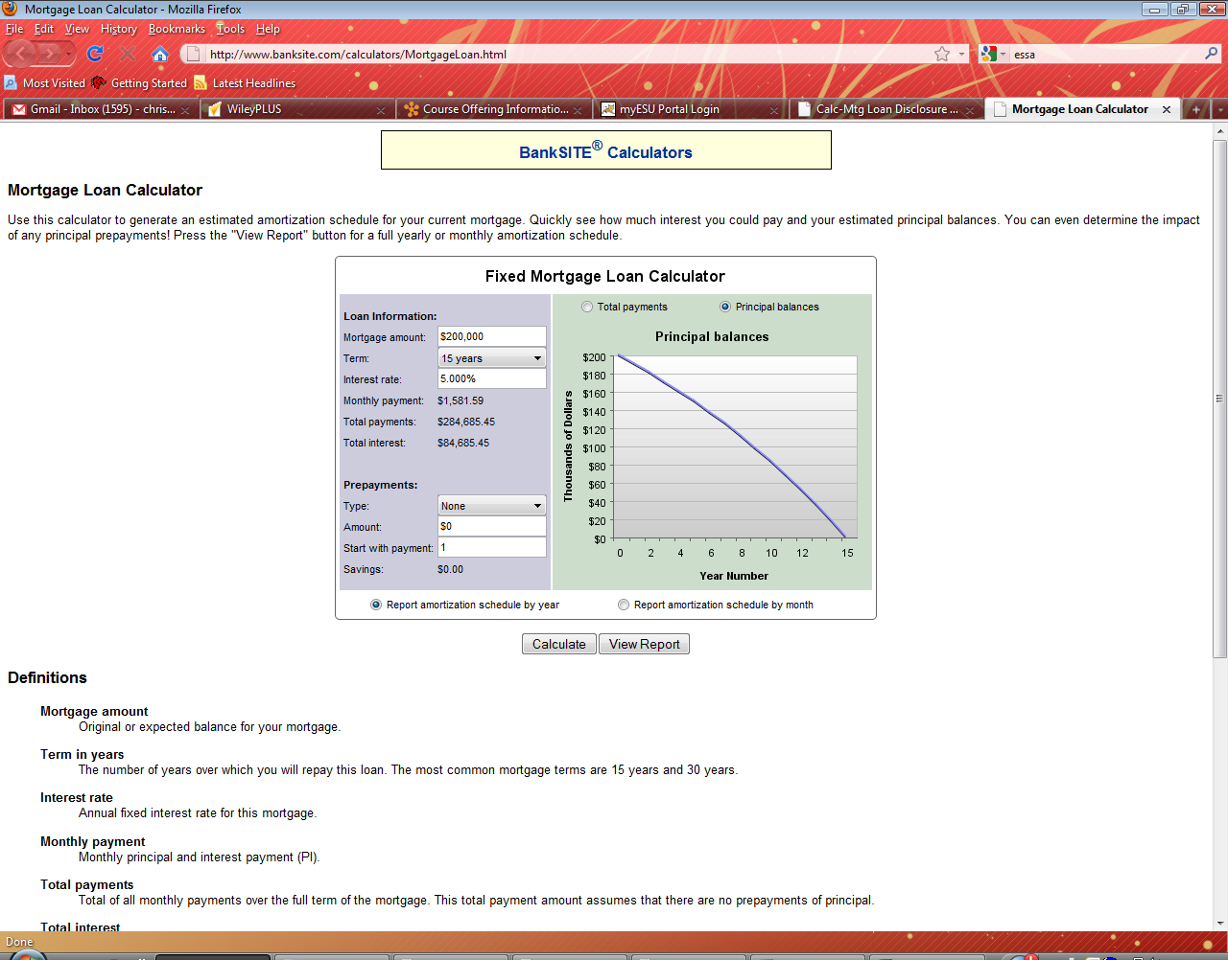

The OMC computes the values displayed in the header area, then computes and displays the monthly payment schedule, e.g. as shown below:

|  |  |  |  |  |  |  |  |  |
| --- | --- | --- | --- | --- | --- | --- | --- | --- |
|  |  |  |  |  |  |  |  |  |
| **Mortgage Amount (Dollars)** | | | $30,000.00 |  |  |  |  |  |
|  | **Term (in whole years)** | | 2 |  |  |  |  |  |
|  | **Interest Rate (APR)** | | 3.10% |  |  |  |  |  |
|  |  |  |  |  |  |  |  |  |
|  | **Monthly Payment** | | $1,290.76 |  |  |  |  |  |
|  | **Total Payments** | | $30,939.93 |  |  |  |  |  |
|  | **Total Interest** | | $939.93 |  |  |  |  |  |
|  |  |  |  |  |  |  |  |  |
|  | **Payment Number** | **Beginning Balance** | **Monthly Payment** | **Additional Principal Payment** | **Total Principal Paid** | **Interest Paid** | **Ending Balance** |  |
|  | 1 | $30,000.00 | $1,290.76 | $0.00 | $1,213.26 | $77.50 | $28,786.74 |  |
|  | 2 | $28,786.74 | $1,290.76 | $100.00 | $1,316.40 | $74.37 | $27,470.34 |  |
|  | 3 | $27,470.34 | $1,290.76 | $0.00 | $1,219.80 | $70.97 | $26,250.54 |  |
|  | 4 | $26,250.54 | $1,290.76 | $150.00 | $1,372.95 | $67.81 | $24,877.59 |  |
|  | 5 | $24,877.59 | $1,290.76 | $0.00 | $1,226.50 | $64.27 | $23,651.09 |  |
|  | 6 | $23,651.09 | $1,290.76 | $100.00 | $1,329.67 | $61.10 | $22,321.43 |  |
|  | 7 | $22,321.43 | $1,290.76 | $0.00 | $1,233.10 | $57.66 | $21,088.33 |  |
|  | 8 | $21,088.33 | $1,290.76 | $50.00 | $1,286.29 | $54.48 | $19,802.04 |  |
|  | 9 | $19,802.04 | $1,290.76 | $30.00 | $1,269.61 | $51.16 | $18,532.43 |  |
|  | 10 | $18,532.43 | $1,290.76 | $0.00 | $1,242.89 | $47.88 | $17,289.55 |  |
|  | 11 | $17,289.55 | $1,290.76 | $100.00 | $1,346.10 | $44.66 | $15,943.45 |  |
|  | 12 | $15,943.45 | $1,290.76 | $0.00 | $1,249.58 | $41.19 | $14,693.87 |  |
|  | 13 | $14,693.87 | $1,290.76 | $200.00 | $1,452.80 | $37.96 | $13,241.07 |  |
|  | 14 | $13,241.07 | $1,290.76 | $0.00 | $1,256.56 | $34.21 | $11,984.51 |  |
|  | 15 | $11,984.51 | $1,290.76 | $0.00 | $1,259.80 | $30.96 | $10,724.70 |  |
|  | 16 | $10,724.70 | $1,290.76 | $175.00 | $1,438.06 | $27.71 | $9,286.65 |  |
|  | 17 | $9,286.65 | $1,290.76 | $0.00 | $1,266.77 | $23.99 | $8,019.87 |  |
|  | 18 | $8,019.87 | $1,290.76 | $0.00 | $1,270.05 | $20.72 | $6,749.83 |  |
|  | 19 | $6,749.83 | $1,290.76 | $200.00 | $1,473.33 | $17.44 | $5,276.50 |  |
|  | 20 | $5,276.50 | $1,290.76 | $0.00 | $1,277.13 | $13.63 | $3,999.37 |  |
|  | 21 | $3,999.37 | $1,290.76 | $150.00 | $1,430.43 | $10.33 | $2,568.93 |  |
|  | 22 | $2,568.93 | $1,290.76 | $0.00 | $1,284.13 | $6.64 | $1,284.81 |  |
|  | 23 | $1,284.81 | $1,288.13 | $0.00 | $1,284.81 | $3.32 | $0.00 |  |
|  | 24 | $0.00 | $0.00 | $0.00 | $0.00 | $0.00 | $0.00 |  |
|  |  |  |  |  |  |  |  |  |

The user can update any of the fields in white, and the summary information and payment schedule will be recomputed and redisplayed. As soon as the user starts to change a value in one of the white fields, the computed data should be treated as invalid until the new value has been completely entered. The user must be made aware of when the data is invalid. It is not yet determined whether the system should have a “Compute” button, or whether the display is automatically recomputed.

## Header Area

In the header area, the monthly payment is computed as follows:

monthlyIntRate

schedMonthlyPayment = amtFinanced x -------------------------------

(1-(1+monthlyIntRate)–termInMonths))

where

monthlyIntRate = APR / 12

termInMonths = termInYears * 12

Also in the header area, the ‘Total Payments’ is the sum of the columns ‘Monthly Payment’ and ‘Additional Principal Payment’. The ‘Total Interest’ is the sum of the ‘Interest Paid’ column.

## Monthly Rows

For each month, the ‘Beginning Balance’ is either the previous month’s ‘Ending Balance’ or (for the first month) is the entire ‘Mortgage Amount’. Other monthly values are computed as follows:

interestPaid = beginningBalance * (APR / 12)

monthlyPayment = min(schedMonthlyPayment,

(beginningBalance + interestPaid))

totPrincipalPaid = monthlyPayment +

additionalPrincipalPayment – interestPaid

endingBalance = beginningBalance - totPrincipalPaid

The user will have the option to download the results in a pdf file.

The OMC must function correctly in Firefox, Internet Explorer, and Chrome.

dled also.