# GUI Layer

GUILayer

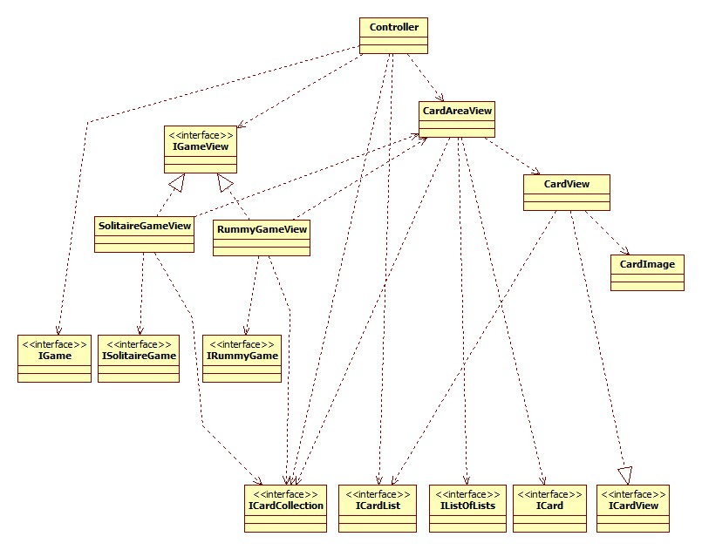

GameLogicLayer

ModelLayer

# GameLogicLayer

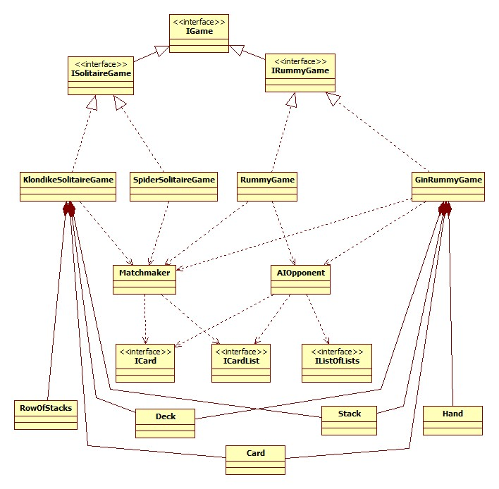

ModelLayer

GameLogicLayer

Note:

* SpiderSolitaireGame has the same dependencies to the ModelLayer as KlondikeSolitaireGame has.
* RummyGame has the dependencies to the ModelLayer as GinRummyGame has.

# ModelLayer

ModelLayer

