*–––*

| Angol szóbeli vizsga | Középszint | 1.Vizsgafeladat | Bevezető interjú |
| --- | --- | --- | --- |

**1. Vizsgafeladat -vizsgáztatói példány**

**Bevezetés (nem értékeljük)**

*Mielőtt a tényleges szóbeli vizsga elkezdődik, egy rövid (kb. egyperces) bemelegítő beszélgetés szükséges.*

Vizsgáztató:

* Did you sleep well?
* How are you today?
* What did you do yesterday evening?
* When did you get up?
* Is it the first time you are taking an exam?
* How did you come here?
* Are you planning to have a party after the exam?
* ( If “no”: ) What are you going to do after the exam?

Now I am going to ask you a few questions. If you can’t understand me, I can repeat the question once. Let’s get started.

**Tényleges vizsga (ettől a résztől értékeljük):**

Vizsgáztató:

We are going to talk about your place of living.

A What can you tell me about Hungary?

B Could you tell me something about the place where you live? What is your town/village famous for?

C What are the places you can go out in your town/village?

Thank you very much.

That’s the end of your first task.

| Angol szóbeli vizsga | Középszint | 2.Vizsgafeladat | Szituációs feladat |
| --- | --- | --- | --- |

# 2. Vizsgafeladat - vizsgáztatói példány

*A vizsgáztató átadja a vizsgázónak a vizsgázó feladatlapját. A vizsgázó kb. fél percig készülhet.*

**A vizsgázó példánya**

You want to go on holiday to a seaside resort in Italy with one of your friends. Discuss which means of transport to use. Include the following points:

- advantages/disadvantages of each

- buying tickets

- activities you can do during the journey

- your experience

**Prompts for the interlocutor:**

* What are the advantages and disadvantages of each?
* Which one is the cheapest / the most comfortable / the fastest means of transport?
* What else would you choose if you wanted to travel independently?
* Where can you buy the tickets?
* What can you do during the journey?
* Have you ever flown?
* (If “yes”: What was it like? Where did you fly?If “no”: Would you like to try it?)

Melléklet: 2.1 kép

**2.1**

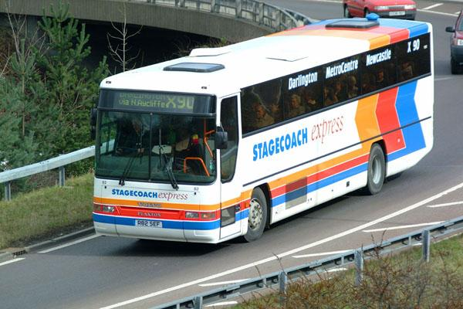

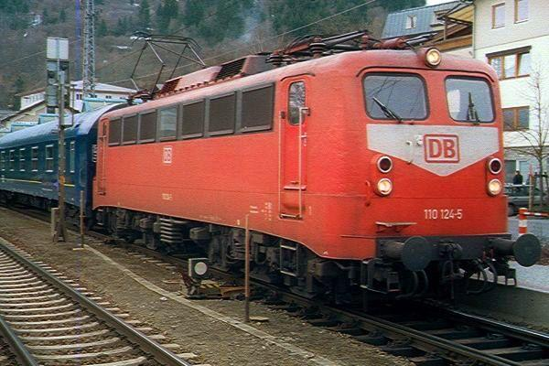

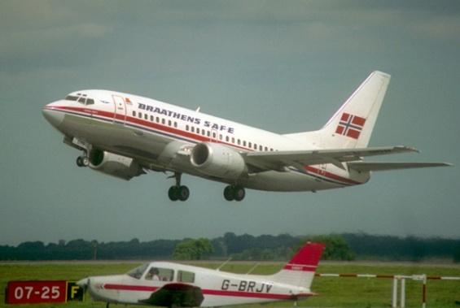

| Angol szóbeli vizsga | Középszint | 3.Vizsgafeladat | Önálló témakifejtés |
| --- | --- | --- | --- |

#### **3. Vizsgafeladat - vizsgáztatói példány**

*A vizsgáztató átadja a vizsgázónak a vizsgázó feladatlapját. A vizsgázó kb. fél percig készülhet.*

# A vizsgázó példánya

Tell us about the differences between traditional dishes and junk food. Describe the different types of restaurants. Include the following points:

- healthy diet

- your favourite breakfast/lunch

- traditional Hungarian dishes

- possibilities for eating out

**Prompts for the interlocutor:**

* What’s your opinion about healthy food / healthy diet?
* What’s your favourite breakfast/lunch/food?
* What do you usually eat/drink then?
* What about goulash/lecso/langos…?
* Where can you eat out in your town? / Are there any good restaurants in your town?

**THANK YOU, THIS IS THE END OF YOUR EXAMINATION.**

Melléklet: 3.1

**K 3.1**

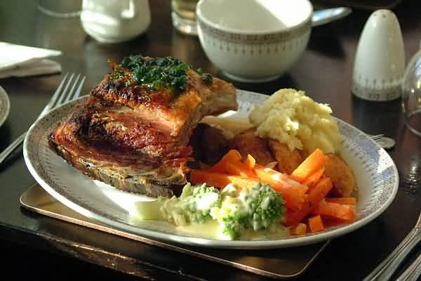

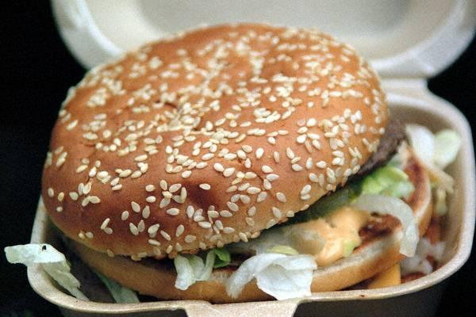

| Angol szóbeli vizsga | Középszint | 2.Vizsgafeladat | Szituációs feladat |
| --- | --- | --- | --- |

# 2. Vizsgafeladat - vizsgázói példány

**A vizsgázó példánya**

You want to go on holiday to a seaside resort in Italy with one of your friends. Discuss which means of transport to use. Include the following points:

- advantages/disadvantages of each

- buying tickets

- activities you can do during the journey

- your experience





| Angol szóbeli vizsga | Középszint | 3.Vizsgafeladat | Önálló témakifejtés |
| --- | --- | --- | --- |

#### **3. Vizsgafeladat - vizsgázói példány**

# A vizsgázó példánya

Tell us about the differences between traditional dishes and junk food. Describe the different types of restaurants. Include the following points:

healthy diet

- healthy diet

- your favourite breakfast/lunch

- traditional Hungarian dishes

- possibilities for eating out

