| Angol szóbeli vizsga | Középszint | 1.Vizsgafeladat | Bevezető interjú |
| --- | --- | --- | --- |

**1. Vizsgafeladat -vizsgáztatói példány**

**Bevezetés (nem értékeljük)**

*Mielőtt a tényleges szóbeli vizsga elkezdődik, egy rövid (kb. egyperces) bemelegítő beszélgetés szükséges.*

Vizsgáztató:

* Did you sleep well?
* How are you today?
* What did you do yesterday evening?
* When did you get up?
* Is it the first time you are taking an exam?
* How did you come here?
* Are you planning to have a party after the exam?
* ( If “no”: ) What are you going to do after the exam?

Now I am going to ask you a few questions. If you can’t understand me, I can repeat the question once. Let’s get started:

**Tényleges vizsga (ettől a résztől értékeljük):**

Vizsgáztató:

We are going to talk about jobs.

A At what age do people usually begin to work in Hungary?

B Do you think it is more important to make a lot of money or to enjoy your job?

C What are the advantages and disadvantages of having a summer job?

Thank you very much.

That’s the end of your first task.

| Angol szóbeli vizsga | Középszint | 2.Vizsgafeladat | Szituációs feladat |
| --- | --- | --- | --- |

# 2. Vizsgafeladat - vizsgáztatói példány

*A vizsgáztató átadja a vizsgázónak a vizsgázó feladatlapját. A vizsgázó kb. fél percig készülhet.*

**A vizsgázó példánya**

You feel ill so you decide to visit the doctor. Explain what symptoms you have and answer the doctor’s questions. Ask what you should do to recover and what medicine you have to take.

Prompts for the interlocutor:

• Good morning, sit down!

• What’s your problem? What can I do for you?  
  
• Do you have temperature?

• How long have you been unwell?

• I see. Get undressed, please. I have to examine you.

• Well, I think you should stay at home for a few days. You should drink a lot of tea… If you feel worse, come back.

| Angol szóbeli vizsga | Középszint | 3.Vizsgafeladat | Önálló témakifejtés |
| --- | --- | --- | --- |

#### **3. Vizsgafeladat - vizsgáztatói példány**

*A vizsgáztató átadja a vizsgázónak a vizsgázó feladatlapját. A vizsgázó kb. fél percig készülhet.*

# A vizsgázó példánya

Compare and contrast the two pictures. Include the following points:

- The most important differences between winter and summer.

- What are the four seasons in Hungary?

- What are the good and bad aspects of them?

- What activities can people do in the different seasons?

**Prompts for the interlocutor:**

* What is the weather like in summer / autumn…etc.?
* What sort of clothes should people wear in summer/autumn…etc.?
* What happens to nature during the year?

**THANK YOU. THIS IS THE END OF YOUR EXAMINATION.**

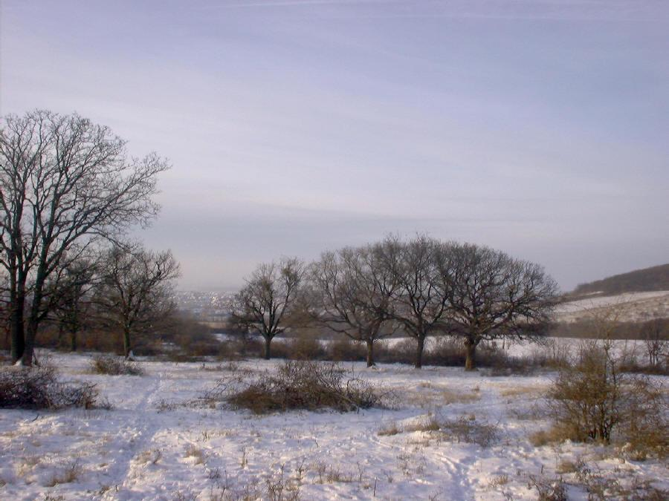

**

| Angol szóbeli vizsga | Középszint | 2.Vizsgafeladat | Szituációs feladat |
| --- | --- | --- | --- |

# 2. Vizsgafeladat - vizsgázói példány

**A vizsgázó példánya**

You feel ill so you decide to visit the doctor. Explain what symptoms you have got and answer the doctor’s questions. Ask what you should do to recover and what medicine you have to take.

| Angol szóbeli vizsga | Középszint | 3.Vizsgafeladat | Önálló témakifejtés |
| --- | --- | --- | --- |

#### **3. Vizsgafeladat - vizsgázói példány**

# A vizsgázó példánya

Compare and contrast the two pictures. Include the following points:

- The most important differences between winter and summer.

- What are the four seasons in Hungary?

- What are the good and bad aspects of them?

- What activities can people do in the different seasons?



