Contents

1.Select an appropriate visual: 2

1.1 Categorical visuals : 4

1.2 Time series visuals 4

1.3 Proportional visuals 6

1.4 Numeric visuals 8

1.5 Grid visuals 9

1.6 Performance visuals: 10

1.7 Geospatial visuals : 11

1.8 Visual layout : 11

2.Format and configure visuals : 12

2.1 You can drag and drop the visual and size it directly on power bi 13

2.2 Map semantic model to field allow to drag and drop model semantic in order to see your visualization in function of your visualization you can have more semantic model available . 14

2.3 You can apply visual filter in the visual or directly in the page or in the report . 15

2.4 Modify field mappings, possibly renaming fields, modifying summarization behavior 15

2.5 Optionally, modify the sort field and the sort of direction (in ascending or descending order). 16

2.6 Apply format options to produce the desired result and style. 17

2.7 use the **Analytics** options to overlay supporting data, like minimum or maximum lines, or Artificial Intelligence (AI) results, like anomaly detection and forecasts. 17

3.Apply and customize a theme: 18

3.1 Select from the available built-in report themes 19

3.2 Customize current theme 20

3.3 Json theme 20

4)Apply conditional formatting : 21

5) Apply slicing and filtering 21

5.3 Apply filter to report structure : 22

5.2 Apply slicer 23

6)Configure the report page: 25

7. When to use paginated report 26

8.Create visual with Dax 26

9.Configure Bookmark 28

10.Create custom tooltip 28

11. Edit and configure interaction between visuals.(X) 29

12. Configure Navigation for a report 30

13. Apply sorting to visuals 30

14. Group and layer visuals by using Selection pane . 30

15. Configure drill through navigation 30

16 configure export settings 30

# 1.Select an appropriate visual:

In power bi you have access to the visual thank to the visual pane and elements:

The purpose of visualization is to communicate information but in a way that is the most relevant for the reader.

Selecting the wrong visual type could make it difficult for report consumers to understand the data, or worse, it could result in the misrepresentation of the data.

We will divide visual into 7 categories:

1. Categorical visuals
2. Time series visuals
3. Proportional visuals
4. Numeric visuals
5. Grid visuals
6. Performance visuals
7. Geospatial visuals
8. Visual layout

## 1.1 Categorical visuals :

 Bar or column charts are good choices when you need to show data across multiple categories.

## 1.2 Time series visuals

Always use a line or column chart to show values over time. The X-axis should present time, sorted from earliest to latest periods (left to right).

Line chart is the perfect visual for time series but if flow of data is consistent (no gap in the data)

Stacked column chart :

Area chart :

Line and stacked column chart :

Ribbon chart :

## 1.3 Proportional visuals

Proportional visuals show data as part of a whole. They effectively communicate how a value is distributed across a dimension. Column and bar chart visuals work well for visualizing proportions across multiple dimensions.

You have 100% stacked bar chart and Column chart .

## 1.4 Numeric visuals

## 1.5 Grid visuals

You have 2 grid visuals matrix and table , you can use conditional formatting and add in it some graphs, colors and other things.

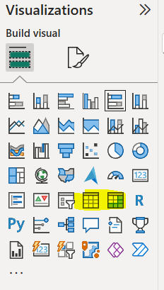

## 1.6 Performance visuals:

The Performance visual compare data to target , and with power bi you have just 4 visuals :

KPI,Gauge, table with conditional and matrix with conditional formmating

## 1.7 Geospatial visuals :

When a semantic model stores geospatial information, it can be conveyed by using map visuals. Power BI includes several core map visuals. Each visual offers various formatting options that, when appropriately applied, can help highlight geospatial data.

## 1.8 Visual layout :

Often, you can choose between multiple visual types to meet design requirements. To narrow down the selection, you might also consider the visual that best fits the available space on the report page. Use a visual that is aesthetically pleasing while maximizing the use of the available page space.

The following examples show two visuals side by side: a 100% Stacked Bar chart visual and a 100% Stacked Column chart visual. Each visual shows the same data and occupies the same space on the page. One visual is easier to read. In this instance, the 100% Stacked Bar chart visual helps make it easier for you to determine relative values. The reason is because the visuals occupy a wide yet short area: The lengths of the long bars are easier to interpret than the heights of the short columns.

It will depend in function of the length of the column or bar .

# 2.Format and configure visuals :

## You can drag and drop the visual and size it directly on power bi

## 2.2 Map semantic model to field allow to drag and drop model semantic in order to see your visualization in function of your visualization you can have more semantic model available .

## 2.3 You can apply visual filter in the visual or directly in the page or in the report .

## 2.4 Modify field mappings, possibly renaming fields, modifying summarization behavior

You can modify fields mappings changing the field in the X-axis and Y-axis or legend .

You can rename fields directly in the visualization pane

You have the possibility to modify the summarization with Average,Median etc. ..

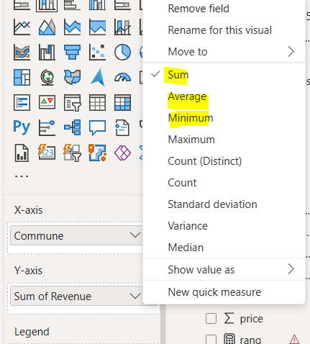

## 2.5 Optionally, modify the sort field and the sort of direction (in ascending or descending order).

## 2.6 Apply format options to produce the desired result and style.

## 2.7 use the **Analytics** options to overlay supporting data, like minimum or maximum lines, or Artificial Intelligence (AI) results, like anomaly detection and forecasts.

# 3.Apply and customize a theme:

In power bi, you have 3 ways to apply a theme, you can just take in the power BI desktop directly in view. download a theme in gallery, customize a theme.

## 3.1 Select from the available built-in report themes

You can download a theme-on-theme gallery or customize a current theme

## 3.2 Customize current theme

You can do that with name, colour, text , visuals , page and filter pane .

## 3.3 Json theme

Documentation for more example :

<https://learn.microsoft.com/en-us/power-bi/create-reports/desktop-report-themes#example-report-theme-json-file>

# 4)Apply conditional formatting :

Conditional formatting is used for Table and Matrix , it allows to create color , add graph and image on your table to highlight data .

# 5) Apply slicing and filtering

There are several ways to filter your data with Power bi .

You can filter the semantic model directly with Row level security (RLS).

You can also filter directly on the report at various level with the filter pane: Report level,Page level or visual level and you can also filter directly in the measure with DAX.

## 5.3 Apply filter to report structure :

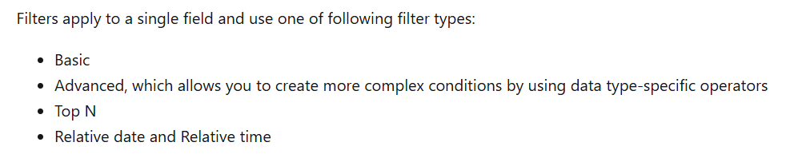

You can lock filters to ensure that report consumers can't remove or modify them. It's a good idea to lock filters that are critical to the design of the report, page, or visual. Additionally, you can hide filters. A hidden filter isn't visible to report consumers. Consider hiding a filter when the report consumer doesn't need to know about it, such as when filters are cleaning up the data, perhaps by removing BLANKs.

## 5.2 Apply slicer

The Slicer is a core visual with one purpose: *filter other visuals*. It's one of the most common visuals that you add to a report page because it presents an intuitive way for report consumers to filter data. As a report author, you have considerable control over how the visual is laid out and formatted and how it functions.

You have various slicers in function of the semantic model use .

# 6)Configure the report page:

You can configure in the visualization pan, the size and alignment of the canvas, you can also customize it but be aware that it will impact the time of rendering ! and more visualization impact also the rendering.

# 7. When to use paginated report

# 8.Create visual with Dax

Visual calculations are a simple way to add calculations to your Power BI report. They're DAX calculations defined on a visual and are defined visually. Compared to measures, the DAX required is easier to write, understand, and maintain.

They are stocked directly in the visual.

I selected running sum for example , you can select also moving average ...

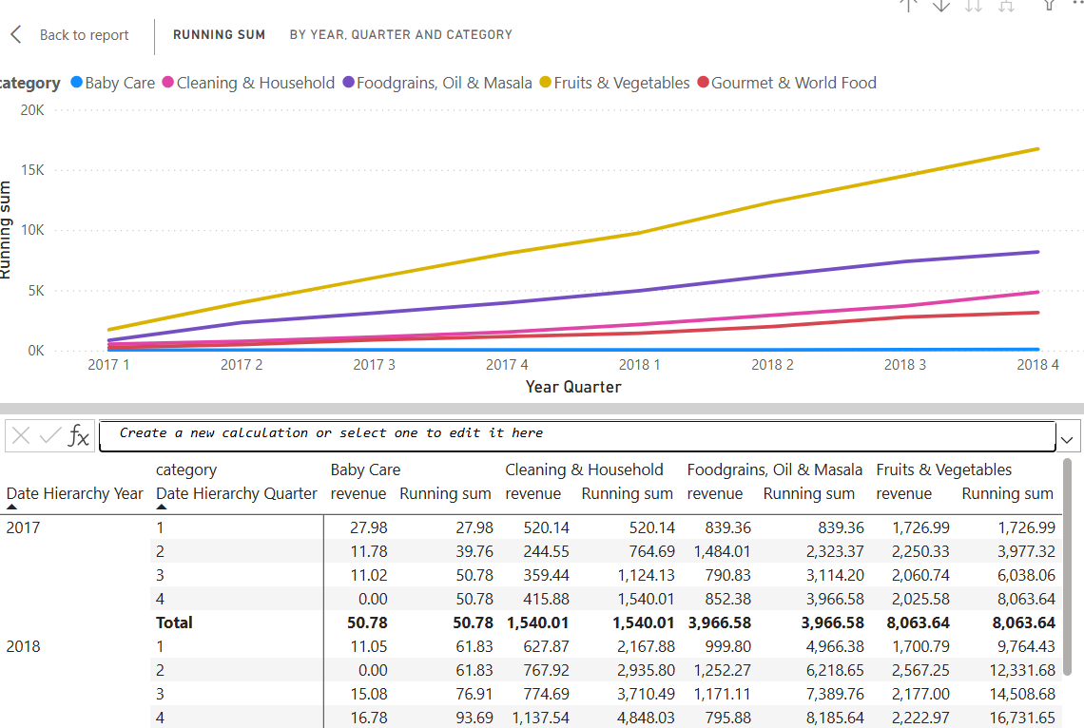

# 9.Configure Bookmark

Bookmarks capture a specific view of a report, including filters, slicers, the page selection, and the state of visuals. Report authors and report consumers can create them.

# 10.Create custom tooltip

Custom tooltip will appear when report consumers hover the cursor over visuals. By default, the report tooltip receives all filters that apply to the visual.

## 10.1 Default tooltip .

I will create a custom tooltip for my sales when I selected sales for example i want to have data concerning stock in this month.

I added just in the visualization tooltips the semantic .

## 10.2 Custom tooltip

You can also create more sophisticated tooltip .

You create a new page and add it the visual that you want after that you go to canvas settings and set as tooltip.

Before configure settings in Caneva for tooltip :

It is not difficult you should just create your tooltip page on a new page and name it .

After that you should just go to the page where the visual that you want to add tooltip go to format and tooltips and choose report page and select the page

Result :

# 11. Edit and configure interaction between visuals.(X)

By default, when report consumers interact with visuals, filters are propagated to other visuals on the report page. This way, visuals behave like slicers. For example, a report consumer can select a column of a column chart visual to filter other visuals on the page. To remove the cross filters, they can either select the column again or select a different visual.

As you can see below it is synchronized by default but we can stop it thanks to format / edit interaction, but you should select the slicer .

You can now select and remove from the second visual interaction .

As you can see below now the revenue , sales and stock stay static in the second multi row card.

# 12. Configure Navigation for a report

# 13. Apply sorting to visuals

# 14. Group and layer visuals by using Selection pane .

# 15. Configure drill through navigation

 Allow report consumers to drill from visuals. By default, the drillthrough action propagates all filters that apply to the visual to the drillthrough page.

# 16 configure export settings

# 17. Design report for mobile device .

# 18. Enable personal visuals in report

# 19. Design power bi for accessibility

# 20 .Configure automatic page refresh

