History and Definition:

Developers, Product owner and Scrum master

Why agile?

Above it is a waterfall , we start from the top to the bottom.

Agile has been developed to respond to the request of customers which can change with time , if for example, you receive a request from customer to create a new software in order to manage his stock.

It took 1 year to implement the software in the customer environment.

The issue is that after 1 year the customer could discover that He wants new features or remove some features etc …

It is for this reason that agile is born.

4 pillars and 12 values:

1. it is focused on individual interactions over process and tools.

Not focus on process but on interactions between individuals.

1. Working software over comprehensive document, more important than documentation.

Feature and specification created before software, it is loss of time , the best is to create a basic software, receive feed-back and have feed-back .

Before the customer was involved in the beginning.

1. Customer collaboration over contract negotiations (adapt even if it is not in the contract)

Before they did just what was negotiated and now it is finished, we will respond to change and collaborate with customer.

1. Responding to change over following a plan. (Include the client on the way you think)

Before they were focusing on process and not on clients’ needs.

12 Principles:

1. We will prioritise the client (Best value) and will change in function of his needs continuously. (Not like waterfall framework)
2. Included change if needed.
3. We work in short development deliver and feed-back better than long development and feed-back after a while. (We save time)
4. Businesspeople and developers should work daily
5. Build projects around motivated individuals. (Trust is important)
6. The most efficient and effective method is face-to-face conversations
7. Working software is the most important thing (customer doesn’t need documentation and not working software)
8. The purpose is not a sprint, you want a stable team and sustainable, (remain the same team)
9. Continuously improving and improving your software.
10. Do it simple!
11. Instead of assigning things but it is the team together. (there is no project manager we discuss together, no hierarchy)
12. Continuous improvement

Scrum team

Scrum master:

Product owner:

Developers:

Scrum framework:

3 pillars : transparency (everything you do should be visible to anyone ) , Inspect (whatever you do , you check that it works as expected) and adapt

The team is self-managed.

The job of the scrum master is to fix issue which blocks the team to progress and the scrum principles happens.

For example the number of hours in meeting limitation .

Scrum event sprint :

It is a time-box which goal is to create a product during a period defined.

It should be between 1 to 4 weeks, and you should not change the size sprint.

You start directly after the first sprint.

Consistency is the key, and you continue immediately after.

The constraint in terms of the size of the sprint is discussed with the team .

During the first sprint you will have the first planning meeting .

Planning meeting max 1 per sprint (max 8 hours/4weeks sprint)

PO select highest priorities stories.

Team presents its plan and get confirmation from PO.

Break down into tasks and efforts. (Planning poker we have different scales and it gives us an idea on the difficulty and we will distribute )

During the sprint, the team picked up.

(you take the ownership/responsibility)

Scrum events , it is max 15 minutes per day .

3 questions : What did I do yesterday ?

What will I do today

Why is blocking me ?

Preferably standing up (purpose is to share knowledge)

Same time same place

Mandatory for the team (everybody can speak)

Story focused.

The purpose of this discussion is just to discuss where I am and where I go if I am blocked .

The scrum master will check that it is relevant and correct no technical part and the time is max 15 minutes.

It is a meeting where we will do a review to the product owner he will check it is a demo session for the product owner .

MAX 4 hours each 4 weeks

Occurs at the end of sprint

Attendees , team and stakeholders (Business)

Show and tell how each story is completed and done .

Time to check with PO

Select items for the following sprint.

Retrospective the purpose is to improve the process it is just with the scrum team .

It is max 3 hours for 4 weeks (one sprint)

Create improvement plans.

We will discuss what has been not efficient and try to improve it .

During this period they find their own solution.

They create improvement plan.

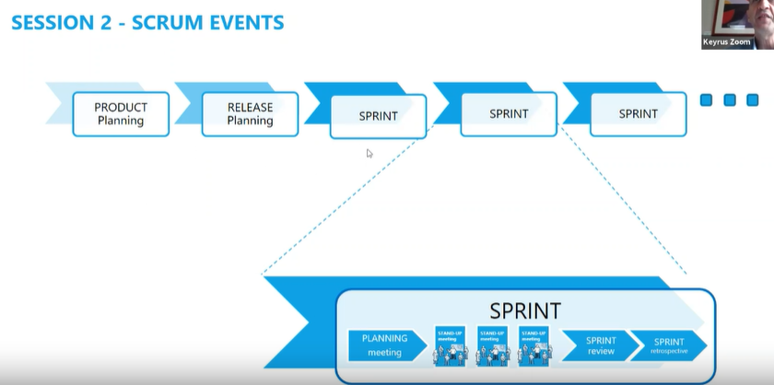

The product planning and release which arrive once at the very beginning of the start of the product life cycle.

The sprint is a timebox in which we have different events (sprint) .We have a planning meeting and standup

Planning meeting : PO will give backlogs

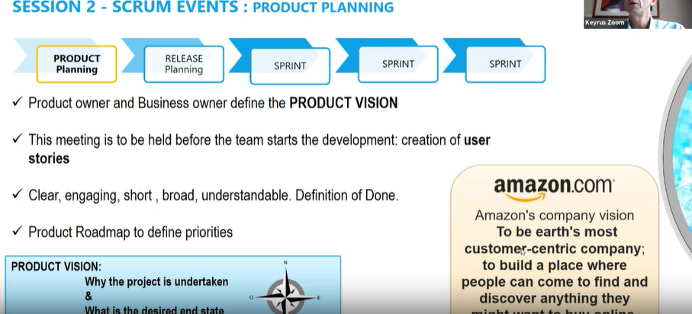

Product release not mandatory .