Abstract
Realm is a fast and cross-platform mobile database, running directly inside phones, tablets or wearables and designed to be an alternative to
Core Data and SQLite. The project was pioneered by‘Y Combinator’to make managing database easier and faster. Realm is an open source project living in GitHub and it is being maintained and developed by the core developers as well as quite a few external contributors. In this chapter Realm is analyzed in the following aspects: stakeholder analysis, context view, functional view, technical debts，evolution perspective and conclusion. The chapter as a whole can serve as a helpful introduction to prospective developers looking to better understand the architecture to which they might contribute. Lastly, we observe that Realm is a well-engineered project without glaring technical holes or major debt.

Table of Contents
1. Introduction
2. Stakeholder Analysis
3. Context View
4. Functional View
5. Technical Debt
6. Evolutional Perspective
7.Conclusion

Introduction
With the increasing use of the mobile devices such as phones, wearables and so on, the amount of data transferring between mobile devices grows exponentially every year, and the need for a database handling the data on mobile devices more efficiently is getting more intense. In 2014, the entrepreneurial team behind Y Combinator created Realm--The first database designed specifically for mobile platforms.
Realm is a cross-platform mobile database for iOS and Android, of which the core data engine is built in C++ instead of an ORM based on SQLite, so Realm is faster, better, and easier to use and accomplish database operations with less code than SQLite and CoreData. Besides, rather than simply encapsulating CoreData, Realm uses its own set of persistent storage engines. Furthermore, Realm is completely free, which makes it both more popular and more accessible to developers.
This chapter aims to give users a quick understanding of how Realm is organized, developed and maintained. Firstly, the Stakeholders and Context view are analyzed to provide insights into the organization of the project. Furthermore, detailed analysis of the architecture is presented in order to understand its structure. In addition, technical debt in terms of code, testing and documentation was also found throughout the analysis of the system and is presented in the chapter. This is followed by the evolution of the project explaining how Realm emerged from C++ and discussing the Realm which is considered as the alternative to CoreData and SQLite. Finally, the chapter is closed with the conclusion of the whole analysis.

Stakeholders
As a MVCC (Multi-Version Concurrency Control) database which runs on mobile phone, pad and wearable devices, thousands of developer was engaged in its development on Github. Nowadays, it interacts with lots of stakeholders.

Stakeholders | Description
Acquirers | Realm is created by an entrepreneurial team of Y Combinator, who are authorized funding for products and system development.
Assessor | Rules and regulations that apply to the Realm product portfolio are handled by the General Management team.
Communicators | The Community Management team explains the system with documentation and training materials.
Users | Realm is used by students, hobbyist as well as professions who want an excellent database in the embedded system development.
Testers | All bugs in the software can be posted on the Realm forum, emailed or issued on GitHub. Bugs and problems are picked up by the software and hardware staff employees of Realm or the contributors on GitHub.
Developers | There are both software and hardware teams working on the code for the end products.
Support Staff | The website realm.io plays a central role in staying in touch with users that report bugs as well as positive explanations about nice projects that can be built with the products.
Suppliers | Realm is created by core data engine C++ and provide its own data engine. We can work with data objects directly and create database more efficiently.
Maintainers | Software solutions are assessed by the Software development team in order to maintain the programming standards and architectural choices.
Table 1.1 : Summary most important stakeholders
On April 24th,2019 MongoDB announced that Realm had signed a final agreement for the acquisition, which is expected to be completed by January 31st, 2020. Dev Ittycheria, President and CEO of MongoDB, said: "Realm is very popular with mobile developers because it allows mobile developers to use data to accelerate innovation easily, which is very consistent with our philosophy.”
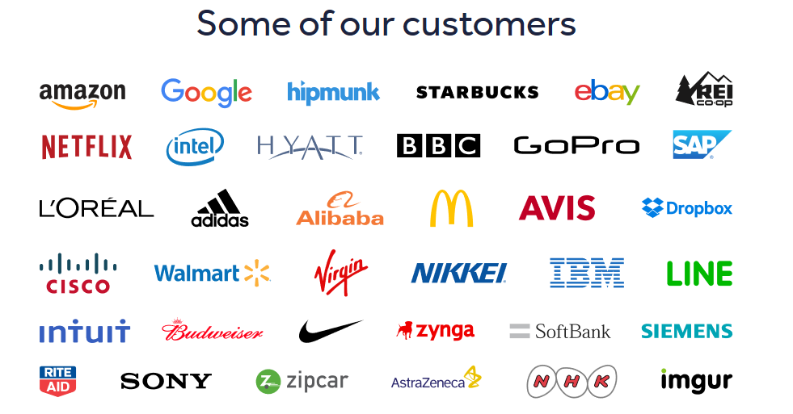
Picture 1.1: Customers of Realm
The acquisition of Realm will deepen MongoDB's relationship with the developer community focused on mobile and Server-Free development. Active developers using Realm have exceeded 100,000, and the solution has been downloaded more than 2 billion times. Realm currently has Realm database and Realm platform, which can help users deploy quickly and achieve seamless cloud data synchronization.
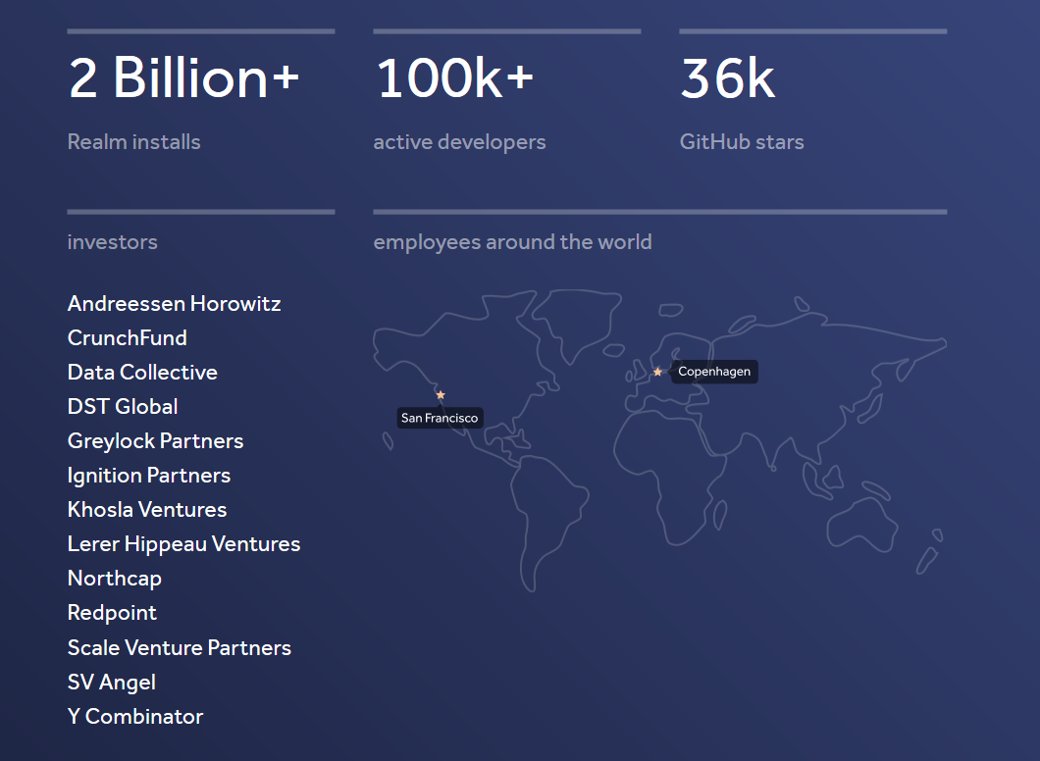
Picture 1.2: Wilde usage of Realm
Now Realm is still trying its best to communicate with the latest and hot technical aspects, such as 5G, IBM Cloud Functions, Microsoft Azure and so on. The group of stakeholders will become more and more powerful, as well as its bright future.

Context View
The context view shows the different relations, dependencies and interactions Realm has with its environment. Important for the context are the people, systems and external entities with which the system interacts.

System Scope & Responsibilities
Realm aims to help developers build better apps faster. It provides a unique set of tools and platform technologies designed to make it easy for developers to build apps with sophisticated, powerful features—things like real-time collaboration, augmented reality, live data synchronization, offline experiences, messaging, and more.
The core of the Realm product lien is the Realm Database. A true object database, it transforms how developers work live objects up data automatically, run code in response to changes, and persist easily. It fully replaces the old-fashioned SQLite-based databases that are the alternatives for IOS and Android developers today.
The Realm team are proud to provide the Realm Database entirely free and open source. They are also proud to be the creators and maintainers of popular developer utilities and open-source projects including SwiftLint and Jazzy. And we are committed to producing and publishing the very best developer content, as well as supporting great developer events and meetups around the world.

External Entities
Realm Java is a widely-used mobile database out of Y Combinator Inc. As one can imagine, a software project like this cannot be developed without external libraries, tools and frameworks. On the other, many companies cannot develop their software without Realm Java. These external relations are examined in this section.
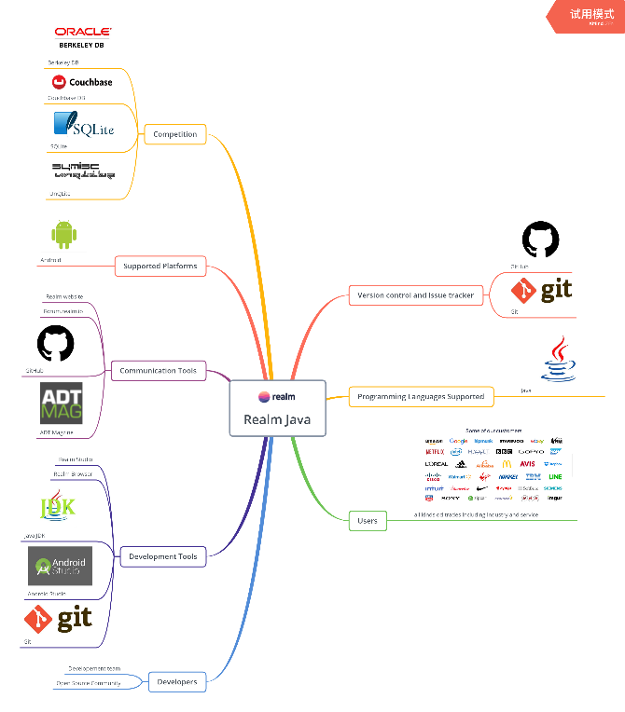
Picture 2.1: External Entities
In order to understand the context model of Realm Java, the role of the external entities with respect to Realm Java is explained.
- IDE
The core of Realm Java is written in Java language. The users that work with Realm Java can write programs on Android Studio in a form of android programs. The software of Android Studio can be installed on multiple platforms: Linux, Mac OS and Windows. The user of Realm Java are mostly mobile application developers.
- Communication Tools
Realm Java uses GitHub and Git for version control to help developers collaborate and track issues related to the software. Contributions in this repository come from the Realm Java development team, as well as from open source community. In order to stay in contact with developers and users the following communication tools are used: Realm website, the Realm forum and GitHub.

Realm’s community managers also need to maintain a good relationship with magazines like ADT Magazine who write about Realm products and competitors.

Evolutional Perspective
The evolution perspective deals with concerns related to evolution during the lifetime of a system, which is relevant to Realm for it need to be changing continuously along with the coding language and developing tools.

Realm has changed significantly since its first draft in 2014-09-29. Its initial intension was to build a mobile database which is faster and safer than the existing one such as SQLite etc. However, five years from then, Realm has done much more than that. It supports not only Android, but Swift, JavaScript, .Net other platforms as well. It’s an embedded database which provides developers a distinct way to treat modules and their service logics. All notable changes to the project are documented in the CHANGELOG.md.

The first draft version is 0.71.0, released in 2014. After the first version, various changes have been made, which were either to fix bugs or to add new features. The first breaking release took place in 2015-10-08. This release announced that the current Realm files no longer support previous ones, and many deprecated functions, methods, and constructors from the Realm class were removed. The most noteworthy one is that boxed type such as Boolean, Byte, Short, Integer, Long, Float and Double were introduced to the Realm class. Additionally, from now on, Realm adds support for x86-64. Other bug fixing job has done in this version as well.
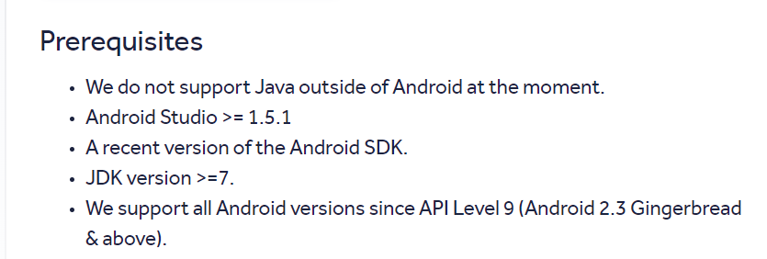
Picture 6.1: Realm Version 0.88.0 prerequisite
Five months later, in 2016-03-10, Realm has released version 0.88.0. In this version Realm has to be installed as a Gradle plugin, which means it relies on Android Studio from now on, and do not support Java outside of Android. This means that Realm in Java has a tighter bonding relationship with Android Studio, which indicates it has a bigger potential to be applied in an Android Operating System mobile device.
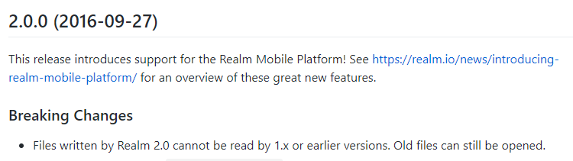
Picture 6.2: Realm Version 2.0.0
In 2016-09-27, Realm released the version of 2.0.0. As we can see, within 2 years, Realm has released two upward compatible versions. On the one hand, we have to admit that, with the increasing amount of software engineers joining into the project, as well as the popularity of the development of ‘light database’, Realm has made great breakthroughs and provided convenience for mobile software development. However, on the other hand, frequent forward upgrades increase the instability of the whole system. The new release also added many features, such as added new ‘RealmFileException’ etc. However, Realm 2.0.0 contained a serious bug ‘Build error when using Java 7’ which would cause serious problem for programmers for Java 7 is still the latest version back then, and was not finished until version 2.0.2.
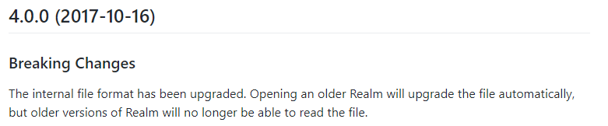
Picture 6.3: Realm Version 4.0.0
For almost two years, programmers have been using Realm from version 2.X.0 to 3.X.0. Realm has made a lot of changes during this period but not as noteworthy until the release of version 4.0.0 in 2017-10-16. In Realm 4.0.0, The internal file format has been upgraded, which means opening an older Realm will upgrade the file automatically, but older versions of Realm will no longer be able to read the file. Additionally, Realm upgraded a series of Internal components to adapt to the current version.
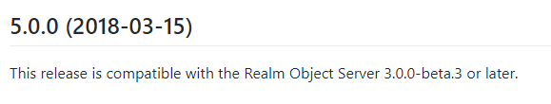
Picture 6.4: Realm Version 5.0.0
Half a year later, Realm 5.0.0 was released in 2018-03-15. This release is compatible with the Realm Object Server 3.0.0-beta.3 or later.

The latest version is Realm 5.15.1, which was released in 2019-09-09, and the lead developers are still making progress for new version. The project is published on Github, which is still an active project. This is necessary, considering Realm is intended to replace SQLite as a mobile database.

