Developing Advanced Smart

Contracts

Advanced Smart Contracts


Have been using core Solidity features Will look into more advanced features
Build a DApp using advanced Solidity features

Will build a web front-end for it later
Advanced Features


Working with time Custom modifiers Libraries

Inheritance of |  | Events |  | Contracts
smart contracts |  | Events |  | interaction

Crowdfunding Application

Collect funds for a specific cause

- Similar to Kickstarter

Basic crowdfunding

- Campaign has a deadline

- Should collect predetermined amount
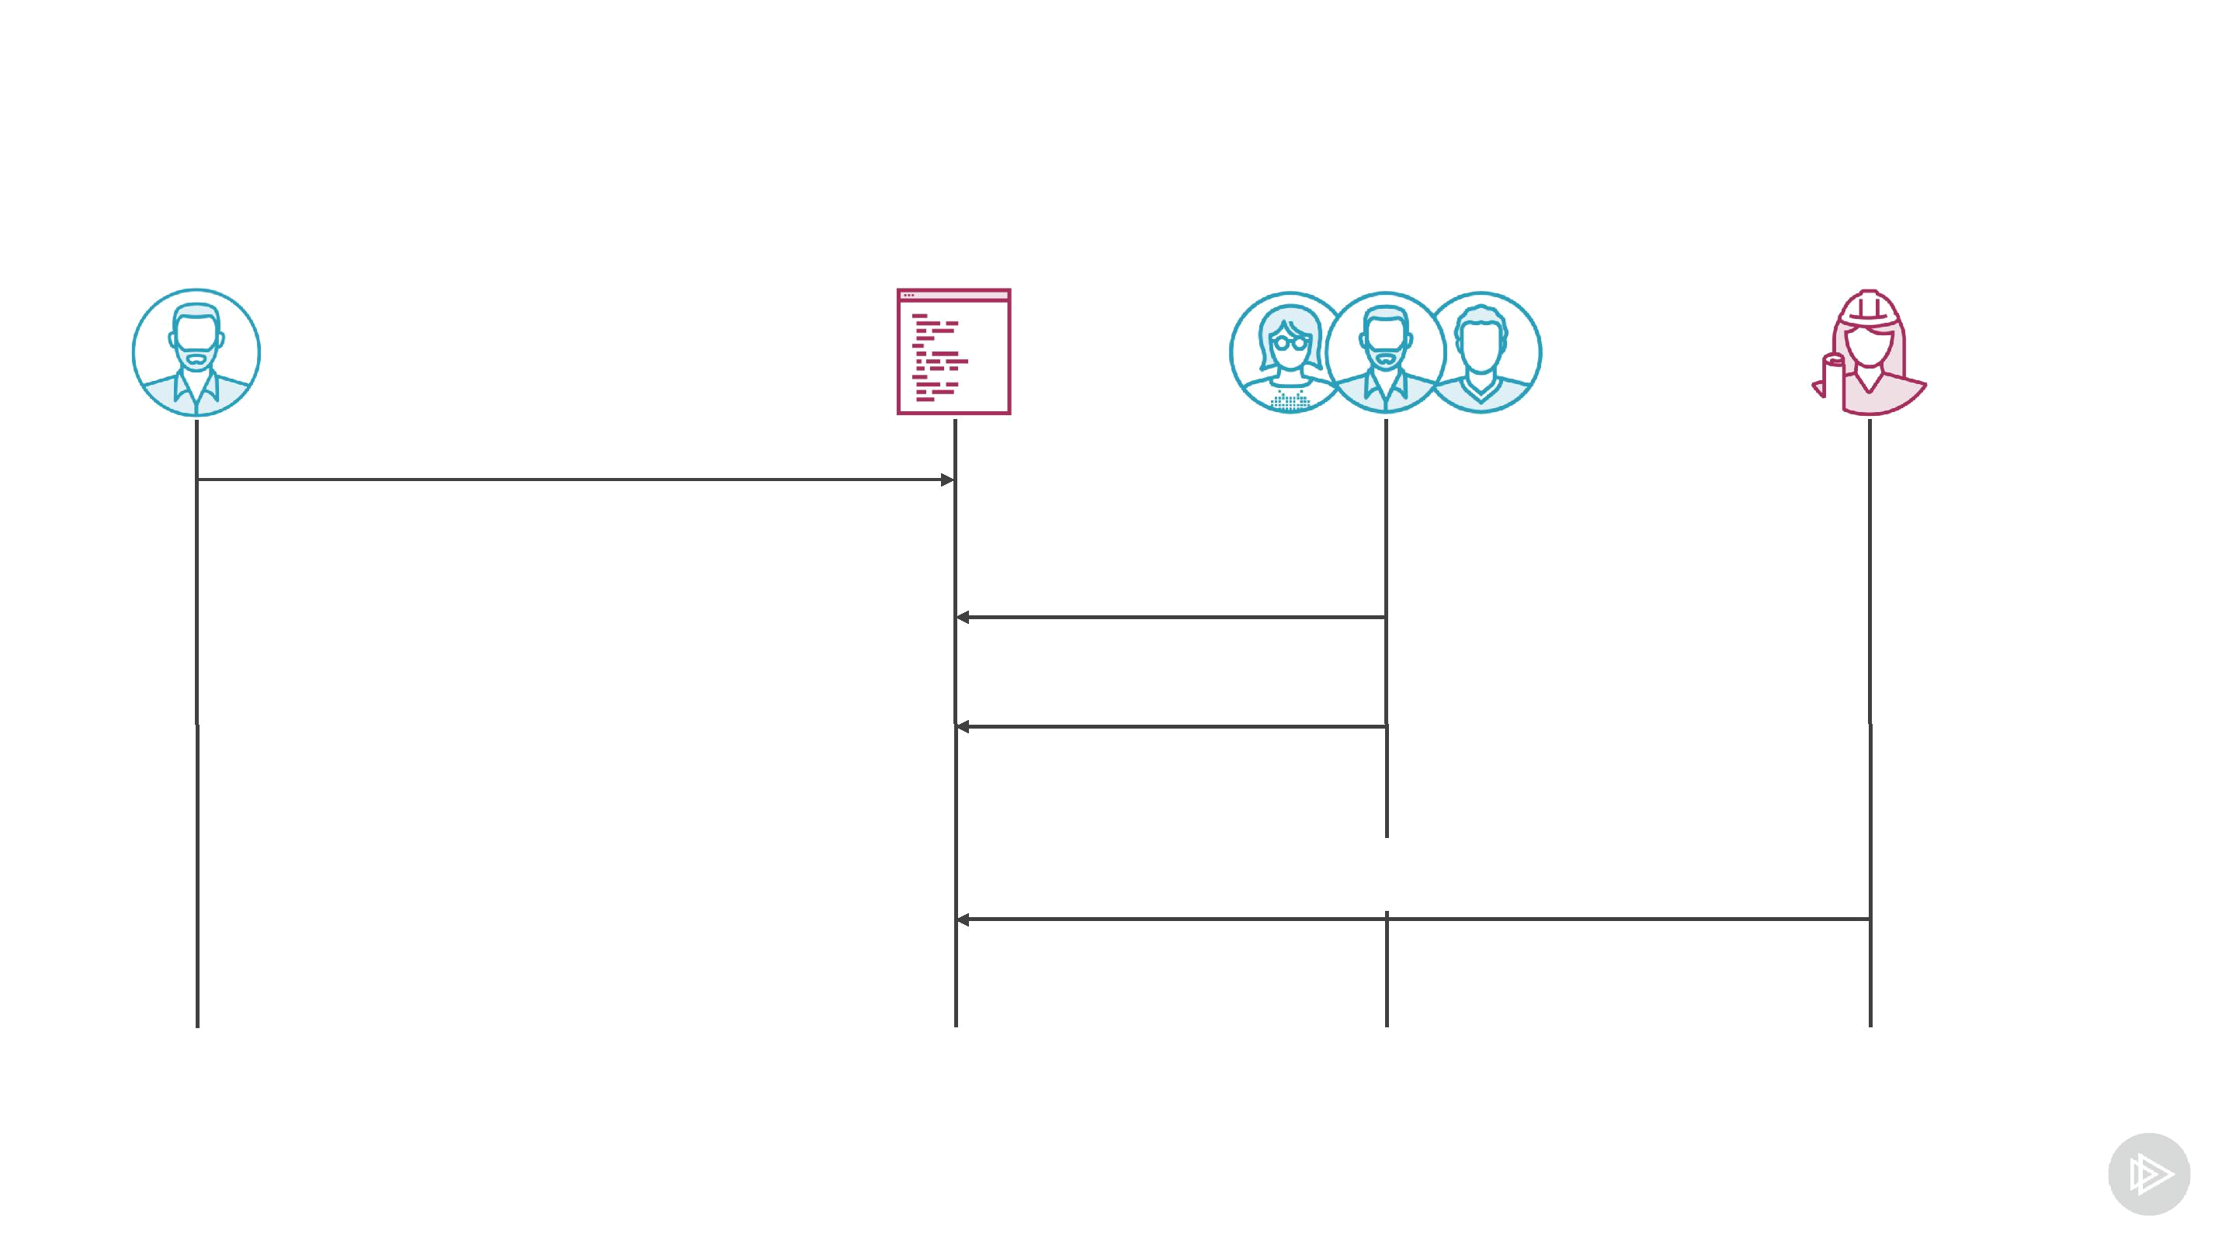
Crowdfunding Contract

create

(amount, deadline, beneficiary)

contribute

contribute

collect
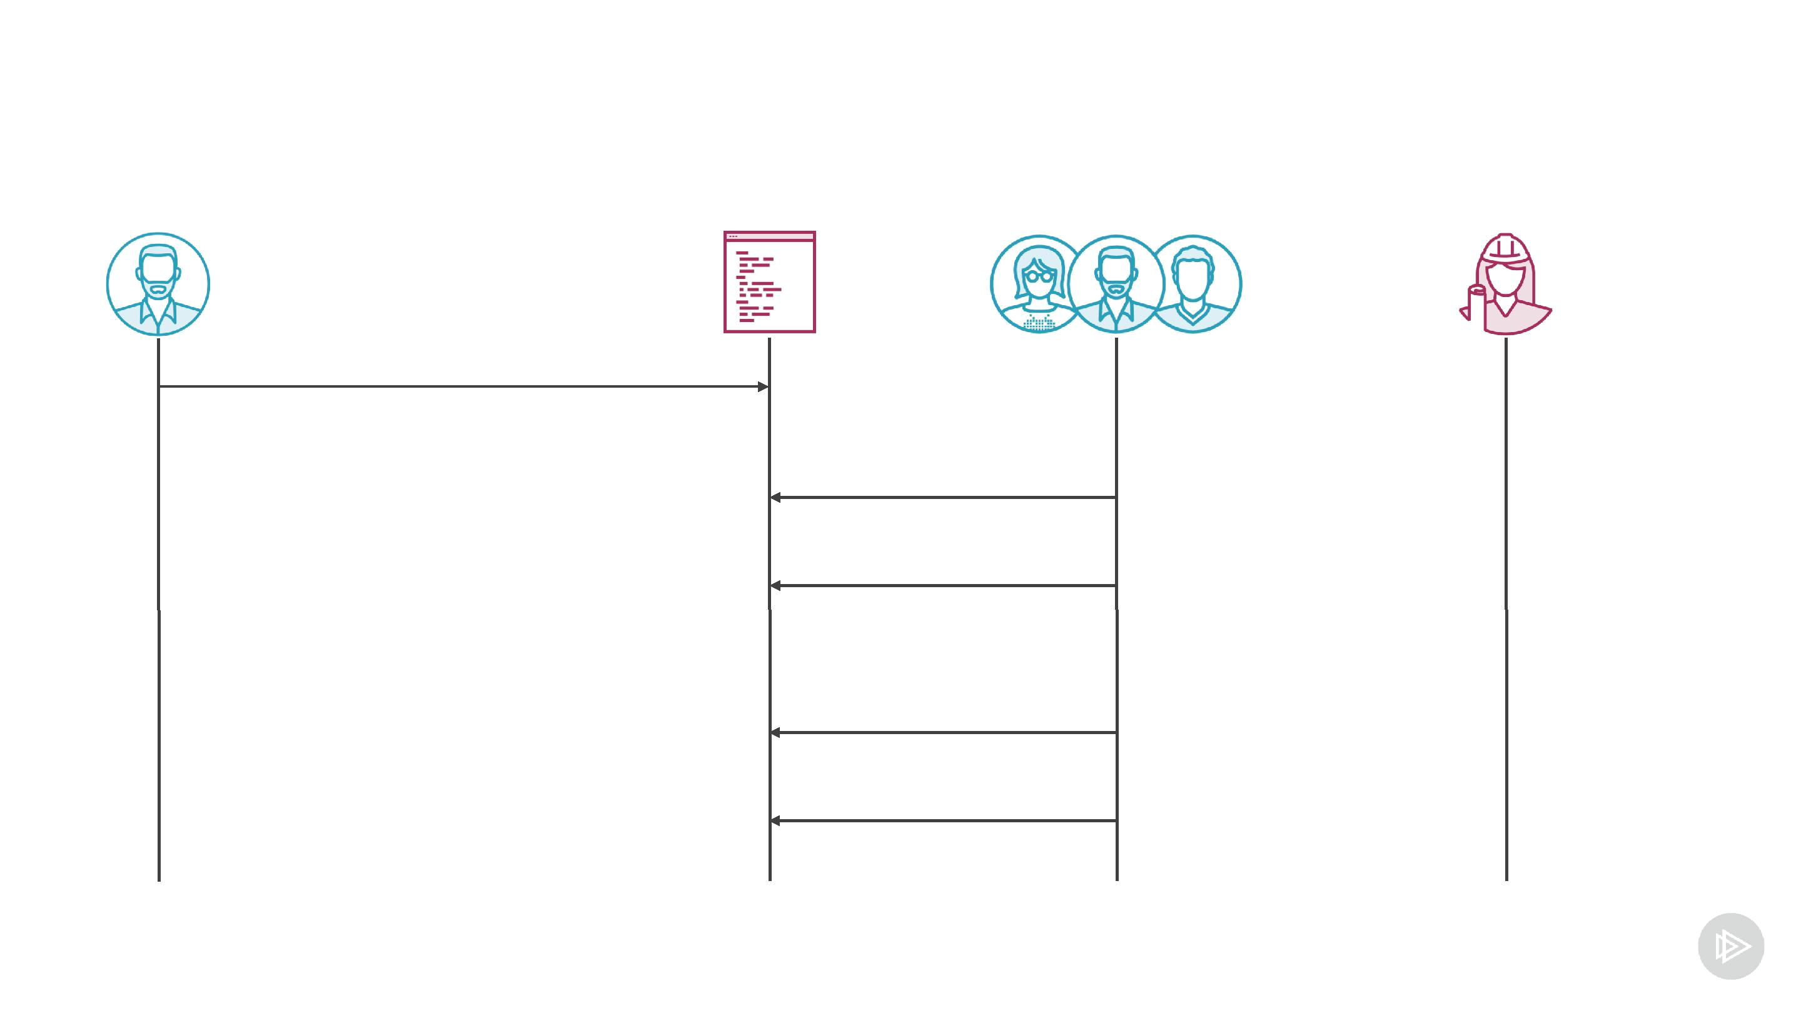
Crowd Funding Contract - Failure

create

(amount, deadline, beneficiary)

contribute contribute

get refund get refund
Time and Smart Contracts

How to get current time in a smart contract Tricky!
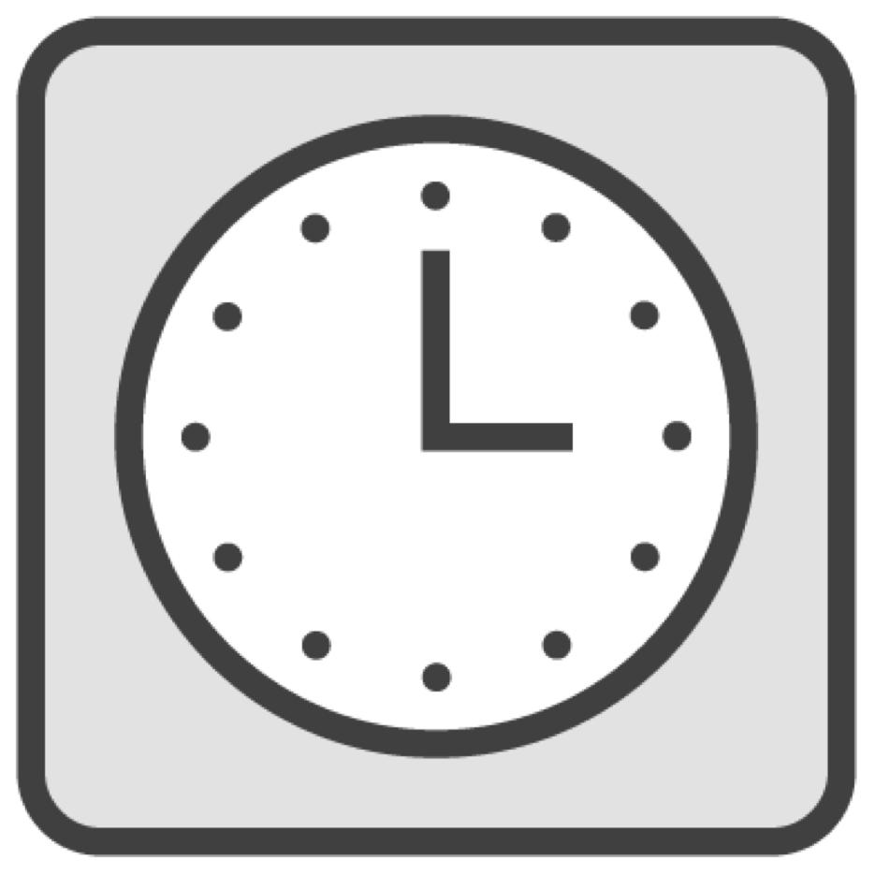
- All contracts should be deterministic

- Every network participant has different time

Can get a timestamp from a block


Get Current Time

contract Foo {

uint deadline = ...; // Time in seconds function checkTime() {

uint currentTime = block.timestamp; require(currentTime < deadline);
uint currentTime = now; // Alias for "block.timestamp"

}

}
Other Block Information

function method() {

block.timestamp; // Block timestamp

block.difficulty; // Block difficulty

block.gaslimit; // Gas limit

block.number; // Block number

block.coinbase; // Miner's address

}
Block Timestamp

Controlled by a miner
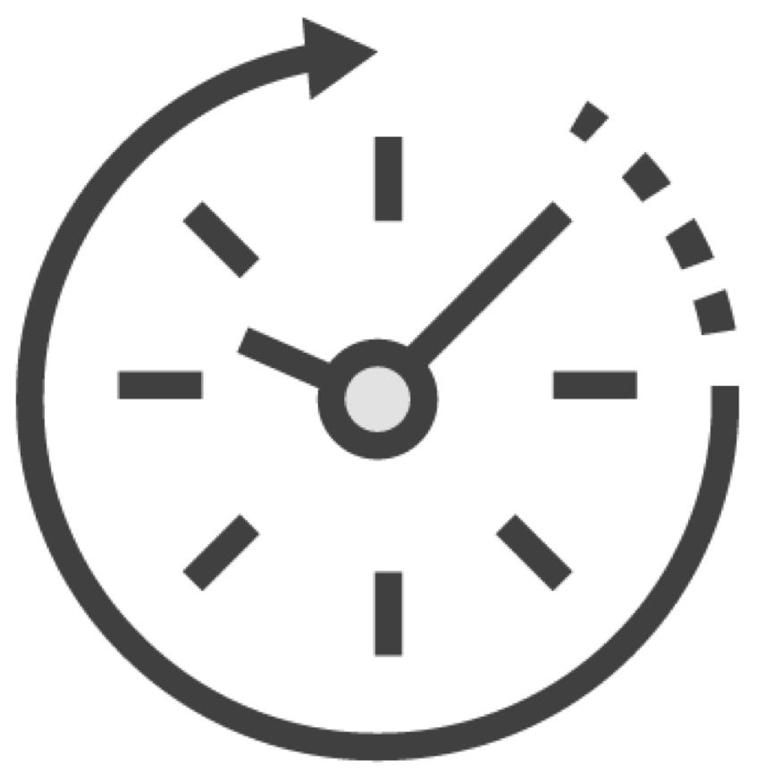
Protocol imposes certain limits

- Using previous blocks time to generate block

Should not treat it as absolutely precise Can be manipulated to a certain degree
 |  |  | Time Units
uint oneSecond = |  | 1 | seconds;
uint oneHour | = | 60 minutes;
uint oneWeek | = | 7 | days;

function convertToSeconds(uint mins) returns(uint) { uint inSeconds = mins minutes; // NOT allowed uint inSeconds = mins * 1 minute; // Use instead

}
Ethereum Denominations


wei 0.000000000000000001

kilo-wei 0.000000000000001

mega-wei 0.000000000001

giga-wei 0.000000001

szabo 0.000001

finney 0.001

ether 1

kilo-ether 1,000

mega-ether 1,000,000

giga-ether 1,000,000,000
Ethereum Units

uint v1 = 10 wei; uint v2 = 20 finney; uint v3 = 30 ether;

function convertToWei(uint sumInEth) returns(uint) { return sumInEth * 1 ether;
}
Enums

Allows to create a datatype with a fixed set of values
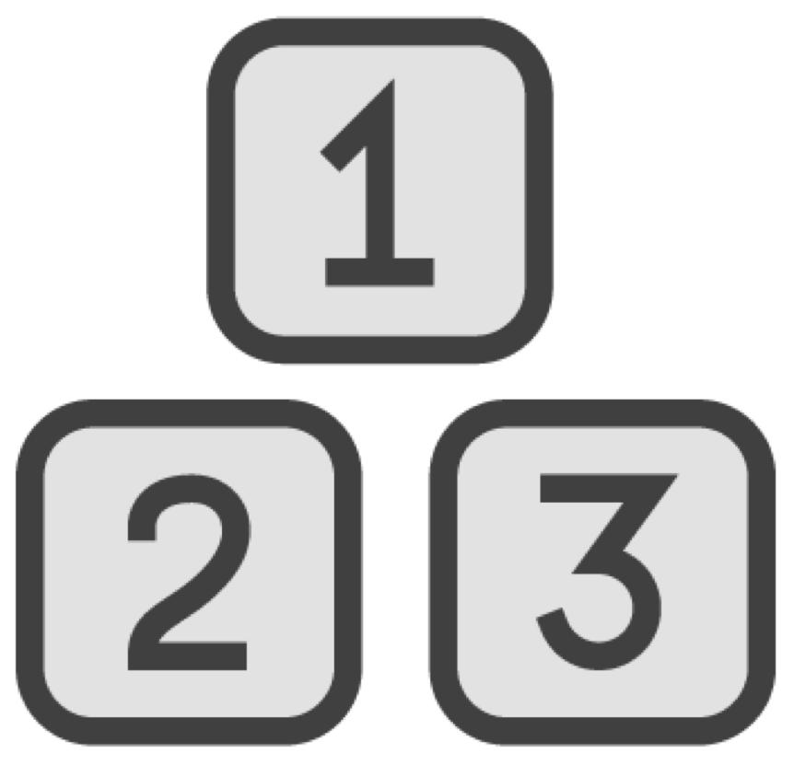
More readable and safer than using integers

Useful in many cases:

- Day of a week

- States of a contract
Defining Enums

enum AuctionState { NotStarted, Ongoing, Finished

}

AuctionState currentState = AuctionState.NotStarted; require(currentState != AuctionState.Finished);
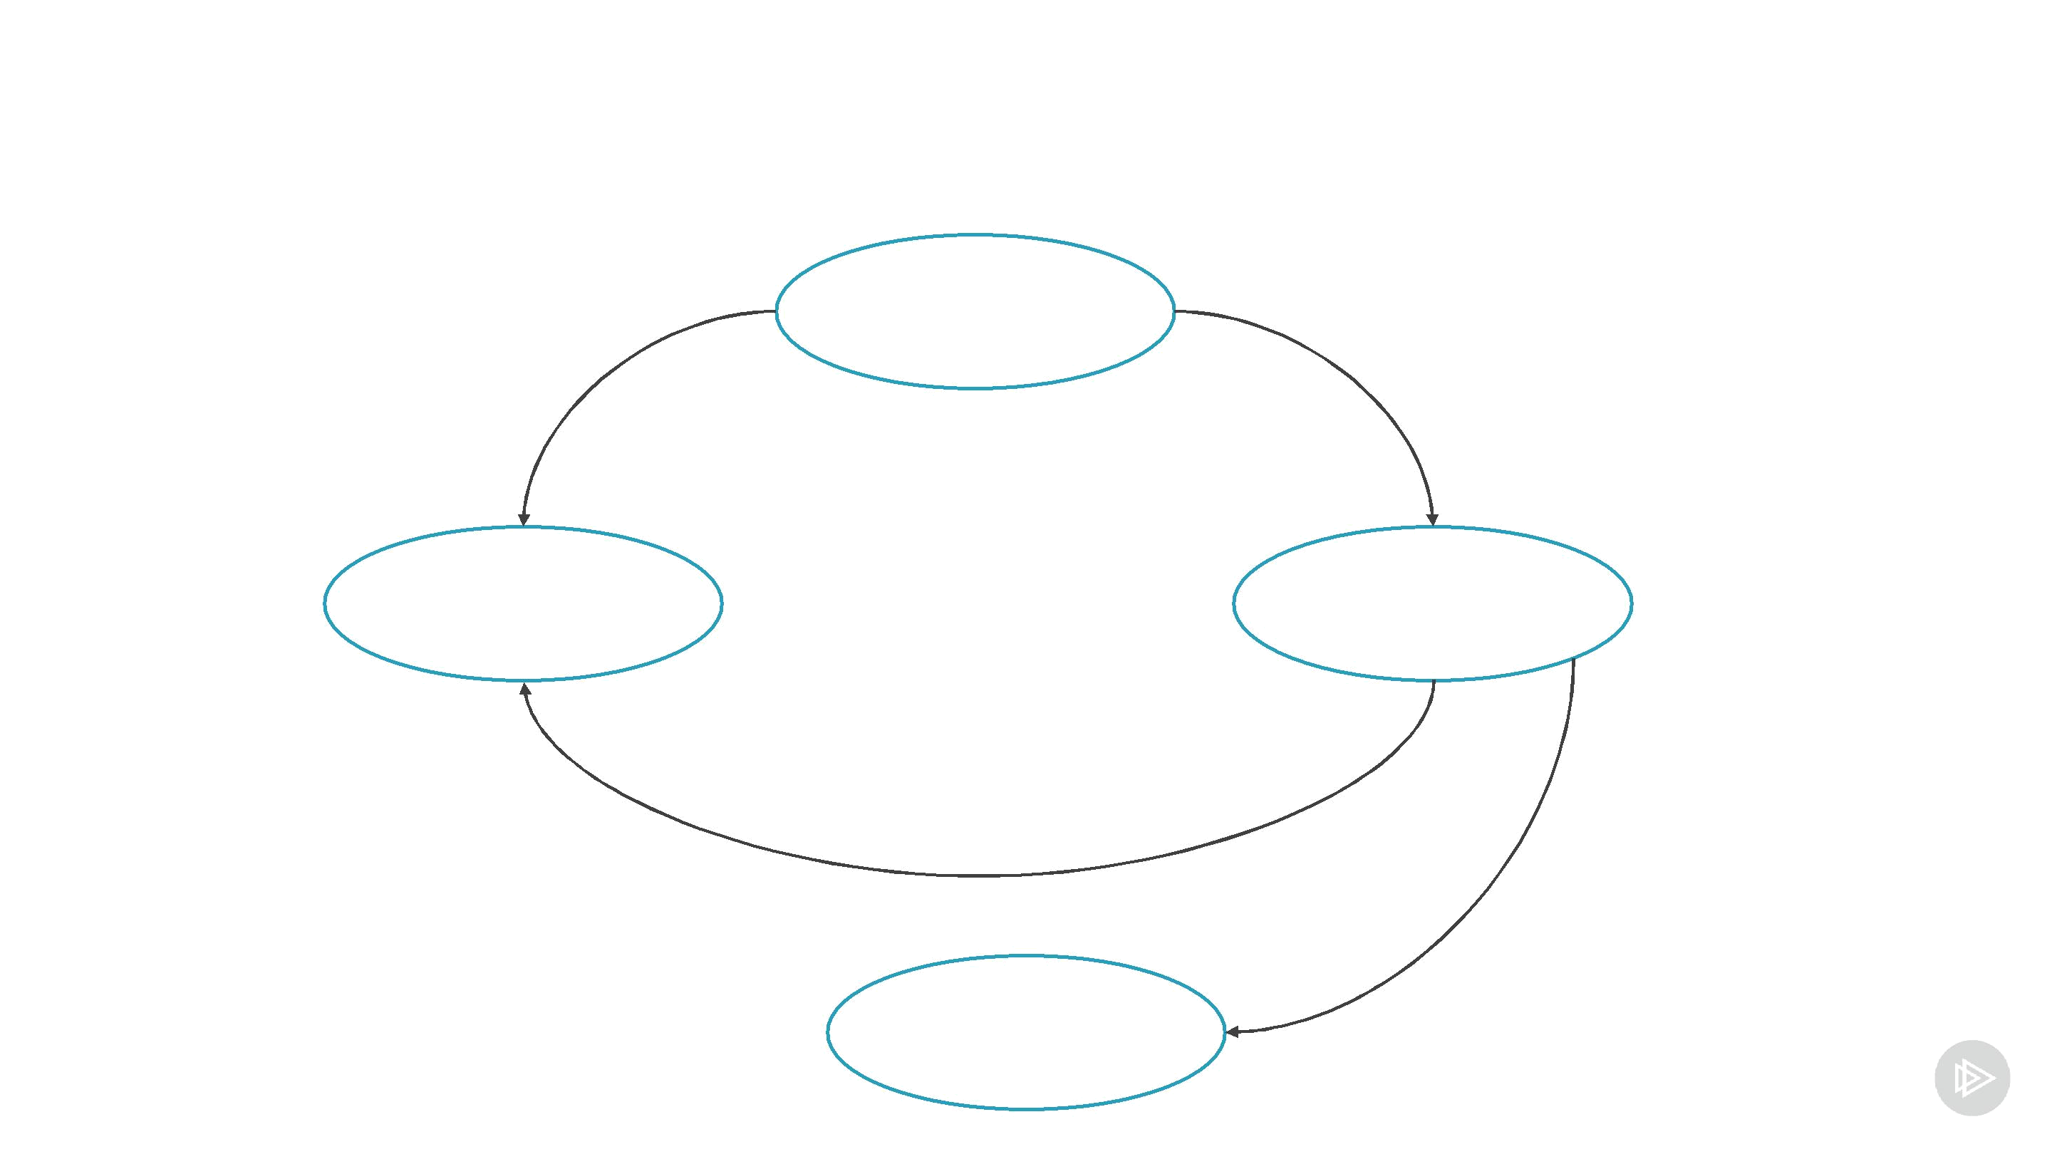
States of a Crowdfunding Contract

Ongoing

Failed Succeeded

PaidOut



Demo

Create a crowdfunding contract Implement a constructor

- ether units

- time units

- enum

Implement a unit test for all new functionality
Function Modifiers

Many functions start with parameters/state checking
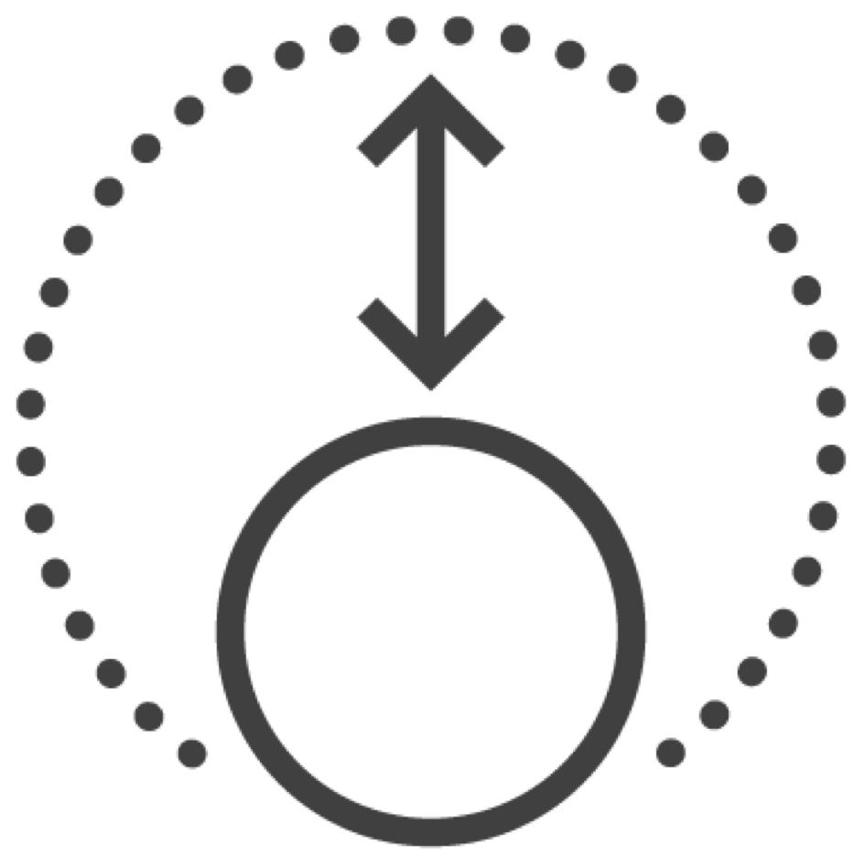
- Can this sender do this?

- Is a contract in a valid state?

- Are these arguments valid?

Can cause a lot of code duplication

Function modifiers allow to extract this code
Checks Duplication

contract Foo { address owner;

function removeContract() { require(msg.sender == owner);

}

function updateContract() { require(msg.sender == owner);

}

}
Function Modifiers

contract Foo { address owner; modifier ownerOnly {

require(msg.sender == owner); _;

}

function removeContract() ownerOnly { ... } function updateContract() ownerOnly { ... }

}
Modifiers with Parameters

contract Shop {

address owner; address moderator; modifier onlyBy(address addr) { require(msg.sender == addr);

_;

}

function removeItem(uint itemId) onlyBy(moderator) {...} function removeContract() onlyBy(owner) {...}

}
Multiple Modifiers

modifier isOwner { require(msg.sender == owner); _;

}

modifier gameStarted {

require (state == States.Started); _;

}

function stopGame() isOwner gameStarted {...}

Demo
Implement a function modifier

- Check if a contract is in a proper state

Implement a function to contribute funds to the contract
Testing Time-dependent Contracts


Crowdfunding contract depends on time

Can't control time from tests

Common pattern

- Allow to change time in a contract

- Only in tests!
Contracts Inheritance

Allows to reuse existing contract code

Similar to inheritance in many OO languages

- Most similar to Python

Creates another contract

- Reuse code

- Can add new methods

- Can replace methods
Simple Inheritance

contract Restricted { // Parent contract function allowed(address addr) returns(bool) {

return true;

}

function changeState() { require(allowed(msg.caller)); }

}

contract AllowsOwner is Restricted { address owner;

function allowed(address addr) returns(bool) { return owner == addr;

}

}
Constructors and Inheritance

constructor Auction { uint roundsNum;

constructor(uint _roundsNum) { roundsNum = _roundsNum;

}

}

contract MaxPriceAuction is Action { uint maxPrice;

constructor(uint _maxPrice) Auction(5) {

}

}
Abstract Contracts

Some methods are not defined
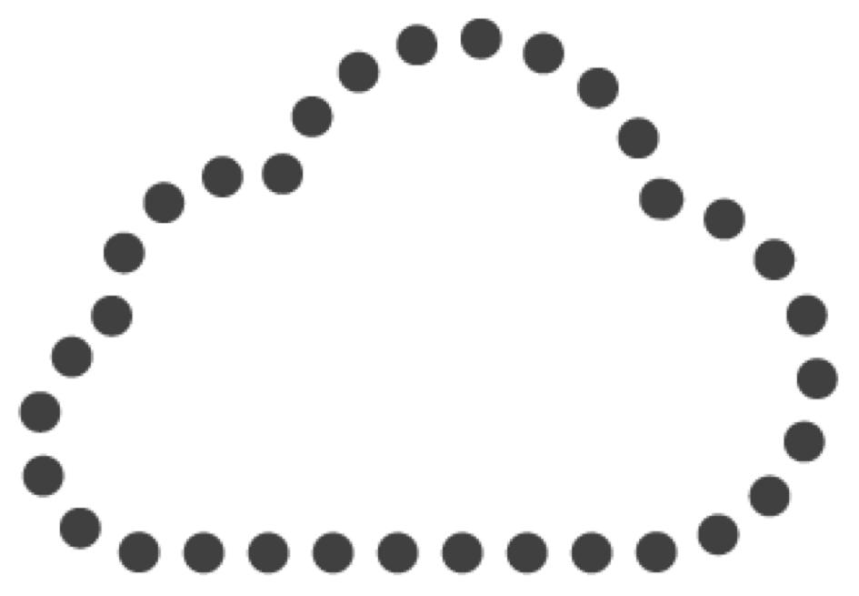
- Should be defined by child contracts

- Cannot be deployed

- Can be inherited

Template of an implementation
Abstract Contract

// Cannot be deployed contract ShopItem {

// Method not defined function pay() public payable

}

// Can be deployed

contract SimpleItem is ShopItem { function pay() public payable {

require(msg.value == price); setOwnership(msg.sender);

}

}
Import Contract from Another File

// Access contract in another file import "./ShopItem.sol";

contract AuctionItem is ShopItem {

// The rest is as usual

}
Access Modifiers and Inheritance


internal private

Cannot be accessed from outside

Can be accessed from a child contract

Cannot be accessed from outside

Cannot be accessed from a child contract

Possible Solution

Production contract Test contract

Uses "now" to get current time | Same functionality
Contract we will deploy | Allows to set current "time"
 | Will use only in tests

Testing Crowdfunding Contract

contract CrowdFunding { // Use in production

function currentTime() internal view returns(uint) { return now; // Get current time

}

}

contract CrowdFundingTest { // Use for testing uint time;

// Implement setter

function currentTime() internal view returns(uint) { return time; // Return set time

}

}

Demo

Create a test version of the crowdfunding contract

Use the test version to improve testing

Demo

Finish crowdfunding smart contract No new topics
Useful for the next module
Events

Allow to notify about a smart contract event


- Clients can subscribe to events

- Stored in a transaction log

- Contracts cannot subscribe to events

Can be used to store historical data

- Cheaper than storing to memory
Event Example

event ItemForSale( uint id,

uint price );

function saleItem(uint id, uint price) { emit ItemForSale(1, 4000);

}
Subscribing to Events – web3js

contract.events.ItemForSale(

{

fromBlock: 0, // optional

toBlock: 'latest’ // optional },

function(error, event) { console.log(event);

}

);
Indexed Attributes


Allows to filter by a particular attribute

Attributes can be indexed

- Use "indexed" keyword
Indexed Events

event ItemForSale( uint id,

uint price,

uint indexed type );

function saleItem(uint id, uint price) { emit ItemForSale(1, 4000, 0);

}
Indexed Events

contract.events.ItemForSale(

{

filter: { type: [0, 1] } fromBlock: 0,

toBlock: 'latest' },

function(error, event) { console.log(event);

}

);

Demo

Emit an event from the crowdfunding smart contract

Write a test that receives this event
Interaction Between Contracts
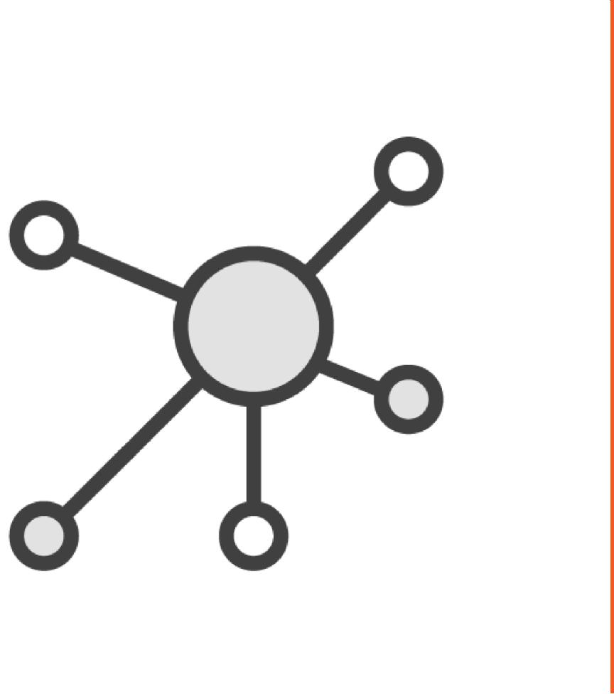

Used smart contracts in isolation

Contracts can interact with each other

- Deploy contracts

- Send transactions

- Call methods
Calling Other Contract

import "./ShopItem.sol"; contract OnlineShop {

address itemAddr = 0xEB1...374; function sellItem() {
ShopItem shopItem = ShopItem(itemAddr); stopItem.startSelling();
}

}
Deploying Contract Instance

import "./ShopItem.sol"; contract OnlineShop {

function sellItem(string name, uint price) { ShopItem shopItem = new ShopItem(name, price); shopItem.startSelling();

}

}
Polymorphism
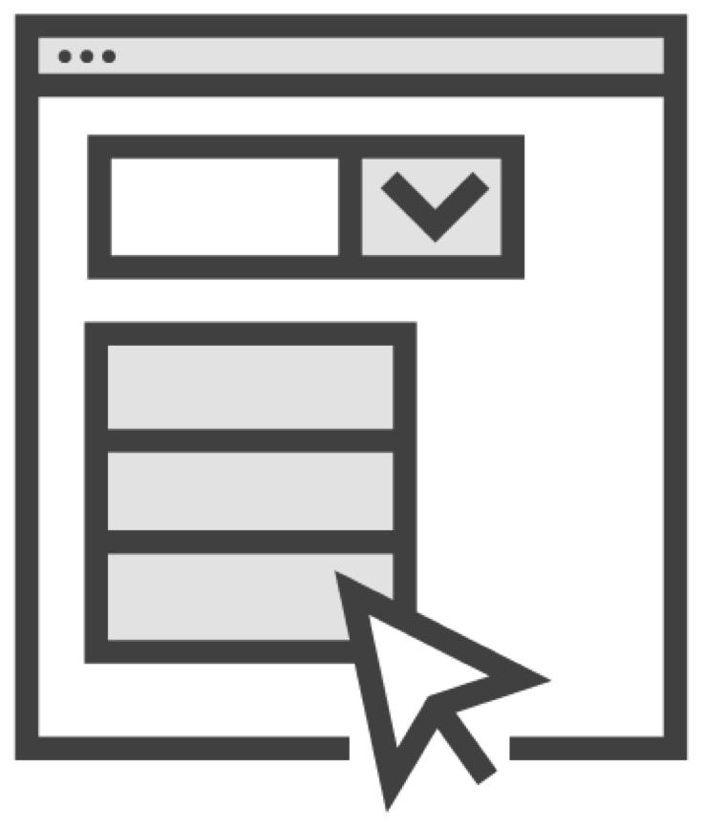

Pass reference to a child contract where parent contract is expected

Calls method of a referenced contract

- Despite the reference type
Polymorphism

contract ShopItem {

function startSale(uint price);

}

contract AuctionShopItem is ShopItem { uint deadline;

uint price

function startSale(uint price) { deadline = now + 1 month;

}

}
Polymorphism

contract Shop { ShopItem[] items;

function addItem(uint price) {

AuctionShopItem item = new AuctionShopItem(); items.push(item)

}

function startSale(uint itemPos) { ShopItem shopItem = item[itemPos]; // Calls method of AuctionShopItem shopItem.startSale(price);

}

}
Why Is This Useful?

Same code an interact with different contracts

Can use abstract contracts

- No methods implementation

- Just methods definitions

- Called "interfaces"

  - Similar to Java, TypeScript, C#, etc.
Libraries


All code in smart contracts

Can extract some of the code

- Reuse in other smart contracts

Libraries allows us to do just that
Libraries


Other type of a smart contract


Has no storage


Accessible for everyone to call


Allow to save gas

Custom Methods

library NumLib {

function negative(int self) returns(int) { return –self;

}

}
Custom Methods

import "./NumLib.sol";

contract Foo {

using NumLib for int;

function method(int value) returns(int) { return value.negative();
return true.negative(); // Won't work

}

}
Library Example

library Utils {

function maxNumber(uint a, uint b) returns(uint) { if (a > b) return a;

else return b;

}

}
Using Library

import "./Utils.sol";

contract Foo { using Utils for *;
function method() returns(uint) { return Utils.maxNumber(5, 6);
}

}
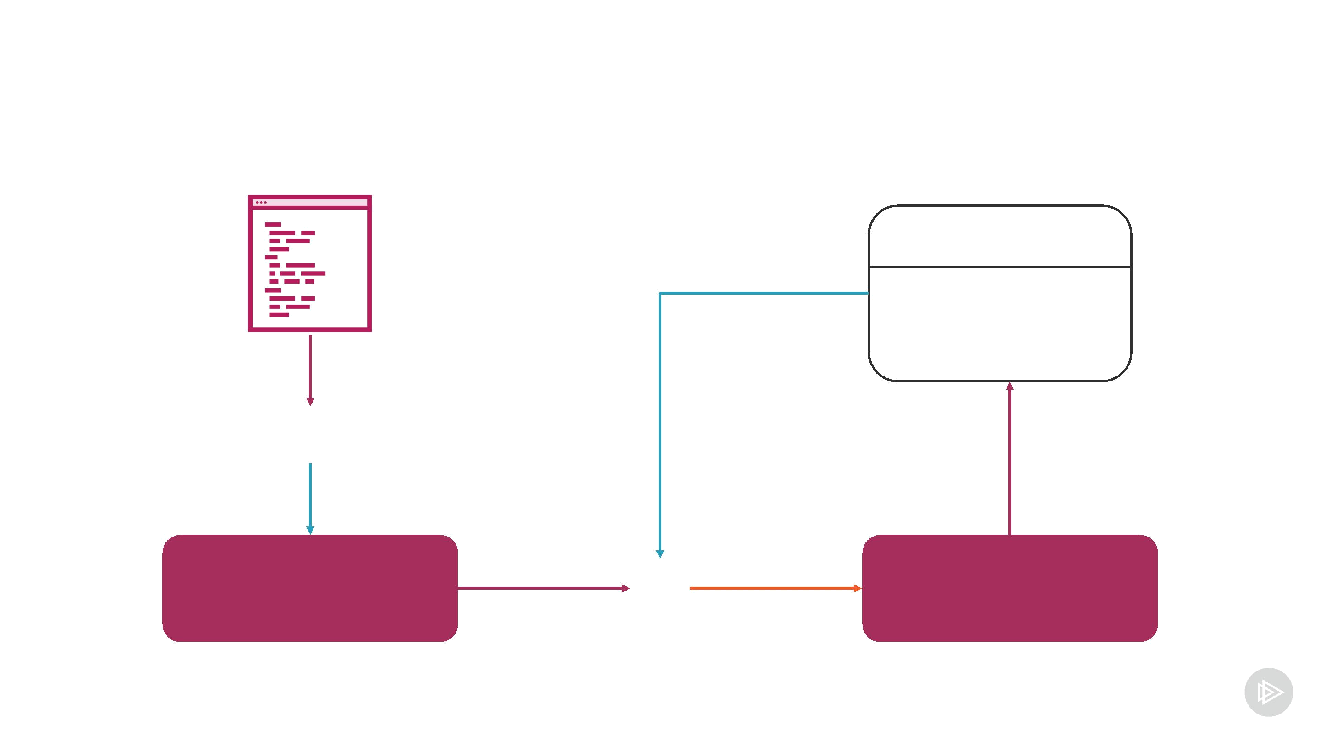
Linking a Library

Smart contract | Library
 | Address: 0x456
 | Methods:
 | maxNumber
 | convertToEth
Compiler

Unlinked contract  Linked contract
Linking a Library

let Utils = artifacts.require("./Utils.sol");

let Contract = artifacts.require("./Contract.sol");

module.exports = async function(deployer) { await deployer.deploy(Utils); deployer.link(Utils, Contract);

};

Demo

Implement a library with Solidity

- Implement conversion utility methods

- Link crowdfunding smart contract
Summary

create

(amount, deadline, beneficiary)

contribute

contribute

collect
Summary

Working with time Custom modifiers Libraries

Inheritance ofEventsContractssmart contractsinteraction

