Web Applications with Ethereum

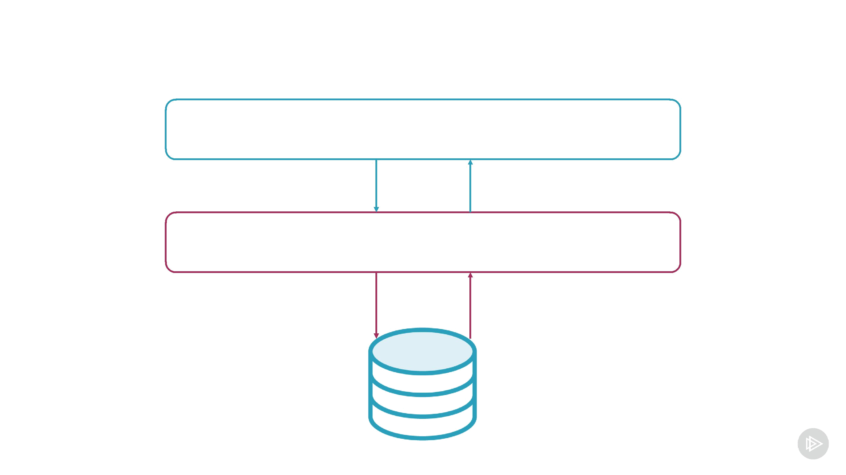
Traditional Web Application

Browser

Web server
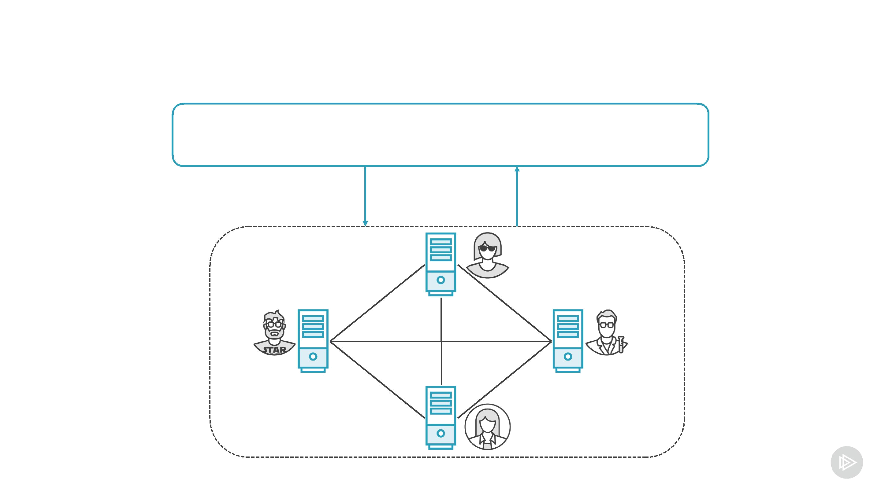
Ethereum Web Application

Browser
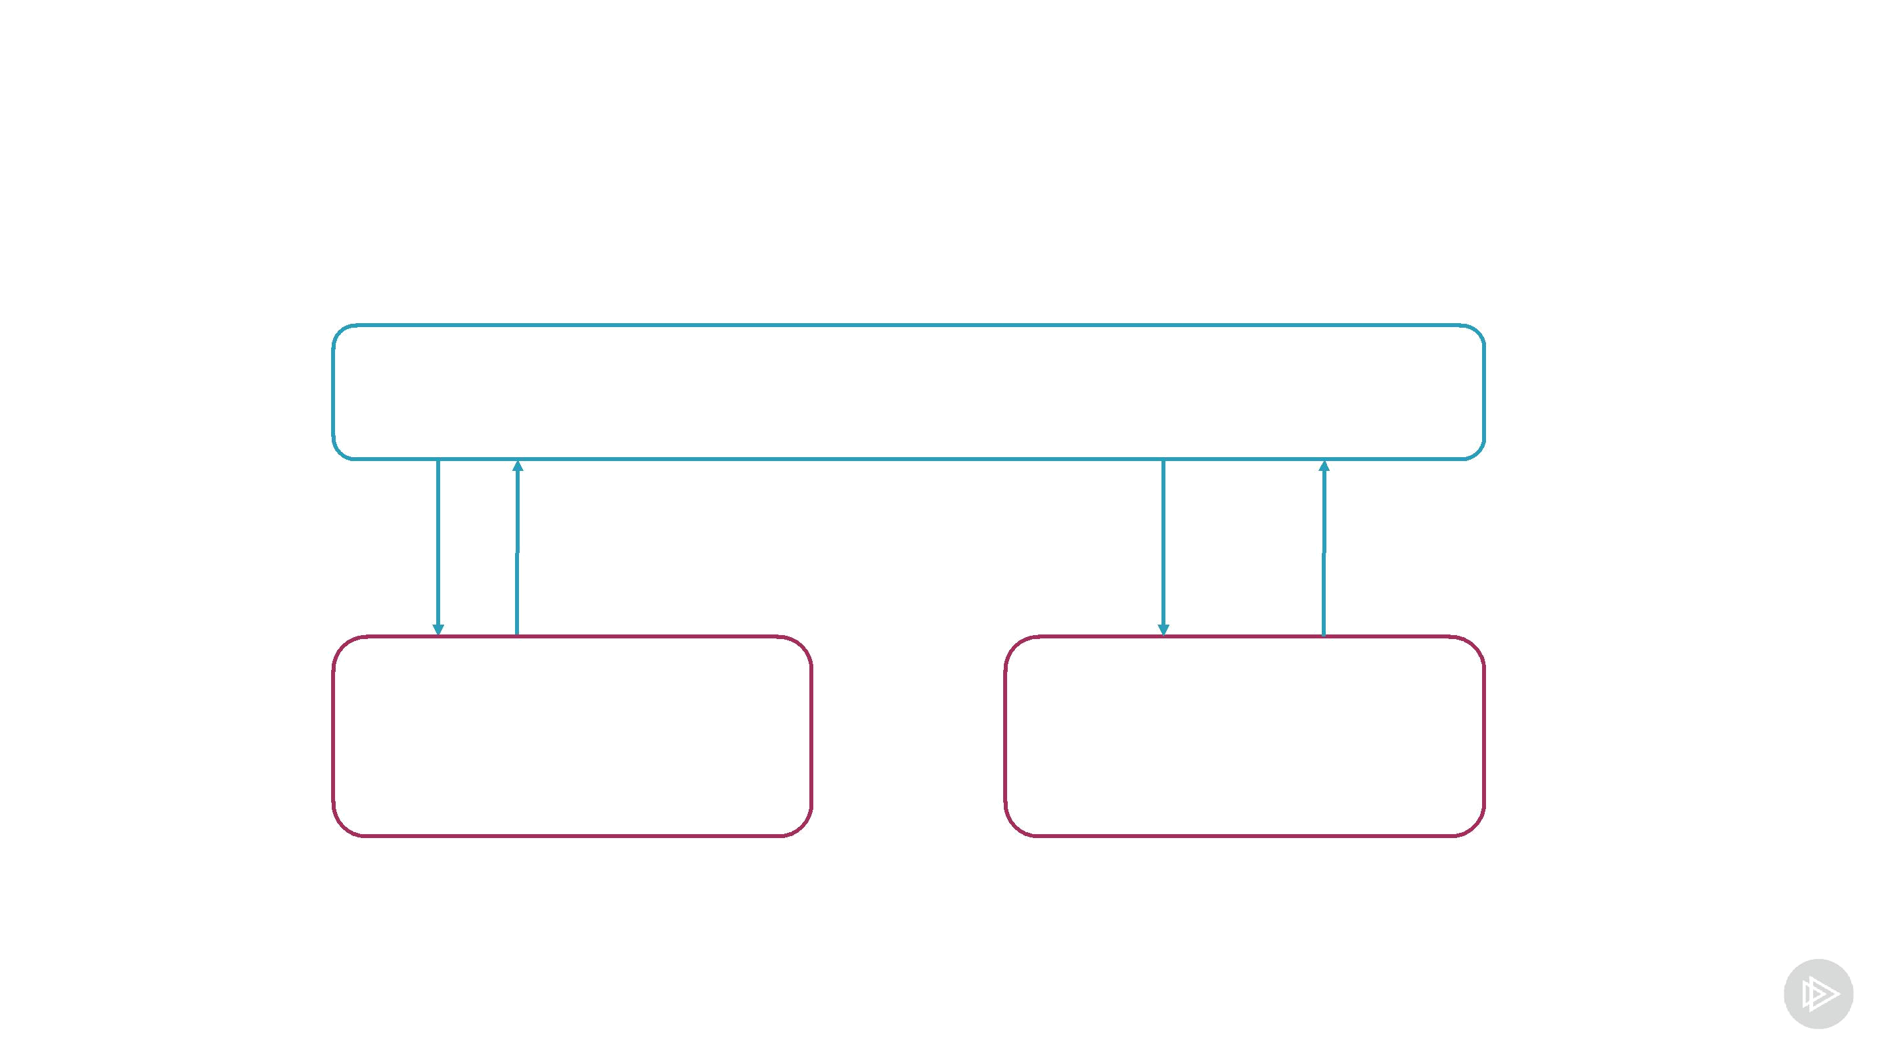
Single-page Web Application

Browser

download | send | fetch
CSS/JS | transactions | data

Web Ethereum network
What We Will Build


UI for the crowdfunding smart contract

- View a campaign

- Contribute to a campaign

What We Won't Cover
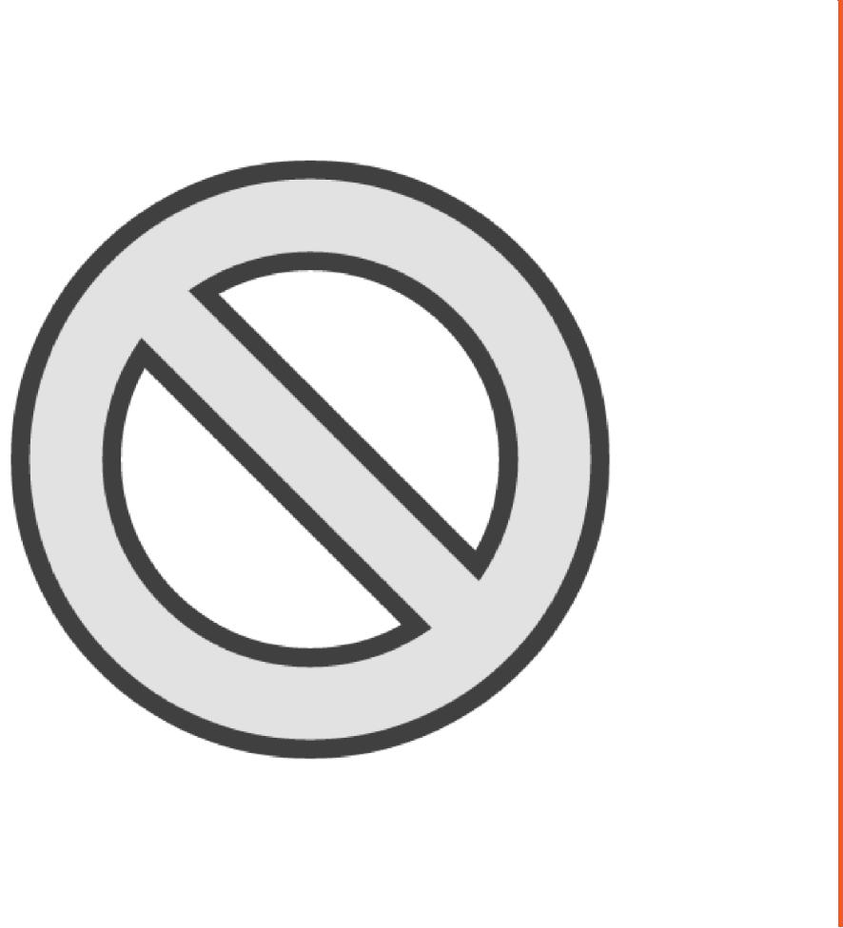

Won't build a full-fledged application

- No input validation

- No error checking

Covers the essentials of building Ethereum web applications
UI Technologies


React React Router Semantic UI MetaMask

Popular UI | To implement | Popular CSS | Stores private
library | navigation | framework | keys


Demo

Write a Truffle migration script

Deploy the crowdfunding contract to Genache

Connect Metamask to Genache
React Introduction


Basics of developing with React

- Just to understand upcoming demos

Skip if you are a React expert
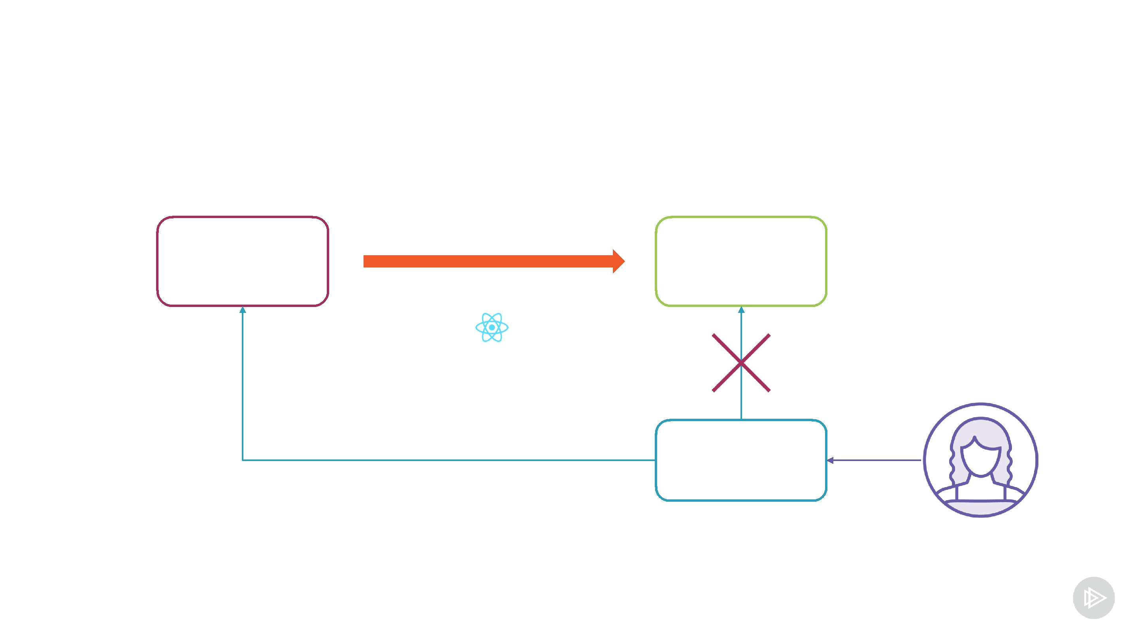
React Flow

State | generates | HTML
State |  | DOM tree
 | React | DOM tree

change state | Event
 | handler

React Philosophy

Unidirectional data flow

- Define how to create UI from data

- Simple to reason about

UI is build from components

React Component

class DisplayInteger extends Component { state = {

counter: 10

}
React Component (JSX file)

render() { return <div>

<h1>Counter</h1>

<p>Counter value: {this.state.counter}</p> </div>

}

}
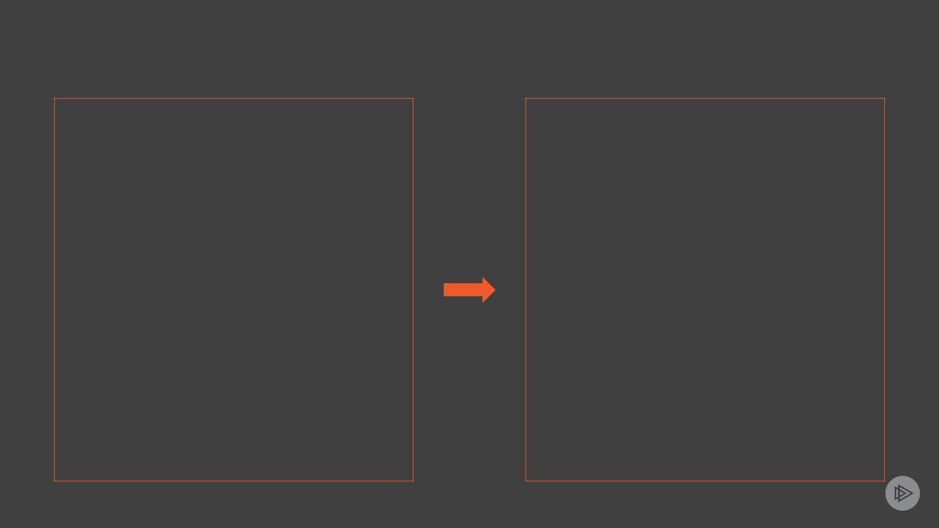
JSX to JavaScript

React.createElement(

<div>

"div", null,
React.createElement(

<p>Hello world</p>

</div>
"p", null,

"Hello world"

));

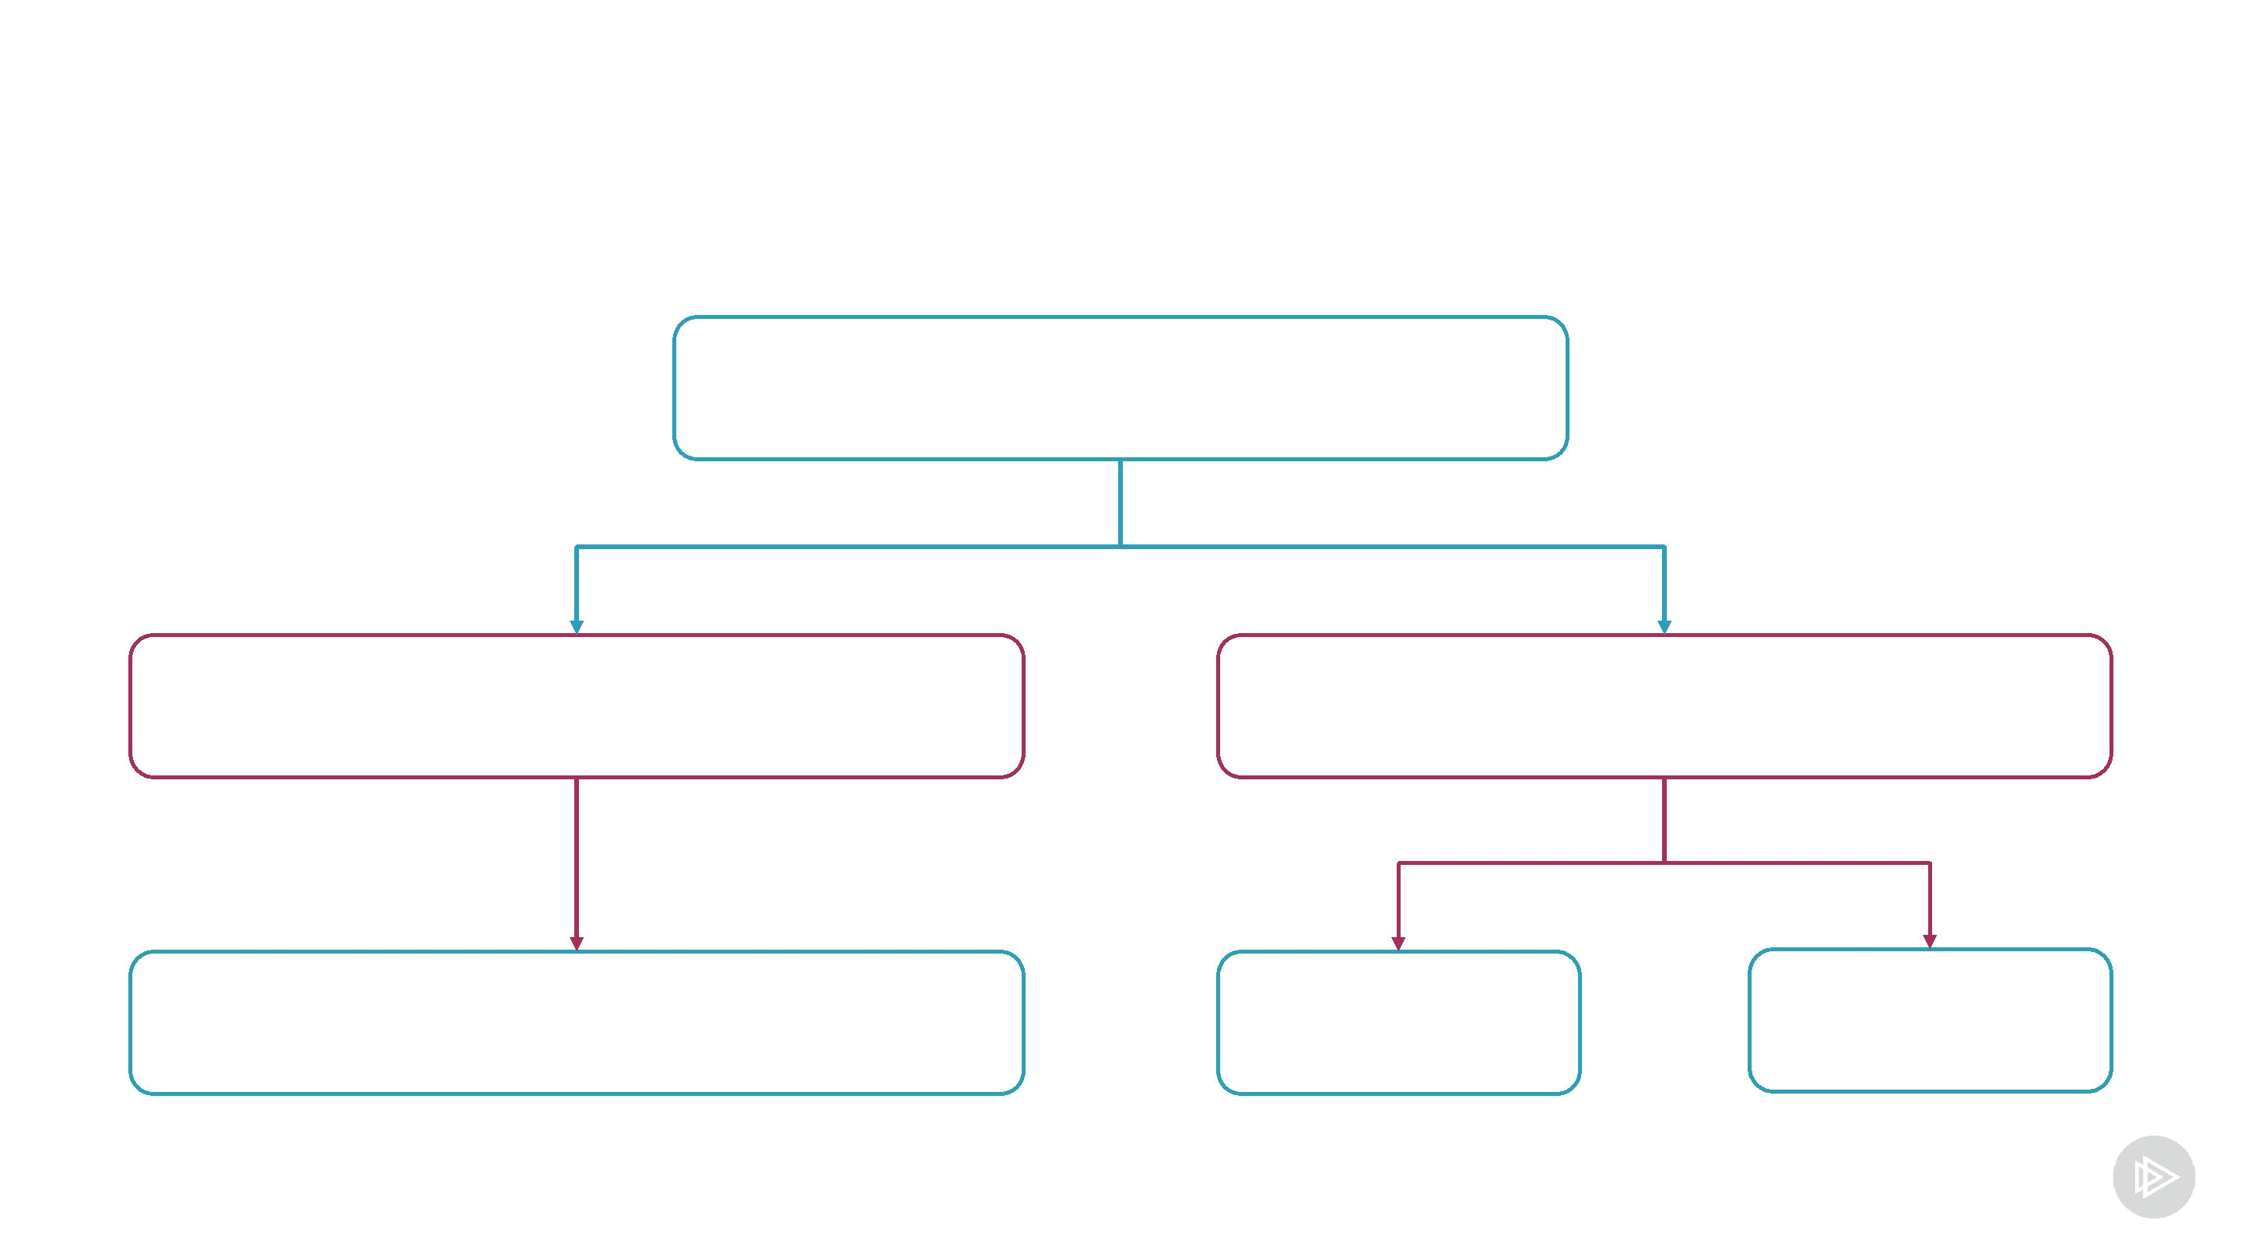
Components as Building Blocks

Campaign Page

Campaign Info Campaign Controls

Table Input Button

Using Other Components

import { Input } from 'semantic-ui-react' render() {

return <div> <Input
actionPosition="left" label="ETH" labelPosition="right"/>

</div>

}
Loading Initial State
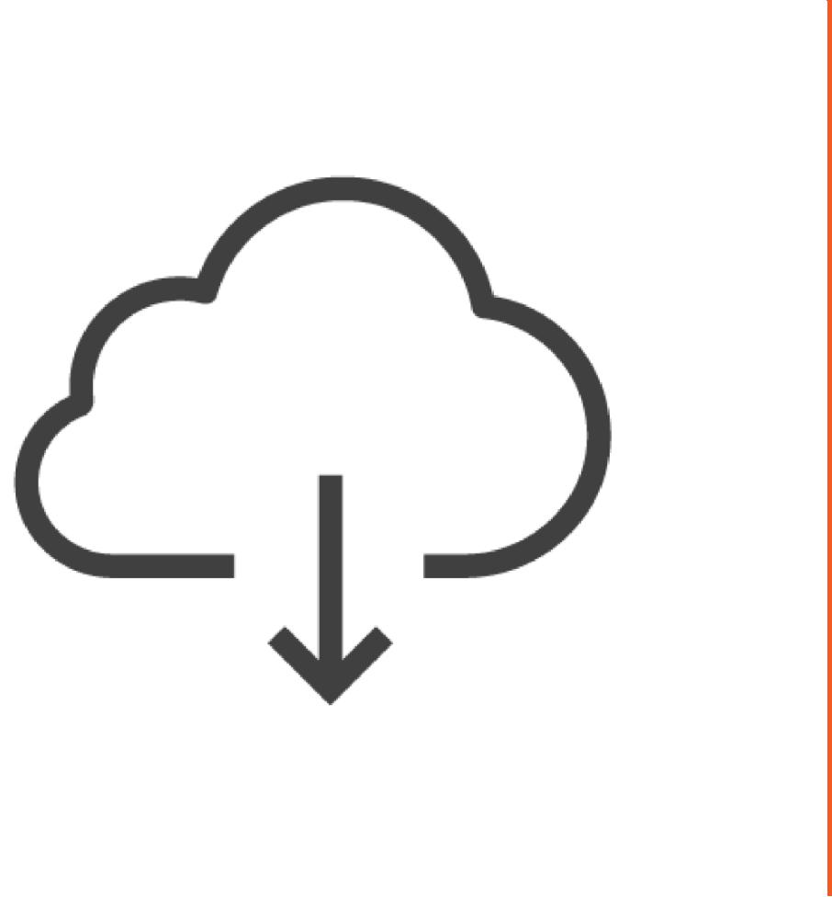

State can be loaded from outside

- Load data from a web server

- Load campaign state from an Ethereum network
Load Initial State

async componentDidMount() {

const campaign = await loadInfo(campaignAddress) this.setState({

campaign: currentCampaign })

}

Demo

Create a React app

Go through the UI code

- Basis for other other demos
Accessing Ethereum from a Browser


How to access Ethereum network

The role of Metamask

How web3js interacts with Metamask
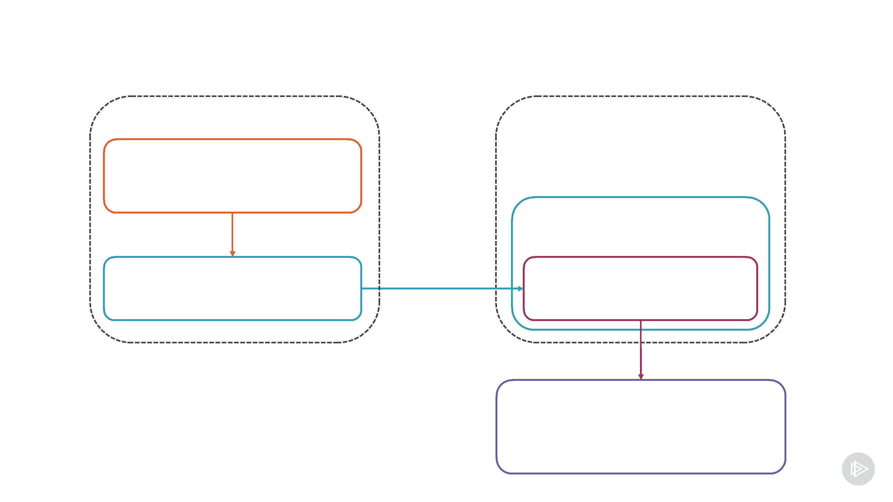
web3js in the Browser

Web application Metamask

React component

web3js

web3js Provider

Ethereum network

Accessing web3 in browser

import Web3 from 'web3'

const provider = window.web3.currentProvider const web3 = new Web3(provider)

// Use web3 instances as usual
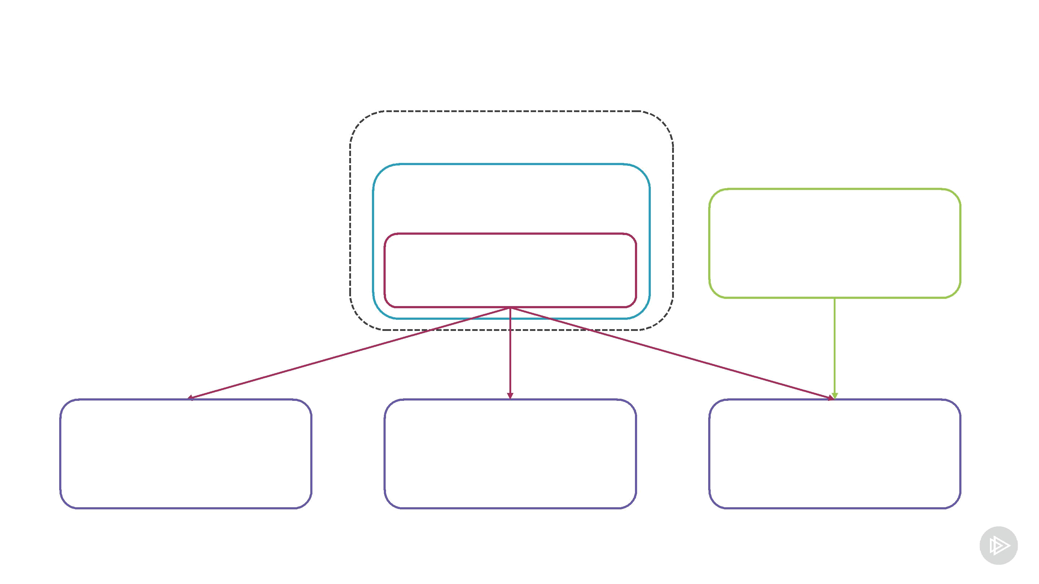
Multiple Providers

Metamask

web3js

Truffle

Provider

Main network Rinkeby network Genache
Sending a Transaction

const accounts = await web3.eth.getAccounts() const account = accounts[0] contract.methods.contribute()

.send({

from: account value: 123
})
web3js Events

contract.methods.doWork(1, 2).send({from: account})

.on('receipt', (receipt) => { ... })

.on('confirmation', (confirmationNumber) => {

...

})

.on('error', (error) => { ... })

Demo

Fetch data from Ethereum network

Display information about a campaign

Demo

Send a transaction to a network

Contribute to a campaignw
Where to Get Contract Addresses
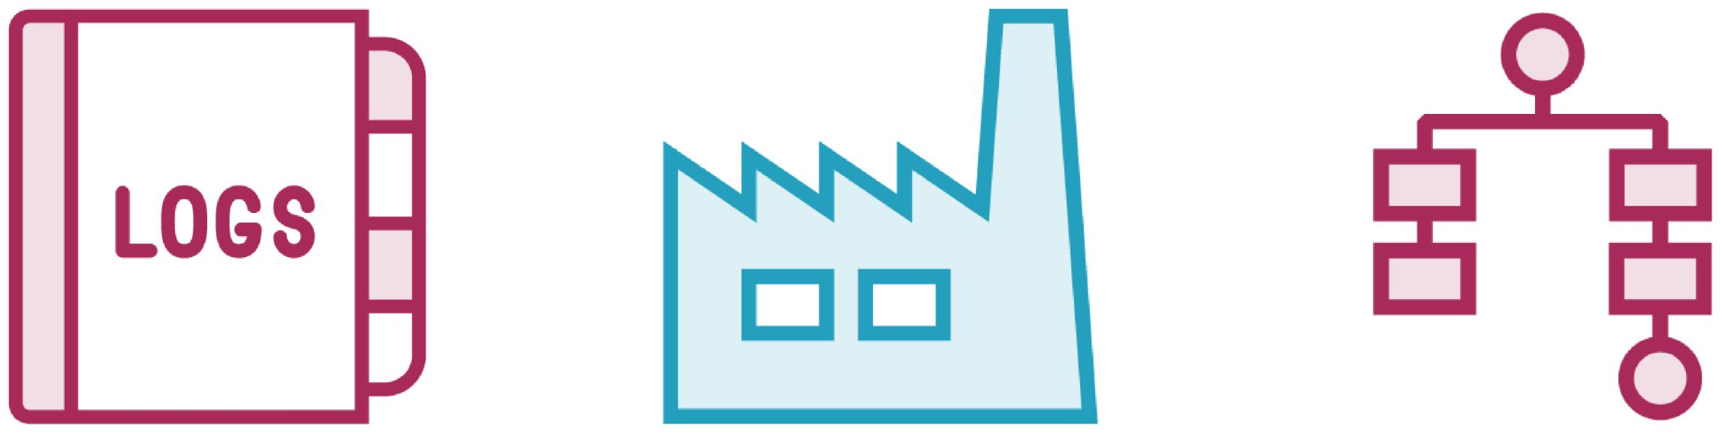

Contracts events | Factory contract | ENS
Generate events | Creates contracts | Name service
Read old events | Stores addresses | Name to address
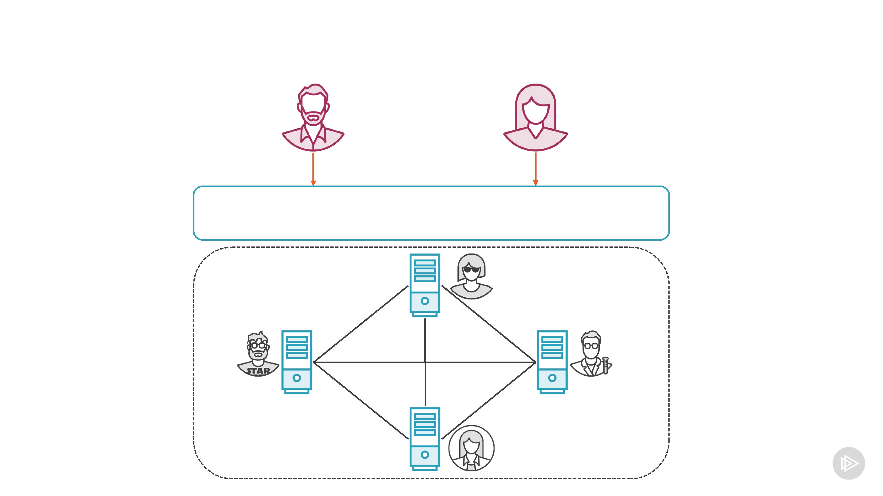
Summary - Decentralized Applications

Decentralized application

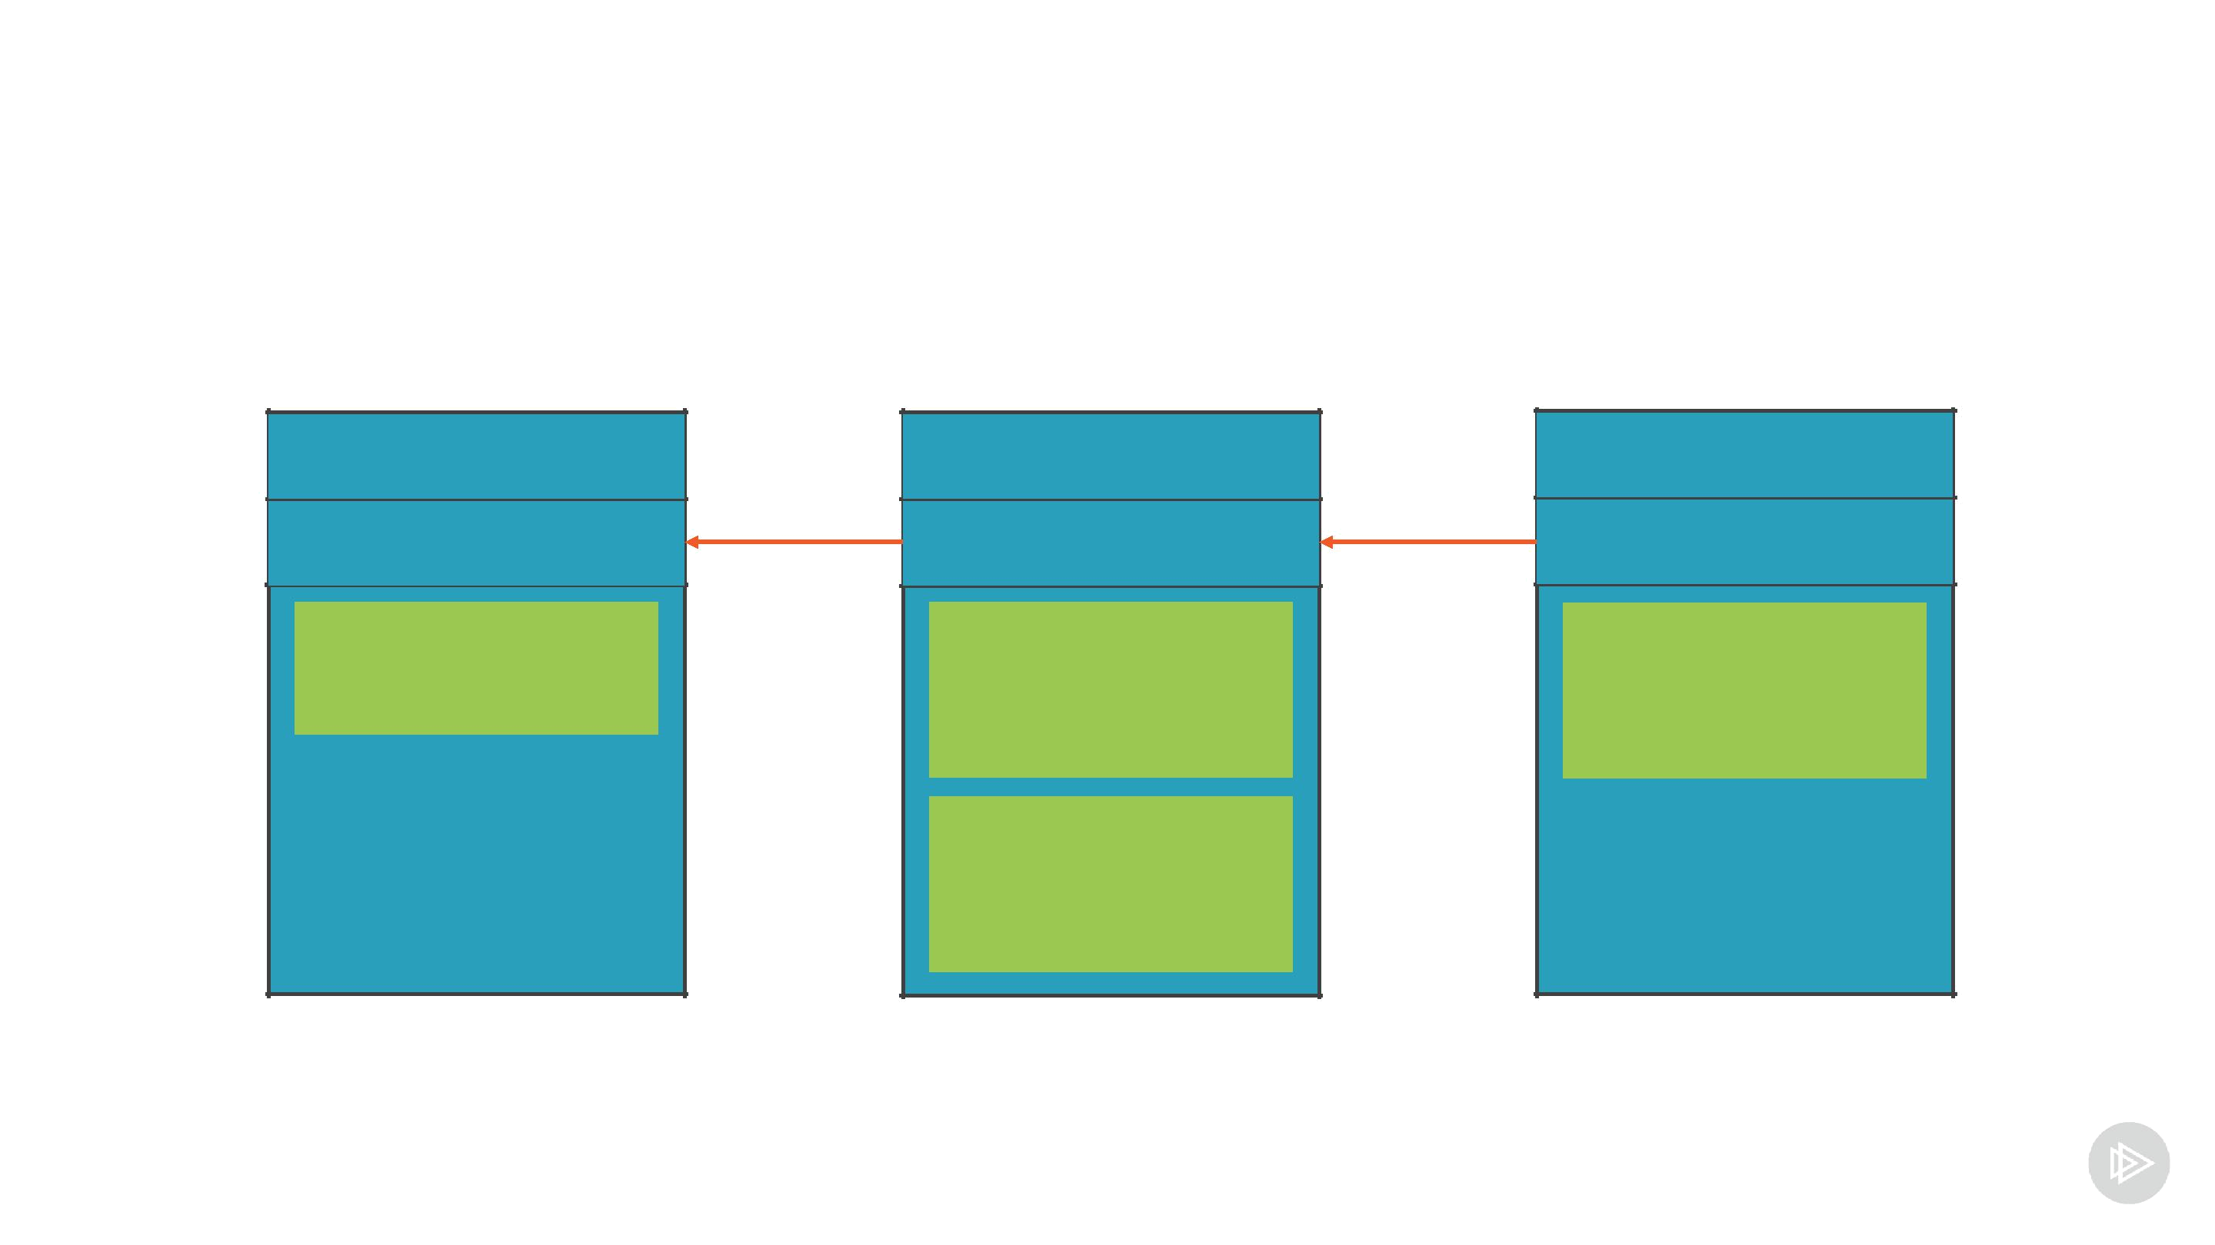
Summary - Blockchain

Genesis block

1

null

50 BTC

TO: Alice

2

prev

10 BTC

TO: Bob

FROM: Alice

10 BTC

TO: Eve

FROM: Alice

3

prev

5 BTC

TO: Eve

FROM: Bob

Summary – Ethereum Platform

Financial |  | Domain name |  | Voting
applications |  | system |  | Voting


Ethereum


Blockchain

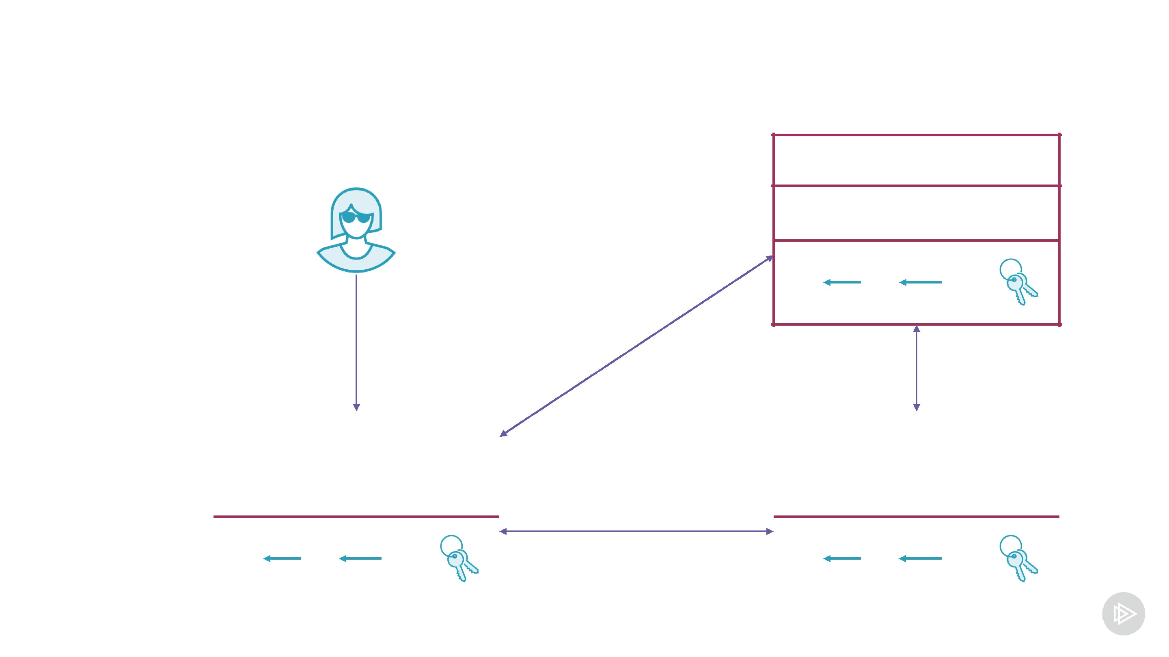
Summary - Interacting with Ethereum

web3 API

Client

 |  |  |  |  |  |  | Ethereum
 |  | web3 API |  |  |  |  | network |  |  | web3 API
 |  |  | Client |  |  |  |  |  |  |  | Client

Summary - Smart Contracts Compilation
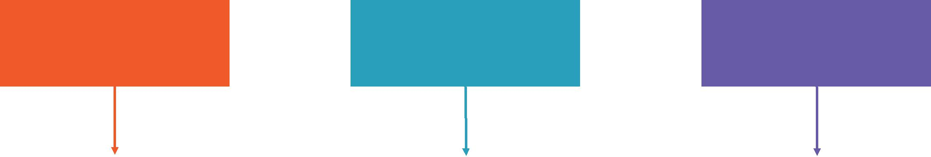

Solidity code Serpent code Vyper code

Solidity |  | Serpent |  | Vyper compiler
compiler |  | compiler |  | Vyper compiler
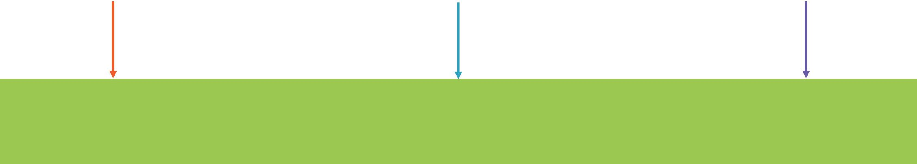

Ethereum bytecode
Single-Page Web Application

Browser

download | send | fetch
CSS/JS | transactions | data

Web server Ethereum network
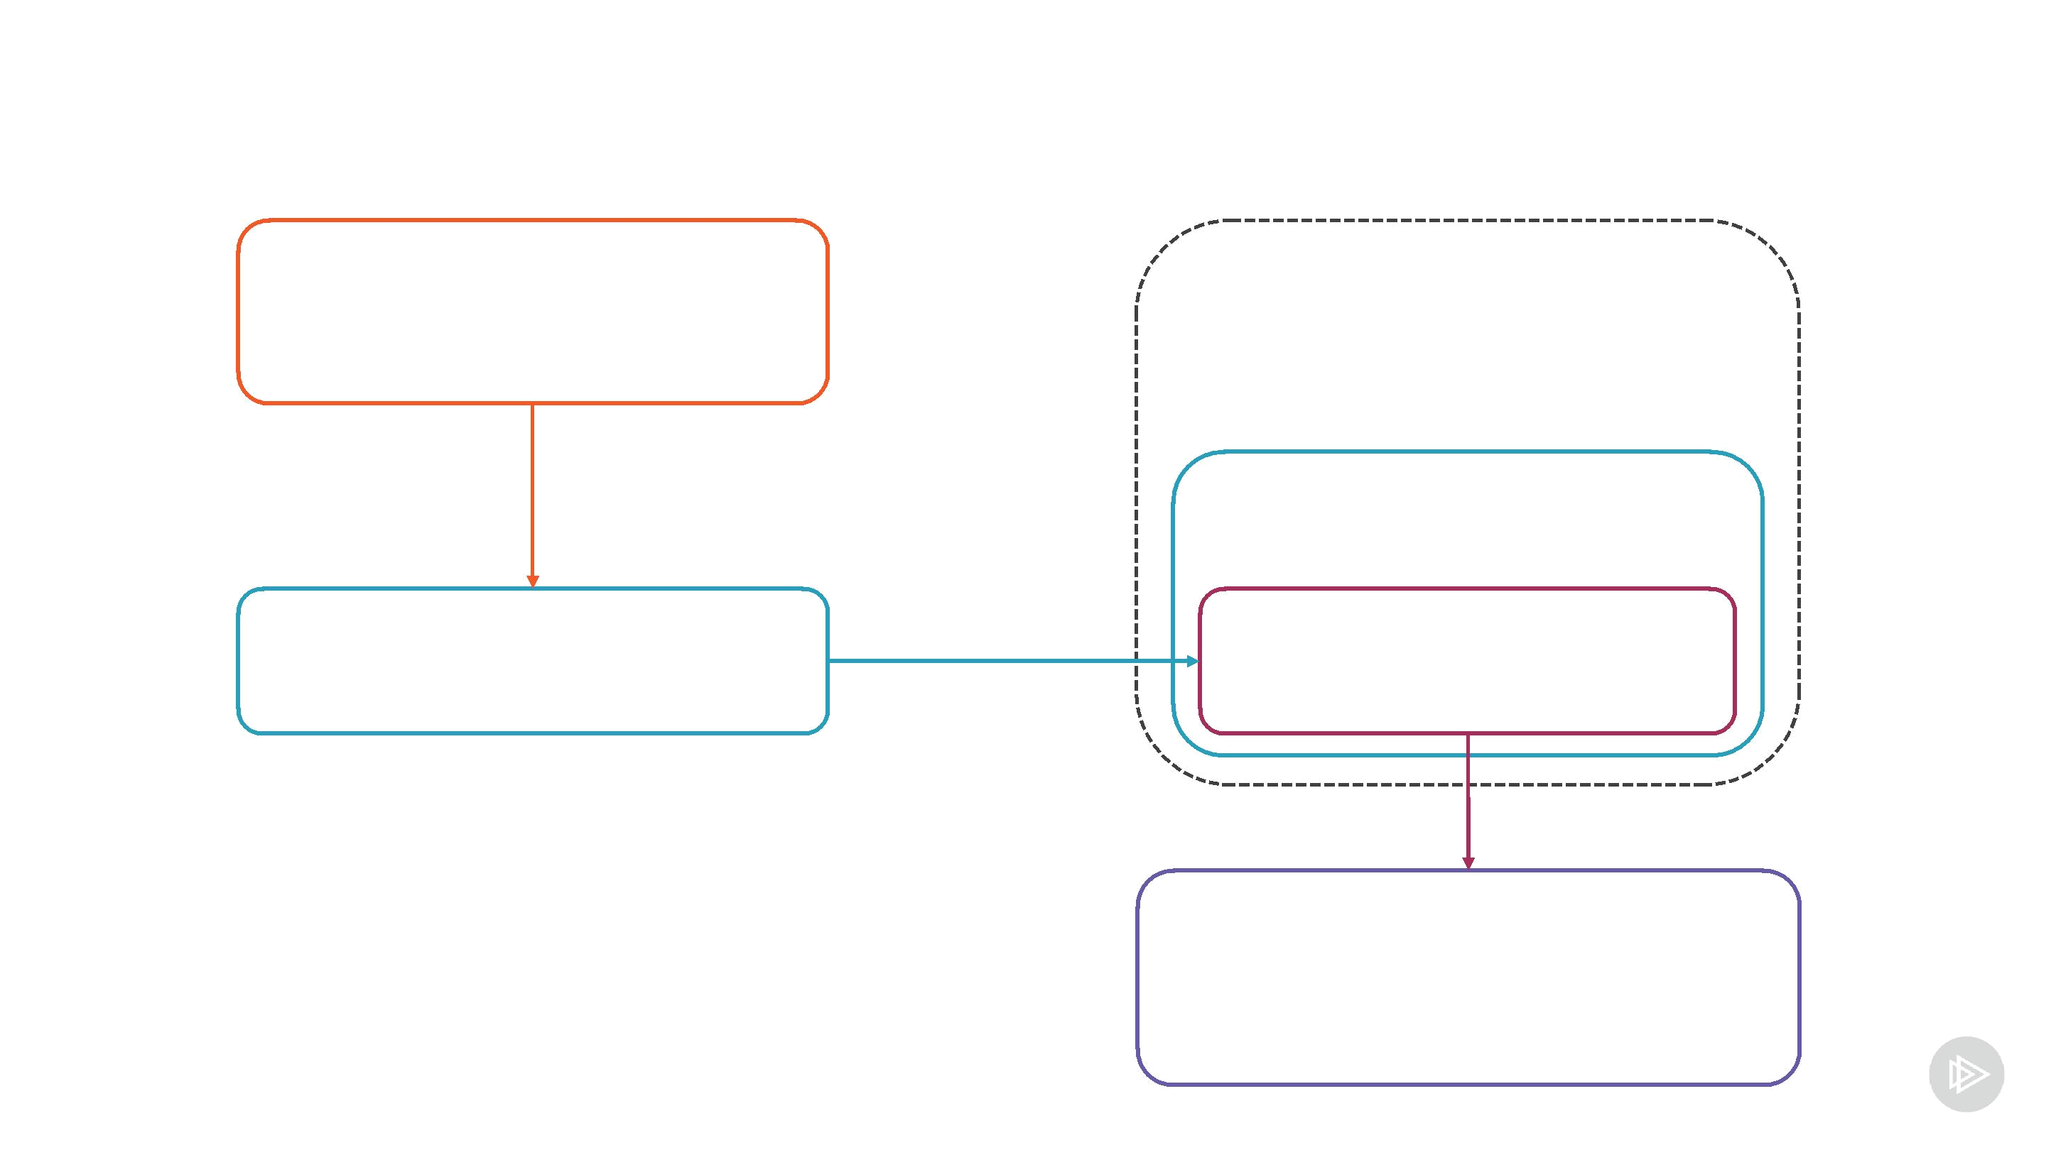
web3js in the Browser

Metamask

React component

web3js

web3js Provider

Ethereum network

Metamask

Can access Ethereum only with Metamask

- Stores user keys and accounts

- Provides connection to Ethereum

Will use our version of web3js

- Install via npm

- Will be downloaded with the UI code
Privacy Concerns

User stores private key

Web application in the browser signs all transactions

No intermediary

- Private keys are not shared

- Nothing can happen without user's consent

